YUVAINTERN
FINAL WEEK 5 PROJECT REPORT
Comprehensive Data Science Project Reporting
and Strategic Recommendations
Student Performance Analysis and Predictive Modeling using Python
Intern | Keval Prashant Chaudhari
Organization | YuvaIntern
Role | Virtual Data Science with Python Apprentice Intern
Project Duration | Weeks 1–5
Project Theme | Student Performance Analysis and Predictive Modeling

1. Executive Summary
This final report integrates the five-week YuvaIntern data science workflow into one end-to-end project. The project uses the UCI Student Performance Mathematics dataset to demonstrate data acquisition and cleaning, exploratory analysis, data visualization and storytelling, statistical hypothesis testing, machine-learning development, evaluation, and strategic recommendation.
Across the internship, the analysis progressed from understanding the structure and quality of student data to formal statistical testing and predictive modeling. The Week 3 analysis examined whether first-period grades (G1) differed from final grades (G3), while Week 4 developed a Logistic Regression classifier for a binary Pass/Fail target. For the machine-learning model, Pass was defined as G3 ≥ 10 and Fail as G3 < 10. G1, G2 and G3 were excluded from predictors to avoid near-target information and to create a more realistic early-warning scenario.
On the held-out Week 4 test set, the baseline model achieved 59.49% accuracy, 71.43% precision, 66.04% recall, 68.63% F1-score and 59.51% ROC-AUC. Five-fold stratified cross-validation produced mean scores of 64.81% accuracy, 76.30% precision, 69.06% recall, 72.42% F1-score and 68.10% ROC-AUC. These results show that the baseline has useful predictive signal but is not strong enough to be treated as a production decision system.
The strategic recommendation is to use this type of analysis as a decision-support and student-support framework: identify patterns, prioritize outreach, and evaluate interventions while keeping human educators responsible for final decisions. Future work should compare additional algorithms, tune thresholds, validate on external data, and assess fairness and calibration.

2. Project Background and Objectives
The project addresses a practical data-science question: how can student-performance data be transformed into reliable evidence that supports understanding and early intervention? The same dataset was intentionally carried across the internship so that each week's methods build on the previous week's work.
- Acquire and understand a publicly available student-performance dataset.
- Clean and preprocess the data using Python and Pandas.
- Explore patterns through statistical summaries and visualizations.
- Communicate findings using data storytelling.
- Formulate and test a statistical hypothesis.
- Develop and evaluate a reproducible machine-learning baseline.
- Translate findings into cautious, actionable recommendations.
- Document limitations and define a roadmap for future improvement.

3. Dataset and Scope
The UCI Student Performance dataset contains student achievement information from two Portuguese schools. The Mathematics file used in the project contains 395 student records and 33 original attributes. Variables cover demographic, family, school, social, study and attendance characteristics, together with academic grades.
The project uses the Mathematics file consistently across the five weeks. The final Week 4 target is derived from G3: Pass = G3 ≥ 10 and Fail = G3 < 10. Because G3 is the final grade, it is never used as an input feature for the classification model. G1 and G2 are also excluded from the final predictor set because they are earlier course grades closely related to G3.

4. End-to-End Methodology
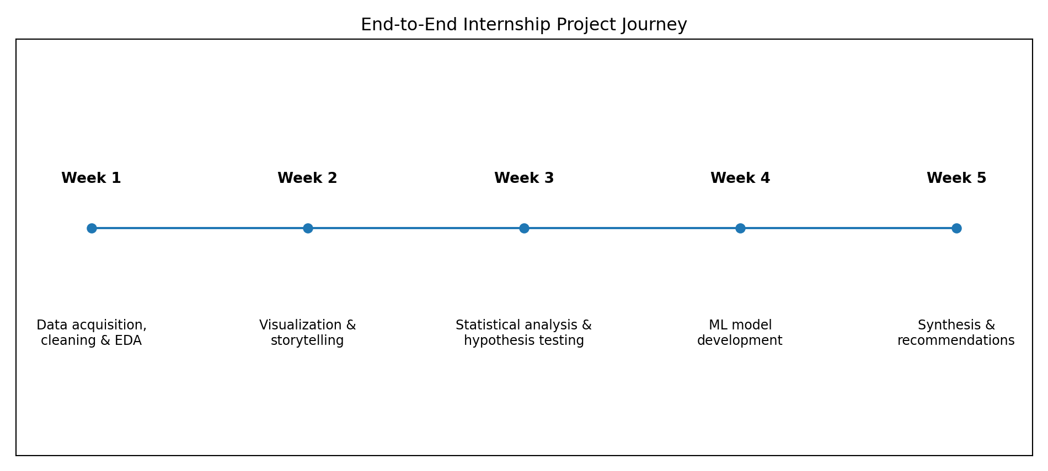
Figure 1. Progression of the five-week data science project.
The project follows a staged workflow: first establish data quality and descriptive understanding, then communicate patterns visually, formally test a selected hypothesis, build a predictive baseline, and finally synthesize the evidence into strategic recommendations.

5. Week 1 – Data Acquisition, Cleaning and Exploratory Analysis
Week 1 focused on the foundations of the project. The publicly available Mathematics student-performance dataset was acquired and examined using Python and Pandas. The workflow included checking structure, data types, missing values, duplicates and descriptive statistics before exploratory analysis.
- Loaded the Mathematics student-performance dataset.
- Inspected rows, columns, data types and summary statistics.
- Checked missing values and duplicate records.
- Reviewed numerical and categorical variables.
- Used visual exploration to understand grade distributions and selected social/attendance patterns.
- Documented the rationale behind cleaning and preprocessing decisions.
Key takeaway: the dataset provides a broad set of student characteristics suitable for descriptive analysis and predictive experimentation, but its school-specific observational nature limits generalization.

6. Week 2 – Advanced Visualization and Data Storytelling
Week 2 expanded the descriptive analysis into a visual narrative. Multiple chart types were used to communicate distributions, grade progression, performance groups, social behavior and absences.
- Final-grade distribution highlighted variation in academic outcomes.
- Grade progression from G1 to G2 to G3 showed how academic measurements change across periods.
- Performance bands made broad achievement levels easier for a non-technical audience to interpret.
- Going-out and weekend alcohol-consumption analyses provided contextual comparisons without claiming causality.
- Absence visualization highlighted attendance variation.
The storytelling principle was to connect each chart to a question and explain what the viewer should notice. The visualizations support exploration rather than causal conclusions.

7. Week 3 – Statistical Analysis and Hypothesis Testing

7.1 Primary Research Question
Is the average first-period Mathematics grade (G1) different from the final Mathematics grade (G3) for the same students?
H₀: μ(G1 − G3) = 0. H₁: μ(G1 − G3) ≠ 0. Significance level α = 0.05.

7.2 Statistical Findings
- Paired t-test: t = 3.5517, df = 394, p = 0.0004291.
- Estimated mean difference G1 − G3 = 0.4937 grade points.
- 95% confidence interval = [0.2204, 0.7669].
- Cohen's d ≈ 0.18, indicating a very small practical effect.
- Wilcoxon signed-rank sensitivity test: p = 0.3151.
- Study-time category × final-grade band chi-square: χ² = 6.16, df = 6, p = 0.4054.
The paired t-test rejects the null hypothesis of zero mean difference, but the effect is very small. The non-parametric sensitivity test does not reject its null hypothesis. Therefore, the evidence should be reported cautiously: the mean-based test identifies a small difference, but the result is not robust to the alternative non-parametric test. The chi-square analysis also did not find statistically significant evidence of an association between the chosen study-time categories and final-grade bands.

8. Week 4 – Machine Learning Model Development and Evaluation
Week 4 converted the project into a binary classification problem. The objective was to predict Pass/Fail status from non-grade student characteristics. Logistic Regression was selected as an interpretable baseline classifier.

8.1 Model Pipeline
- Pass = G3 ≥ 10; Fail = G3 < 10.
- Exclude G1, G2 and G3 from predictors.
- Use an 80/20 stratified train/test split with random_state=42.
- Median-impute and standardize numerical features.
- Most-frequent-impute and one-hot encode categorical features.
- Train balanced Logistic Regression.
- Evaluate on the held-out test set.
- Perform five-fold stratified cross-validation.

8.2 Actual Model Performance
Metric | Test set | 5-fold CV mean
Accuracy | 0.595 | 0.648
Precision | 0.714 | 0.763
Recall | 0.660 | 0.691
F1-score | 0.686 | 0.724
ROC-AUC | 0.595 | 0.681
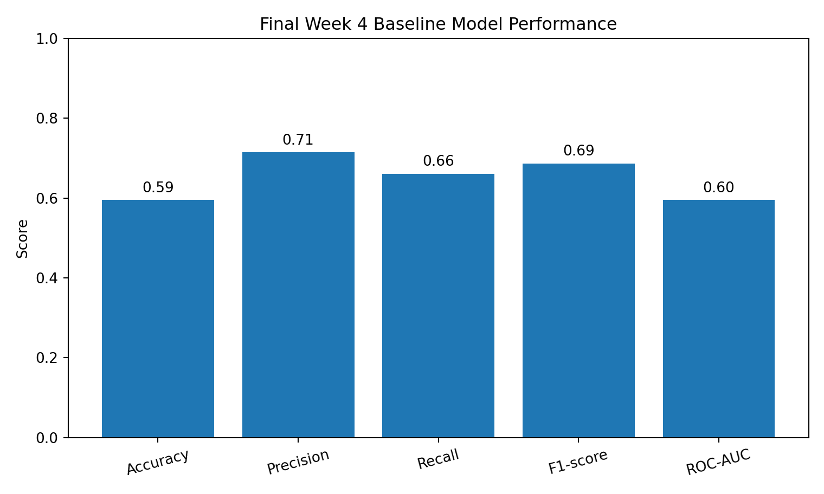
Figure 2. Week 4 baseline model performance on the held-out test set.
The held-out model is modest rather than highly accurate. Cross-validation is somewhat better than the single split, suggesting that performance varies with the partition. The ROC-AUC results especially indicate that there is substantial room for improvement in separating the two classes.

8.3 Confusion Matrix
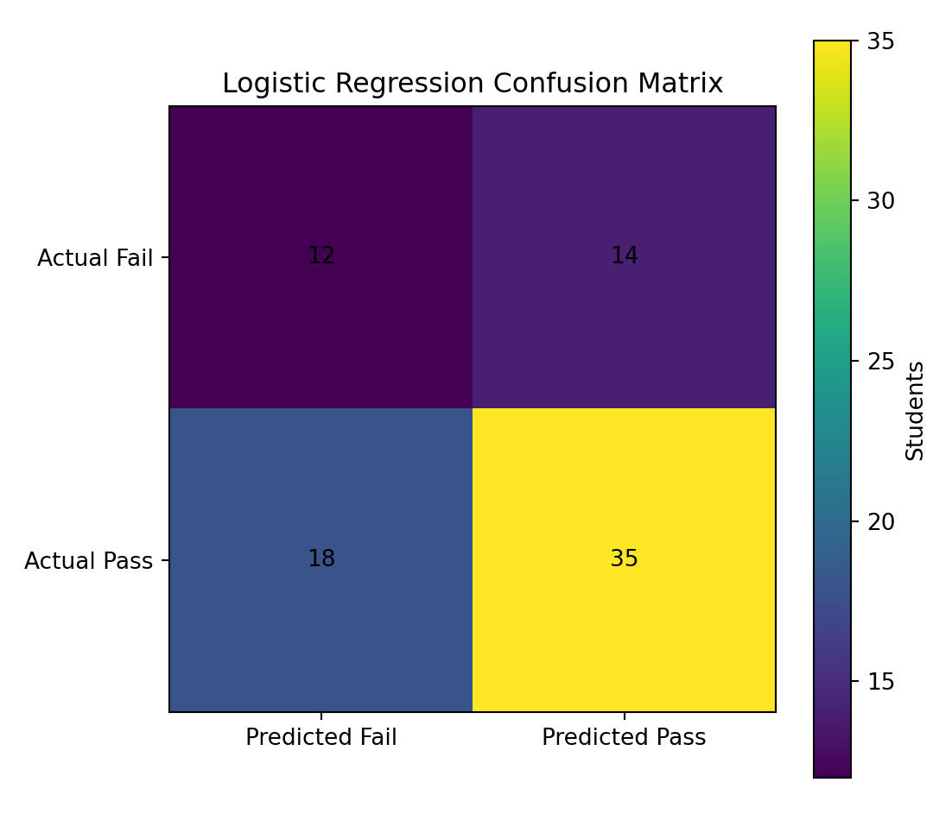
Figure 3. Week 4 confusion matrix.
The confusion matrix contains 12 correctly predicted Fail cases, 14 false positives, 18 false negatives and 35 correctly predicted Pass cases. False negatives deserve attention in an early-support setting because a student who may need support can be missed.

9. Integrated Key Findings
- The project demonstrates a complete progression from raw data to decision-oriented analysis.
- The dataset supports rich descriptive exploration because it combines academic, demographic, family, social and attendance variables.
- Visual analysis is useful for communicating patterns, but descriptive relationships should not be interpreted as causal effects.
- The Week 3 paired t-test found a statistically significant mean difference between G1 and G3, but the estimated effect was very small and the Wilcoxon sensitivity test was not significant.
- The Week 3 chi-square analysis did not find significant evidence that the selected study-time categories were associated with final-grade bands.
- The Week 4 Logistic Regression baseline has moderate classification performance and should be treated as an experimental baseline rather than a deployment-ready model.
- Model errors matter: false negatives could lead to missed opportunities for student support.

10. Strategic Recommendations

10.1 Build an Early-Support, Not a Punitive, Workflow
Use predictive outputs to prioritize supportive outreach such as mentoring, tutoring or academic advising. Predictions should not be used as automatic labels that determine a student's opportunities.

10.2 Improve Data Collection
Collect larger datasets across additional cohorts and institutions. More representative data would improve confidence in whether observed patterns generalize beyond the original schools.

10.3 Compare Multiple Models
Use Logistic Regression as a transparent baseline, then compare Decision Trees, Random Forests and Gradient Boosting. Select a final model based on performance, interpretability, calibration, fairness and operational requirements rather than accuracy alone.

10.4 Optimize the Decision Threshold
If the objective is to minimize missed at-risk students, evaluate thresholds that increase recall while monitoring the number of students incorrectly flagged. The appropriate threshold depends on the cost of false negatives versus false positives.

10.5 Keep Humans in the Loop
Educators should review model-supported signals together with contextual information. The model should support professional judgment, not replace it.

10.6 Validate Before Deployment
Before any real-world use, evaluate the model on an independent external dataset, check calibration, monitor performance over time and assess fairness across relevant groups.

11. Potential Business / Research Impact
Although this is an educational dataset rather than a business dataset, the workflow demonstrates a general decision-support pattern applicable to many organizations: acquire data, validate it, understand it, test claims, build a baseline model, evaluate errors, and translate evidence into actions.
- Educational institutions could use similar pipelines to prioritize limited student-support resources.
- Researchers can use the workflow to test whether proposed relationships remain statistically supported under formal analysis.
- Organizations can adapt the same pipeline to customer churn, employee retention, fraud screening or operational risk, provided the target and ethical requirements are appropriate.
- Transparent reporting of limitations can reduce the risk of overinterpreting model predictions.

12. Limitations
- The dataset contains only 395 Mathematics records from two Portuguese schools.
- The observations are not a random sample of all students, so generalization is limited.
- Most variables are observational and some are self-reported; association does not imply causation.
- The Week 3 t-test and Wilcoxon test answer different statistical questions, so their differing conclusions must be interpreted carefully.
- The Week 4 model excludes G1 and G2 intentionally; allowing them would change the prediction problem and likely increase performance.
- The Week 4 Logistic Regression is a baseline and does not represent a fully optimized machine-learning system.
- Model performance may change on new cohorts, schools or countries.
- Ethical, privacy and fairness requirements would need to be addressed before operational use.

13. Future Work
- Expand the dataset with multiple years and institutions.
- Compare Logistic Regression, Decision Tree, Random Forest and Gradient Boosting.
- Perform systematic hyperparameter tuning.
- Analyze precision-recall trade-offs and threshold selection.
- Calibrate predicted probabilities.
- Use permutation importance or other interpretable methods to understand model behavior.
- Perform subgroup and fairness evaluation.
- Validate on a completely external dataset.
- Track model drift and retrain only when justified by new evidence.

14. Technical Implementation Summary
# Overall Week 4 modeling workflow
df = pd.read_csv("student-mat.csv", sep=";")
df["pass_fail"] = (df["G3"] >= 10).astype(int)
# Prevent near-target leakage
X = df.drop(columns=["G1", "G2", "G3", "pass_fail"])
y = df["pass_fail"]
# Preprocess numerical/categorical columns in a Pipeline
# Split 80/20 with stratification
# Train balanced Logistic Regression
# Evaluate accuracy, precision, recall, F1 and ROC-AUC
# Inspect confusion matrix and ROC curve
# Confirm stability with 5-fold stratified cross-validation
The complete Week 4 Python implementation is included in the GitHub-ready project assets.

15. Final Conclusion
This five-week internship project demonstrates an end-to-end data science workflow using a single public student-performance dataset. The work progressed from data acquisition and exploratory analysis to visual storytelling, statistical inference, machine learning and strategic recommendations.
The final machine-learning baseline achieved 59.49% accuracy and 59.51% ROC-AUC on the held-out test set, with five-fold cross-validation averaging 64.81% accuracy and 68.10% ROC-AUC. These results indicate that the selected non-grade student characteristics contain some predictive information, but the baseline is not sufficiently strong to justify unsupervised deployment.
The most important strategic outcome is therefore not a claim that the model can make definitive decisions about students. Instead, the project demonstrates how data science can provide structured evidence for further investigation and targeted support. Future development should focus on stronger validation, model comparison, threshold optimization, fairness, calibration and external testing.

16. References
UCI Machine Learning Repository. Student Performance, Dataset ID 320. https://archive.ics.uci.edu/dataset/320/student+performance
Cortez, P. (2008). Student Performance [Dataset]. UCI Machine Learning Repository. https://doi.org/10.24432/C5TG7T
Scikit-learn documentation. Classification metrics and model-selection utilities. https://scikit-learn.org/stable/

