YuvaIntern
WEEK 1 INTERNSHIP REPORT
Data Acquisition, Cleaning and Exploratory Analysis
of Student Performance
Virtual Data Science with Python Apprentice Intern
Intern | Keval Prashant Chaudhari
Organization | YuvaIntern
Internship Role | Virtual Data Science with Python Apprentice Intern
Task | Week 1 – Data Acquisition, Cleaning, and Exploratory Analysis
Dataset | UCI Student Performance – Mathematics (student-mat.csv)

Prepared according to the Week 1 task requirements shown in the YuvaIntern internship portal.

1. Executive Summary
This report documents a complete introductory data-science workflow using the UCI Student Performance dataset for the Mathematics course. The workflow covers public-data acquisition, data-quality checks, preprocessing decisions, exploratory analysis, visualization, and interpretation.
The selected dataset contains 395 Mathematics-course student records and 33 columns. The UCI documentation describes demographic, social, school-related and academic attributes, including study time, previous failures, absences, first- and second-period grades (G1 and G2), and the final grade (G3).
The data-quality review found no missing values and no duplicate rows in the Mathematics dataset. Therefore, no imputation or row deletion was necessary. The analysis also confirms that G3 is concentrated around the middle of the 0–20 grading scale, with a mean of approximately 10.42 and a median of 11.

2. Objectives
- Acquire and document a publicly available dataset relevant to data science.
- Inspect the structure, dimensions, data types, missing values, and duplicate records.
- Apply appropriate cleaning and preprocessing decisions without altering valid observations unnecessarily.
- Perform exploratory data analysis using descriptive statistics and grouped summaries.
- Create more than the required three visualizations.
- Identify meaningful patterns and limitations from the exploratory analysis.
- Document the methodology and provide reproducible Python code snippets.

3. Dataset Acquisition and Description
The dataset selected for this task is the Student Performance dataset from the UCI Machine Learning Repository. The Mathematics file (student-mat.csv) is used for this report. UCI states that the data concerns student achievement in secondary education at two Portuguese schools and was collected from school reports and questionnaires.
The Mathematics file contains 395 observations and 33 attributes. UCI identifies the dataset as suitable for classification and regression tasks and reports that the dataset has no missing values.
Item | Value | Notes
Records | 395 | Mathematics-course students
Columns | 33 | Demographic, social, school and academic attributes
Target | G3 | Final Mathematics grade, 0–20
Earlier grades | G1, G2 | First- and second-period grades
Missing values | None | Verified in published reproductions and UCI metadata
Duplicate rows | 0 | Verified in published reproductions

3.1 Important Variables
Variable | Meaning | Type / Scale
studytime | Weekly study time | Ordinal 1–4
failures | Number of past class failures | Integer
absences | Number of school absences | Integer, 0–93
G1 | First-period grade | Integer, 0–20
G2 | Second-period grade | Integer, 0–20
G3 | Final grade | Integer, 0–20
goout | Going out with friends | Ordinal 1–5
Walc | Weekend alcohol consumption | Ordinal 1–5

4. Methodology
The analysis follows the sequence requested by the internship task:
Data acquisition → structural inspection → missing-value check → duplicate check → type review → EDA → visualization → insights → documentation.

4.1 Data Acquisition
import pandas as pd
df = pd.read_csv("student-mat.csv", sep=";")
print(df.head())
print(df.shape)
print(df.columns)
The semicolon delimiter is required because the original student-mat.csv file is semicolon-separated.

4.2 Data Cleaning and Preprocessing
# Structure
df.info()
# Missing values
df.isna().sum()
# Duplicate rows
df.duplicated().sum()
# Summary statistics
df.describe()
The checks show 0 missing values across the dataset and 0 duplicate rows. Because the observations are already complete and unique, deleting rows or imputing values would introduce unnecessary transformations. The correct cleaning decision is therefore to retain all 395 observations.
For analysis, categorical variables can be represented as pandas categorical variables, while numeric and ordinal variables such as age, studytime, failures, absences, G1, G2 and G3 remain numeric where arithmetic operations are needed.

4.3 Data-Quality Decision Table
Check | Result | Action | Rationale
Missing values | 0 | No imputation | No values require replacement.
Duplicate rows | 0 | No deletion | All rows are unique.
Data types | Mixed, as expected | Review/retain | Categorical and numeric fields have different meanings.
G3 range | 0–20 | Retain | Matches the documented grading scale.

5. Exploratory Data Analysis

5.1 Final Grade Summary
Statistic | G3
Count | 395
Mean | 10.415
Standard deviation | 4.581
Minimum | 0
25th percentile | 8
Median | 11
75th percentile | 14
Maximum | 20
The average final grade is approximately 10.42/20, while the median is 11. The standard deviation of about 4.58 indicates substantial variation in final performance.

5.2 Visualization 1 – Final Grade Distribution
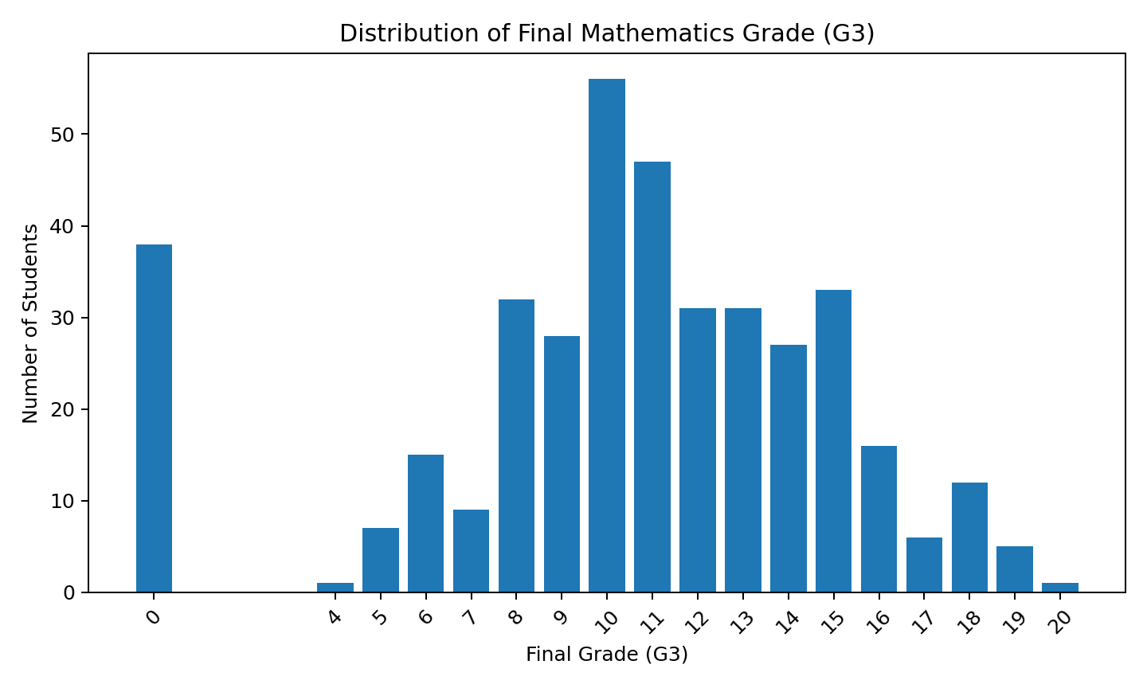
Figure 1. Distribution of G3 final Mathematics grades.
The most frequent final grade is 10, followed by 11 and 8. There are also 38 observations with a final grade of 0. The distribution is therefore not perfectly symmetric and contains a notable group at the zero grade.

5.3 Visualization 2 – Pass/Fail Distribution
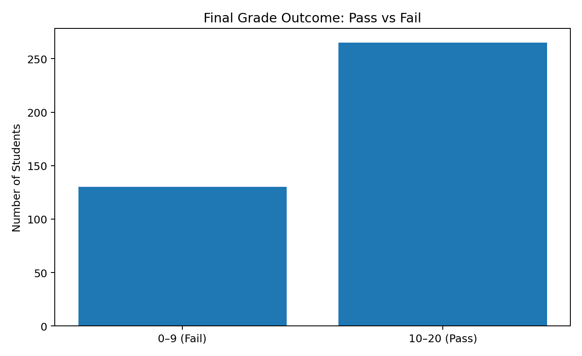
Figure 2. Students with G3 below 10 versus G3 of 10 or above.
Using a simple exploratory threshold of G3 ≥ 10, 265 students fall in the pass group and 130 fall below the threshold. This classification is used only to summarize the observed grades; the original UCI dataset defines G3 as a numeric final-grade target.

5.4 Visualization 3 – Going Out and Final Grade
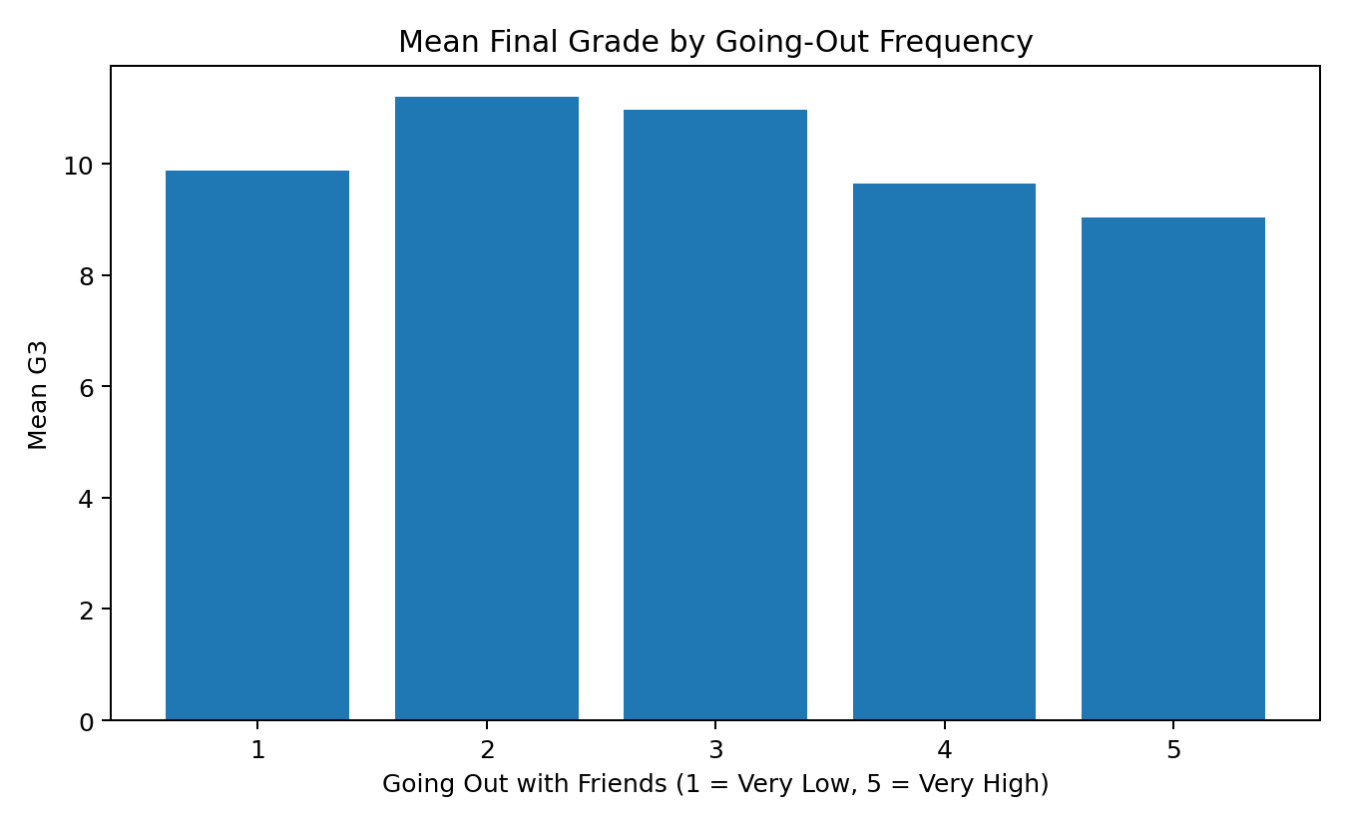
Figure 3. Mean G3 for each going-out frequency level.
The grouped means do not form a simple increasing pattern. The highest mean is observed at level 2, while the lowest is observed at level 5. This suggests that going-out frequency alone does not provide a straightforward linear explanation of final grades.

5.5 Visualization 4 – Weekend Alcohol Consumption and Final Grade
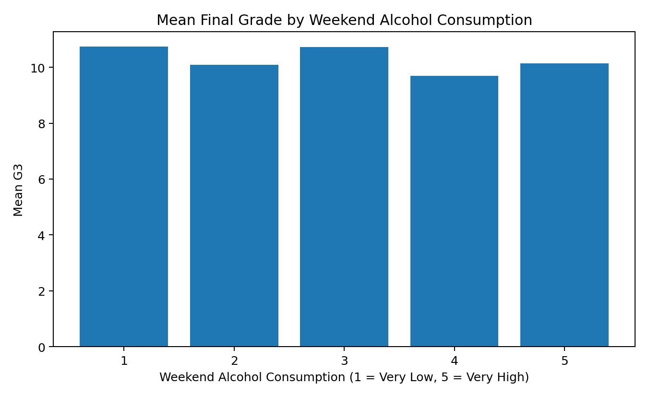
Figure 4. Mean G3 for each weekend alcohol-consumption level.
The group means also do not show a simple monotonic relationship. The mean grade is highest at level 1, very similar at level 3, and lower at level 4. Because this is observational data, these grouped differences should not be interpreted as causal effects.

5.6 Visualization 5 – Missing-Value Check
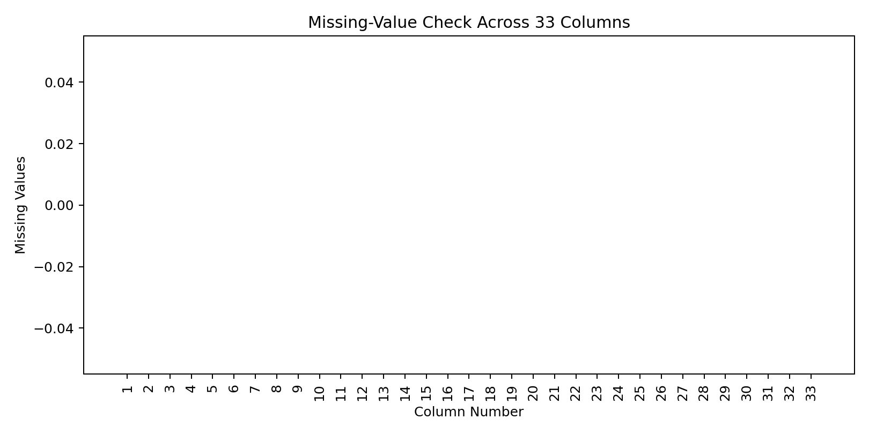
Figure 5. Missing values across all 33 columns.
Every column has zero missing values. This supports the decision not to perform imputation and preserves the original 395 observations.

6. Key Insights
- The Mathematics dataset contains 395 student records and 33 attributes.
- The data-quality checks identify no missing values and no duplicate rows, so no row-level deletion or imputation is required.
- Final Mathematics grades have a mean of approximately 10.42 and a median of 11.
- Grade 10 is the most common final-grade value, while 38 observations have G3 = 0.
- Using G3 ≥ 10 as an exploratory threshold gives 265 students in the pass group and 130 below the threshold.
- Going-out frequency shows a non-monotonic relationship with mean G3; the highest group mean occurs at level 2 and the lowest at level 5.
- Weekend alcohol-consumption groups also do not show a simple monotonic relationship with final grade.
- The UCI documentation notes that G3 has a strong correlation with G1 and G2. This is expected because G1 and G2 are earlier-period grades from the same course and should therefore be interpreted as closely related academic-performance variables rather than independent lifestyle factors.

7. Limitations
- The dataset represents students from two Portuguese schools, so the results should not automatically be generalized to all schools or countries.
- The analysis is exploratory and observational; grouped differences do not establish causation.
- G1 and G2 are strongly related to G3 by construction because they are earlier grades in the same course.
- The dataset is relatively small for broad population-level conclusions.
- Some variables are self-reported questionnaire measures and may contain reporting bias.

8. Reproducible Python Workflow
import pandas as pd
import matplotlib.pyplot as plt
import seaborn as sns
# Load
df = pd.read_csv("student-mat.csv", sep=";")
# Inspect
print(df.shape)
print(df.info())
print(df.describe())
# Quality checks
print(df.isna().sum())
print("Duplicate rows:", df.duplicated().sum())
# G3 distribution
df["G3"].value_counts().sort_index().plot(kind="bar")
plt.xlabel("Final Grade (G3)")
plt.ylabel("Number of Students")
plt.title("Distribution of Final Grade")
plt.show()
# Study-time EDA
print(df.groupby("studytime")["G3"].mean())
# Going-out EDA
print(df.groupby("goout")["G3"].mean())
# Weekend alcohol EDA
print(df.groupby("Walc")["G3"].mean())
# Correlation among academic grades
print(df[["G1", "G2", "G3"]].corr())
The code above is intentionally simple and aligned with the Week 1 learning objective. It demonstrates data acquisition, cleaning checks, descriptive statistics, grouped analysis, visualization and correlation analysis.

9. Conclusion
This Week 1 project demonstrates the essential data-preparation and exploratory-analysis stages of a data-science workflow. A public student-performance dataset was selected, its structure and quality were reviewed, and no missing or duplicate observations were found. Exploratory analysis of the final Mathematics grade showed meaningful variation in student outcomes. Additional grouped analyses showed that lifestyle-related variables such as going out and weekend alcohol consumption do not exhibit simple monotonic relationships with final grades.
The project provides a foundation for further work, such as statistical testing, feature engineering, visualization dashboards, or machine-learning models for predicting final performance. Any future predictive model should carefully consider the strong relationship between G1/G2 and G3 noted in the original UCI documentation.

10. YuvaIntern Submission Checklist
- Final DOCX report – completed.
- At least three visualizations – completed (five included).
- Data cleaning rationale – documented.
- Code snippets – included.
- Exploratory insights – included.
- Public dataset source – documented.
- GitHub URL – add your repository URL if you create/upload the project code, as requested by the YuvaIntern submission page for technical internships.

11. References
Cortez, P. (2008). Student Performance [Dataset]. UCI Machine Learning Repository. https://doi.org/10.24432/C5TG7T
UCI Machine Learning Repository. Student Performance dataset documentation, Dataset ID 320. https://archive.ics.uci.edu/dataset/320/student%2Bperformance
Public reproducibility sources were consulted to cross-check dataset dimensions, data-quality checks and selected EDA statistics used in this report.

