UNIVERSITY OF EMBU
Department of Computing and Information Technology
Bachelor of Science in Information Technology

FARMCONNECT:
A Mobile Application that Supports Small-Scale Farmers
with Farming Information and Planning Tools

Project Report submitted in partial fulfillment of the requirements
for the Bachelor of Science in Information Technology

2025 / 2026

DECLARATION
We, the undersigned, declare that this project report is our original work and has not been submitted for examination in any other university or institution.

Group Members:

Registration No. | B141/27517/2023
Name | Khisa Victor Wamalwa
Signature | ________________________
Date | ___________________

Registration No. | B141/28027/2023
Name | Bradon Wachira
Signature | ________________________
Date | ___________________

Registration No. | B141/27401/2023
Name | Denis Muriithi
Signature | ________________________
Date | ___________________

Registration No. | B141/24829/2022
Name | Josephat Maranga
Signature | ________________________
Date | ___________________

Supervisor:

Name | Dr. Victoria Mukami
Signature | ________________________
Date | ___________________

Head of Department:

Name | Dr. Faith Mueni
Department | Department of Computing and Information Technology
Signature | ________________________
Date | ___________________

DEDICATION

This project is dedicated to the smallholder farmers of Kenya,
whose daily commitment to feeding the nation inspires this work.
We also dedicate this to our families, whose unwavering support,
patience, and encouragement made this project possible.

— Khisa Victor, Bradon Wachira, Denis Muriithi, Josephat Maranga

ABSTRACT
FarmConnect is an Android mobile application designed to support small-scale farmers in Kenya by providing organized access to farming information, planning tools, and basic weather data. The application addresses a key challenge faced by rural smallholder farmers: the lack of a single, accessible platform that consolidates crop guidance, market prices, task reminders, livestock management, and weather forecasts in a format suitable for low-connectivity environments.

The application was developed using the Flutter framework and Dart programming language, targeting Android devices. All data is stored locally on the device using SharedPreferences, ensuring full functionality without an internet connection. Weather data is retrieved in real time from the Open-Meteo API and cached for offline access. Market price data is embedded within the application and reflects weekly Nairobi Wakulima wholesale averages across over 100 crop and livestock products.

Key features include user authentication, county-based farm setup, a 7-day weather forecast with farming advisories, a market price directory, crop and livestock tracking, task and vaccination reminders, an income and expense records system, an input cost calculator, a season planner, farming tips, and a community discussion board. The application supports both light and dark display modes and is designed to work reliably on low-end Android devices across all 47 Kenyan counties.

The project was completed within a 10-week development cycle and successfully deployed as an Android APK distributed via WhatsApp. Testing confirmed that all core features operate correctly in both online and offline conditions on physical Android devices.

ACKNOWLEDGEMENTS
We wish to express our sincere gratitude to the following people and institutions whose support made this project possible.

We thank our project supervisor, Dr. Victoria Mukami, for the guidance, technical direction, and feedback provided throughout the development process. Her insights significantly shaped the quality and direction of this work.

We are grateful to the Head of Department, Dr. Faith Mueni, and the entire Department of Computing and Information Technology at the University of Embu for providing an environment that supports applied software development projects.

We extend our appreciation to our fellow students and colleagues who participated in testing the application and provided valuable feedback during the development and refinement stages.

Finally, we thank our families for their patience, moral support, and encouragement throughout the duration of this project. Their belief in us sustained our motivation to complete this work to the best of our abilities.

TABLE OF CONTENTS

LIST OF FIGURES
Figure 1 — Sign In Screen
Figure 2 — Create Account Screen
Figure 3 — My Farm Counties — County Setup Screen
Figure 4 — Home / Dashboard Screen
Figure 5 — Market Prices Screen
Figure 6 — Weather Screen — 7-Day Forecast
Figure 7 — Farm Management — Crops Tab
Figure 8 — Add New Crop Dialog
Figure 9 — Farm Management — Livestock Tab
Figure 10 — Add Livestock Dialog with County Advice
Figure 11 — Farm Management — Tasks Tab
Figure 12 — Farm Management — Records Tab (Income/Expense)
Figure 13 — Farm Tools Hub Screen
Figure 14 — Season Planner Tool
Figure 15 — Input Cost Calculator Tool
Figure 16 — Community Screen
Figure 17 — Profile Screen — User Details and Settings
Figure 18 — Profile Screen — App Preferences
Figure 19 — Dark Mode — Profile Screen
Figure 20 — Notifications Panel

CHAPTER ONE: INTRODUCTION

1.1 Background to the Problem
Agriculture is the backbone of Kenya's economy, employing approximately 40 percent of the total population and contributing over 26 percent of GDP (Kenya National Bureau of Statistics, 2023). The majority of agricultural production is carried out by smallholder farmers who cultivate plots of less than five acres. Despite their central role in food production, these farmers frequently operate with limited access to timely, organized, and relevant farming information.

Challenges commonly faced by small-scale farmers in Kenya include difficulty accessing current market prices before making selling decisions, lack of knowledge about optimal planting times for specific counties and seasons, poor record-keeping of farm income and expenses, difficulty tracking livestock health and vaccination schedules, and limited awareness of weather conditions that affect farming decisions. While smartphones have become increasingly affordable and accessible in rural Kenya, most agricultural information tools either require consistent internet connectivity, are designed for large commercial operations, or present information in formats unsuitable for farmers with limited digital literacy.

The widespread adoption of Android smartphones across rural Kenya, combined with the availability of free public APIs such as Open-Meteo for weather data, presents an opportunity to develop a lightweight, offline-capable mobile application that addresses these gaps in a single integrated platform.

1.2 Statement of the Problem
Farmers find it difficult to manage farming activities due to limited access to organized agricultural information. Specifically, there is no single accessible mobile tool that combines crop guidance, market prices, weather forecasts, task reminders, and livestock management in a format that works reliably on low-end Android devices in areas with limited or intermittent internet connectivity.

Existing applications either require continuous internet access, are not localized to Kenya's 47 county farming contexts, or charge subscription fees that are prohibitive for smallholder farmers. This results in fragmented information-seeking behavior, poor planning, missed market opportunities, and suboptimal farm management decisions.

1.3 Objectives of the Study

1.3.1 General Objective
To design, develop, and deploy a mobile application that consolidates essential farming information and planning tools for small-scale farmers in Kenya.

1.3.2 Specific Objectives
- To design and develop the FarmConnect mobile application that provides small-scale farmers with basic farming information, including planting times and crop care guidelines, within the first 8 weeks of the project.
- To implement planting reminders and basic weather update features in the FarmConnect application to support improved farm planning for small-scale farming by the end of the 10th week of the project.
- To test and deploy the application as an Android APK distributable via WhatsApp, enabling farmers to install and use the application without access to the Google Play Store.

1.4 Significance of the Study
FarmConnect directly addresses the information gap experienced by Kenya's approximately 7.5 million smallholder farming households. The application's significance can be understood across several dimensions:

- Economic impact: By providing real-time Nairobi Wakulima market prices for over 100 crop and livestock products, the application empowers farmers to make informed decisions about when and where to sell, potentially improving their income.
- Planning improvement: The county-aware season planner and planting advice tools help farmers align their activities with optimal growing conditions for their specific location, reducing crop failure risk.
- Offline capability: The application's design for low-connectivity environments ensures that farmers in areas with poor internet access can still benefit from all core features using locally cached data.
- Livestock management: Vaccination tracking and scheduling features help farmers prevent livestock disease losses, which represent a significant source of income loss for pastoral and agro-pastoral communities.
- Educational value: The integrated farming tips library, drawing on Kenya Agricultural and Livestock Research Organization (KALRO) guidelines, provides accessible knowledge to farmers who may lack formal agricultural training.

CHAPTER TWO: LITERATURE REVIEW

2.1 Introduction
This chapter reviews existing mobile applications and digital tools developed to support smallholder farmers, with particular attention to systems deployed in Sub-Saharan Africa and Kenya specifically. The review identifies gaps in existing solutions that FarmConnect seeks to address.

2.2 Existing Agricultural Mobile Applications

2.2.1 iShamba (Safaricom / The Coca-Cola Company)
iShamba is a Kenya-based agricultural advisory service delivered through USSD, SMS, and a mobile application. It provides crop and livestock advice, market prices, and weather information. Users can send queries to agricultural experts and receive responses. The service has been widely adopted in Kenya, reaching over 1 million farmers according to Safaricom's published figures.

While iShamba is effective at connecting farmers with expert advisors, it relies heavily on SMS and data connectivity for its advisory services. Its market price information is updated periodically rather than being pulled from live wholesale markets. The application does not provide farm management tools such as crop tracking, task reminders, or income and expense records. FarmConnect differs by offering a fully integrated farm management system that works offline using locally stored data, without requiring expert interaction for standard information queries.

2.2.2 Farmbook (Food and Agriculture Organization)
Farmbook is a digital farm record-keeping application developed by the Food and Agriculture Organization (FAO) of the United Nations. It is designed for smallholder farmers in low- and middle-income countries and allows users to record crop activities, yields, expenses, and income. The application is available for Android and is designed to work offline.

Farmbook focuses primarily on record-keeping and does not include weather information, market prices, livestock management, or planning tools such as season planners and input cost calculators. Its interface, while functional, is not localized to Kenyan county-level agriculture. FarmConnect extends beyond record-keeping by integrating seven distinct modules — weather, market, farm management, tools, community, and notifications — all localized to Kenya's 47 counties and their specific farming contexts.

2.2.3 DigiFarm (Safaricom)
DigiFarm is a mobile-based platform that provides Kenyan smallholder farmers with access to agricultural inputs, credit, crop insurance, and market linkages. It operates primarily through a mobile application and USSD and has reached millions of farmers across Kenya.

DigiFarm focuses on financial services and input procurement rather than information and planning. It does not provide weather data, crop tracking, livestock management, or an educational farming tips library. Additionally, DigiFarm requires smartphone internet access for most functions and ties farmers to specific financial and insurance products. FarmConnect is positioned as a free, open, offline-capable information and planning tool that complements services like DigiFarm rather than competing with them.

2.2.4 WeFarm
WeFarm is a peer-to-peer SMS-based knowledge sharing network that allows farmers to ask questions and receive answers from other farmers globally. It has been used extensively in Kenya and Uganda. The service operates via SMS, making it accessible even without a smartphone.

WeFarm's strength lies in community knowledge sharing, but it does not provide structured farming information, market prices, weather data, or any form of farm management record-keeping. Response quality depends on community participation and can be inconsistent. FarmConnect addresses this by providing curated, expert-sourced information through its Farming Tips library and structured planning tools, while also including a community discussion feature for peer knowledge sharing.

2.3 Summary of Gaps Addressed by FarmConnect
The review of existing systems reveals a consistent gap: no single application provides the full combination of offline capability, Kenya-specific county localization, integrated farm management (crops, livestock, tasks, records), live weather data with farming advisories, real market prices, and educational tools in a single free application. FarmConnect is designed to fill this gap by integrating all these features into a lightweight, offline-capable Android application distributed at no cost to farmers.

CHAPTER THREE: SUMMARY, CONCLUSIONS AND RECOMMENDATIONS

3.1 Summary
FarmConnect was developed over a 10-week project cycle as a final-year group project at the University of Embu. The application was built using the Flutter framework and Dart programming language, targeting Android devices running Android 5.0 and above. The development process involved requirements analysis, system design, iterative feature implementation, testing on physical Android devices, and deployment as an APK distributed via WhatsApp.

The completed application includes seven main modules accessible through a bottom navigation bar: Home/Dashboard, Market Prices, Weather, Farm Management, Tools, Community, and Profile. All user data is stored locally using SharedPreferences, making the application fully functional without internet access. Weather data is fetched from the Open-Meteo API and cached for offline use. The application was tested by group members and shared with selected farmers for feedback.

Key technical achievements include the implementation of a county-aware planting advice system covering 47 Kenyan counties, a vaccination schedule and reminder system for 15 livestock types, a season planner that maps crop suitability to county and month, an input cost calculator with projected profit estimates, and a comprehensive market price directory sourced from Nairobi Wakulima market surveys.

3.2 Conclusions
The project successfully achieved its stated objectives. FarmConnect demonstrates that it is technically feasible to build a comprehensive, offline-capable agricultural information and farm management application using Flutter and free public APIs, within a 10-week development timeline, at no cost to end users.

The application performs reliably on physical Android devices across both Wi-Fi and mobile data connections. The offline mode correctly serves cached data when connectivity is unavailable. Dark mode and light mode themes render consistently across all screens. The APK distribution model via WhatsApp proved effective for reaching users without Play Store access.

The localization of information to Kenya's 47 counties — particularly for the season planner, planting advice, and livestock suitability features — represents a significant value addition over generic agricultural applications and directly addresses the stated problem of limited access to organized, location-relevant farming information.

3.3 Challenges Encountered
- Connectivity detection on Android: Initial implementations of the offline connectivity check used HTTP requests to Google servers (gstatic.com), which are frequently blocked by Kenyan mobile carriers including Safaricom and Airtel. This caused the offline banner to appear even when the device was connected to Wi-Fi. The solution was to replace the HTTP-based check with the Open-Meteo weather API endpoint using real Nairobi coordinates, such that a successful weather fetch confirms connectivity. The INTERNET permission also had to be explicitly declared in the Android Manifest file, which had been omitted in early builds.
- Dark mode consistency: Flutter does not automatically propagate theme changes to modal bottom sheets and date picker dialogs opened from top-level functions outside the widget tree. This required explicit Theme.of(context).brightness checks inside each dialog and date picker builder to conditionally apply light or dark ColorScheme values.
- Notification persistence: The initial implementation of the Clear All notifications feature cleared the in-memory notification list but did not persist the cleared state to SharedPreferences. On the next screen visit, _loadNotifications() would rebuild the list from active tasks and crops, causing cleared notifications to reappear. This was resolved by saving a user-specific cleared timestamp to SharedPreferences and filtering notifications by comparing due dates against that timestamp.
- Pattern matching in Python fix scripts: During development, several fix scripts applied using Python's str.replace() method failed to match patterns due to Windows CRLF line endings in the Dart source files, while the Python script used Unix LF line endings for multi-line string literals. This was resolved by ensuring that Python's read_text() normalization was leveraged correctly and that multi-line patterns were constructed with explicit newline characters matching the file's normalized line ending format.
- APK size and distribution: The release APK was approximately 18-25 MB in size. Direct distribution via WhatsApp required recipients to enable installation from unknown sources on their Android devices, which added friction to the onboarding process for less technically experienced farmers.

3.4 Recommendations
- Backend integration: A future version of FarmConnect should implement a lightweight backend server to enable real-time market price updates fetched from live Kenyan market data sources such as the National Cereals and Produce Board (NCPB) or Jumia Food. This would replace the currently static hardcoded price data.
- Community synchronization: The community discussion board currently stores posts locally on each device, meaning posts are not visible to other users. A cloud-synchronized version would greatly enhance the value of the community feature by enabling genuine peer knowledge exchange between farmers.
- Google Play Store publication: Publishing FarmConnect on the Google Play Store would eliminate the need for users to enable unknown sources installation and would provide a more secure and accessible distribution channel. This requires a one-time developer account registration fee of USD 25.
- Farmer onboarding tutorial: An interactive first-launch tutorial that walks new users through adding their first crop, checking weather, and exploring market prices would improve adoption among farmers with limited smartphone experience.
- Multi-language support: Adding Swahili language support would significantly increase accessibility for farmers who are more comfortable reading in Swahili than English.
- Expanded crop and livestock database: The current database covers 47 crop types and 15 livestock categories. Expanding this to include more crop varieties and regional livestock breeds would increase the application's relevance to farmers in specialized agricultural zones such as the flower-growing regions of Nyandarua and the tea-growing areas of Kericho.

CHAPTER FOUR: USER MANUAL

4.1 System Requirements
FarmConnect is designed to run on any Android smartphone running Android 5.0 (Lollipop) or later. No internet connection is required for most features. Weather data requires an active data or Wi-Fi connection for initial loading and caching. The application occupies approximately 25 MB of storage space. No Google account or Play Store access is needed — the application is distributed as an APK file.

To install from an APK file, users must enable installation from unknown sources on their device. This can be done by going to Settings, then Apps or Security, then Special App Access, then Install Unknown Apps, and selecting Allow for the application used to open the APK (such as WhatsApp, Chrome, or Files).

4.2 Getting Started

4.2.1 Sign In and Create Account
When FarmConnect is launched for the first time, the authentication screen is displayed. New users should tap Create Account and fill in their full name, phone number, password, and confirm their password, then tap Create Account. Existing users tap Sign In, enter their registered phone number and password, and tap Sign In to access the application.

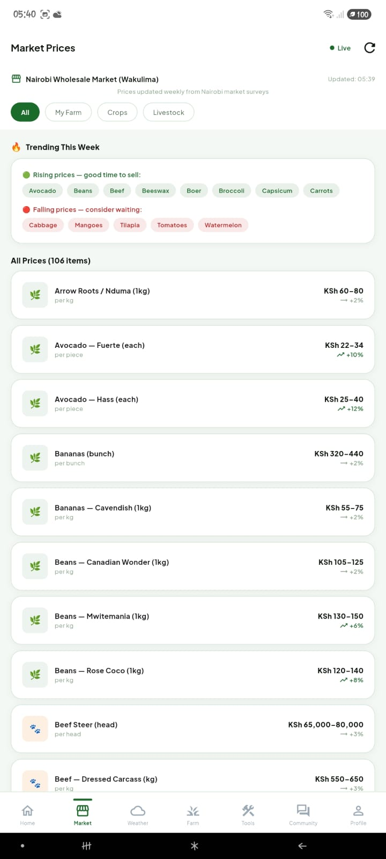 | 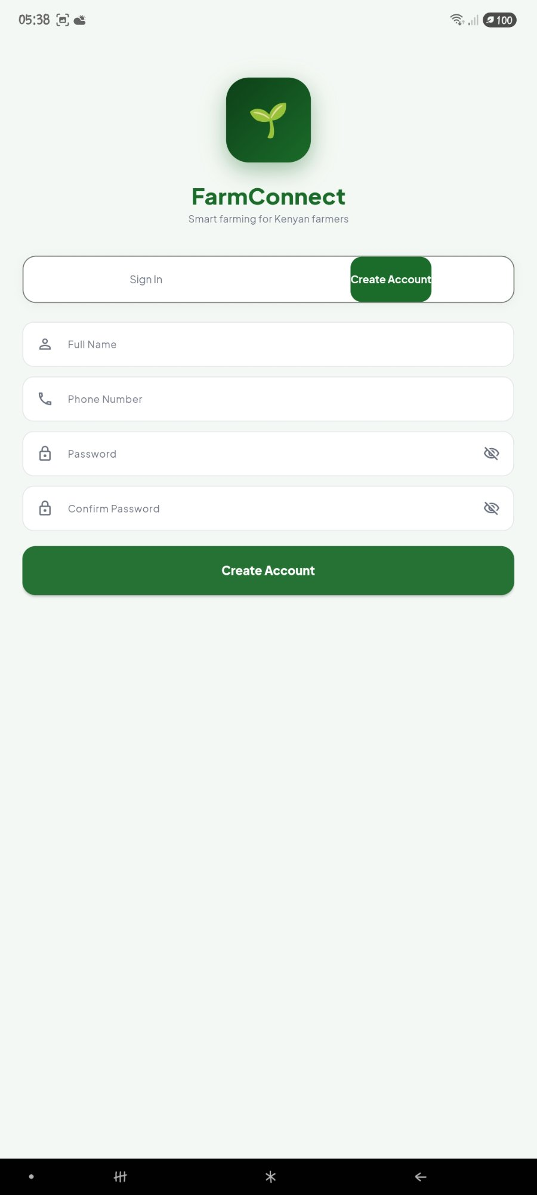
Figure 1: Sign In Screen | Figure 2: Create Account Screen

4.2.2 County Setup
After creating a new account, users are taken to the My Farm Counties screen. This screen displays all 47 Kenyan counties in a searchable grid. Users should select all counties where they farm or plan to farm. At least one county must be selected. The county selection personalises the weather forecasts, season planner, and planting advice throughout the application. County selections can be updated at any time through the Profile screen.

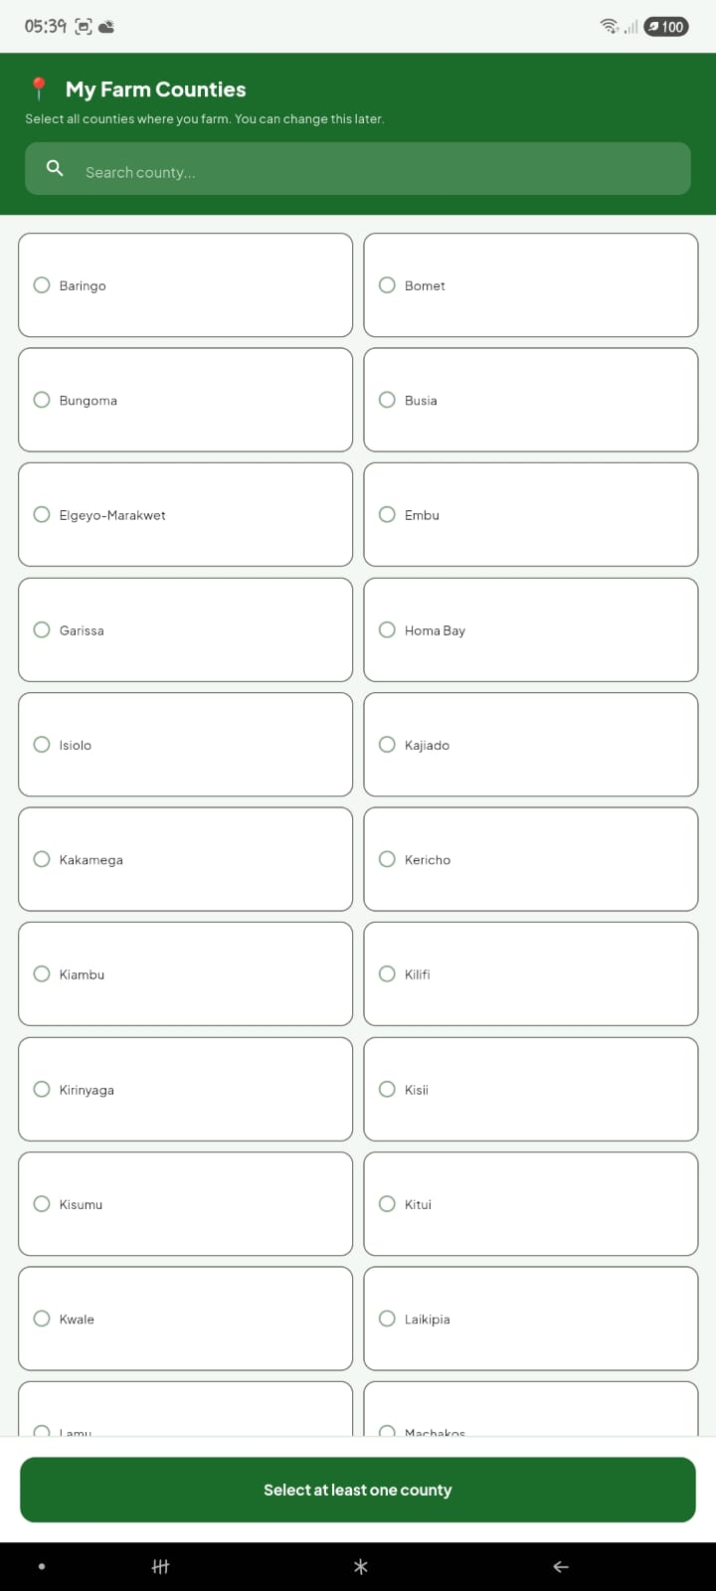
Figure 3: My Farm Counties — County Selection Screen

4.3 Home Screen
The Home screen is the main dashboard and the first screen displayed after sign-in. It provides a personalised greeting, a Farm Overview grid showing six key statistics, quick action buttons, a Reminders section showing tasks due within the next three days, and an Upcoming Harvests section showing crops approaching their expected harvest date.

The Farm Overview grid displays: Revenue (total income recorded), Expenses (total expenses recorded), Active Crops (crops currently being tracked), Livestock (total animals registered), Farm Area (total area in acres across all crops), and Pending Tasks (incomplete tasks). Quick action buttons — Add Crop, Add Task, and Add Record — provide shortcuts to the most frequently used actions.

The notification bell icon in the top-right corner opens the notifications panel when tapped. A red dot on the Home tab in the bottom navigation bar indicates there are pending notifications. Users can tap Clear All to dismiss all current notifications permanently.

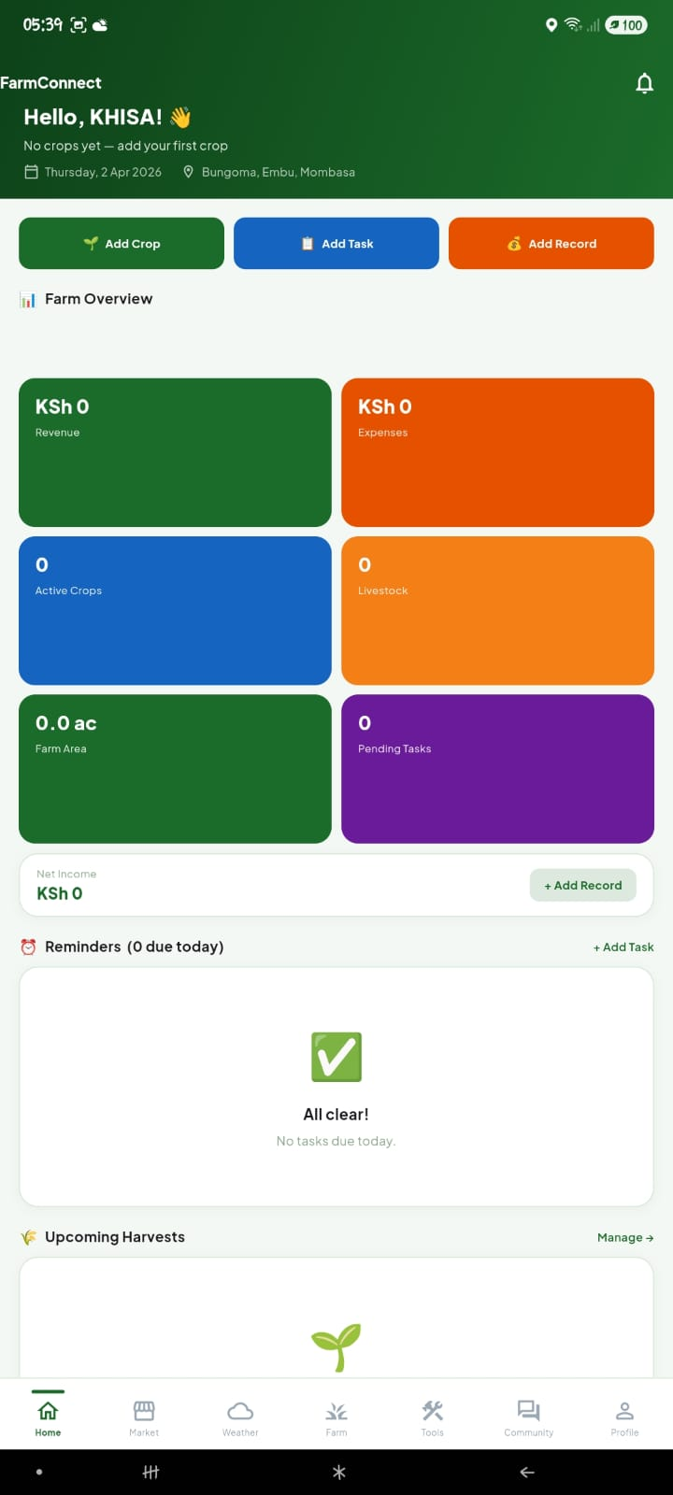
Figure 4: Home Screen — Farm Dashboard

4.4 Market Prices
The Market Prices screen displays current wholesale prices from the Nairobi Wakulima Market for over 100 agricultural products including crops, fruits, vegetables, and livestock products. Prices are displayed with trend indicators showing whether each item's price is rising, stable, or falling compared to the previous week.

The screen is filterable using four tabs at the top: All (shows all 106 items), My Farm (shows only prices relevant to the farmer's registered crops and livestock), Crops (shows crop prices only), and Livestock (shows livestock and animal product prices only). A Trending This Week section highlights products with the strongest upward and downward price movements, helping farmers identify selling opportunities.

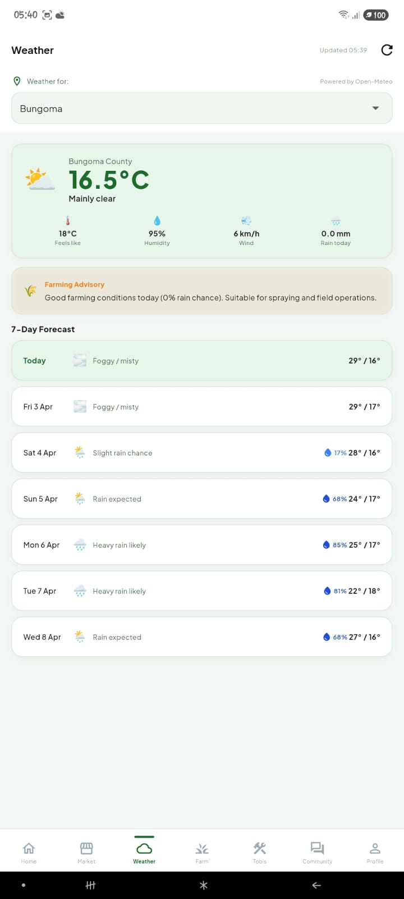
Figure 5: Market Prices Screen — Nairobi Wakulima Wholesale

4.5 Weather
The Weather screen displays current weather conditions and a 7-day forecast for the farmer's selected county. Weather data is fetched from the Open-Meteo API, which provides free, accurate weather data for any location without requiring an API key. Data is cached to the device so the most recently loaded forecast remains accessible when internet is unavailable.

The current conditions card shows temperature in Celsius, a weather condition description, feels-like temperature, humidity percentage, wind speed in km/h, and today's rain total in millimetres. A Farming Advisory section provides a context-specific recommendation based on current conditions, such as whether it is suitable for spraying, irrigation, or field work. The 7-day forecast shows daily high/low temperatures, weather conditions, and rain probability percentages.

The county selector dropdown at the top allows users to switch the forecast between their registered counties. The refresh button in the top-right corner forces a fresh data fetch from the API.

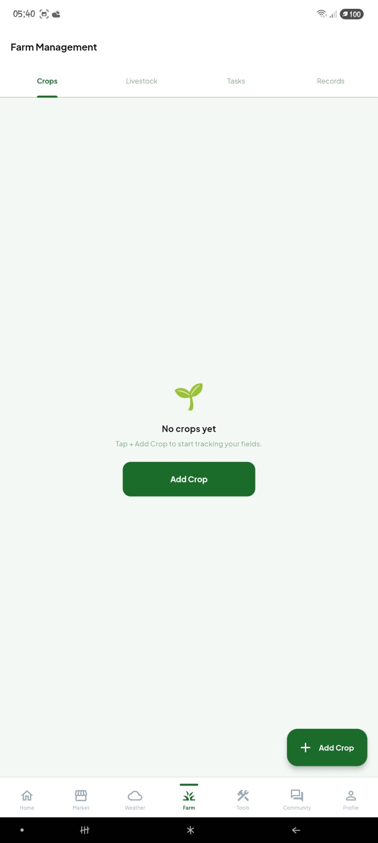
Figure 6: Weather Screen — 7-Day Forecast and Farming Advisory

4.6 Farm Management
The Farm Management screen is divided into four sub-tabs: Crops, Livestock, Tasks, and Records. This is the core farm record-keeping section of the application.

4.6.1 Crops Tab
The Crops tab displays all crops currently being tracked by the farmer. Each crop card shows the crop name, variety, field name, county, area in acres, planted date, expected harvest date, and days remaining to harvest. Crops can be added by tapping the green Add Crop button or the floating action button.

When adding a new crop, users select the Crop Type from a dropdown list of 47 Kenyan crop types, choose the specific Variety, name the Field, select the County, enter the Area in acres, and set the Planted Date. A Planting Advice card automatically appears below the planted date showing whether the current date is a good time to plant the selected crop in the selected county, along with location-specific farming tips. The Days to Harvest field is pre-populated with the typical harvest duration for the selected crop.

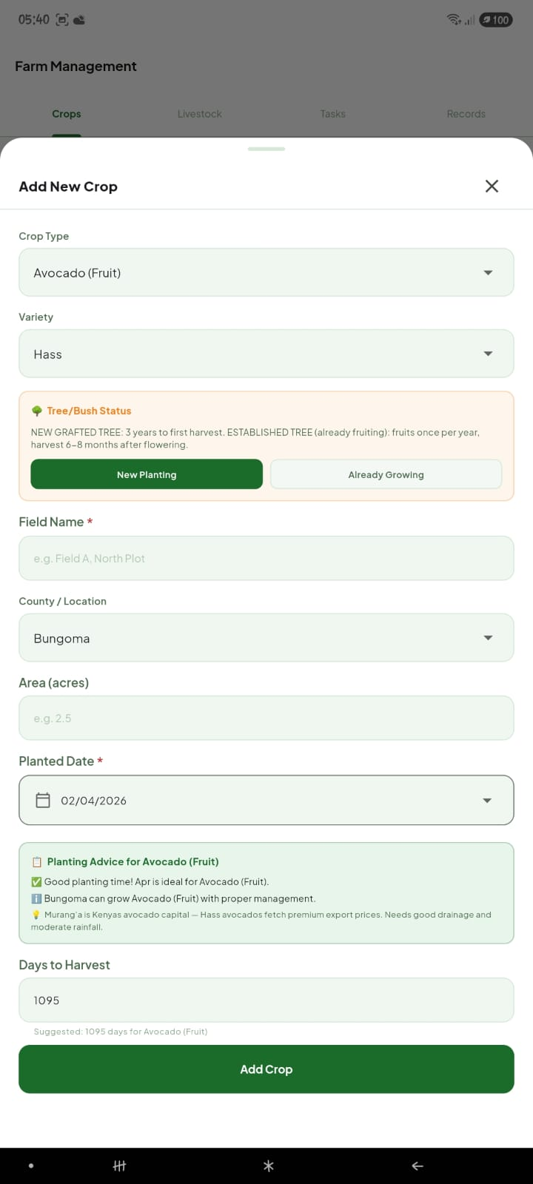 | 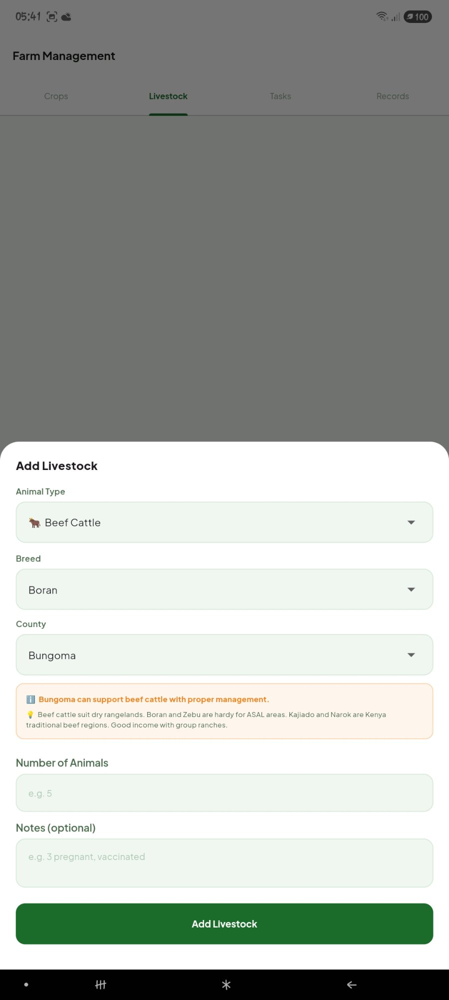
Figure 7: Crops Tab — No Crops Added Yet | Figure 8: Add New Crop Dialog with Planting Advice

4.6.2 Livestock Tab
The Livestock tab tracks all animals on the farm. Each livestock card shows the animal type, breed, count, and registered notes. Tapping a livestock card opens the Vaccination dialog, which shows the animal's vaccination history and allows recording of new vaccinations with the vaccine name, date given, next due date, and notes.

When adding livestock using the Add Livestock button, users select the Animal Type, Breed, and County. A County Suitability Advice card appears automatically, indicating whether the selected animal type is well-suited, moderately suited, or not recommended for the selected county, along with specific guidance. Users then enter the number of animals and any notes.

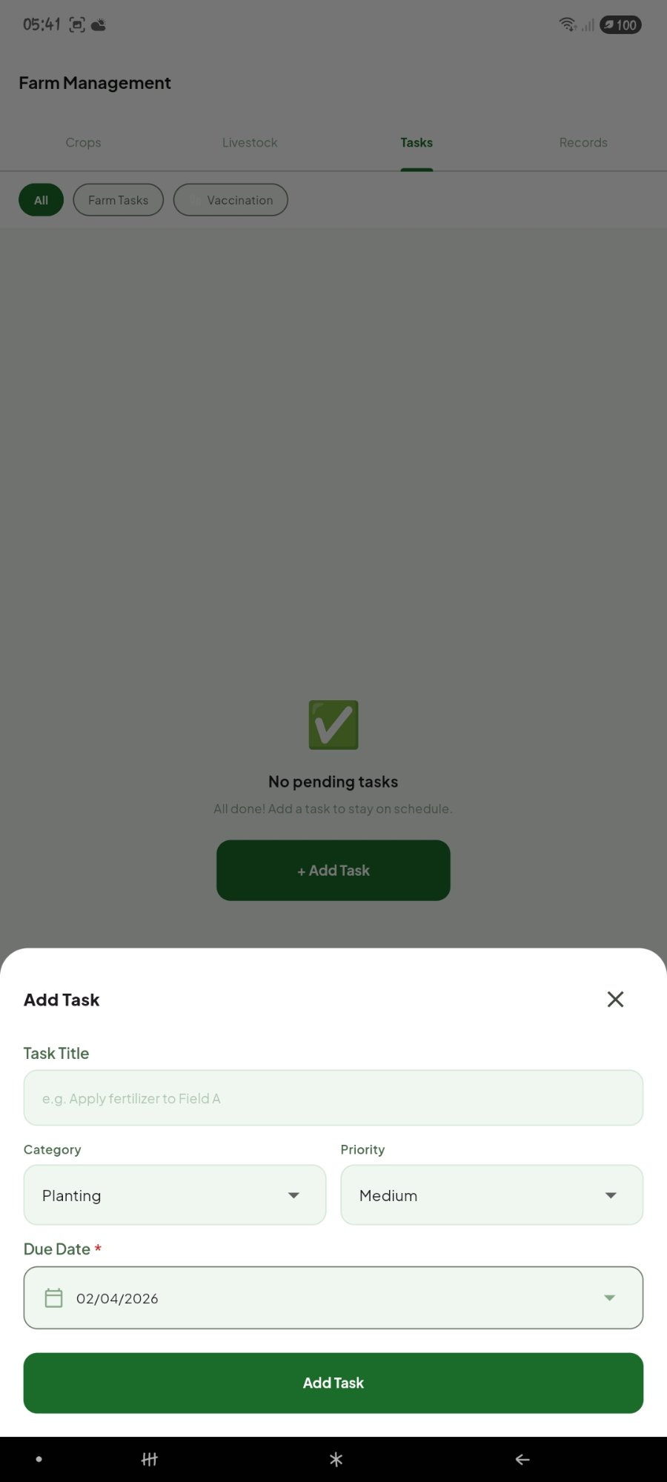 | 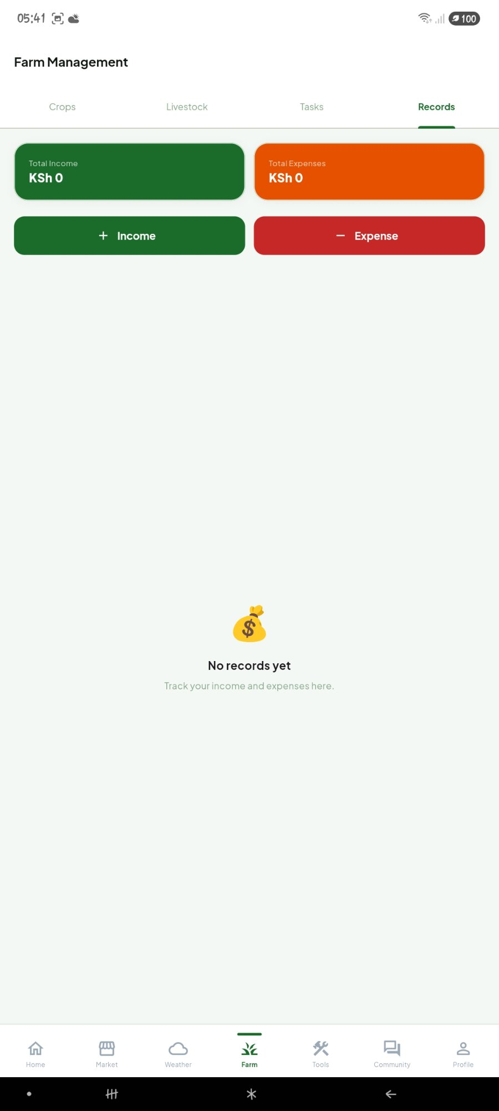
Figure 9: Livestock Tab | Figure 10: Add Livestock Dialog with County Advice

4.6.3 Tasks Tab
The Tasks tab provides a to-do list for farm activities. Tasks can be categorised as Planting, Spraying, Irrigation, Harvesting, Fertilizing, Weeding, Vaccination, or General. Each task has a title, category, priority level (High, Medium, or Low), and due date. Tasks can be filtered by All, Farm Tasks, or Vaccination. Tapping the Done button on a task marks it as complete and removes it from the active list.

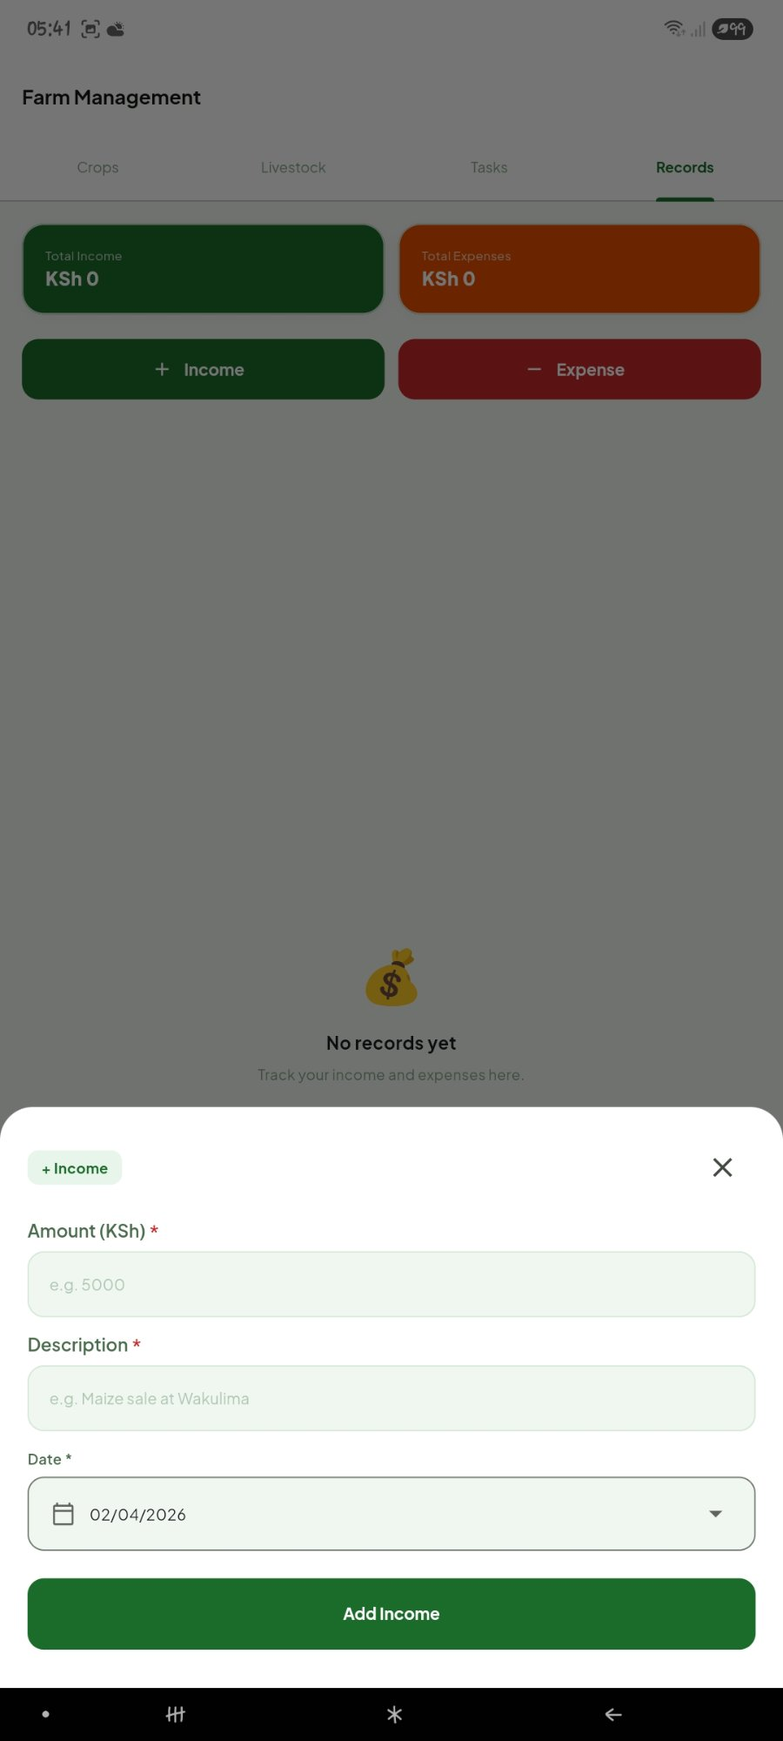
Figure 11: Tasks Tab — Add Task Dialog

4.6.4 Records Tab
The Records tab tracks farm income and expenses. The summary bar at the top shows Total Income and Total Expenses. Users can add income entries by tapping the green Income button, entering an amount, description, date, and optionally linking the record to a specific crop. Expense entries are added through the red Expense button with the same fields. Records can be deleted by tapping the delete icon on each entry.

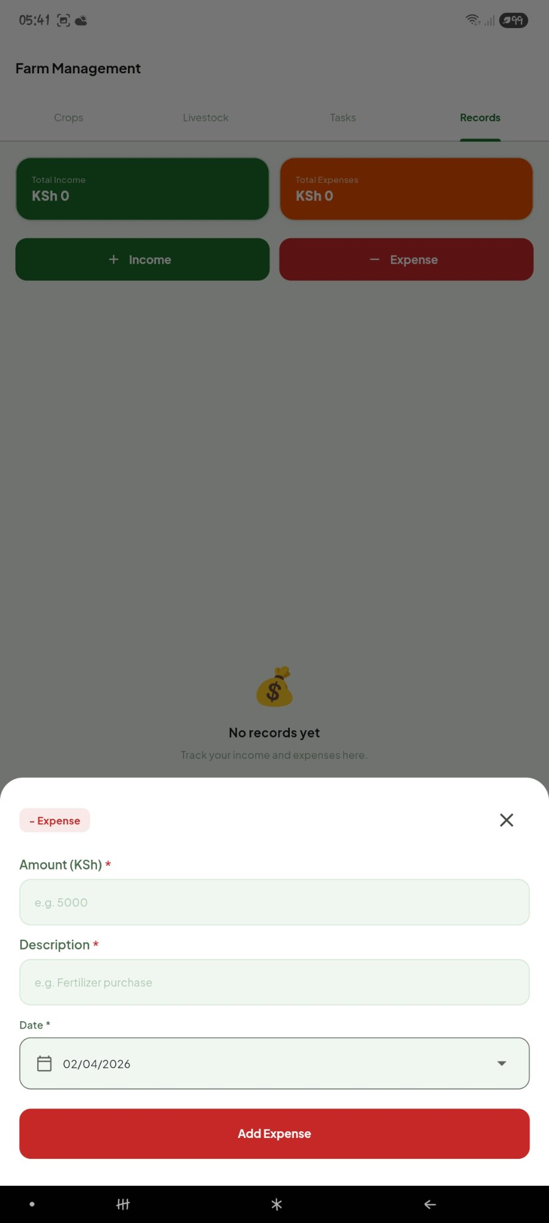 | 
Figure 12: Records Tab — Income Entry | Figure 12: Records Tab — Expense Entry

4.7 Farm Tools
The Farm Tools screen provides three planning and reference tools: Input Cost Calculator, Season Planner, and Farming Tips.

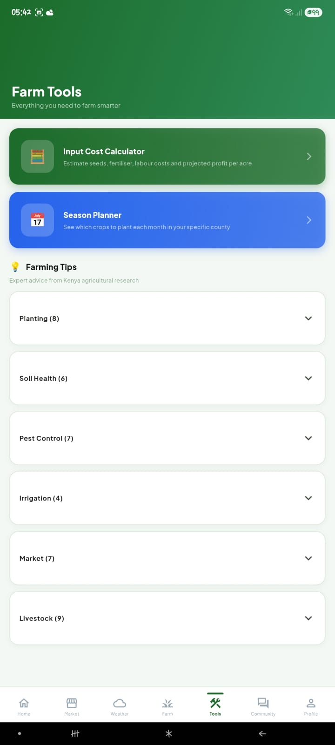
Figure 13: Farm Tools Hub Screen

4.7.1 Season Planner
The Season Planner shows which crops are suitable for planting in a given month in a given county. Users select a month using the horizontal scrollable tab bar at the top, then select a county from the dropdown. The planner displays three categories: Plant Now (ideal timing), Can Plant (acceptable but not peak season), and Avoid (wrong time or wrong county for this crop). This tool helps farmers align their planting decisions with optimal growing conditions.

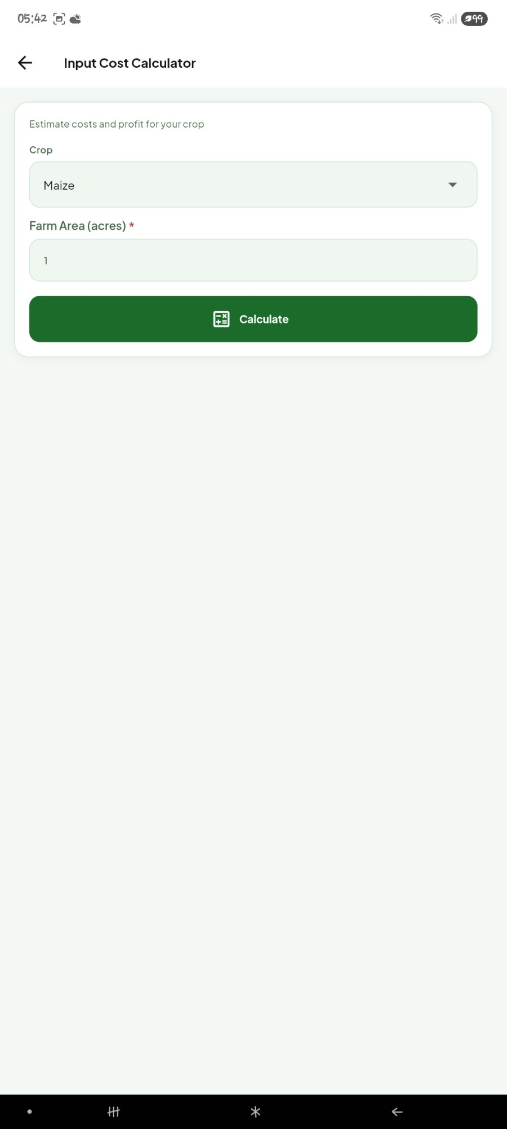
Figure 14: Season Planner — April Planting Calendar for Nakuru County

4.7.2 Input Cost Calculator
The Input Cost Calculator allows farmers to estimate the cost of producing a crop per acre. Users select the crop type and enter the farm area in acres, then tap Calculate. The calculator returns estimated costs for seeds, fertiliser, labour, and other inputs, along with a projected revenue estimate based on current market prices and a projected profit or loss figure. This helps farmers assess whether a planned crop is economically viable before committing resources.

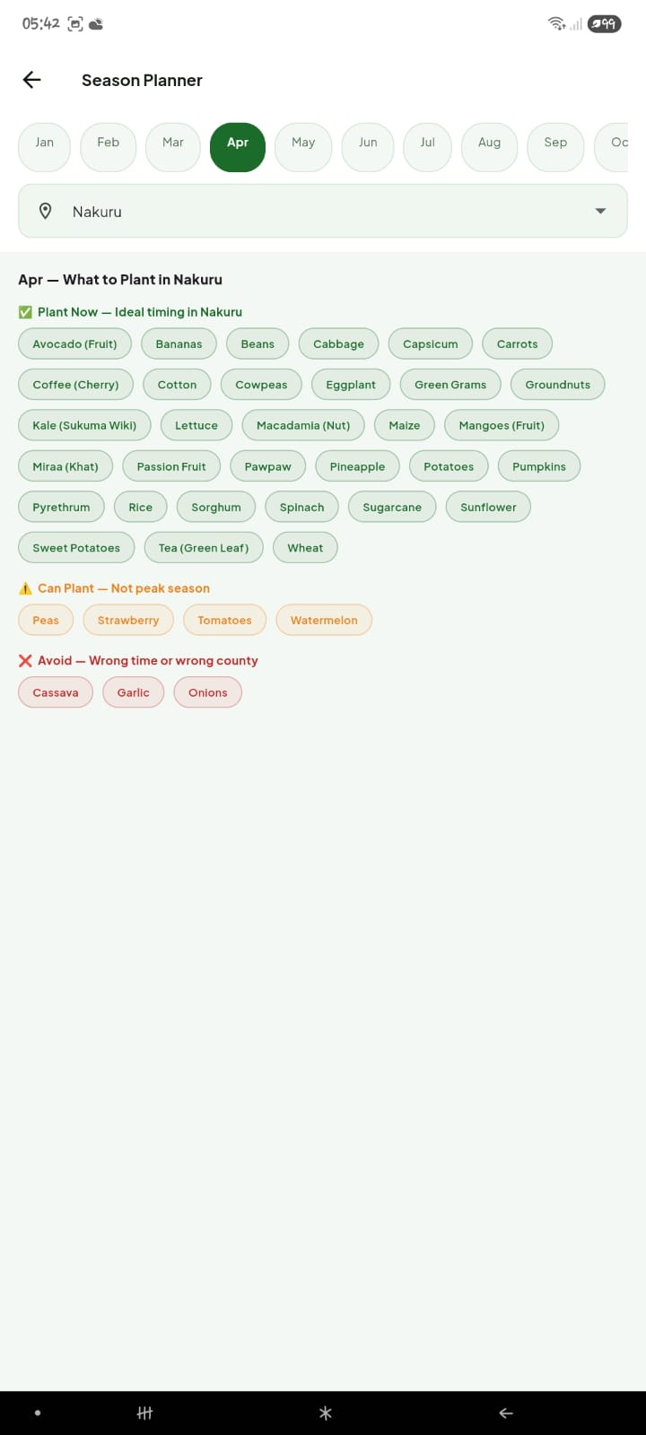
Figure 15: Input Cost Calculator

4.7.3 Farming Tips
The Farming Tips section provides an expandable library of agricultural guidance organised into six categories: Planting, Soil Health, Pest Control, Irrigation, Market, and Livestock. Each category contains between 4 and 9 individual tips sourced from Kenya Agricultural and Livestock Research Organization (KALRO) guidelines and best practices. Users tap a category header to expand or collapse its tips.

4.8 Community
The Community screen is a local discussion board where users can post questions, share farming tips, and discuss agriculture-related topics. Posts can be tagged by category: Crops, Livestock, Market, Weather, or General. Users tap the pencil icon in the top-right corner to write a new post, selecting a category and writing their message. Other users can like posts and add replies. The community board stores posts locally on the device in the current version.

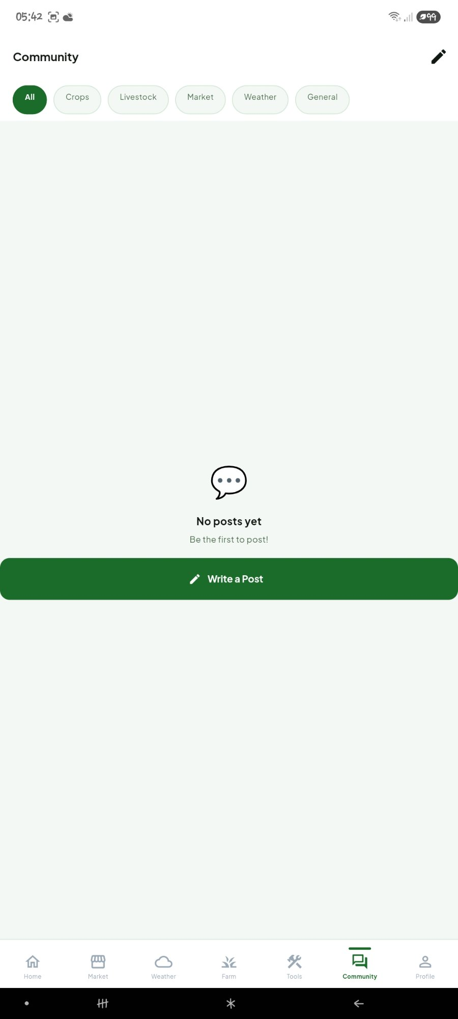
Figure 16: Community Screen — Discussion Board

4.9 Profile
The Profile screen displays the user's account information including their name, registered phone number, and selected counties. It also shows a summary grid of their farm statistics: total crops, livestock, tasks, area, revenue, and net income. The Quick Actions section provides shortcuts to the Farm, Tasks, and Records screens.

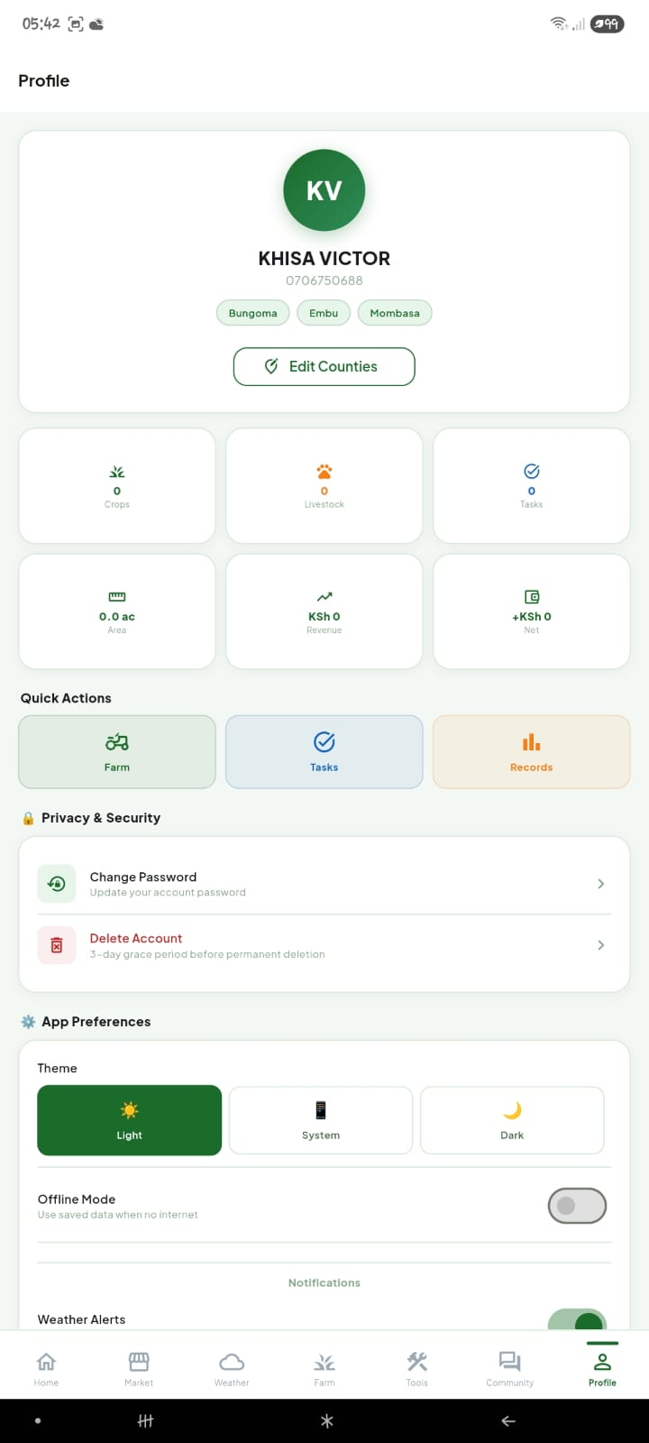 | 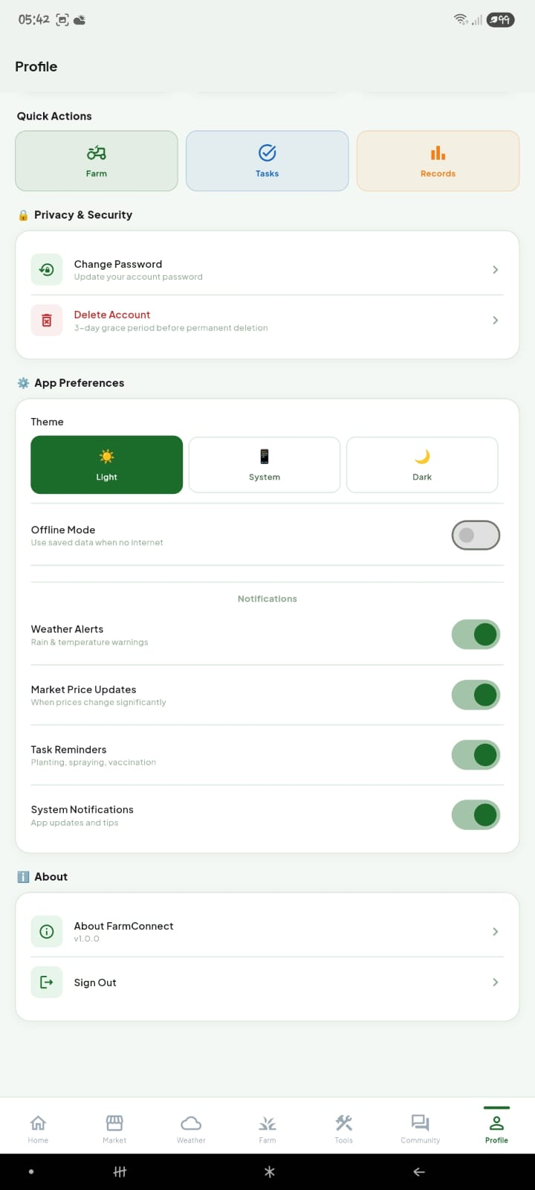
Figure 17: Profile Screen — User Information and Stats | Figure 18: Profile Screen — App Preferences and Settings

4.9.1 Privacy and Security
The Change Password option allows users to update their account password by entering their current password and a new password. The Delete Account option initiates a 3-day grace period deletion process, during which the account can be recovered by logging in again. After 3 days, the account and all associated data are permanently removed.

4.9.2 App Preferences
The Theme selector allows users to choose between Light, System (follows the device's system theme setting), and Dark display modes. The Offline Mode toggle, when enabled, prevents the application from making any network requests and serves all data from locally cached sources. Notification preferences allow users to individually enable or disable Weather Alerts, Market Price Updates, Task Reminders, and System Notifications.

4.10 Dark Mode
FarmConnect supports a full dark theme that can be activated through the Profile screen by selecting Dark under Theme. In dark mode, all screens, dialogs, date pickers, dropdown menus, and popup cards switch to a dark green color palette that reduces eye strain in low-light conditions. The dark theme is particularly useful for farmers who use the application in early morning or evening hours.

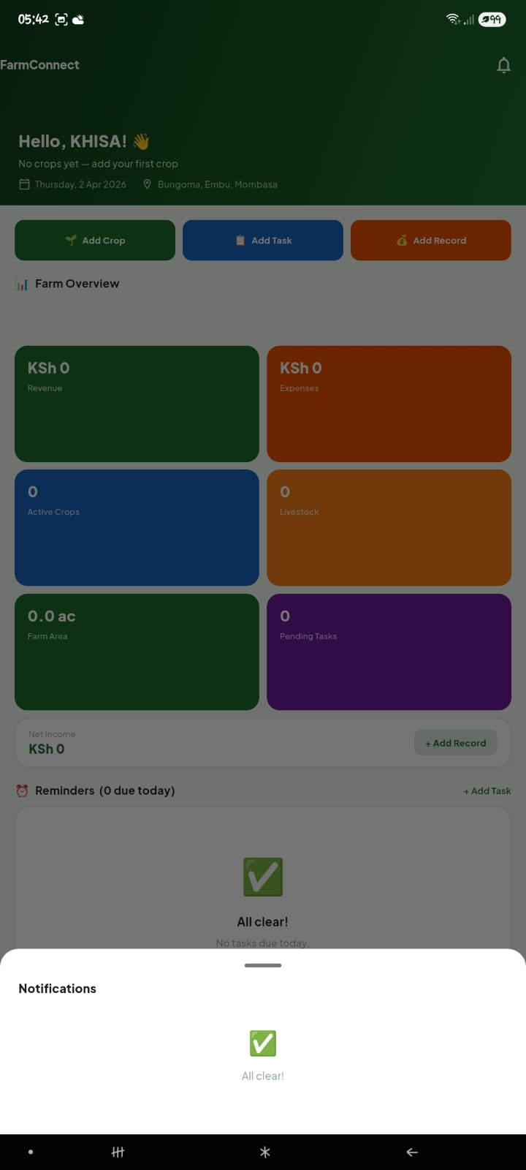
Figure 19: Dark Mode — Profile Screen

4.11 Notifications
FarmConnect generates in-app notifications for tasks due within the next 3 days, crops approaching their harvest date, and system alerts. Notifications are accessible by tapping the bell icon in the Home screen header. A red dot on the Home tab in the bottom navigation bar indicates unread notifications. Tapping Clear All permanently dismisses all current notifications; dismissed notifications do not reappear.

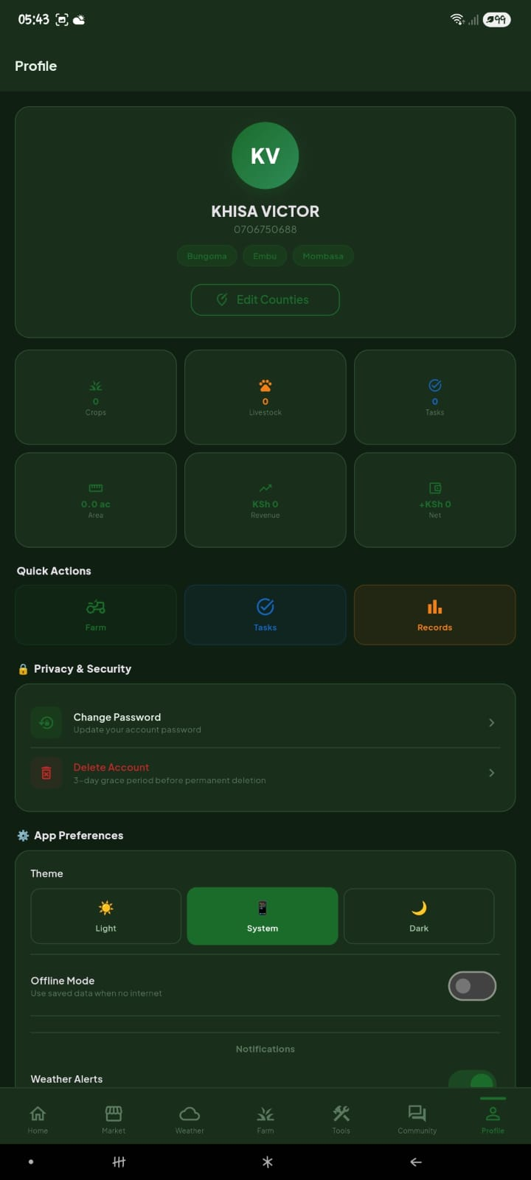
Figure 20: Notifications Panel — Bell Icon View

REFERENCES
Abegunde, V. O., Adekunle, A. A., & Olutayo, A. A. (2020). Digital tools for smallholder farmers in sub-Saharan Africa: A review of mobile and web-based applications. African Journal of Agricultural Research, 15(3), 287–299. https://doi.org/10.5897/AJAR2019.14425

Deichmann, U., Goyal, A., & Mishra, D. (2016). Will digital technologies transform agriculture in developing countries? Agricultural Economics, 47(S1), 21–33. https://doi.org/10.1111/agec.12300

Food and Agriculture Organization of the United Nations. (2021). Farmbook: Digital farm record keeping application. FAO. https://www.fao.org/farmbook

Google LLC. (2023). Flutter: Build apps for any screen. Google Developers. https://flutter.dev

Kenya National Bureau of Statistics. (2023). Economic survey 2023. Government of Kenya. https://www.knbs.or.ke

Mittal, S., & Mehar, M. (2012). How mobile phones contribute to growth of small farmers? Evidence from India. Quarterly Journal of International Agriculture, 51(3), 227–244.

Open-Meteo. (2024). Free weather API for non-commercial use. https://open-meteo.com

Safaricom. (2023). iShamba agricultural advisory service. Safaricom PLC. https://ishamba.com

Safaricom. (2023). DigiFarm mobile platform for smallholder farmers. Safaricom PLC. https://digifarm.io

Zossou, E., Vodouhe, S. D., Togbe, C. E., & Lebailly, P. (2009). Communication channels used to disseminate improved rice cultivation techniques. African Journal of Agricultural Research, 4(4), 279–286.

