VEDAKRISHI AI
Bharat's Smartest Farming Companion
Merging Vedic Agricultural Wisdom with Cutting-Edge AI
CAPSTONE PROJECT REPORT

140M+  Farming Households | 12  Regional Languages | 6  AI Tool Cards | 4  AI Modalities

Created by
Lakshan

GitHub: github.com/itslaks/VedaKrishi_AI
Live: veda-krishi-ai.vercel.app
April 2026

1. Executive Summary
VedaKrishi AI is a full-stack, production-deployed AI agricultural assistant for the 140 million+ farming households of India. It merges ancient Vedic agronomic wisdom with GPT-4o, Whisper, TTS, and Vision APIs — delivering expert guidance free, in 12 regional languages, 24/7.

Mission
Every farmer deserves expert guidance — not just the ones who can afford it. VedaKrishi AI bridges the agricultural knowledge gap in rural India by providing instant, expert-level advice in the farmer's own language, available 24/7 on any smartphone.

Next.js 16  Frontend Framework | GPT-4o  Primary AI Engine | Vercel  Serverless Deploy | MIT  Open Source License

2. Problem Statement

2.1 The Agricultural Knowledge Gap
India is home to 140 million+ farming households contributing ~15-18% of GDP. Despite this scale, severe information asymmetry costs lives and livelihoods every season.

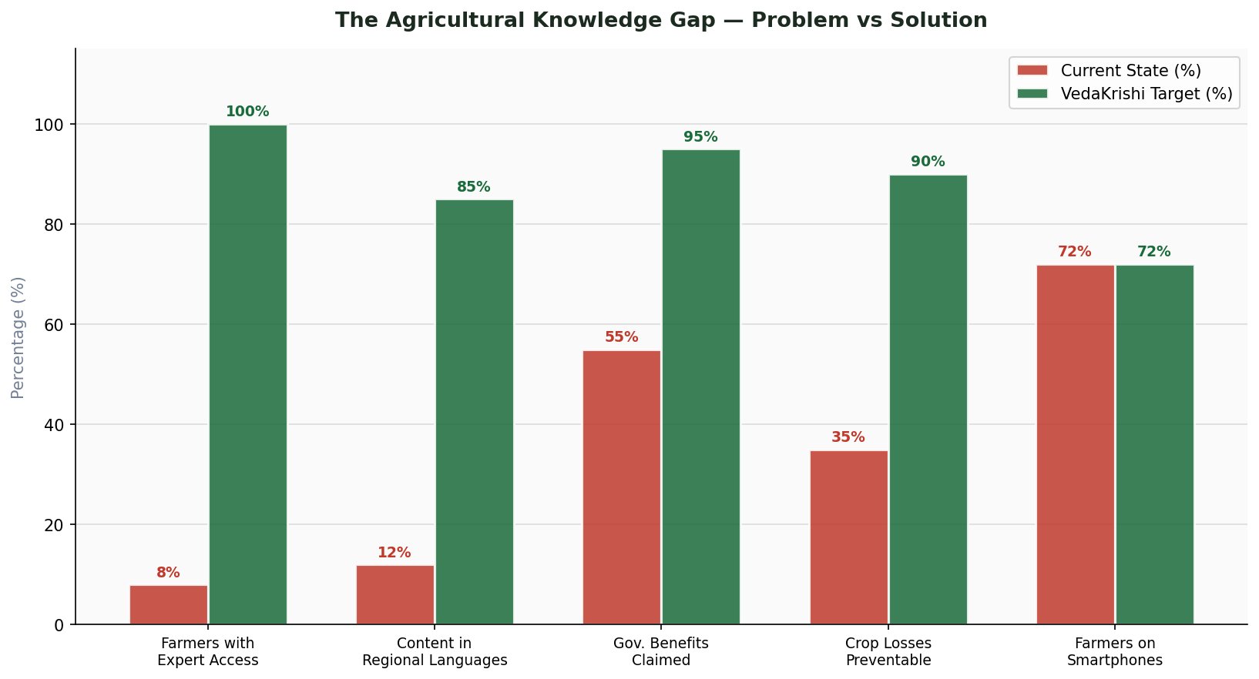
Figure: Current State vs VedaKrishi Target — Agricultural Knowledge Gap

Key Access Failures
- KVKs reach only 5-10% of farmers annually — 90%+ have no structured expert access.
- Private consultants charge Rs.500-2000 per visit, unaffordable for marginal farmers.
- Government advisories are delayed — often arriving after crop damage has occurred.
- 65% of farmers are comfortable only in their regional language; English content dominates.
- 30-40% of crop losses are caused by preventable pests and diseases.
- Billions in government benefits go unclaimed due to low scheme awareness.

2.2 Failure of Existing Solutions

Existing Solution | Failure Mode | VedaKrishi Advantage
Agricultural Websites | English-only, not conversational | Multilingual, voice-first, AI-powered
Government Apps (mKisan) | Poor UX, no AI, no image support | GPT-4o reasoning, Vision, rich UX
WhatsApp Groups | Unverified, slow response | 24/7 AI, verified, instant
SMS Advisory | No images, very limited content | Image analysis, 6 infographic tools
Private Consultants | Rs.500-2000/visit, not 24/7 | Free, available anytime, anywhere
KVK Extension | Reaches <10% of farmers | Unlimited scale, zero marginal cost

3. Proposed Solution

3.1 System Architecture
VedaKrishi AI is built on a three-layer architecture: a React 19 + Next.js 16 frontend, Next.js API Routes for backend orchestration, and a dual-model AI layer combining OpenAI and Groq.

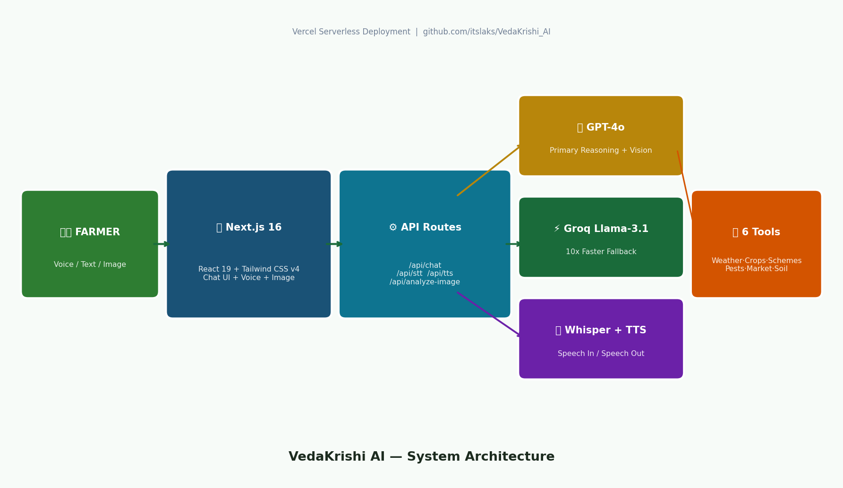
Figure: VedaKrishi AI — System Architecture Diagram

3.2 Architecture Layers
Layer | Components & Responsibility
Frontend (Client) | Next.js 16 App Router, React 19, Tailwind CSS v4, Lucide React — renders chat UI, voice controls, image upload, infographic cards
API Layer (Server) | Next.js Routes: /api/chat (streaming), /api/speech-to-text, /api/text-to-speech, /api/analyze-image
AI Orchestration | Vercel AI SDK v5: streamText, tool(), UIMessage, convertToModelMessages, stepCountIs(5)
Primary AI | OpenAI GPT-4o — chat reasoning, multilingual output, tool calling, image analysis
Fallback AI | Groq Llama-3.1-8B-instant — 10x faster, 100x cheaper, maintains full tool support
Voice Stack | Whisper-1 (STT) + TTS-1 nova voice (TTS) — full audio round-trip in 12 languages
Deployment | Vercel Serverless — 60s max API duration, edge CDN, auto-scaling, GitHub CI/CD

3.3 Request Data Flow
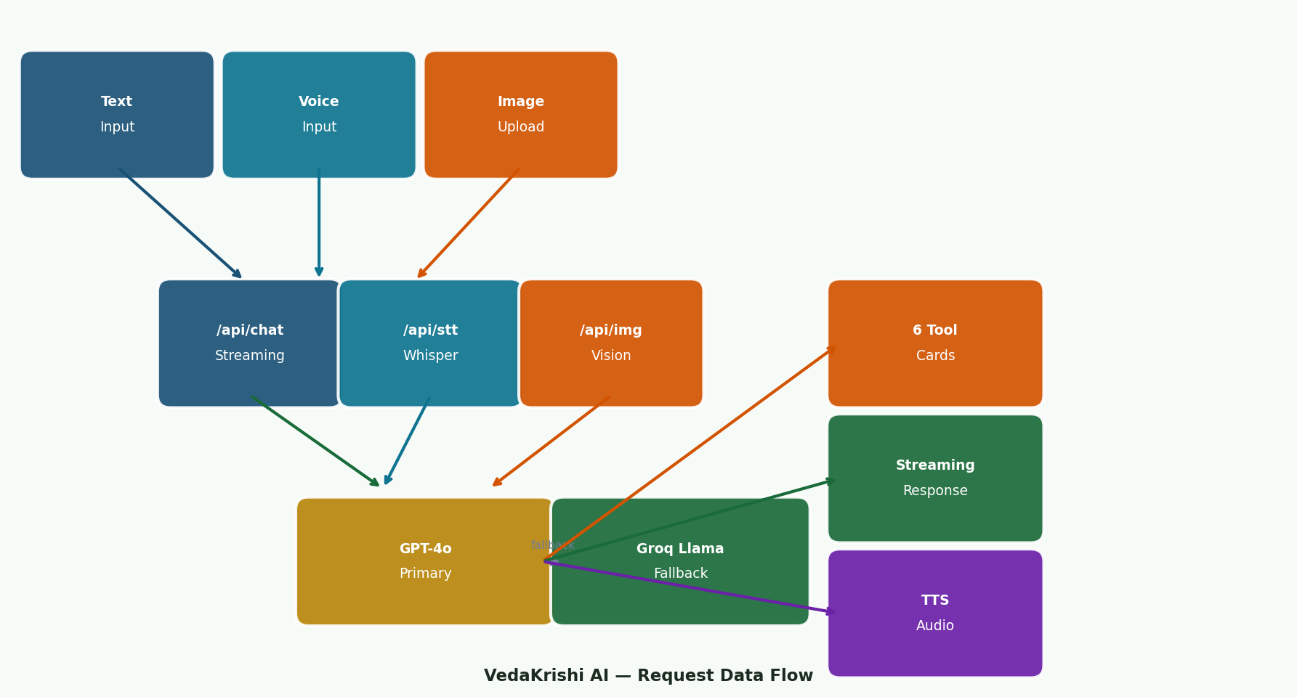
Figure: VedaKrishi AI — Request Data Flow Diagram

4. Technology Stack
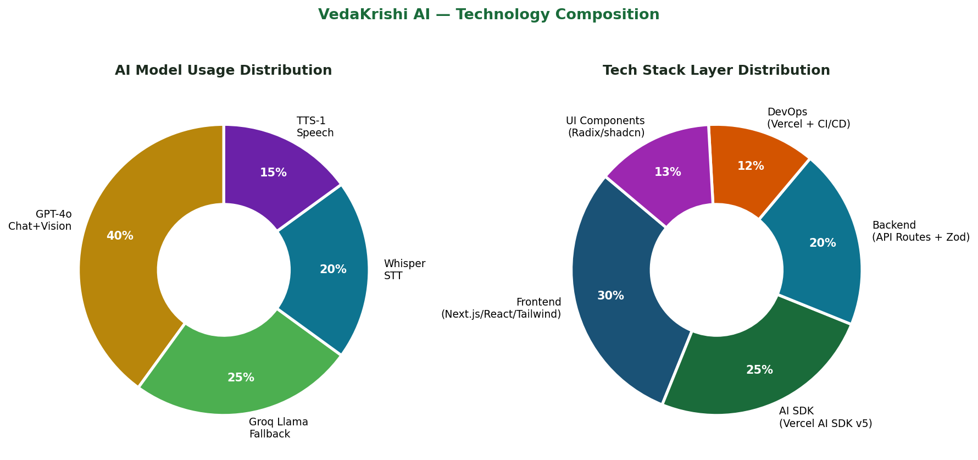
Figure: AI Model & Tech Layer Distribution

4.1 Frontend Technologies
Technology | Version | Purpose | Why Chosen
Next.js | 16.0.10 | Full-stack framework, App Router, API routes | Vercel-native, SSR, file routing, streaming
React | 19.2.0 | UI with concurrent features | Latest boundaries, smooth 3G rendering
Tailwind CSS | v4.1.9 | Utility-first styling, dark mode | Rapid theming, nature palette, zero runtime
Vercel AI SDK | v5 (ai@6.0.156) | Chat state, streaming, tools | UIMessage, streamText, DefaultChatTransport
react-markdown | 10.1.0 | Render AI markdown as HTML | Custom overrides, safe AI output rendering
Radix UI | Various | 40+ accessible headless UI components | Dialogs, dropdowns, modals — all a11y compliant

4.2 AI Models & APIs
Model | Provider | Usage | Cost
GPT-4o | OpenAI | Primary chat, tool calling, multilingual | ~$5/M tokens
GPT-4o Vision | OpenAI | Crop disease image analysis | ~$5/M + image tokens
Whisper-1 | OpenAI | Speech-to-text, 12 languages | $0.006/minute
TTS-1 (nova) | OpenAI | Text-to-speech audio generation | $15/M characters
Llama-3.1-8B | Groq | Fallback chat (100x cheaper) | ~$0.05/M tokens

4.3 DevOps & Infrastructure
Component | Details
Deployment | Vercel Serverless — auto-scaling, edge CDN, zero-config CI/CD from GitHub
API Timeout | maxDuration = 60s on all routes (vercel.json) — prevents streaming timeouts
Package Manager | pnpm (pnpm-lock.yaml) — faster installs, disk-efficient
Type Safety | TypeScript 5 strict mode across all components and API routes
Build | next build — TypeScript type checking included in CI pipeline

5. Feature Documentation

5.1 Language Support
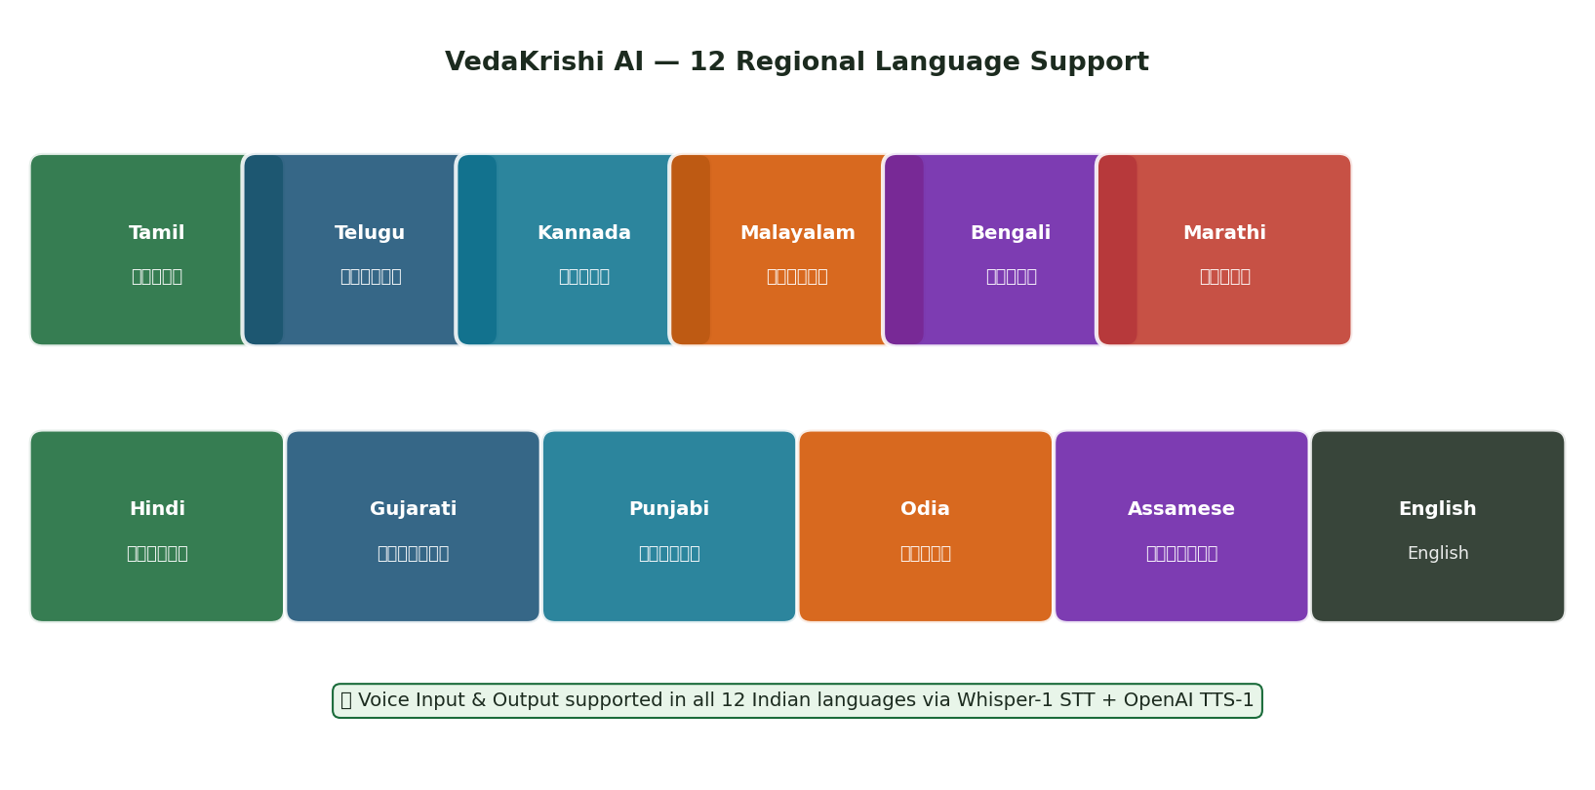
Figure: VedaKrishi AI — 12 Regional Language Support

5.2 Feature Overview
Feature | Description
Multilingual Chat | 12 Indian regional languages + German, French, Spanish. AI auto-detects and responds in same language.
Voice Input (STT) | MediaRecorder audio blob → Whisper-1 with per-language hint → transcribed text auto-fills input.
Voice Output (TTS) | AI responses read aloud via TTS-1 (nova) at 0.95x speed. Binary MP3 streamed to browser.
Crop Image Analysis | GPT-4o Vision diagnoses diseases, pests, deficiencies from photos. 7-section structured output.
Weather Card | Temperature, humidity, rainfall%, wind, condition, 3-day forecast, farming advisory.
Crop Calendar | Phase timeline (Land Prep → Sowing → Vegetative → Flowering → Harvest) with timings.
Gov Scheme Card | PM-KISAN, PMFBY, KCC — benefit amount, eligibility, application, helpline.
Pest Solution Card | Severity badge, organic vs chemical options, safety warnings, cost estimates.
Market Price Card | MSP vs market price comparison, trend vs MSP, best sell time, eNAM link.
Soil Health Card | N/P/K kg/ha progress bars, pH, organic matter, green manure recommendations.
Workflow Status UI | 4-step animated indicator: Understanding → Searching → Analysing → Generating.
Dual-Model Fallback | Automatic GPT-4o → Groq Llama switch — zero user impact on failure.
Zero-Token Greetings | Pre-written per-language greetings served instantly from static map — no AI call.

5.3 AI Tool Suite — 6 Infographic Cards
Tool Function | Trigger Context & Infographic Output
getWeatherInfo(location, state) | Triggered by: weather, rain, spray timing. Card: temp gauge, humidity bar, rainfall%, 3-day forecast, advisory.
getCropCalendar(crop, season, region) | Triggered by: planting time, harvest planning. Card: 5-phase timeline with dates and tasks.
getSchemeInfo(schemeName) | Triggered by: PM-KISAN, PMFBY, KCC, subsidies. Card: benefit, eligibility, how-to-apply, helpline.
getPestSolution(crop, symptoms) | Triggered by: yellowing, spots, wilting, holes. Card: severity, organic+chemical treatments, safety note.
getMarketPrice(crop, marketState) | Triggered by: MSP, mandi rates, sell timing. Card: MSP vs price, trend arrow, eNAM link.
getSoilRecommendation(soilType, crop) | Triggered by: fertiliser, soil health, NPK. Card: N/P/K bars, pH, FYM, green manure.

6. API Reference

6.1 Endpoint Summary
Endpoint | Method | Input | Output
/api/chat | POST | JSON: messages[], language, initLang? | SSE stream — text + tool call events
/api/speech-to-text | POST | multipart: audio Blob, language | JSON: { text, language }
/api/text-to-speech | POST | JSON: { text, language } | Binary: audio/mpeg MP3
/api/analyze-image | POST | multipart: image File, language | JSON: { analysis (markdown), language }

6.2 /api/chat — Model Fallback Logic
Model Selection Priority
Priority 1: OPENAI_API_KEY starts with "sk-" → GPT-4o (best reasoning, vision support). Priority 2: GROQ_API_KEY present → llama-3.1-8b-instant (100x cheaper, text-only). Fallback: Neither configured → HTTP 500 with clear remediation message.

6.3 Error Handling Matrix
Error Condition | HTTP Code & User Message
No API key configured | 500 — "Set OPENAI_API_KEY or GROQ_API_KEY in .env.local"
Invalid OpenAI key | 500 — "Invalid OpenAI API key. Please check your OPENAI_API_KEY"
Quota exceeded | 500 — "API quota exceeded. Please check your OpenAI billing."
No audio provided | 400 — "No audio file provided"
Invalid image type | 400 — "Invalid file type. Please upload JPEG, PNG, WebP, or GIF"
Image too large | 413 — "Image too large. Please upload an image smaller than 10MB."
Vision API error | 500 — "Could not read the image. Please ensure it is a clear photo."

7. Code Quality Assessment

7.1 TypeScript & Type Safety
- Entire codebase in TypeScript 5 with strict mode — all API routes, components, and hooks fully typed.
- Zod schemas validate all 6 tool inputs at runtime, providing type inference + runtime safety simultaneously.
- React component props fully typed (WeatherCardProps, ChatMessageProps, InfographicCardProps, etc.).
- "use client" / "use server" directives correctly applied — no server code leaks into client bundle.
- All React hooks use explicit TypeScript generics (useState<LanguageCode>, useRef<HTMLDivElement>).

7.2 Architecture Quality
Directory | Responsibility
app/api/ | 4 self-contained route handlers — single responsibility per modality.
components/chat/ | 7 specialized components: message, input, cards, language-selector, workflow-status.
components/ui/ | 40+ shadcn/Radix primitives for consistent, accessible design system.
hooks/ | Custom hooks extracted: useVoiceRecording, useTextToSpeech — clean separation.
lib/ | Utility: cn() for Tailwind class merging.

7.3 Token & Performance Optimisations
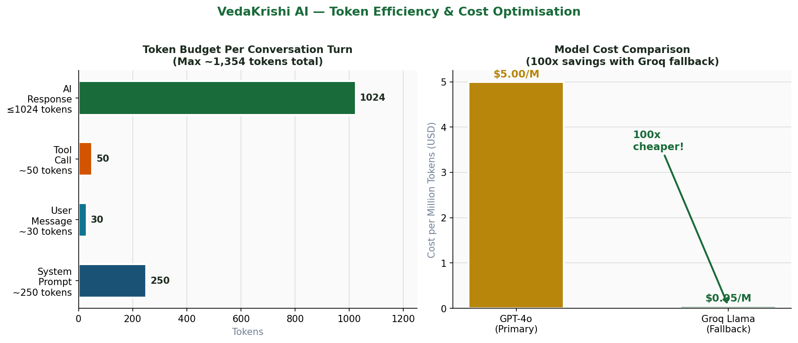
Figure: Token Budget Per Turn & Cost Comparison — GPT-4o vs Groq

Optimisation | Implementation & Impact
Compact system prompt | 69% reduction from ~800 → ~250 tokens. Saves ~$0.003 per request at scale.
maxTokens: 1024 cap | Hard ceiling on response length prevents runaway generation costs.
stopWhen: stepCountIs(5) | Guards infinite tool call loops — prevents cost explosion.
Zero-token greetings | INIT_GREETINGS served from static map — no AI call, zero latency for onboarding.
Structured tool data | Tools return JSON data; AI does not re-explain tool output in prose.
Groq fallback | 100x cheaper for text-only queries — transparent to user.

8. Observability & Monitoring

8.1 Current Implementation
Component | Implementation
Error Logging | console.error() in all 4 API routes — captured in Vercel Functions tab.
HTTP Status Codes | Explicit 200/400/413/500/503 per failure type — structured observability.
Vercel Analytics | @vercel/analytics 1.3.1 — page views, route performance, Core Web Vitals.
Streaming Guard | maxDuration=60 — Vercel auto-terminates and logs functions exceeding limit.
Tool State Machine | Async generators yield loading/ready states — client-visible execution trace.
User-Facing Errors | Specific messages per error type — invalid key, quota exceeded, file too large.

8.2 Production Observability Stack (Recommended)
- Sentry — frontend + backend error tracking with stack traces, session replay, and alerting.
- Vercel AI SDK telemetry — built-in tracing for model calls, token counts, latency, tool chains.
- Prometheus + Grafana — requests/sec, token rate, model latency P50/P95/P99.
- Structured logging (Winston/Pino) — JSON logs with request IDs, model names, latency.
- OpenTelemetry — distributed tracing across all 4 API routes for end-to-end visibility.

9. Test Cases

9.1 Functional Test Cases
ID | Test Case | Steps | Expected Result
TC-01 | English chat | Set lang=English. Send: "How do I grow rice in Kharif?" | Step-by-step guide. getCropCalendar tool triggered. Infographic card rendered.
TC-02 | Hindi response | Set lang=Hindi. Send Hindi wheat query. | Response fully in Devanagari. Language context injected in system prompt.
TC-03 | Bilingual (Tamil Nadu) | Send: "I am a farmer in Tamil Nadu. MSP for paddy?" | English + Tamil response separated by ---. getMarketPrice triggered.
TC-04 | Weather tool | Send: "Weather in Pune for farming?" | Weather Card: temp, humidity, rainfall%, wind, forecast, advisory.
TC-05 | Crop calendar | Send: "Crop calendar for wheat Rabi season" | Crop Calendar Card with 5-phase timeline and sowing/harvest dates.
TC-06 | PM-KISAN scheme | Send: "Tell me about PM-KISAN" | Scheme Card: Rs.6,000/year, eligibility, application, helpline 155261.
TC-07 | Pest diagnosis | Send: "Tomato leaves have yellow spots" | Pest Card: severity badge, neem oil organic, chemical option, safety warning.
TC-08 | Market price | Send: "MSP for cotton in Maharashtra?" | Market Card: MSP vs market price, Above/Below MSP indicator, eNAM link.
TC-09 | Soil recommendation | Send: "Soil for black cotton soybean" | Soil Card: N/P/K kg/ha bars, pH range, FYM, green manure suggestion.

9.2 Voice & Image Test Cases
ID | Test Case | Input | Expected Result
TC-10 | Hindi STT | Click mic. Speak Hindi pest query. Stop. | Transcribed text auto-fills input field via Whisper-1.
TC-11 | TTS playback | Click Listen on any AI response. | TTS-1 audio plays at 0.95x speed. Stop button appears.
TC-12 | Healthy crop image | Upload clear photo of healthy paddy. | "Healthy" status. Correct crop ID. Prevention tips only.
TC-13 | Disease diagnosis | Upload leaf with yellow spots (early blight). | 7-section analysis. "Moderate Issue". Organic + chemical treatment.
TC-14 | Invalid image type | Upload .pdf file. | HTTP 400: "Invalid file type. Please upload JPEG, PNG, WebP, or GIF."
TC-15 | Oversized image | Upload image > 10MB. | HTTP 413: "Image too large. Please upload image smaller than 10MB."

9.3 System & Edge Case Tests
ID | Test Case | Condition | Expected Result
TC-16 | Groq fallback | Remove OPENAI_API_KEY, keep GROQ_API_KEY. | App uses llama-3.1-8b. Text chat works. Image shows graceful unavailability.
TC-17 | No API keys | Remove both keys. | HTTP 500: "No AI provider configured." Clear error message displayed.
TC-18 | Tool loop guard | Ask question triggering multiple tool chains. | stepCountIs(5) stops after 5 steps. No infinite loop. Graceful completion.
TC-19 | Zero-token greeting | Load chat with initLang=hi. | Hindi greeting served instantly. Zero tokens consumed. No AI call.
TC-20 | Stream abort | Click Stop mid-response. | AbortSignal triggers. isAborted check in onFinish. Stream cleanly terminated.

10. Security Analysis

10.1 Implemented Security Controls
Control | Implementation
API Key Protection | All keys in Vercel Environment Variables — never exposed to client bundle.
Server-side Proxy | All AI calls made server-side — client never touches AI providers directly.
MIME Validation | Whitelist: jpeg/png/webp/gif only. Validated before any base64 conversion.
File Size Limit | 10MB hard limit on uploads — prevents memory exhaustion on serverless.
Zod Schema Validation | All 6 tool inputs validated at runtime — prevents injection via parameters.
Error Safety | Generic user messages — internal stack traces never exposed to client.
No PII Storage | No user accounts, no session persistence, no DB — zero stored PII.

10.2 Recommended Enhancements
- Rate limiting — per-IP throttling via Upstash Redis + @upstash/ratelimit to prevent API key abuse.
- CORS policy — explicitly configure allowed origins in Next.js API routes for production hardening.
- Content Security Policy — add CSP headers via next.config.mjs to prevent XSS.
- Audio validation — MIME type check on /api/speech-to-text (currently size-only).
- Input length limits — cap max chat message length to prevent token stuffing attacks.

11. Deployment Architecture

11.1 Production Stack
Aspect | Configuration
Platform | Vercel Serverless — Node.js runtime, global edge CDN
Live URL | veda-krishi-ai.vercel.app
CI/CD | GitHub push → Vercel auto-deploy (zero-config)
API Timeout | maxDuration = 60s on all routes (vercel.json)
Environment | OPENAI_API_KEY, GROQ_API_KEY in Vercel Project Settings
Build | next build — TypeScript type checking in CI pipeline
Node | 18+ (required for Web Crypto API, FormData, streaming Response)

11.2 Local Dev Setup
- git clone https://github.com/itslaks/VedaKrishi_AI.git
- npm install (or pnpm install)
- Create .env.local with OPENAI_API_KEY and GROQ_API_KEY.
- npm run dev — access at http://localhost:3000
- HTTPS required for microphone — localhost satisfies this automatically.

12. Roadmap
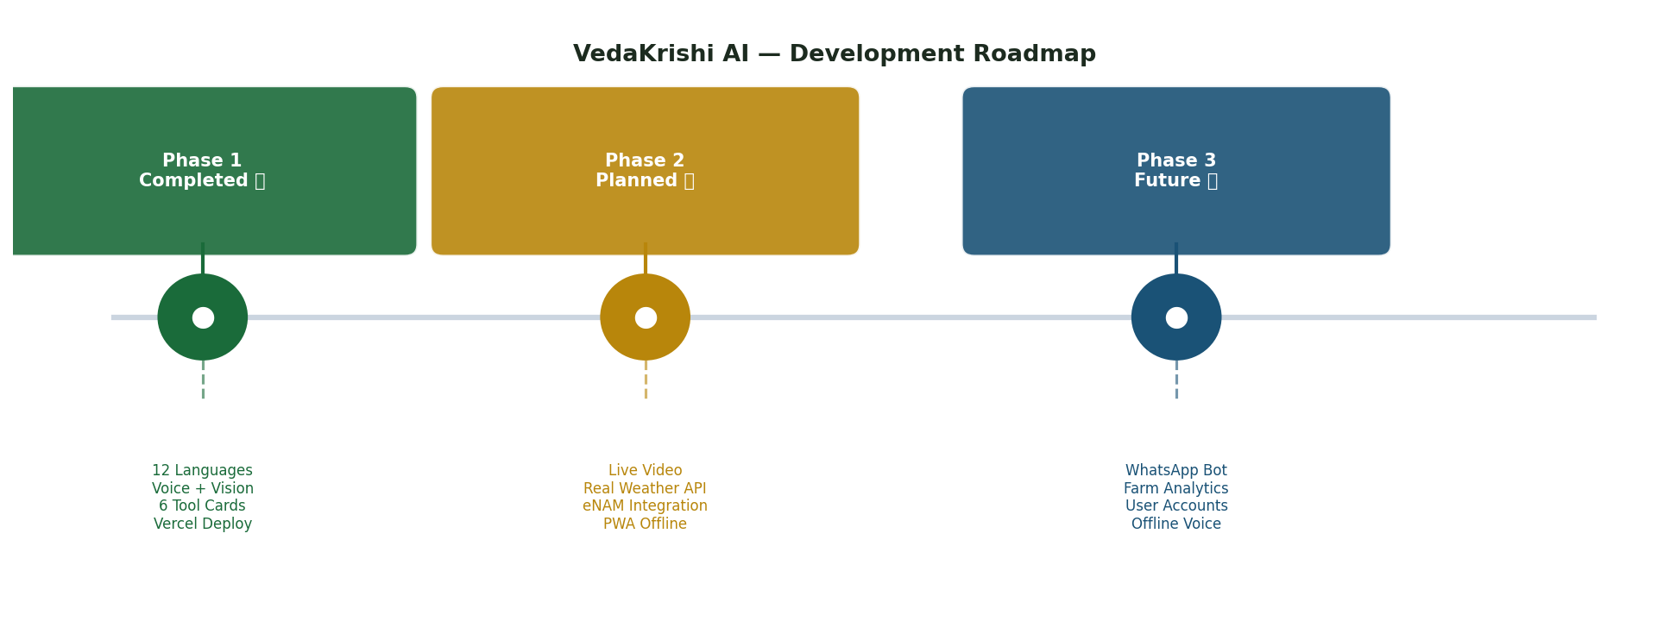
Figure: VedaKrishi AI — Development Roadmap (3 Phases)

Phase 1 — Completed
- Multilingual text chat in 12 Indian regional languages + 3 European.
- Voice input (Whisper-1 STT) and voice output (TTS-1).
- Crop disease image analysis via GPT-4o Vision.
- 6 infographic tool cards: weather, crop calendar, schemes, pests, market, soil.
- Groq Llama-3.1-8B fallback model with automatic switching.
- Vercel serverless deployment at veda-krishi-ai.vercel.app.
- Token efficiency optimization — 69% system prompt reduction.

Phase 2 — Planned
- Live video field analysis using WebRTC + OpenAI Realtime API.
- Progressive Web App (PWA) with offline message caching.
- Real weather API integration (OpenWeatherMap).
- eNAM live market price integration for real mandi data.

Phase 3 — Future Vision
- WhatsApp/Telegram bot version for SMS-familiar farmers.
- Farm analytics dashboard with crop performance tracking.
- User accounts and persistent chat history.
- Region-specific crop databases (Cauvery Delta, Vidarbha cotton, etc.).
- Offline voice support with locally hosted Whisper model.

13. Impact Analysis
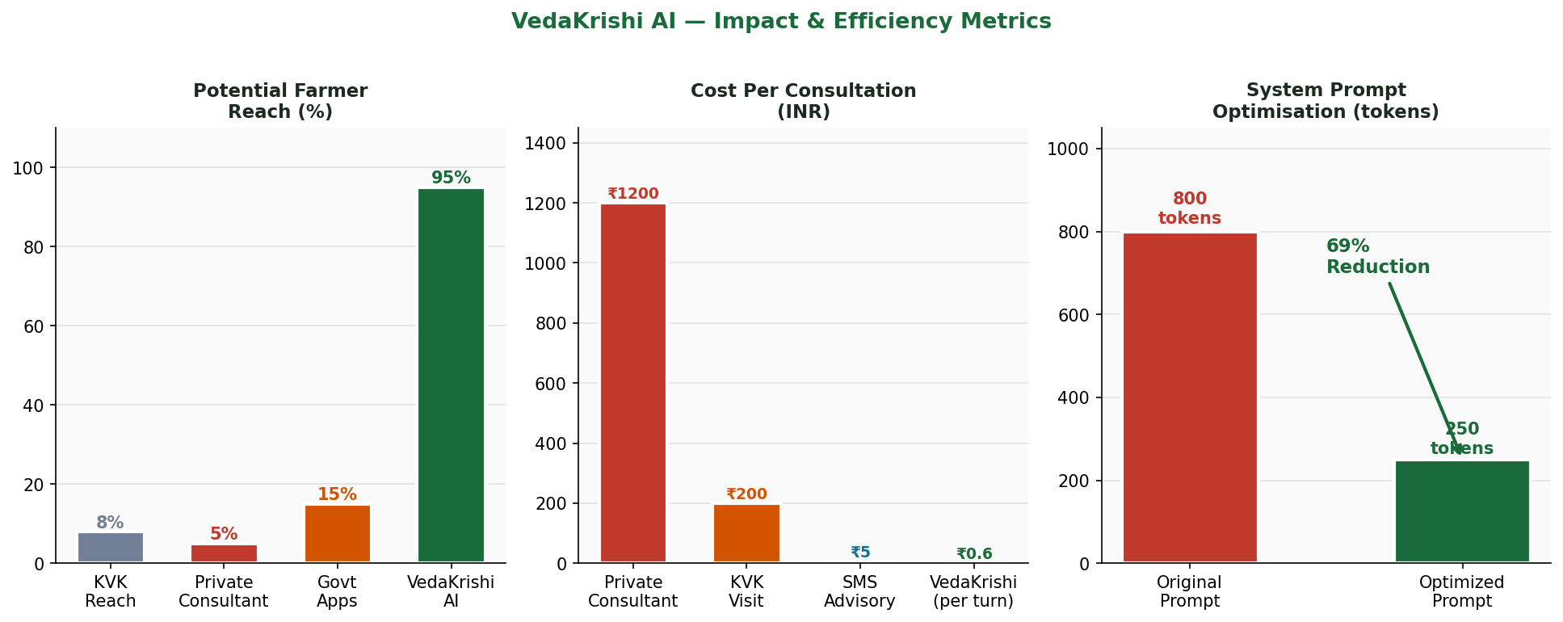
Figure: Farmer Reach, Consultation Cost, and Token Optimisation Metrics

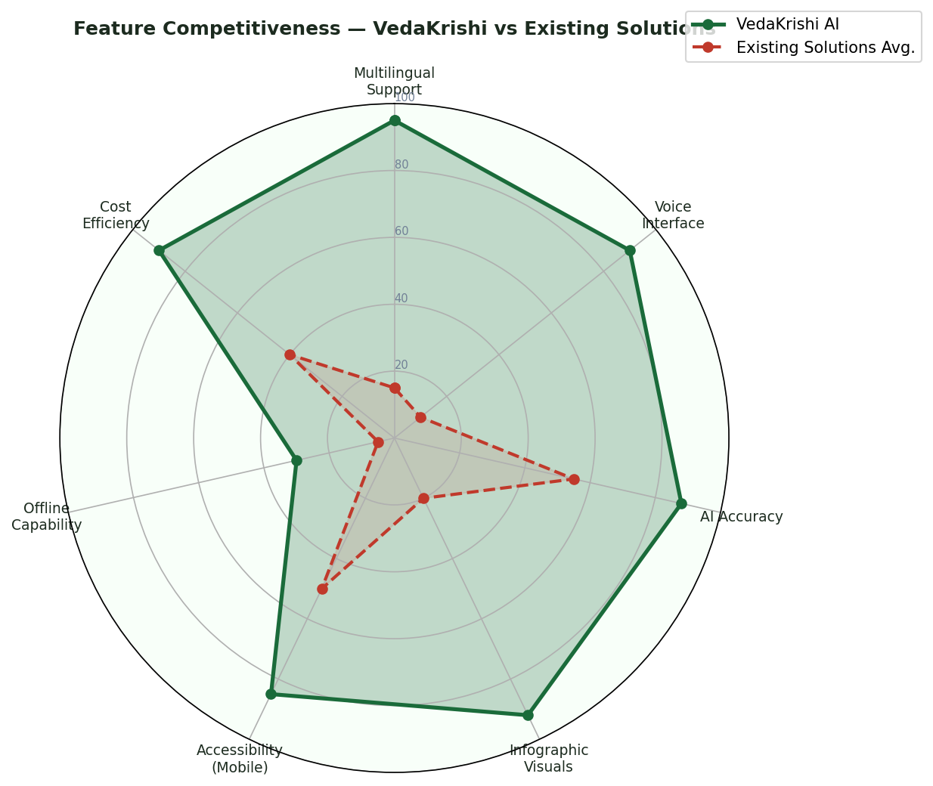
Figure: Feature Competitiveness — VedaKrishi vs Existing Solutions

13.1 Social Impact
Dimension | Detail
Target Users | 140M+ farming households, especially small/marginal farmers (<2 ha)
Language Inclusion | 12 languages — Tamil Nadu, Andhra, Karnataka, Kerala, Bengal, Maharashtra, Gujarat, Punjab, Odisha, Assam
Accessibility | Voice-first design removes literacy barrier — farmers who cannot type can speak
Cost | Eliminates Rs.500-2000/visit private consultant cost — democratises expert access
Gov Awareness | PM-KISAN, PMFBY, KCC surfaced automatically in conversation
Crop Protection | Instant pest/disease diagnosis prevents 30-40% preventable losses
Market Power | MSP + mandi price transparency reduces middlemen exploitation

14. Conclusion
VedaKrishi AI is a comprehensive demonstration of production-ready full-stack AI engineering applied to a high-impact social problem. The project delivers on every axis of modern AI application development:

- Full-stack architecture — Next.js 16, React 19, TypeScript 5, Tailwind CSS v4, Vercel.
- Multi-modal AI — GPT-4o, Whisper, TTS-1, Vision APIs orchestrated in one application.
- Agentic tools — 6 purpose-built agricultural tools using Vercel AI SDK v5 async generators.
- Production resilience — dual-model failover (GPT-4o → Groq) with zero user impact.
- Responsible design — token efficiency, structured error handling, safety-conscious advice.
- Live deployment — accessible to any Indian farmer with a smartphone at veda-krishi-ai.vercel.app.

Project Significance
VedaKrishi AI is not merely a capstone demonstration — it is a production-deployed service with real potential to impact 140 million farming households in India. It stands as evidence that AI engineering, when applied with purpose and cultural sensitivity, can be a powerful force for social equity.

Grow with Knowledge. Harvest with Pride.
Built by Lakshan | April 2026
veda-krishi-ai.vercel.app | github.com/itslaks/VedaKrishi_AI

