TechShop, an electronic gadgets shop

**Task:1. Database Design:**

1) Create the database named "TechShop"

SOLUTION:

**CREATE DATABASE TechShop;**

**2)** Define the schema for the Customers, Products, Orders, OrderDetails and Inventory tables

based on the provided schema.

SOLUTION:

**CREATE TABLE Customers (**

**CustomerID INT IDENTITY(1,1) PRIMARY KEY,**

**FirstName VARCHAR(50) NOT NULL,**

**LastName VARCHAR(50) NOT NULL,**

**Email VARCHAR(100) UNIQUE NOT NULL,**

**Phone VARCHAR(15) NOT NULL,**

**Address VARCHAR(255) NOT NULL**

**);**

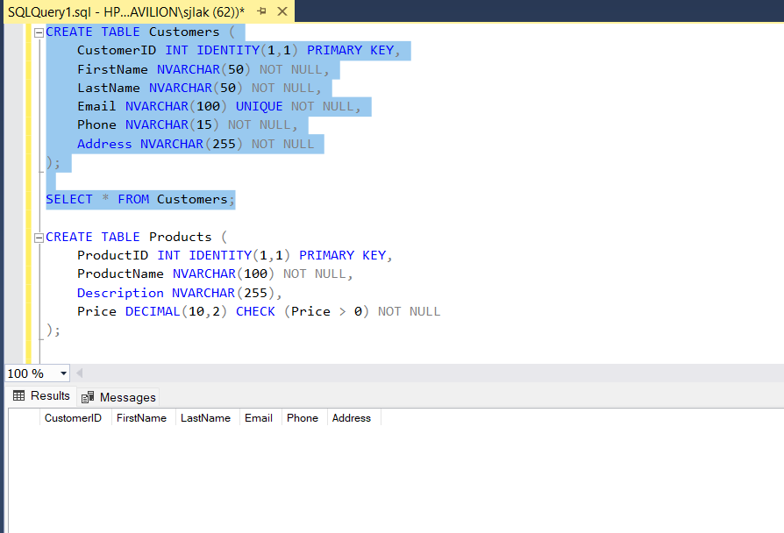

**CREATE TABLE Products (**

**ProductID INT IDENTITY(1,1) PRIMARY KEY,**

**ProductName VARCHAR(100) NOT NULL,**

**Description VARCHAR(255),**

**Price DECIMAL NOT NULL**

**);**

**CREATE TABLE Orders (**

**OrderID INT IDENTITY(1,1) PRIMARY KEY,**

**CustomerID INT NOT NULL,**

**OrderDate DATETIME DEFAULT GETDATE(),**

**TotalAmount DECIMAL(10,2) CHECK (TotalAmount >= 0),**

**FOREIGN KEY (CustomerID) REFERENCES Customers(CustomerID) ON DELETE CASCADE**

**);**

**CREATE TABLE OrderDetails (**

**OrderDetailID INT IDENTITY(1,1) PRIMARY KEY,**

**OrderID INT NOT NULL,**

**ProductID INT NOT NULL,**

**Quantity INT CHECK (Quantity > 0) NOT NULL,**

**FOREIGN KEY (OrderID) REFERENCES Orders(OrderID) ON DELETE CASCADE,**

**FOREIGN KEY (ProductID) REFERENCES Products(ProductID)**

**);**

**CREATE TABLE Inventory (**

**InventoryID INT IDENTITY(1,1) PRIMARY KEY,**

**ProductID INT NOT NULL UNIQUE,**

**QuantityInStock INT CHECK (QuantityInStock >= 0) NOT NULL,**

**LastStockUpdate DATETIME DEFAULT GETDATE(),**

**FOREIGN KEY (ProductID) REFERENCES Products(ProductID) ON DELETE CASCADE**

**);**

3) Create an ERD (Entity Relationship Diagram) for the database

4) Create appropriate Primary Key and Foreign Key constraints for referential integrity.

SOLUTION;

**CREATE TABLE Customers (**

**CustomerID INT IDENTITY(1,1) PRIMARY KEY,**

**FirstName NVARCHAR(50) NOT NULL,**

**LastName NVARCHAR(50) NOT NULL,**

**Email NVARCHAR(100) UNIQUE NOT NULL,**

**Phone NVARCHAR(15) NOT NULL,**

**Address NVARCHAR(255) NOT NULL**

**);**

**CREATE TABLE Products (**

**ProductID INT IDENTITY(1,1) PRIMARY KEY,**

**ProductName NVARCHAR(100) NOT NULL,**

**Description NVARCHAR(255),**

**Price DECIMAL(10,2) CHECK (Price > 0) NOT NULL**

**);**

**CREATE TABLE Orders (**

**OrderID INT IDENTITY(1,1) PRIMARY KEY,**

**CustomerID INT NOT NULL,**

**OrderDate DATETIME DEFAULT GETDATE(),**

**TotalAmount DECIMAL(10,2) CHECK (TotalAmount >= 0),**

**FOREIGN KEY (CustomerID) REFERENCES Customers(CustomerID) ON DELETE CASCADE**

**);**

**CREATE TABLE OrderDetails (**

**OrderDetailID INT IDENTITY(1,1) PRIMARY KEY,**

**OrderID INT NOT NULL,**

**ProductID INT NOT NULL,**

**Quantity INT CHECK (Quantity > 0) NOT NULL,**

**FOREIGN KEY (OrderID) REFERENCES Orders(OrderID) ON DELETE CASCADE,**

**FOREIGN KEY (ProductID) REFERENCES Products(ProductID)**

**);**

**CREATE TABLE Inventory (**

**InventoryID INT IDENTITY(1,1) PRIMARY KEY,**

**ProductID INT NOT NULL UNIQUE,**

**QuantityInStock INT CHECK (QuantityInStock >= 0) NOT NULL,**

**LastStockUpdate DATETIME DEFAULT GETDATE(),**

**FOREIGN KEY (ProductID) REFERENCES Products(ProductID) ON DELETE CASCADE**

**);**

5) Insert at least 10 sample records into each of the following tables.

SOLUTION:

**INSERT INTO Customers VALUES**

**('Ram', 'Verma', 'ramverma@yahoo.com', '9876543210', '12 MG Road, Delhi'),**

**('Kishore', 'Patel', 'kishorepatel@gmail.com', '8765432109', '34 Park Street, Mumbai'),**

**('Kumar', 'Reddy', 'kumarreddy@yahoo.com', '7654321098', '56 Brigade Road, Bangalore'),**

**('Haley', 'Pearl', 'haleypearl@gmail.com', '6543210987', '78 Connaught Place, Delhi'),**

**('Nan', 'laks', 'nan.laks@yahoo.com', '5432109876', '90 Banjara Hills, Hyderabad'),**

**('Harish', 'potta', 'harish@outlook.com', '4321098765', '21 Sarojini Nagar, Chennai'),**

**('Kamalesh', 'waran', 'kamalesh@yahoo.com', '3210987654', '33 MG Road, Pune'),**

**('Rahul', 'logesh', 'delhi@gmail.com', '2109876543', '45 Koramangala, Bangalore'),**

**('Virat', 'kohli', 'anushka@rcb.com', '1098765432', '67 Jubilee Hills, Hyderabad'),**

**('joshy', 'agarwal', 'joshy@outlook.com', '9988776655', '89 Indiranagar, Bangalore');**

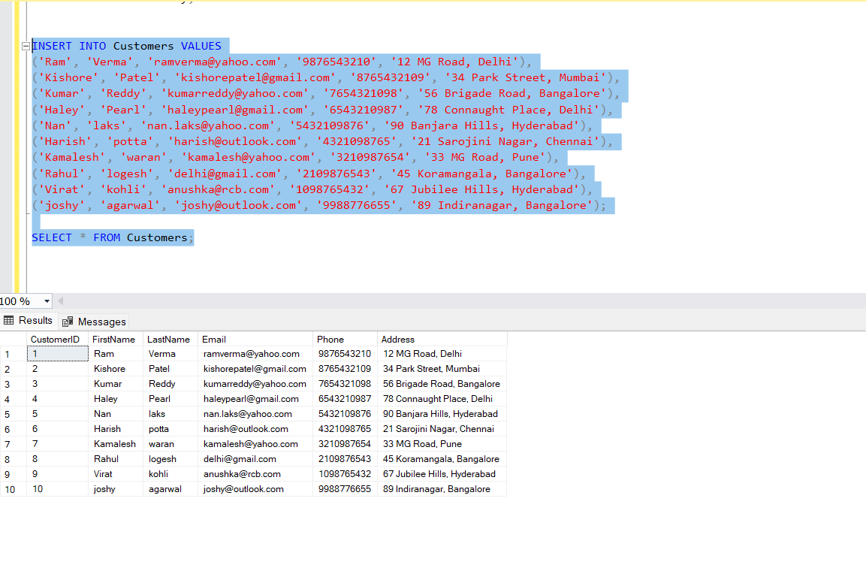

**INSERT INTO Products (ProductName, Description, Price) VALUES**

**('Laptop', 'HP PAVILION EC 2004 AX', 58000),**

**('Smartphone', 'REALME GT NEO 3T', 32000),**

**('Tablet', 'Apple iPad Pro 12.9-inch', 90000),**

**('Smartwatch', 'BOAT IZTRA', 4500),**

**('Headphones', 'CMF BUDS PRO', 3000),**

**('Camera', 'Canon EOS 90D DSLR Camera', 120000),**

**('Gaming Console', 'Sony PlayStation 5', 50000),**

**('Monitor', 'LG 4K UltraFine 27-inch Monitor', 40000),**

**('Keyboard', 'Logitech MX Keys Wireless Keyboard', 12000),**

**('Mouse', 'Razer DeathAdder V2 Gaming Mouse', 5000);**

INSERT INTO Inventory (ProductID, QuantityInStock) VALUES

(1, 20),

(2, 30),

(3, 15),

(4, 25),

(5, 40),

(6, 10),

(7, 12),

(8, 18),

(9, 50),

(10, 35);

INSERT INTO Orders (CustomerID, TotalAmount) VALUES

(1, 240000),

(2, 85000),

(3, 90000),

(4, 45000),

(5, 30000),

(6, 120000),

(7, 50000),

(8, 40000),

(9, 12000),

(10, 5000);

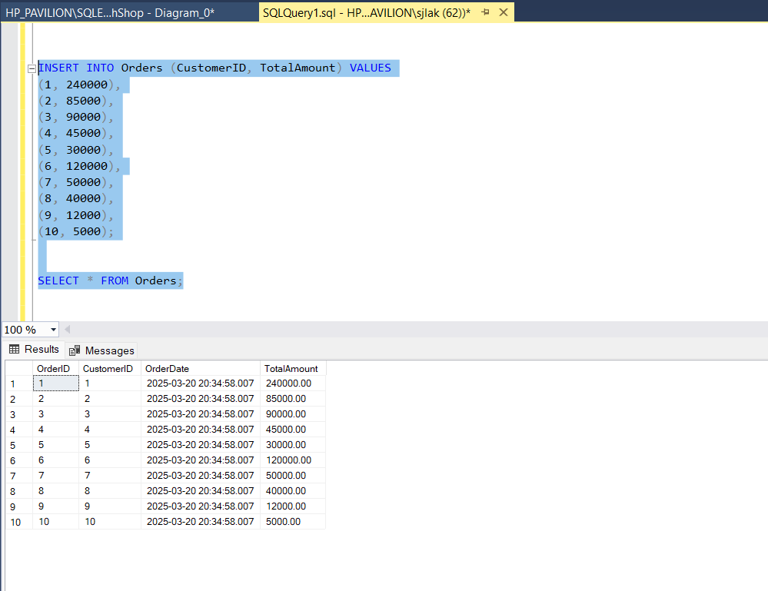

INSERT INTO OrderDetails (OrderID, ProductID, Quantity) VALUES

(1, 1, 2),

(2, 2, 1),

(3, 3, 1),

(4, 4, 2),

(5, 5, 3),

(6, 6, 1),

(7, 7, 1),

(8, 8, 2),

(9, 9, 1),

(10, 10, 2);

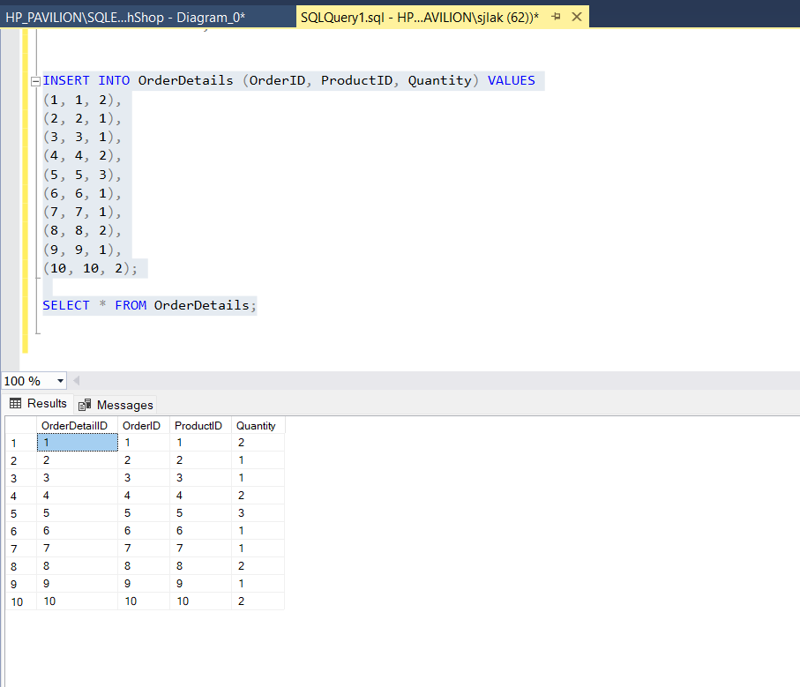

**Tasks 2: Select, Where, Between, AND, LIKE:**

1)Write an SQL query to retrieve the names and emails of all customers.

**SELECT FirstName, LastName, Email FROM Customers;**

2. List all orders with their order dates and corresponding customer names.

**SELECT O.OrderID, O.OrderDate, C.FirstName, C.LastName**

**FROM Orders O**

**JOIN Customers C ON O.CustomerID = C.CustomerID;**

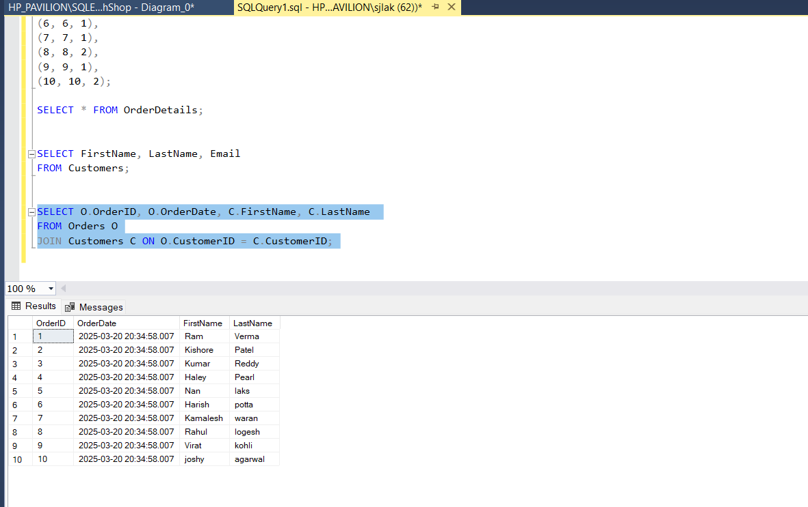

3. Insert a new customer record into the "Customers" table.

**INSERT INTO Customers VALUES**

**('king', 'kong', 'kkang@jungle.com', '9876543211', 'vandoolur, Chennai');**

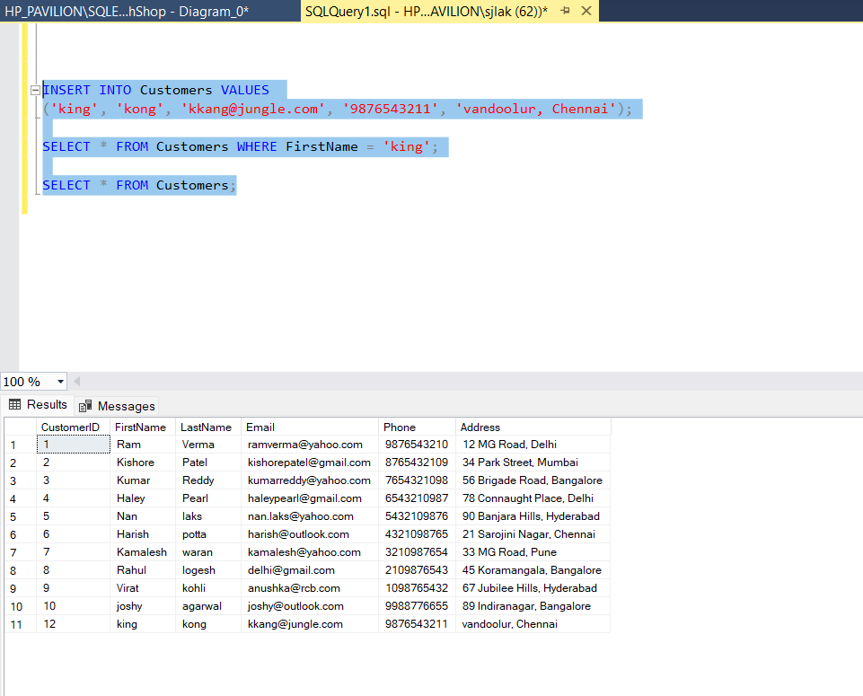

4. Update the prices of all electronic gadgets in the "Products" table by increasing them by 10%.

**UPDATE Products**

**SET Price = Price * 1.10;**

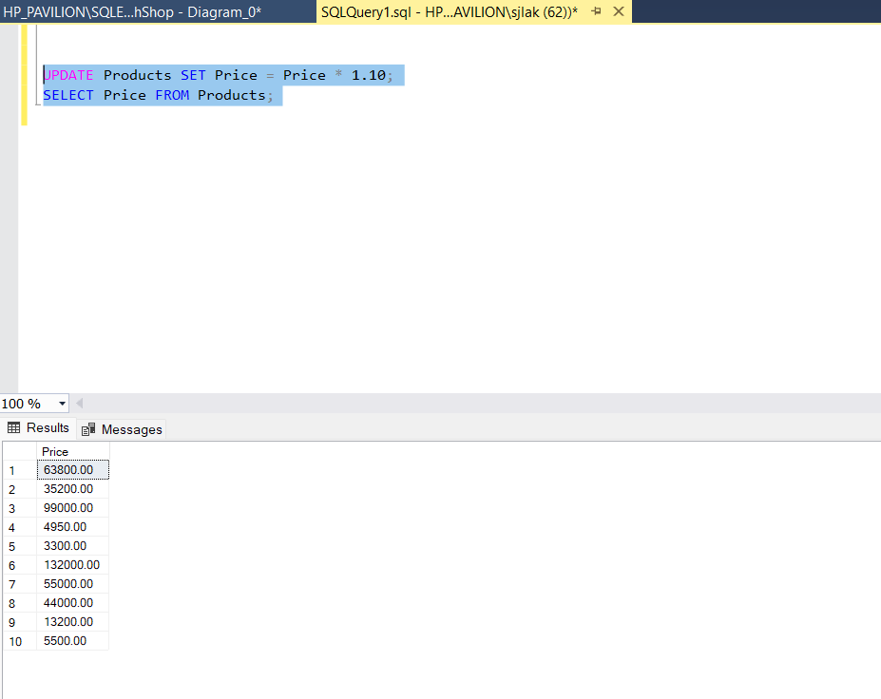

5. Delete a specific order and its associated order details.

**DELETE FROM OrderDetails WHERE OrderID = 2;**

**SELECT * FROM Orders;**

**DELETE FROM Orders WHERE OrderID = 2;**

**SELECT * FROM OrderDetails;**

6)Insert a new order into the "Orders" table.

**INSERT INTO Orders (CustomerID, OrderDate, TotalAmount)**

**VALUES (2,2024-12-20, 75000);**

**SELECT * FROM Orders;**

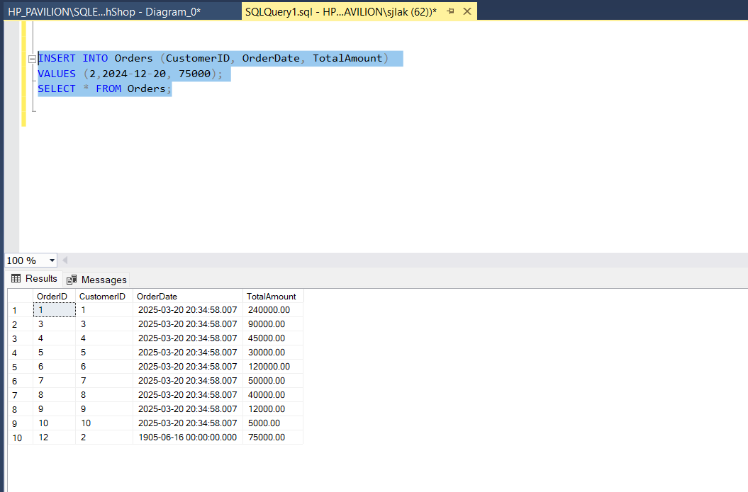

7) Update the contact information (email and address) of a specific customer.

**UPDATE Customers SET Email = 'jacksparrow@xbox.com', Address = 'middle of ocean Atlanta' WHERE CustomerID = 3;**

**SELECT * FROM Customers;**

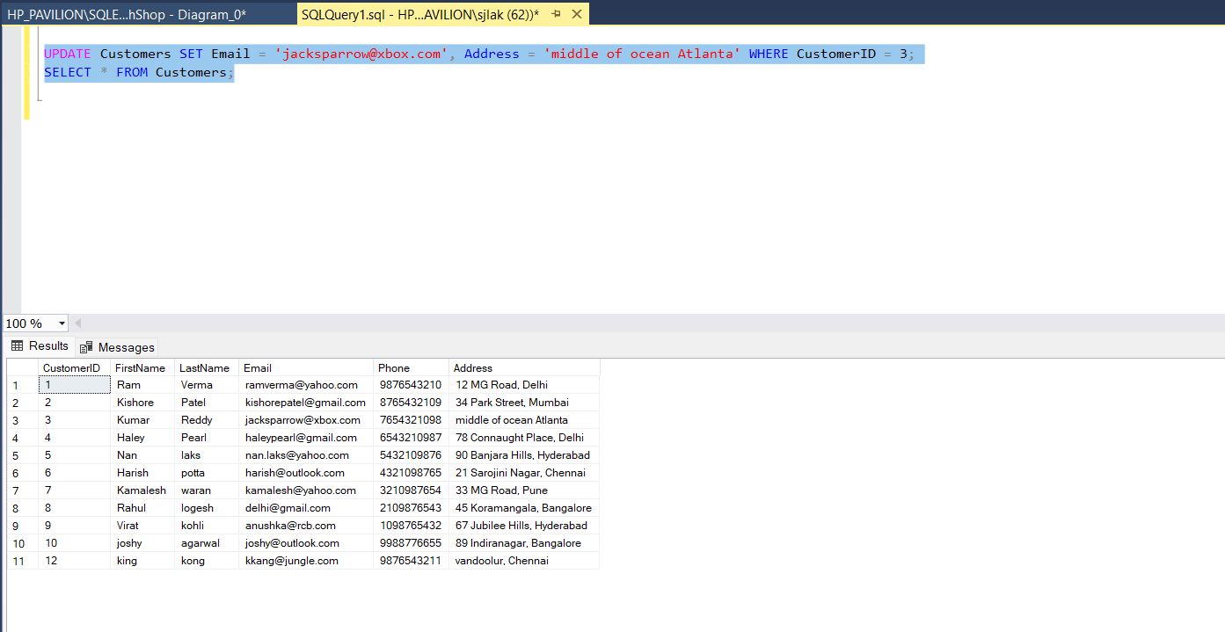

8. Recalculate and update the total cost of each order in the "Orders" table.

**UPDATE Orders**

**SET TotalAmount = (**

**SELECT SUM(P.Price * OD.Quantity)**

**FROM OrderDetails OD**

**JOIN Products P ON OD.ProductID = P.ProductID**

**WHERE OD.OrderID = Orders.OrderID**

**);**

**SELECT * FROM Orders;**

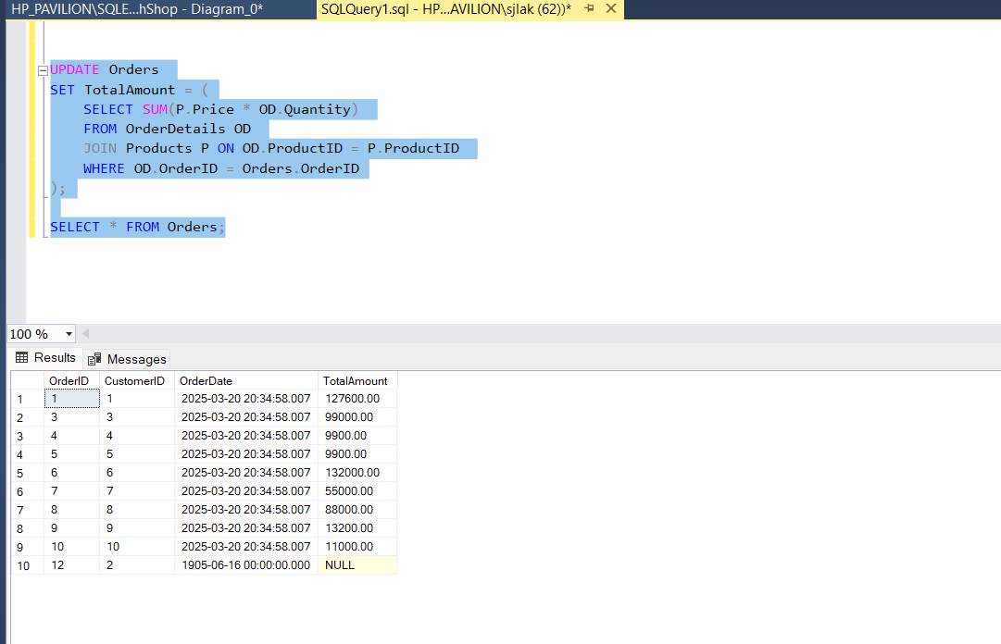

9. Delete all orders and their associated order details for a specific customer.

**DELETE FROM OrderDetails WHERE OrderID IN (SELECT OrderID FROM Orders WHERE CustomerID = 5);**

**DELETE FROM Orders WHERE CustomerID = 5;**

**SELECT * FROM Orders;**

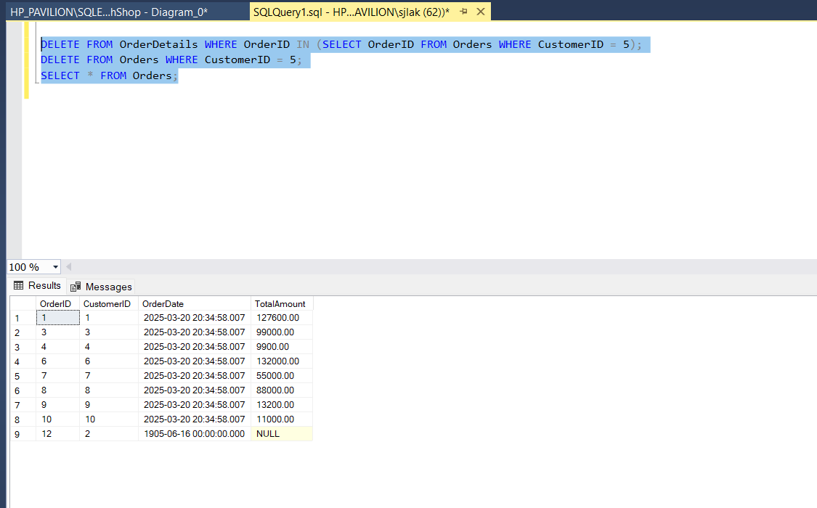

10. Insert a new electronic gadget product into the "Products" table.

**INSERT INTO Products (ProductName, Description, Price)**

**VALUES ('AR GLASS', 'META GLASSES', 15000000);**

**SELECT * FROM Products;**

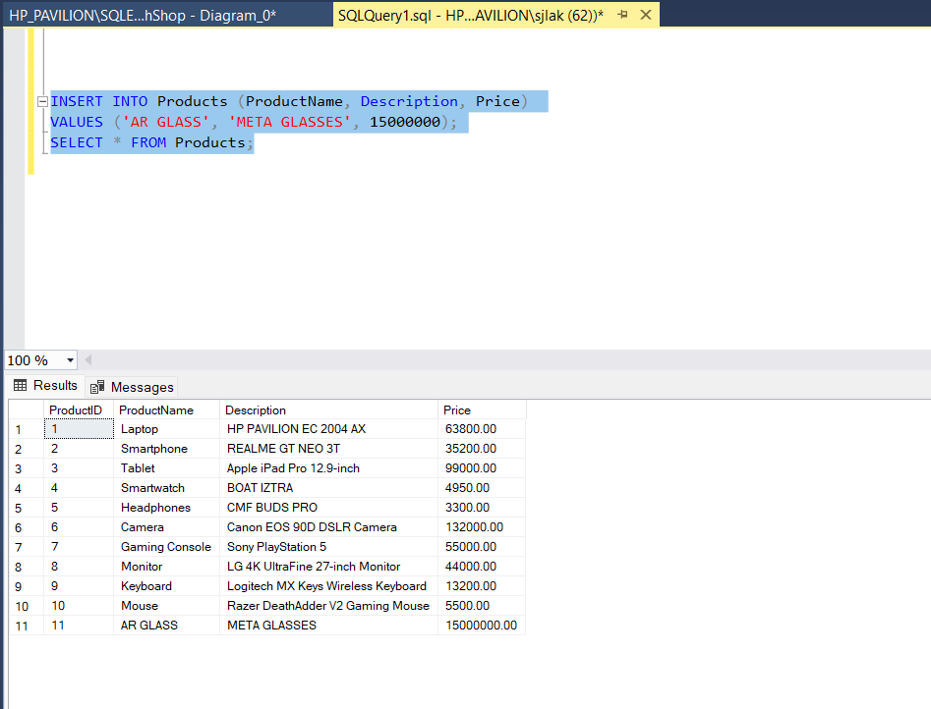

12. Calculate and update the number of orders placed by each customer.