Day 1 (29-5-25)

Assignment – 1

IPL Datasets

Creating Database as newvalue,

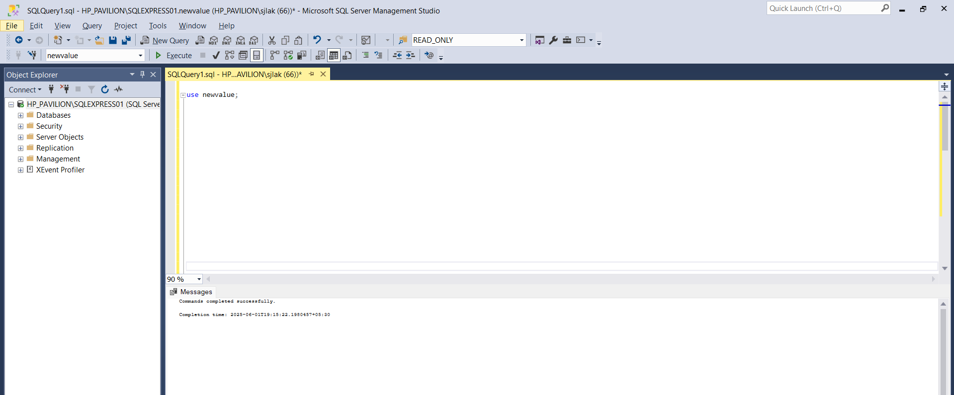

Checking Whether all the datas are properly viewing,

-- 1. Total matches

SELECT COUNT(*) FROM matches;

-- 2. Total seasons

SELECT COUNT(DISTINCT season) FROM matches;

-- 3. Max win by runs

SELECT TOP 1 winner FROM matches WHERE win_by_runs > 0 ORDER BY win_by_runs DESC;

-- 4. Max win by wickets

SELECT TOP 1 winner FROM matches WHERE win_by_wickets > 0 ORDER BY win_by_wickets DESC;

-- 5. Closest win by runs

SELECT TOP 1 winner FROM matches WHERE win_by_runs > 0 ORDER BY win_by_runs ASC;

-- 6. Min win by wickets

SELECT TOP 1 winner FROM matches WHERE win_by_wickets > 0 ORDER BY win_by_wickets ASC;

-- 7. Season with most matches

SELECT TOP 1 season FROM matches GROUP BY season ORDER BY COUNT(*) DESC;

-- 8. Most successful team

SELECT TOP 1 winner FROM matches WHERE winner IS NOT NULL GROUP BY winner ORDER BY COUNT(*) DESC;

