**PROJECT 1**

**ShopFast**

**STEP 1: Creating a new Database,**

create database ShopFast;

**STEP 2: using the new database,**

use ShopFast;

**STEP 3: Inserting the values through given csv files,**

**STEP 4: Check weather all the data’s are inserted properly,**

select * from CUSTOMERS;

select * from ORDER_ITEMS;

select * from ORDERS;

select * from PRODUCTS;

**STEP 5: Answers for all Problem Set**

--1. Customer Sign-up Trend: New customers per month (last 12 months)

SELECT customer_id, name, signup_date FROM CUSTOMERS

WHERE signup_date >= DATEADD(MONTH, -12, GETDATE());

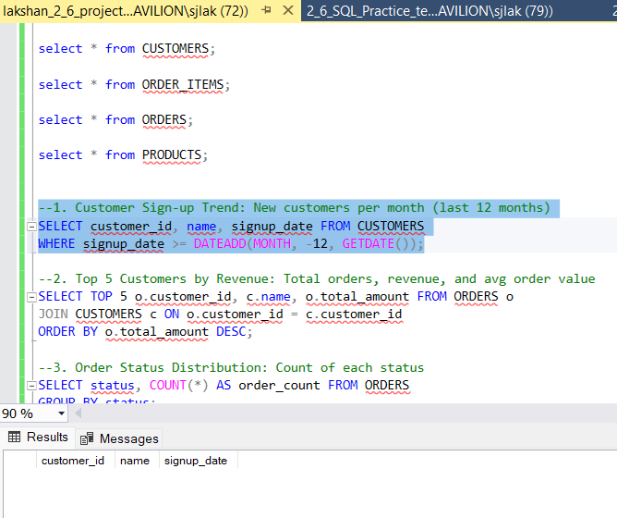

--2. Top 5 Customers by Revenue: Total orders, revenue, and avg order value

SELECT TOP 5 o.customer_id, c.name, o.total_amount FROM ORDERS o

JOIN CUSTOMERS c ON o.customer_id = c.customer_id

ORDER BY o.total_amount DESC;

--3. Order Status Distribution: Count of each status

SELECT status, COUNT(*) AS order_count FROM ORDERS

GROUP BY status;

--4. Revenue by Category: Total revenue by category

SELECT o.product_id, p.product_name, o.quantity, o.price_per_unit

FROM ORDER_ITEMS o

JOIN PRODUCTS p ON o.product_id = p.product_id;

--5. Best-Selling Products: Top 5 by quantity sold

SELECT o.product_id, p.product_name, o.quantity

FROM ORDER_ITEMS o

JOIN PRODUCTS p ON o.product_id = p.product_id

ORDER BY o.quantity DESC;

--6. Low-Stock Products: Products with <10% stock using CASE

SELECT product_name, stock_quantity, CASE WHEN stock_quantity < 10 THEN 'Low Stock' ELSE 'OK' END AS stock_status

FROM PRODUCTS;

--7. Avg Delivery Time per Month

SELECT FORMAT(order_date, 'yyyy-MM') AS order_month, AVG(DATEDIFF(DAY, order_date, delivery_date)) AS avg_delivery_days

FROM ORDERS

WHERE delivery_date IS NOT NULL

GROUP BY FORMAT(order_date, 'yyyy-MM')

ORDER BY order_month;

--8. Orders with Delivery >7 days

SELECT order_id, order_date, delivery_date

FROM ORDERS

WHERE DATEDIFF(DAY, order_date, delivery_date) > 7;

--9. Repeat Customers: More than 1 order

SELECT customer_id FROM ORDERS GROUP BY customer_id

HAVING COUNT(*) > 1;

--10. Monthly Revenue Growth with LAG()

SELECT

FORMAT(order_date, 'yyyy-MM') AS order_month,

SUM(total_amount) AS monthly_revenue,

SUM(total_amount) - LAG(SUM(total_amount)) OVER (ORDER BY FORMAT(order_date, 'yyyy-MM')) AS revenue_growth

FROM ORDERS

WHERE total_amount IS NOT NULL

GROUP BY FORMAT(order_date, 'yyyy-MM')

ORDER BY order_month;

--11. Cohort Analysis using CTE (signup year)

SELECT customer_id, name, YEAR(signup_date) AS signup_year

FROM CUSTOMERS;

--12. Cancelled/Returned Product Revenue Loss

SELECT order_id, status, total_amount FROM ORDERS

WHERE status = 'Cancelled' OR status = 'Returned';

--13. Customer City Heatmap

SELECT customer_id, city FROM CUSTOMERS;

--14. First & Last Order per Customer with ROW_NUMBER()

WITH RankedOrders AS (

SELECT

customer_id,

order_id,

order_date,

ROW_NUMBER() OVER (PARTITION BY customer_id ORDER BY order_date ASC) AS rn_asc,

ROW_NUMBER() OVER (PARTITION BY customer_id ORDER BY order_date DESC) AS rn_desc

FROM ORDERS

)

SELECT customer_id, order_id, order_date, 'First Order' AS order_type

FROM RankedOrders WHERE rn_asc = 1

UNION

SELECT customer_id, order_id, order_date, 'Last Order'

FROM RankedOrders WHERE rn_desc = 1;

--15. NULL Handling: Orders with missing delivery/amount

SELECT order_id, delivery_date, total_amount FROM ORDERS

WHERE delivery_date IS NULL OR total_amount IS NULL;

