**Coding Challenge – 2 (09-06-2025)**

**Online Store Order Management - MongoDB**

Creating new database and named it as OnlineStore,

Q1. Insert 5 different orders

db.orders.insertMany([

{

order_id: "ORD1001",

order_date: "2024-06-01",

customer: { name: "Deepa Roy", email: "deepa@example.com", phone: "9876543210" },

shipping_address: { street: "123 Green Park", city: "Mumbai", state: "MH", pincode: "400001" },

items: [

{ product: "Wireless Mouse", price: 599, quantity: 2 },

{ product: "Keyboard", price: 899, quantity: 1 }

],

total_amount: 2097,

payment_status: "Paid",

delivery_status: "Delivered"

},

{

order_id: "ORD1002",

order_date: "2024-06-03",

customer: { name: "Arjun Mehta", email: "arjun@example.com", phone: "9998887777" },

shipping_address: { street: "45 Sector 9", city: "Delhi", state: "DL", pincode: "110001" },

items: [

{ product: "Laptop Bag", price: 1299, quantity: 1 }

],

total_amount: 1299,

payment_status: "Paid",

delivery_status: "Shipped"

},

{

order_id: "ORD1003",

order_date: "2024-06-04",

customer: { name: "Neha Sharma", email: "neha@example.com", phone: "8887776666" },

shipping_address: { street: "78 Hill View", city: "Chennai", state: "TN", pincode: "600001" },

items: [

{ product: "Monitor", price: 10999, quantity: 1 }

],

total_amount: 10999,

payment_status: "Pending",

delivery_status: "Not Shipped"

},

{

order_id: "ORD1004",

order_date: "2024-06-05",

customer: { name: "Suresh Babu", email: "suresh@example.com", phone: "7776665555" },

shipping_address: { street: "Plot 22", city: "Hyderabad", state: "TS", pincode: "500001" },

items: [

{ product: "Pen Drive", price: 399, quantity: 3 },

{ product: "Notebook", price: 99, quantity: 5 }

],

total_amount: 1392,

payment_status: "Paid",

delivery_status: "Processing"

},

{

order_id: "ORD1005",

order_date: "2024-06-06",

customer: { name: "Meena Das", email: "meena@example.com", phone: "6665554444" },

shipping_address: { street: "Lake Road", city: "Delhi", state: "DL", pincode: "110002" },

items: [

{ product: "Desk Lamp", price: 799, quantity: 1 },

{ product: "Chair", price: 2499, quantity: 1 },

{ product: "Table", price: 3499, quantity: 1 }

],

total_amount: 6797,

payment_status: "Paid",

delivery_status: "Delivered"

}

])

Q2. Find "Paid" but not "Delivered" orders

db.orders.find({

payment_status: "Paid",

delivery_status: { $ne: "Delivered" }

})

Q3. Orders with at least one product priced > 1000

db.orders.find({

"items.price": { $gt: 1000 }

})

Q4. Orders shipped to Mumbai or Delhi, sorted by date

db.orders.find(

{ "shipping_address.city": { $in: ["Mumbai", "Delhi"] } },

{ _id: 0, order_id: 1, "shipping_address.city": 1, order_date: 1 }

).sort({ order_date: -1 })

Q5. Group by payment_status

db.orders.aggregate([

{ $group: { _id: "$payment_status", count: { $sum: 1 } } }

])

Q6. Total revenue from delivered orders

db.orders.aggregate([

{ $match: { delivery_status: "Delivered" } },

{ $group: { _id: null, total_revenue: { $sum: "$total_amount" } } }

])

Q7. Add "priority: High" where items > 3

db.orders.updateMany(

{ $expr: { $gt: [{ $size: "$items" }, 3] } },

{ $set: { priority: "High" } }

)

Q8. Count how many times each product was ordered

db.orders.aggregate([

{ $unwind: "$items" },

{ $group: {

_id: "$items.product",

total_quantity: { $sum: "$items.quantity" }

}}

])

Q9. Add "USB Cable" to order_id "ORD1001"

db.orders.updateOne(

{ order_id: "ORD1001" },

{

$push: {

items: { product: "USB Cable", price: 199, quantity: 1 }

}

}

)

Q10. Rename "phone" to "mobile_number" in customer

db.orders.updateMany(

{},

{ $rename: { "customer.phone": "customer.mobile_number" } }

)

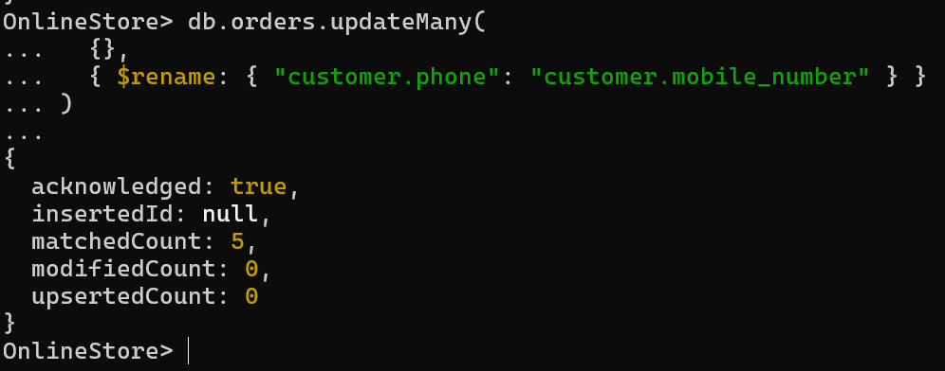

Q11. Create index on customer email

db.orders.createIndex({ "customer.email": 1 })



Q12. Export the data using `mongoexport` for reporting purposes.

mongoexport --db=OnlineStore --collection=orders --out=orders.json

--(for specific path)

mongoexport --db=OnlineStore --collection=orders --out=C:\Users\sjlak\Downloads\orders.json  
  
