Prerequisites

## Course Prerequisites

This course assumes a willingness to learn. No previous coding experience is required, but familiarity with transport planning concepts will be beneficial.

You must have a GitHub account and have saved your username. We will cover version control concepts in the course.

## Software Prerequisites

You should bring a laptop with the following software installed and tested:

* A modern web browser (e.g., Chrome, Firefox, Edge).
* A text editor (e.g., VS Code, Notepad++).
* The gh command-line tool (see [cli.github.com](https://cli.github.com/) for installation and set-up instructions).

## Recommended Online Courses

To prepare for this course, we recommend watching the following short video:

* [Introduction to AI Fluency](https://www.youtube.com/watch?v=JpGtOfSgR-c) by Anthropic (Lesson 1, ~5 minutes).

And taking these short but very useful online courses:

* [Intro to GitHub](https://github.com/skills/introduction-to-github) (should take less than an hour).
* [Communicate using Markdown](https://github.com/skills/communicate-using-markdown) (should take around 30 minutes or less).

## Testing your setup

You can test your setup by running the following code in Python or R.

## Python

import osmnx as ox  
import geopandas as gpd  
import matplotlib.pyplot as plt  
import shapely  
  
# Centered on London  
study_point = shapely.Point(-0.1278, 51.5074)  
study_geom = gpd.GeoSeries([study_point], crs=4326)  
study_polygon = study_geom.to_crs(epsg=3857).buffer(8000).to_crs(epsg=4326).unary_union  
study_polygon_gpd = gpd.GeoDataFrame(geometry=[study_polygon], crs="EPSG:4326")  
tags = {"highway": True, "maxspeed": True, "lit": True, "cycleway": True}  
gdf = ox.features_from_polygon(study_polygon, tags)  
gdf = gdf[gdf.geom_type.isin(["LineString", "MultiLineString"])]  
gdf = gdf.to_crs(epsg=3857)  
gdf.plot(column="maxspeed", figsize=(10, 10), legend=True)  
plt.show()

## R

options(repos = c(CRAN = "https://cloud.r-project.org"))  
if (!require("pak")) install.packages("pak")  
pkgs = c(  
 "sf",  
 "tidyverse",  
 "tmap",  
 "tmaptools",  
 "osmextract"  
)  
pak::pak(pkgs)  
library(tidyverse)  
library(sf)  
# Centered on London  
study_area = st_point(c(-0.1278, 51.5074)) |>  
 st_sfc(crs = 4326) |>  
 st_transform(27700) |>  
 st_buffer(8000) |>  
 st_transform(4326)  
extra_tags = c(  
 "maxspeed",  
 "lit",  
 "cycleway"  
)  
osm_network = osmextract::oe_get(  
 place = study_area,  
 boundary = study_area,  
 boundary_type = "clipsrc",  
 extra_tags = extra_tags  
)

osm_network |>  
 select(maxspeed) |>  
 plot()

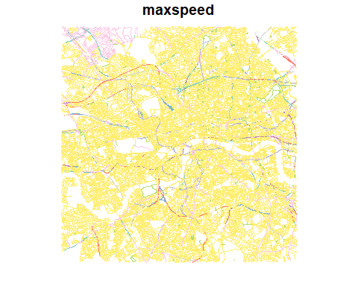

Let us know how you get on and if you have any issues getting set up, either by email, or (preferably) via the Discussion forum on GitHub associated with this course repository.