Repeat Assessment

You are going to create a Movie application which looks like that in the screenshot below.

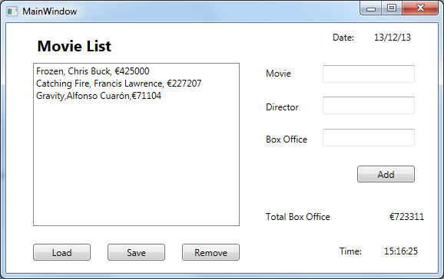

|  |  |  |  |  |  |  |  |  |  |  |  |  |  |  |  |  |  |  |  |  |  |  |  |  |  |
| --- | --- | --- | --- | --- | --- | --- | --- | --- | --- | --- | --- | --- | --- | --- | --- | --- | --- | --- | --- | --- | --- | --- | --- | --- | --- |
| **Functionality**  Tasks you need to complete   1. Create the GUI 2. Create a Movie class with the following attributes  * Title * Director * Box Office Receipts  1. You should be able to add Movie information using the controls at the side of the screen 2. You should be able to delete movie information by selecting an item in the listbox and clicking remove. 3. The total field should keep an updated total of the box office receipts displayed 4. You should be able to load movie information from a text file 5. You should be able to save the listbox information to a text file 6. You should be able to display both date and time on the screen. Time should update every second | **Marking Scheme**   |  |  | | --- | --- | | GUI Layout | 5 | | Album Class | 5 | | Date | 5 | | Time | 5 | | Add Button | 5 | | Remove Button | 5 | | Running total | 5 | | File Load | 5 | | File Save | 5 | | Style/Comments etc | 5 | |  |  | |  | 50 | |