Project 5 Graph
Assigned：Nov. 5th
Due time: Nov. 19th
ADT of Graph:
Structure Undirected Graph is an object composed of a nonempty set of vertices and a set of undirected edges, where each edge is a pair of vertices
Functions: for all graph ∈Graph, v, v1 and v2 ∈ Vertices
Graph Create(), return an empty graph
Graph InsertVertex(graph, v), return a graph with v inserted. v has no incident edge.
Graph InsertEdge(graph, v1,v2), return a graph with new edge between v1 and v2
Graph DeleteVertex(graph, v), return a graph in which v and all edges incident to it are removed
Graph DeleteEdge(graph, v1, v2), return a graph in which the edge (v1, v2) is removed
Boolean IsEmpty(graph), if the graph is empty return TRUE else return FALSE

Use adjacency list as the storage structure. Finish the following tasks:
- Realize all the above functions
- Use the functions to implement the graph shown in Fig. 1
- Traverse the graph in BFS manner.
- Output the adjacency list
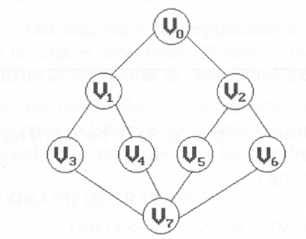
Fig. 1 An undirected graph

