# Import pandas
import pandas as pd
import numpy as np
# Read in white wine data
white = pd.read_csv("http://archive.ics.uci.edu/ml/machine-learning-databases/wine-quality/winequality-white.csv", sep=';')
# Read in red wine data
red = pd.read_csv("http://archive.ics.uci.edu/ml/machine-learning-databases/wine-quality/winequality-red.csv", sep=';')
# Print info on white wine
print(white.info())
# Print info on red wine
print(red.info())
<class 'pandas.core.frame.DataFrame'>
RangeIndex: 4898 entries, 0 to 4897
Data columns (total 12 columns):
fixed acidity 4898 non-null float64
volatile acidity 4898 non-null float64
citric acid 4898 non-null float64
residual sugar 4898 non-null float64
chlorides 4898 non-null float64
free sulfur dioxide 4898 non-null float64
total sulfur dioxide 4898 non-null float64
density 4898 non-null float64
pH 4898 non-null float64
sulphates 4898 non-null float64
alcohol 4898 non-null float64
quality 4898 non-null int64
dtypes: float64(11), int64(1)
memory usage: 459.3 KB
None
<class 'pandas.core.frame.DataFrame'>
RangeIndex: 1599 entries, 0 to 1598
Data columns (total 12 columns):
fixed acidity 1599 non-null float64
volatile acidity 1599 non-null float64
citric acid 1599 non-null float64
residual sugar 1599 non-null float64
chlorides 1599 non-null float64
free sulfur dioxide 1599 non-null float64
total sulfur dioxide 1599 non-null float64
density 1599 non-null float64
pH 1599 non-null float64
sulphates 1599 non-null float64
alcohol 1599 non-null float64
quality 1599 non-null int64
dtypes: float64(11), int64(1)
memory usage: 150.0 KB
None
white.describe()
fixed acidity volatile acidity citric acid residual sugar \
count 4898.000000 4898.000000 4898.000000 4898.000000
mean 6.854788 0.278241 0.334192 6.391415
std 0.843868 0.100795 0.121020 5.072058
min 3.800000 0.080000 0.000000 0.600000
25% 6.300000 0.210000 0.270000 1.700000
50% 6.800000 0.260000 0.320000 5.200000
75% 7.300000 0.320000 0.390000 9.900000
max 14.200000 1.100000 1.660000 65.800000
chlorides free sulfur dioxide total sulfur dioxide density \
count 4898.000000 4898.000000 4898.000000 4898.000000
mean 0.045772 35.308085 138.360657 0.994027
std 0.021848 17.007137 42.498065 0.002991
min 0.009000 2.000000 9.000000 0.987110
25% 0.036000 23.000000 108.000000 0.991723
50% 0.043000 34.000000 134.000000 0.993740
75% 0.050000 46.000000 167.000000 0.996100
max 0.346000 289.000000 440.000000 1.038980
pH sulphates alcohol quality
count 4898.000000 4898.000000 4898.000000 4898.000000
mean 3.188267 0.489847 10.514267 5.877909
std 0.151001 0.114126 1.230621 0.885639
min 2.720000 0.220000 8.000000 3.000000
25% 3.090000 0.410000 9.500000 5.000000
50% 3.180000 0.470000 10.400000 6.000000
75% 3.280000 0.550000 11.400000 6.000000
max 3.820000 1.080000 14.200000 9.000000
red.describe()
fixed acidity volatile acidity ... alcohol quality
count 1599.000000 1599.000000 ... 1599.000000 1599.000000
mean 8.319637 0.527821 ... 10.422983 5.636023
std 1.741096 0.179060 ... 1.065668 0.807569
min 4.600000 0.120000 ... 8.400000 3.000000
25% 7.100000 0.390000 ... 9.500000 5.000000
50% 7.900000 0.520000 ... 10.200000 6.000000
75% 9.200000 0.640000 ... 11.100000 6.000000
max 15.900000 1.580000 ... 14.900000 8.000000
[8 rows x 12 columns]
pd.isnull(red).count()
fixed acidity 1599
volatile acidity 1599
citric acid 1599
residual sugar 1599
chlorides 1599
free sulfur dioxide 1599
total sulfur dioxide 1599
density 1599
pH 1599
sulphates 1599
alcohol 1599
quality 1599
dtype: int64
pd.isnull(white).count()
fixed acidity 4898
volatile acidity 4898
citric acid 4898
residual sugar 4898
chlorides 4898
free sulfur dioxide 4898
total sulfur dioxide 4898
density 4898
pH 4898
sulphates 4898
alcohol 4898
quality 4898
dtype: int64
%matplotlib inline
import matplotlib.pyplot as plt
fig, ax = plt.subplots(1, 2)
ax[0].hist(red.alcohol, 10, facecolor='red', alpha=0.5, label="Red wine")
ax[1].hist(white.alcohol, 10, facecolor='white', ec="black", lw=0.5, alpha=0.5, label="White wine")
fig.subplots_adjust(left=0, right=1, bottom=0, top=0.5, hspace=0.05, wspace=1)
ax[0].set_ylim([0, 1000])
ax[0].set_xlabel("Alcohol in % Vol")
ax[0].set_ylabel("Frequency")
ax[1].set_xlabel("Alcohol in % Vol")
ax[1].set_ylabel("Frequency")
#ax[0].legend(loc='best')
#ax[1].legend(loc='best')
fig.suptitle("Distribution of Alcohol in % Vol")
plt.show()
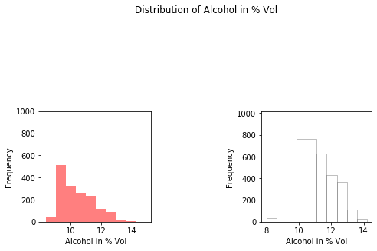
import seaborn as sns
sns.pairplot(data=red, diag_kind = 'kde')
C:\Users\Mukesh\Anaconda3\lib\site-packages\scipy\stats\stats.py:1706: FutureWarning: Using a non-tuple sequence for multidimensional indexing is deprecated; use `arr[tuple(seq)]` instead of `arr[seq]`. In the future this will be interpreted as an array index, `arr[np.array(seq)]`, which will result either in an error or a different result.
return np.add.reduce(sorted[indexer] * weights, axis=axis) / sumval
<seaborn.axisgrid.PairGrid at 0x2118e436da0>
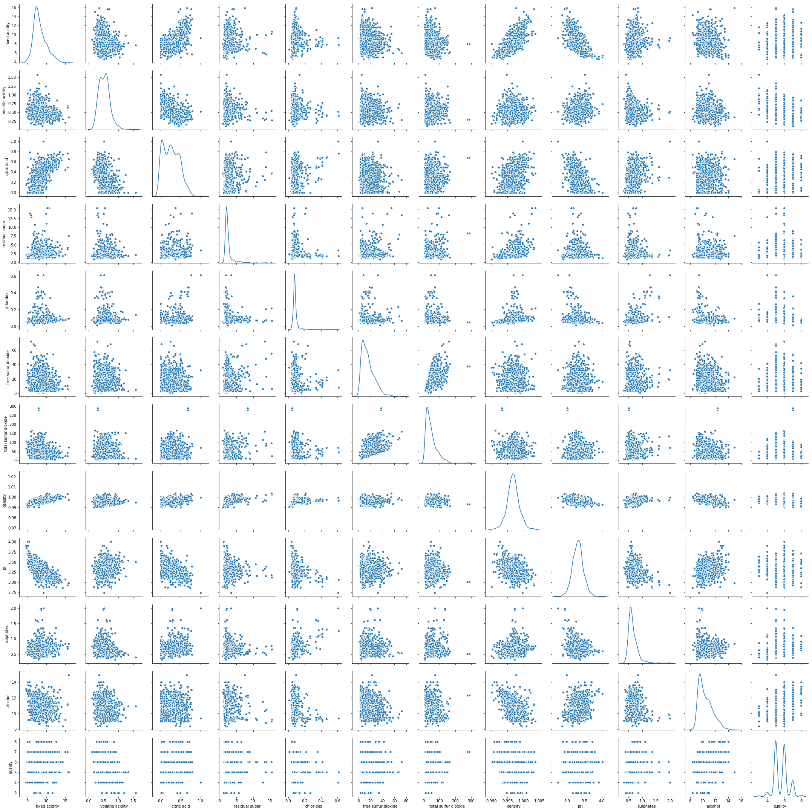
sns.pairplot(data=white, diag_kind = 'kde')
C:\Users\Mukesh\Anaconda3\lib\site-packages\scipy\stats\stats.py:1706: FutureWarning: Using a non-tuple sequence for multidimensional indexing is deprecated; use `arr[tuple(seq)]` instead of `arr[seq]`. In the future this will be interpreted as an array index, `arr[np.array(seq)]`, which will result either in an error or a different result.
return np.add.reduce(sorted[indexer] * weights, axis=axis) / sumval
<seaborn.axisgrid.PairGrid at 0x2118869f4e0>
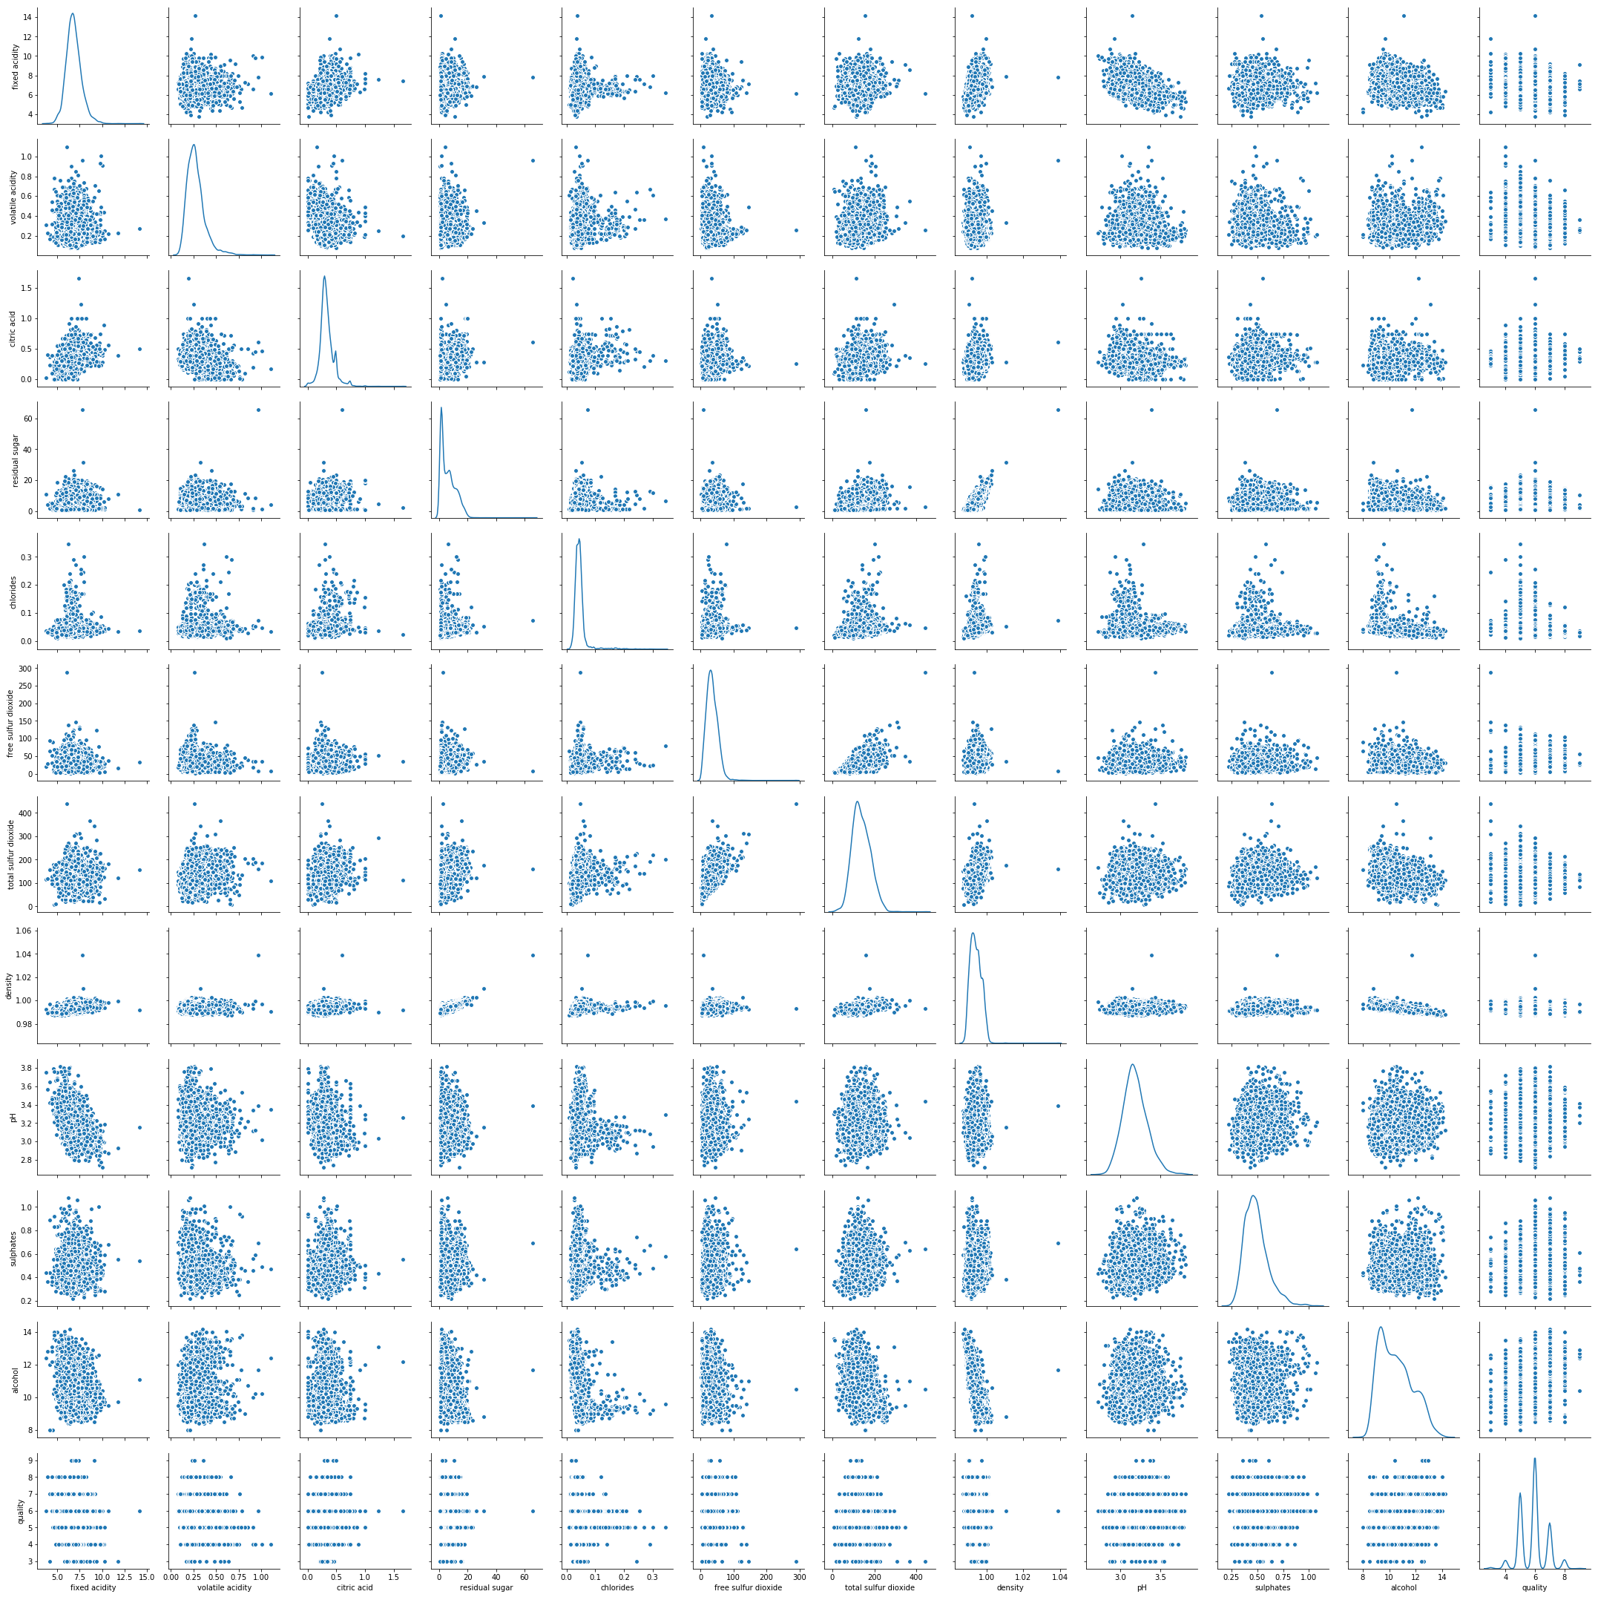
# Add `type` column to `red` with value 1
red['type'] = 1
# Add `type` column to `white` with value 0
white['type'] = 0
# Append `white` to `red`
wines = red.append(white, ignore_index=True)
wines.tail()
fixed acidity volatile acidity citric acid residual sugar chlorides \
6492 6.2 0.21 0.29 1.6 0.039
6493 6.6 0.32 0.36 8.0 0.047
6494 6.5 0.24 0.19 1.2 0.041
6495 5.5 0.29 0.30 1.1 0.022
6496 6.0 0.21 0.38 0.8 0.020
free sulfur dioxide total sulfur dioxide density pH sulphates \
6492 24.0 92.0 0.99114 3.27 0.50
6493 57.0 168.0 0.99490 3.15 0.46
6494 30.0 111.0 0.99254 2.99 0.46
6495 20.0 110.0 0.98869 3.34 0.38
6496 22.0 98.0 0.98941 3.26 0.32
alcohol quality type
6492 11.2 6 0
6493 9.6 5 0
6494 9.4 6 0
6495 12.8 7 0
6496 11.8 6 0
# Import `train_test_split` from `sklearn.model_selection`
from sklearn.model_selection import train_test_split
# Specify the data
X=wines.ix[:,0:11]
# Specify the target labels and flatten the array
y= np.ravel(wines.type)
#y= wines.type
# Split the data up in train and test sets
X_train, X_test, y_train, y_test = train_test_split(X, y, test_size=0.30, random_state=42)
d:\Anaconda3\lib\site-packages\ipykernel_launcher.py:5: FutureWarning:
.ix is deprecated. Please use
.loc for label based indexing or
.iloc for positional indexing
See the documentation here:
http://pandas.pydata.org/pandas-docs/stable/user_guide/indexing.html#ix-indexer-is-deprecated
"""
d:\Anaconda3\lib\site-packages\pandas\core\indexing.py:822: FutureWarning:
.ix is deprecated. Please use
.loc for label based indexing or
.iloc for positional indexing
See the documentation here:
http://pandas.pydata.org/pandas-docs/stable/user_guide/indexing.html#ix-indexer-is-deprecated
retval = getattr(retval, self.name)._getitem_axis(key, axis=i)
y_test[0:10]
array([0, 1, 0, 0, 0, 1, 0, 0, 1, 0])
# Import `StandardScaler` from `sklearn.preprocessing`
from sklearn.preprocessing import StandardScaler
# Define the scaler
scaler = StandardScaler().fit(X_train)
# Scale the train set
X_train = scaler.transform(X_train)
# Scale the test set
X_test = scaler.transform(X_test)

Deep Neural Network
# Using Tensorflow Keras instead of the original Keras
from tensorflow.keras import Sequential
from tensorflow.keras.layers import Dense
# define the model architecture
# Initialize the constructor
model = Sequential()
# Add an input layer
model.add(Dense(12, activation='sigmoid', input_shape=(11,)))
# Add one hidden layer
model.add(Dense(8, activation='sigmoid'))
# Add an output layer
model.add(Dense(1, activation='sigmoid'))
model.compile(loss='binary_crossentropy',
optimizer='adam',
metrics=['accuracy'])
history = model.fit(X_train, y_train,epochs=20, batch_size=1, verbose=1)
Train on 4547 samples
Epoch 1/20
4547/4547 [==============================] - 10s 2ms/sample - loss: 0.1606 - accuracy: 0.9468
Epoch 2/20
4547/4547 [==============================] - 9s 2ms/sample - loss: 0.0325 - accuracy: 0.9934
Epoch 3/20
4547/4547 [==============================] - 9s 2ms/sample - loss: 0.0265 - accuracy: 0.9949
Epoch 4/20
4547/4547 [==============================] - 9s 2ms/sample - loss: 0.0245 - accuracy: 0.9947
Epoch 5/20
4547/4547 [==============================] - 9s 2ms/sample - loss: 0.0229 - accuracy: 0.9947
Epoch 6/20
4547/4547 [==============================] - 9s 2ms/sample - loss: 0.0223 - accuracy: 0.9956
Epoch 7/20
4547/4547 [==============================] - 9s 2ms/sample - loss: 0.0209 - accuracy: 0.9960
Epoch 8/20
4547/4547 [==============================] - 9s 2ms/sample - loss: 0.0203 - accuracy: 0.9958
Epoch 9/20
4547/4547 [==============================] - 9s 2ms/sample - loss: 0.0197 - accuracy: 0.9960
Epoch 10/20
4547/4547 [==============================] - 9s 2ms/sample - loss: 0.0191 - accuracy: 0.9963
Epoch 11/20
4547/4547 [==============================] - 9s 2ms/sample - loss: 0.0187 - accuracy: 0.9963
Epoch 12/20
4547/4547 [==============================] - 9s 2ms/sample - loss: 0.0180 - accuracy: 0.9963
Epoch 13/20
4547/4547 [==============================] - 8s 2ms/sample - loss: 0.0174 - accuracy: 0.9965
Epoch 14/20
4547/4547 [==============================] - 8s 2ms/sample - loss: 0.0170 - accuracy: 0.9965
Epoch 15/20
4547/4547 [==============================] - 9s 2ms/sample - loss: 0.0166 - accuracy: 0.9967
Epoch 16/20
4547/4547 [==============================] - 9s 2ms/sample - loss: 0.0161 - accuracy: 0.9965
Epoch 17/20
4547/4547 [==============================] - 8s 2ms/sample - loss: 0.0158 - accuracy: 0.9967
Epoch 18/20
4547/4547 [==============================] - 8s 2ms/sample - loss: 0.0157 - accuracy: 0.99670s - loss: 0.0151
Epoch 19/20
4547/4547 [==============================] - 9s 2ms/sample - loss: 0.0151 - accuracy: 0.9967
Epoch 20/20
4547/4547 [==============================] - 8s 2ms/sample - loss: 0.0149 - accuracy: 0.9969
y_pred = np.round(model.predict(X_test))
y_pred[0:10]
array([[0.],
[1.],
[0.],
[0.],
[0.],
[1.],
[0.],
[0.],
[1.],
[0.]], dtype=float32)
loss, acc = model.evaluate(X_test, y_test, verbose=0)
print('Test Accuracy: %.3f' % acc)
loss, acc = model.evaluate(X_train, y_train, verbose=0)
print('Test Accuracy: %.3f' % acc)
Test Accuracy: 0.995
Test Accuracy: 0.997
from sklearn import metrics
print(pd.DataFrame(metrics.confusion_matrix(y_test, y_pred, labels=[0 ,1]), index=['true:White', 'true:Red'], columns=['pred:White', 'pred:Red']))
pred:White pred:Red
true:White 1446 2
true:Red 7 495
%matplotlib inline
from matplotlib import pyplot
from numpy import where
# plot loss during training
pyplot.subplot(211)
pyplot.title('Loss')
pyplot.plot(history.history['loss'], label='train')
pyplot.legend()
<matplotlib.legend.Legend at 0x1760a261188>
