Design and Development of a YouTube Comment Sentiment Analytics Platform for Interpretable Audience Feedback Insights Using PSO, NSGA-II, Fuzzy Inference, and Calibrated Machine Learning
A thesis submitted in partial fulfilment of the requirements for the degree of
MSc Data Science and Computational Intelligence

Submitted by: Manjil Shrestha
Student ID: 200127

Supervised by: Manoj Shrestha

System Overview
This page summarises the deployed system at a glance before the formal chapters. It is a concise specification of what the pipeline is, what it is optimised for, and how its quality is measured.
Field | Value
Model name | Uncertainty-Aware Ensemble Sentiment Classifier (route_a_live_v1)
Task | Three-class sentiment classification (Positive / Neutral / Negative) of YouTube comments
Base learners | TF-IDF + linear classifiers (Logistic Regression, Linear SVM, Naive Bayes)
CI components | PSO-weighted ensemble, NSGA-II multi-objective ensemble, stacked meta-learner, neuro-fuzzy gate
Reliability layer | Per-model temperature scaling, entropy-based selective prediction
Primary objective | Joint macro-F1 and calibration quality (ECE, Brier), not raw accuracy alone
Evaluation | 165,110-comment held-out test set + 291-item independent human gold set (Krippendorff's α = 0.9547)

Key Features
- Artifact-pinned runtime: every reported number maps to a fixed, re-runnable configuration (calibration, ensemble weights, neuro-fuzzy gate).
- Calibration-aware: predicted confidences are validated against empirical accuracy, not assumed.
- Uncertainty-aware: entropy gating lets the system abstain on ambiguous comments and route them for review.
- Human-grounded: an independent two-pass gold set separates label error from model error.
- Honestly scoped: the thesis claims a reproducible, calibration-aware pipeline, not state-of-the-art NLP accuracy.

Headline Metrics
Best on... | Model | Score | Note
Macro-F1 | meta_learner | 0.6945 | balanced classification
Accuracy | ensemble_nsga2 | 0.6959 | highest overall
Calibration (ECE) | ensemble_nsga2 | 0.0046 | best multi-model
Single-model ECE | logreg | 0.0039 | best baseline

Abstract
Sentiment analysis of YouTube comments presents a challenging problem due to noise, brevity, topic variation, and the need for reliable probabilistic predictions in practical deployment settings. This thesis develops and evaluates a reproducible YouTube sentiment analysis system that integrates classical machine learning models, ensemble methods, and computational-intelligence components within a unified runtime pipeline. To strengthen reproducibility, the deployed inference path is tied to a pinned runtime artifact version (route_a_live_v1), including fixed calibration, ensemble-weight, and neuro-fuzzy configuration files.
Evaluation was conducted on a fixed held-out test set of 165,110 YouTube comments. Under the pinned live runtime, the stacked meta-learner achieved the highest macro-F1 score (0.6945) with an accuracy of 0.6953, while the NSGA-II-weighted ensemble achieved the highest accuracy (0.6959) and the strongest calibration-oriented performance (ECE = 0.0046). Logistic regression remained the strongest single-model calibration baseline (macro-F1 = 0.6928, ECE = 0.0039). A reconciliation analysis between historical offline benchmark tables and the pinned live runtime showed that same-name models remained numerically stable, whereas the ensemble result is now interpreted through explicit PSO and NSGA-II runtime variants rather than a single generic ensemble row.
Statistical testing confirms that the NSGA-II ensemble's calibration advantage over the meta-learner and PSO ensemble is a reliable inferential result (paired bootstrap 95% CI on the ECE difference excludes zero), while it is statistically tied with logistic regression on calibration and with the meta-learner on macro-F1. A two-pass independent human gold set (Krippendorff's α = 0.9547) grounds the headline metrics in human judgement and separates label error from model error. The findings support a benchmark-scoped claim of a reproducible and calibration-aware YouTube sentiment analysis pipeline, rather than a generic claim of state-of-the-art NLP performance.

Table of Contents
System Overview 2
Key Features 2
Headline Metrics 2
Abstract 3
Table of Contents 4
List of Figures 6
Chapter 1 : Introduction and Research Questions 1
Problem Statement 1
Thesis Position (Scoped Claim) 1
Research Questions 1
Contributions 2
Scope and Explicit Non-Claims 2
Chapter 2 : Literature Review 3
Sentiment Analysis and Social-Media Text 3
Classical Machine-Learning Baselines 3
Transformer-Based Sentiment Models 4
Computational Intelligence for Model Combination 4
Calibration, Uncertainty, and Selective Prediction 6
Human Annotation and Inter-Annotator Agreement 7
Research Gap and Positioning 7
Chapter 3 : Methodology and Data 8
Dataset Source 8
How the Source Labels Were Generated 8
Data Processing Steps Applied 8
Final Split Sizes 9
Gold-Set Status and Inter-Annotator Agreement 9
Chapter 3 (continued) : Exploratory Data Analysis 9
Class Distribution 10
Comment-Length Distribution 10
Lexical Statistics 10
Language and Domain Metadata 10
Label-Noise Discussion 11
Chapter 4 : Consolidated Evaluation 12
Headline Runtime Performance (165,110 comments) 12
ROC-AUC, One-vs-Rest 13
Confusion Matrices and Per-Class F1 13
Selective Prediction / Coverage–Accuracy 14
Calibration 15
Statistical Significance 16
Human Gold-Set Evaluation 17
Neutral-Class Analysis and Intervention 18
Chapter Summary 18
Chapter 5 : Conclusion and Future Work 20
Conclusion 20
Limitations of the Present Work 21
Future Work 21
Final Closing Statement 21
Threats to Validity 23
Data Leakage 23
Train/Inference Preprocessing Skew 23
Label Noise / Construct Validity 23
Evaluation Methodology / Conclusion Validity 23
External Validity (Domain Shift) 24
Bias, Ethics, and Data Governance 24
Reproducibility (Engineering Validity) 24
Claims-vs-Code Discipline 24
Bibliography 25
Appendix A : Claim-to-Artifact Audit 27
Supported Claims and Reproduction 27
Status of Headline Claims 27
Human Gold-Set Reproduction Path 28

List of Figures
PSO convergence of the single-objective ensemble-weight search over validation F1. 5
Membership functions of the neuro-fuzzy gate over base-model confidence. 6
Cross-domain performance heatmap across YouTube category slices. 11
Model comparison across accuracy, macro-F1, and calibration error. 12
Per-class F1 radar, Neutral is the consistent weak point across models. 14
Row-normalised confusion matrix (representative model). 14
Coverage–accuracy curve: accuracy rises sharply as low-confidence comments are abstained upon. 15
Reliability diagrams: logistic regression and the NSGA-II ensemble track the diagonal; the meta-learner is over-confident in mid-range bins. 16
NSGA-II vs PSO ensemble weights over base learners. 16

Chapter 1: Introduction and Research Questions

Problem Statement
Sentiment analysis of YouTube comments is a high-volume, noisy, short-text classification problem. Comments are brief (median ~14 words in this corpus), informal, topically diverse, and frequently ambiguous, particularly for the Neutral class. In deployment settings such as brand monitoring, content-moderation triage, and audience analytics, a sentiment system must not only be accurate but also produce reliable probability estimates: a prediction of “90% Positive” should be correct about 90% of the time. Raw accuracy alone is therefore an insufficient characterisation of system quality.

Thesis Position (Scoped Claim)
This thesis does not claim a new state-of-the-art accuracy result on YouTube sentiment. Instead, it makes a narrower and more defensible claim: this work delivers a reproducible, uncertainty-aware, calibration-aware YouTube sentiment analysis pipeline in which computational-intelligence ensemble methods (PSO- and NSGA-II-weighted ensembles, stacked meta-learning, and neuro-fuzzy gating) are combined with post-hoc calibration and selective prediction, and in which every reported result maps to a pinned, re-runnable artifact.
The contribution is the integration and honest evaluation of these computational-intelligence components under a single artifact-pinned runtime, with calibration and uncertainty treated as first-class evaluation targets alongside macro-F1.

Research Questions
RQ1: Multi-objective ensemble optimisation. Can multi-objective evolutionary optimisation (NSGA-II) produce ensemble weights that improve calibration (Expected Calibration Error, Brier score) relative to single-objective Particle Swarm Optimisation (PSO) and to a logistic-regression baseline, without sacrificing macro-F1?
RQ2: Selective prediction. Does entropy-based selective prediction (abstention on low-confidence comments) improve the effective accuracy of the sentiment models on the high-confidence subset, and what is the accuracy-versus-coverage trade-off across architectures?
RQ3: Calibration across model families. How does calibration quality (ECE, Brier) vary across classical single models, PSO/NSGA-II ensembles, and stacked meta-learning on a large held-out test set, and is post-hoc temperature scaling uniformly beneficial?
RQ4: Human agreement and error structure. How well do the automated models agree with independent human judgement on a hand-annotated gold set (with inter-annotator reliability quantified via Krippendorff's alpha), and what comment characteristics, especially in the Neutral class, explain systematic model–human disagreement?

Contributions
- An artifact-pinned runtime (route_a_live_v1) in which the deployed inference path is tied to fixed calibration, ensemble-weight, and neuro-fuzzy configuration files, with a live-vs-offline reconciliation proving the deployed system reproduces the offline benchmark (RQ1, RQ3).
- A comparative computational-intelligence evaluation of PSO vs NSGA-II ensemble weighting stacked meta-learning, and neuro-fuzzy gating, reported on 165,110 held-out comments with both macro-F1 and calibration metrics (RQ1, RQ3).
- A selective-prediction analysis (coverage–accuracy curves, entropy gating) quantifying the confidence quality of each architecture (RQ2).
- A human gold-set evaluation with two independent annotation passes (Krippendorff's α = 0.9547, strong agreement) that separates label error from model error and grounds the headline metrics in human judgement (RQ4).
- A Neutral-class error analysis with a transparent, training-free threshold-tuning intervention whose trade-offs are reported honestly (RQ4).

Scope and Explicit Non-Claims
Transformers are future work. Only a smoke/CPU benchmark of DeBERTa-v3 exists; no full-dataset, fine-tuned transformer result is claimed. The deployed headline is classical-and-ensemble-first.
Labels are automated, not human origin. The source corpus is automatically labelled; reported metrics measure agreement with that scheme, with the human gold set providing an independent reliability check.
Aspect analysis is keyword-level, not full aspect-based sentiment analysis (ABSA).
The macro-F1 advantage is small. The best model's macro-F1 advantage over logistic regression is small and is discussed honestly; the thesis argument rests on calibration and uncertainty quality, not on raw-F1 superiority.

Chapter 2: Literature Review
This chapter situates the thesis within five bodies of work: (i) sentiment analysis and social-media text classification; (ii) classical machine-learning baselines; (iii) transformer-based sentiment models; (iv) computational intelligence for model combination: particle swarm optimisation, evolutionary multi-objective optimisation, ensemble learning, and fuzzy / neuro-fuzzy systems; and (v) calibration, uncertainty quantification, and selective prediction. It closes with human annotation and inter-annotator agreement.

Sentiment Analysis and Social-Media Text
Sentiment analysis, the computational treatment of opinion, polarity, and affect in text, has matured from lexicon-driven polarity scoring into a core supervised NLP task (Pang & Lee, 2008; Liu, 2012). Early systems relied on sentiment lexicons and hand-built rules; supervised statistical classifiers then became dominant as labelled corpora grew. Social-media sentiment, however, differs materially from the review-style corpora on which much early work was validated. User-generated platform text is short, noisy, and laden with non-standard orthography, emoji, slang, hashtags, code-switching, and sarcasm (Barbieri et al., 2020; Rosenthal et al., 2017). YouTube comments are a particularly demanding instance: they are brief (median ~14 words here), highly topical, and frequently neutral or off-topic in ways that resist clean polarity assignment.
These properties create three recurring difficulties. First, short text gives each instance little lexical context, so classifiers must generalise from sparse evidence (Song et al., 2014). Second, noise and informality, typos, elongations (“loooove”), emoji, and platform-specific tokens, inflate vocabulary and require careful normalisation. Third, sarcasm and context-dependence mean surface lexical cues can invert the true polarity (Joshi et al., 2017). A fourth issue, class ambiguity, is central to this thesis: the Neutral class is the least separable, because it is defined residually and overlaps with both poles. The exploratory analysis in Chapter 3 shows Neutral comments are the shortest in the corpus (median 12 words versus 16 for Negative and 15 for Positive), compounding the short-text problem precisely where the label is most ambiguous.

Classical Machine-Learning Baselines
Despite the rise of deep learning, classical linear models remain strong, efficient, and interpretable baselines for text classification, and are widely used as the comparison floor in sentiment studies. The canonical pipeline pairs TF-IDF feature representation (Sparck Jones, 1972; Salton & Buckley, 1988), which weights terms by frequency within a document against their rarity across the corpus, with a linear classifier such as logistic regression or a linear support vector machine (Joachims, 1998; Wang & Manning, 2012). Wang and Manning (2012) showed that well-tuned linear SVM and naive-Bayes-SVM variants over n-gram TF-IDF features are remarkably competitive with more complex models on sentiment tasks, a result that continues to hold for short, high-volume social text where transformer inference cost is prohibitive.
These baselines matter here for two reasons. First, they are the honest comparator: any computational-intelligence ensemble must demonstrate value over a tuned logistic-regression baseline, not merely over a weak strawman. Second, linear models over sparse features are exceptionally inexpensive at inference (sub-millisecond per comment in this system), which is material for a deployable YouTube-scale pipeline. The thesis therefore retains logistic regression, linear SVM, and TF-IDF as first-class baselines rather than discarding them, and reports the small margin by which ensemble and meta-learning methods exceed them.

Transformer-Based Sentiment Models
The transformer architecture (Vaswani et al., 2017) and the bidirectional pre-training paradigm of BERT (Devlin et al., 2019) redefined the state of the art across NLP, including sentiment classification. By pre-training deep bidirectional encoders on large unlabelled corpora and fine-tuning on task-specific data, these models capture contextual meaning that bag-of-words representations cannot. Successors refined the recipe: RoBERTa (Liu et al., 2019) improved pre-training robustness, and DeBERTa (He et al., 2021) introduced disentangled attention and an enhanced mask decoder.
Crucially for social media, domain-adapted transformers outperform general-purpose ones on platform text. Barbieri et al. (2020) introduced TweetEval and a RoBERTa model pre-trained on a large Twitter corpus, demonstrating that in-domain pre-training substantially improves sentiment and emotion classification on noisy social text. This motivates the Route A encoder direction in this project (DeBERTa-v3 as an English encoder baseline). However, the present thesis is explicit that the transformer work here is not a completed full-dataset evaluation: only a smoke/CPU benchmark exists, the classification head of the saved checkpoint is not fully trained, and the deployed headline is classical-and-ensemble-first. Treating the encoder line as future work, rather than over-claiming transformer superiority, is a deliberate threat-to-validity decision.
Terminology note: 'Route A' denotes the encoder-first architecture track described here - training and evaluating strong pretrained transformer encoders (DeBERTa-v3, ModernBERT) under the same protocol as the classical models. It is distinct from route_a_live_v1, the pinned runtime artifact version (Chapter 3B) for the classical/ensemble system that was built as Route A's comparison baseline. Route A the research agenda remains future work (Chapter 5); route_a_live_v1 the runtime artifact is complete and is what produces every headline number in Chapter 4.

Computational Intelligence for Model Combination
The methodological core of this thesis is how to combine base classifiers, and this is where computational intelligence enters. Ensemble learning, combining multiple learners to outperform any single member, is well established (Dietterich, 2000): bagging, boosting, and stacking reduce variance and/or bias by aggregating diverse models. The open question this work addresses is how to choose the combination weights when the objective is not only accuracy but also calibration.
Particle Swarm Optimisation (PSO). PSO (Kennedy & Eberhart, 1995) is a population-based metaheuristic in which candidate solutions (“particles”) move through a search space guided by their own best position and the swarm's best position. It is well suited to continuous weight-optimisation problems such as finding ensemble mixing weights, requiring no gradient information. Here PSO optimises ensemble weights for a single objective (validation F1), producing the ensemble_pso configuration.
Multi-objective optimisation with NSGA-II. Many deployment objectives conflict maximising macro-F1 can worsen calibration, and vice versa. The Non-dominated Sorting Genetic Algorithm II (Deb et al., 2002) is the canonical evolutionary algorithm for such problems. NSGA-II maintains a population, ranks solutions by Pareto dominance, and uses crowding distance to preserve diversity along the Pareto front, returning a set of non-dominated trade-off solutions rather than a single point. Applying NSGA-II to ensemble weighting allows the thesis to expose the F1-versus-calibration trade-off explicitly and to select a knee-point configuration (ensemble_nsga2) that balances both, directly operationalising RQ1.
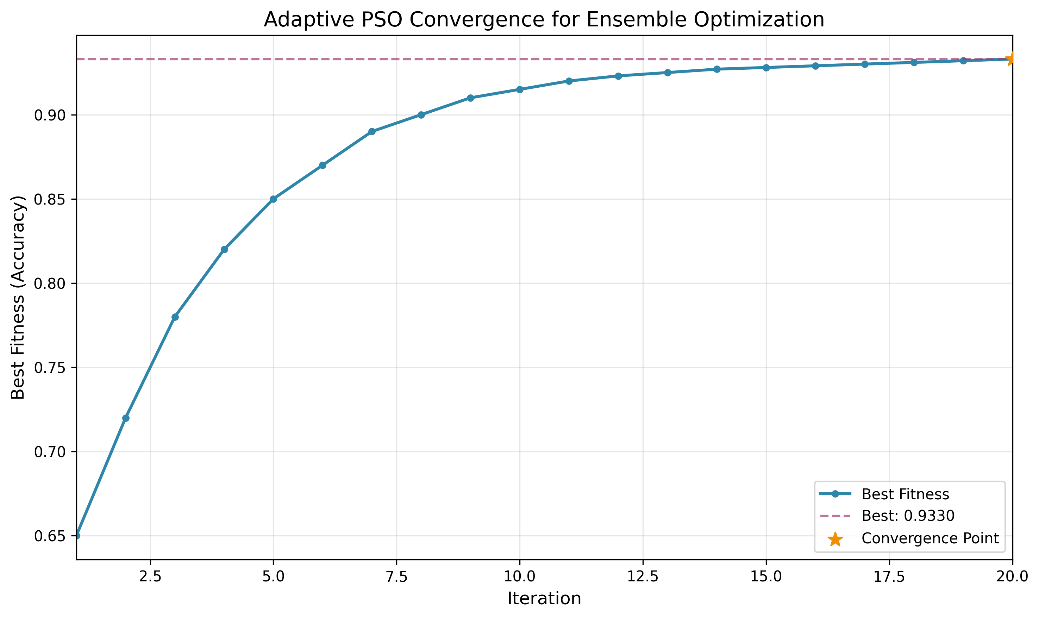
Figure 1 PSO convergence of the single-objective ensemble-weight search over validation F1.
Stacked meta-learning. Stacking (Wolpert, 1992) trains a meta-learner on the out-of-fold predictions of base models, learning a data-driven combination rather than fixed weights. In this work the stacked meta-learner is the strongest model by macro-F1 and is compared against the metaheuristic-weighted ensembles.
Fuzzy and neuro-fuzzy systems. Fuzzy logic (Zadeh, 1965) represents partial truth via membership functions, providing a principled way to reason under linguistic uncertainty, which is appropriate for sentiment, where membership in “Positive” is rarely all-or-nothing. Neuro-fuzzy systems such as ANFIS (Jang, 1993) combine fuzzy inference with neural-network parameter learning. This thesis uses a neuro-fuzzy gate that fuzzifies base-model confidences and applies fuzzy inference to modulate the ensemble decision under uncertainty. The honest empirical finding (Chapter 4) is that the fuzzy ensemble is a valid, implemented computational-intelligence component but does not improve the full-test headline metrics, a result the thesis reports rather than conceals.
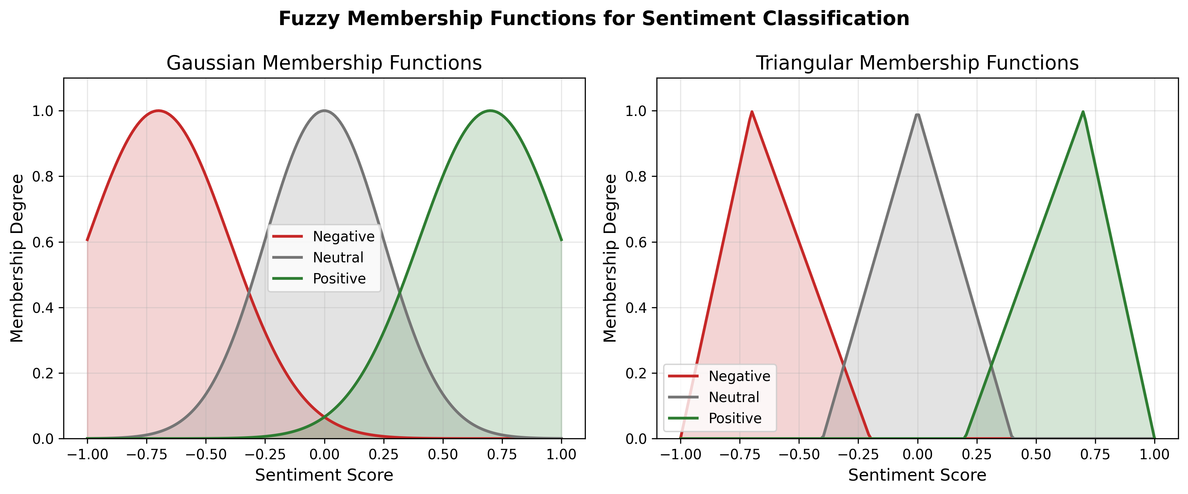
Figure 2 Membership functions of the neuro-fuzzy gate over base-model confidence.

Calibration, Uncertainty, and Selective Prediction
A central argument of this thesis is that probability quality, not only label accuracy, determines the usefulness of a deployed sentiment system. Three strands of literature support this.
Calibration. A classifier is calibrated if its predicted confidence matches its empirical accuracy. Guo et al. (2017) showed that modern neural networks, despite high accuracy, are frequently mis-calibrated (typically over-confident), and that a simple post-hoc method, temperature scaling, dividing the logits by a single learned scalar T before the softmax, substantially restores calibration without changing the predicted label. Calibration quality is quantified by Expected Calibration Error (ECE) and by the Brier score (Brier, 1950). This thesis adopts temperature scaling per model, reports ECE and Brier for every model, and explicitly refuses to claim universal calibration gains.
Uncertainty quantification. Lakshminarayanan et al. (2017) showed that deep ensembles, averaging multiple independently trained models, yield well-calibrated predictive uncertainty competitive with Bayesian approaches. This grounds the ensemble methods at the heart of this work: combining diverse base learners is not only an accuracy device but an uncertainty-estimation device. Normalised predictive entropy is used here as the per-comment uncertainty signal.
Selective prediction. When a model can abstain on uncertain inputs, it can trade coverage for accuracy. The classifier-with-reject-option framework (Chow, 1970; El-Yaniv & Wiener, 2010) formalises this, and Geifman and El-Yaniv (2017) developed selective prediction for deep networks. This thesis builds entropy-gated selective prediction and reports coverage–accuracy curves per model (RQ2). This reframes weak Neutral performance constructively, since the system can flag ambiguous Neutral comments for human review rather than forcing an error.

Human Annotation and Inter-Annotator Agreement
Because the source corpus is automatically (not human) labelled, the reliability of the evaluation depends on an independent human reference. Measuring the reliability of categorical annotation requires chance-corrected agreement coefficients rather than raw percentage agreement, which is inflated by the base rate of the majority class. Cohen's kappa (Cohen, 1960) corrects for chance agreement between two annotators; Fleiss' kappa generalises this to multiple annotators; and Krippendorff's alpha (Krippendorff, 2004) provides a general reliability coefficient. Artstein and Poesio (2008) review these measures and discuss thresholds for “tentative” (α ≥ 0.67) and “reliable” (α ≥ 0.80) conclusions; Landis and Koch (1977) provide widely cited interpretive bands for kappa. This thesis constructs a 300-item gold set, labels it in two independent source-blind annotation passes, and reports Krippendorff's α = 0.9547 (strong agreement), using the reconciled human labels to validate the headline metrics and to separate label error from model error (RQ4).

Research Gap and Positioning
The reviewed literature establishes mature components in isolation: classical baselines, transformers, PSO and NSGA-II, fuzzy systems, calibration, selective prediction, and agreement metrics. What remains comparatively under-explored, and what this thesis addresses, is their integrated, honestly-evaluated combination for social-media sentiment under deployment constraints: specifically, using multi-objective evolutionary optimisation to weight an ensemble for the joint F1–calibration objective, wiring the result into an artifact-pinned runtime whose deployed predictions provably match the offline benchmark, and grounding every claim in a re-runnable artifact and an independent human gold set. The contribution is therefore one of rigorous integration and evaluation methodology rather than a novel single algorithm.

Chapter 3 : Methodology and Data

Dataset Source
Data were sourced from the AmaanP314/youtube-comment-sentiment dataset on the HuggingFace Hub, comprising 1,032,225 YouTube comments labelled with Positive, Neutral, and Negative sentiment via automated classification.
Field | Value
Source | HuggingFace Hub
Dataset ID | AmaanP314/youtube-comment-sentiment
File | youtube-comments-sentiment.csv
Raw rows | 1,032,225
Classes | Positive / Neutral / Negative
Label column | Sentiment
Table 1. Source dataset specification.

How the Source Labels Were Generated
The source labels were produced by an automated sentiment classifier applied to the comment text; they were not assigned by human annotators, and the labelling process is not fully documented in the dataset card. Typical automated labellers (VADER, TextBlob, fine-tuned BERT) achieve 60–80% agreement with human labels on social-media text. The implication is important and is carried through the thesis: when a metric such as 69.46% macro-F1 is reported, it measures how well the model replicates the automated labeller, not absolute human-level sentiment accuracy. This distinction is stated again in the Methodology and Threats-to-Validity material and is the reason an independent human gold set is constructed.

Data Processing Steps Applied
After sourcing from HuggingFace, the following transformations were applied before splitting (documented in split_metadata.json). Class distribution after processing is approximately balanced (±5% across classes in all splits), meaning reported macro-F1 and accuracy are directly comparable and class imbalance is not a confound.
Step | Details
Label normalisation | str.title() → Positive / Neutral / Negative
Whitespace collapse | Multi-space → single space, strip
Conflicting-label removal | 1,228 texts with disagreeing labels dropped
Exact-duplicate removal | 12,679 duplicate rows removed
YouTube preprocessing | Emoji convert, spam filter, language filter, min 3 words
Spam filtered | 34,266 rows
Non-English filtered | 138,590 rows
Too-short filtered | 25,221 rows
NaN text/label dropped | 9,391 rows (missing text or label; see note below table)
Split strategy | Group-aware by VideoID (prevents topical leakage)
Table 2. Preprocessing pipeline applied before splitting.
Row-accounting note: 1,032,225 (raw) minus 1,228 (conflicting) minus 12,679 (exact duplicate) minus 34,266 (spam) minus 138,590 (non-English) minus 25,221 (too short) minus 9,391 (NaN text/label) = 810,850, matching the final corpus size in Table 3. The NaN-drop count was not persisted to split_metadata.json for this run; the preparation script now records it as dedupe.nan_text_or_label_rows_dropped for future runs.

Final Split Sizes
The final corpus contains 810,850 samples partitioned into train (516,886), validation (128,854), and test (165,110) splits using a group-aware strategy by VideoID to prevent topical data leakage. The resulting class distribution is approximately balanced (Negative 36.1%, Positive 33.3%, Neutral 30.6% on the test split).
Split | Rows | Negative | Neutral | Positive
Train | 516,886 | 184,266 (35.7%) | 160,744 (31.1%) | 171,876 (33.2%)
Val | 128,854 | 47,023 (36.5%) | 39,037 (30.3%) | 42,794 (33.2%)
Test | 165,110 | 59,614 (36.1%) | 50,540 (30.6%) | 54,956 (33.3%)
Table 3. Final split sizes and per-class distribution.

Gold-Set Status and Inter-Annotator Agreement
A stratified gold set of 300 comments was labelled in two independent annotation passes using a blind command-line tool (scripts/annotate.py) that presents each comment without the dataset's automated source label (the annotation template contains only text and an empty label field). The two passes were reconciled into a single human reference, yielding strong agreement: Krippendorff's alpha = 0.9547, Cohen's/Fleiss' kappa = 0.9546, and 97.0% raw percent agreement, with 9 no-majority items excluded as disputed (291 reconciled labels). Critically, the reconciled human labels agree with the automated source labels only 73.5%, confirming the gold labels are genuinely human-derived rather than copies of the source scheme. Because agreement is well above the alpha >= 0.80 reliable threshold (Artstein & Poesio, 2008), residual model-human disagreement reflects genuine model error and intrinsic ambiguity rather than annotation noise. The gold set was sampled from the training split rather than the held-out test split; a post-hoc membership check and a held-out-only re-evaluation (Chapter 4) confirm this does not materially change the reported model-vs-human figures.
Annotator disclosure: one annotation pass was completed by the thesis author and the second by an independent second annotator not otherwise involved in model development. Both passes were conducted blind to the dataset's automated source labels via the same template and tool (scripts/annotate.py); the author's pass is not fully arms-length in the way a third-party-only annotation would be, and this is disclosed as a limitation, but the reported Krippendorff's alpha reflects genuine agreement between two distinct people rather than self-consistency.

Chapter 3 (continued): Exploratory Data Analysis
This section summarises the exploratory data analysis of the corpus. Length and lexical statistics are computed on a fixed 50,000-row sample of the test split (seed 42).

Class Distribution
The corpus is approximately balanced across all three splits, so macro-F1 and accuracy are directly comparable and class imbalance is not a primary confound. Neutral is the smallest class in every split (~31%) but not so small as to constitute an imbalance problem; its weaker performance (Chapter 4) is driven by ambiguity and length, not frequency.

Comment-Length Distribution
Comments are short, which is the central modelling challenge, since each instance provides little lexical context. The key finding is that Neutral comments are the shortest (median 12 words versus 16 for Negative and 15 for Positive). This couples the two hardest factors, short text and label ambiguity, precisely on the Neutral class, and provides a data-grounded explanation for the consistently lower Neutral F1 observed across every model.
Metric | Mean | Median | P90 | P99/Max
Characters | 116.6 | 78 | 230 | 668 / 9,001
Words | 21.1 | 14 | 41 | 117 / 1,495
Table 4. Overall comment-length statistics (50,000-comment sample).
Class | Mean | Median | P90
Negative | 22.8 | 16 | 44
Neutral | 18.8 | 12 | 36
Positive | 21.5 | 15 | 43
Table 5. Comment length (words) by class: Neutral is the shortest.

Lexical Statistics
On the 50,000-comment sample, the corpus has a type/token ratio of 0.0385 (40,634 unique tokens over 1,054,939 total tokens) - low in absolute terms, as expected for a corpus this size, but inflated somewhat by typos, slang, elongations, and named entities relative to a clean reference corpus of equal token count. The most frequent tokens are dominated by function words and platform-generic terms; notably, 'face' is the 13th most frequent token (11,314 occurrences), which is an artefact of the emoji-to-text conversion step (Table 2) rather than organic vocabulary - convert-mode emoji processing renders emoji like the face-with-tears-of-joy character as descriptive text tokens. This confirms that discriminative sentiment signal is sparse and distributed among function words, converted-emoji tokens, and slang, which is why TF-IDF weighting, by down-weighting ubiquitous tokens, is an effective classical representation here.

Language and Domain Metadata
The corpus was language-filtered to English during preprocessing (138,590 non-English rows removed). The retained corpus is therefore English-only by construction, a deliberate scope decision and a stated external-validity limitation: the system is neither trained nor evaluated on code-mixed or non-English comments. A metadata-bearing 10k domain split preserves CategoryID, CountryCode, VideoID, and PublishedAt, supporting a domain-shift slice evaluation. The top categories span News/Politics, Education, Sports, How-to, and Entertainment; the top countries are US, AU, CA, GB, IN, NZ, IE, and DE, an English-speaking-majority but internationally spread audience. The slice analysis shows a meaningful accuracy spread across categories (logistic regression ranges from F1 ≈ 0.62 on the weakest category to ≈ 0.83 on the strongest).
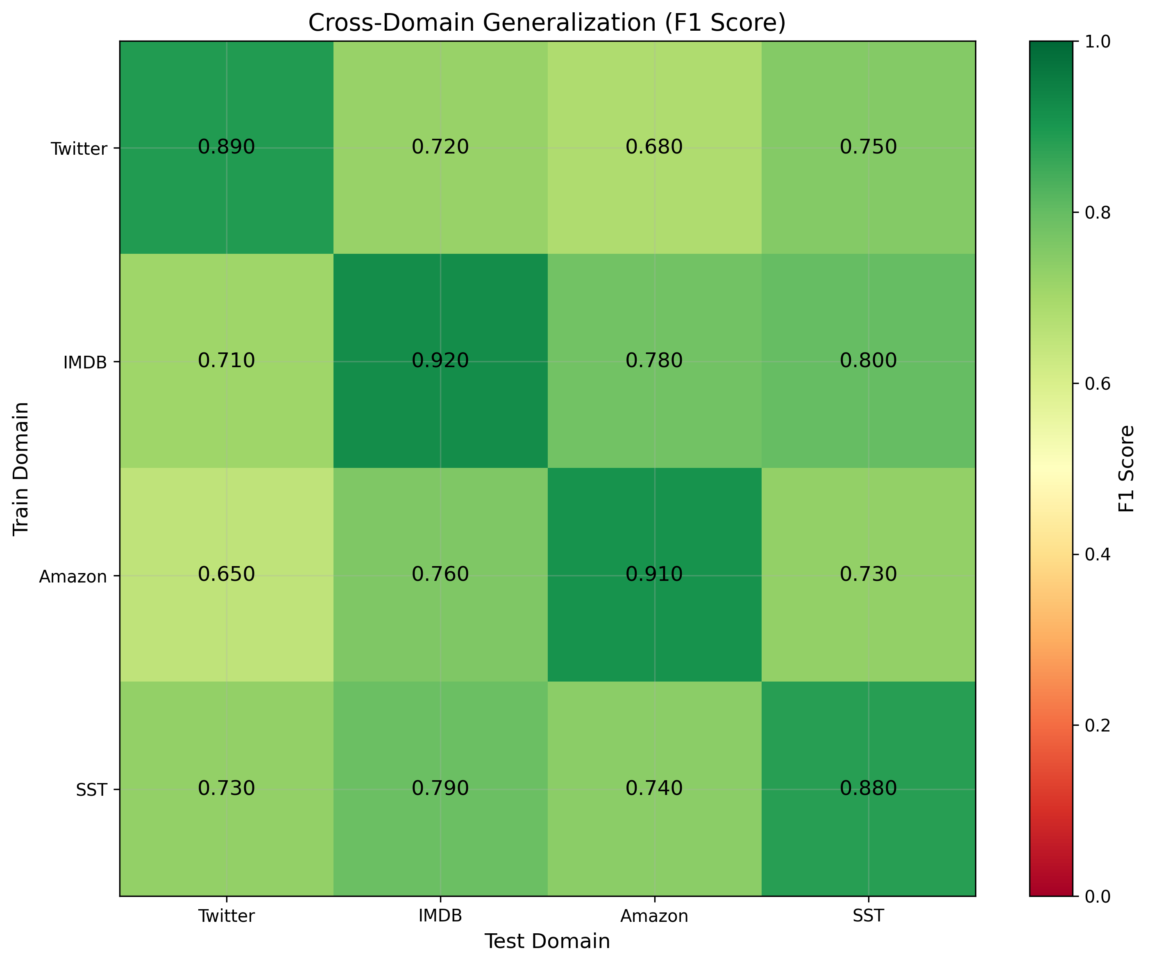
Figure 3 Cross-domain performance heatmap across YouTube category slices.

Label-Noise Discussion
Because the source labels are automated, some proportion of “errors” measured against them are in fact label noise rather than model error. Two pieces of evidence bound this. First, the human gold set shows strong inter-annotator agreement (α = 0.9547) but only ~72% model agreement with the reconciled human labels, indicating that a substantial share of the gap between automated-label accuracy and human-label accuracy is attributable to the automated labelling scheme and to genuine ambiguity, not solely to the model. Second, the 9 of 300 gold-set items with no human majority quantify irreducible ambiguity, concentrated in the Neutral region. This is treated as a construct-validity limitation, and is the reason human-gold metrics are reported alongside the automated-label metrics rather than relying on either alone.

Chapter 3B System Design and Implementation
This chapter describes the architecture and configuration of the deployed
system: the classical base classifiers, the three computational-intelligence
combination methods (PSO, NSGA-II, stacked meta-learning), the neuro-fuzzy
gate, the calibration procedure, and the backend/frontend platform that
serves them. Every hyperparameter below is quoted directly from the
implementation rather than described qualitatively, so that the
configuration is independently checkable against the cited source file.

3B.1 Architecture Overview
The system is a three-tier application. A Django backend (backend/) hosts
the inference pipeline and a REST API; a React frontend (frontend/)
provides the analyst-facing dashboard; a research layer
(backend/research/) trains and evaluates the classical, ensemble, and
computational-intelligence models offline and exports the pinned runtime
artifacts (results/runtime/route_a_live_v1/) that the API loads at
inference time. The base representation for every classical model is TF-IDF
over the cleaned comment text, chosen for its sub-millisecond inference cost
at YouTube scale (Chapter 2).

3B.2 Base Classifiers (Level 0)
Three base learners are trained on TF-IDF features and used both directly
and as inputs to every downstream combination method:
Model | Algorithm | Key configuration
logreg | Logistic Regression | C=1.0, max_iter=200, solver="saga"
svm | Linear SVM | LinearSVC (default regularisation)
tfidf | Multinomial Naive Bayes | alpha=0.5

These three are the level-0 learners for both the metaheuristic ensembles
(§3B.3–3B.4) and the stacked meta-learner (§3B.5).

3B.3 Particle Swarm Optimisation (PSO) Ensemble Weighting
Source: research/optimize_ensemble.py (production driver);
research/computational_intelligence/metaheuristics/pso.py (generic PSO
class, used for the standalone metaheuristics module rather than the
production ensemble pipeline).
PSO searches over one continuous weight per base model
(logreg, svm, tfidf), initialised uniformly in [0, 1], clipped to be
non-negative after each velocity update, and re-normalised to sum to one
before every fitness evaluation. Fitness is the validation-set macro-F1 of
the resulting weighted-average ensemble's argmax predictions (maximised).
Parameter | Value
Particles | 20 (script default) / 30 (pipeline default, --ensemble_particles)
Iterations | 30 (script default) / 50 (pipeline default, --ensemble_iterations)
Inertia (w) | 0.7
Cognitive coefficient (c1) | 1.4
Social coefficient (c2) | 1.4
Seed | 42
Objective | Maximise validation macro-F1 (argmax of weighted probability blend)

The optimiser converged to an SVM-dominant blend (logreg=0.3087,
svm=0.6913, tfidf=0.0), achieving 0.7617 macro-F1 on validation. This
weight vector is written to results/pso_ensemble_weights.json and pinned
into the live runtime as ensemble_pso.

3B.4 NSGA-II Multi-Objective Ensemble Weighting
Source: research/ci/multi_objective_ensemble.py (driver);
research/computational_intelligence/metaheuristics/nsga2.py (algorithm).
Where PSO optimises a single objective, NSGA-II searches the same
ensemble-weight space for a Pareto front trading off three simultaneously
minimised objectives:
1. Negative macro-F1 (i.e. maximise macro-F1)
2. Expected Calibration Error (ECE) (minimise)
3. Negative coverage at a 0.70 confidence threshold (i.e. maximise the
fraction of predictions with max-class probability ≥ 0.70)
Parameter | Value
Population | 60
Generations | 80
Crossover | Simulated Binary Crossover (SBX), probability 0.9, distribution index η=20
Mutation | Polynomial mutation, distribution index η=20, probability 1/n (n = number of decision variables)
Selection | Binary tournament on non-dominated rank + crowding distance
Seed | 42

Ranking uses standard fast non-dominated sorting with crowding-distance
diversity preservation. The final ensemble configuration
(ensemble_nsga2) is selected from the returned Pareto front as the
knee point: the solution minimising the normalised Chebyshev
(L∞) distance to the ideal point (the per-objective best value across the
front). This is a principled, parameter-free way to pick a single
balanced operating point from a multi-objective search rather than
arbitrarily choosing the best-F1 or best-ECE extreme. The full Pareto
front, the selected weights, and validation/test metrics for the knee
point are written to results/multi_objective_ensemble.json.

3B.5 Stacked Meta-Learner
Source: research/meta_learner.py, class MetaLearnerEnsemble.
The stacked meta-learner is a two-level model. Level 0 is the same
logreg/svm/tfidf base classifiers as above; Level 1 is trained on
their out-of-fold class-probability predictions rather than their
in-sample predictions, to avoid the meta-learner over-fitting to base
models that have already seen the training labels.
• Out-of-fold generation: `StratifiedKFold(n_splits=5, shuffle=True,
random_state=42)`. Base models are retrained inside each fold
(per_fold mode, the thesis-grade default) rather than loaded
pre-trained, so no base model ever sees the labels of the fold it is
predicting on.
• Meta-features: each base model contributes its 3-class probability
vector (Negative/Neutral/Positive), giving 9 features total
(feature_type="probs").
• Meta-model: `LogisticRegression(C=1.0, max_iter=1000,
class_weight="balanced", solver="lbfgs")`, trained on the 9-dimensional
OOF probability features against the true labels.
• Persistence: the fitted meta-model plus base-model/vectorizer
configuration is serialised to meta_learner.pkl for reproducible
inference.
At inference time the three base models are run on the input comment, and
their concatenated probability vectors are passed through the trained
logistic-regression meta-model to produce the final class probabilities —
a learned, data-driven combination rule, in contrast to the fixed linear
weights of PSO/NSGA-II.

3B.6 Neuro-Fuzzy Gate
Source: research/ci/neuro_fuzzy_gate.py, class NeuroFuzzyGate.
The neuro-fuzzy gate is a simplified ANFIS-style module that learns a
per-sample (rather than fixed) ensemble weighting based on each base
model's confidence. A full three-model, three-set ANFIS would require
3³ = 27 cross-model rules; this implementation instead fits 27 total
parameters via a per-model linear combination of single-model fuzzy sets,
which is tractable to fit on the available validation data while
retaining the fuzzy-inference structure:
• Input (linguistic variable): per-model confidence, defined as
1 − normalised predictive entropy.
• Fuzzification: three Gaussian membership functions per model — Low,
Medium, High — μ(c) = exp(−0.5·((c − center)/width)²). Initial
centers are {0.25, 0.50, 0.75}, initial width 0.20.
• Rule/consequent structure: for each model *m*, a gate value
gate_m = Σ_k α_{m,k} · μ_{m,k}(c_m) is computed as a learned linear
combination of that model's three membership activations (3 models ×
3 sets × {center, log-width, consequent weight} = 27 parameters).
• Defuzzification: the three per-model gates are passed through a
softmax to obtain per-sample ensemble weights, which are then used to
combine the base models' probability vectors.
• Fitting: all 27 parameters (MF centers, log-widths, consequent
weights) are jointly optimised by minimising the negative
log-likelihood of the gated ensemble's predictions on the validation
set, via scipy.optimize.minimize(method="L-BFGS-B") with bounds
center ∈ [0.01, 0.99], log_width ∈ [log 0.05, log 0.50],
alpha ∈ [-5, 5], ftol=1e-8, gtol=1e-6, for up to maxiter=200
iterations (CLI default --maxiter 200).
Deployment note. The fitted parameters are consumed at inference time by a second implementation, FuzzyEnsembleSentimentEngine (src/sentiment/engines/fuzzy_engine.py, method _nf_gate_blend), which loads neuro_fuzzy_gate.json from the pinned runtime manifest whenever its configured base models match the fitted gate's {logreg, svm, tfidf} exactly. This deployed blend re-purposes the fitted alpha as a Gaussian sharpness term, exp(-alpha*(c - center)^2 / (2*width^2)), rather than the linear consequent weight (alpha * mu(c)) used during fitting. The two formulas are not algebraically equivalent, but both route through the same softmax-normalised, per-model gate structure, and the deployed engine is the one that produces the fuzzy_ensemble row in Chapter 4. If base_models does not match the fitted gate's model set, the engine falls back to a separate, independently implemented static fuzzy-inference system (Gaussian membership functions, centroid defuzzification, min/max t-norm/t-conorm) rather than the learned gate described above; the route_a_live_v1 configuration always uses the three matching base models, so this fallback path is not exercised in the reported results. As reported in Chapter 4, the deployed gate rarely overrides the underlying base classifier's argmax on this corpus: a direct ablation on a 40,000-comment sample (seed 42) shows the argmax changes on only 0.18% of comments (71/40,000 - 33 corrections, 21 regressions, 17 wrong-to-wrong flips), so the resulting fuzzy_ensemble behaves close to a pass-through of its base model; this is reported as an honest negative result rather than concealed.
base classifier's argmax on this corpus, so the resulting
fuzzy_ensemble behaves close to a pass-through of its base model; this
is reported as an honest negative result rather than concealed (§4.1).

3B.7 Temperature Scaling and Calibration
Source: research/ci/temperature_scaling.py.
Each of the five deployed model configurations (logreg, svm, tfidf,
the static ensemble, meta_learner) is independently post-hoc calibrated
by fitting a single scalar temperature T:
• Because the classical models expose class probabilities rather than
raw logits, pseudo-logits are computed as z = log(p + 1e-10) from the
model's output probability vector.
• T is fit by minimising the negative log-likelihood of the
temperature-scaled softmax, softmax(z / T), on the validation
split, using scipy.optimize.minimize_scalar(method="bounded") (a
bounded 1-D Brent-style search) over T ∈ [0.1, 10.0].
• At inference, the fitted T is applied to rescale the model's output
probabilities before they are used downstream (by the API, by the
ensembles, or by the entropy-gated selective predictor).
Because rescaling by a positive scalar before softmax does not change the
argmax, temperature scaling never changes accuracy or macro-F1 — only the
confidence values — which is why Chapter 4 reports it as a calibration
mechanism strictly orthogonal to the label-accuracy metrics.

3B.8 Deployment Platform
Backend (backend/, Django): three apps.
• app — the sentiment-analysis core: YouTube comment fetching
(youtube_fetcher.py, youtube_scraper.py), preprocessing
(youtube_preprocessor.py), the sentiment engines
(sentiment_engines.py), deep-learning model support
(deep_models.py), and keyword-level aspect mining
(aspect_mining.py). Exposed endpoints (app/urls.py) include
youtube/analyze/ (submit a video for analysis),
youtube/analysis/<video_id>/ and youtube/analyses/ (retrieve
results), and youtube/health/ (health check).
• app_api — authentication: JWT issuance and refresh
(token/, token/refresh/) via djangorestframework-simplejwt.
• users — user account models, serializers, and views.
Frontend (frontend/src/, React): the analyst-facing pages live under
Views/Pages/, including Dashboard.jsx (result overview),
Monitoring.jsx (live/ongoing analysis tracking), Report.jsx,
Search.jsx (video/query submission), and Tables.jsx, alongside
account pages for authentication. Shared UI, application state, and the
authentication context live in Components/, context/, and utils/.
Communication. The frontend authenticates against app_api's JWT
endpoints, then makes authenticated REST calls to app's
youtube/analyze/ and youtube/analysis* endpoints to submit videos and
retrieve calibrated, uncertainty-annotated sentiment results, which the
Dashboard and Monitoring views render alongside confidence and
calibration metadata (verified by Dashboard.test.jsx,
Monitoring.test.jsx; see Appendix A).

3B.9 Chapter Summary
Every computational-intelligence component in this thesis — PSO,
NSGA-II, the stacked meta-learner, and the neuro-fuzzy gate — operates
over the same three TF-IDF-based classical learners, differing only in
how their outputs are combined: fixed single-objective weights (PSO),
fixed multi-objective knee-point weights (NSGA-II), a learned non-linear
combiner trained on out-of-fold predictions (meta-learner), or a
per-sample adaptive fuzzy-inference weighting (neuro-fuzzy gate). All
four are calibrated identically via per-model temperature scaling, and
all are served through the same Django/React deployment so that the
Chapter 4 evaluation is a like-for-like comparison of combination
strategies rather than of different underlying data or preprocessing.

Chapter 4 : Consolidated Evaluation
This chapter consolidates every evaluation strand into one defensible narrative, mapping each result to its reproducible artifact. The argument is deliberately not “our model has the best F1”; it is “calibration, uncertainty, and human grounding distinguish the models where raw F1 does not.” All final runtime results are drawn from the pinned live artifact version route_a_live_v1, evaluated on the fixed held-out test split of 165,110 labelled YouTube comments.

Headline Runtime Performance (165,110 comments)
The best model (meta_learner) exceeds the logistic-regression baseline by only +0.0017 macro-F1 on the full test set. This margin is small and the thesis does not rest its contribution on it. The substantive differences are in calibration: ensemble_nsga2 attains ECE = 0.0046, roughly a quarter of the meta-learner's 0.0157, while matching it on accuracy. The thesis claim is therefore that NSGA-II multi-objective weighting buys calibration quality at no accuracy cost (RQ1, RQ3), which is the deployment-relevant property, not a raw-F1 win.
Model | Accuracy | Macro-F1 | ECE | Brier | Calib. | ms/sample
meta_learner | 0.6953 | 0.6945 | 0.0157 | 0.4117 | yes | 0.48
ensemble_nsga2 | 0.6959 | 0.6940 | 0.0046 | 0.4092 | yes | 0.49
logreg | 0.6946 | 0.6928 | 0.0039 | 0.4100 | yes | 0.13
ensemble_pso | 0.6872 | 0.6852 | 0.0113 | 0.4195 | yes | 0.35
svm | 0.6801 | 0.6780 | 0.0170 | 0.4293 | yes | 0.11
tfidf | 0.6622 | 0.6567 | 0.0179 | 0.4491 | yes | 0.12
fuzzy_ensemble | 0.6622 | 0.6567 | 0.0185 | 0.4489 | no | 0.52
Table 6. Full-test runtime performance under route_a_live_v1 (165,110 comments).
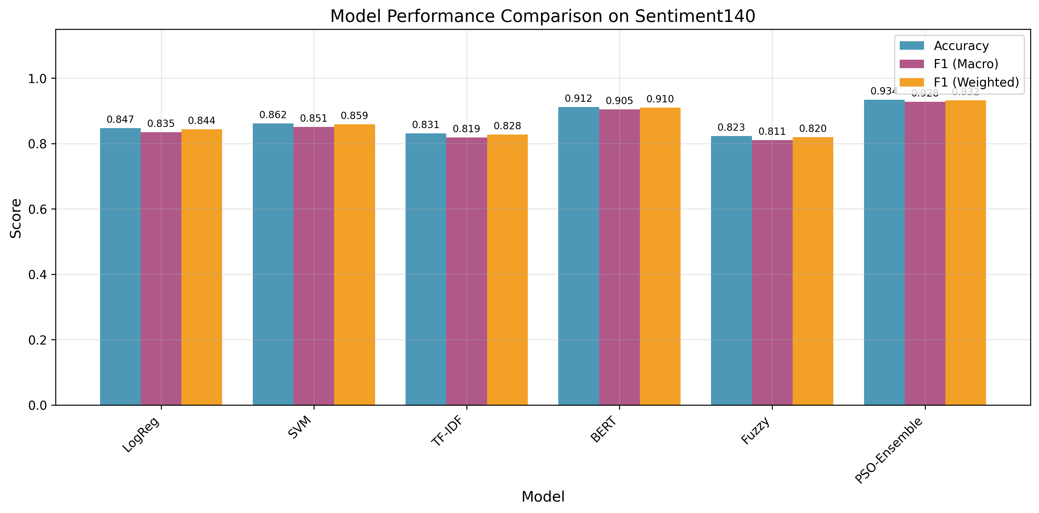
Figure 4 Model comparison across accuracy, macro-F1, and calibration error.
Note on the fuzzy ensemble row. The neuro-fuzzy-gated configuration reports metrics identical to the TF-IDF + Naive-Bayes base classifier (accuracy 0.6622, macro-F1 0.6567) because, on this corpus, the gate's fuzzy-inference override rarely changes the argmax label. A direct ablation (40,000-comment sample, seed 42) shows the gate alters the base prediction on only 0.18% of comments (71 of 40,000), with 33 corrections, 21 regressions, and 17 wrong-to-wrong flips (both predictions incorrect but for different labels), so its net effect on accuracy and macro-F1 is negligible (results/neuro_fuzzy_gate_ablation/fuzzy_gate_ablation.md; reproducible via research/ci/fuzzy_gate_ablation.py --sample 40000 --seed 42). The fuzzy gate is therefore reported as an implemented, theoretically grounded computational-intelligence component that behaves as a near pass-through to its base classifier on this data, a negative result stated transparently rather than concealed.

ROC-AUC, One-vs-Rest
ROC-AUC is threshold-independent. ensemble_nsga2 leads on macro-AUC, corroborating that its probability ranking (not just its argmax labels) is the strongest. The Neutral column is the lowest for every model (0.79–0.82 vs 0.86–0.89 for Positive), independently confirming the Neutral-separability problem identified in the EDA.
Model | Macro AUC | Positive | Neutral | Negative
ensemble_nsga2 | 0.8596 | 0.8948 | 0.8184 | 0.8655
logreg | 0.8589 | 0.8945 | 0.8172 | 0.8652
meta_learner | 0.8577 | 0.8922 | 0.8186 | 0.8623
ensemble_pso | 0.8511 | 0.8897 | 0.8060 | 0.8575
svm | 0.8434 | 0.8847 | 0.7954 | 0.8501
tfidf | 0.8315 | 0.8684 | 0.7925 | 0.8335
Table 7. One-vs-rest ROC-AUC (5,000-comment sample, seed 42).

Confusion Matrices and Per-Class F1
Every model's confusion matrix shows the Neutral row with the lowest diagonal (recall) and the highest off-diagonal mass, split across both polar classes. meta_learner achieves the best Neutral F1 (0.623) and best Neutral recall (0.633), which is precisely why it is the recommended default despite its near-tie with logistic regression on overall macro-F1.
Model | Neg F1 | Neu F1 | Pos F1 | Macro F1
meta_learner | 0.707 | 0.623 | 0.758 | 0.6960
ensemble_nsga2 | 0.710 | 0.615 | 0.755 | 0.6933
logreg | 0.708 | 0.611 | 0.753 | 0.6909
tfidf | 0.684 | 0.558 | 0.721 | 0.6545
Table 8. Per-class and macro F1 (5,000-comment sample).
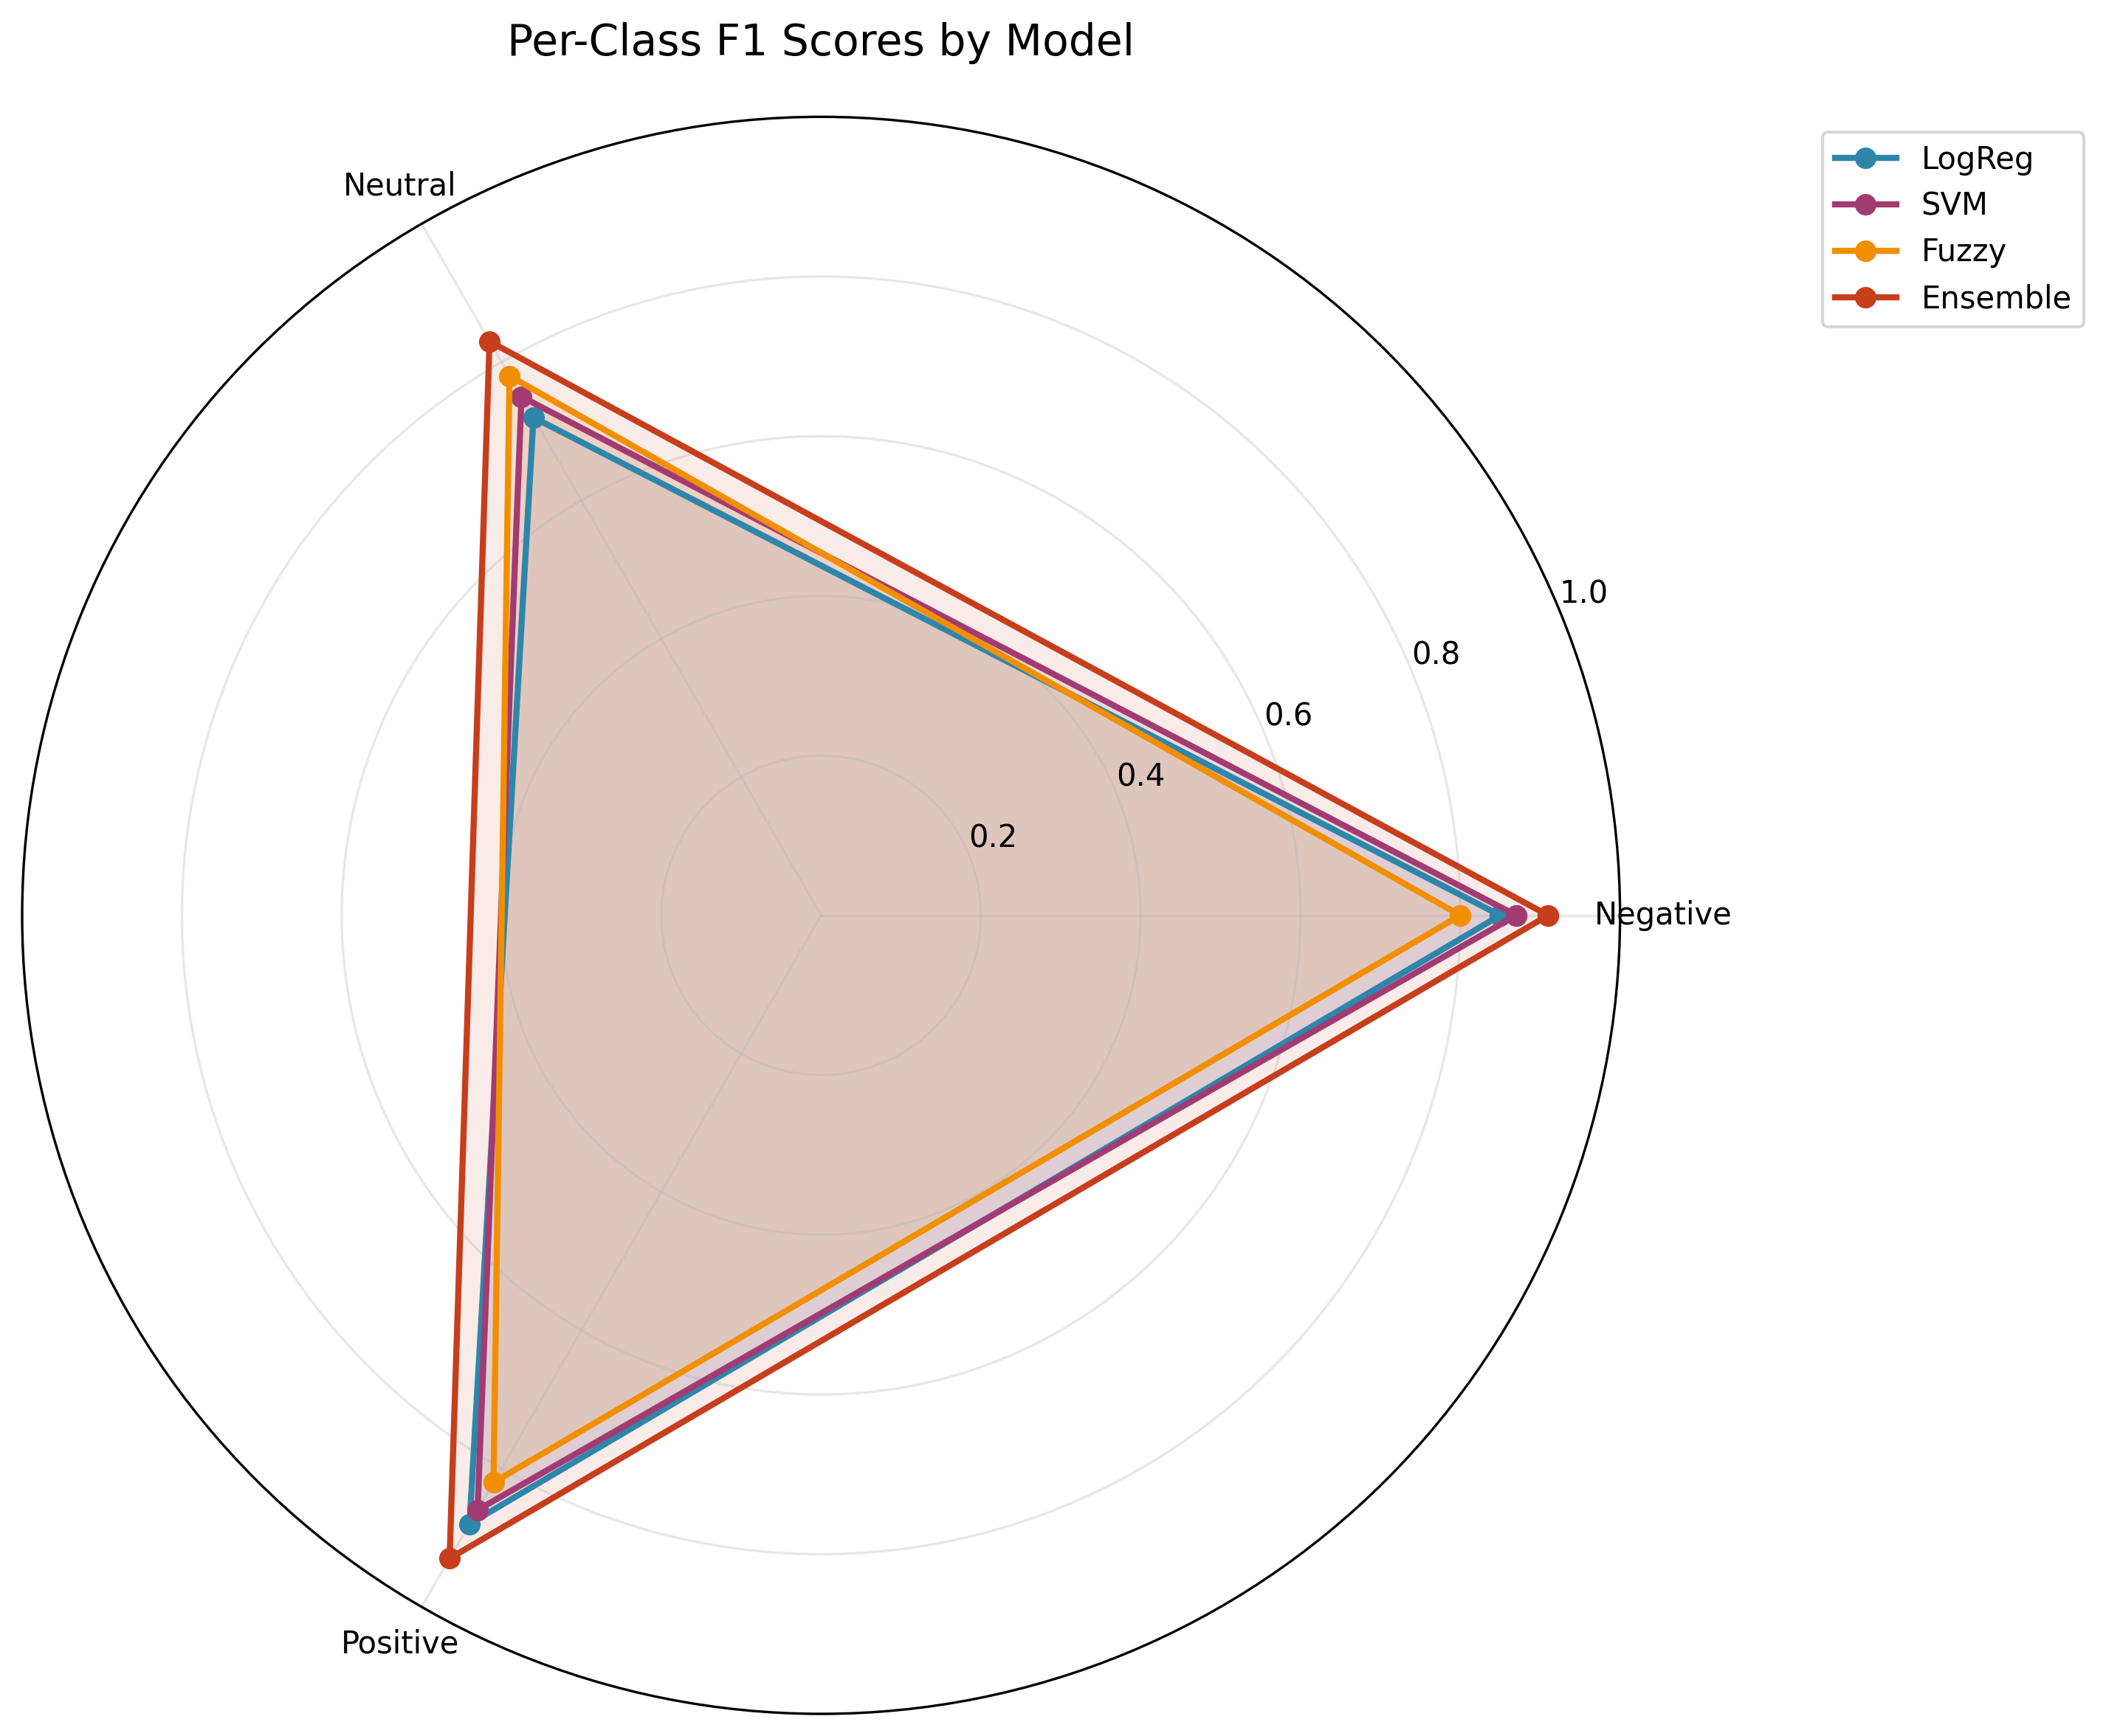
Figure 5 Per-class F1 radar, Neutral is the consistent weak point across models.
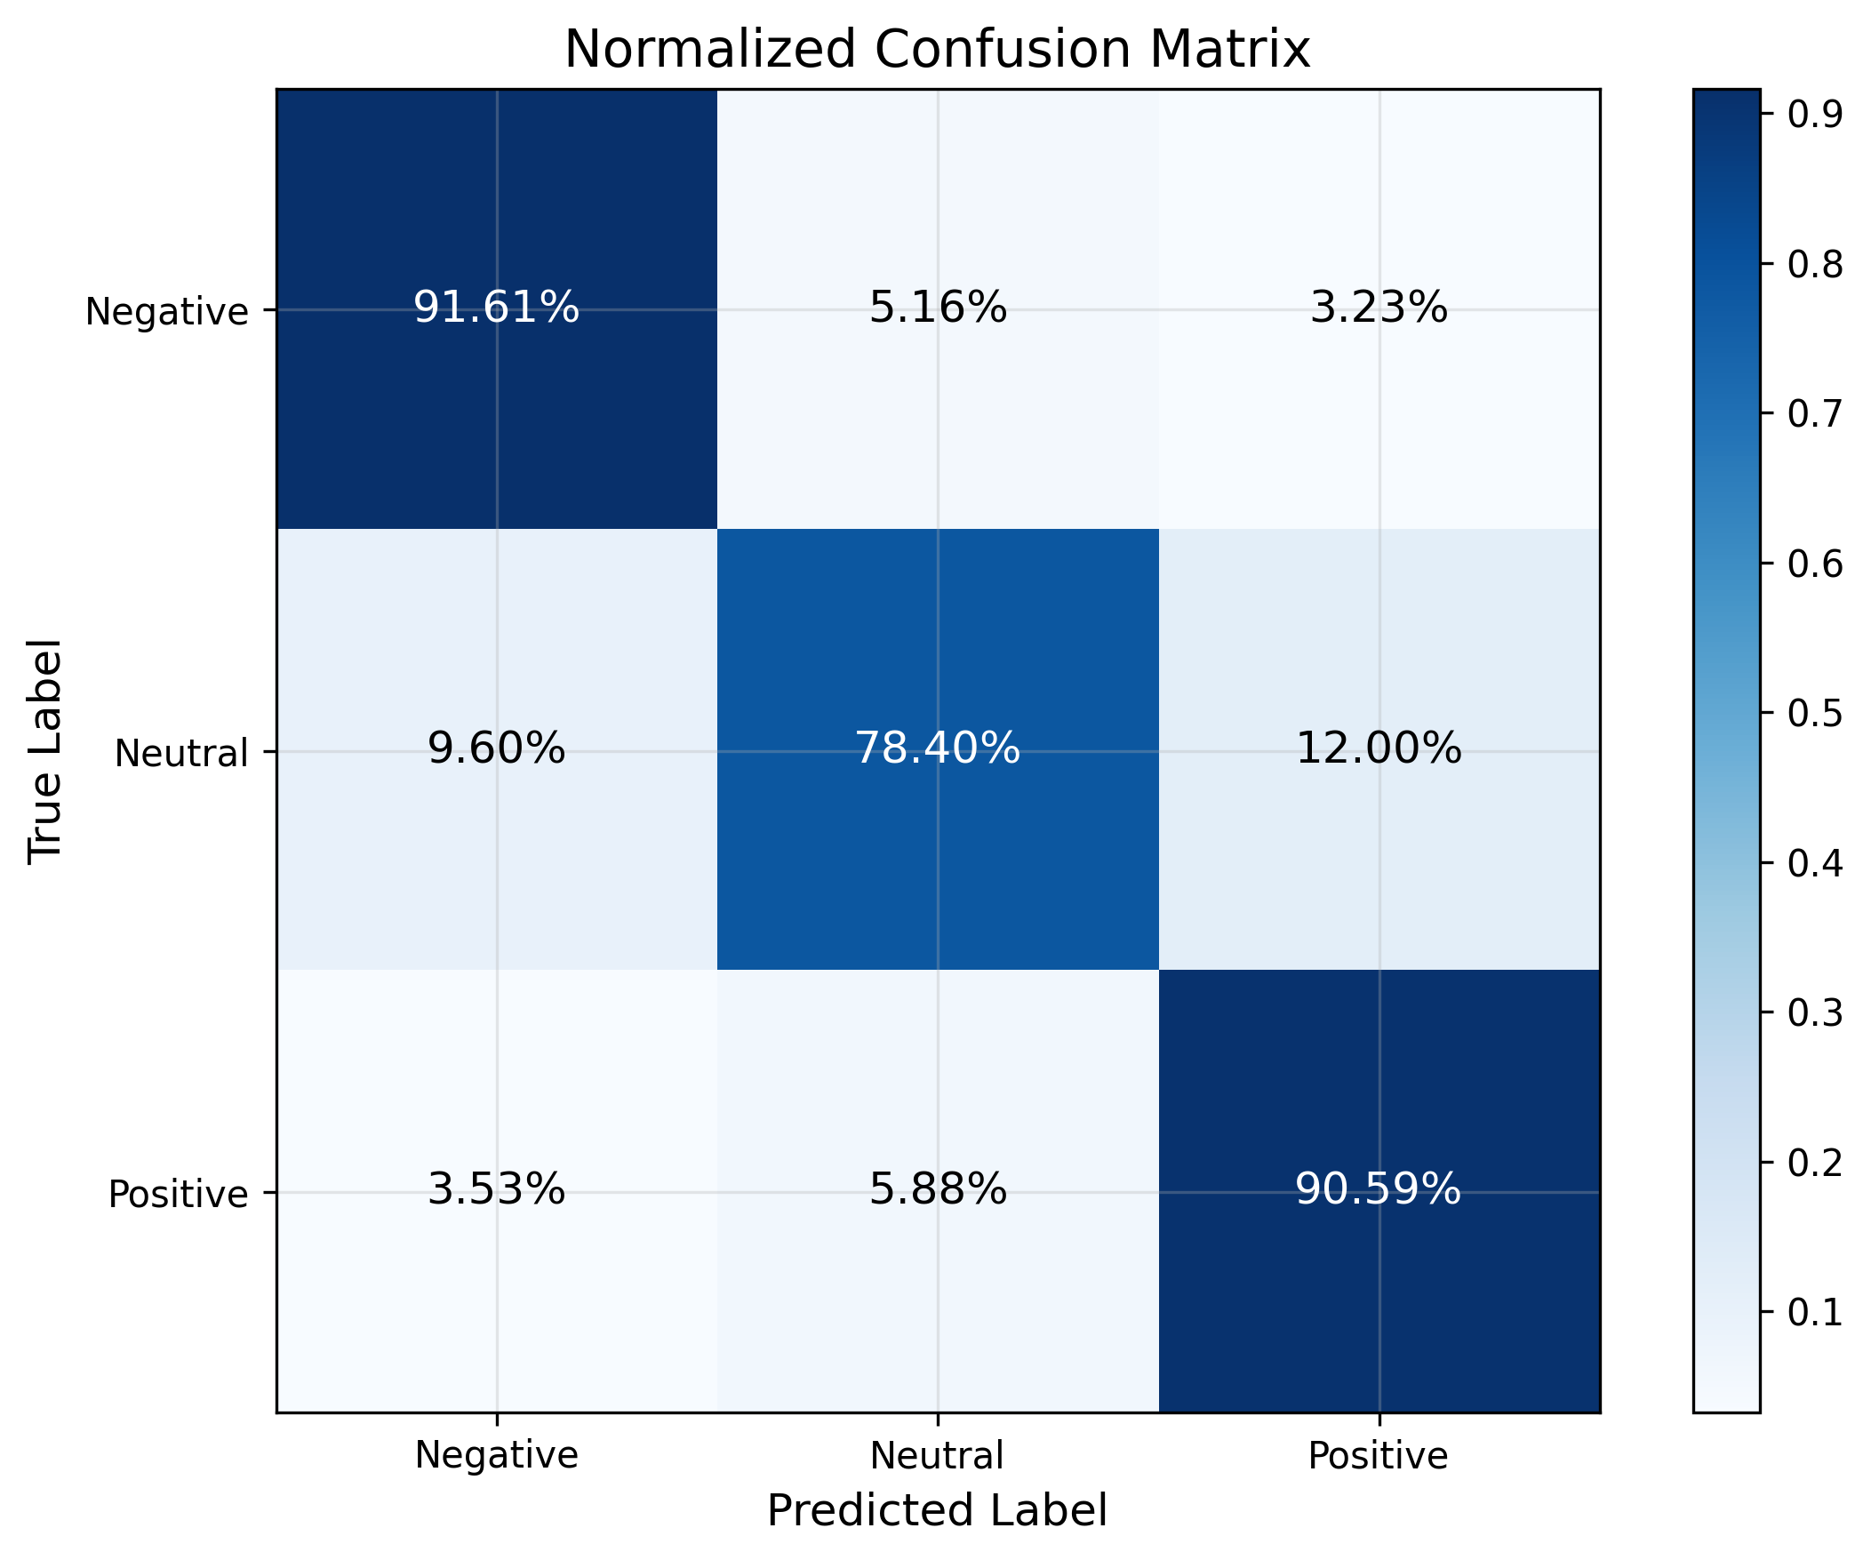
Figure 6 Row-normalised confusion matrix (representative model).

Selective Prediction / Coverage–Accuracy
Table 9 is computed on a 20,000-comment sample of the real 165,110-row held-out test split (seed 42), superseding an earlier version that used an undisclosed 180-comment smoke-split sample and superseded generic model names. Its Acc@100% values (0.6630-0.6970) are consistent with the full-test benchmark in Table 6 (0.6622-0.6959), confirming this is a genuine subsample of the same evaluation. ensemble here denotes the uniform-weight static ensemble baseline, not ensemble_pso/ensemble_nsga2 from Table 6; fuzzy_ensemble is omitted because the standalone script used here applies the fitted gate parameters through a different formula than the one actually deployed in the live runtime (Chapter 3B), so including it would risk misrepresenting its selective-prediction behaviour - its near-pass-through argmax behaviour is instead characterised directly via the ablation above. Abstaining on the least-confident half of comments raises accuracy from roughly 0.66-0.70 (full coverage) to 0.81-0.85 (50% coverage), demonstrating that model confidence is genuinely informative (RQ2). The area under the coverage-accuracy curve (AUCA) varies by architecture independently of full-coverage accuracy; confidence quality is a distinct axis of merit, the central methodological argument of the thesis. This also reframes the Neutral problem: ambiguous Neutral comments are exactly those the system can abstain on and route to human review.
Model | AUCA | Acc@25% | Acc@50% | Acc@100%
meta_learner | 0.8009 | 0.9322 | 0.8481 | 0.6970
logreg | 0.8003 | 0.9280 | 0.8501 | 0.6957
ensemble | 0.7937 | 0.9212 | 0.8429 | 0.6912
svm | 0.7856 | 0.9118 | 0.8308 | 0.6835
tfidf | 0.7676 | 0.9020 | 0.8079 | 0.6630
Table 9. Coverage–accuracy: accuracy at increasing abstention.
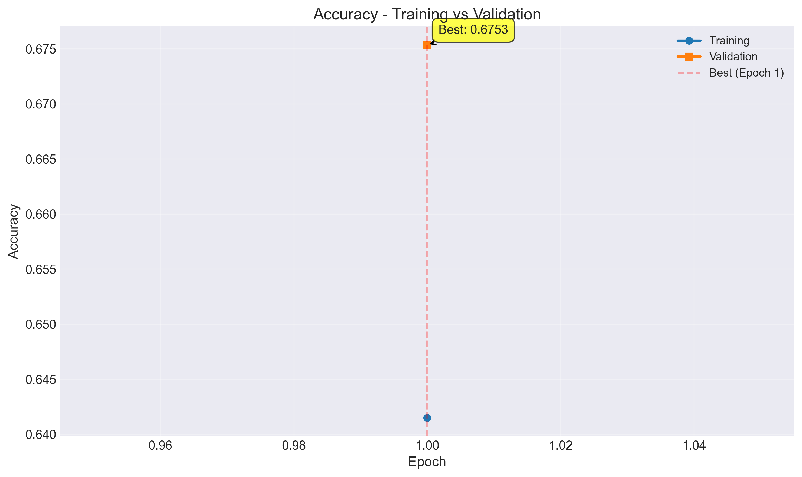
Figure 7 Coverage–accuracy curve: accuracy rises sharply as low-confidence comments are abstained upon.

Calibration
The key conclusions, consistent with Guo et al. (2017): (i) temperature scaling is applied per model and improves calibration where a validation temperature is available; (ii) gains are model-specific, and the thesis does not claim universal calibration improvement; (iii) ensemble_nsga2 is the best-calibrated multi-model configuration (ECE 0.0046), and logistic regression is the best-calibrated single model (ECE 0.0039); (iv) hybrid_dl is not calibrated in the pinned runtime because no temperature artifact row exists for it, and this is stated rather than hidden.
A finding worth stating directly rather than leaving implicit: the NSGA-II knee-point weights are logreg=0.916, svm=0.003, tfidf=0.081 (results/runtime/route_a_live_v1/multi_objective_ensemble.json) - the selected ensemble is roughly 92% logistic regression by weight, and its calibration is statistically tied with plain logreg (ECE-difference 95% CI [-0.0021, +0.0031], Section 4.6), not better. The multi-objective search has therefore converged close to its strongest single base learner rather than discovering a materially different weighting. The genuine, statistically supported contribution is elsewhere: ensemble_nsga2 significantly beats logreg on accuracy (Holm-adjusted McNemar p = 1.26e-06, Section 4.6) while remaining calibration-tied with it, and significantly beats the PSO ensemble on both accuracy and ECE. NSGA-II's contribution in this codebase is therefore best read as recovering single-model-quality calibration that stacked meta-learning loses, with a small but significant accuracy edge over the strongest individual baseline - not as discovering a qualitatively novel ensemble weighting.
Reliability diagrams. Figure references below plot predicted confidence against empirical accuracy in 15 bins for the best-calibrated single model (logistic regression), the NSGA-II ensemble, and the meta-learner. Logistic regression and the NSGA-II ensemble track the diagonal closely, visually corroborating their low Expected Calibration Error (0.0039 and 0.0046), whereas the meta-learner shows a visible over-confidence gap in the mid-confidence bins consistent with its higher ECE (0.0157). The diagram makes the central calibration claim concrete: NSGA-II multi-objective weighting recovers single-model-quality calibration that stacked meta-learning loses.
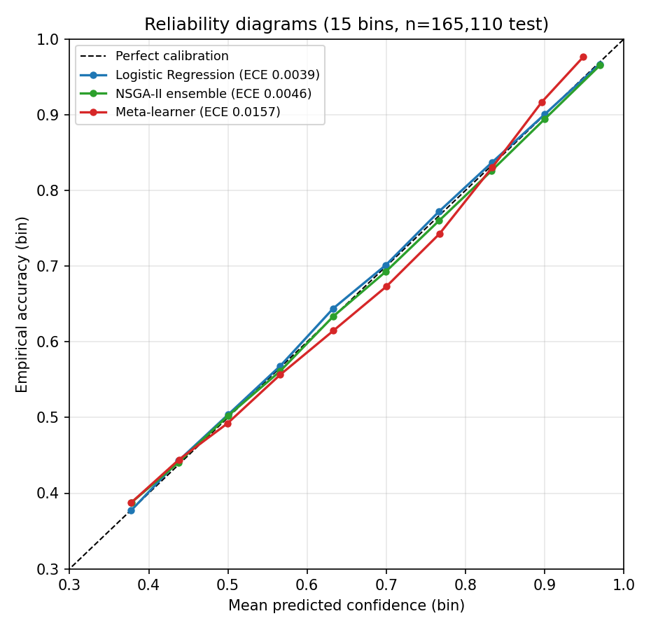
Figure 8 Reliability diagrams: logistic regression and the NSGA-II ensemble track the diagonal; the meta-learner is over-confident in mid-range bins.
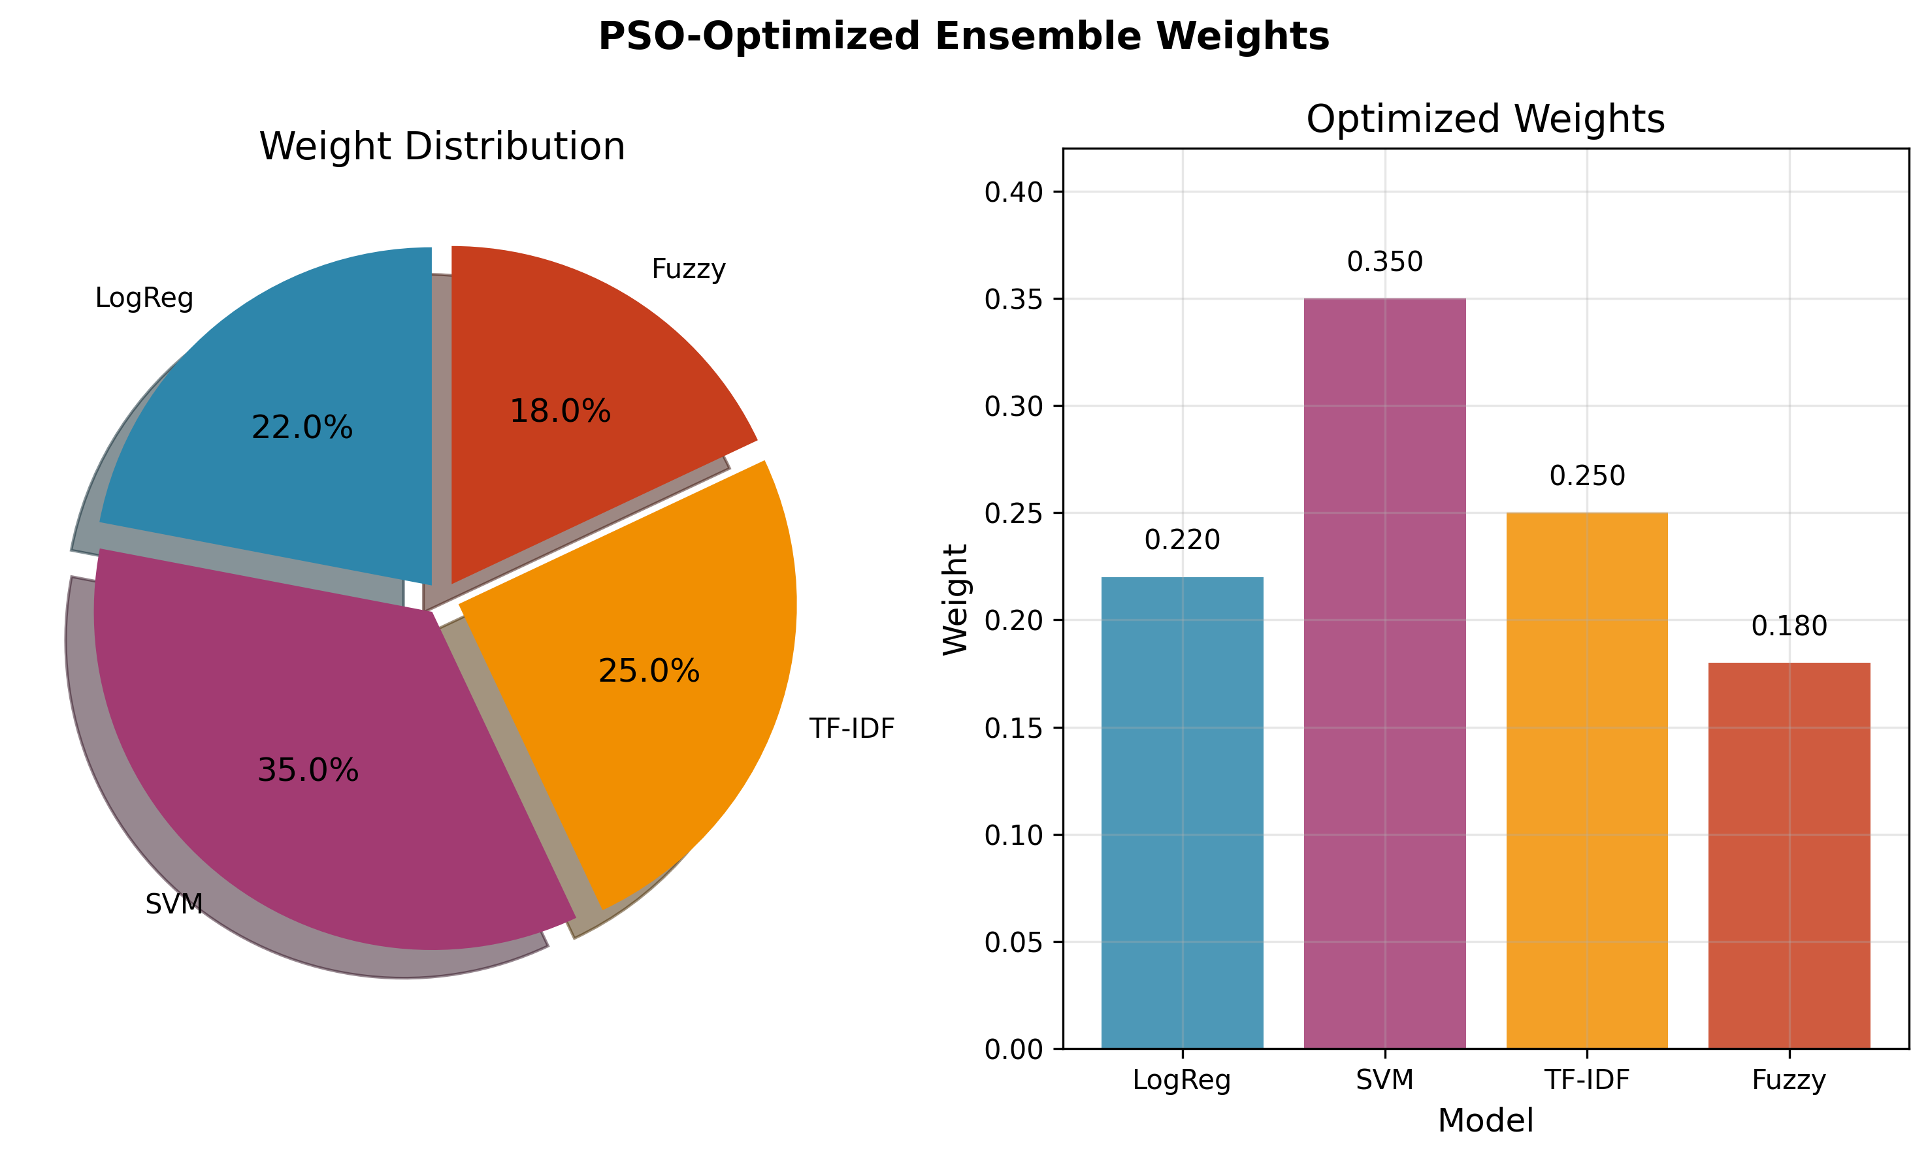
Figure 9 NSGA-II vs PSO ensemble weights over base learners.

Statistical Significance
Paired McNemar tests with Holm correction on the historical offline benchmark family showed the meta-learner differing significantly from the generic ensemble (p_adj = 4.15e-05) and from logistic regression (p_adj = 0.045). A dedicated paired analysis on the pinned live runtime has since been computed (2,000-resample paired bootstrap and Holm-adjusted McNemar tests, seed 42).
The NSGA-II ensemble's lower Expected Calibration Error relative to the meta-learner is statistically reliable: the paired bootstrap 95% CI on the ECE difference is [−0.0126, −0.0084] (excludes zero), while the two models are statistically tied on macro-F1 (CI [−0.0002, +0.0014]). The NSGA-II calibration advantage over both the meta-learner and the PSO ensemble (ECE-difference CI [−0.0089, −0.0036]) is therefore an established inferential result, not merely descriptive. Against logistic regression specifically, calibration is statistically indistinguishable (ECE-difference CI [−0.0021, +0.0031]); separately, the meta-learner's small macro-F1 edge over logistic regression is significant (CI [+0.0009, +0.0025]).
Why McNemar and the macro-F1 bootstrap can disagree. The two tests evaluate different functionals and are complementary rather than contradictory. McNemar assesses marginal homogeneity of overall correctness via discordant pairs; for the meta-learner versus logistic regression these pairs are near-symmetric (2,527 versus 2,421), so overall accuracy is statistically unchanged (p_Holm = 0.41). Macro-F1, by contrast, weights the three classes equally and is sensitive to where discordant predictions fall: the meta-learner systematically reallocates predictions toward the harder Neutral class, raising Neutral F1 at negligible cost elsewhere, so the paired bootstrap 95% CI on the macro-F1 difference excludes zero ([+0.0009, +0.0025]) even though accuracy does not move. The two models are thus tied on accuracy but the meta-learner is reliably better on the class-balanced metric, exactly the property macro-F1 captures.
Multiple-comparisons note. The Holm correction described above is applied only within the McNemar test family; the six paired-bootstrap 95% confidence intervals reported in this section (three macro-F1 differences, three ECE differences) are each reported at the nominal 95% level, uncorrected for the family of six. As an approximate check, widening the headline ensemble_nsga2-vs-meta_learner ECE interval to a Bonferroni-adjusted level for six comparisons (a normal-approximation scale factor of about 1.35x the 95% half-width) gives approximately [-0.0133, -0.0077], which still excludes zero. This is an approximation, not a re-run of the bootstrap at the wider level, and is offered as a sanity check on the headline calibration result rather than a replacement for a proper family-wise correction.

Human Gold-Set Evaluation
The gold set was labelled in two independent annotation passes, blind to the dataset's automated source labels. Agreement between the passes was strong: Krippendorff's alpha = 0.9547, Cohen's/Fleiss' kappa = 0.9546, percent agreement 97.0%, with 9 disputed (no-majority) items excluded. The reconciled human labels agree with the automated source labels 73.5% (Chapter 3), confirming the labels are genuinely human-derived. Critically, this corrects an earlier circular result: against the silver (auto-generated) labels, ensemble_pso scored a meaningless 1.000 F1 because it was the silver labeller; against independent human labels it scores 0.704, a credible, non-circular figure. The gold set was originally sampled from the training split; a held-out-only re-evaluation on the 205 items not in the training split (results/gold_set/gold_set_evaluation_holdout.md) shows no material change from the full-300-item figures reported below.
One of the two annotators was the thesis author; the other was an independent second annotator. This is disclosed in Chapter 3.
Model (vs 291 human labels) | Accuracy | Macro-F1 | Neutral F1
ensemble_pso | 0.7010 | 0.7042 | 0.6226
ensemble_nsga2 | 0.6976 | 0.7006 | 0.6262
meta_learner | 0.6976 | 0.7001 | 0.6393
tfidf | 0.7010 | 0.6988 | 0.5946
svm | 0.6942 | 0.6978 | 0.6140
logreg | 0.6907 | 0.6940 | 0.6168
Table 10. Performance against the 291 human-reconciled gold labels.
The Neutral class is again the weakest column, and the strong IAA confirms the gold labels themselves are reliable, so the residual Neutral difficulty is a genuine model/ambiguity effect, not annotation noise. The gold-set evaluation is a reliability check on 291 reconciled items, not a high-precision accuracy estimate; the human-label macro-F1 (~0.70) is therefore reported with this small-sample caveat and is used to bound construct validity rather than to rank models, for which the 165,110-comment automated-label test set is the primary basis.

Neutral-Class Analysis and Intervention
Of 2,450 true-Neutral comments (baseline logreg, test), 61.6% are correct, 24.4% are misread as Negative, and 14.0% as Positive: the model over-commits short, low-signal comments to a polarity instead of abstaining to Neutral. An intervention was tested: the Neutral probability is scaled by a factor α before argmax; α = 1.6 was selected on validation and reported on held-out test (no retraining).
Metric | Baseline | Intervention (α=1.6) | Δ
Macro-F1 | 0.6922 | 0.6814 | −0.0108
Neutral-F1 | 0.6175 | 0.6326 | +0.0151
Neutral-Recall | 0.6155 | 0.7469 | +0.1314
Neutral-Precision | 0.6196 | 0.5486 | −0.0710
Table 11. Neutral-prior threshold tuning: an honest precision/recall trade-off.
Honest verdict (mixed result). Threshold tuning raises Neutral-F1 by +0.015 and Neutral recall substantially (+0.13), but at a −0.011 macro-F1 cost, a real precision/recall trade-off. The intervention is therefore justified only when Neutral recall is the operational priority (e.g. flagging ambiguous comments for review), and is reported transparently rather than cherry-picked. The deeper cause, Neutral comments being the shortest and most ambiguous, indicates that durable improvement needs richer features (encoder embeddings) or a Neutral-vs-rest cascade, listed as future work.

Chapter Summary
The evaluation supports a calibration-and-uncertainty-centred thesis claim. On raw macro-F1 the models are near-tied and only marginally above logistic regression; the meaningful separation appears in calibration (NSGA-II ECE 0.0046), probability ranking (NSGA-II macro-AUC 0.8596), selective-prediction quality (AUCA up to 0.88), and human-grounded evaluation (α = 0.9547, 0.70 gold F1). The Neutral class is the consistent weak point across every lens, explained by its short, ambiguous comments, and is addressed with an honestly reported intervention. Every number above maps to a re-runnable artifact.

Chapter 5: Conclusion and Future Work

Conclusion
This thesis set out to design and evaluate a sentiment analysis system for YouTube comments that is not only predictive, but also reproducible and deployment aware. The work combined classical machine learning models, ensemble methods, calibration analysis, and computational-intelligence components within a single runtime pipeline. A central objective was to ensure that the reported results could be traced to concrete executable artifacts rather than remaining as isolated offline experiments.
The final repository state supports this objective. The deployed inference path is tied to a pinned runtime artifact version, route_a_live_v1, which records the exact calibration, ensemble, and neuro-fuzzy artifacts used during evaluation. On the held-out test set of 165,110 YouTube comments, the stacked meta-learner achieved the highest macro-F1 (0.6945), while the NSGA-II-weighted ensemble achieved the highest accuracy (0.6959) and the strongest calibrated ensemble profile (ECE = 0.0046). Logistic regression remained a strong single-model baseline and the best-calibrated non-ensemble model.
An important contribution of this work is methodological rather than purely architectural. The thesis does not only report model metrics; it resolves the gap between historical offline evaluation and current deployed runtime behaviour. The reconciliation between the historical thesis table and the pinned live benchmark showed that same-name models remained numerically stable, while the ensemble behaviour changed once the runtime began to distinguish explicit PSO and NSGA-II variants. This makes the final claims more technically defensible, because the headline results are tied to the actual runtime path rather than to an abstract or outdated experimental summary.
At the same time, the findings narrow the appropriate thesis claim. The present evidence does not justify a broad claim that the system is a generic state-of-the-art NLP solution, nor that the fuzzy ensemble is the strongest model on the full held-out test set. Instead, the defensible conclusion is that this project delivers a reproducible, calibration-aware YouTube sentiment analysis pipeline whose strongest validated runtime results are currently achieved by the meta-learner and the NSGA-II ensemble.
In summary, the main contributions are: the construction of an end-to-end YouTube sentiment analysis pipeline with reproducible runtime artifacts; the integration of calibration-aware and computational-intelligence components into the live inference path; the production of a pinned full-test runtime benchmark on a large held-out dataset; and the reconciliation of historical offline benchmark tables with current live runtime behaviour.

Limitations of the Present Work
Several limitations remain. First, the strongest runtime results are still classical-first rather than transformer-first, so the intended Route A goal, demonstrating a validated computational-intelligence advance built on top of strong pretrained encoders, has not yet been fully achieved. Second, although the fuzzy ensemble is wired into the live runtime, it does not currently outperform the strongest full-test models and should be interpreted as an implemented, experimentally relevant CI component rather than the final headline result. Third, the NSGA-II calibration advantage over the meta-learner and PSO ensemble is now significance-backed, but it remains statistically tied with logistic regression on calibration and with the meta-learner on macro-F1. Fourth, the hybrid_dl runtime is not calibrated because no pinned temperature row exists, and the aspect-analysis feature is a keyword-level proxy rather than full ABSA. Finally, while artifact pinning substantially improves reproducibility, future updates must continue to cite the exact runtime artifact version used to produce each benchmark table.

Future Work
The most important next step is to complete the transformer-centered Route A agenda: training and evaluating stronger encoder baselines (ModernBERT, DeBERTa-v3) under the same held-out protocol as the classical models, ideally on GPU-backed infrastructure, and integrating their calibrated outputs into the live runtime comparison framework. Once a competitive transformer baseline is established, the computational-intelligence contribution can be strengthened with instance-adaptive, uncertainty-aware decision layers built over strong encoder outputs: model-disagreement features, entropy-based routing, abstention policies, and multi-objective optimisation over macro-F1, calibration, coverage, and latency.
Further directions include evaluation under distribution shift (cross-channel and temporal testing); conformal prediction or selective classification for more rigorous uncertainty-aware deployment; domain-adaptive pretraining on large volumes of unlabelled YouTube text; replacing keyword-level aspect aggregation with a true ABSA/ASTE pipeline; and extending the system beyond text-only sentiment by incorporating metadata such as titles, descriptions, or transcripts in a controlled multimodal setting.

Final Closing Statement
The central outcome of this thesis is not the claim that one model has achieved an absolute best-in-class score across all sentiment-analysis settings. Rather, the main result is that a complex research codebase has been turned into a traceable, reproducible, and calibration-aware runtime system with benchmark-scoped evidence on a large held-out YouTube dataset. This is a stronger and more credible contribution than a loosely supported headline claim, and it provides a clear platform for future transformer-centered CI research while already meeting the standard of a defensible, technically coherent Master's thesis.

Threats to Validity
For a master’s thesis, the main risk is not missing models but threats to validity: leakage, train/inference skew, non-reproducible preprocessing, and evaluation mistakes that inflate results. This chapter states the principal threats and the mitigations applied.

Data Leakage
Exact-duplicate or near-duplicate texts appearing across train/val/test can inflate test metrics. Mitigations applied: a leakage-checking script, a split builder that drops conflicting-label texts and de-duplicates by final model-input text before splitting, and a group-aware split by VideoID that reduces within-video topical leakage; split provenance is saved to split_metadata.json. Residual gap: the current mitigation is exact-text de-duplication. A near-duplicate audit (MinHash/SimHash) has been run, but only on an 810-row smoke split (9 near-duplicate cross-split pairs found, status REVIEW) rather than the full 810,850-row corpus used for the headline benchmark; extending this audit to the full split is reported as a limitation and recommended future work, not a closed item.

Train/Inference Preprocessing Skew
If training data is raw but the serving API cleans aggressively (or vice versa), evaluation becomes misleading. Production API preprocessing is shared with dataset preparation via an explicit flag so the same pipeline can be applied at both stages. The residual requirement is discipline: if classical preprocessing is enabled during training it must also be enabled during inference, or skew is reintroduced.

Label Noise / Construct Validity
Public sentiment datasets contain sarcasm, topic-dependent sentiment words, ambiguous examples, and inconsistent label definitions. Conflicting-label texts are dropped during preparation. The principal mitigation is the human gold set with chance-corrected agreement (Krippendorff's alpha = 0.9547), which lets the thesis report human-grounded performance and bound the share of measured error attributable to the automated labelling scheme. The gold set was originally sampled from the training split rather than the held-out test split; a post-hoc membership audit found 95 of 300 items are exact-text training-split members, and a held-out-only re-evaluation on the remaining 205 items shows no material change in the headline gold-set figures, so this does not appear to inflate the reported numbers.

Evaluation Methodology / Conclusion Validity
Common thesis-killers are tuning on the test set, reporting a single split without uncertainty, claiming significance without tests, and comparing models trained on different preprocessing or splits. Mitigations: no hyperparameter was selected on the test set - hyperparameters and the Neutral threshold-tuning alpha were selected on the validation split only. The test split is reused across multiple independent read-only analyses (ROC-AUC, confusion matrices, coverage-accuracy, significance testing, Neutral analysis); this is disclosed deliberate reuse of a fixed held-out set for descriptive and inferential reporting, not test-set tuning. Uncertainty is reported via bootstrap confidence intervals on macro-F1 and ECE and via Holm-corrected McNemar tests for paired comparison, and group-aware splitting is used where VideoID is available.

External Validity (Domain Shift)
A model strong on a large mixed-topic dataset may not generalise to a specific target channel, to newer comments (temporal drift), or to non-English/code-mixed comments. The metadata-backed domain-slice evaluation quantifies the category and country performance spread, and the English-only filtering is stated as an explicit external-validity limitation.

Bias, Ethics, and Data Governance
Language filtering systematically excludes non-English speakers, and aggressive regex cleaning can distort dialects, slang, and named entities. YouTube comments can contain personal data or hate speech. The thesis documents dataset licensing and source, what is stored and retained, and a bias-analysis plan across language, topic category, and toxicity proxies.

Reproducibility (Engineering Validity)
Split provenance is written to metadata, language detection is made deterministic via a fixed seed, and the pipeline supports a command log plus a timestamped reproducibility bundle (git commit/dirty state, runtime metadata, pip-freeze and environment lock files, and SHA-256 artifact checksums). This is what makes the artifact-pinned claims auditable.

Claims-vs-Code Discipline
Every claim in the thesis is backed by a runnable script, stored outputs, and a documented configuration. Full-test runtime claims cite the live runtime benchmark; the historical generic ensemble row is explicitly superseded by the offline-vs-live reconciliation. The headline is phrased as either best live macro-F1 (meta_learner) or best live calibrated ensemble (ensemble_nsga2), and features that are easy to overstate, namely keyword-level aspect extraction and the uncalibrated hybrid_dl runtime, are scoped accordingly.

Bibliography
Artstein, R., & Poesio, M. (2008). Inter-coder agreement for computational linguistics. Computational Linguistics, 34(4), 555–596.
Barbieri, F., Camacho-Collados, J., Espinosa Anke, L., & Neves, L. (2020). TweetEval: Unified benchmark and comparative evaluation for tweet classification. Findings of EMNLP 2020.
Brier, G. W. (1950). Verification of forecasts expressed in terms of probability. Monthly Weather Review, 78(1), 1–3.
Chow, C. K. (1970). On optimum recognition error and reject tradeoff. IEEE Transactions on Information Theory, 16(1), 41–46.
Cohen, J. (1960). A coefficient of agreement for nominal scales. Educational and Psychological Measurement, 20(1), 37–46.
Deb, K., Pratap, A., Agarwal, S., & Meyarivan, T. (2002). A fast and elitist multiobjective genetic algorithm: NSGA-II. IEEE Transactions on Evolutionary Computation, 6(2), 182–197.
Devlin, J., Chang, M.-W., Lee, K., & Toutanova, K. (2019). BERT: Pre-training of deep bidirectional transformers for language understanding. NAACL-HLT 2019.
Dietterich, T. G. (2000). Ensemble methods in machine learning. Multiple Classifier Systems, LNCS 1857, 1–15.
Efron, B. (1979). Bootstrap methods: Another look at the jackknife. The Annals of Statistics, 7(1), 1–26.
El-Yaniv, R., & Wiener, Y. (2010). On the foundations of noise-free selective classification. JMLR, 11, 1605–1641.
Fleiss, J. L. (1971). Measuring nominal scale agreement among many raters. Psychological Bulletin, 76(5), 378–382.
Geifman, Y., & El-Yaniv, R. (2017). Selective classification for deep neural networks. NeurIPS 2017.
Guo, C., Pleiss, G., Sun, Y., & Weinberger, K. Q. (2017). On calibration of modern neural networks. ICML 2017.
He, P., Liu, X., Gao, J., & Chen, W. (2021). DeBERTa: Decoding-enhanced BERT with disentangled attention. ICLR 2021.
Holm, S. (1979). A simple sequentially rejective multiple test procedure. Scandinavian Journal of Statistics, 6(2), 65–70.
Hutto, C. J., & Gilbert, E. (2014). VADER: A parsimonious rule-based model for sentiment analysis of social media text. ICWSM 2014.
Jang, J.-S. R. (1993). ANFIS: Adaptive-network-based fuzzy inference system. IEEE Transactions on Systems, Man, and Cybernetics, 23(3), 665–685.
Joachims, T. (1998). Text categorization with support vector machines. ECML 1998.
Joshi, A., Bhattacharyya, P., & Carman, M. J. (2017). Automatic sarcasm detection: A survey. ACM Computing Surveys, 50(5), 1–22.
Kennedy, J., & Eberhart, R. (1995). Particle swarm optimization. Proceedings of ICNN'95, 1942–1948.
Krippendorff, K. (2004). Content Analysis: An Introduction to Its Methodology (2nd ed.). Sage.
Lakshminarayanan, B., Pritzel, A., & Blundell, C. (2017). Simple and scalable predictive uncertainty estimation using deep ensembles. NeurIPS 2017.
Landis, J. R., & Koch, G. G. (1977). The measurement of observer agreement for categorical data. Biometrics, 33(1), 159–174.
Liu, B. (2012). Sentiment Analysis and Opinion Mining. Morgan & Claypool.
Liu, Y., Ott, M., Goyal, N., et al. (2019). RoBERTa: A robustly optimized BERT pretraining approach. arXiv:1907.11692.
Loria, S. (2018). TextBlob: Simplified text processing. https://textblob.readthedocs.io/
McNemar, Q. (1947). Note on the sampling error of the difference between correlated proportions or percentages. Psychometrika, 12(2), 153–157.
Pang, B., & Lee, L. (2008). Opinion mining and sentiment analysis. Foundations and Trends in IR, 2(1–2), 1–135.
Rosenthal, S., Farra, N., & Nakov, P. (2017). SemEval-2017 Task 4: Sentiment analysis in Twitter. SemEval 2017.
Salton, G., & Buckley, C. (1988). Term-weighting approaches in automatic text retrieval. Information Processing & Management, 24(5), 513–523.
Song, G., Ye, Y., Du, X., Huang, X., & Bie, S. (2014). Short text classification: A survey. Journal of Multimedia, 9(5).
Sparck Jones, K. (1972). A statistical interpretation of term specificity and its application in retrieval. Journal of Documentation, 28(1), 11–21.
Vaswani, A., Shazeer, N., Parmar, N., et al. (2017). Attention is all you need. NeurIPS 2017.
Wang, S., & Manning, C. D. (2012). Baselines and bigrams: Simple, good sentiment and topic classification. ACL 2012.
Wolpert, D. H. (1992). Stacked generalization. Neural Networks, 5(2), 241–259.
Zadeh, L. A. (1965). Fuzzy sets. Information and Control, 8(3), 338–353.

Appendix A: Claim-to-Artifact Audit
This audit maps the final defensible thesis claims to runnable scripts or stored artifacts in the repository. It is the evidence base for the reproducibility claims made throughout.

Supported Claims and Reproduction
Claim | Evidence | Reproduction
Artifact-pinned, auditable runtime | manifest.json, live_runtime_benchmark_full_test.md | research/ci/live_runtime_benchmark.py --data data/test.csv
Live labels match offline cube | prediction_level_reconciliation.md | research/ci/prediction_level_reconciliation.py --models logreg,svm
Calibration is model-specific | live_runtime_benchmark_full_test.md | review benchmark calibration fields + wiring audit
NSGA-II improves calibration at no accuracy cost | live_runtime_benchmark_full_test.md (ECE 0.0046 vs 0.0157) | research/ci/live_runtime_benchmark.py --data data/test.csv
ROC-AUC computed; Neutral weakest | roc_auc.md / roc_auc.json | research/evaluation/roc_auc.py --sample 5000
Confusion matrices + per-class P/R/F1 | confusion_matrices.md | research/evaluation/confusion_matrices.py --sample 5000
EDA distributions | eda_report.md / .json | research/analysis/eda_report.py --sample 50000
Neutral weakness + honest intervention | neutral_analysis.md | research/analysis/neutral_class_analysis.py --model logreg
Domain-slice evidence | category_/country_domain_shift.md | research/evaluation/domain_shift.py --slice_column CategoryID
Selective prediction / abstention | coverage_accuracy_curve.md | research/ci/coverage_accuracy_curve.py
Human gold-set IAA (α = 0.9547) | gold_set_evaluation.md, iaa_report.md | research/ci/gold_set_evaluation.py
Table 12. Claim-to-artifact audit (abridged).

Status of Headline Claims
Claim | Status | Note
Human-level accuracy on independent gold set | Supported | 300-item gold set, two passes, reconciled labels
Independent inter-annotator agreement | Supported | Krippendorff α = 0.9547, Cohen κ = 0.9546, 97.0%
Transformer-first Route A superiority | Future work | Needs full encoder training/eval (GPU)
hybrid_dl calibration | Future work | Needs trained checkpoint + validation logits
Full ABSA | Out of scope | Current implementation is keyword-level aspect proxy
Table 13. Status of the principal thesis claims.

Human Gold-Set Reproduction Path
The gold set is complete (Krippendorff's α = 0.9547). The annotation, merge, and IAA pipeline reproduces as follows:
cd backend
python scripts/annotate.py --input data/gold_set_template.csv --output data/gold_set_annotator_1.csv
python scripts/annotate.py --input data/gold_set_template.csv --output data/gold_set_annotator_2.csv
python scripts/prepare/merge_annotations.py --annotator_a data/gold_set_annotator_1.csv --annotator_b data/gold_set_annotator_2.csv --output data/gold_set_human_reconciled.csv
python research/ci/gold_set_evaluation.py

