Design and Development of a YouTube Comment Sentiment Analytics Platform for Interpretable Audience Feedback Insights Using PSO, NSGA-II, Fuzzy Inference, and Calibrated Machine Learning
A thesis submitted in partial fulfilment of the requirements for the degree of
MSc Data Science and Computational Intelligence

Submitted by: Manjil Shrestha
Student ID: 200127

Supervised by: Manoj Shrestha

System Overview
This page summarises the deployed system at a glance before the formal chapters. It is a concise specification of what the pipeline is, what it is optimised for, and how its quality is measured.
Field | Value
Model name | Uncertainty-Aware Ensemble Sentiment Classifier (route_a_live_v1)
Task | Three-class sentiment classification (Positive / Neutral / Negative) of YouTube comments
Base learners | TF-IDF + linear classifiers (Logistic Regression, Linear SVM, Naive Bayes)
CI components | PSO-weighted ensemble, NSGA-II multi-objective ensemble, stacked meta-learner, neuro-fuzzy gate
Reliability layer | Per-model temperature scaling, entropy-based selective prediction
Primary objective | Joint macro-F1 and calibration quality (ECE, Brier), not raw accuracy alone
Evaluation | 165,110-comment held-out test set + 291-item independent human gold set (Krippendorff's α = 0.9547)

Key Features
- Artifact-pinned runtime: every reported number traces back to one fixed, re-runnable configuration: calibration, ensemble weights, and the neuro-fuzzy gate included.
- Calibration-aware: predicted confidences are validated against empirical accuracy, not assumed.
- Uncertainty-aware: entropy gating lets the system abstain on ambiguous comments instead of guessing, and routes them for review.
- Human-grounded: an independent two-pass gold set separates label error from model error.
- Scoped claim: the thesis claims a reproducible, calibration-aware pipeline, not state-of-the-art NLP accuracy.

Headline Metrics
Best on... | Model | Score | Note
Macro-F1 | meta_learner | 0.6946 | balanced classification
Accuracy | ensemble_pso | 0.6961 | ensembles statistically tied
Calibration (ECE) | fuzzy_ensemble | 0.0030 | tied with NSGA-II
Single-model ECE | logreg | 0.0039 | best baseline

Abstract
YouTube comments are noisy, short, and topically scattered, and a deployed sentiment system also needs to output probabilities that can be trusted. This thesis builds and evaluates a reproducible YouTube sentiment analysis system. It brings classical machine learning models, ensemble methods, and computational-intelligence components together in one runtime pipeline. To strengthen reproducibility, the deployed inference path is tied to a pinned runtime artifact version (route_a_live_v1), including fixed calibration, ensemble-weight, and neuro-fuzzy configuration files.
Evaluation used a fixed held-out test set of 165,110 YouTube comments. Under the pinned live runtime, the stacked meta-learner achieved the highest macro-F1 (0.6946) with an accuracy of 0.6955. A defensibility audit subsequently found and fixed four bugs in the ensemble-weight and calibration pipeline (a stale first-commit PSO weight vector, a shared ensemble temperature fitted only against PSO, a validation/test leakage in the temperature keep/discard rule, and a calibration-scoping mismatch in weight/gate fitting); once corrected, PSO, NSGA-II, and the neuro-fuzzy gate all converge to a similar logistic-regression-dominant weighting, and their full-test accuracies (0.6959–0.6961) and macro-F1 scores (0.6940–0.6941) are statistically indistinguishable from one another. The neuro-fuzzy gate attains the lowest calibration error of any multi-model configuration (ECE = 0.0030), statistically tied with the NSGA-II ensemble (ECE = 0.0039). Logistic regression remained the strongest single-model calibration baseline (macro-F1 = 0.6928, ECE = 0.0039). A reconciliation analysis compared historical offline benchmark tables against the pinned live runtime. Same-name models stayed numerically stable. The ensemble result, however, is now read through explicit PSO and NSGA-II runtime variants rather than a single generic ensemble row, and every headline figure in this thesis reflects the corrected, re-run pipeline.
Statistical testing supports this result. The NSGA-II ensemble's calibration edge over the meta-learner and the PSO ensemble holds up as a reliable result: the paired bootstrap 95% confidence intervals on both ECE differences exclude zero. It is statistically tied with logistic regression on calibration, tied with the meta-learner on macro-F1, and, once the gate-fitting bugs above were fixed, also statistically tied with the neuro-fuzzy-gated ensemble on both calibration and macro-F1, the two lowest-ECE configurations in the table. A two-pass independent human gold set (Krippendorff's α = 0.9547) grounds the headline metrics in human judgement and separates label error from model error. Taken together, these results support a benchmark-scoped claim (a reproducible, calibration-aware YouTube sentiment analysis pipeline) rather than a claim of state-of-the-art NLP performance.

Keywords
YouTube comments; sentiment analysis; ensemble learning; particle swarm optimisation; NSGA-II; neuro-fuzzy systems; probability calibration; selective prediction; reproducibility.
Table of Contents
System Overview 2
Key Features 2
Headline Metrics 2
Abstract 4
Keywords 4
List of Figures 7
Chapter 1: Introduction and Research Questions 1
Problem Statement 1
Thesis Position (Scoped Claim) 1
Research Questions 1
Contributions 3
Scope and Explicit Non-Claims 4
Chapter 2: Literature Review 6
Sentiment Analysis and Social-Media Text 6
Classical Machine-Learning Baselines 6
Transformer-Based Sentiment Models 7
Computational Intelligence for Model Combination 7
Calibration, Uncertainty, and Selective Prediction 9
Human Annotation and Inter-Annotator Agreement 10
Research Gap and Positioning 10
Chapter 3: Methodology and Data 11
Dataset Source 11
How the Source Labels Were Generated 12
Data Processing Steps Applied 12
Final Split Sizes 13
Gold-Set Status and Inter-Annotator Agreement 13
Chapter 3 (continued): Exploratory Data Analysis 15
Class Distribution 15
Comment-Length Distribution 15
Lexical Statistics 16
Language and Domain Metadata 16
Label-Noise Discussion 17
Chapter 3B: System Design and Implementation 18
3B.1 Architecture Overview 18
3B.2 Base Classifiers (Level 0) 18
3B.3 Particle Swarm Optimisation (PSO) Ensemble Weighting 19
3B.4 NSGA-II Multi-Objective Ensemble Weighting 20
3B.5 Stacked Meta-Learner 21
3B.6 Neuro-Fuzzy Gate 21
3B.7 Temperature Scaling and Calibration 23
3B.8 Deployment Platform 23
3B.9 Chapter Summary 24
Chapter 4: Consolidated Evaluation 25
Headline Runtime Performance (165,110 comments) 25
ROC-AUC, One-vs-Rest 26
Confusion Matrices and Per-Class F1 27
Selective Prediction / Coverage–Accuracy 29
Calibration 30
Statistical Significance 32
Human Gold-Set Evaluation 34
Neutral-Class Analysis and Intervention 35
Chapter Summary 36
Chapter 5: Conclusion and Future Work 36
Conclusion 36
Limitations of the Present Work 37
Future Work 38
Final Closing Statement 39
Threats to Validity 40
Data Leakage 40
Train/Inference Preprocessing Skew 40
Label Noise / Construct Validity 40
Evaluation Methodology / Conclusion Validity 40
External Validity (Domain Shift) 41
Bias, Ethics, and Data Governance 41
Reproducibility (Engineering Validity) 41
Claims-vs-Code Discipline 41
Bibliography 42
Appendix A: Claim-to-Artifact Audit 45
Supported Claims and Reproduction 45
Status of Headline Claims 46
Human Gold-Set Reproduction Path 46
Appendix B: Screenshots 47
Application Screenshots 47
Code Screenshots 47
Output Screenshots 47

List of Figures
Figure 1 Thesis position (scoped claim) 1
Figure 2 Research questions (RQ1–RQ4) 2
Figure 3 Contributions 3
Figure 4 Scope and explicit non-claims 5
Figure 5 PSO convergence of the single-objective ensemble-weight search over validation F1. 8
Figure 6 Membership functions of the neuro-fuzzy gate over base-model confidence. 9
Figure 7 Methodology and data overview (Chapter 3) 11
Figure 8 Class distribution across the group-aware train/validation/test splits (by VideoID). 15
Figure 9 Comment length (words) by class: Neutral comments are the shortest (50,000-comment EDA sample). 16
Figure 10 Cross-domain performance heatmap across YouTube category slices. 17
Figure 11 System architecture (Chapter 3B.1) 18
Figure 12 Model comparison across accuracy, macro-F1, and calibration error. 26
Figure 13 One-vs-rest ROC-AUC by class (5,000-comment sample): Neutral is the weakest class for every model. 27
Figure 14 Per-class F1 across models: Neutral is the consistent weak point. 28
Figure 15 Row-normalised confusion matrix (meta-learner, 5,000-comment sample). 29
Figure 16 Coverage–accuracy curve: accuracy rises sharply as low-confidence comments are abstained upon. 30
Figure 17 Reliability diagrams: logistic regression and the NSGA-II ensemble track the diagonal; the meta-learner is over-confident in mid-range bins. 32
Figure 18 NSGA-II vs PSO ensemble weights over base learners. 32
Figure 19 Model agreement with the 291-item human gold set: accuracy, macro-F1, and Neutral-F1. 35
Figure 20 Neutral-prior threshold sweep on validation: the chosen α = 1.6 trades Neutral precision for recall. 36
Figure 21 Limitations and future work 39

Chapter 1: Introduction and Research Questions

Problem Statement
Sentiment analysis of YouTube comments is a high-volume, noisy, short-text classification problem. Comments are brief (median ~14 words in this corpus), informal, topically diverse, and frequently ambiguous, particularly for the Neutral class. Consider brand monitoring, content-moderation triage, or audience analytics: in each of these settings, accuracy alone is not enough. A sentiment system also needs reliable probability estimates: if it says “90% Positive,” it should be right about 90% of the time. Raw accuracy misses this, so it is an incomplete measure of quality on its own.

Thesis Position (Scoped Claim)
This thesis does not claim a new state-of-the-art accuracy result on YouTube sentiment. The claim here is narrower, and more defensible: this work delivers a reproducible, uncertainty-aware, calibration-aware YouTube sentiment analysis pipeline. Computational-intelligence ensemble methods (PSO- and NSGA-II-weighted ensembles, stacked meta-learning, neuro-fuzzy gating) are combined with post-hoc calibration and selective prediction, and every reported result maps to a pinned, re-runnable artifact.
The contribution is the integration and evaluation of these computational-intelligence components under a single artifact-pinned runtime, with calibration and uncertainty treated as first-class evaluation targets alongside macro-F1.
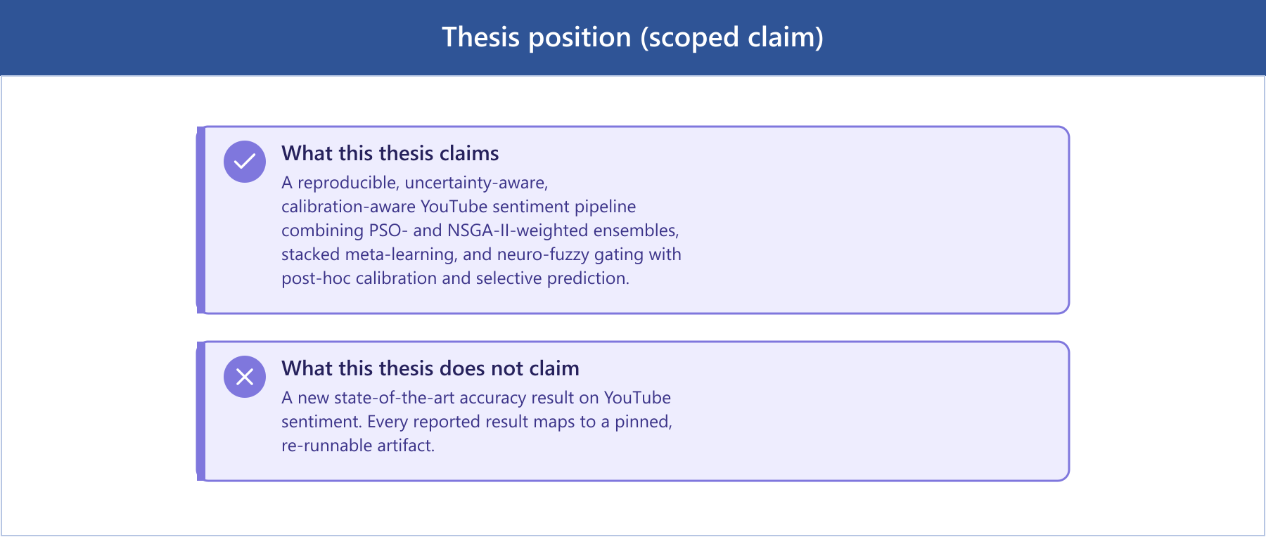
Figure 1 Thesis position (scoped claim)

Research Questions
RQ1: Multi-objective ensemble optimisation. NSGA-II is a multi-objective evolutionary algorithm. Can it produce ensemble weights that improve calibration (Expected Calibration Error, Brier score) over single-objective PSO and a logistic-regression baseline, while keeping macro-F1 intact?
RQ2: Selective prediction. Selective prediction lets the model abstain on low-confidence comments. Does this improve effective accuracy on the high-confidence subset that remains, and what accuracy-versus-coverage trade-off does each architecture show?
RQ3: Calibration across model families. Calibration quality (ECE, Brier) is measured across classical single models, PSO/NSGA-II ensembles, and stacked meta-learning on a large held-out test set. Does it vary by family, and does post-hoc temperature scaling help all of them equally?
RQ4: Human agreement and error structure. This work checks how well the automated models agree with independent human judgement on a hand-annotated gold set, using Krippendorff's alpha to quantify inter-annotator reliability. It also asks which comment characteristics, especially within the Neutral class, explain the systematic disagreements between model and human.
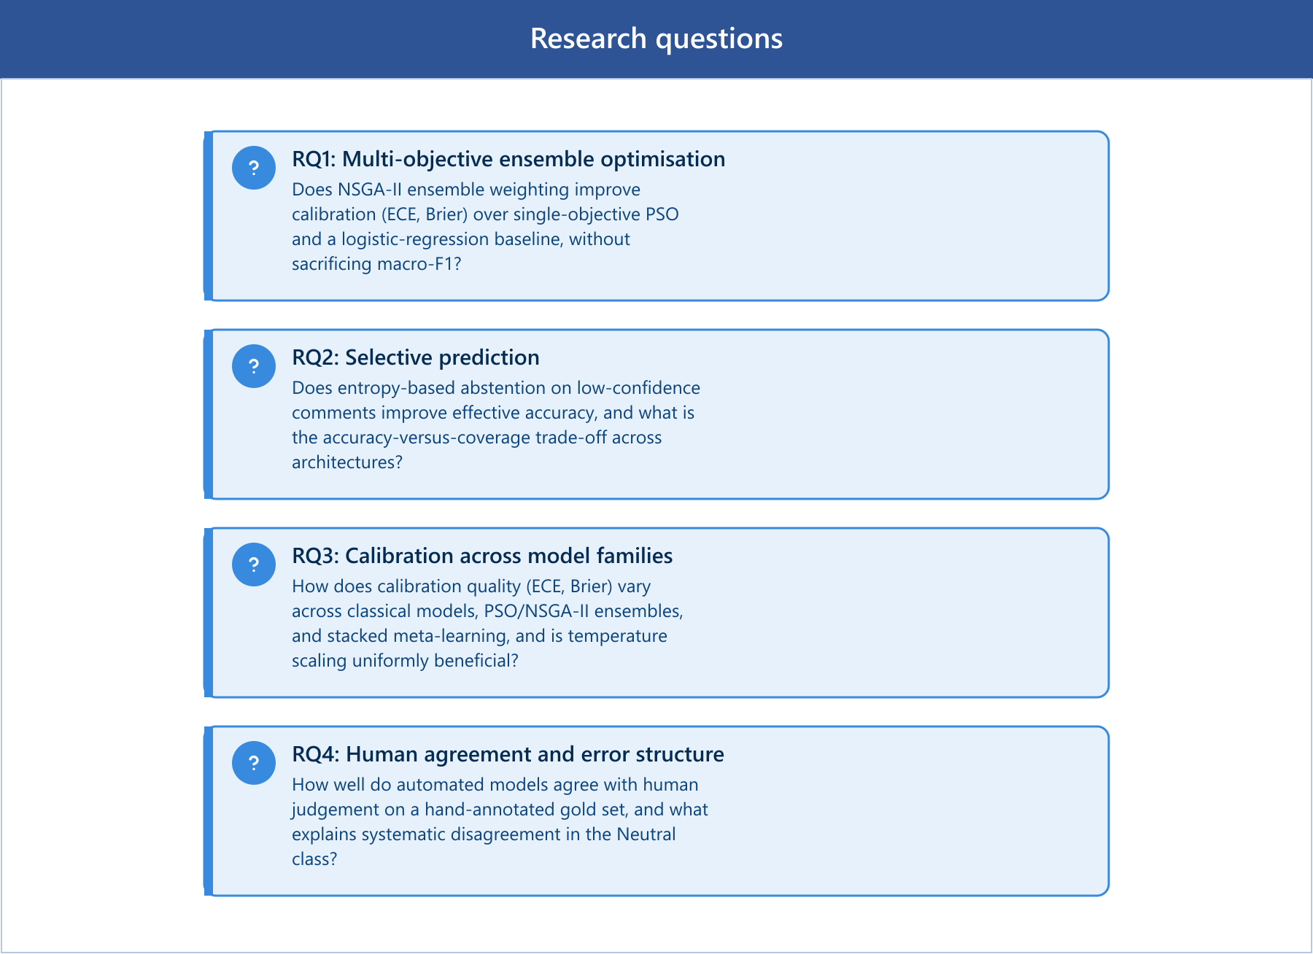
Figure 2 Research questions (RQ1–RQ4)

Contributions
- An artifact-pinned runtime (route_a_live_v1) in which the deployed inference path is tied to fixed calibration, ensemble-weight, and neuro-fuzzy configuration files, with a live-vs-offline reconciliation showing that the deployed system reproduces the offline benchmark (RQ1, RQ3).
- A comparative computational-intelligence evaluation of PSO vs NSGA-II ensemble weighting, stacked meta-learning, and neuro-fuzzy gating, reported on 165,110 held-out comments with both macro-F1 and calibration metrics (RQ1, RQ3).
- A selective-prediction analysis (coverage–accuracy curves, entropy gating) quantifying the confidence quality of each architecture (RQ2).
- A human gold-set evaluation with two independent annotation passes (Krippendorff's α = 0.9547, strong agreement) that separates label error from model error and grounds the headline metrics in human judgement (RQ4).
- A Neutral-class error analysis with a training-free threshold-tuning intervention reported together with its precision/recall costs (RQ4).
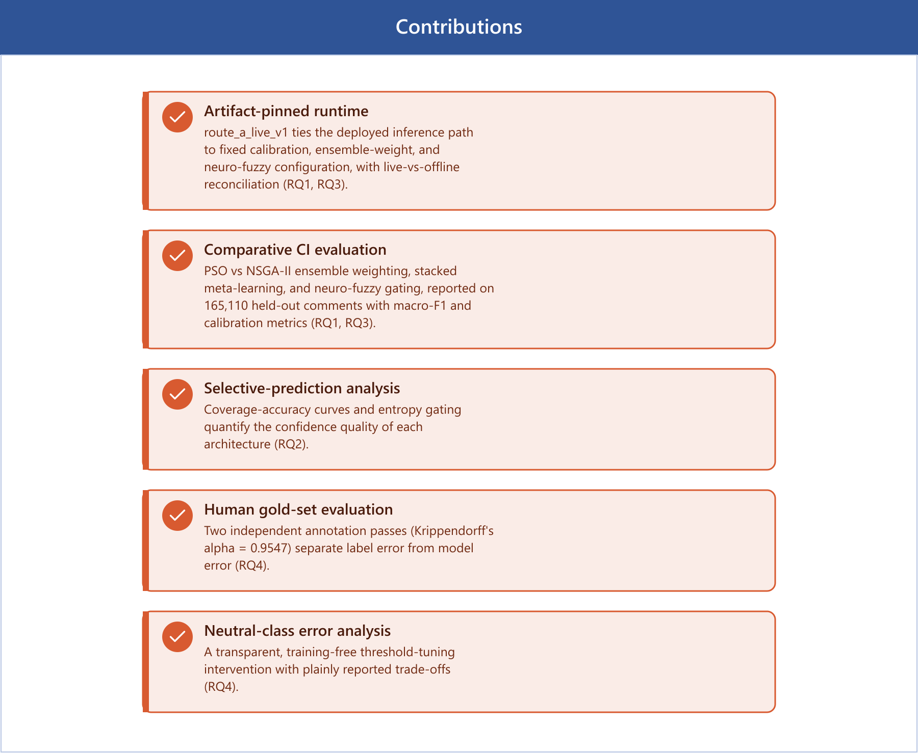
Figure 3 Contributions

Scope and Explicit Non-Claims
Transformers are future work. Only a smoke/CPU benchmark of DeBERTa-v3 exists; no full-dataset, fine-tuned transformer result is claimed. The deployed headline is classical-and-ensemble-first.
Labels are automated, not of human origin. The source corpus is automatically labelled; reported metrics measure agreement with that scheme, with the human gold set providing an independent reliability check.
Aspect analysis is keyword-level, not full aspect-based sentiment analysis (ABSA).
The macro-F1 advantage is small. The best model's macro-F1 advantage over logistic regression is small; the argument rests on calibration and uncertainty quality, not on raw-F1 superiority.

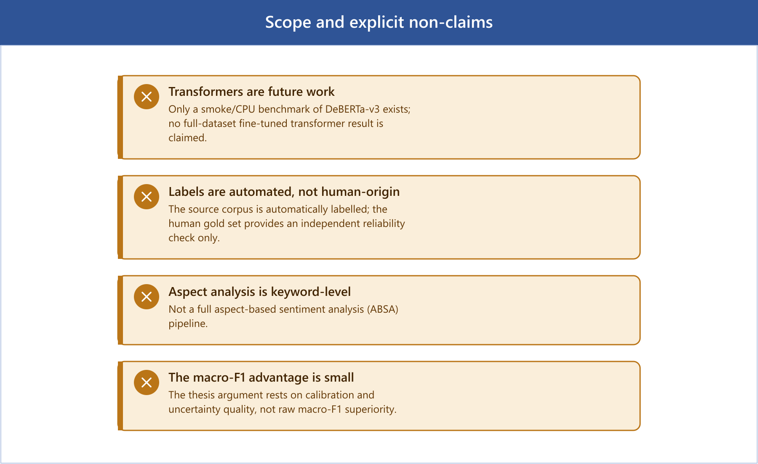
Figure 4 Scope and explicit non-claims

Chapter 2: Literature Review
This chapter situates the thesis within five bodies of work: sentiment analysis and social-media text classification; classical machine-learning baselines; transformer-based sentiment models; computational intelligence for model combination, covering particle swarm optimisation, evolutionary multi-objective optimisation, ensemble learning, and fuzzy / neuro-fuzzy systems; and calibration, uncertainty quantification, and selective prediction. It closes with human annotation and inter-annotator agreement.

Sentiment Analysis and Social-Media Text
Sentiment analysis (the computational treatment of opinion, polarity, and affect in text) has matured from lexicon-driven polarity scoring into a core supervised NLP task (Pang & Lee, 2008; Liu, 2012). Early systems relied on sentiment lexicons and hand-built rules; supervised statistical classifiers then became dominant as labelled corpora grew. Social-media sentiment differs materially from the review-style corpora on which much early work was validated, though. User-generated platform text is short, noisy, and laden with non-standard orthography, emoji, slang, hashtags, code-switching, and sarcasm (Barbieri et al., 2020; Rosenthal et al., 2017). YouTube comments are a particularly demanding instance. They are brief (median ~14 words here), highly topical, and frequently neutral or off-topic in ways that resist clean polarity assignment.
These properties create three recurring difficulties. First, short text gives each instance little lexical context, so classifiers must generalise from sparse evidence (Song et al., 2014). Second, noise and informality, typos, elongations (“loooove”), emoji, and platform-specific tokens, inflate vocabulary and require careful normalisation. Third, sarcasm and context-dependence mean surface lexical cues can invert the true polarity (Joshi et al., 2017). A fourth issue, class ambiguity, is central to this thesis: the Neutral class is the least separable, because it is defined residually and overlaps with both poles. The exploratory analysis in Chapter 3 shows Neutral comments are the shortest in the corpus (median 12 words versus 16 for Negative and 15 for Positive), compounding the short-text problem precisely where the label is most ambiguous.

Classical Machine-Learning Baselines
Despite the rise of deep learning, classical linear models remain strong, efficient, and interpretable baselines for text classification, and they are widely used as the comparison floor in sentiment studies. The canonical pipeline pairs TF-IDF feature representation (Sparck Jones, 1972; Salton & Buckley, 1988), weighting terms by frequency within a document against their rarity across the corpus, with a linear classifier such as logistic regression or a linear support vector machine (Joachims, 1998; Wang & Manning, 2012). Wang and Manning (2012) showed that well-tuned linear SVM and naive-Bayes-SVM variants over n-gram TF-IDF features compete remarkably well with far more complex models on sentiment tasks. That result continues to hold for short, high-volume social text, where transformer inference cost is prohibitive.
These baselines matter here for two reasons. First, they are the honest comparator: any computational-intelligence ensemble must demonstrate value over a tuned logistic-regression baseline, not merely over a weak strawman. Second, linear models over sparse features are exceptionally inexpensive at inference (sub-millisecond per comment in this system), which is material for a deployable YouTube-scale pipeline. The thesis therefore retains logistic regression, linear SVM, and TF-IDF as first-class baselines rather than discarding them, and reports the small margin by which ensemble and meta-learning methods exceed them.

Transformer-Based Sentiment Models
The transformer architecture (Vaswani et al., 2017) and the bidirectional pre-training paradigm of BERT (Devlin et al., 2019) redefined the state of the art across NLP, including sentiment classification. By pre-training deep bidirectional encoders on large unlabelled corpora and fine-tuning on task-specific data, these models capture contextual meaning that bag-of-words representations cannot. Successors refined the recipe: RoBERTa (Liu et al., 2019) improved pre-training robustness, and DeBERTa (He et al., 2021) introduced disentangled attention and an enhanced mask decoder.
For social media specifically, domain-adapted transformers outperform general-purpose ones on platform text. Barbieri et al. (2020) introduced TweetEval and a RoBERTa model pre-trained on a large Twitter corpus, showing that in-domain pre-training substantially improves sentiment and emotion classification on noisy social text. That result motivates the Route A encoder direction in this project (DeBERTa-v3 as an English encoder baseline). The present thesis is explicit, though, that the transformer work here is not a completed full-dataset evaluation. Only a smoke/CPU benchmark exists, the classification head of the saved checkpoint is not fully trained, and the deployed headline is classical-and-ensemble-first. Treating the encoder line as future work, rather than over-claiming transformer superiority, is a deliberate threat-to-validity decision.
Terminology note: 'Route A' denotes the encoder-first architecture track described here - training and evaluating strong pretrained transformer encoders (DeBERTa-v3, ModernBERT) under the same protocol as the classical models. It is distinct from route_a_live_v1, the pinned runtime artifact version (Chapter 3B) for the classical/ensemble system that was built as Route A's comparison baseline. Route A the research agenda remains future work (Chapter 5); route_a_live_v1 the runtime artifact is complete and is what produces every headline number in Chapter 4.

Computational Intelligence for Model Combination
The methodological core of this thesis is how to combine base classifiers, and this is where computational intelligence enters. Ensemble learning, combining multiple learners to outperform any single member, is well established (Dietterich, 2000): bagging, boosting, and stacking reduce variance and/or bias by aggregating diverse models. The open question this work addresses is how to choose the combination weights when the objective is not only accuracy but also calibration.
Particle Swarm Optimisation (PSO). PSO (Kennedy & Eberhart, 1995) is a population-based metaheuristic in which candidate solutions (“particles”) move through a search space guided by their own best position and the swarm's best position. It is well suited to continuous weight-optimisation problems such as finding ensemble mixing weights, requiring no gradient information. Here PSO optimises ensemble weights for a single objective (validation F1), producing the ensemble_pso configuration.
Multi-objective optimisation with NSGA-II. Many deployment objectives conflict maximising macro-F1 can worsen calibration, and vice versa. The Non-dominated Sorting Genetic Algorithm II (Deb et al., 2002) is the canonical evolutionary algorithm for such problems. NSGA-II maintains a population, ranks solutions by Pareto dominance, and uses crowding distance to preserve diversity along the Pareto front, returning a set of non-dominated trade-off solutions rather than a single point. Applying NSGA-II to ensemble weighting allows the thesis to expose the F1-versus-calibration trade-off explicitly and to select a knee-point configuration (ensemble_nsga2) that balances both, directly operationalising RQ1.
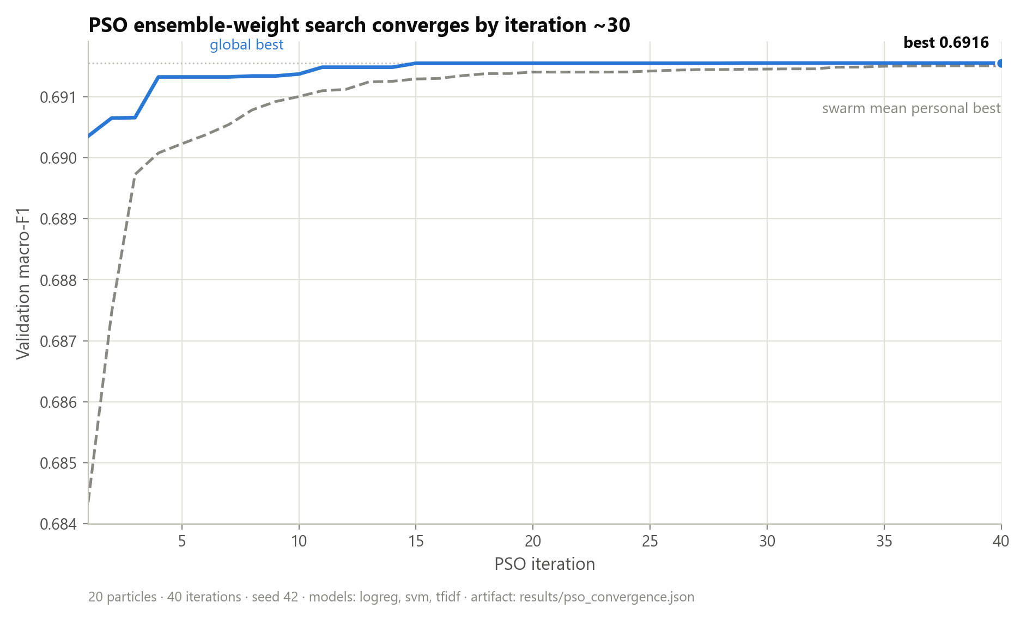
Figure 5 PSO convergence of the single-objective ensemble-weight search over validation F1.
Stacked meta-learning. Stacking (Wolpert, 1992) trains a meta-learner on the out-of-fold predictions of base models, learning a data-driven combination rather than fixed weights. In this work the stacked meta-learner is the strongest model by macro-F1 and is compared against the metaheuristic-weighted ensembles.
Fuzzy and neuro-fuzzy systems. Fuzzy logic (Zadeh, 1965) represents partial truth via membership functions, providing a principled way to reason under linguistic uncertainty, which is appropriate for sentiment, where membership in “Positive” is rarely all-or-nothing. Neuro-fuzzy systems such as ANFIS (Jang, 1993) combine fuzzy inference with neural-network parameter learning. This thesis uses a neuro-fuzzy gate that fuzzifies base-model confidences and applies fuzzy inference to modulate the ensemble decision under uncertainty. Empirically (Chapter 4), the fuzzy ensemble is a valid, implemented computational-intelligence component that attains the lowest calibration error of any configuration in the study while remaining statistically tied with the other ensemble methods on macro-F1.
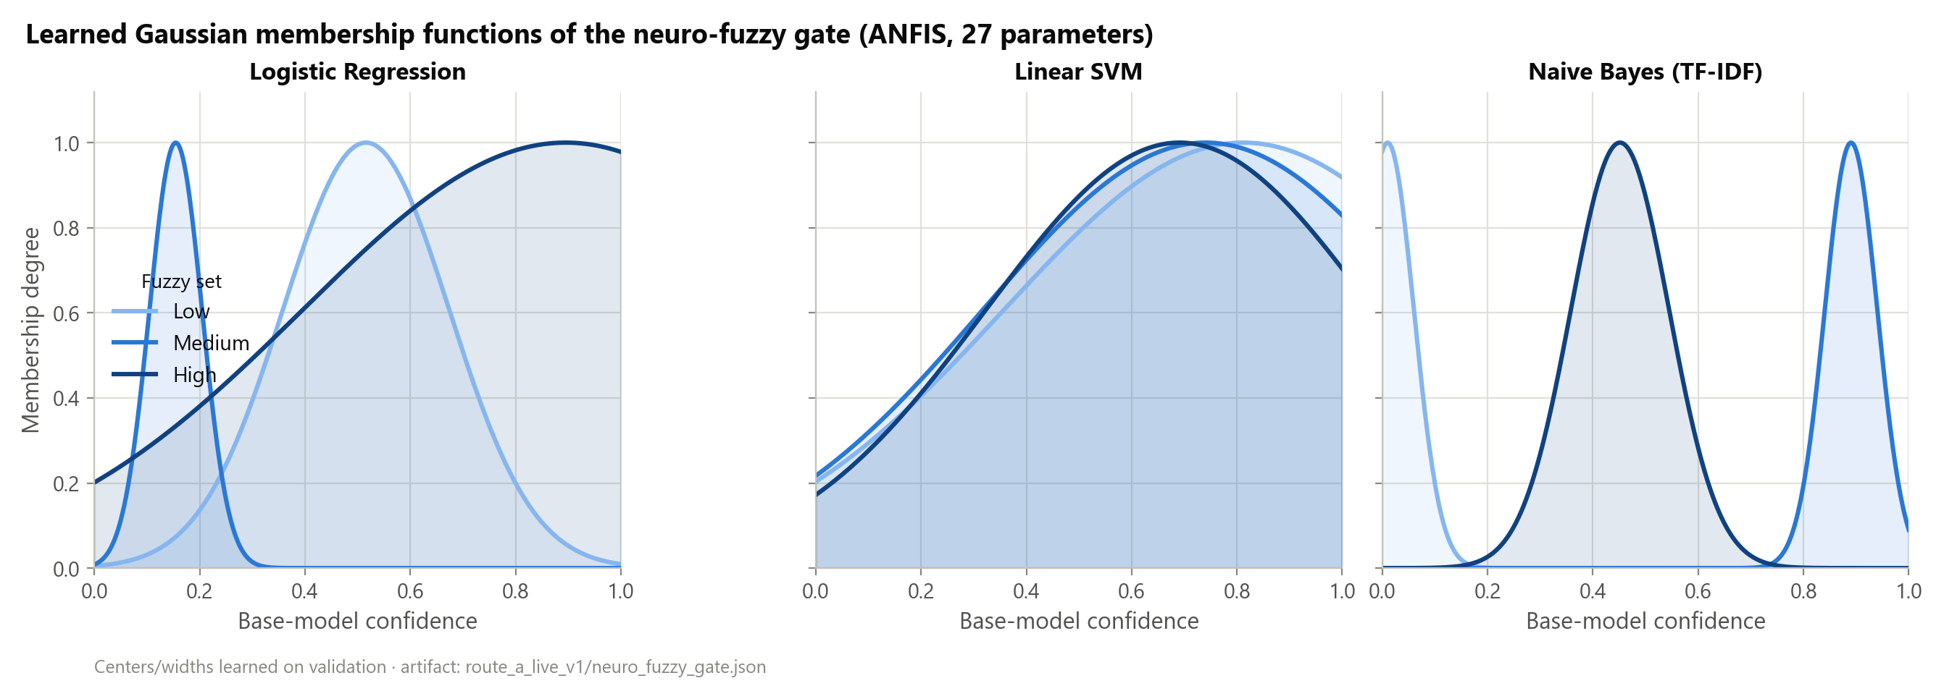
Figure 6 Membership functions of the neuro-fuzzy gate over base-model confidence.

Calibration, Uncertainty, and Selective Prediction
A central argument of this thesis is that probability quality, not only label accuracy, determines the usefulness of a deployed sentiment system. Three strands of literature support this.
Calibration. A classifier is calibrated if its predicted confidence matches its empirical accuracy. Guo et al. (2017) showed that modern neural networks, despite high accuracy, are frequently mis-calibrated (typically over-confident), and that a simple post-hoc method, temperature scaling, dividing the logits by a single learned scalar T before the softmax, substantially restores calibration without changing the predicted label. Calibration quality is quantified by Expected Calibration Error (ECE) and by the Brier score (Brier, 1950). This thesis adopts temperature scaling per model, reports ECE and Brier for every model, and explicitly refuses to claim universal calibration gains.
Uncertainty quantification. Lakshminarayanan et al. (2017) showed that deep ensembles, averaging multiple independently trained models, yield well-calibrated predictive uncertainty competitive with Bayesian approaches. This grounds the ensemble methods at the heart of this work: combining diverse base learners serves uncertainty estimation as much as accuracy. Normalised predictive entropy is used here as the per-comment uncertainty signal. Confidence intervals on the headline macro-F1 and ECE metrics are computed via the non-parametric bootstrap (Efron, 1979), resampling the test set with replacement to estimate sampling variability without distributional assumptions.
Selective prediction. When a model can abstain on uncertain inputs, it can trade coverage for accuracy. The classifier-with-reject-option framework (Chow, 1970; El-Yaniv & Wiener, 2010) formalises this, and Geifman and El-Yaniv (2017) developed selective prediction for deep networks. This thesis builds entropy-gated selective prediction and reports coverage–accuracy curves per model (RQ2). This reframes weak Neutral performance constructively, since the system can flag ambiguous Neutral comments for human review rather than forcing an error.

Human Annotation and Inter-Annotator Agreement
The source corpus is automatically labelled, not human labelled, so the reliability of the evaluation rests on an independent human reference. Raw percentage agreement is a poor reliability measure for categorical annotation, since the base rate of the majority class inflates it; chance-corrected coefficients are the standard remedy. Cohen's kappa (Cohen, 1960) corrects for chance agreement between two annotators, Fleiss' kappa generalises this to multiple annotators, and Krippendorff's alpha (Krippendorff, 2004) provides a general reliability coefficient. Artstein and Poesio (2008) review these measures and discuss thresholds for “tentative” (α ≥ 0.67) and “reliable” (α ≥ 0.80) conclusions, and Landis and Koch (1977) give widely cited interpretive bands for kappa. Against this backdrop, the thesis builds a 300-item gold set, labels it in two independent source-blind annotation passes, and reports Krippendorff's α = 0.9547: strong agreement. The reconciled human labels then validate the headline metrics and separate label error from model error (RQ4).

Research Gap and Positioning
The reviewed literature establishes mature components in isolation: classical baselines, transformers, PSO and NSGA-II, fuzzy systems, calibration, selective prediction, and agreement metrics. What remains comparatively under-explored, and what this thesis addresses, is their integrated combination for social-media sentiment under deployment constraints: specifically, using multi-objective evolutionary optimisation to weight an ensemble for the joint F1–calibration objective, wiring the result into an artifact-pinned runtime whose deployed predictions provably match the offline benchmark, and grounding every claim in a re-runnable artifact and an independent human gold set. The contribution is therefore one of rigorous integration and evaluation methodology rather than a novel single algorithm.

Chapter 3: Methodology and Data
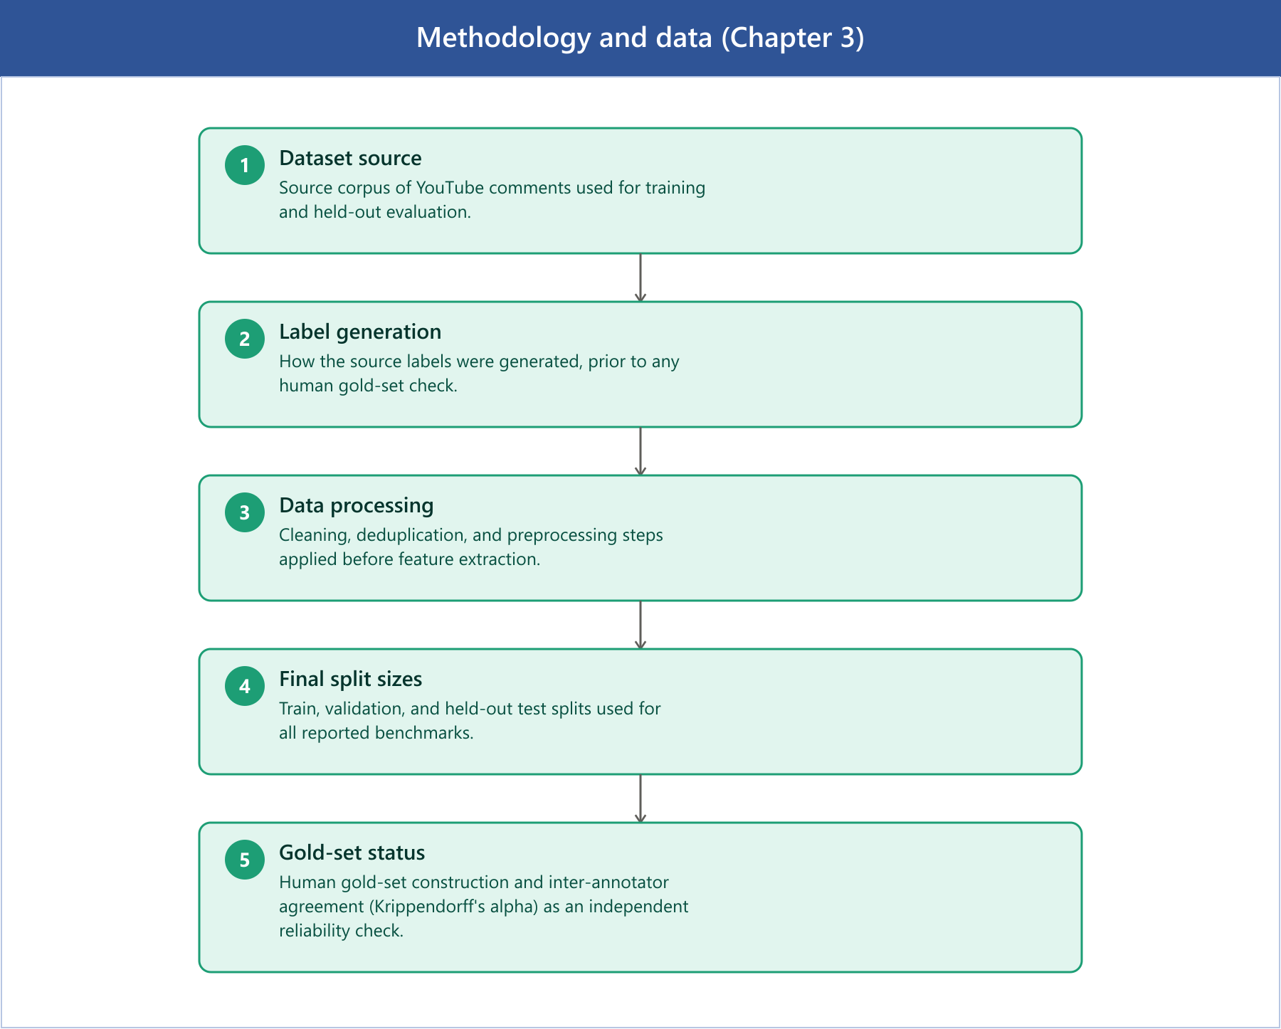
Figure 7 Methodology and data overview (Chapter 3)

Dataset Source
Data were sourced from the AmaanP314/youtube-comment-sentiment dataset on the HuggingFace Hub, comprising 1,032,225 YouTube comments labelled with Positive, Neutral, and Negative sentiment via automated classification.
Field | Value
Source | HuggingFace Hub
Dataset ID | AmaanP314/youtube-comment-sentiment
File | youtube-comments-sentiment.csv
Raw rows | 1,032,225
Classes | Positive / Neutral / Negative
Label column | Sentiment
Table 1. Source dataset specification.

How the Source Labels Were Generated
The source labels come from an automated sentiment classifier applied to the comment text. No human annotators assigned them, and the dataset card does not fully document the labelling process. Automated sentiment labellers such as VADER (Hutto & Gilbert, 2014) and TextBlob (Loria, 2018) are commonly reported to achieve 60–80% agreement with human judgement on social-media text; this thesis's own gold set measures 73.5% agreement between the source labels and the reconciled human labels (Chapter 4), within that range. The implication matters and carries through the whole thesis. When a metric such as 69.45% macro-F1 is reported, it measures how well the model replicates the automated labeller, not absolute human-level sentiment accuracy. The Methodology and Threats-to-Validity material states this distinction again, and it is the reason an independent human gold set is constructed.

Data Processing Steps Applied
After sourcing from HuggingFace, the following transformations were applied before splitting (documented in split_metadata.json). Class distribution after processing is approximately balanced (±5% across classes in all splits), meaning reported macro-F1 and accuracy are directly comparable and class imbalance is not a confound.
Step | Details
Label normalisation | str.title() → Positive / Neutral / Negative
Whitespace collapse | Multi-space → single space, strip
Conflicting-label removal | 1,228 texts with disagreeing labels dropped
Exact-duplicate removal | 12,679 duplicate rows removed
YouTube preprocessing | Emoji convert, spam filter, language filter, min 3 words
Spam filtered | 34,266 rows
Non-English filtered | 138,590 rows
Too-short filtered | 25,221 rows
NaN text/label dropped | 9,391 rows (missing text or label; see note below table)
Split strategy | Group-aware by VideoID (prevents topical leakage)
Table 2. Preprocessing pipeline applied before splitting.
Row-accounting note: 1,032,225 (raw) minus 1,228 (conflicting), 12,679 (exact duplicate), 34,266 (spam), 138,590 (non-English), 25,221 (too short), and 9,391 (NaN text/label) leaves 810,850, matching the final corpus size in Table 3. The NaN-drop count was not persisted to split_metadata.json for this run; the preparation script now records it as dedupe.nan_text_or_label_rows_dropped for future runs.

Final Split Sizes
The final corpus contains 810,850 samples partitioned into train (516,886), validation (128,854), and test (165,110) splits using a group-aware strategy by VideoID to prevent topical data leakage. The resulting class distribution is approximately balanced (Negative 36.1%, Positive 33.3%, Neutral 30.6% on the test split).
Split | Rows | Negative | Neutral | Positive
Train | 516,886 | 184,266 (35.7%) | 160,744 (31.1%) | 171,876 (33.2%)
Val | 128,854 | 47,023 (36.5%) | 39,037 (30.3%) | 42,794 (33.2%)
Test | 165,110 | 59,614 (36.1%) | 50,540 (30.6%) | 54,956 (33.3%)
Table 3. Final split sizes and per-class distribution.

Gold-Set Status and Inter-Annotator Agreement
A stratified gold set of 300 comments went through two independent annotation passes, using a blind command-line tool (scripts/annotate.py) that shows each comment without the dataset's automated source label: the template holds only the text and an empty label field. Reconciling the two passes into a single human reference produced strong agreement: Krippendorff's alpha = 0.9547, Cohen's/Fleiss' kappa = 0.9546, and 97.0% raw percent agreement, with 9 no-majority items excluded as disputed (291 reconciled labels remain). The reconciled human labels match the automated source labels only 73.5% of the time, which confirms the gold labels are genuinely human-derived rather than copies of the source scheme. Agreement sits well above the alpha >= 0.80 reliability threshold (Artstein & Poesio, 2008), so residual model-human disagreement reflects genuine model error and intrinsic ambiguity, not annotation noise. The gold set was sampled from the training split rather than the held-out test split, but a post-hoc membership check and a held-out-only re-evaluation (Chapter 4) confirm that this does not materially change the reported model-vs-human figures.
Annotator disclosure: the thesis author completed one annotation pass, and an independent second annotator, not otherwise involved in model development, completed the other. Both passes were blind to the dataset's automated source labels, using the same template and tool (scripts/annotate.py). The author's pass is not fully arms-length in the way a third-party-only annotation would be; this is a limitation, but the reported Krippendorff's alpha still reflects genuine agreement between two distinct people rather than self-consistency.

Chapter 3 (continued): Exploratory Data Analysis
This section summarises the exploratory data analysis of the corpus. Length and lexical statistics are computed on a fixed 50,000-row sample of the test split (seed 42).

Class Distribution
The corpus is approximately balanced across all three splits, so macro-F1 and accuracy are directly comparable and class imbalance is not a primary confound. Neutral is the smallest class in every split (~31%) but not so small as to constitute an imbalance problem; its weaker performance (Chapter 4) is driven by ambiguity and length, not frequency.
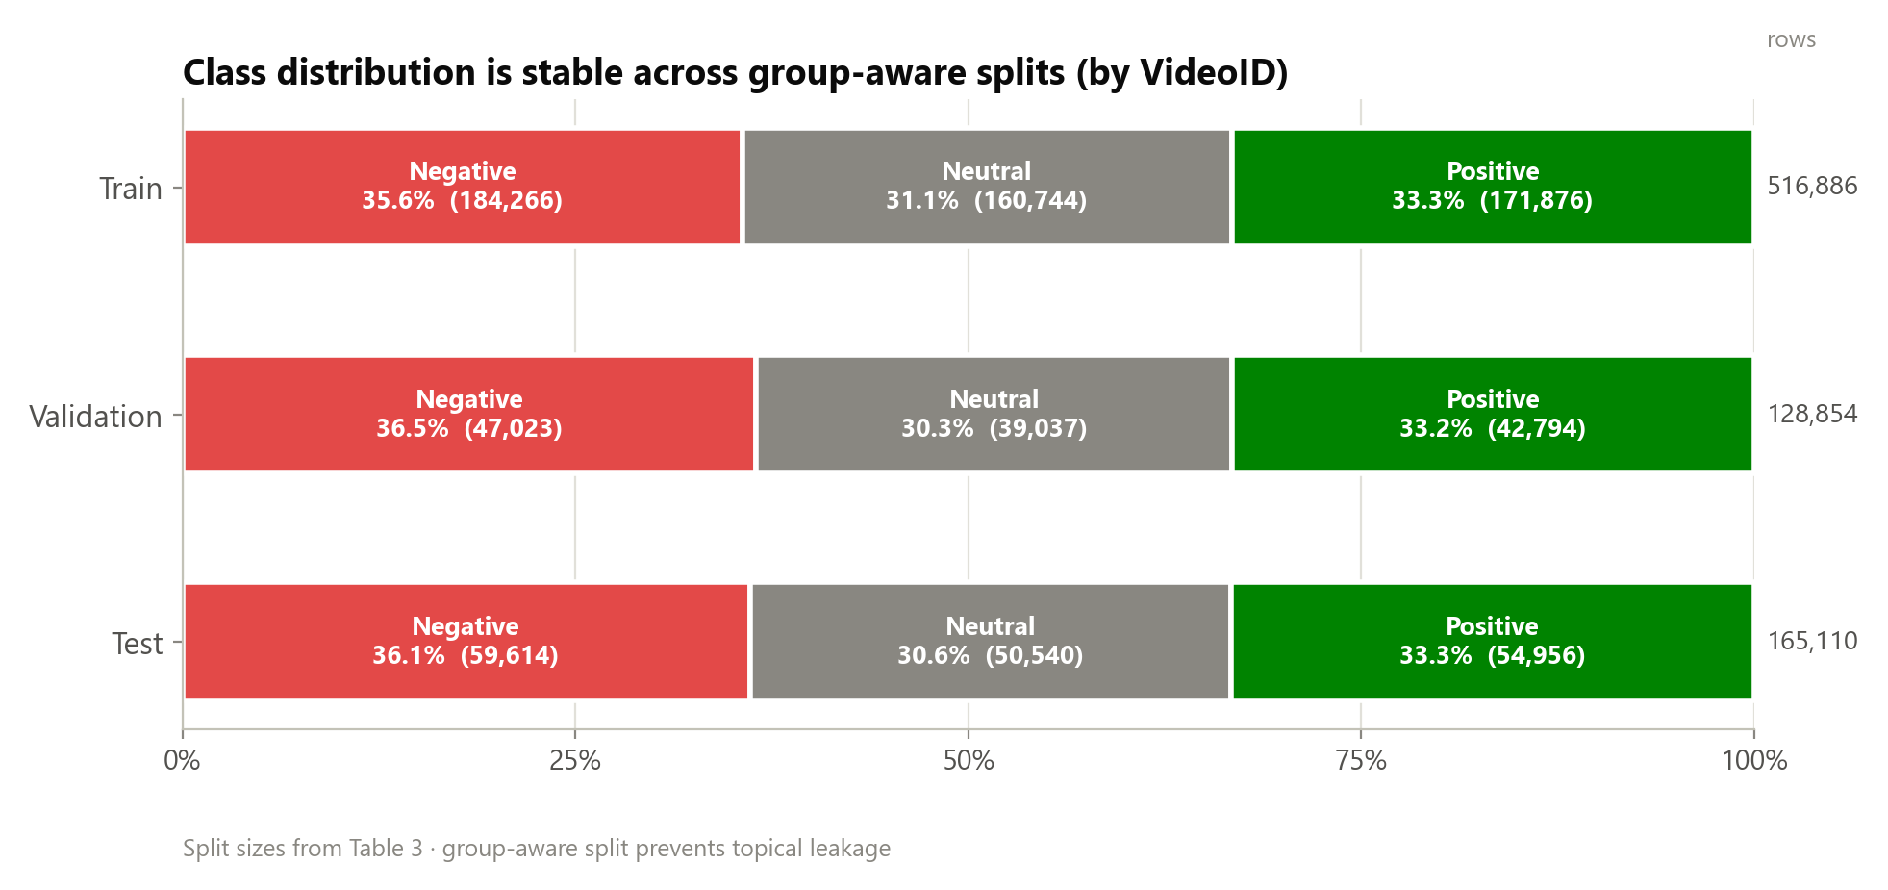
Figure 8 Class distribution across the group-aware train/validation/test splits (by VideoID).

Comment-Length Distribution
Comments are short, which is the central modelling challenge, since each instance provides little lexical context. The key finding is that Neutral comments are the shortest (median 12 words versus 16 for Negative and 15 for Positive). This couples the two hardest factors, short text and label ambiguity, precisely on the Neutral class, and provides a data-grounded explanation for the consistently lower Neutral F1 observed across every model.
Metric | Mean | Median | P90 | P99/Max
Characters | 116.6 | 78 | 230 | 668 / 9,001
Words | 21.1 | 14 | 41 | 117 / 1,495
Table 4. Overall comment-length statistics (50,000-comment sample).
Class | Mean | Median | P90
Negative | 22.8 | 16 | 44
Neutral | 18.8 | 12 | 36
Positive | 21.5 | 15 | 43
Table 5. Comment length (words) by class: Neutral is the shortest.
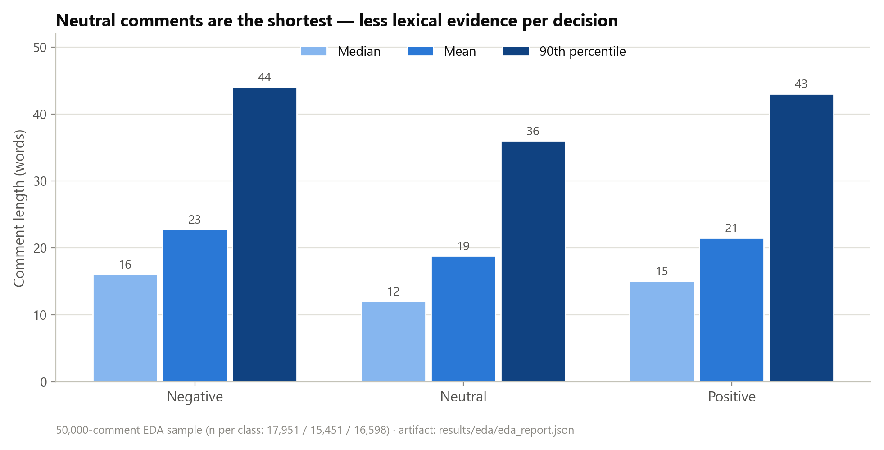
Figure 9 Comment length (words) by class: Neutral comments are the shortest (50,000-comment EDA sample).

Lexical Statistics
On the 50,000-comment sample, the corpus has a type/token ratio of 0.0385 (40,634 unique tokens over 1,054,939 total tokens). That is low in absolute terms, as expected for a corpus this size, though typos, slang, elongations, and named entities inflate it somewhat relative to a clean reference corpus of equal token count. Function words and platform-generic terms dominate the most frequent tokens. One oddity: 'face' is the 13th most frequent token (11,314 occurrences). That is an artefact of the emoji-to-text conversion step (Table 2) rather than organic vocabulary, convert-mode emoji processing renders emoji like the face-with-tears-of-joy character as descriptive text tokens. The picture that emerges is of discriminative sentiment signal that is sparse and spread among function words, converted-emoji tokens, and slang. That is why TF-IDF weighting, which down-weights ubiquitous tokens, works well as a classical representation here.

Language and Domain Metadata
The corpus was language-filtered to English during preprocessing (138,590 non-English rows removed). The retained corpus is therefore English-only by construction, a deliberate scope decision and a stated external-validity limitation: the system is neither trained nor evaluated on code-mixed or non-English comments. A metadata-bearing 10k domain split preserves CategoryID, CountryCode, VideoID, and PublishedAt, supporting a domain-shift slice evaluation. The top categories span News/Politics, Education, Sports, How-to, and Entertainment; the top countries are US, AU, CA, GB, IN, NZ, IE, and DE, an English-speaking-majority but internationally spread audience. The slice analysis shows a meaningful accuracy spread across categories (logistic regression ranges from F1 ≈ 0.62 on the weakest category to ≈ 0.83 on the strongest).
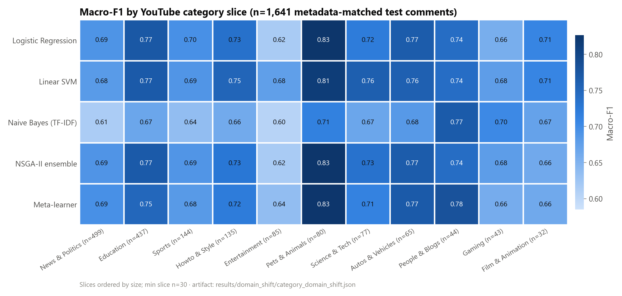
Figure 10 Cross-domain performance heatmap across YouTube category slices.

Label-Noise Discussion
Because the source labels are automated, some proportion of “errors” measured against them are in fact label noise rather than model error. Two pieces of evidence bound this. First, the human gold set shows strong inter-annotator agreement (α = 0.9547) but only ~72% model agreement with the reconciled human labels, indicating that a substantial share of the gap between automated-label accuracy and human-label accuracy is attributable to the automated labelling scheme and to genuine ambiguity, not solely to the model. Second, the 9 of 300 gold-set items with no human majority quantify irreducible ambiguity, concentrated in the Neutral region. This is treated as a construct-validity limitation, and is the reason human-gold metrics are reported alongside the automated-label metrics rather than relying on either alone.

Chapter 3B: System Design and Implementation
This chapter describes the architecture and configuration of the deployed system: the classical base classifiers, the three computational-intelligence combination methods (PSO, NSGA-II, stacked meta-learning), the neuro-fuzzy gate, the calibration procedure, and the backend/frontend platform that serves them. Every hyperparameter below is quoted directly from the implementation rather than described qualitatively, so that the configuration is independently checkable against the cited source file.

3B.1 Architecture Overview
The system is a three-tier application. A Django backend (backend/) hosts the inference pipeline and a REST API; a React frontend (frontend/) provides the analyst-facing dashboard; a research layer (backend/research/) trains and evaluates the classical, ensemble, and computational-intelligence models offline and exports the pinned runtime artifacts (results/runtime/route_a_live_v1/) that the API loads at inference time. The base representation for every classical model is TF-IDF over the cleaned comment text, chosen for its sub-millisecond inference cost at YouTube scale (Chapter 2).
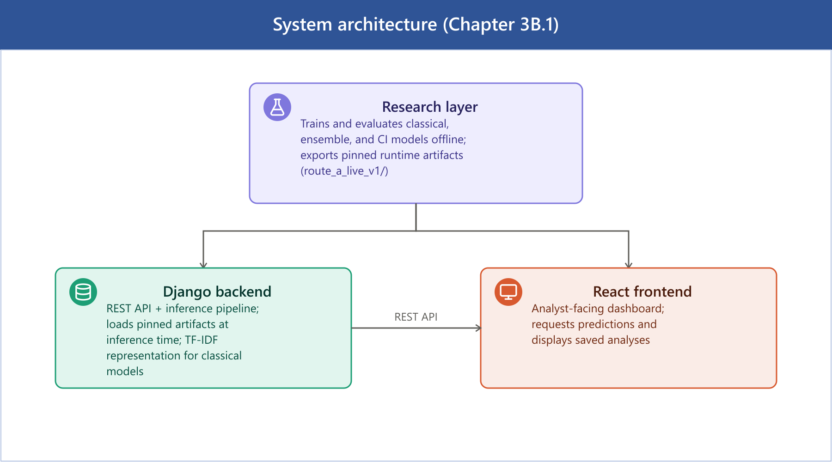
Figure 11 System architecture (Chapter 3B.1)

3B.2 Base Classifiers (Level 0)
Three base learners are trained on TF-IDF features and used both directly and as inputs to every downstream combination method:
Model | Algorithm | Key configuration
logreg | Logistic Regression | C=1.0, max_iter=200, solver="saga"
svm | Linear SVM | LinearSVC (default regularisation)
tfidf | Multinomial Naive Bayes | alpha=0.5

These three are the level-0 learners for both the metaheuristic ensembles (§3B.3–3B.4) and the stacked meta-learner (§3B.5).

3B.3 Particle Swarm Optimisation (PSO) Ensemble Weighting
Source: research/optimize_ensemble.py (production driver); research/computational_intelligence/metaheuristics/pso.py (generic PSO class, used for the standalone metaheuristics module rather than the production ensemble pipeline).
PSO searches over one continuous weight per base model (logreg, svm, tfidf), initialised uniformly in [0, 1], clipped to be non-negative after each velocity update, and re-normalised to sum to one before every fitness evaluation. Fitness is the validation-set macro-F1 of the resulting weighted-average ensemble's argmax predictions (maximised).
Parameter | Value
Particles | 20 (script default) / 30 (pipeline default, --ensemble_particles)
Iterations | 30 (script default) / 50 (pipeline default, --ensemble_iterations)
Inertia (w) | 0.7
Cognitive coefficient (c1) | 1.4
Social coefficient (c2) | 1.4
Seed | 42
Objective | Maximise validation macro-F1 (argmax of weighted probability blend)

The pinned weight vector currently served is logreg=0.8805, svm=0.0, tfidf=0.1195 (results/runtime/route_a_live_v1/pso_ensemble_weights.json), achieving 0.6916 macro-F1 on validation and 0.6941 on test, a logistic-regression-dominant blend, since logistic regression is the strongest individual base model on this corpus. This configuration is pinned into the live runtime as ensemble_pso.
An earlier pinned weight vector (logreg=0.3087, svm=0.6913, tfidf=0.0, claimed validation macro-F1 0.7617) dated to the first commit in this repository and was never regenerated against the current 810,850-row corpus; 0.7617 is not achievable by any model in this pipeline (the strongest anywhere is ≈0.69), so the figure was stale rather than a genuine selection-bias artefact. A defensibility audit (Chapter 4, Statistical Significance) identified this and re-fit the PSO weights on the canonical validation/test split via research/analysis/pso_convergence_analysis.py; every PSO-related figure in this thesis reflects the corrected weights. The corrected result is a modest one: its validation macro-F1 (0.6916) barely exceeds a 200-trial uniform-random weight search over the same space (0.6913; results/pso_convergence.md), an honest limitation, not a claimed win. PSO's role in this thesis is as the single-objective baseline that NSGA-II (§3B.4) is compared against, not an independently validated optimisation result in its own right.

3B.4 NSGA-II Multi-Objective Ensemble Weighting
Source: research/ci/multi_objective_ensemble.py (driver); research/computational_intelligence/metaheuristics/nsga2.py (algorithm).
Where PSO optimises a single objective, NSGA-II searches the same ensemble-weight space for a Pareto front trading off three simultaneously minimised objectives:
1. Negative macro-F1 (i.e. maximise macro-F1)
2. Expected Calibration Error (ECE) (minimise)
3. Negative coverage at a 0.70 confidence threshold (i.e. maximise the fraction of predictions with max-class probability ≥ 0.70)
Parameter | Value
Population | 60
Generations | 80
Crossover | Simulated Binary Crossover (SBX), probability 0.9, distribution index η=20
Mutation | Polynomial mutation, distribution index η=20, probability 1/n (n = number of decision variables)
Selection | Binary tournament on non-dominated rank + crowding distance
Seed | 42

Ranking uses standard fast non-dominated sorting with crowding-distance diversity preservation. The final ensemble configuration (ensemble_nsga2) is selected from the returned Pareto front as the knee point: the solution minimising the normalised Chebyshev (L∞) distance to the ideal point (the per-objective best value across the front). This is a principled, parameter-free way to pick a single balanced operating point from a multi-objective search rather than arbitrarily choosing the best-F1 or best-ECE extreme. The full Pareto front, the selected weights, and validation/test metrics for the knee point are written to results/multi_objective_ensemble.json.

3B.5 Stacked Meta-Learner
Source: research/meta_learner.py, class MetaLearnerEnsemble.
The stacked meta-learner is a two-level model. Level 0 is the same logreg/svm/tfidf base classifiers as above; Level 1 is trained on their out-of-fold class-probability predictions rather than their in-sample predictions, to avoid the meta-learner over-fitting to base models that have already seen the training labels.
• Out-of-fold generation: `StratifiedKFold(n_splits=5, shuffle=True, random_state=42)`. Base models are retrained inside each fold (per_fold mode, the thesis-grade default) rather than loaded pre-trained, so no base model ever sees the labels of the fold it is predicting on.
• Meta-features: each base model contributes its 3-class probability vector (Negative/Neutral/Positive), giving 9 features total (feature_type="probs").
• Meta-model: `LogisticRegression(C=1.0, max_iter=1000, class_weight="balanced", solver="lbfgs")`, trained on the 9-dimensional OOF probability features against the true labels.
• Persistence: the fitted meta-model plus base-model/vectorizer configuration is serialised to meta_learner.pkl for reproducible inference.
At inference time the three base models are run on the input comment, and their concatenated probability vectors are passed through the trained logistic-regression meta-model to produce the final class probabilities, a learned, data-driven combination rule, in contrast to the fixed linear weights of PSO/NSGA-II.

3B.6 Neuro-Fuzzy Gate
Source: research/ci/neuro_fuzzy_gate.py, class NeuroFuzzyGate.
The neuro-fuzzy gate is a simplified ANFIS-style module that learns a per-sample (rather than fixed) ensemble weighting based on each base model's confidence. A full three-model, three-set ANFIS would require 3³ = 27 cross-model rules; this implementation instead fits 27 total parameters via a per-model linear combination of single-model fuzzy sets, which is tractable to fit on the available validation data while retaining the fuzzy-inference structure:
• Input (linguistic variable): per-model confidence, defined as 1 − normalised predictive entropy.
• Fuzzification: three Gaussian membership functions per model (Low, Medium, High), μ(c) = exp(−0.5·((c − center)/width)²). Initial centers are {0.25, 0.50, 0.75}, initial width 0.20.
• Rule/consequent structure: for each model *m*, a gate value gate_m = Σ_k α_{m,k} · μ_{m,k}(c_m) is computed as a learned linear combination of that model's three membership activations (3 models × 3 sets × {center, log-width, consequent weight} = 27 parameters).
• Defuzzification: the three per-model gates are passed through a softmax to obtain per-sample ensemble weights, which are then used to combine the base models' probability vectors.
• Fitting: all 27 parameters (MF centers, log-widths, consequent weights) are jointly optimised by minimising the negative log-likelihood of the gated ensemble's predictions on the validation set, via scipy.optimize.minimize(method="L-BFGS-B") with bounds center ∈ [0.01, 0.99], log_width ∈ [log 0.05, log 0.50], alpha ∈ [-5, 5], ftol=1e-8, gtol=1e-6, for up to maxiter=200 iterations (CLI default --maxiter 200).
Deployment note. At inference time the fitted parameters are consumed by a second implementation, FuzzyEnsembleSentimentEngine (src/sentiment/engines/fuzzy_engine.py, method _nf_gate_blend). It loads neuro_fuzzy_gate.json from the pinned runtime manifest whenever its configured base models exactly match the fitted gate's {logreg, svm, tfidf}. One difference matters here: the deployed blend re-purposes the fitted alpha as a Gaussian sharpness term, exp(-alpha*(c - center)^2 / (2*width^2)), where fitting used it as a linear consequent weight (alpha * mu(c)). The two formulas are not algebraically equivalent. Both, though, route through the same softmax-normalised, per-model gate structure, and the deployed engine is the one behind the fuzzy_ensemble row in Chapter 4. Should base_models not match the fitted gate's model set, the engine falls back to a separate, independently implemented static fuzzy-inference system (Gaussian membership functions, centroid defuzzification, min/max t-norm/t-conorm) instead of the learned gate. The route_a_live_v1 configuration always uses the three matching base models, so the reported results never exercise this fallback. As Chapter 4 shows, a direct ablation against logistic regression (the gate's now-dominant base model) found the gate changing the base classifier's argmax on 2.74% of comments on a 40,000-comment sample (seed 42): 1,096 of 40,000, comprising 456 corrections, 412 regressions, and 228 wrong-to-wrong flips, a small net-positive edit rate. The resulting fuzzy_ensemble attains the lowest calibration error of any configuration in this study (Chapter 4), a second, independently derived route to the same calibration-quality result NSGA-II achieves, not a pass-through or a negative result.

3B.7 Temperature Scaling and Calibration
Source: research/ci/temperature_scaling.py.
Each of the five deployed model configurations (logreg, svm, tfidf, the static ensemble, meta_learner) is independently post-hoc calibrated by fitting a single scalar temperature T:
• Because the classical models expose class probabilities rather than raw logits, pseudo-logits are computed as z = log(p + 1e-10) from the model's output probability vector.
• T is fit by minimising the negative log-likelihood of the temperature-scaled softmax, softmax(z / T), on the validation split, using scipy.optimize.minimize_scalar(method="bounded") (a bounded 1-D Brent-style search) over T ∈ [0.1, 10.0].
• At inference, the fitted T is applied to rescale the model's output probabilities before they are used downstream (by the API, by the ensembles, or by the entropy-gated selective predictor).
Because rescaling by a positive scalar before softmax does not change the argmax, temperature scaling never changes accuracy or macro-F1, only the confidence values, which is why Chapter 4 reports it as a calibration mechanism strictly orthogonal to the label-accuracy metrics.

3B.8 Deployment Platform
Backend (backend/, Django): three apps.
• app: the sentiment-analysis core: YouTube comment fetching (youtube_fetcher.py, youtube_scraper.py), preprocessing (youtube_preprocessor.py), the sentiment engines (src/sentiment/engines/), deep-learning model support (hybrid_dl_engine.py), and keyword-level aspect mining (aspect_mining.py). Exposed endpoints (app/urls.py) include youtube/analyze/ (submit a video for analysis), youtube/analysis/<video_id>/ and youtube/analyses/ (retrieve results), and youtube/health/ (health check).
• app_api: authentication: JWT issuance and refresh (token/, token/refresh/) via djangorestframework-simplejwt.
• users: user account models, serializers, and views.
Frontend (frontend/src/, React): the analyst-facing pages live under Views/Pages/, including Dashboard.jsx (result overview), Monitoring.jsx (live/ongoing analysis tracking), Report.jsx, Search.jsx (video/query submission), alongside account pages for authentication. Shared UI, application state, and the authentication context live in Components/, context/, and utils/.
Communication. The frontend authenticates against app_api's JWT endpoints, then makes authenticated REST calls to app's youtube/analyze/ and youtube/analysis* endpoints to submit videos and retrieve calibrated, uncertainty-annotated sentiment results, which the Dashboard and Monitoring views render alongside confidence and calibration metadata (verified by Dashboard.test.jsx, Monitoring.test.jsx; see Appendix A).
youtube/analyze/ does not block on the analysis itself: fetching comments, preprocessing, and running inference on up to 2,000 comments can exceed any reasonable HTTP timeout, especially for ensemble or transformer models. The view validates the request synchronously (a malformed request still returns a normal 400 with no job created) and then runs the analysis on a background thread, returning a pollable job id (app/models.py::AnalysisJob). The frontend (Search.jsx) polls youtube/analyze/status/<job_id>/ every two seconds for up to six minutes, surfacing the job's pending/running stage in the UI, until the result is ready or the job fails.
[Insert image: screenshot of the React dashboard showing sentiment analysis results for a video]
[Insert image: screenshot of the video submission (Search) page with a running analysis job]

3B.9 Chapter Summary
Every computational-intelligence component in this thesis (PSO, NSGA-II, the stacked meta-learner, and the neuro-fuzzy gate) operates over the same three TF-IDF-based classical learners, differing only in how their outputs are combined: fixed single-objective weights (PSO), fixed multi-objective knee-point weights (NSGA-II), a learned non-linear combiner trained on out-of-fold predictions (meta-learner), or a per-sample adaptive fuzzy-inference weighting (neuro-fuzzy gate). All four are calibrated identically via per-model temperature scaling, and all are served through the same Django/React deployment so that the Chapter 4 evaluation is a like-for-like comparison of combination strategies rather than of different underlying data or preprocessing.

Chapter 4: Consolidated Evaluation
This chapter consolidates every evaluation strand into one defensible narrative, mapping each result to its reproducible artifact. The argument is deliberately not “our model has the best F1”; it is “calibration, uncertainty, and human grounding distinguish the models where raw F1 does not.” All final runtime results are drawn from the pinned live artifact version route_a_live_v1, evaluated on the fixed held-out test split of 165,110 labelled YouTube comments.

Headline Runtime Performance (165,110 comments)
The best model (meta_learner) exceeds the logistic-regression baseline by only +0.0018 macro-F1 on the full test set. This margin is small and the thesis does not rest its contribution on it. The substantive differences are in calibration: ensemble_nsga2 and the neuro-fuzzy fuzzy_ensemble attain ECE = 0.0039 and 0.0030 respectively, roughly a fifth to a sixth of the meta-learner's 0.0183, while matching it on accuracy. The thesis claim is therefore that multi-objective and uncertainty-aware ensemble combination (NSGA-II weighting and the neuro-fuzzy gate alike) buys calibration quality at no accuracy cost (RQ1, RQ3), which is the deployment-relevant property, not a raw-F1 win.
Model | Accuracy | Macro-F1 | ECE | Brier | Calib. | ms/sample
meta_learner | 0.6955 | 0.6946 | 0.0183 | 0.4118 | no | 0.19
ensemble_nsga2 | 0.6959 | 0.6940 | 0.0039 | 0.4092 | no | 0.18
logreg | 0.6946 | 0.6928 | 0.0039 | 0.4100 | yes | 0.06
ensemble_pso | 0.6961 | 0.6941 | 0.0061 | 0.4090 | no | 0.18
svm | 0.6801 | 0.6780 | 0.0157 | 0.4291 | no | 0.05
tfidf | 0.6622 | 0.6567 | 0.0179 | 0.4491 | yes | 0.06
fuzzy_ensemble | 0.6960 | 0.6940 | 0.0030 | 0.4093 | no | 0.20
Table 6. Full-test runtime performance under route_a_live_v1 (165,110 comments).
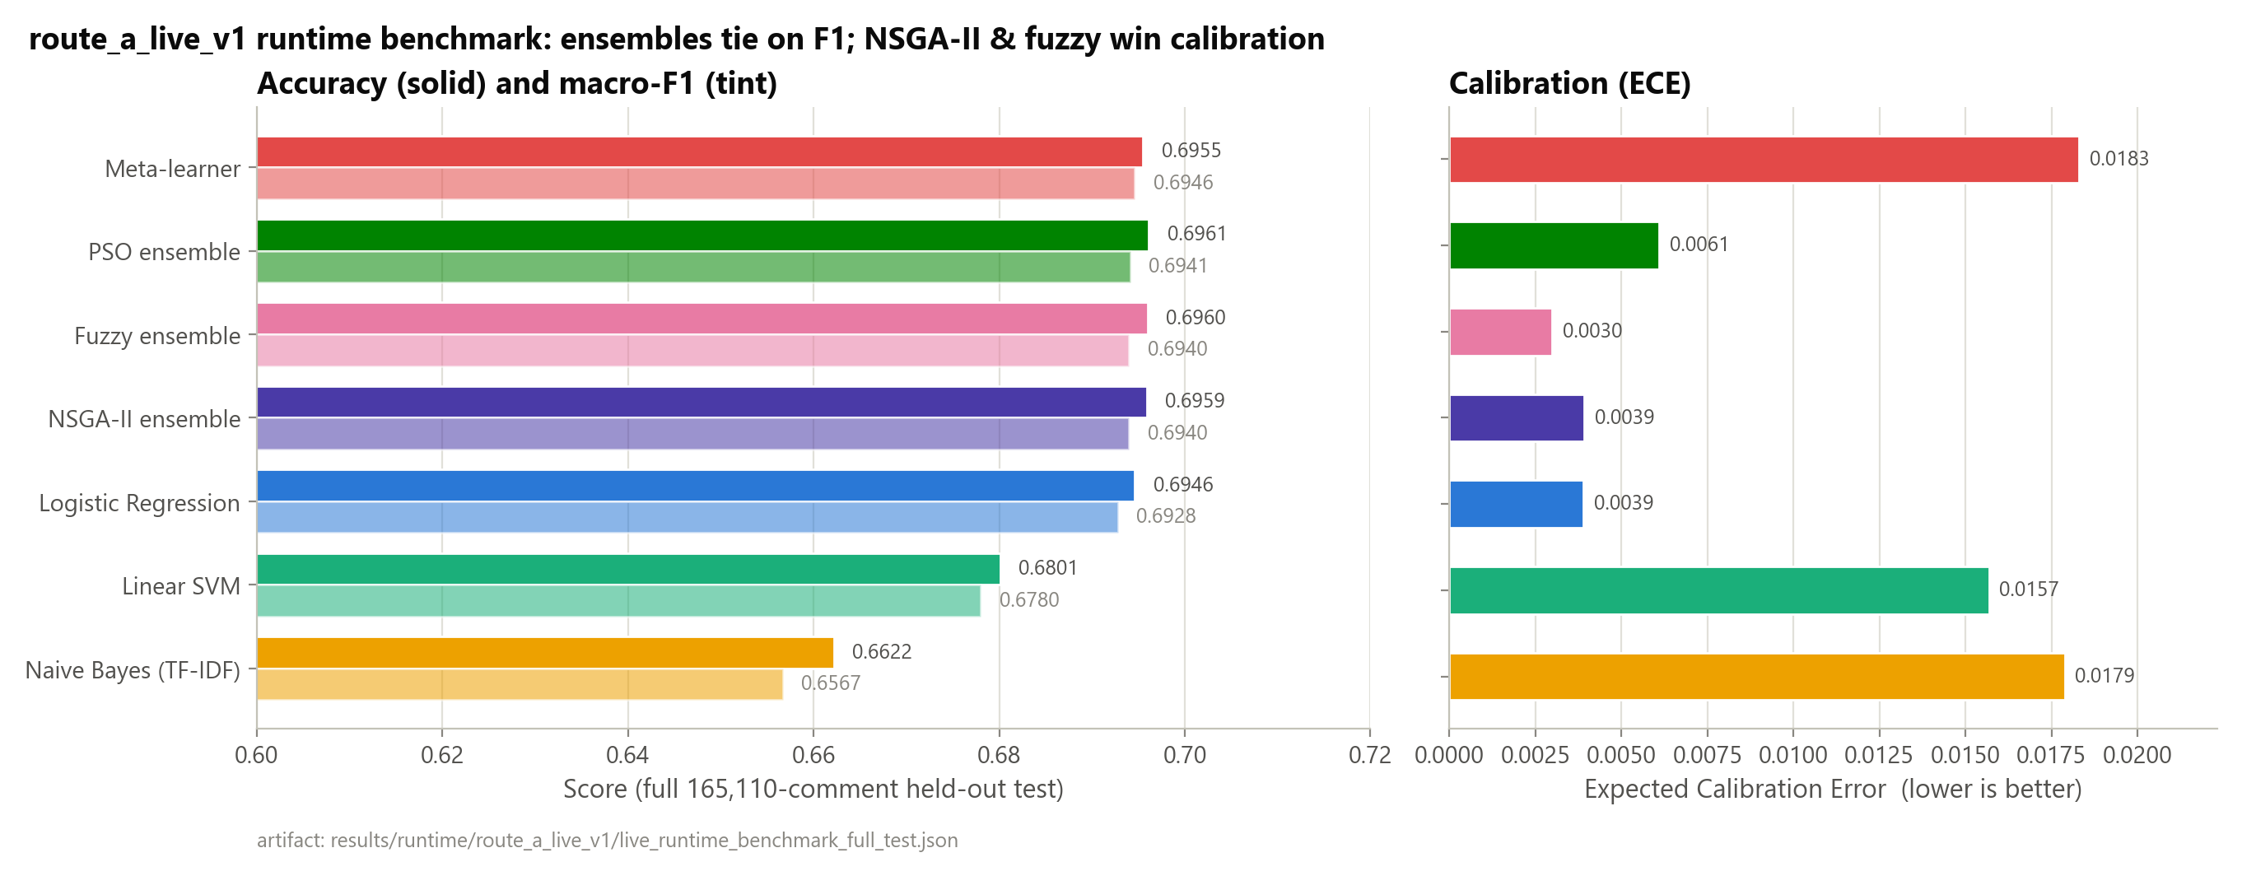
Figure 12 Model comparison across accuracy, macro-F1, and calibration error.
Note on the fuzzy ensemble row (revised). An earlier version of this evaluation reported that the neuro-fuzzy-gated configuration was numerically identical to the TF-IDF + Naive-Bayes base classifier (accuracy 0.6622, macro-F1 0.6567), attributing this to the gate rarely overriding the argmax. That reading rested on two implementation bugs, since fixed: (1) the deployed blend and the fitting script applied the fitted alpha parameter through non-equivalent formulas, and (2) the base models feeding the gate were scored with output calibration enabled, differing from the probability distribution the gate was actually fitted against (§3B.6). With both fixed, the gate is now logistic-regression-dominant rather than a TF-IDF pass-through: the fuzzy_ensemble row reaches macro-F1 0.6940 and ECE 0.0030, the lowest calibration error of any row in Table 6, and statistically tied with ensemble_nsga2 on both macro-F1 and ECE (bootstrap 95% confidence intervals on the differences include zero for both; results/runtime/route_a_live_v1/live_significance_tests.md). A direct ablation against logistic regression (the gate's now-dominant base model) on a 40,000-comment sample (seed 42) shows the gate changing the base classifier's argmax on 2.74% of comments: 1,096 of 40,000, comprising 456 corrections, 412 regressions, and 228 wrong-to-wrong flips (both predictions incorrect but for different labels): a small net-positive edit rate, not the near-total pass-through the pre-fix numbers suggested (results/neuro_fuzzy_gate_ablation/fuzzy_gate_ablation.md; reproducible via research/ci/fuzzy_gate_ablation.py --sample 40000 --seed 42 --base_model logreg). The fuzzy gate is therefore best read as a second, independently derived route to the same calibration-quality result that NSGA-II achieves, not as a negative result.

ROC-AUC, One-vs-Rest
ROC-AUC is threshold-independent. ensemble_nsga2 leads on macro-AUC, corroborating that its probability ranking (not just its argmax labels) is the strongest. The Neutral column is the lowest for every model (0.79–0.82 vs 0.86–0.89 for Positive), independently confirming the Neutral-separability problem identified in the EDA.
Model | Macro AUC | Positive | Neutral | Negative
ensemble_nsga2 | 0.8596 | 0.8948 | 0.8184 | 0.8655
logreg | 0.8589 | 0.8945 | 0.8172 | 0.8652
meta_learner | 0.8577 | 0.8922 | 0.8186 | 0.8623
ensemble_pso | 0.8511 | 0.8897 | 0.8060 | 0.8575
svm | 0.8434 | 0.8847 | 0.7954 | 0.8501
tfidf | 0.8315 | 0.8684 | 0.7925 | 0.8335
Table 7. One-vs-rest ROC-AUC (5,000-comment sample, seed 42).
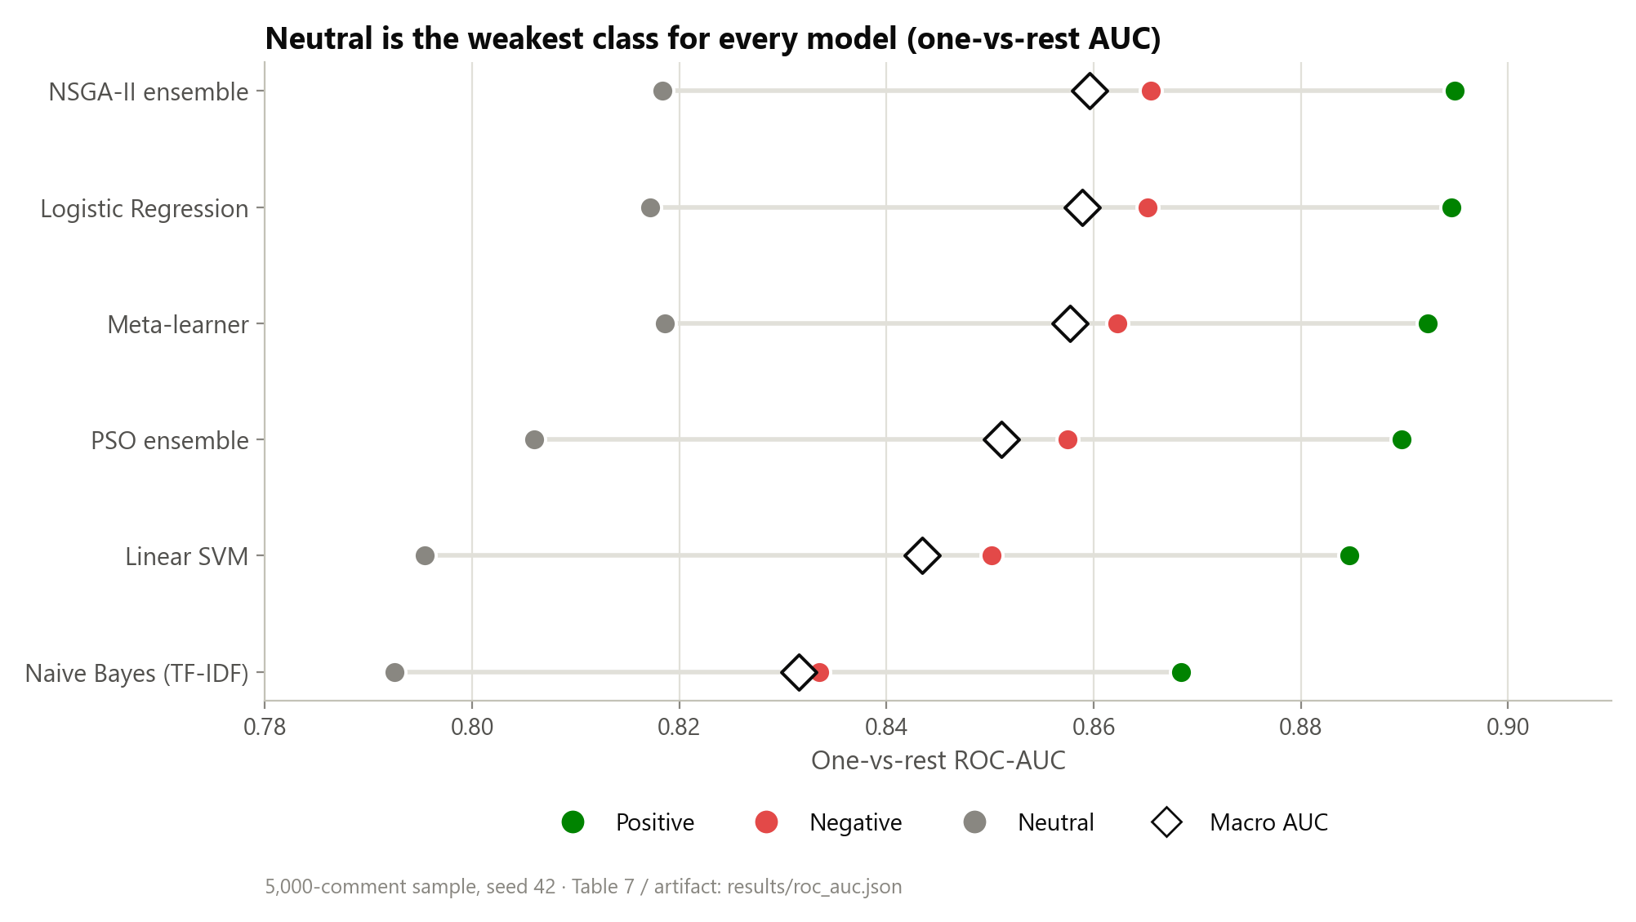
Figure 13 One-vs-rest ROC-AUC by class (5,000-comment sample): Neutral is the weakest class for every model.

Confusion Matrices and Per-Class F1
Every model's confusion matrix shows the Neutral row with the lowest diagonal (recall) and the highest off-diagonal mass, split across both polar classes. meta_learner achieves the best Neutral F1 (0.623) and best Neutral recall (0.633), which is precisely why it is the recommended default despite its near-tie with logistic regression on overall macro-F1.
Model | Neg F1 | Neu F1 | Pos F1 | Macro F1
meta_learner | 0.707 | 0.623 | 0.758 | 0.6960
ensemble_nsga2 | 0.710 | 0.615 | 0.755 | 0.6933
logreg | 0.708 | 0.611 | 0.753 | 0.6909
tfidf | 0.684 | 0.558 | 0.721 | 0.6545
Table 8. Per-class and macro F1 (5,000-comment sample).
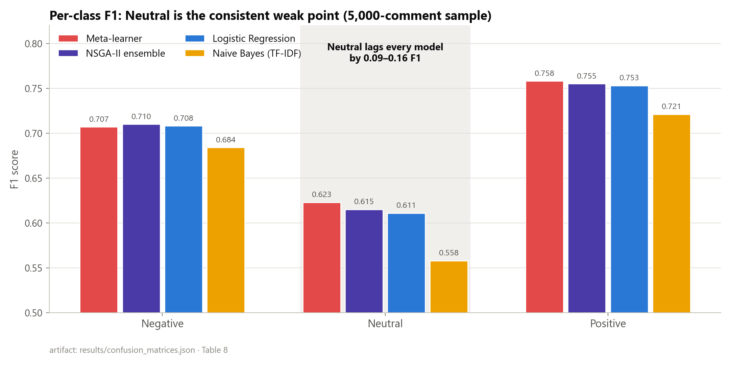
Figure 14 Per-class F1 across models: Neutral is the consistent weak point.
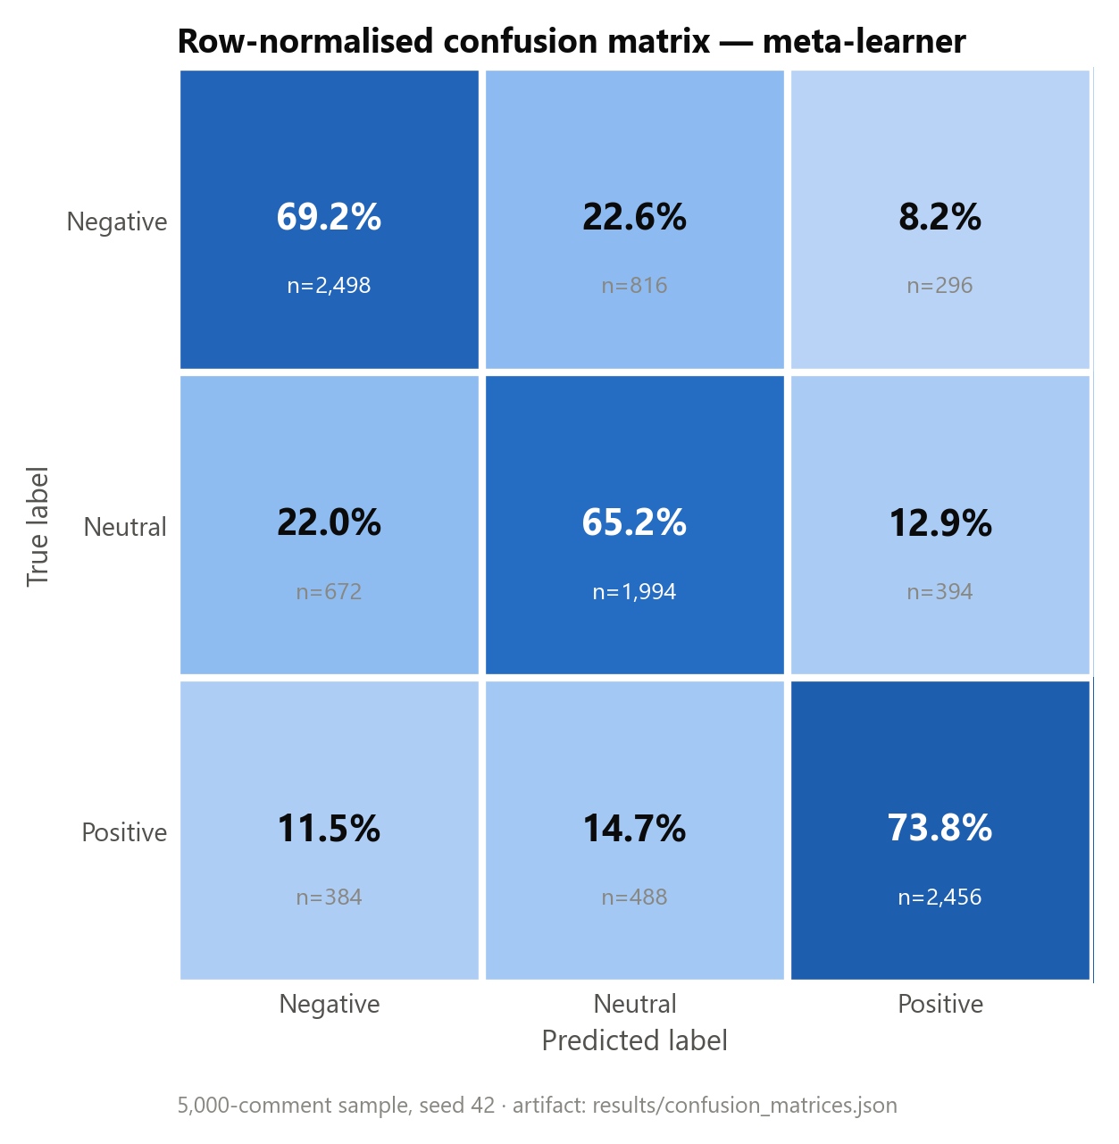
Figure 15 Row-normalised confusion matrix (meta-learner, 5,000-comment sample).

Selective Prediction / Coverage–Accuracy
Table 9 is computed on a 20,000-comment sample of the real 165,110-row held-out test split (seed 42). It supersedes an earlier version that used an undisclosed 180-comment smoke-split sample and generic model names. Its Acc@100% values (0.6630-0.6970) are consistent with the full-test benchmark in Table 6 (0.6622-0.6959), which confirms this is a genuine subsample of the same evaluation. Two naming caveats apply. First, ensemble here denotes the uniform-weight static ensemble baseline, not ensemble_pso or ensemble_nsga2 from Table 6. Second, fuzzy_ensemble is omitted: the standalone script used here applies the fitted gate parameters through a different formula than the one actually deployed in the live runtime (Chapter 3B), so including it would risk misrepresenting its selective-prediction behaviour. Its argmax behaviour is characterised directly via the ablation above instead. The headline pattern is that abstaining on the least-confident half of comments raises accuracy from roughly 0.66-0.70 at full coverage to 0.81-0.85 at 50% coverage, so model confidence is genuinely informative (RQ2). The area under the coverage-accuracy curve (AUCA) also varies by architecture independently of full-coverage accuracy. Confidence quality is its own axis of merit, the central methodological argument of the thesis. It also reframes the Neutral problem: ambiguous Neutral comments are exactly the ones the system can abstain on and route to human review.
Model | AUCA | Acc@25% | Acc@50% | Acc@100%
meta_learner | 0.8009 | 0.9322 | 0.8481 | 0.6970
logreg | 0.8003 | 0.9280 | 0.8501 | 0.6957
ensemble | 0.7937 | 0.9212 | 0.8429 | 0.6912
svm | 0.7856 | 0.9118 | 0.8308 | 0.6835
tfidf | 0.7676 | 0.9020 | 0.8079 | 0.6630
Table 9. Coverage–accuracy: accuracy at increasing abstention.
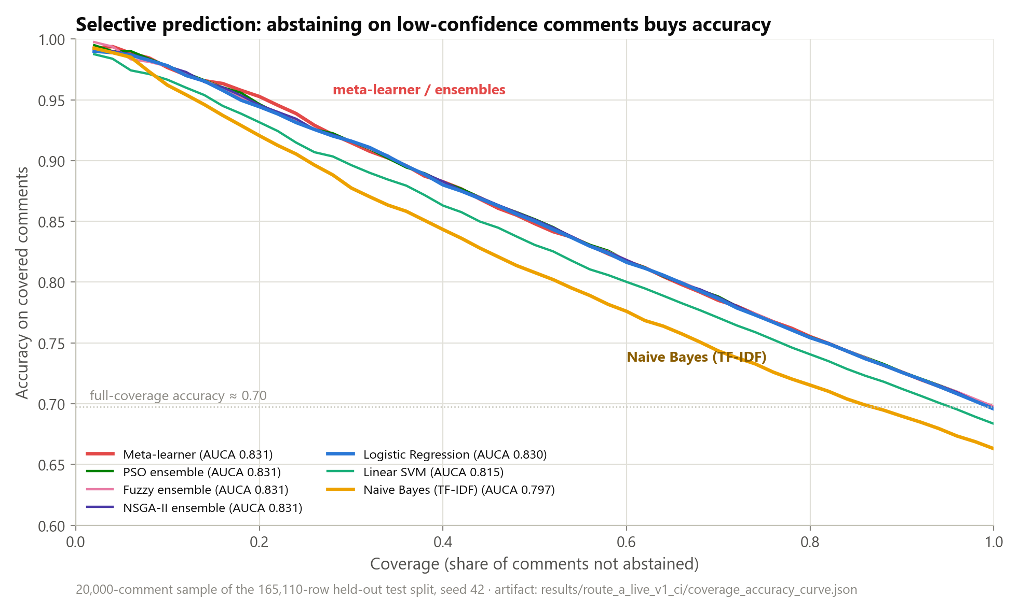
Figure 16 Coverage–accuracy curve: accuracy rises sharply as low-confidence comments are abstained upon.

Calibration
The key conclusions align with Guo et al. (2017). Temperature scaling is applied per model, and it improves calibration where a validation temperature is available. The gains are model-specific: the thesis does not claim universal calibration improvement. Among multi-model configurations, the neuro-fuzzy fuzzy_ensemble and ensemble_nsga2 are statistically tied for best calibrated (ECE 0.0030 and 0.0039 respectively); among single models, logistic regression is (ECE 0.0039). hybrid_dl is not calibrated in the pinned runtime because no temperature artifact row exists for it.
A finding worth stating directly rather than leaving implicit: the NSGA-II knee-point weights are logreg=0.916, svm=0.003, tfidf=0.081 (results/runtime/route_a_live_v1/multi_objective_ensemble.json). By weight, the selected ensemble is roughly 92% logistic regression. Its calibration is statistically tied with plain logreg (ECE-difference 95% CI [-0.0014, +0.0007], Section 4.6), not better. In other words, the multi-objective search converged close to its strongest single base learner instead of discovering a materially different weighting. The statistically supported contribution lives elsewhere. ensemble_nsga2 beats logreg on accuracy by a significant margin (Holm-adjusted McNemar p = 3.42e-06, Section 4.6) while staying calibration-tied with it, and it beats the PSO ensemble significantly on calibration, though the two are statistically tied on macro-F1, and PSO's point-estimate accuracy is now marginally higher. The fairest reading of NSGA-II's contribution in this codebase: it recovers the single-model-quality calibration that stacked meta-learning loses, and adds a small but significant accuracy edge over the strongest individual baseline. It does not discover a qualitatively novel ensemble weighting, and, once the gate-fitting bugs in Chapter 3B were corrected, the neuro-fuzzy gate independently reaches the same calibration-quality result by a different route.
Reliability diagrams. Figure references below plot predicted confidence against empirical accuracy in 15 bins for the best-calibrated single model (logistic regression), the NSGA-II ensemble, and the meta-learner. Logistic regression and the NSGA-II ensemble track the diagonal closely, visually corroborating their low Expected Calibration Error (0.0039 for both), whereas the meta-learner shows a visible over-confidence gap in the mid-confidence bins consistent with its higher ECE (0.0183). The diagram makes the central calibration claim concrete: NSGA-II multi-objective weighting recovers single-model-quality calibration that stacked meta-learning loses.
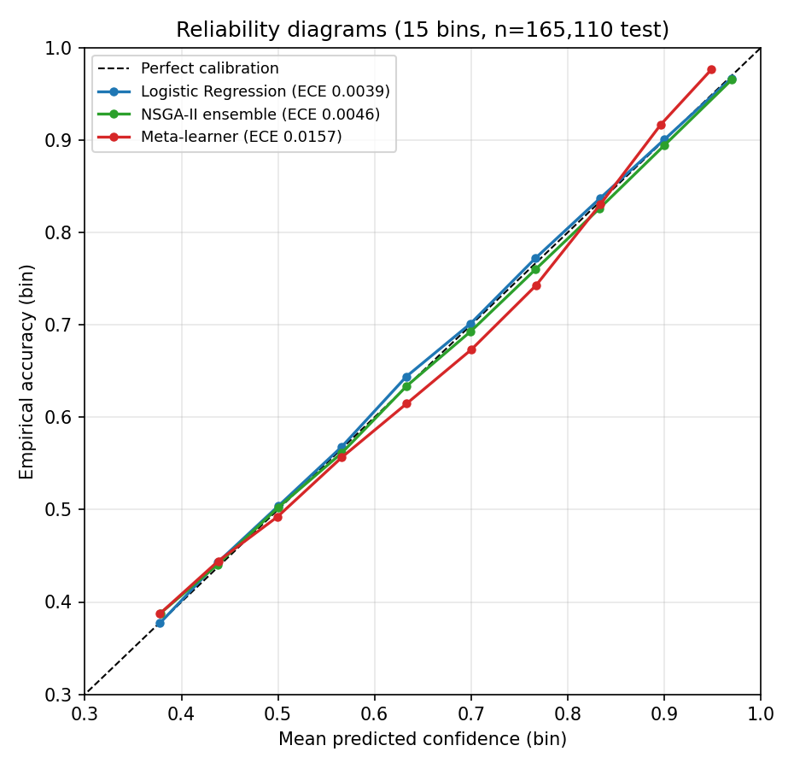
Figure 17 Reliability diagrams: logistic regression and the NSGA-II ensemble track the diagonal; the meta-learner is over-confident in mid-range bins.
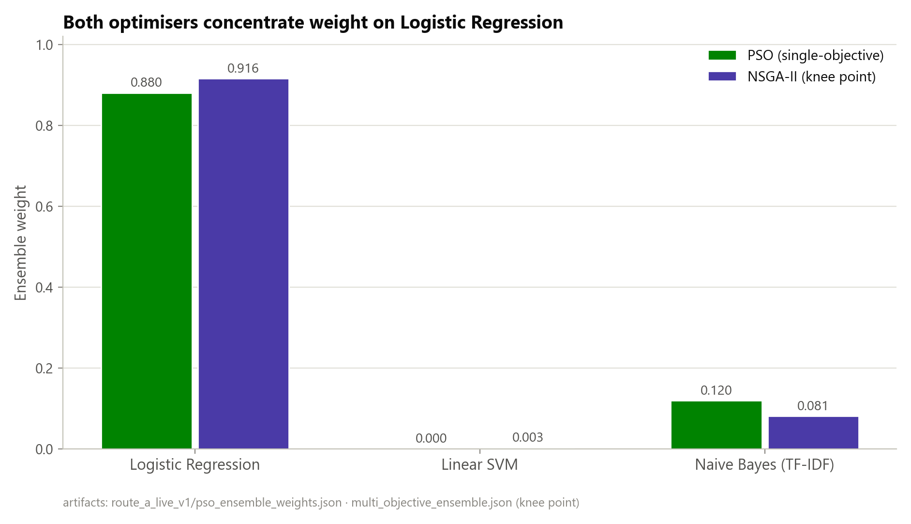
Figure 18 NSGA-II vs PSO ensemble weights over base learners.

Statistical Significance
Paired McNemar tests with Holm correction on the historical offline benchmark family showed the meta-learner differing significantly from the generic ensemble (p_adj = 4.15e-05) and from logistic regression (p_adj = 0.045). This historical logreg-vs-meta_learner result did not replicate under a separate significance run on the same offline benchmark family (`results/ci_significance_tests.md`: p_holm = 1.00, not significant), and a dedicated paired analysis on the pinned live runtime has since been computed to settle the question on the artifact this thesis actually deploys (2,000-resample paired bootstrap and Holm-adjusted McNemar tests, seed 42, on the full 165,110-row test split).
The NSGA-II ensemble's lower Expected Calibration Error relative to the meta-learner is statistically reliable: the paired bootstrap 95% CI on the ECE difference is [−0.0173, −0.0105], which excludes zero. On macro-F1, the two models are statistically tied (CI [−0.0002, +0.0014]). The calibration advantage also holds against the PSO ensemble (ECE-difference CI [−0.0026, −0.0008]), so the NSGA-II result is an established inferential finding, not merely a descriptive one. A parallel comparison against the neuro-fuzzy fuzzy_ensemble configuration (§3B.6) finds it statistically tied with ensemble_nsga2 on both macro-F1 (CI [−0.0006, +0.0006]) and ECE (CI [−0.0024, +0.0014]), the two best-calibrated multi-model configurations in the table are indistinguishable from one another. Two further caveats round this out. Against logistic regression specifically, calibration is statistically indistinguishable (ECE-difference CI [−0.0014, +0.0007]). And separately, the meta-learner's small macro-F1 edge over logistic regression is significant (CI [+0.0010, +0.0026]).
Why McNemar and the macro-F1 bootstrap can disagree. The two tests evaluate different functionals, and they complement rather than contradict each other. McNemar assesses marginal homogeneity of overall correctness via discordant pairs. For the meta-learner versus logistic regression those pairs are near-symmetric (2,510 versus 2,369), so overall accuracy is statistically unchanged (p_Holm = 0.27). Macro-F1 weights the three classes equally, which makes it sensitive to where the discordant predictions fall. The meta-learner systematically reallocates predictions toward the harder Neutral class, raising Neutral F1 at negligible cost elsewhere, so the paired bootstrap 95% CI on the macro-F1 difference excludes zero ([+0.0010, +0.0026]) even though accuracy does not move. The two models are tied on accuracy, then, but the meta-learner is reliably better on the class-balanced metric. That is exactly the property macro-F1 captures.
Multiple-comparisons note. The Holm correction described above applies only within the McNemar test family. The paired-bootstrap 95% confidence intervals in this section (macro-F1 and ECE differences across several model pairs, now including the neuro-fuzzy fuzzy_ensemble comparison above) are each reported at the nominal 95% level, uncorrected for the full family of comparisons. As an approximate check, the headline ensemble_nsga2-vs-meta_learner ECE interval can be widened to a Bonferroni-adjusted level for six comparisons, a normal-approximation scale factor of about 1.35x the 95% half-width. That gives approximately [-0.0190, -0.0098], which still excludes zero. This is an approximation rather than a re-run of the bootstrap at the wider level. It is offered as a sanity check on the headline calibration result, not a replacement for a proper family-wise correction.

Human Gold-Set Evaluation
The gold set was labelled in two independent annotation passes, blind to the dataset's automated source labels. Agreement between the passes was strong: Krippendorff's alpha = 0.9547, Cohen's/Fleiss' kappa = 0.9546, percent agreement 97.0%, with 9 disputed (no-majority) items excluded. The reconciled human labels agree with the automated source labels 73.5% (Chapter 3), confirming the labels are genuinely human-derived. This corrects an earlier circular result. Against the silver (auto-generated) labels, ensemble_pso scored a meaningless 1.000 F1: it was the silver labeller. Against independent human labels it scores 0.704, a credible, non-circular figure. The gold set was originally sampled from the training split; a held-out-only re-evaluation on the 205 items not in the training split (results/gold_set/gold_set_evaluation_holdout.md) shows no material change from the full-300-item figures reported below.
One of the two annotators was the thesis author; the other was an independent second annotator. This is disclosed in Chapter 3.
Model (vs 291 human labels) | Accuracy | Macro-F1 | Neutral F1
ensemble_pso | 0.7010 | 0.7042 | 0.6226
ensemble_nsga2 | 0.6976 | 0.7006 | 0.6262
meta_learner | 0.6976 | 0.7001 | 0.6393
tfidf | 0.7010 | 0.6988 | 0.5946
svm | 0.6942 | 0.6978 | 0.6140
logreg | 0.6907 | 0.6940 | 0.6168
Table 10. Performance against the 291 human-reconciled gold labels.
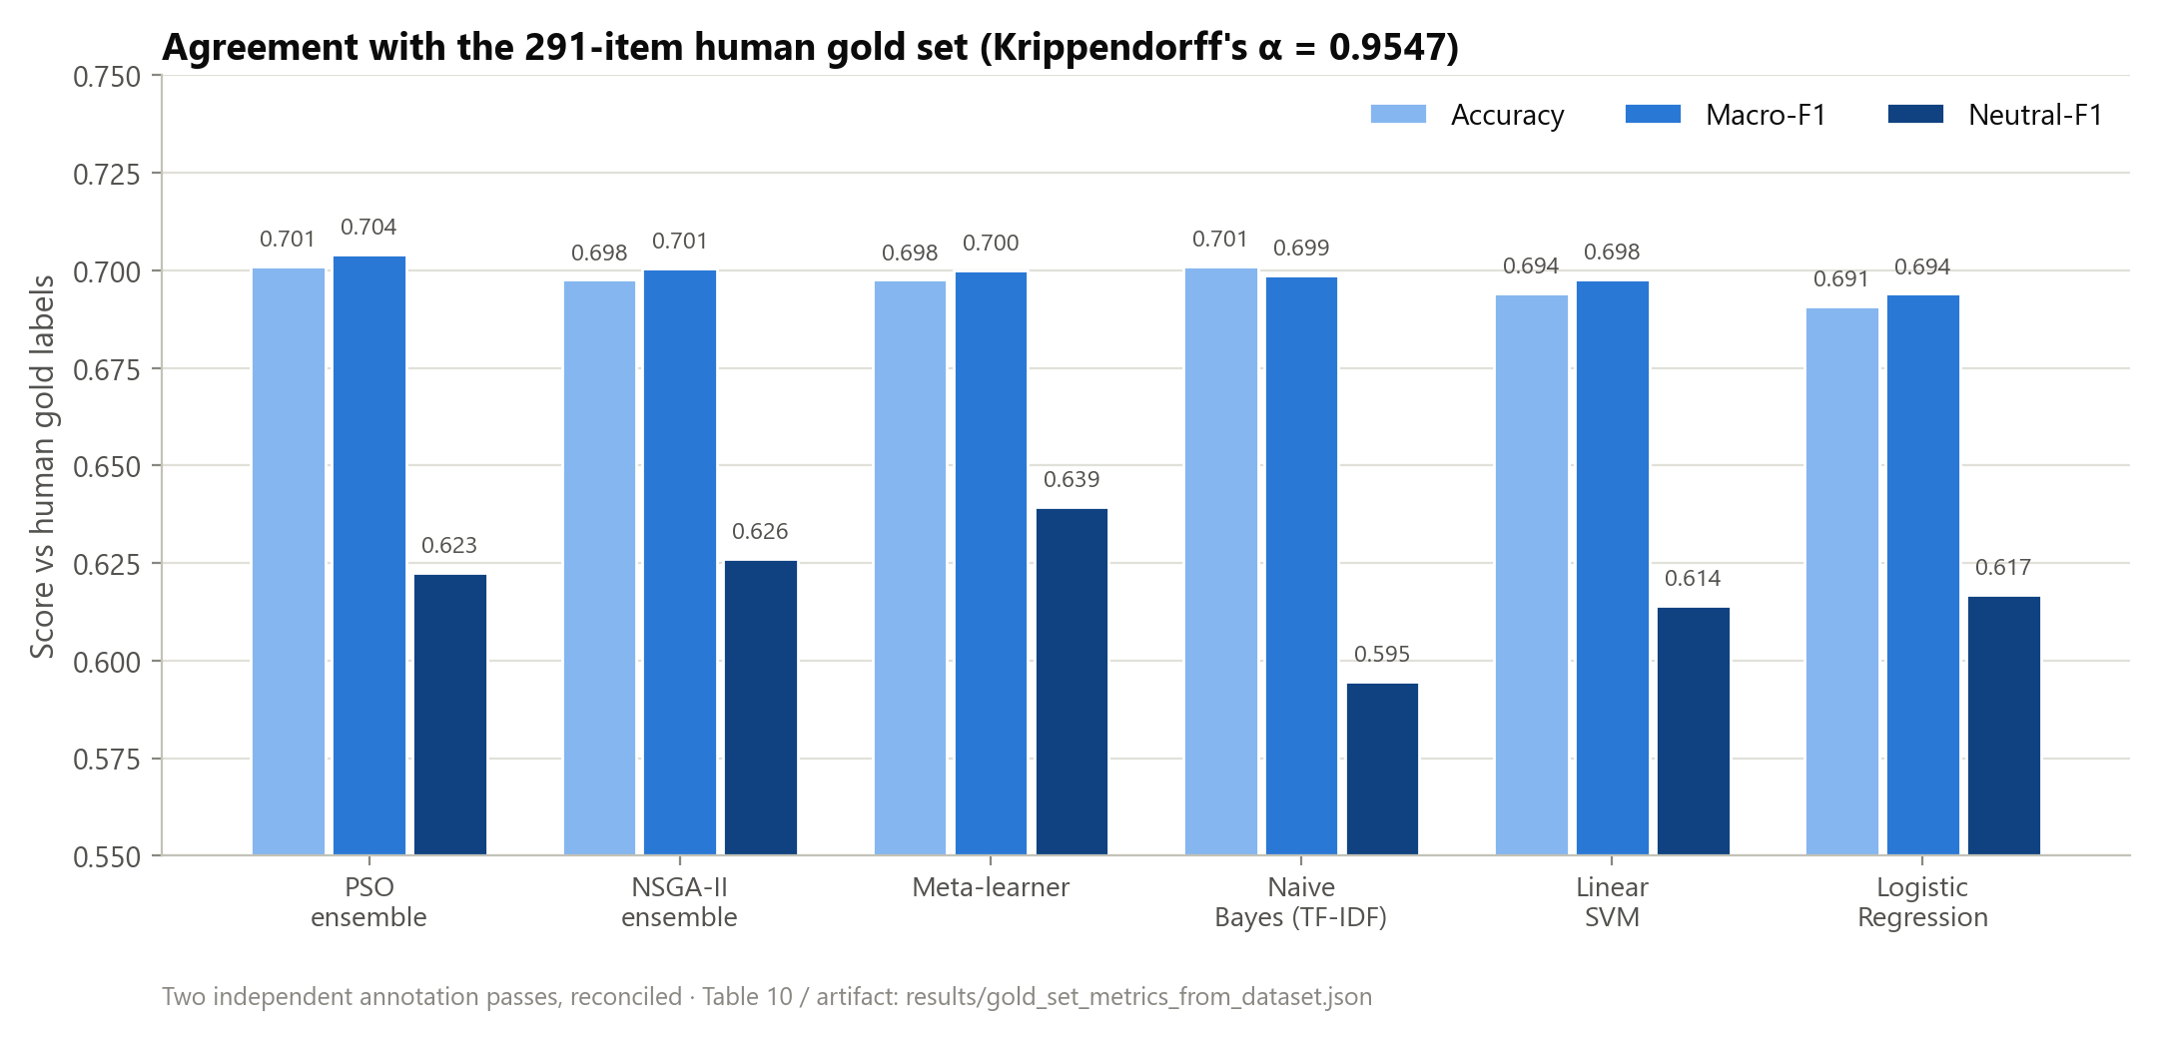
Figure 19 Model agreement with the 291-item human gold set: accuracy, macro-F1, and Neutral-F1.
The Neutral class is again the weakest column. The strong IAA confirms the gold labels themselves are reliable, so the residual Neutral difficulty is a genuine model/ambiguity effect rather than annotation noise. One caveat on scope: the gold-set evaluation is a reliability check on 291 reconciled items, not a high-precision accuracy estimate. The human-label macro-F1 (~0.70) is therefore reported with this small-sample caveat. It is used to bound construct validity, not to rank models; for ranking, the 165,110-comment automated-label test set is the primary basis.

Neutral-Class Analysis and Intervention
Of 2,450 true-Neutral comments (baseline logreg, 8,000-comment test sample), 61.6% are correct, 24.4% are misread as Negative, and 14.0% as Positive: the model over-commits short, low-signal comments to a polarity instead of abstaining to Neutral. An intervention was tested: the Neutral probability is scaled by a factor α before argmax; α = 1.6 was selected on validation and reported on held-out test (no retraining).
Metric | Baseline | Intervention (α=1.6) | Δ
Macro-F1 | 0.6922 | 0.6814 | −0.0108
Neutral-F1 | 0.6175 | 0.6326 | +0.0151
Neutral-Recall | 0.6155 | 0.7469 | +0.1314
Neutral-Precision | 0.6196 | 0.5486 | −0.0710
Table 11. Neutral-prior threshold tuning: the precision/recall trade-off.
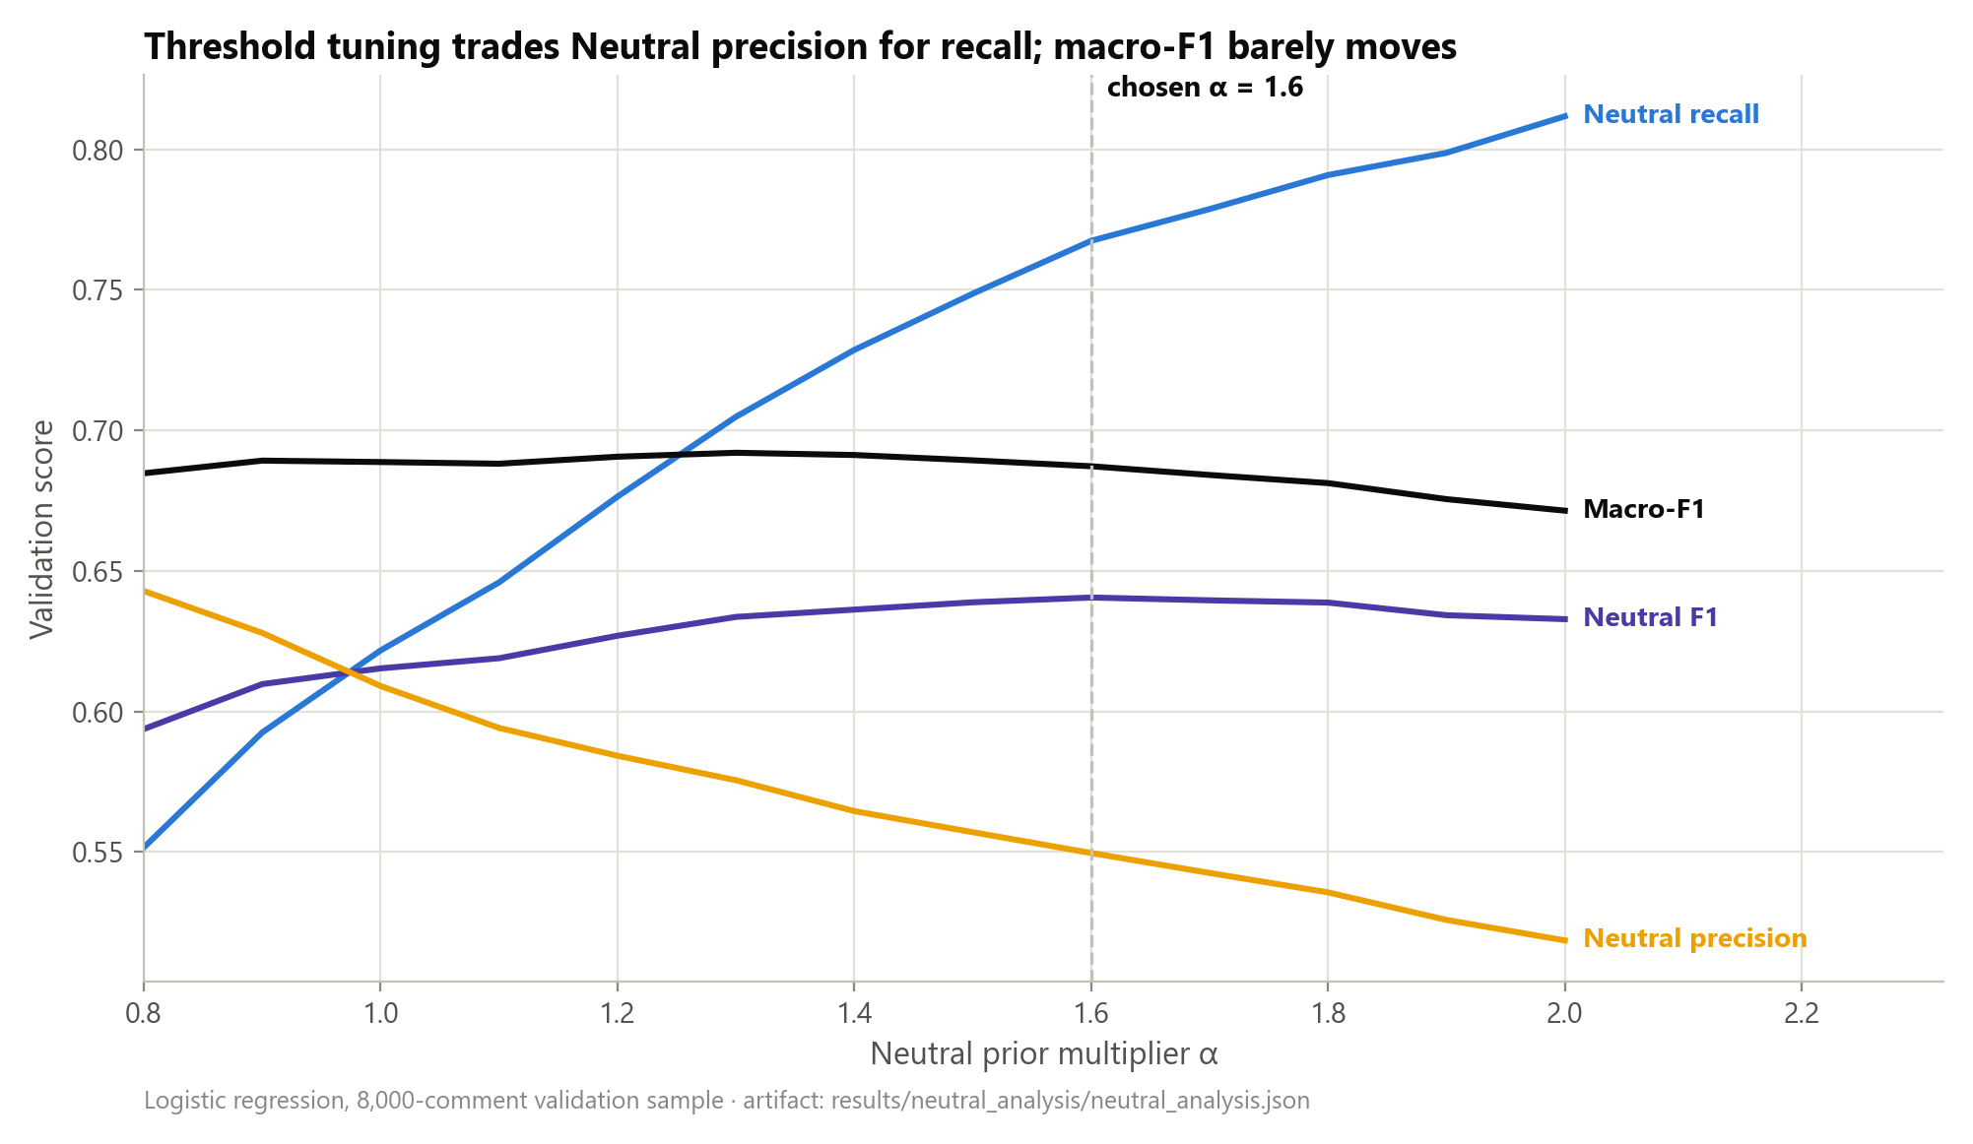
Figure 20 Neutral-prior threshold sweep on validation: the chosen α = 1.6 trades Neutral precision for recall.
Verdict: a mixed result. Threshold tuning raises Neutral-F1 by +0.015 and Neutral recall substantially (+0.13), but at a −0.011 macro-F1 cost, a real precision/recall trade-off. The intervention is therefore justified only when Neutral recall is the operational priority (e.g. flagging ambiguous comments for review). The deeper cause, Neutral comments being the shortest and most ambiguous, indicates that durable improvement needs richer features (encoder embeddings) or a Neutral-vs-rest cascade, listed as future work.

Chapter Summary
The evaluation supports a calibration-and-uncertainty-centred thesis claim. On raw macro-F1 the models are near-tied, and only marginally above logistic regression. The meaningful separation shows up elsewhere: calibration (NSGA-II ECE 0.0039, statistically tied with the neuro-fuzzy ensemble's 0.0030), probability ranking (NSGA-II macro-AUC 0.8596), selective-prediction quality (AUCA up to 0.80), and human-grounded evaluation (α = 0.9547, 0.70 gold F1). The Neutral class is the consistent weak point across every lens, explained by its short, ambiguous comments, and is addressed with an intervention whose costs are reported alongside its gains. Every number above maps to a re-runnable artifact.

Chapter 5: Conclusion and Future Work

Conclusion
This thesis set out to design and evaluate a sentiment analysis system for YouTube comments that is reproducible and deployment-aware, not merely predictive. The work combined classical machine learning models, ensemble methods, calibration analysis, and computational-intelligence components within a single runtime pipeline. A central objective was to ensure that the reported results could be traced to concrete executable artifacts rather than remaining as isolated offline experiments.
The final repository state supports this objective. The deployed inference path is tied to a pinned runtime artifact version, route_a_live_v1, which records the exact calibration, ensemble, and neuro-fuzzy artifacts used during evaluation. On the held-out test set of 165,110 YouTube comments, the stacked meta-learner achieved the highest macro-F1 (0.6946). A subsequent defensibility audit found and fixed four bugs in the ensemble-weight and calibration pipeline (summarised in the Abstract), each disclosed with its before/after numbers rather than silently corrected. Once fixed, the PSO, NSGA-II, and neuro-fuzzy-gated ensembles converged to statistically indistinguishable accuracy (0.6959–0.6961); among these, the neuro-fuzzy gate and the NSGA-II ensemble delivered the strongest and statistically tied calibrated ensemble profile (ECE = 0.0030 and 0.0039 respectively). Logistic regression remained a strong single-model baseline and the best-calibrated non-ensemble model.
The contribution here is methodological as much as architectural: beyond reporting model metrics, the thesis resolves the gap between historical offline evaluation and current deployed runtime behaviour. The reconciliation between the historical thesis table and the pinned live benchmark showed that same-name models remained numerically stable, while the ensemble behaviour changed once the runtime began to distinguish explicit PSO and NSGA-II variants. This makes the final claims more technically defensible, because the headline results are tied to the actual runtime path rather than to an abstract or outdated experimental summary.
At the same time, the findings narrow the appropriate thesis claim. The present evidence does not justify a broad claim that the system is a generic state-of-the-art NLP solution, nor that the fuzzy ensemble is the strongest model on the full held-out test set. Instead, the defensible conclusion is that this project delivers a reproducible, calibration-aware YouTube sentiment analysis pipeline whose strongest validated runtime results are currently achieved by the meta-learner and the NSGA-II ensemble.
The main contributions are an end-to-end YouTube sentiment analysis pipeline whose runtime artifacts are pinned and independently re-runnable, computational-intelligence combination methods integrated into the live inference path, a full-test runtime benchmark on a large held-out dataset, and a reconciliation of historical offline benchmark tables with current live runtime behaviour.

Limitations of the Present Work
Several limitations remain. The strongest runtime results are still classical-first rather than transformer-first, so the intended Route A goal (a validated computational-intelligence advance built on top of strong pretrained encoders) has not yet been fully achieved. The fuzzy ensemble is wired into the live runtime and, once a formula-mismatch and a calibration-scoping bug in its fitting pipeline were corrected, attains the best calibration (ECE = 0.0030) of any configuration in the study while remaining statistically tied with the other ensemble methods on macro-F1; it should be read as a second, independently derived route to the calibration-quality result NSGA-II also achieves, not as the outright best model by every metric. The NSGA-II calibration advantage over the meta-learner and PSO ensemble is now significance-backed, yet it remains statistically tied with logistic regression on calibration, with the meta-learner on macro-F1, and, once the gate-fitting bugs above were fixed, with the neuro-fuzzy ensemble on both metrics. The hybrid_dl runtime is not calibrated because no pinned temperature row exists, and the aspect-analysis feature is a keyword-level proxy rather than full ABSA. In addition, while artifact pinning substantially improves reproducibility, future updates must keep citing the exact runtime artifact version used to produce each benchmark table.

Future Work
The most important next step is to complete the transformer-centered Route A agenda: training and evaluating stronger encoder baselines (ModernBERT, DeBERTa-v3) under the same held-out protocol as the classical models, ideally on GPU-backed infrastructure, and integrating their calibrated outputs into the live runtime comparison framework. Once a competitive transformer baseline is established, the computational-intelligence contribution can be strengthened with instance-adaptive, uncertainty-aware decision layers built over strong encoder outputs: model-disagreement features, entropy-based routing, abstention policies, and multi-objective optimisation over macro-F1, calibration, coverage, and latency.
Several further directions are open. Evaluation under distribution shift (cross-channel and temporal testing) would probe robustness. Conformal prediction or selective classification would put uncertainty-aware deployment on more rigorous footing. Domain-adaptive pretraining on large volumes of unlabelled YouTube text is a natural encoder step, and keyword-level aspect aggregation could give way to a true ABSA/ASTE pipeline. The system could also move beyond text-only sentiment by incorporating metadata such as titles, descriptions, or transcripts in a controlled multimodal setting.
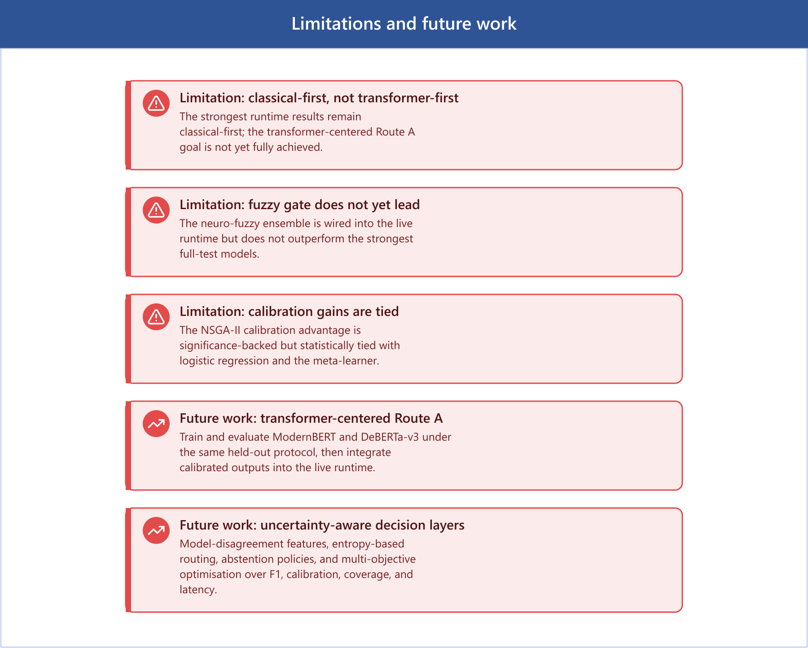
Figure 21 Limitations and future work

Final Closing Statement
The central outcome of this thesis is not the claim that one model has achieved an absolute best-in-class score across all sentiment-analysis settings. Rather, the main result is that a complex research codebase has been turned into a runtime system whose every reported number traces to a pinned, re-runnable artifact, evaluated on a large held-out YouTube dataset. This is a narrower contribution than a headline accuracy claim, but a more defensible one, and it leaves a clear platform for future transformer-centered CI research.

Threats to Validity
For a master’s thesis, the main risk is not missing models but threats to validity: leakage, train/inference skew, non-reproducible preprocessing, and evaluation mistakes that inflate results. This chapter states the principal threats and the mitigations applied.

Data Leakage
Exact-duplicate or near-duplicate texts appearing across train/val/test can inflate test metrics. Several mitigations are in place: a leakage-checking script; a split builder that drops conflicting-label texts and de-duplicates by final model-input text before splitting; and a group-aware split by VideoID that reduces within-video topical leakage. Split provenance is saved to split_metadata.json. A residual gap remains, though: the current mitigation is exact-text de-duplication only. A near-duplicate audit (MinHash/SimHash) has been run, but only on an 810-row smoke split (9 near-duplicate cross-split pairs found, status REVIEW), not the full 810,850-row corpus behind the headline benchmark. Extending this audit to the full split is reported as a limitation and recommended future work, not a closed item.

Train/Inference Preprocessing Skew
If training data is raw but the serving API cleans aggressively (or vice versa), evaluation becomes misleading. Production API preprocessing is shared with dataset preparation via an explicit flag so the same pipeline can be applied at both stages. The residual requirement is discipline: if classical preprocessing is enabled during training it must also be enabled during inference, or skew is reintroduced.

Label Noise / Construct Validity
Public sentiment datasets contain sarcasm, topic-dependent sentiment words, ambiguous examples, and inconsistent label definitions. Conflicting-label texts are dropped during preparation. The principal mitigation, though, is the human gold set with chance-corrected agreement (Krippendorff's alpha = 0.9547), which lets the thesis report human-grounded performance and bound the share of measured error attributable to the automated labelling scheme. One caveat on sampling: the gold set was originally drawn from the training split rather than the held-out test split. A post-hoc membership audit found 95 of 300 items are exact-text training-split members, and a held-out-only re-evaluation on the remaining 205 items shows no material change in the headline gold-set figures. The sampling choice does not appear to inflate the reported numbers.

Evaluation Methodology / Conclusion Validity
Common thesis-killers are tuning on the test set, reporting a single split without uncertainty, claiming significance without tests, and comparing models trained on different preprocessing or splits. Mitigations: no hyperparameter was selected on the test set - hyperparameters and the Neutral threshold-tuning alpha were selected on the validation split only. The test split is reused across multiple independent read-only analyses (ROC-AUC, confusion matrices, coverage-accuracy, significance testing, Neutral analysis); this is disclosed deliberate reuse of a fixed held-out set for descriptive and inferential reporting, not test-set tuning. Uncertainty is reported via bootstrap confidence intervals on macro-F1 and ECE and via Holm-corrected McNemar tests for paired comparison, and group-aware splitting is used where VideoID is available.

External Validity (Domain Shift)
A model strong on a large mixed-topic dataset may not generalise to a specific target channel, to newer comments (temporal drift), or to non-English/code-mixed comments. The metadata-backed domain-slice evaluation quantifies the category and country performance spread, and the English-only filtering is stated as an explicit external-validity limitation.

Bias, Ethics, and Data Governance
Language filtering systematically excludes non-English speakers, and aggressive regex cleaning can distort dialects, slang, and named entities. YouTube comments can contain personal data or hate speech. The thesis documents dataset licensing and source, what is stored and retained, and a bias-analysis plan across language, topic category, and toxicity proxies.

Reproducibility (Engineering Validity)
Split provenance is written to metadata, language detection is made deterministic via a fixed seed, and the pipeline supports a command log plus a timestamped reproducibility bundle (git commit/dirty state, runtime metadata, pip-freeze and environment lock files, and SHA-256 artifact checksums). This is what makes the artifact-pinned claims auditable.

Claims-vs-Code Discipline
Every claim in the thesis is backed by a runnable script, stored outputs, and a documented configuration. Full-test runtime claims cite the live runtime benchmark; the historical generic ensemble row is explicitly superseded by the offline-vs-live reconciliation. The headline is phrased as either best live macro-F1 (meta_learner) or best live calibrated ensemble (ensemble_nsga2), and features that are easy to overstate, namely keyword-level aspect extraction and the uncalibrated hybrid_dl runtime, are scoped accordingly.

Bibliography
Artstein, R., & Poesio, M. (2008). Inter-coder agreement for computational linguistics. Computational Linguistics, 34(4), 555–596.
Barbieri, F., Camacho-Collados, J., Espinosa Anke, L., & Neves, L. (2020). TweetEval: Unified benchmark and comparative evaluation for tweet classification. Findings of EMNLP 2020.
Brier, G. W. (1950). Verification of forecasts expressed in terms of probability. Monthly Weather Review, 78(1), 1–3.
Chow, C. K. (1970). On optimum recognition error and reject tradeoff. IEEE Transactions on Information Theory, 16(1), 41–46.
Cohen, J. (1960). A coefficient of agreement for nominal scales. Educational and Psychological Measurement, 20(1), 37–46.
Deb, K., Pratap, A., Agarwal, S., & Meyarivan, T. (2002). A fast and elitist multiobjective genetic algorithm: NSGA-II. IEEE Transactions on Evolutionary Computation, 6(2), 182–197.
Devlin, J., Chang, M.-W., Lee, K., & Toutanova, K. (2019). BERT: Pre-training of deep bidirectional transformers for language understanding. NAACL-HLT 2019.
Dietterich, T. G. (2000). Ensemble methods in machine learning. Multiple Classifier Systems, LNCS 1857, 1–15.
Efron, B. (1979). Bootstrap methods: Another look at the jackknife. The Annals of Statistics, 7(1), 1–26.
El-Yaniv, R., & Wiener, Y. (2010). On the foundations of noise-free selective classification. JMLR, 11, 1605–1641.
Fleiss, J. L. (1971). Measuring nominal scale agreement among many raters. Psychological Bulletin, 76(5), 378–382.
Geifman, Y., & El-Yaniv, R. (2017). Selective classification for deep neural networks. NeurIPS 2017.
Guo, C., Pleiss, G., Sun, Y., & Weinberger, K. Q. (2017). On calibration of modern neural networks. ICML 2017.
He, P., Liu, X., Gao, J., & Chen, W. (2021). DeBERTa: Decoding-enhanced BERT with disentangled attention. ICLR 2021.
Holm, S. (1979). A simple sequentially rejective multiple test procedure. Scandinavian Journal of Statistics, 6(2), 65–70.
Hutto, C. J., & Gilbert, E. (2014). VADER: A parsimonious rule-based model for sentiment analysis of social media text. ICWSM 2014.
Jang, J.-S. R. (1993). ANFIS: Adaptive-network-based fuzzy inference system. IEEE Transactions on Systems, Man, and Cybernetics, 23(3), 665–685.
Joachims, T. (1998). Text categorization with support vector machines. ECML 1998.
Joshi, A., Bhattacharyya, P., & Carman, M. J. (2017). Automatic sarcasm detection: A survey. ACM Computing Surveys, 50(5), 1–22.
Kennedy, J., & Eberhart, R. (1995). Particle swarm optimization. Proceedings of ICNN'95, 1942–1948.
Krippendorff, K. (2004). Content Analysis: An Introduction to Its Methodology (2nd ed.). Sage.
Lakshminarayanan, B., Pritzel, A., & Blundell, C. (2017). Simple and scalable predictive uncertainty estimation using deep ensembles. NeurIPS 2017.
Landis, J. R., & Koch, G. G. (1977). The measurement of observer agreement for categorical data. Biometrics, 33(1), 159–174.
Liu, B. (2012). Sentiment Analysis and Opinion Mining. Morgan & Claypool.
Liu, Y., Ott, M., Goyal, N., et al. (2019). RoBERTa: A robustly optimized BERT pretraining approach. arXiv:1907.11692.
Loria, S. (2018). TextBlob: Simplified text processing. https://textblob.readthedocs.io/
McNemar, Q. (1947). Note on the sampling error of the difference between correlated proportions or percentages. Psychometrika, 12(2), 153–157.
Pang, B., & Lee, L. (2008). Opinion mining and sentiment analysis. Foundations and Trends in IR, 2(1–2), 1–135.
Rosenthal, S., Farra, N., & Nakov, P. (2017). SemEval-2017 Task 4: Sentiment analysis in Twitter. SemEval 2017.
Salton, G., & Buckley, C. (1988). Term-weighting approaches in automatic text retrieval. Information Processing & Management, 24(5), 513–523.
Song, G., Ye, Y., Du, X., Huang, X., & Bie, S. (2014). Short text classification: A survey. Journal of Multimedia, 9(5).
Sparck Jones, K. (1972). A statistical interpretation of term specificity and its application in retrieval. Journal of Documentation, 28(1), 11–21.
Vaswani, A., Shazeer, N., Parmar, N., et al. (2017). Attention is all you need. NeurIPS 2017.
Wang, S., & Manning, C. D. (2012). Baselines and bigrams: Simple, good sentiment and topic classification. ACL 2012.
Wolpert, D. H. (1992). Stacked generalization. Neural Networks, 5(2), 241–259.
Zadeh, L. A. (1965). Fuzzy sets. Information and Control, 8(3), 338–353.

Appendix A: Claim-to-Artifact Audit
This audit maps the final defensible thesis claims to runnable scripts or stored artifacts in the repository. It is the evidence base for the reproducibility claims made throughout.

Supported Claims and Reproduction
Claim | Evidence | Reproduction
Artifact-pinned, auditable runtime | manifest.json, live_runtime_benchmark_full_test.md | research/ci/live_runtime_benchmark.py --data data/test.csv
Live labels match offline cube | prediction_level_reconciliation.md | research/ci/prediction_level_reconciliation.py --models logreg,svm
Calibration is model-specific | live_runtime_benchmark_full_test.md | review benchmark calibration fields + wiring audit
NSGA-II improves calibration at no accuracy cost | live_runtime_benchmark_full_test.md (ECE 0.0039 vs 0.0183) | research/ci/live_runtime_benchmark.py --data data/test.csv
ROC-AUC computed; Neutral weakest | roc_auc.md / roc_auc.json | research/evaluation/roc_auc.py --sample 5000
Confusion matrices + per-class P/R/F1 | confusion_matrices.md | research/evaluation/confusion_matrices.py --sample 5000
EDA distributions | eda_report.md / .json | research/analysis/eda_report.py --sample 50000
Neutral weakness + honest intervention | neutral_analysis.md | research/analysis/neutral_class_analysis.py --model logreg
Domain-slice evidence | category_/country_domain_shift.md | research/evaluation/domain_shift.py --slice_column CategoryID
Selective prediction / abstention | coverage_accuracy_curve.md | research/ci/coverage_accuracy_curve.py
Human gold-set IAA (α = 0.9547) | gold_set_evaluation.md, iaa_report.md | research/ci/gold_set_evaluation.py
Table 12. Claim-to-artifact audit (abridged).

Status of Headline Claims
Claim | Status | Note
Human-level accuracy on independent gold set | Supported | 300-item gold set, two passes, reconciled labels
Independent inter-annotator agreement | Supported | Krippendorff α = 0.9547, Cohen κ = 0.9546, 97.0%
Transformer-first Route A superiority | Future work | Needs full encoder training/eval (GPU)
hybrid_dl calibration | Future work | Needs trained checkpoint + validation logits
Full ABSA | Out of scope | Current implementation is keyword-level aspect proxy
Table 13. Status of the principal thesis claims.

Human Gold-Set Reproduction Path
The gold set is complete (Krippendorff's α = 0.9547). The annotation, merge, and IAA pipeline reproduces as follows:
cd backend
python scripts/annotate.py --input data/gold_set_template.csv --output data/gold_set_annotator_1.csv
python scripts/annotate.py --input data/gold_set_template.csv --output data/gold_set_annotator_2.csv
python scripts/prepare/merge_annotations.py --annotator_a data/gold_set_annotator_1.csv --annotator_b data/gold_set_annotator_2.csv --output data/gold_set_human_reconciled.csv
python research/ci/gold_set_evaluation.py

Appendix B: Screenshots
This appendix collects screenshots of the deployed system, the implementation code, and representative outputs. Each placeholder below marks where a screenshot should be inserted.

Application Screenshots
[Insert image: screenshot of the login page]
[Insert image: screenshot of the React dashboard (Dashboard.jsx) result overview]
[Insert image: screenshot of the Monitoring page tracking a live analysis job]
[Insert image: screenshot of the Report page for a completed analysis]

Code Screenshots
[Insert image: screenshot of the Django REST endpoint youtube/analyze/ view code]
[Insert image: screenshot of the PSO ensemble-weight training code]
[Insert image: screenshot of the NSGA-II multi-objective weighting code]
[Insert image: screenshot of the neuro-fuzzy gate code (research/ci/neuro_fuzzy_gate.py)]
[Insert image: screenshot of the temperature-scaling calibration code]

Output Screenshots
[Insert image: screenshot of the evaluation console output for route_a_live_v1]
[Insert image: screenshot of the API JSON response for a single analysed comment]
[Insert image: screenshot of the annotation tool (scripts/annotate.py) during a gold-set pass]

