IPL Data Analysis using R
A Report Submitted in
Partial Fulfilment for award of Bachelor of Technology

In DATA ANALYTICS (BCSDS0651)
COMPUTER SCIENCE & ENGINEERING
By
Vishal (2301330100223)
Vishal Chauhan (2301330100225)

Under the Supervision of

Ms. Ayushi Gupta
Assistant Professor



Department of Computer Science & Engineering
School of Computer Science and Information Technology
NOIDA INSTITUTE OF ENGINEERING AND TECHNOLOGY
GREATER NOIDA (An Autonomous Institute) Affiliated to
DR. A.P.J. ABDUL KALAM TECHNICAL UNIVERSITY, LUCKNOW

2025-26

COVER PAGE

Title: IPL Data Analysis using R
Subject: Data Analytics using R
Workshop Name: B. Tech Workshop
Submitted By:
Student Name: Vishal, Vishal Chauhan
Roll Number: 2301330100223,2301330100225
Branch & Year: CSE (3rd)
Submitted To:
Faculty Name: Mrs. Ayushi Gupta
Institute: Noida Institute of Engineering and Technology

Certificate
This is to certify that the project titled “IPL Data Analysis using R” submitted by Vishal , Vishal Chauhan is a Bonafide work carried out during the Data Analytics using R Workshop.
Faculty Signature: __________
Date:08-03-2026

Acknowledgement
I would like to express my sincere gratitude to our respected faculty and the institution for providing me with the valuable opportunity to work on this Data Analytics project using R programming. Their constant guidance, encouragement, and support throughout the project helped me gain a deeper understanding of data analytics concepts, including data preprocessing, data visualization, and analytical techniques. Their suggestions and constructive feedback played an important role in improving the quality of this project.
I would also like to thank my classmates and teammates for their cooperation and support during the development of this project. Their ideas, discussions, and collaboration helped in overcoming various challenges and made the project work more effective and enjoyable.

ABSTRACT

This project focuses on performing data analytics on an IPL dataset using the R programming language. The dataset contains synthetic match records including information such as teams, match venue, runs scored, toss decisions, and match winners.
The dataset was generated using R and includes around 2000 records to simulate real-world sports data. Several preprocessing techniques were applied including handling missing values and removing incomplete records to ensure data quality.
The analysis was conducted using tools such as RStudio along with libraries like ggplot2 and dplyr. Various exploratory data analysis techniques were applied to identify trends in match outcomes, scoring patterns, and team performance.
The results of the analysis were visualized through multiple charts including bar charts, histograms, boxplots, pie charts, and scatter plots. These visualizations help reveal insights such as which cities host the most matches, which teams win the most matches, and how runs are distributed across games.
This project demonstrates how data analytics techniques can be applied in sports analytics to extract meaningful insights and support data-driven decision making.

INTRODUCTION

The Indian Premier League (IPL) is one of the most popular and widely followed cricket leagues in the world. Since its launch in 2008, the tournament has attracted millions of viewers and cricket fans across the globe. The IPL involves several teams representing different cities in India, competing in a fast-paced Twenty20 (T20) format.

Statistical analysis and data visualization techniques make it easier to interpret complex datasets. Visual tools such as graphs, charts, and plots help present information in a clear and understandable way. These methods allow analysts to explore trends such as average scores, win percentages, player contributions, and team performance over different seasons of the IPL.

In this project, R programming is used as the primary tool for analysing IPL data. R is a powerful programming language widely used for statistical computing, data analysis, and visualization. It provides various libraries and packages that make it easier to perform data preprocessing, exploratory data analysis (EDA), and graphical representation of data.

The main objective of this project is to apply data preprocessing techniques and exploratory data analysis methods to the IPL dataset in order to identify patterns and trends. By analysing the dataset using R programming, the project aims to gain insights into team performances, scoring behaviour, and other important aspects of IPL matches. This analysis helps demonstrate how data analytics can be effectively used in sports to support decision-making and performance evaluation.

Objectives of the Study

The main objectives of this study are:
- To generate and analyze a large IPL dataset
- To introduce missing values and outliers in the dataset
- To perform data cleaning and preprocessing
- To perform exploratory data analysis using R
- To visualize patterns and trends using charts
- To derive meaningful insights from the dataset

DATA DESCRIPTION

The dataset used in this project was synthetically generated using R programming.
It contains approximately 2000 rows and 12 columns.

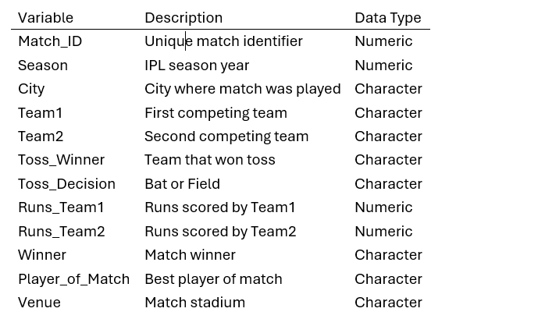

DATA PREVIEW

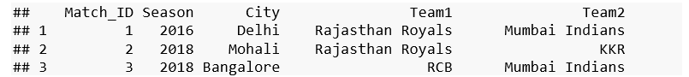

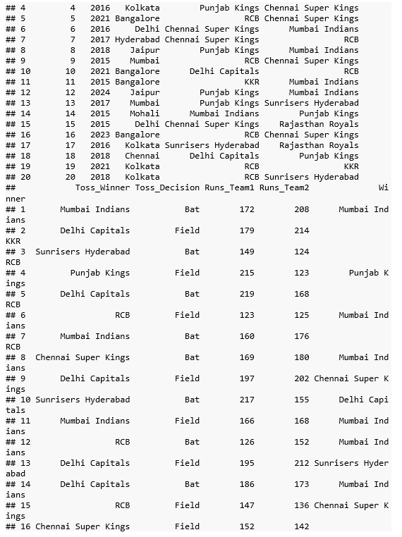

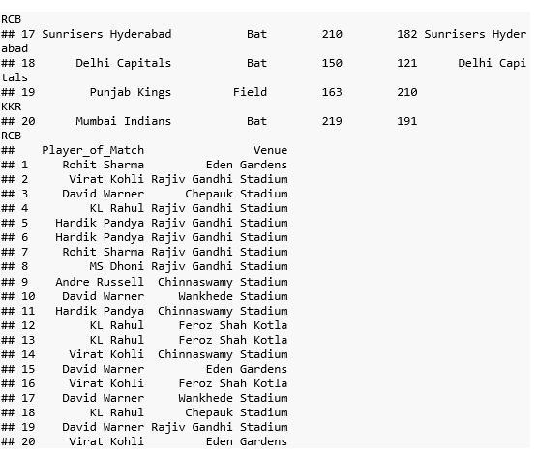

The table above shows a sample of the dataset containing match details such as teams, venue, runs scored, and match winner.

Tools & Technologies Used
- R Programming Language
- RStudio
Libraries Used:
- ggplot2 (data visualization)
- dplyr (data manipulation)

DATA CLEANING AND PREPROCESSING
The dataset was preprocessed before analysis. Missing values were intentionally introduced into the dataset to simulate real-world scenarios.
Missing values were identified using the is.na() function and removed using the na.omit() function.

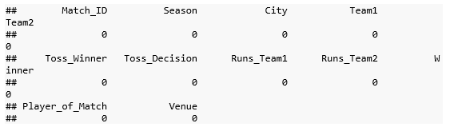
This ensured that the dataset used for analysis contained only complete records.

Exploratory Data Analysis (EDA)

Match played in each cities
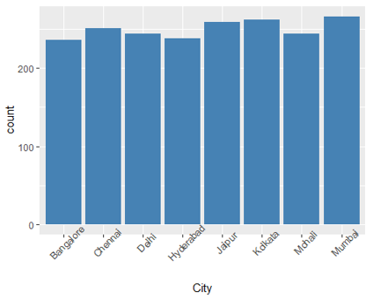
- The bar graph represents the number of IPL matches played in different cities.
- Each bar shows a city, and the height of the bar indicates the total match count in that city.
- Mumbai and Kolkata host slightly more matches compared to most other cities.

MATCH WON BY EACH TEAM
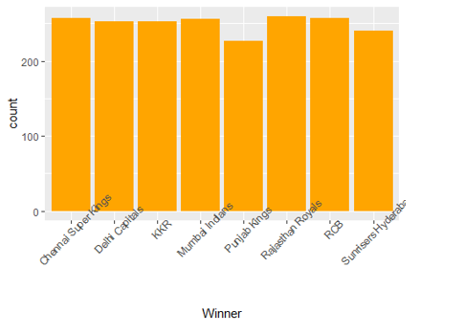
- The graph shows the count of wins by different IPL teams.
- Punjab Kings appears to have the lowest win count among the listed teams.
- Overall, the wins are fairly close across teams, indicating competitive performance.

TOSS DECISION DISTRIBUTION

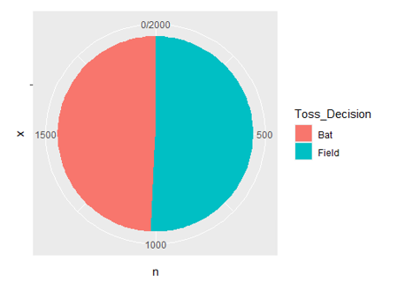
- The chart shows the toss decision distribution in IPL matches.
- Teams choose to bat and field almost equally after winning the toss.
- Fielding has a slightly higher count compared to batting.
- This indicates that many teams prefer to chase the target in IPL matches.

RUN DISTRIBUTION
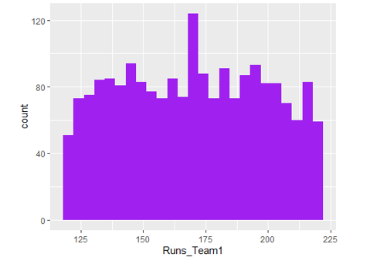

- The histogram shows the distribution of runs scored by Team 1 in matches.
- Most scores are between 140 and 200 runs, indicating common IPL totals.
- The highest frequency of scores appears around 160–180 runs.
- Very few matches have extremely low (≈120) or very high (≈220) scores.

RUN OUTLIER DETECTION
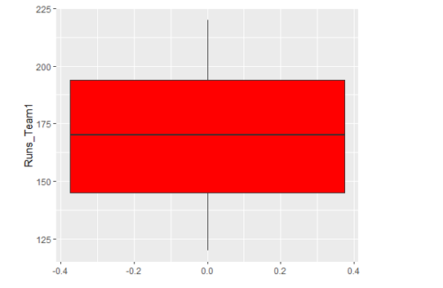

- The box plot represents the distribution of runs scored by Team 1.
- The median score is around 170 runs, indicating the typical team score.
- Most scores lie between about 145 and 195 runs (interquartile range).
- The minimum and maximum scores are approximately 120 and 220 runs, showing the overall scoring spread.

PLAYER OF THE MATCH FREQUENCY

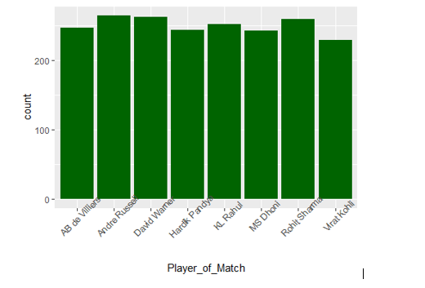
- The bar chart shows the count of Player of the Match awards for different players.
- AB de Villiers, David Warner, and Rohit Sharma have higher award counts compared to others.
- Players like Virat Kohli and MS Dhoni have slightly fewer awards in the dataset.
- Overall, the awards are fairly evenly distributed among the top players, showing consistent performances.

MATCH PER SEASON

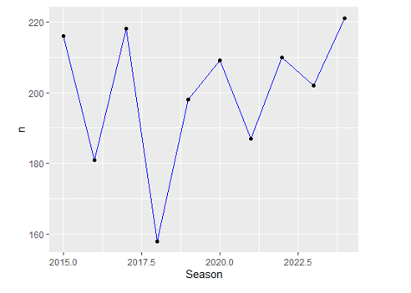
- The line graph shows the number of runs scored across different IPL seasons.
- There is a significant drop around the 2018 season, showing the lowest run count.
- After 2018, the runs increase again with some fluctuations over the seasons.
- The highest run count appears in the most recent season, indicating improved scoring performance.

TOSS WINNER VS MATCH WINNER
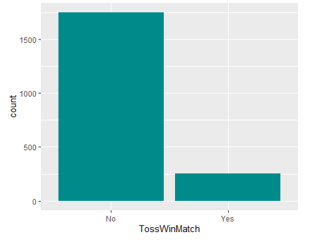
- The chart shows the relationship between winning the toss and winning the match.
- Most matches fall under “No”, meaning the team that won the toss did not win the match.
- Only a smaller number of matches show “Yes”, where the toss winner also won the match.
- This suggests that winning the toss does not strongly guarantee winning the match.

RUNS COMPARISON

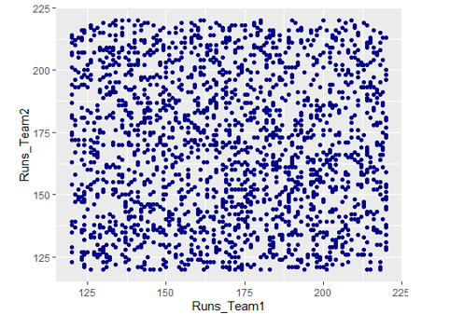

- The scatter plot shows the relationship between runs scored by Team 1 and Team 2.
- The points are widely scattered, indicating no strong correlation between the two teams’ scores.
- Both teams’ runs mostly range between 120 and 220 runs.
- This suggests that one team’s score does not directly determine the other team’s score.

MATCH VENUE

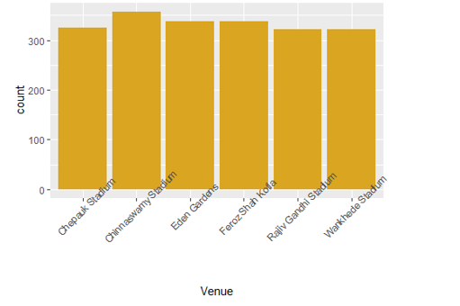

- The bar chart shows the number of IPL matches played at different venues.
- Chinnaswamy Stadium has the highest match count among the listed venues.
- Other stadiums like Eden Gardens and Feroz Shah Kotla also host a large number of matches.
- The match distribution across venues is fairly similar, showing that multiple stadiums are regularly used.

Key Insights

- Certain cities host significantly more matches.
- Some teams have higher win counts compared to others.
- Teams show a preference for fielding after winning the toss.
- Runs distribution indicates typical scoring ranges.
- Outliers reveal extremely high or low scoring matches.
- Some players receive more Player of the Match awards.
- Match frequency varies across seasons.
- Toss advantage does not always guarantee match victory.

CONCLUSION

This project demonstrated the effective use of R programming for data analytics by analyzing an IPL dataset. Through data cleaning, preprocessing, and exploratory data analysis (EDA), meaningful patterns in match outcomes, team performances, player contributions, and scoring trends were identified. The analysis helped in understanding how different factors such as toss decisions, venues, and team strategies can influence match results.

Various data visualization techniques such as bar charts, histograms, box plots, scatter plots, and line graphs were used to represent the data clearly. These visualizations made it easier to interpret complex datasets and uncover hidden insights. Overall, the project highlights how R can be a powerful tool for sports data analysis, helping analysts and enthusiasts gain valuable insights from large datasets.

Limitations of Study
- Synthetic dataset used instead of real-world dataset
- Limited variables included
- Time constraints limited deeper analysis

Future Scope
- Machine learning models can predict match winners
- Interactive dashboards can be built using Shiny
- Real-time cricket analytics can be integrated

References
- R Documentation: https://cran.r-project.org/
- ggplot2 Documentation

