Automated Statistical Analysis and Multi-Format Narrative Generation within the R Programming Environment.

Authors name:
Mr. Mahesh Divakaran — Amity School of Applied Sciences, Amity University Lucknow
Dr. Gunjan Singh — Amity School of Applied Sciences, Amity University Lucknow
Prof. Dr. Jayadevan Shreedharan — Gulf Medical University

Abstract: The present invention is an R package called the EasyStat System, which includes an innovative computer-implemented method for automating the entire statistical analysis and reporting process. First, the user supplies standard R data and formula inputs for common tests (e.g., regression, t-tests), and the system runs the base statistical model. Afterward, the Metric Interpretation Module is used to gather key numeric outputs (P-values, coefficients, R2). At the heart of the system is the Narrative Generator Module, which, by applying conditional logic, instantly converts the collected metrics into a contextualized, plain-language explanation string. This whole process results in a unified Result Object that consists of the raw statistical tables and the interpretative narrative, which can be reported in multiple ways through RStudio Viewer, console output, and direct, automated export into Microsoft Word documents, each of which has the raw statistical results along with the interpretative narrative. The invention overcomes the barrier of complex statistical data being translated into meaningful prose thereby making the whole statistical reporting process for non-expert users much more accessible, accurate and efficient.
Complete Description along with figures/drawings/flow chart/frame work/model/Tools if any, of the work proposed:
The current invention refers to an R package as a novel and user-friendly medium for executing standard statistical procedures, such as hypothesis testing (t-test), ANOVA and regression, and also for translating their technical outputs into plain-language, report-ready narratives all at once. The package has been created to fill the huge gap between the complex statistical results and the need for non-expert reporters or decision-makers to have clear communication. The package takes care of the whole analytical workflow. It runs standard R statistical functions automatically, collecting crucial metrics (like P-values, effect sizes, and model fit indicators) and using them to create detailed, easy-to-understand explanations. Moreover, the package increases its usefulness by offering flexible reporting options that let users output results in the form of well-formatted tables and narratives directly to the RStudio Viewer, via plain text in the console, or automatically into Microsoft Word documents. This setup reduces the chances of misinterpretation, cuts down the time taken for documentation of results drastically, and thus, makes the accurate reporting of quantitative data accessible to everyone.
Figure 1: System Architecture Diagram of the EasyStat Package.
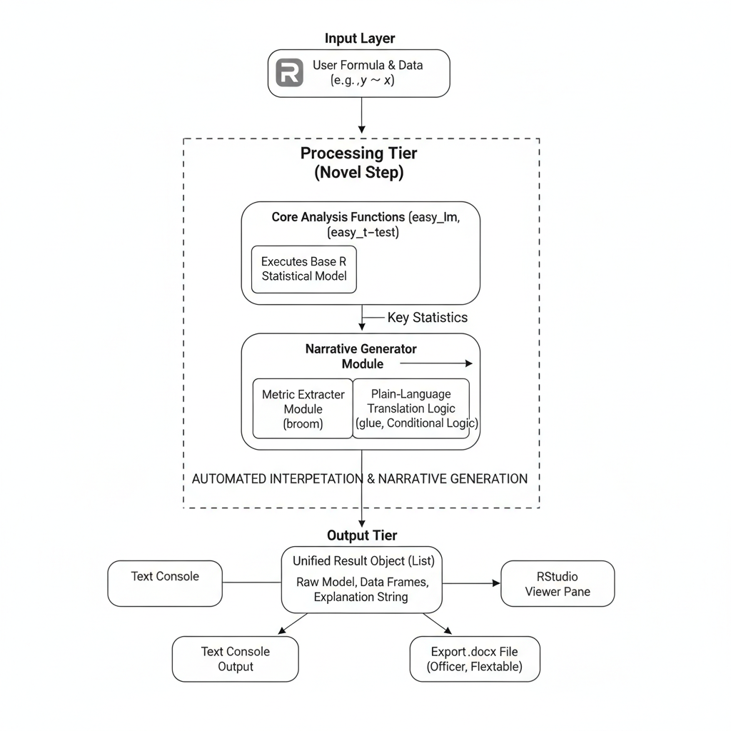
Figure 2: Statistical Analysis and Reporting Flowchart
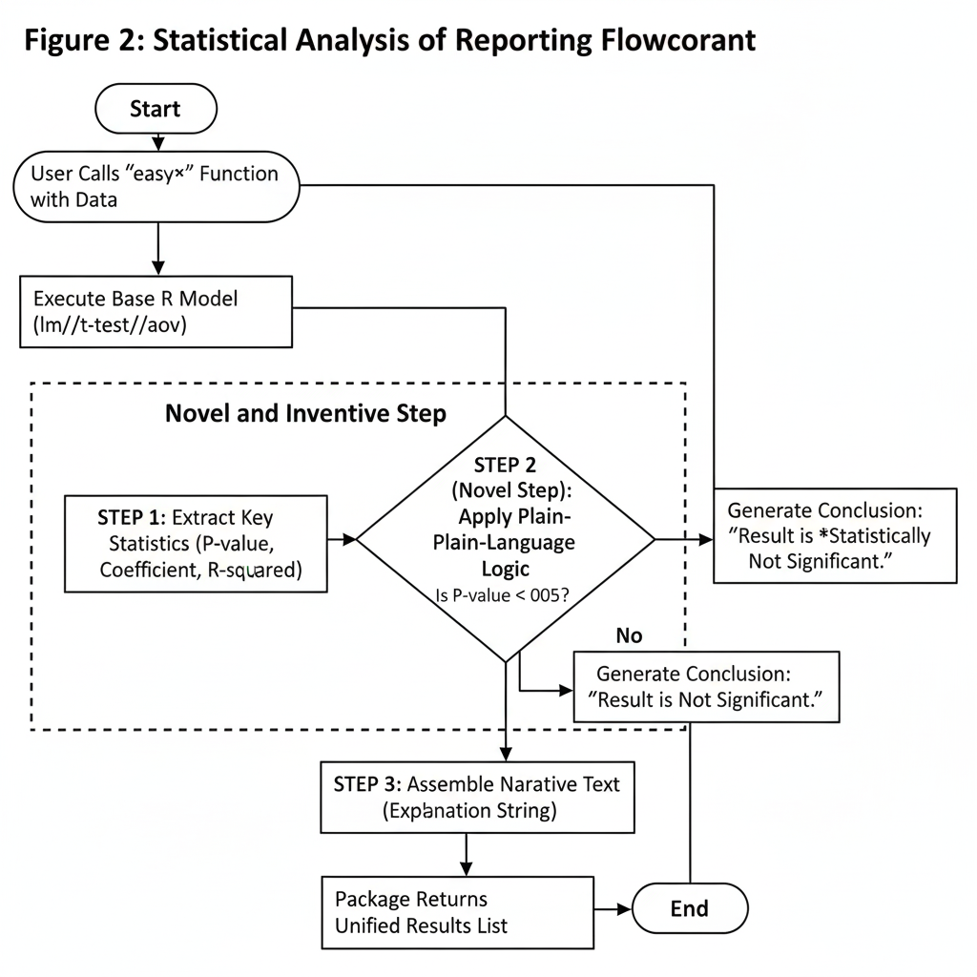

The present invention is an R package, hereinafter referred to as the EasyStat System, designed as a novel computer-implemented system and method for performing standard statistical analyses and automatically generating plain-language, interpretative narratives from the resulting complex statistical output. The system's primary innovation is the seamless integration of statistical computation with automated, contextualized linguistic interpretation, significantly improving reporting accuracy and efficiency for users without specialized statistical expertise.
1. System Architecture and Components
The EasyStat System operates via a four-step sequential method, managed by three interconnected modules that correspond to the functional tiers described .
Step | Component / Function | Action | Novelty
Step 1: Analysis | Core Statistical Engine | Takes user data and formula, and runs the standard R test (lm(), t.test()). | Not novel, but necessary.
Step 2: Metric Extraction | Metric Extractor Module (uses broom) | Takes the complex model result and converts it into clean, simple data tables. It isolates only the P-value, Estimate/Coefficient, and Model Fit ($R^2$ or $F$-statistic). | Improves efficiency.
Step 3: Narrative Generation (The Invention) | Narrative Generator Module (uses glue and logic) | NOVELTY: This module reads the isolated P-value, applies conditional logic (Is P-value < 0.05?), and uses the results to assemble the plain-language explanation string from pre-written templates. | Core Inventive Step.
Step 4: Output Aggregation | Unified Result Object | Combines the raw model, the extracted data tables, and the plain-language explanation into a single, comprehensive R list object. | Improves usability.
2. Reporting Versatility (User Interface)
The present part details the way the singular output can cater to varied reporting requirements.
- Console/Viewer Output: The raw data tables are presented automatically with HTML/CSS (via knitr/kableExtra) and the explanation is shown, making the result look professional without any additional coding.
- Word Document Export: A special function utilizes the flextable and officer packages to take the raw tables and text, and effortlessly build up a complete, orderly Word .docx report.
3. New and Original Contribution
The main contribution is the Narrative Generator Module.
- It cuts down the need for human, expert interpretation.
- It guarantees the reported interpretation is statistically sound by making the whole narrative hinge on the objective, extracted metrics.
It merges the raw data, the formatted tables, and the text into one seamless report object, thus, facilitating the complete statistical reporting procedure.

Significance of the work proposed:

1. Bridging the Interpretive Gap
The primary significance is solving the long-standing problem of misinterpretation in statistical reporting. By automatically converting technical output (like -statistics and -values) into clear, plain-language narrative, the package ensures that findings are communicated accurately and consistently, regardless of the user's statistical expertise. This reduces errors in reporting and accelerates the knowledge transfer from data scientist to decision-maker.

2. Standardization of Reporting
The package enforces a standardized, repeatable reporting format across different statistical tests (t-test, ANOVA, Regression). This consistency is vital for organizations that need to generate numerous comparable reports. It ensures that every time a t-test is run, the key metrics (like -value and effect size) are highlighted and interpreted in the same manner, enhancing organizational efficiency and auditability.

3. Workflow Efficiency and Speed
The integration of computation, interpretation, and professional document export into a single function (easy_regression, export_to_word) drastically improves workflow efficiency. It eliminates the manual, time-consuming steps of copying data, generating explanations, and formatting tables in separate software (like Word or Excel), allowing analysts to spend more time on analysis and less time on reporting.

4. Enhanced Professionalism in Output
By leveraging advanced R packages like flextable and kableExtra, the package generates outputs that are immediately report-ready. The ability to produce clean, formatted tables and a structured narrative directly to a Word document or the RStudio Viewer elevates the professional quality of internal and external statistical reports without requiring complex external coding or formatting skills.

5. Increased Accessibility and Learning
For students and new users of R, the package serves as an educational tool. By providing the correct, contextual interpretation alongside the raw technical output, users can quickly learn what the technical metrics truly mean in practice, thus fostering a deeper understanding of statistical principles.

