1. **Set up the Git repository:**

***mkdir aws-infra***

***cd aws-infra***

***git init***

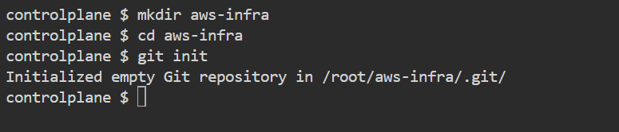

1. **Create Terraform configuration files:**

***touch main.tf***

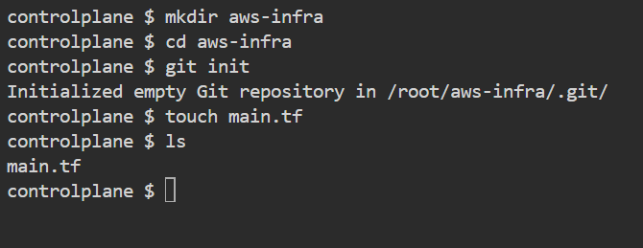

***nano main.tf***

*provider "aws" {*

*region = "us-east-1" # Change to your preferred region*

*}*

*data "aws_availability_zones" "available" {}*

*resource "aws_vpc" "ionginx_vpc" {*

*cidr_block = "10.0.0.0/16"*

*tags = {*

*Name = "ionginx-vpc"*

*}*

*}*

*resource "aws_subnet" "public" {*

*count = 3*

*vpc_id = aws_vpc.ionginx_vpc.id*

*cidr_block = "10.0.${count.index}.0/24"*

*map_public_ip_on_launch = true*

*availability_zone = element(data.aws_availability_zones.available.names, count.index)*

*}*

*resource "aws_subnet" "private" {*

*count = 3*

*vpc_id = aws_vpc.ionginx_vpc.id*

*cidr_block = "10.0.${count.index + 3}.0/24"*

*map_public_ip_on_launch = false*

*availability_zone = element(data.aws_availability_zones.available.names, count.index)*

*}*

*resource "aws_internet_gateway" "igw" {*

*vpc_id = aws_vpc.ionginx_vpc.id*

*}*

*resource "aws_nat_gateway" "nat" {*

*allocation_id = aws_eip.nat.id*

*subnet_id = aws_subnet.public[0].id*

*}*

*resource "aws_eip" "nat" {*

*domain = "vpc"*

*}*

*resource "aws_route_table" "public" {*

*vpc_id = aws_vpc.ionginx_vpc.id*

*route {*

*cidr_block = "0.0.0.0/0"*

*gateway_id = aws_internet_gateway.igw.id*

*}*

*}*

*resource "aws_route_table_association" "public" {*

*count = 3*

*subnet_id = aws_subnet.public[count.index].id*

*route_table_id = aws_route_table.public.id*

*}*

*resource "aws_route_table" "private" {*

*vpc_id = aws_vpc.ionginx_vpc.id*

*route {*

*cidr_block = "0.0.0.0/0"*

*nat_gateway_id = aws_nat_gateway.nat.id*

*}*

*}*

*resource "aws_route_table_association" "private" {*

*count = 3*

*subnet_id = aws_subnet.private[count.index].id*

*route_table_id = aws_route_table.private.id*

*}*

*resource "aws_launch_configuration" "nginx" {*

*name = "nginx-lc"*

*image_id = data.aws_ami.ubuntu.id*

*instance_type = "t2.micro"*

*associate_public_ip_address = false*

*user_data = <<-EOF*

*#!/bin/bash*

*apt-get update*

*apt-get install -y nginx*

*systemctl start nginx*

*systemctl enable nginx*

*EOF*

*lifecycle {*

*create_before_destroy = true*

*}*

*}*

*data "aws_ami" "ubuntu" {*

*most_recent = true*

*owners = ["099720109477"] # Canonical*

*filter {*

*name = "name"*

*values = ["ubuntu/images/hvm-ssd/ubuntu-*-20.04-amd64-server-*"]*

*}*

*}*

*resource "aws_autoscaling_group" "nginx" {*

*desired_capacity = 2*

*max_size = 4*

*min_size = 2*

*vpc_zone_identifier = aws_subnet.private.*.id*

*launch_configuration = aws_launch_configuration.nginx.id*

*tag {*

*key = "Name"*

*value = "nginx"*

*propagate_at_launch = true*

*}*

*}*

*resource "aws_route53_zone" "main" {*

*name = "example.com" # Change to your domain*

*}*

*resource "aws_route53_record" "www" {*

*zone_id = aws_route53_zone.main.zone_id*

*name = "www"*

*type = "A"*

*ttl = 300*

*records = [aws_eip.nat.public_ip]*

*}*

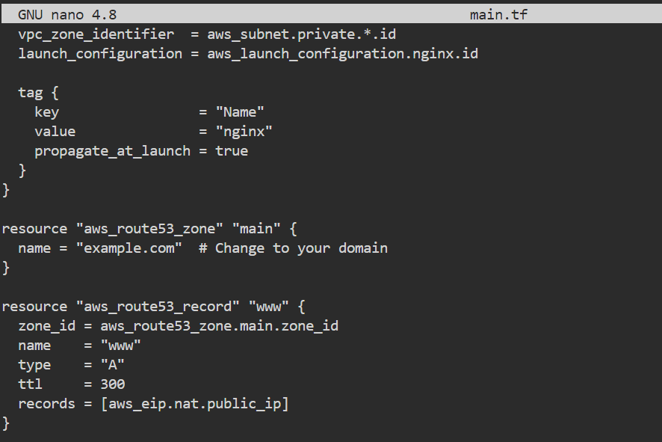

**Verify the main.tf file using the command :- *cat main.tf***

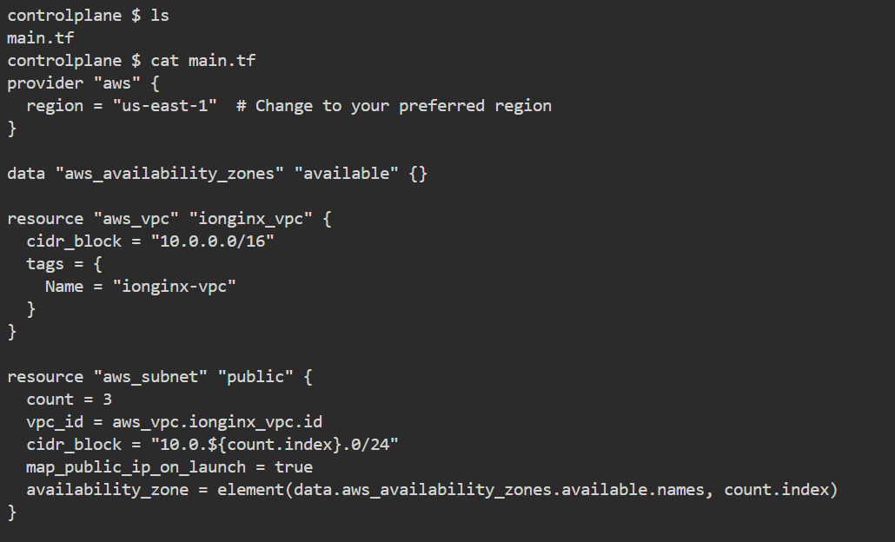

1. **Initialize Terraform:** terraform init

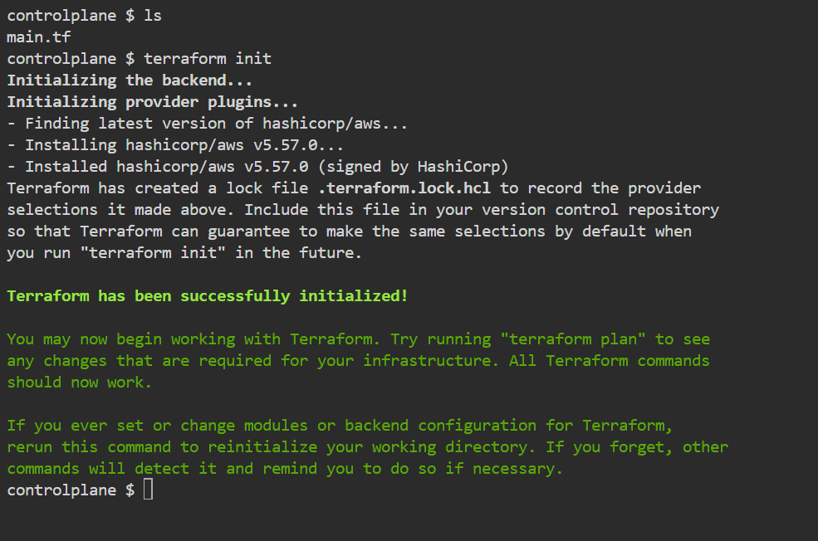

1. **Validate the configuration:** terraform validate

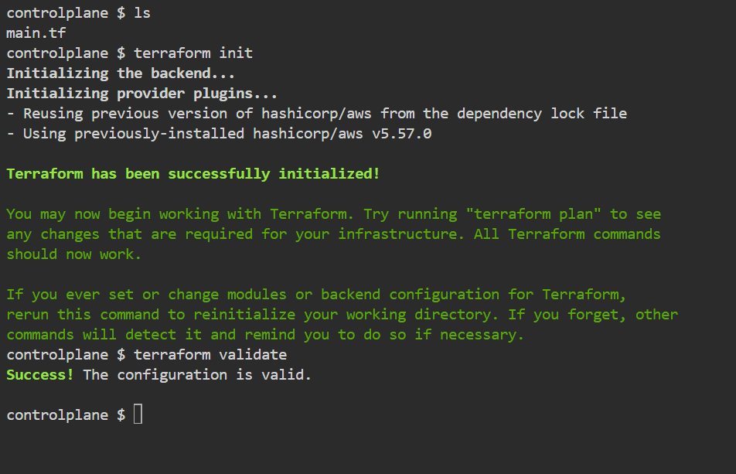

1. **Plan and apply the configuration:**

terraform plan

terraform apply

As I am not having to AWS platform it will throw an error similar in the below attachment :-

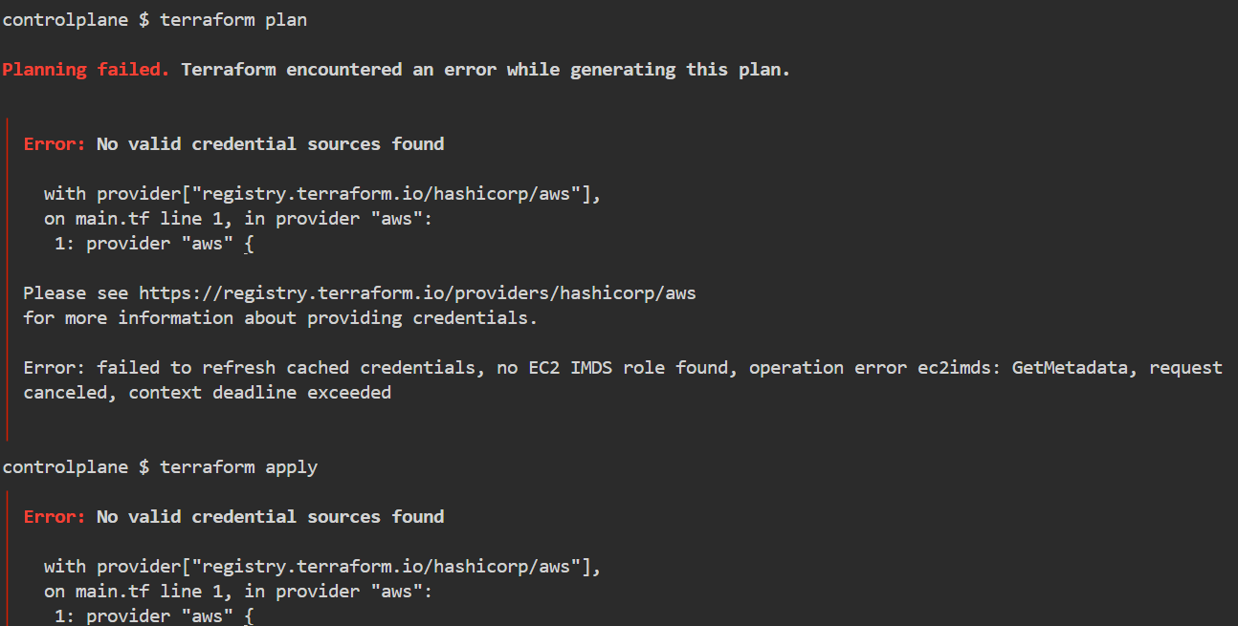

1. **Commit and push the code to GitHub:**

git add main.tf

git commit -m "Initial commit of AWS infrastructure as code"

git remote add origin https://github.com/itsme-aswindev/aws-infra.git

git push -u origin master