
East West University
Department of Computer Science and Engineering (CSE)
Semester: (Fall, Year: 2025), B.Sc. in CSE

Title: Designing an Interconnected Multi-Building Network
Course Title: Computer Network Course Code: CSE405
Section: 05
Students Details

Name | ID
Belal Hossain | 2023-2-60-010
Submission Date: 17/12/2025

Instructor: Md. Khalid Mahbub Khan

Senior Lecturer

Department of Computer Science & Engineering

- Problem Statement:
Modern educational institutions rely heavily on computer networks to support academic, administrative, and communication activities. As the campus expands across multiple buildings, maintaining efficient, reliable, and centralized network communication becomes increasingly challenging. Without proper network design, issues such as IP conflicts, poor routing efficiency, lack of centralized services, and limited scalability can arise.
The institution described in this project consists of five separate facilities:
  - Main Campus
  - Library Center
  - Computer Lab
  - Faculty Offices
  - Administration Block.
Each facility requires independent internal communication as well as seamless connectivity with other facilities. Additionally, the network must support automatic IP address allocation, centralized web access, and reliable inter-building routing.

The key challenges addressed in this project are:
- Designing an interconnected multi-building network with proper segmentation
- Implementing dynamic routing for efficient inter-facility communication
- Managing IP addressing using Class A and Class B schemes
- Deploying centralized network services such as DHCP, DNS, and Web Server
- Ensuring network-wide accessibility and connectivity verification

This project aims to solve these challenges by designing and simulating a scalable campus network using Cisco Packet Tracer, following real-world networking standards.

- Design:
  - Network Architecture:
The network architecture of this project is designed to represent an interconnected multi-building campus network using a client–server model. The overall topology consists of five facilities, each operating as an independent Local Area Network (LAN), while all facilities are interconnected through a central router located in the Administration Block.
Campus Facilities Included
- Main Campus
- Library Center
- Computer Lab
- Faculty Offices
- Administration Block
Each facility contains its own router, switch, client PCs, and DHCP server, ensuring local traffic management and independent IP address allocation. This segmented design minimizes broadcast traffic, improves performance, and enhances scalability.

- Snapshot of Network Design:

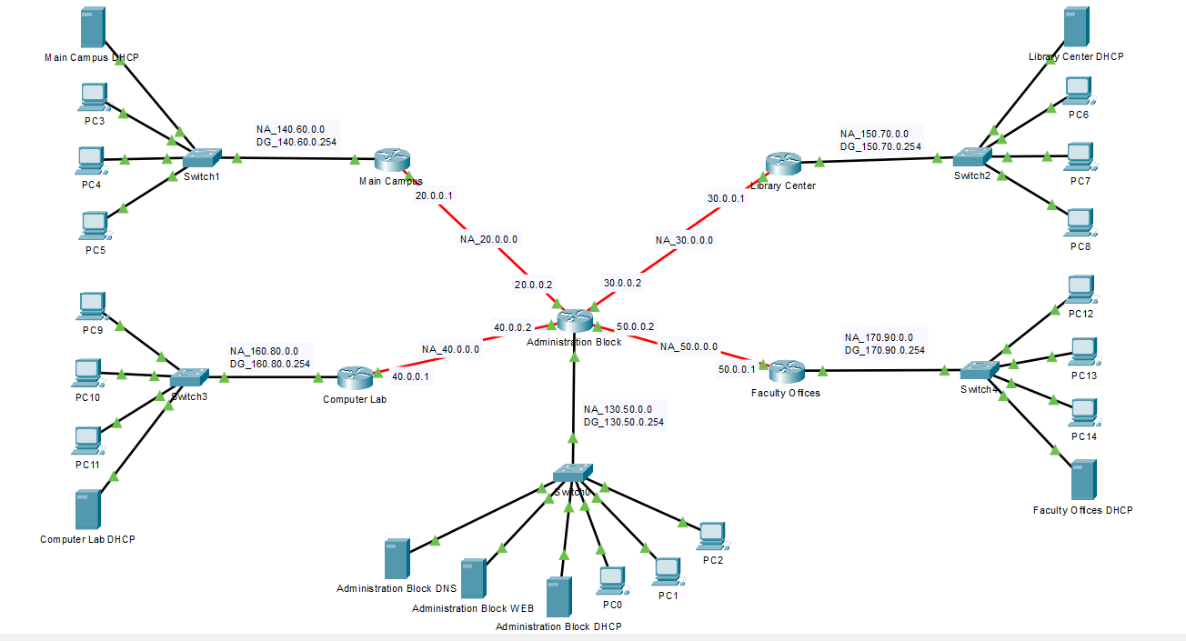
Figure: Network Topology of the Interconnected Multi-Building Campus Network

  - Device and Server Distribution:
- Client PCs
A total of 15 client PCs is deployed in the network:
- 3 PCs per facility
- PCs are used by students, faculty members, and staff to access network services and communicate across facilities.

- DHCP Servers
A total of 5 DHCP servers are implemented. 1 DHCP server per facility:

- Main Campus DHCP Server

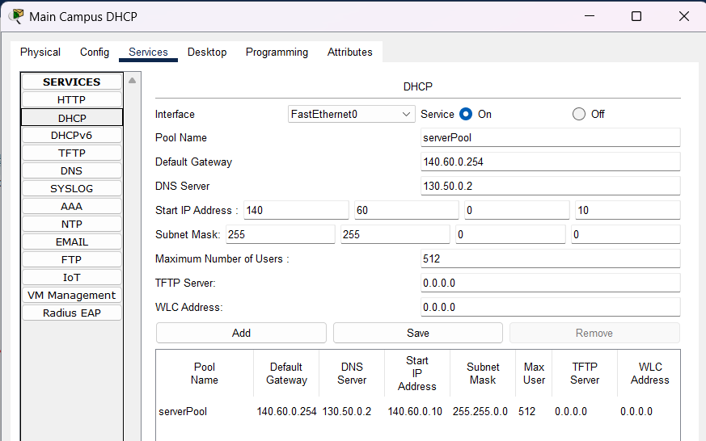

- Library Center DHCP Server

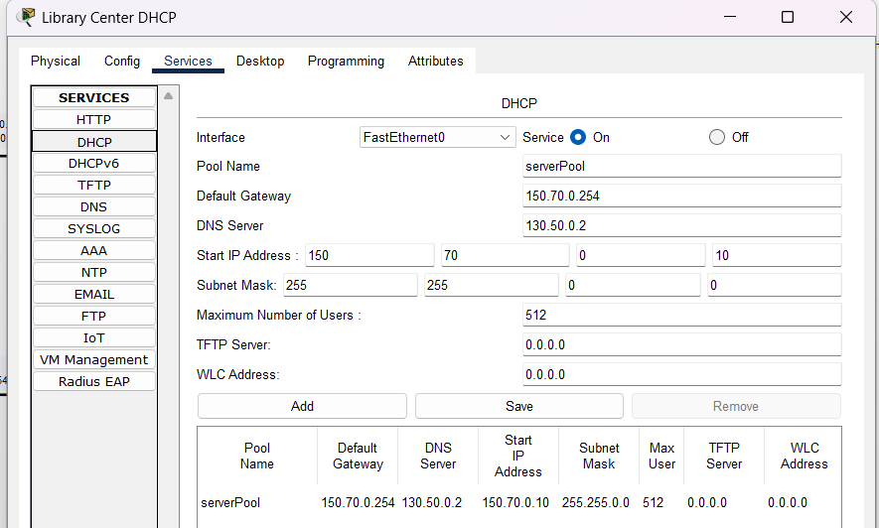

- Computer Lab DHCP Server

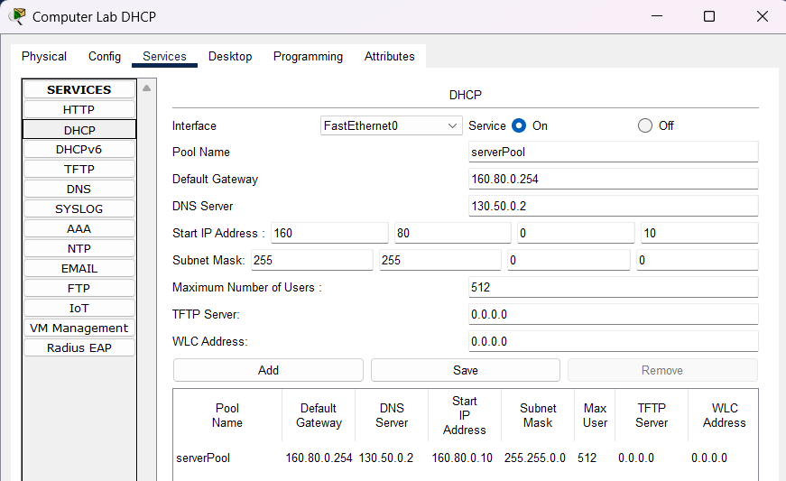

- Faculty Offices DHCP Server

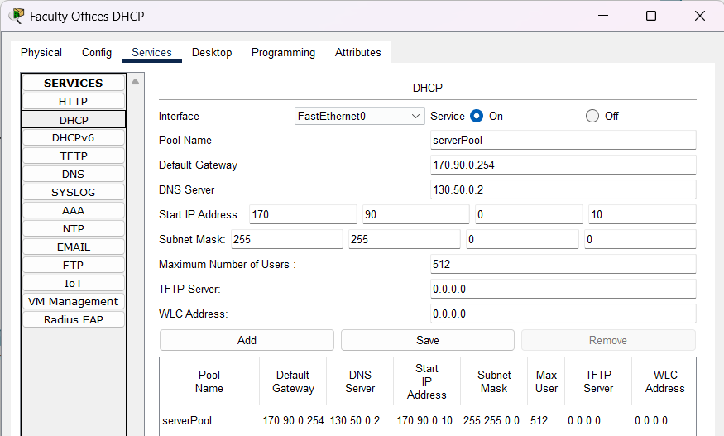

- Administration Block DHCP Server

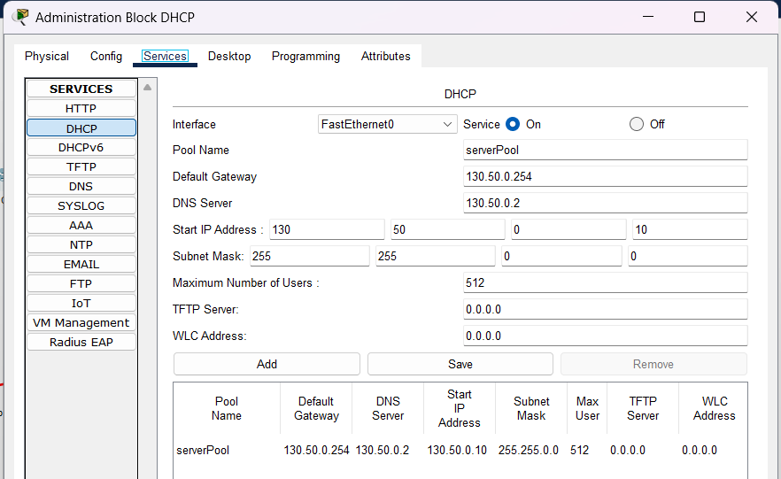

Each DHCP server is responsible for assigning:
- IP address
- Subnet mask
- Default gateway
- DNS server address
This distributed DHCP approach ensures automatic IP assignment, eliminates IP conflicts, and reduces administrative workload.

- DNS Server
- 1 centralized DNS server
- Located in the Administration Block

IP Configuration of DNS Server:
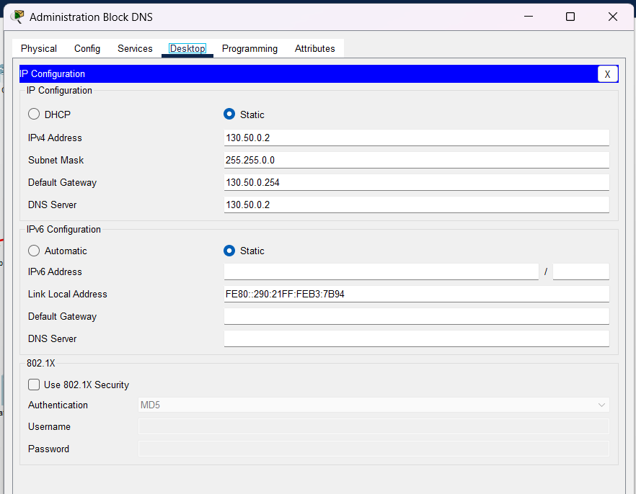

Connecting With Web Server using DNS:
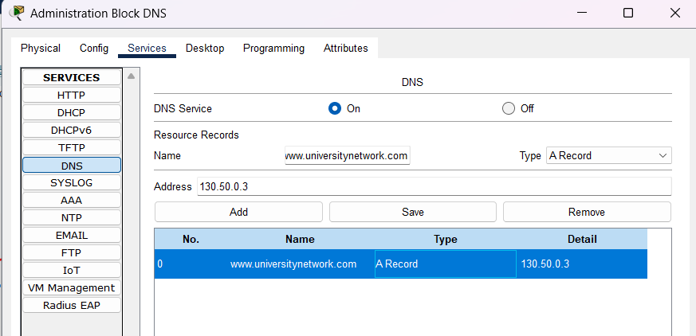

The DNS server (130.50.0.2) resolves the domain name (www.universitynetwork.com) to the IP address of the web server, allowing all users to access the website using a domain name instead of an IP address.

  - Web Server
- 1 Web Server (IP- 10.0.0.3)
- Located in the Administration Block

IP Configuration of Web Server:
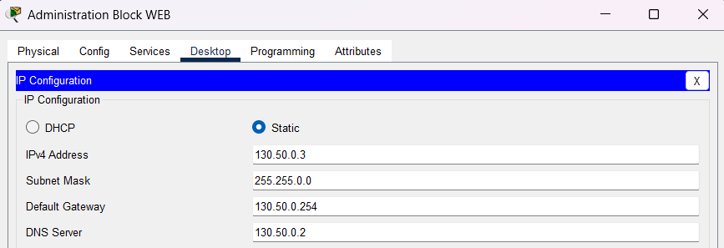

Setting personal information in Web Server:
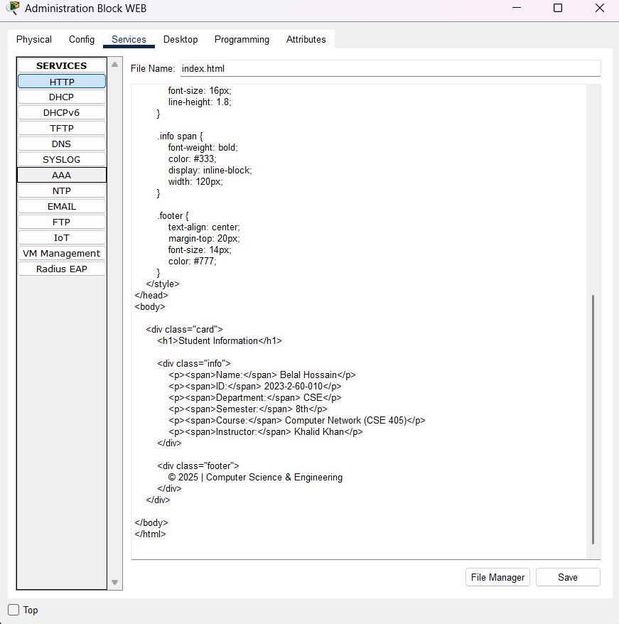
The web server hosts the university webpage containing required information such as the student’s full name and student ID. The server is accessible from all facilities via a web browser using DNS-based access.
  - IP Addressing Scheme:

End Devices and Servers:
Device | Interface | Network Address | IP Address | Subnet Mask | Remarks (Connected to)
Admin Block DHCP | Fa0 | 130.50.0.0 | 130.50.0.1 | 255.255.0.0 | Admin Block Switch
Admin Block DNS | Fa0 | 130.50.0.0 | 130.50.0.2 | 255.255.0.0 | Admin Block Switch
Admin Block Web | Fa0 | 130.50.0.0 | 130.50.0.3 | 255.255.0.0 | Admin Block Switch
PC0 | Fa0 | 130.50.0.0 | DHCP | 255.255.0.0 | Admin Block Switch
PC1 | Fa0 | 130.50.0.0 | DHCP | 255.255.0.0 | Admin Block Switch
PC2 | Fa0 | 130.50.0.0 | DHCP | 255.255.0.0 | Admin Block Switch

Main Campus LAN:
Device | Interface | Network Address | IP Address | Subnet Mask | Remarks
PC3 | Fa0 | 140.60.0.0 | DHCP | 255.255.0.0 | Switch1
PC4 | Fa0 | 140.60.0.0 | DHCP | 255.255.0.0 | Switch1
PC5 | Fa0 | 140.60.0.0 | DHCP | 255.255.0.0 | Switch1
Main Campus DHCP | Fa0 | 140.60.0.0 | 140.60.0.1 | 255.255.0.0 | Switch1

Library Center LAN:
Device | Interface | Network Address | IP Address | Subnet Mask | Remarks
PC6 | Fa0 | 150.70.0.0 | DHCP | 255.255.0.0 | Switch2
PC7 | Fa0 | 150.70.0.0 | DHCP | 255.255.0.0 | Switch2
PC8 | Fa0 | 150.70.0.0 | DHCP | 255.255.0.0 | Switch2
Library DHCP | Fa0 | 150.70.0.0 | 150.70.0.1 | 255.255.0.0 | Switch2

Computer Lab LAN:
Device | Interface | Network Address | IP Address | Subnet Mask | Remarks
PC9 | Fa0 | 160.80.0.0 | DHCP | 255.255.0.0 | Switch3
PC10 | Fa0 | 160.80.0.0 | DHCP | 255.255.0.0 | Switch3
PC11 | Fa0 | 160.80.0.0 | DHCP | 255.255.0.0 | Switch3
Lab DHCP | Fa0 | 160.80.0.0 | 160.80.0.1 | 255.255.0.0 | Switch3

Faculty Offices LAN:
Device | Interface | Network Address | IP Address | Subnet Mask | Remarks
PC12 | Fa0 | 170.90.0.0 | DHCP | 255.255.0.0 | Switch4
PC13 | Fa0 | 170.90.0.0 | DHCP | 255.255.0.0 | Switch4
PC14 | Fa0 | 170.90.0.0 | DHCP | 255.255.0.0 | Switch4
Faculty DHCP | Fa0 | 170.90.0.0 | 170.90.0.1 | 255.255.0.0 | Switch4

Administration Block Router:
Device | Interface | IP Address | Subnet Mask | Remarks
Admin Router | Fa0/0 | 130.50.0.254 | 255.255.0.0 | Admin LAN
Admin Router | Se2/0 | 20.0.0.2 | 255.0.0.0 | Main Campus
Admin Router | Se3/0 | 30.0.0.2 | 255.0.0.0 | Library Center
Admin Router | Se6/0 | 40.0.0.2 | 255.0.0.0 | Computer Lab
Admin Router | Se7/0 | 50.0.0.2 | 255.0.0.0 | Faculty Offices

Others Router:
Router | Interface | IP Address | Subnet Mask | Connected To
Main Campus | Fa0/0 | 140.60.0.254 | 255.255.0.0 | Main LAN
 | Se2/0 | 20.0.0.1 | 255.0.0.0 | Admin Router
Library Center | Fa0/0 | 150.70.0.254 | 255.255.0.0 | Library LAN
 | Se2/0 | 30.0.0.1 | 255.0.0.0 | Admin Router
Computer Lab | Fa0/0 | 160.80.0.254 | 255.255.0.0 | Lab LAN
 | Se2/0 | 40.0.0.1 | 255.0.0.0 | Admin Router
Faculty Offices | Fa0/0 | 170.90.0.254 | 255.255.0.0 | Faculty LAN
 | Se2/0 | 50.0.0.1 | 255.0.0.0 | Admin Router

  - Router Interface Configuration:

Administration Block Router Interface Configuration CLI Commands:
en
config t

interface fa0/0
ip address 130.50.0.254 255.255.0.0
no shutdown
exit

interface se2/0
ip address 20.0.0.2 255.0.0.0
clock rate 64000
no shutdown
exit

interface se3/0
ip address 30.0.0.2 255.0.0.0
no shutdown
exit

interface se6/0
ip address 40.0.0.2 255.0.0.0
no shutdown
exit

interface se7/0
ip address 50.0.0.2 255.0.0.0
no shutdown
exit

do write

Main Campus Router Interface Configuration CLI Command:
en
config t

interface fa0/0
ip address 140.60.0.254 255.255.0.0
no shutdown
exit

interface se2/0
ip address 20.0.0.1 255.0.0.0
no shutdown
exit

do write

Library Center Router Interface Configuration CLI Commands:

en
config t

interface fa0/0
ip address 150.70.0.254 255.255.0.0
no shutdown
exit

interface se2/0
ip address 30.0.0.1 255.0.0.0
no shutdown
exit

do write

Computer Lab Router Interface Configuration CLI Commands:

en
config t

interface fa0/0
ip address 160.80.0.254 255.255.0.0
no shutdown
exit

interface se2/0
ip address 40.0.0.1 255.0.0.0
clock rate 64000
no shutdown
exit

do write

Faculty Offices Router Interface Configuration:

en
config t

interface fa0/0
ip address 170.90.0.254 255.255.0.0
no shutdown
exit

interface se2/0
ip address 50.0.0.1 255.0.0.0
clock rate 64000
no shutdown
exit

do write

Snapshot with Interface:

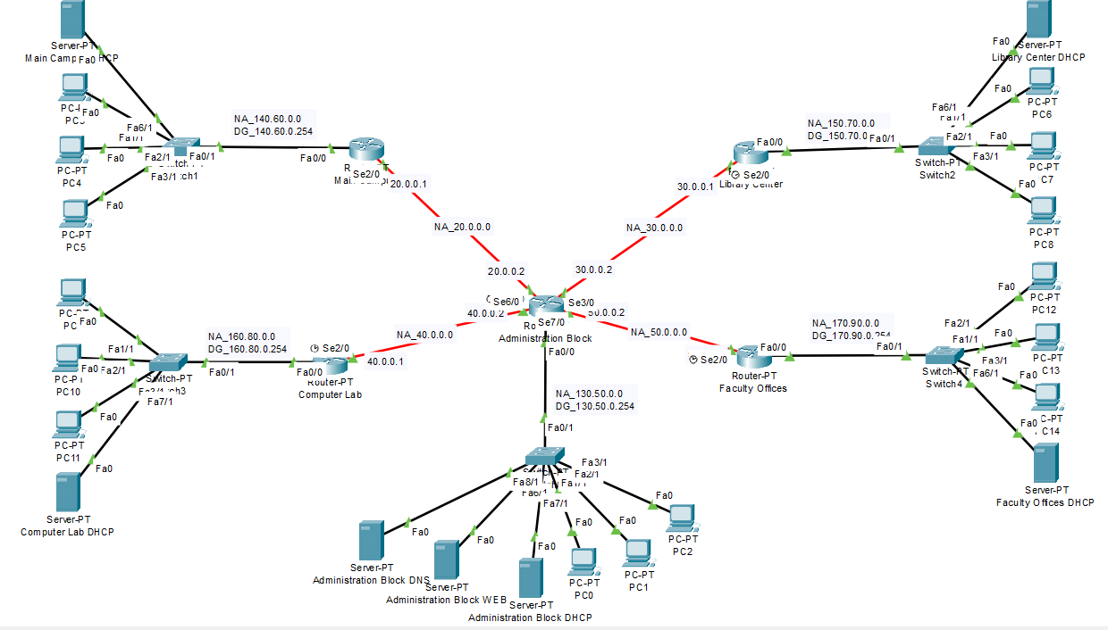
Figure: Interface and Network Address

EIGRP Routing Design and Protocol:
EIGRP (Enhanced Interior Gateway Routing Protocol) is selected as the dynamic routing protocol for this campus network due to its fast convergence, scalability, and efficient route management. The network follows a hub-and-spoke design where the Administration Block router acts as the central hub and all other facility routers connect to it through point-to-point links.
EIGRP enables automatic route discovery and exchange among routers, eliminating the need for manual static routing. It uses the Diffusing Update Algorithm (DUAL) to ensure loop-free routing and to quickly compute the best available path in case of link failure. Since the campus network consists of multiple LANs and WAN links, EIGRP provides reliable and efficient inter-facility communication with minimal routing overhead.
The protocol is also suitable for future expansion, allowing additional buildings or subnets to be added without redesigning the routing configuration. Therefore, EIGRP fulfills the project requirement for efficient, dynamic, and scalable routing across all facilities.

Administration Block Router CLI Command:

en

config t

router eigrp 100

network 130.50.0.0

network 20.0.0.0

network 30.0.0.0

network 40.0.0.0

network 50.0.0.0

exit

do write

Main Campus Router CLI Command:

en

config t

router eigrp 100

network 140.60.0.0

network 20.0.0.0

exit

do write

Computer Lab Router CLI Command:

en

config t

router eigrp 100

network 160.80.0.0

network 40.0.0.0

exit

do write

Faculty Offices Router CLI Command:

en

config t

router eigrp 100

network 170.90.0.0

network 50.0.0.0

exit

do write

Experimental Results:

3.1 DHCP Verification:

All client PCs successfully obtained IP addresses automatically from their respective DHCP servers, confirming correct DHCP configuration.

Administrator Block PC:

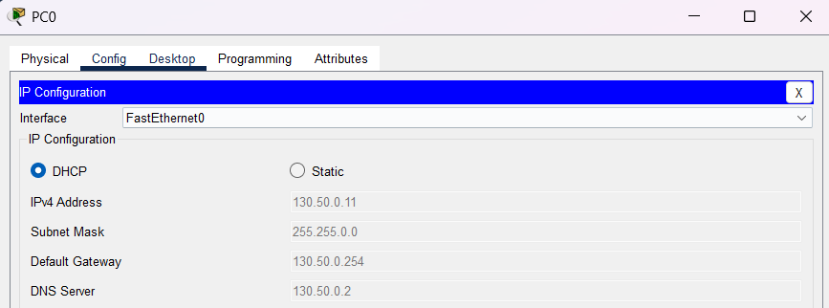

Main Campus PC:

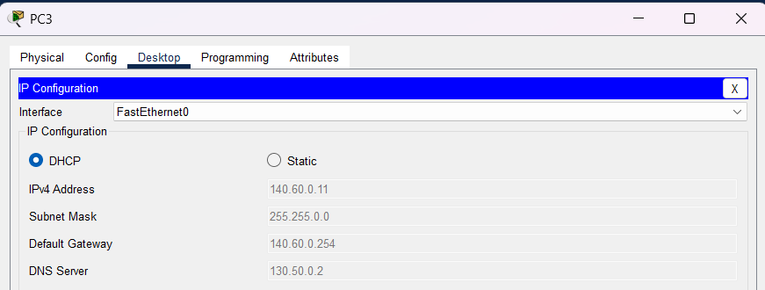

Library Block PC:

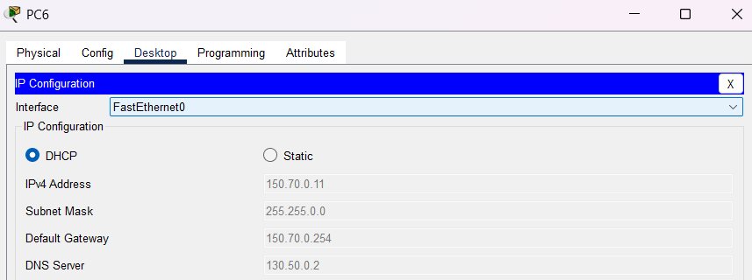

Computer Lab PC:

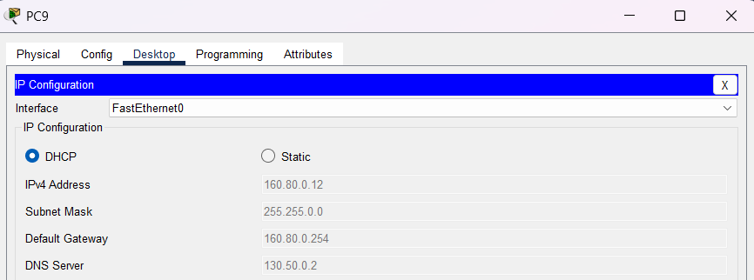\

Faculty Office PC:

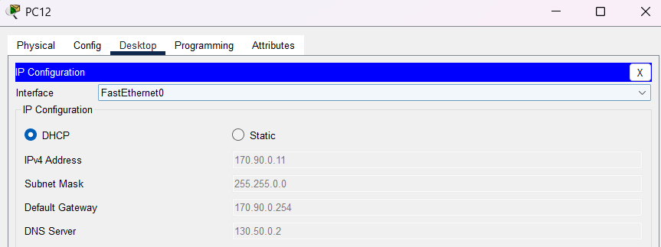

3.2 Router Interface Configuration Test:

Administration Block Router:

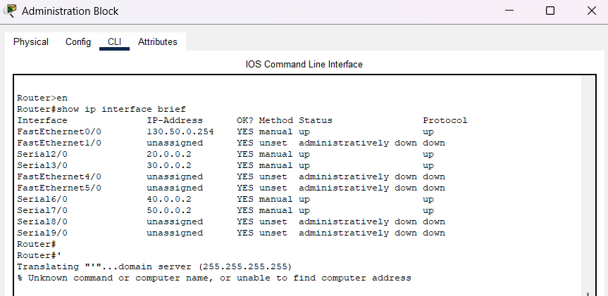

Main Campus Router:

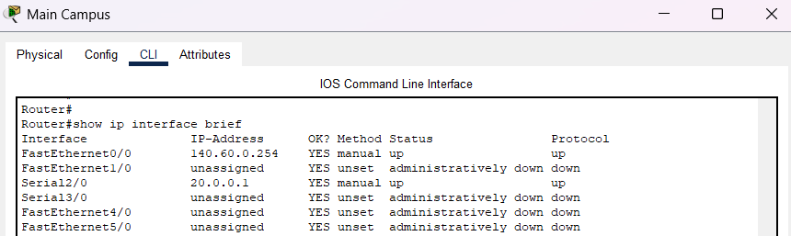

Library Center Router:

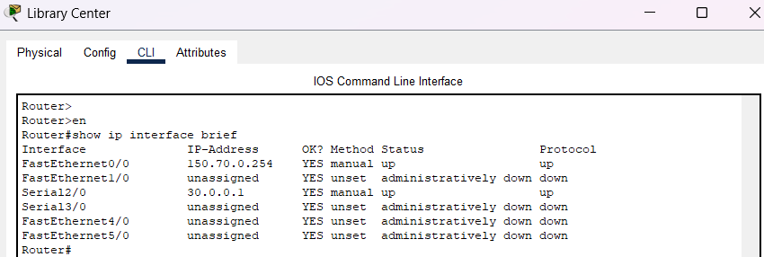

Computer Lab Router:

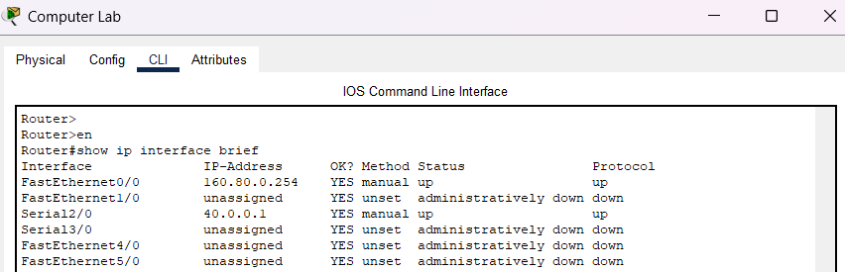

Faculty Office Router:

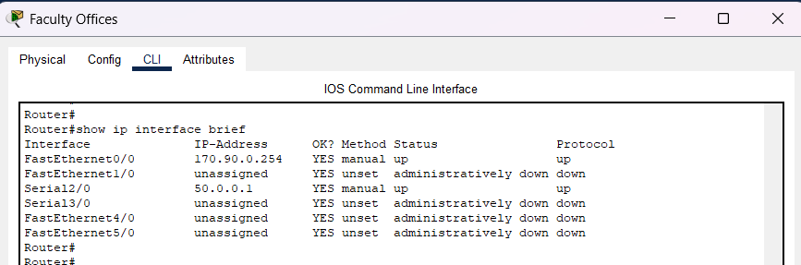

3.3 EIGRP Routing Verification:

The proper operation of the EIGRP dynamic routing protocol was verified by examining the routing tables of the routers in the network. This test confirms that routes to all remote networks were learned automatically without using static routing. The verification was performed from the Administration Block router, which acts as the central hub of the campus network.

Administrator Block Router IP Route:

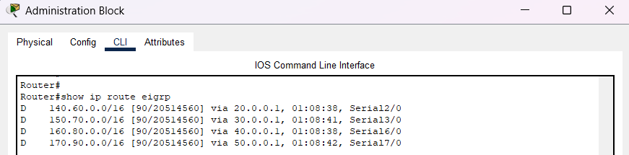

Main Campus Router IP Route:

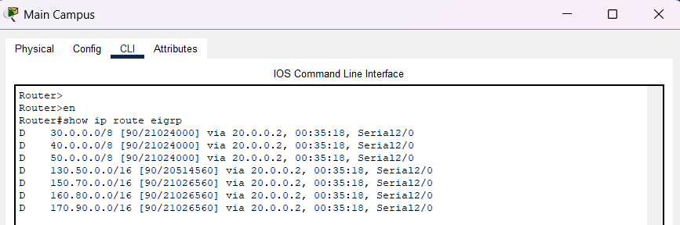

Library center Router IP Route:

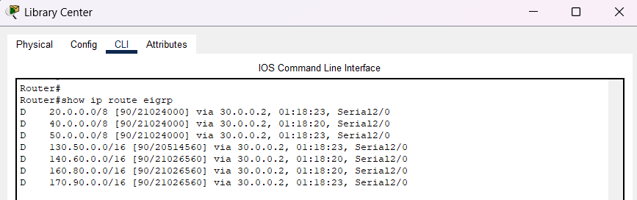

Faculty Office Router IP Route:

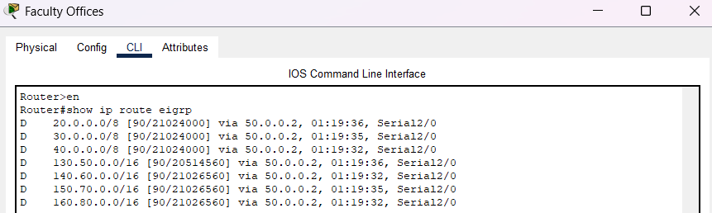

3.4 Connectivity Test (Ping Test):

A successful ping test was performed between the 2nd PC of the Library Center (PC7) and the 3rd PC of the Administration Block (PC2). The successful reply confirms proper inter-facility connectivity and correct routing configuration.

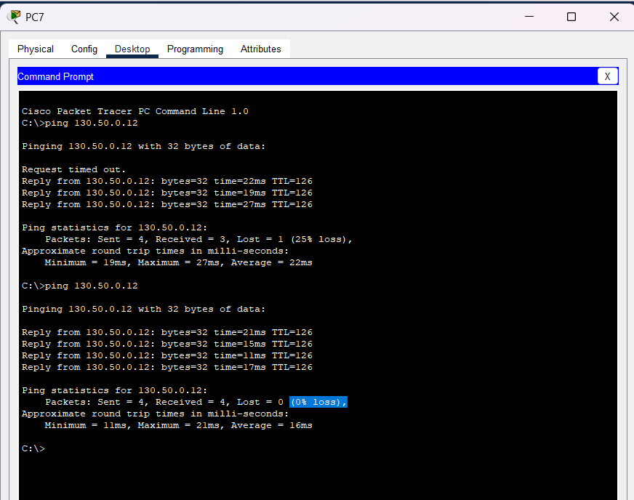

Figure 3: Ping Test between Library Center PC and Administration Block PC

3.5 DNS & Web Server Test:

The DNS and Web Server functionality were verified by accessing the hosted website using both the domain name and the direct IP address. These tests confirm correct DNS resolution and proper web server operation across the campus network.

Test 1: Access Using Domain Name

The domain name www.universitynetwork.com was entered into the web browser from a client PC. The DNS server with IP address 130.50.0.2 successfully resolved the domain name to the web server IP address 130.50.0.3. After successful name resolution, the web page was loaded correctly, confirming proper DNS and HTTP service integration.

Snapshot of Test-1 Output:

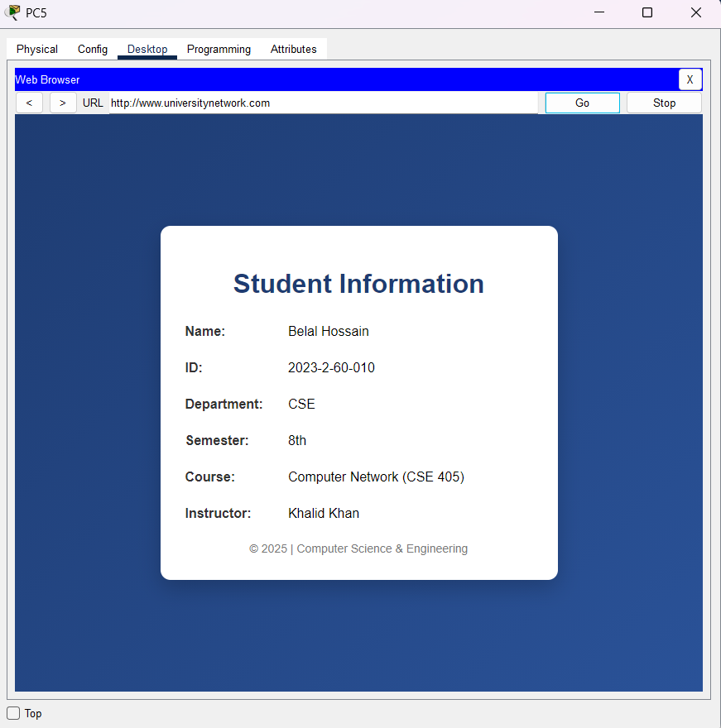

Figure 5: Web Server Access Using Domain Name (www.universitynetwork.com)

Test 2: Access Using Web Server IP Address

To further verify the web server functionality, the website was accessed directly using the IP address 130.50.0.3 in the web browser. The webpage loaded successfully without DNS involvement, confirming that the web server was correctly configured and reachable from all facilities.

Snapshot of Test-2 Output:

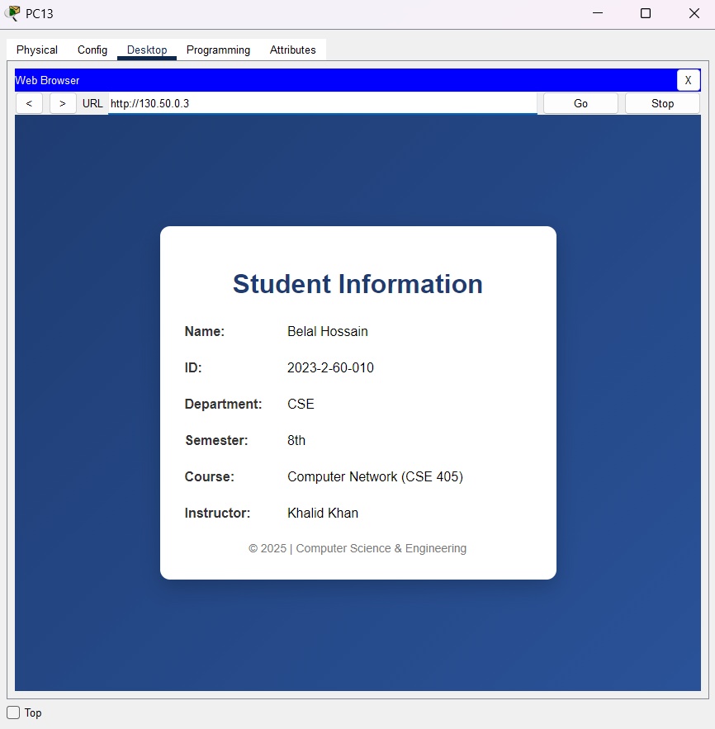

Figure: Web Server Access Using Direct IP Address (130.50.0.3)

DNS lookup screenshot:

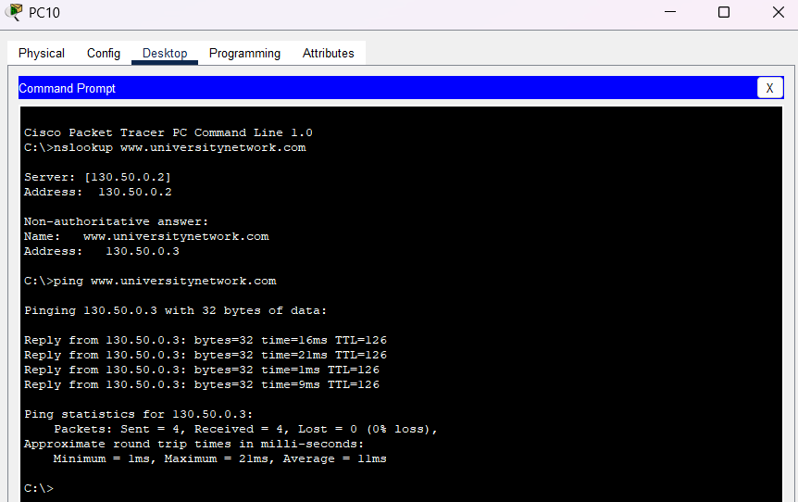

Figure: DNS Lookup Result for www.universitynetwork.com

Conclusion

This project successfully demonstrated the design and implementation of an interconnected multi-building campus network using Cisco Packet Tracer. The network was carefully structured to ensure efficient communication among five major facilities: Main Campus, Library Center, Computer Lab, Faculty Offices, and Administration Block. Each facility was provided with its own router, switch, client PCs, and DHCP server, ensuring proper segmentation and effective local traffic management.

Dynamic routing was implemented using the EIGRP (Enhanced Interior Gateway Routing Protocol), which enabled automatic route discovery and efficient inter-facility communication without the need for static routing. The successful formation of EIGRP neighbor adjacencies and the presence of dynamically learned routes in the routing tables confirmed the correct operation of the routing protocol. Connectivity tests further validated reliable data transmission between devices located in different facilities.

Centralized network services were also deployed to enhance usability and manageability. The DHCP servers ensured automatic IP address allocation, eliminating IP conflicts and reducing administrative overhead. Additionally, the centralized DNS server successfully resolved domain names to IP addresses, and the web server hosted the university webpage, which was accessible from all network segments using both domain-based and IP-based access.

Overall, the project achieved its objectives by providing a scalable, reliable, and well-organized campus network design that follows real-world networking standards. The implementation demonstrates how dynamic routing protocols and centralized services can significantly improve network performance, manageability, and future expandability in modern educational institutions.

