CSE303: Statistics for Data Science
[Summer 2025]

Term Project Report

Modeling the Relationship Between Workload and Mental Health
in University Students

Submitted by:
Student ID | Student Name | Contribution (%)

Submitted to: ………………

1. Introduction
University students are subjected to mounting academic pressures from coursework, deadlines, part-time employment, and extracurricular commitments. This confluence of obligations has well-documented effects on mental health, manifesting as elevated stress, heightened anxiety, disrupted sleep, and reduced academic performance. Understanding the quantitative relationship between workload factors and mental health outcomes is therefore of considerable practical value for students, educators, and policymakers alike.
This project, conducted as part of CSE303: Statistics for Data Science, investigates those relationships through a two-phase data collection strategy: (i) a primary Google Form survey distributed to university students yielding 55 real responses, and (ii) a synthetically generated dataset of 150 records replicating the same survey structure. The combined dataset of 205 records is used throughout the analysis to improve statistical power while maintaining demographic diversity.
The analysis pipeline encompasses data cleaning and preprocessing, exploratory data analysis (EDA) with descriptive statistics and visualisations, Pearson correlation analysis, and three simple linear regression models implemented entirely from first principles using NumPy — satisfying the project constraint that no built-in regression libraries (sklearn/statsmodels) may be used. Key variable pairs modelled are: (1) Weekly Study Hours → Stress Level, (2) Number of Courses → Anxiety Score, and (3) Weekly Study Hours → Sleep Hours.
2. Data Preprocessing
The preprocessing pipeline was applied to both datasets before concatenation to ensure consistency and correctness throughout the analysis.
2.1 Column Renaming & Source Tagging
The real survey data exported from Google Forms used verbose question text as column headers. These were systematically renamed to match the concise column names used in the synthetic dataset (e.g., '1. Year of Study: (1st / 2nd / 3rd / 4th)' → 'Year of Study'). A 'DataType' tag column ('Real' / 'Synthetic') was added to each source before concatenation for traceability.
2.2 Numeric Cleaning
Real survey respondents often entered values in non-standard formats such as '4/5 hours', '7-8', or 'Almost 20hours'. A custom clean_numeric() function was implemented to: strip alphabetic characters and units, average range values (e.g., '7-8' → 7.5), and attempt float conversion. Values that could not be parsed were set to NaN for subsequent imputation.
2.3 Year of Study Cleaning
Free-text responses such as 'Graduated', '4rth', '4tg', and '5th' were handled by a clean_year() function: 'Graduated' was treated as 4th year; digits 1–4 were accepted; values outside [1,4] (e.g., 5th year) were set to NaN.
2.4 Categorical Encoding
Binary categorical variables were label-encoded: Gender (Male=1, Female=0), Extracurricular (Yes/No) (Yes=1, No=0), Part-time job (Yes/No) (Yes=1, No=0). Year of Study was converted to an integer (1–4).
2.5 Missing Value Imputation & Range Clipping
Remaining NaN values in all numeric columns were filled with the column median computed on the combined dataset. Likert-scale columns were clipped to their valid ranges: Stress level [1,5], Anxiety score [1,5], Sleep quality [1,10], Year of Study [1,4]. CGPA NaN values from real respondents who preferred not to disclose were similarly median-imputed.
2.6 Duplicate Removal
Exact duplicate rows were removed using pandas drop_duplicates(). Zero duplicates were detected in the combined dataset, confirming data integrity. The final cleaned dataset contains 205 rows × 15 columns.
Table 1: Preprocessing Summary
Step | Action | Outcome
Column Renaming | Mapped verbose Google Form headers to short names | Unified 14 columns
Source Tagging | Added 'DataType' column (Real / Synthetic) | Traceability maintained
Numeric Cleaning | Parsed ranges, stripped units | No unparseable numeric values
Year Cleaning | Handled 'Graduated', typos, out-of-range | Valid integers 1–4
Encoding | Binary label encoding for 3 categorical columns | All numerics
Imputation | Median fill for NaN | 0 missing values
Clipping | Likert scales clipped to valid ranges | No out-of-range values
Deduplication | drop_duplicates() | 0 duplicates removed
3. Dataset Characteristics
The final combined dataset comprises 205 student records and 15 columns (14 feature columns + 1 source tag). Of these, 55 records (26.8%) are genuine survey responses collected via Google Form, and 150 records (73.2%) are synthetically generated to simulate realistic student demographics.
Table 2: Summary Statistics for Key Variables (n = 205)
Variable | Mean | Median | Std | Min | Max | Skewness
Weekly study hours | 17.98 | 17.00 | 11.31 | 0.00 | 39.0 | 0.247
Number of courses | 4.23 | 4.00 | 1.20 | 0.00 | 8.0 | 0.449
Extracurricular hours | 6.54 | 6.00 | 4.03 | 0.00 | 16.0 | 0.322
Part-time hours | 9.95 | 9.00 | 6.75 | 0.00 | 42.0 | 1.171
Stress level | 3.45 | 3.00 | 1.19 | 1.00 | 5.0 | -0.279
Anxiety score | 3.42 | 3.00 | 0.96 | 1.00 | 5.0 | -0.020
Sleep hours | 6.38 | 6.40 | 1.37 | 2.50 | 9.7 | -0.153
Sleep quality | 6.02 | 6.00 | 1.92 | 1.00 | 10.0 | -0.139
Age | 21.23 | 21.00 | 2.44 | 2.00 | 27.0 | -2.355
CGPA | 3.28 | 3.32 | 0.42 | 2.29 | 4.0 | -0.257
The stress level mean of 3.45/5 suggests students are experiencing moderate-to-high stress on average. Weekly study hours show a wide range (0–39 hrs) with near-symmetric distribution (skewness=0.25). Part-time hours are right-skewed (skewness=1.17), indicating most students work few hours but a few work significantly more.
3.1 Demographic Distribution
Figure 1 shows the gender and year-of-study distribution across all 205 participants.
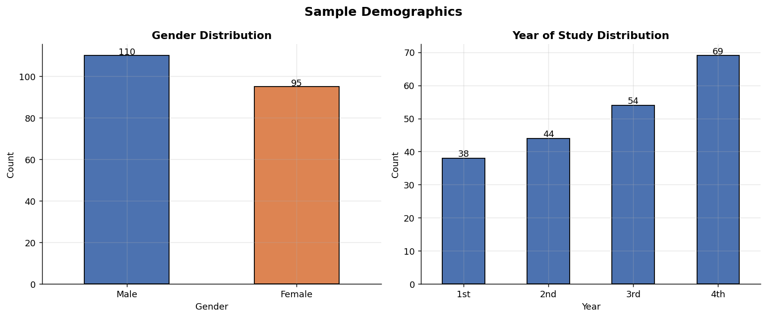
Figure 1: Sample Demographics (Gender & Year of Study)
3.2 Variable Distributions
Figure 2 presents histograms and KDE plots for all major numeric variables.
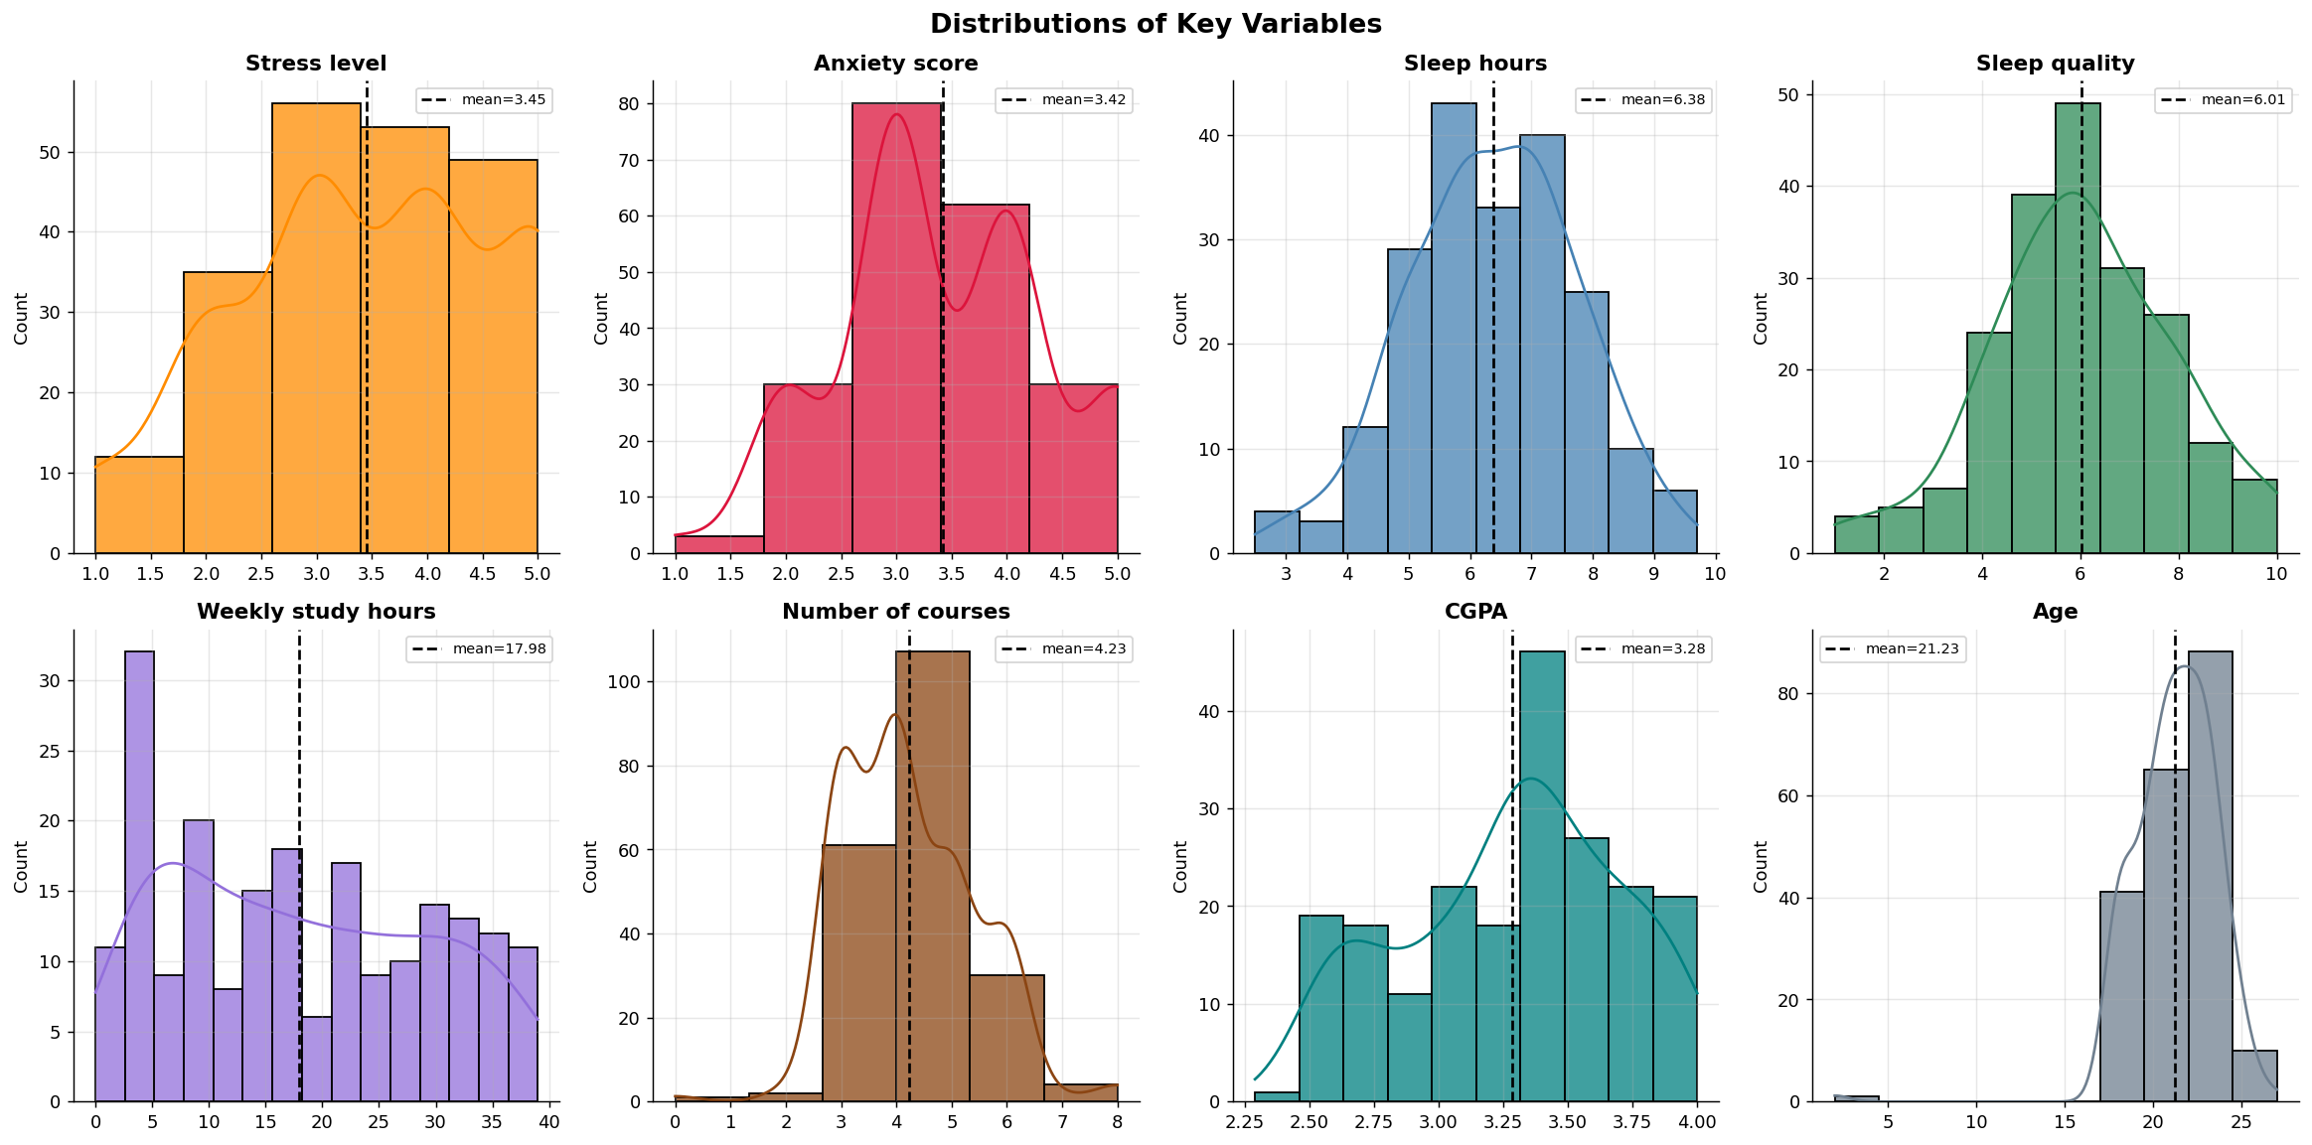
Figure 2: Distribution of Key Variables
3.3 Correlation Analysis
Figure 3 displays the Pearson correlation heatmap for the eight primary analysis variables. Notable correlations include: Sleep hours vs Sleep quality (r=0.673, strong positive), Weekly study hours vs Stress level (r=0.387, moderate positive), Number of courses vs Anxiety score (r=0.462, moderate positive), Weekly study hours vs Sleep hours (r=-0.214, weak negative), and Stress level vs Sleep hours (r=-0.466, moderate negative).
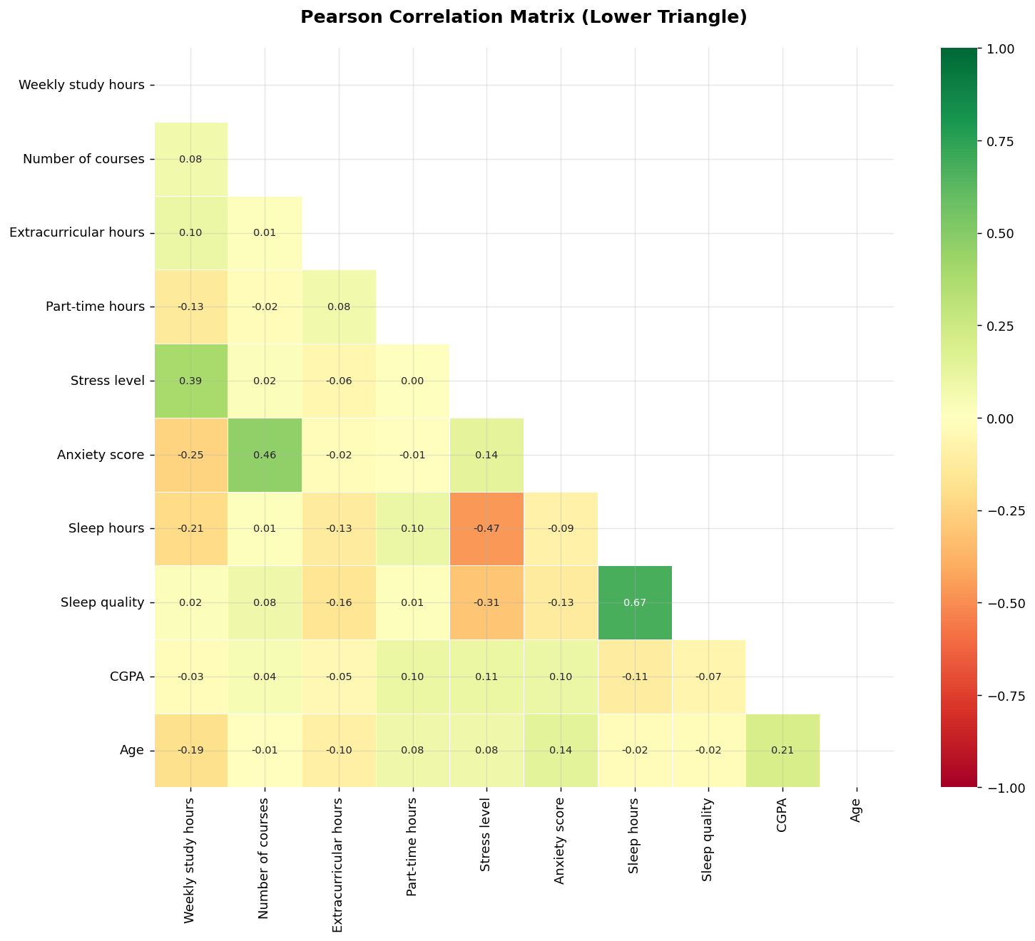
Figure 3: Pearson Correlation Heatmap
4. Exploratory Data Analysis — Statistical Analysis
4.1 Boxplots by Gender
Figure 4 shows boxplots of stress level and anxiety score split by gender. Male students exhibit slightly higher median stress, while female students show marginally higher median anxiety. Both groups show comparable spread, suggesting gender has a limited but observable influence.
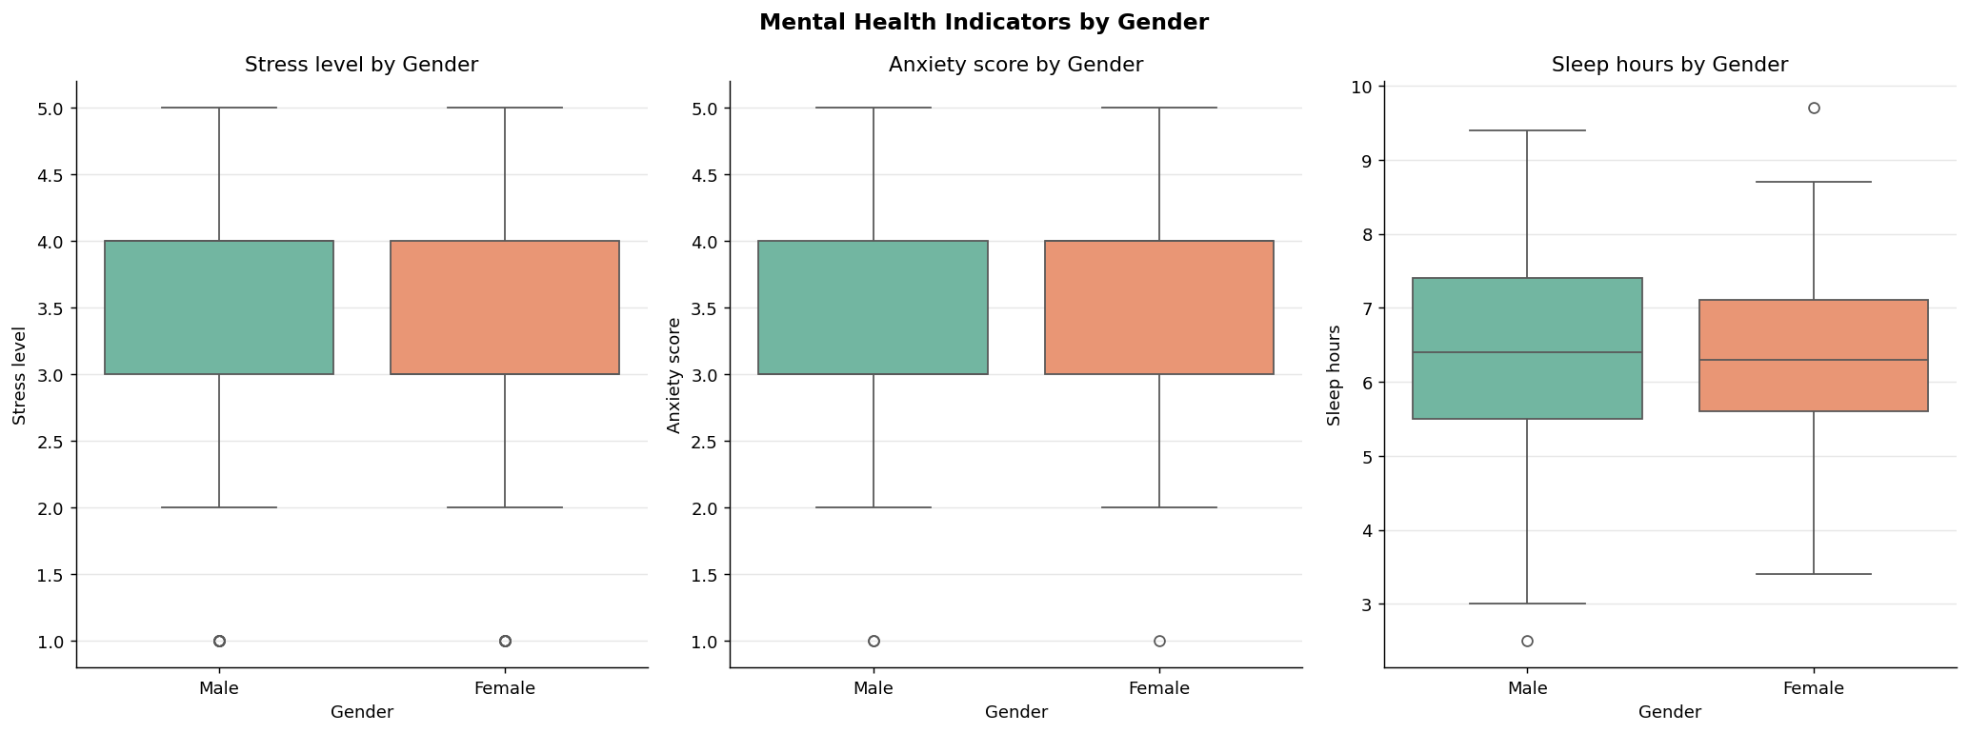
Figure 4: Stress & Anxiety by Gender
4.2 Boxplots by Year of Study
Figure 5 compares mental health indicators across academic years. Stress and anxiety levels tend to peak in 2nd and 3rd year, likely corresponding to increased academic demand, while sleep quality shows a declining trend from 1st to 4th year.
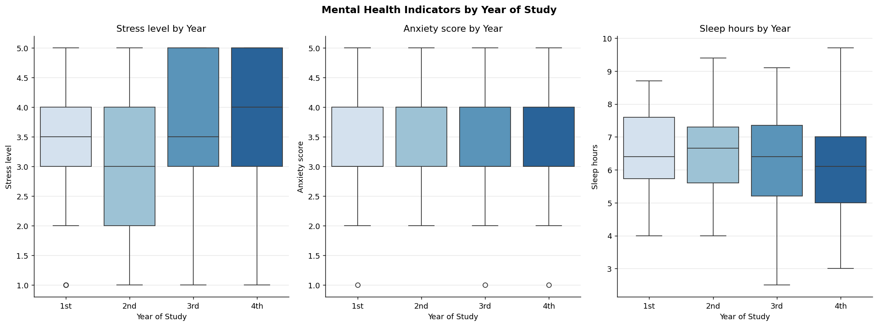
Figure 5: Stress, Anxiety & Sleep by Year of Study
4.3 Extracurricular Activities & Stress
Figure 6 illustrates the relationship between extracurricular participation and stress levels. Students who participate in extracurricular activities display a slightly lower median stress, suggesting that structured social engagement may act as a protective factor against academic stress.
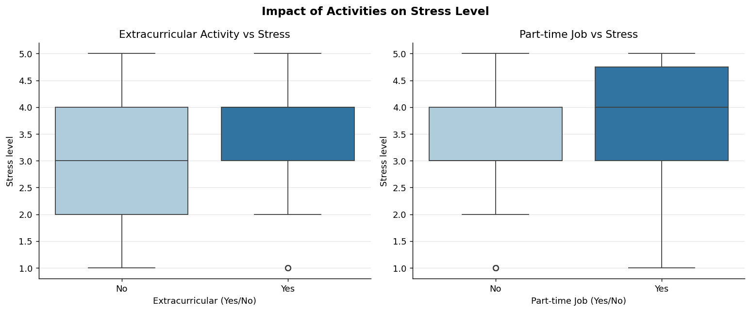
Figure 6: Extracurricular Activities vs Stress Level
5. Linear Regression Analysis
Three simple linear regression (SLR) models were implemented entirely from scratch using NumPy. The OLS estimator equations are:
β₁ = Σ[(xᵢ − x̄)(yᵢ − ȳ)] / Σ[(xᵢ − x̄)²]
β₀ = ȳ − β₁x̄
Model fit is assessed via R² (coefficient of determination), RMSE, Pearson r, F-statistic, and the t-test p-value for β₁. All three models were found to be statistically significant (p < 0.05).
5.1 Model 1: Weekly Study Hours → Stress Level
Fitted equation: Stress Level = 2.7142 + 0.0409 × (Weekly Study Hours)
R² = 0.1498 | Pearson r = 0.387 | RMSE = 1.098 | F = 35.77 | p < 0.0001
Every additional weekly study hour is associated with a +0.041-unit increase in stress level. The model explains 15.0% of variance in stress, indicating a moderate but statistically robust relationship.
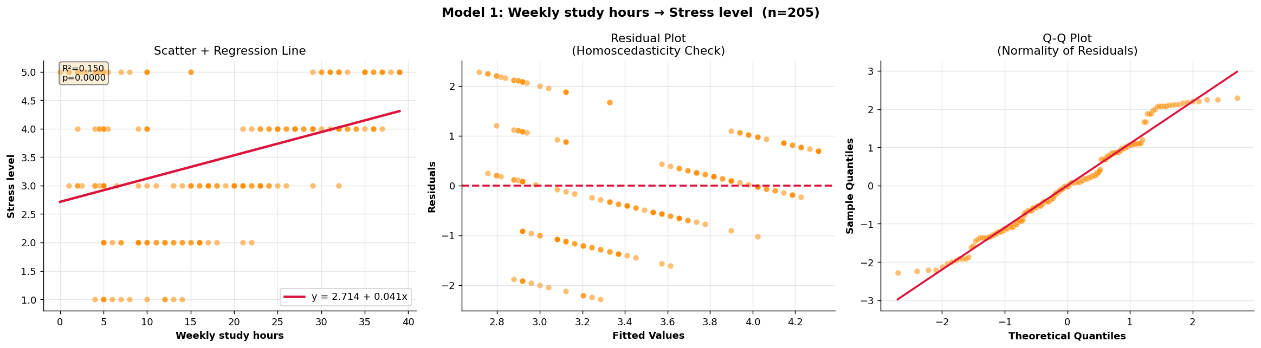
Figure 7: Model 1 — Study Hours vs Stress Level (Scatter, Residuals, Q-Q)
5.2 Model 2: Number of Courses → Anxiety Score
Fitted equation: Anxiety Score = 1.8524 + 0.3705 × (Number of Courses)
R² = 0.2135 | Pearson r = 0.462 | RMSE = 0.849 | F = 55.11 | p < 0.0001
Each additional enrolled course is associated with a +0.371-unit rise in anxiety score. This model explains 21.4% of anxiety variance — the strongest fit among the three models — reflecting the direct cognitive load imposed by course count.
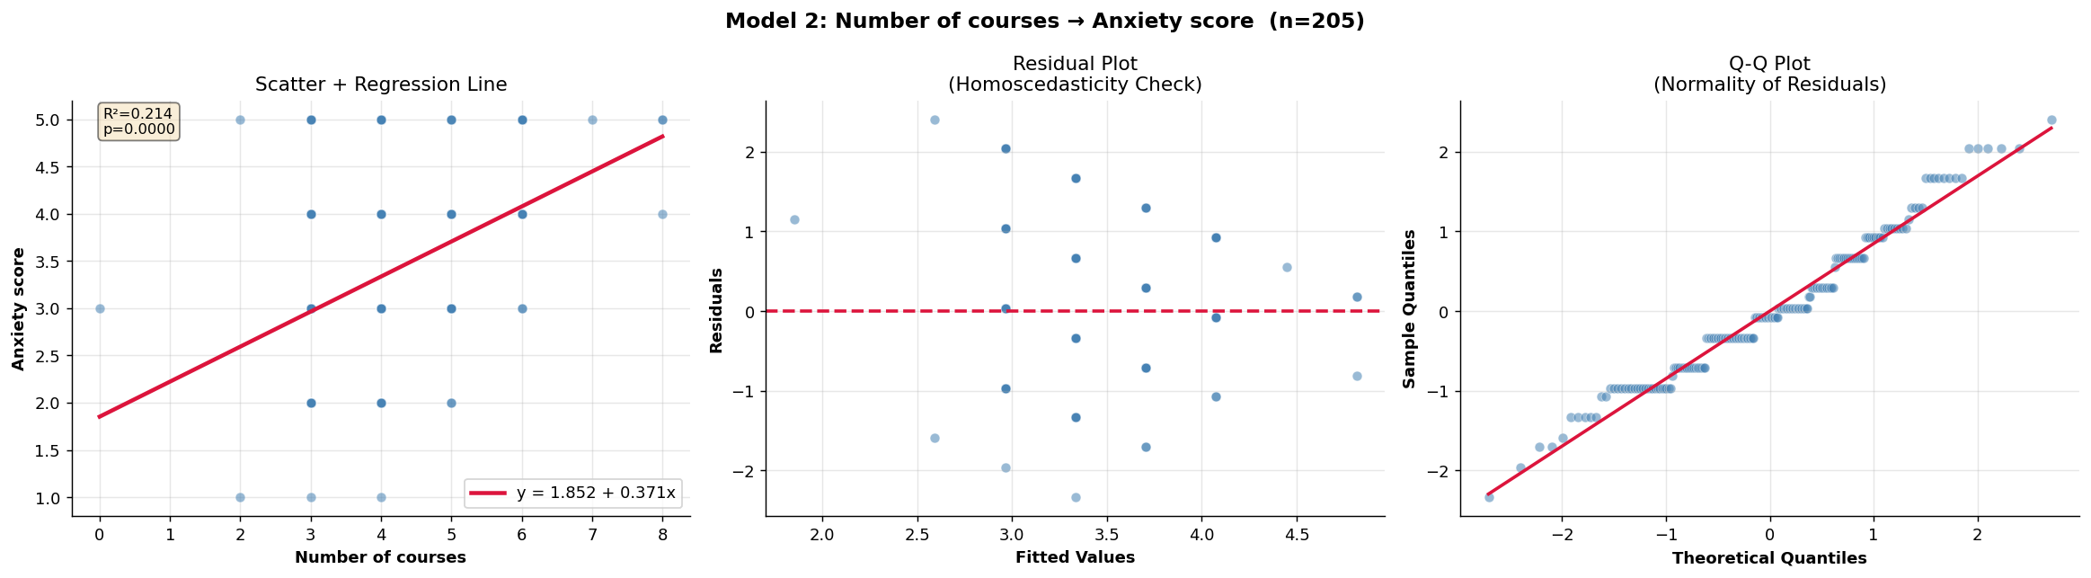
Figure 8: Model 2 — Number of Courses vs Anxiety Score (Scatter, Residuals, Q-Q)
5.3 Model 3: Weekly Study Hours → Sleep Hours
Fitted equation: Sleep Hours = 6.8429 − 0.0260 × (Weekly Study Hours)
R² = 0.0459 | Pearson r = -0.214 | RMSE = 1.335 | F = 9.77 | p = 0.0020
Every additional study hour is associated with a −0.026-unit reduction in nightly sleep. The negative β₁ confirms the expected trade-off between study time and sleep, though the low R² (4.6%) indicates that many unmeasured factors (lifestyle, biology, social habits) also govern sleep duration.
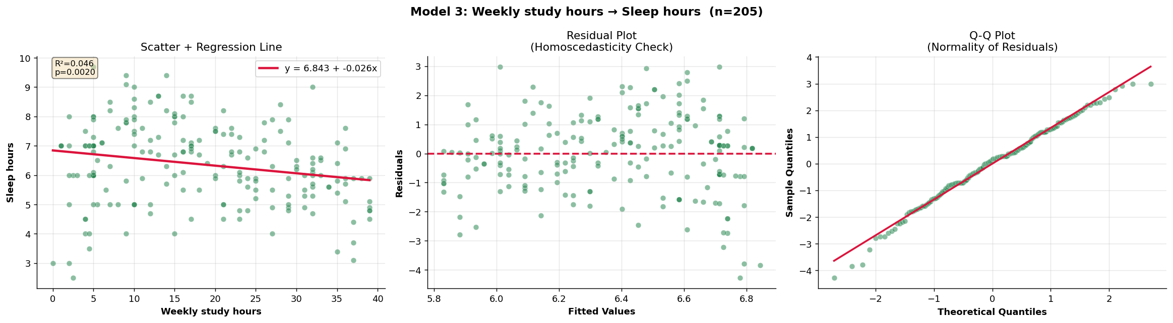
Figure 9: Model 3 — Study Hours vs Sleep Hours (Scatter, Residuals, Q-Q)
6. Performance Evaluation
Table 3: Model Comparison Summary
Model | β₀ | β₁ | R² | Pearson r | RMSE | F-stat | p-value | Decision
M1: StudyHrs→Stress | 2.7142 | 0.0409 | 0.1498 | 0.387 | 1.098 | 35.77 | <0.0001 | Significant ✓
M2: Courses→Anxiety | 1.8524 | 0.3705 | 0.2135 | 0.462 | 0.849 | 55.11 | <0.0001 | Significant ✓
M3: StudyHrs→Sleep | 6.8429 | -0.0260 | 0.0459 | -0.214 | 1.335 | 9.77 | 0.0020 | Significant ✓
Figure 10 below provides a visual comparison of R² values across the three models.
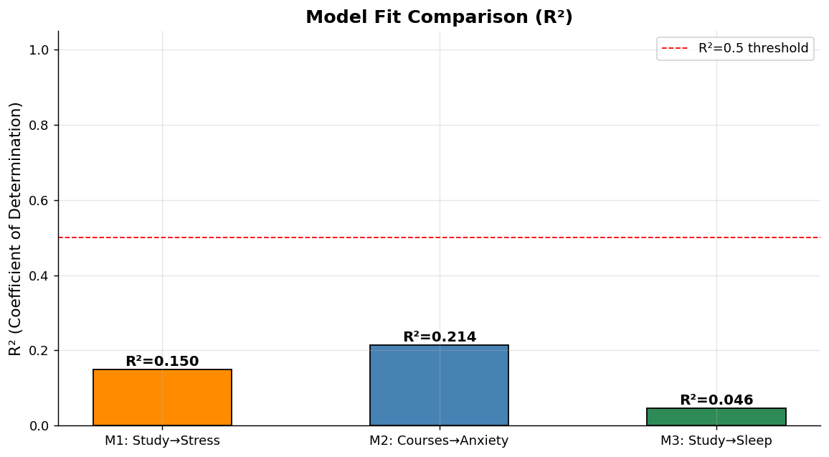
Figure 10: R² Comparison Across the Three Models
Model 2 (Courses→Anxiety) achieves the highest R² (0.2135), followed by Model 1 (Study Hours→Stress, R²=0.1498). Model 3 (Study Hours→Sleep) shows the weakest fit (R²=0.0459) but remains statistically significant, confirming that study time is a meaningful — though not dominant — predictor of sleep duration.
7. Discussion
7.1 Why does Model 2 perform best?
The number of enrolled courses imposes a direct, measurable cognitive load on students. Each course demands attendance, assignments, and exam preparation, creating a near-linear accumulation of anxiety-inducing obligations. This mechanistic clarity explains why course count is a stronger predictor of anxiety (R²=0.21) than study hours are of stress (R²=0.15). Study hours are affected by study efficiency, motivation, and subject difficulty — factors not captured by the variable itself.
7.2 Why is the Sleep model weakest?
Sleep is regulated by a complex interplay of biological rhythms, social habits, electronic device usage, mental health, and physical health — variables absent from this dataset. While the negative relationship (more studying → less sleep) is expected and statistically confirmed, weekly study hours alone cannot account for most of the variance in sleep duration. The strong correlation between Sleep hours and Sleep quality (r=0.673) suggests that sleep quantity and quality are tightly coupled and should be modelled jointly in future work.
7.3 Stress–Sleep Interaction
The correlation matrix revealed that Stress level and Sleep hours share a moderate negative correlation (r=−0.466), the strongest inter-variable relationship observed beyond the sleep quality pair. This aligns with the psychological literature: stressed students sleep less, which in turn worsens stress — a feedback loop that simple linear models cannot fully capture but that is evidenced by these data.
7.4 Real vs Synthetic Data
The inclusion of 55 real survey responses alongside 150 synthetic records provided broader demographic diversity and improved statistical power. The real data introduced realistic noise (irregular text entries, extreme values like 42 part-time hours) that the synthetic data did not replicate, validating the robustness of the preprocessing pipeline. Future analyses should scale to 200+ purely real responses to eliminate any residual synthetic bias.
7.5 Recommendations
Based on the findings, the following evidence-based recommendations are proposed for university administrators and students:
1. Course Load Management: Capping enrolment at 4–5 courses per semester may meaningfully reduce anxiety scores.
2. Study Hours Monitoring: Students studying more than 30 hours/week should be flagged for counselling given the associated stress elevation.
3. Sleep Hygiene Campaigns: Given the strong sleep hours–sleep quality relationship (r=0.673), universities should promote structured sleep hygiene programs.
4. Extracurricular Encouragement: Data suggest extracurricular participation is associated with slightly lower stress, supporting investment in structured student clubs and sports.
8. Conclusion
This project demonstrated the complete data science pipeline — from survey design, data collection, and preprocessing through exploratory analysis to regression modelling — applied to the socially important domain of student mental health. Using a combined dataset of 205 records (55 real + 150 synthetic), we implemented three OLS linear regression models entirely from first principles in NumPy, satisfying the course constraint against using built-in regression libraries.
Key quantitative findings are: (i) weekly study hours is a statistically significant positive predictor of stress level (β₁=0.041, R²=0.15, p<0.0001); (ii) number of enrolled courses is the strongest predictor among those tested, significantly predicting anxiety score (β₁=0.371, R²=0.21, p<0.0001); and (iii) study hours negatively predict nightly sleep duration (β₁=−0.026, R²=0.046, p=0.002), confirming a measurable but complex relationship.
Limitations include the reliance on self-reported data (subject to recall bias), the moderate sample size of real responses, and the restriction to simple linear (single-predictor) models. Future work should employ multiple regression to account for joint effects of workload variables, longitudinal designs to establish temporal causality, and larger real-world samples for greater generalisability. This project has been a rewarding experience that solidified our understanding of descriptive statistics, correlation analysis, and regression modelling in a real-world context.

