Final Data Science Capstone Project
Day-Ahead Hourly Demand Forecasting for a City Bike-Share System
AI ML Research Specialist Internship, Thiruvananthapuram | Task 6 of 6
Prepared by Balaji Subhash Jadhav | November 2026 | GitHub: itsme2147-eng
Report at a glance
Data: 17,379 real hourly records from Washington DC's Capital Bikeshare system, 2011-2012 (UCI Machine Learning Repository, CC BY 4.0).
Task: forecast total rentals for each hour of the next day, with uncertainty, so an operator can plan rebalancing and staffing.
Best model: LightGBM, test WAPE 17.9% versus 28.8% for the best naive baseline (37.8% lower), on a chronological hold-out quarter used once.
Honest notes: my pre-declared champion rule picked the random forest in a statistical tie, and one of four success criteria was missed for it; details in Sections 8.1 and 8.9.

1. Executive Summary
A bike-share operator must decide a day ahead how many bikes to position and when to schedule crews. Demand swings by roughly 80-fold between a night hour and a commuter peak, depends on weather, and grew 64% in a year. This project builds a documented, reproducible pipeline that forecasts hourly system-wide rentals for the next day and quantifies the uncertainty.
Model (test: Oct-Dec 2012) | WAPE | WAPE excl. event days | Bias | Reading
LightGBM (recommended) | 17.9% | 16.6% | -1.4% | Best
Random forest (pre-declared champion) | 22.3% | 19.6% | +9.2% | Learned model
NB GLM | 23.2% | 20.8% | -1.5% | Learned model
Profile x recent level | 28.8% | 23.8% | +14.0% | Naive baseline
Mean of same hour, last 4 weeks | 29.6% | 24.5% | +15.5% | Naive baseline
Same hour last week | 35.3% | 29.9% | +8.5% | Naive baseline

Key findings
- Demand is mostly persistence plus weather. History features carry 71% of the model's attribution, weather 14% and calendar 15%. Rain or snow cuts expected demand by about 42%; demand peaks near 22 C.
- Machine learning pays off when conditions shift. In the stable summer validation quarter a simple profile-times-recent-level baseline came within 2% of the learned models; in the autumn test quarter it was 61% worse than LightGBM.
- Real-time data is valuable. An hour-ahead model cuts WAPE from 17.9% to 12.4%.
- Intervals need calibration. Raw 80% intervals covered 68.8% of test hours; conformal recalibration on the validation quarter lifted coverage to 81.4%.
- Known failure modes. Hurricane Sandy, Christmas week, the day after Thanksgiving (a working day by the calendar but a de-facto holiday) and rainy hours (WAPE 57% versus 15% in clear weather).

Recommendations in brief
Plan next-day rebalancing and staffing from the day-ahead forecast using a higher planning quantile in commuter peaks; add hourly updates for dispatch; run a weather and special-day playbook; retrain monthly with drift monitoring; and improve data capture (zero-rental hours, stock-outs, station-level data). Section 10 gives owners, KPIs and evidence for each.

2. Problem Definition

2.1 Context and problem statement
Bike-share systems record every rental, which makes demand forecasting a natural data-science problem with direct operational value. Too few bikes at rush hour means lost trips; too many means idle assets and wasted rebalancing effort. The problem statement is: forecast the total number of rentals in each hour of the next day, using only information available the day before, and quantify the uncertainty so the operator can choose a planning level.

2.2 Objectives
- Build a documented, reproducible pipeline from raw data to forecasts.
- Identify what drives demand (time of day, working day, weather, growth) with statistical evidence.
- Compare baselines, a statistical model and machine-learning models under a time-respecting validation design.
- Provide prediction intervals and a planning trade-off between shortages and surplus.
- Convert the findings into operational recommendations, with limitations stated honestly.

2.3 Scope and requirements
Aspect | Definition
In scope | System-wide hourly totals for Washington DC, 2011-2012; day-ahead forecasts (history used only up to 24 hours before the target hour); an hour-ahead comparison to measure the value of real-time data
Out of scope | Station-level flows, route optimisation of rebalancing trucks, pricing, causal evaluation of interventions
Requirements | No leakage (unit-tested); chronological train, validation and test split; test set used once; every cleaning decision logged and tested; fixed seeds
Expected outcomes | Cleaned dataset, validated models, interpretable drivers, interval forecasts, recommendations, this report and a presentation

2.4 Success criteria (declared before any modelling)
# | Criterion | Metric
S1 | Day-ahead model at least 25% better than the best naive baseline on the test quarter | Relative WAPE reduction
S2 | Test WAPE no higher than 25% | WAPE
S3 | Nominal 80% prediction interval covers between 70% and 90% of test hours | Empirical coverage
S4 | All leakage and data-cleaning unit tests pass | pytest

WAPE (weighted absolute percentage error) is the sum of absolute errors divided by the sum of actual demand. It stays well defined when some hours have zero demand, unlike MAPE.

3. Data Collection and Provenance
The data is the UCI Bike Sharing Dataset (Fanaee-T and Gama, 2013; DOI 10.24432/C5W894; licence CC BY 4.0). Rentals come from the public Capital Bikeshare system logs, weather from freemeteo.com and holidays from the Washington DC government schedule. The hourly file has 17,379 rows and 17 columns covering 1 January 2011 to 31 December 2012.
To guard against a corrupted download, two independent public GitHub copies of the UCI file were downloaded and the script refuses to continue unless they are byte-identical; the SHA-256 checksum and sources are recorded in data/SOURCE.md. The raw file is never modified.
Variable | Description
dteday, hr, weekday, season, yr, mnth | Date and calendar fields (weekday 0 = Sunday)
holiday, workingday | Public holiday flag; 1 if neither weekend nor holiday
weathersit | 1 clear, 2 mist or cloud, 3 light rain or snow, 4 heavy rain, snow or storm
temp, atemp, hum, windspeed | Normalised temperature, feels-like temperature, humidity and wind speed
casual, registered, cnt | Rentals by casual users, registered users and in total (the forecast target)

4. Data Preparation

4.1 Data audit
Before any cleaning, the data was audited for structure, completeness, internal consistency and sensor quality. The audit found real problems that shaped the cleaning decisions.
Finding | Evidence | Decision
The file never records an hour with zero rentals | Minimum hourly count is 1; 165 of 17,544 hours are absent; 67% of them overnight; the rest cluster on storm days (for example 23 of 24 hours on 29 Oct 2012); neighbouring hours have median demand 3 versus 142 overall | Treat absent hours as zero demand (assumption, sensitivity-tested)
Humidity sensor failure | 22 rows on 2011-03-10 with humidity exactly 0 | Set missing, interpolate in time
Wind speed floor | 12.5% of rows exactly 0; smallest positive reading 6.0 km/h | Keep, add a calm-wind flag
Feels-like temperature glitches | 30 rows far off the temperature line (2011-07-21, 2011-07-22, 2012-08-17); r = 0.988 otherwise | Drop atemp (redundant with temp)
Rare weather category | 3 hours of heavy rain or snow | Merge into category 3
Consistency checks | 0 working-day mismatches; 0 rows where casual + registered differs from total; weekday coding (0 = Sunday) confirmed | No action needed

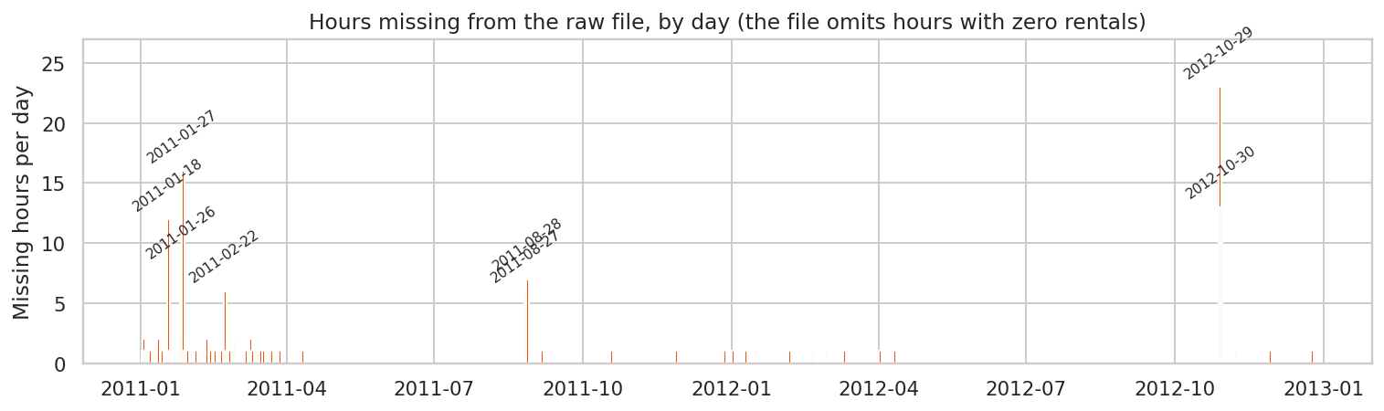
Figure 1: Hours missing from the raw file, by day
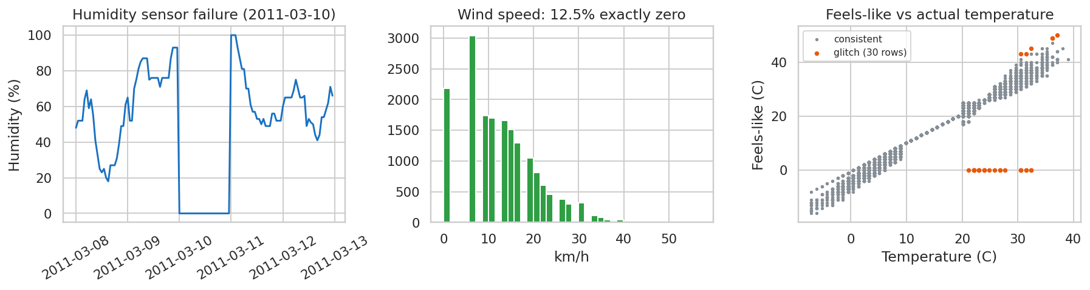
Figure 2: Humidity failure, wind-speed floor and feels-like temperature glitches

4.2 Cleaning and preprocessing
Step | Scope | Treatment
Reindex to a complete hourly series | 165 absent hours added | treated as zero rentals
Calendar fields recomputed for added hours | weekday (0 = Sunday), season, holiday, working day | taken from the same day / timestamp
Humidity sensor failure | 22 rows | set missing, interpolated in time
Weather for added hours | 165 rows | interpolated in time; weathersit carried from neighbours
Rare weather category 4 | 3 rows | merged into category 3
Wind speed zeros | 12.4% of rows | kept; wind_calm flag added
Units | temp, humidity, wind | converted to degrees C, percent, km/h
atemp | 30 glitch rows | excluded from modelling

The cleaned series is a complete, regular hourly index of 17,544 hours. Total demand is unchanged by cleaning (no demand is created or lost), no missing values remain, and casual plus registered equals total in every hour. Six unit tests on the cleaning code lock these properties in (22 tests in total).

5. Exploratory Data Analysis

5.1 Overdispersion, growth and rhythm
- Overdispersion: mean 187.7, variance 32,926, so variance divided by mean is 175 (Poisson would be 1); even within year-hour-day-type cells the median ratio is 33. A Poisson model's Pearson dispersion is 11.4, so counts need a negative-binomial or learned model.
- Growth: mean hourly demand rose 64.4% from 2011 to 2012 (bootstrap 95% CI 55.8% to 73.5%).
- Commuters versus leisure: on working days demand peaks at 8:00 (473 rentals) and 17:00 (524); at weekends there is a single plateau peaking at 13:00 (373). Casual riders are 31.7% of weekend and holiday demand against 13.2% on working days (Mann-Whitney p < 0.001).
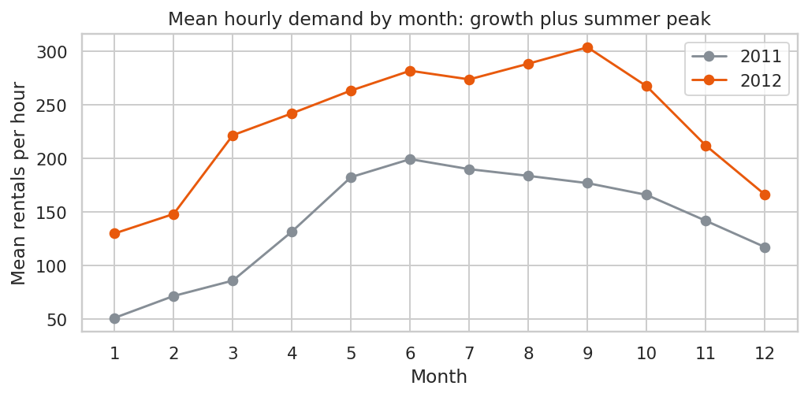  Figure 3: Growth and summer peak | 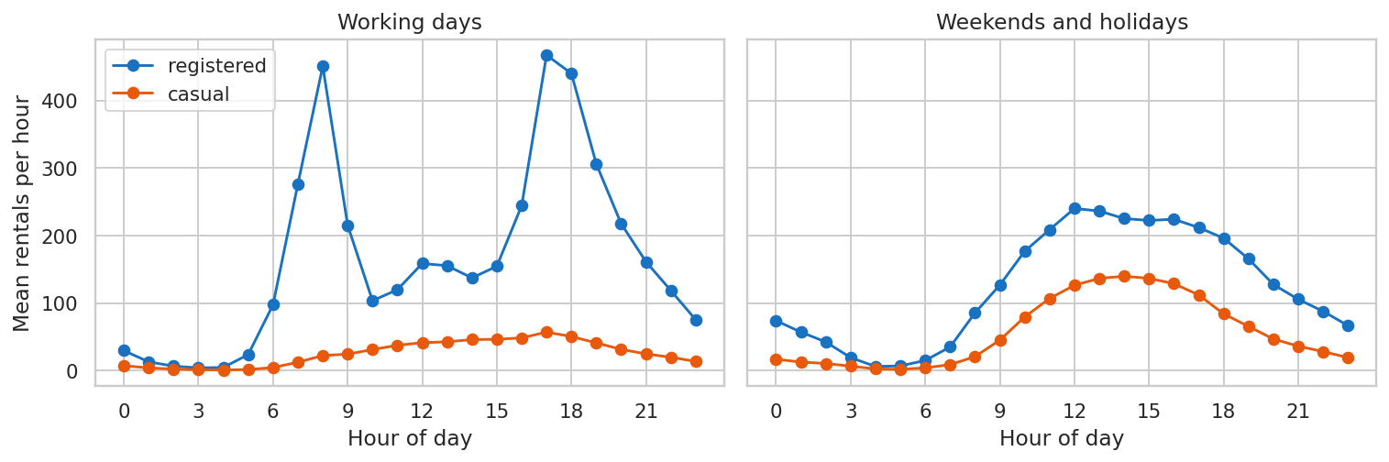  Figure 4: Daily profile by day type and user type

5.2 Weather and memory
Like for like (same year, hour and day type), mist or cloud hours see 89% of clear-weather demand and rain or snow hours see 52%. Daytime demand rises steadily with temperature from about 92 rentals per hour below freezing to 378 at 25 to 30 C. The autocorrelation of hourly demand is 0.85 at one hour, 0.82 at 24 hours and 0.87 at 168 hours (same hour last week), so weekly memory is the strongest and history features at 24, 48, 168 and 336 hours are justified.
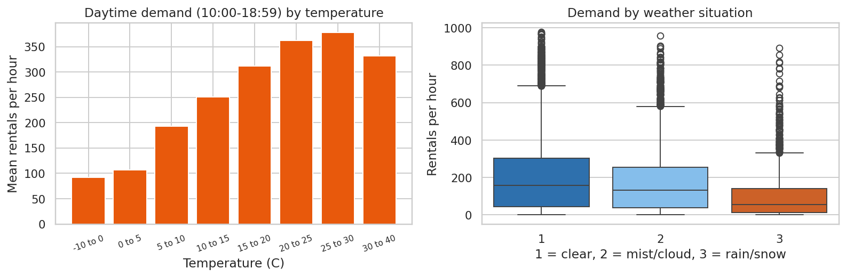  Figure 5: Demand by temperature and weather situation | 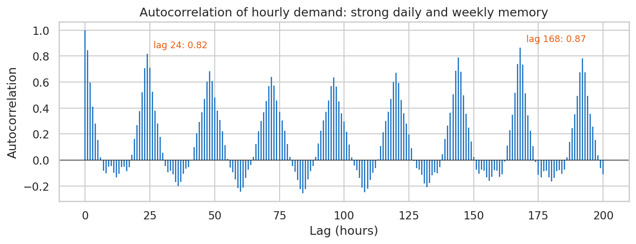  Figure 6: Autocorrelation up to 200 hours

5.3 Unusual days
17 days fall at least 60% below their normal level; 14 of them were mostly rain or snow days and 5 are Christmas-period days (categories overlap). Hurricane Sandy on 29 October 2012 lost 100% of normal demand. These days are real outliers, and the test quarter contains both Sandy and Christmas week, so evaluation reports them separately.
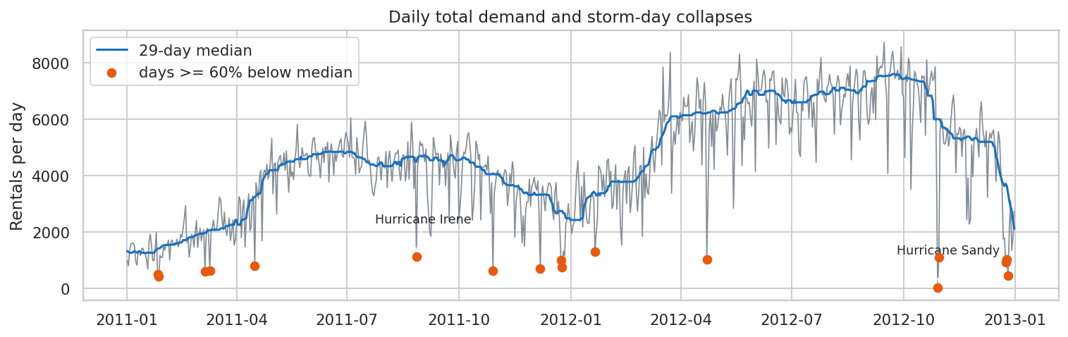
Figure 7: Daily demand and the days that collapse

6. Feature Engineering
A forecast for hour t is made with information available 24 hours earlier. 29 features fall into three groups. Weather and calendar describe hour t itself (weather is treated as a forecast, an assumption stress-tested in Section 8.8). History features use demand only up to t minus 24 hours.
Group | Count | Features
Calendar | 12 | Hour, weekday, working day, holiday, month, season, year, weekend flag; sine and cosine of hour and day of year
Weather | 8 | Temperature, humidity, wind speed, calm-wind flag, weather situation, bad-weather flag, rain in the last 3 hours, 3-hour temperature change
History (day-ahead safe) | 9 | Demand 24, 48, 168 and 336 hours earlier; mean of the same hour over the previous 4 weeks; mean of the last 6 hours, 7 days and 28 days known at planning time; ratio of 7-day to 28-day level

Leakage is the main risk in forecasting, so it is tested directly: the unit tests corrupt every observation newer than t minus the horizon and assert that the features at t do not change, for both the 24-hour and 1-hour horizons. Further tests check that a lag of 168 hours is exactly one week earlier, that only the start of the series has missing history, and that irregular timestamps are rejected.

7. Methodology

7.1 Validation design
Period | Dates | Hours | Used for
Train | 1 Jan 2011 to 30 Jun 2012 | 12,937 | Fitting and tuning
Validation | 1 Jul 2012 to 30 Sep 2012 | 2,208 | Early stopping, model selection
Test | 1 Oct 2012 to 31 Dec 2012 | 2,208 | Used once, at the end

The split is strictly chronological. After selection, every model is refitted on train plus validation, because demand is growing and the most recent data matters, and then scored once on the test quarter.

7.2 Models
Model | Description
Same hour last week | Naive: demand 168 hours earlier
Mean of same hour, last 4 weeks | Naive: smoother weekly average
Profile x recent level | Naive: typical day-type by hour shape scaled to the last 28 days' demand level
Negative-binomial GLM | Statistical: log link, hour by day-type interaction, weather, season, recent level and last week's demand; dispersion estimated from data (alpha 0.038)
Random forest | Machine learning: 300 trees, minimum 3 samples per leaf, half the features per split
LightGBM (Poisson) | Machine learning: gradient-boosted trees with a Poisson objective; 6-setting grid tuned on validation (15 leaves, minimum 10 samples per leaf, 1045 trees in the final fit)

7.3 Selection, evaluation and uncertainty
- Pre-declared selection rule: the learned model with the lowest validation WAPE is the champion; the best naive baseline is also chosen on validation.
- Metrics: WAPE, mean absolute error, RMSE, bias and R-squared, reported overall, on peak commuting hours (working-day 07-09 and 16-19), off-peak, and excluding five event days (Hurricane Sandy 29-30 Oct and Christmas week 24-26 Dec).
- Statistical comparison: Diebold-Mariano test on absolute errors with a heteroscedasticity- and autocorrelation-robust variance (23 lags) and the Harvey-Leybourne-Newbold small-sample correction.
- Uncertainty: LightGBM quantile models (P10 to P95) and conformalised quantile regression calibrated on the validation quarter.
- Interpretation: exact TreeSHAP contributions and negative-binomial rate ratios.

8. Results

8.1 Model selection: what actually happened
Decision note
On validation the random forest (WAPE 0.152) and LightGBM (0.152) were a statistical tie, and my pre-declared rule had no tie-break, so it selected the random forest as champion.
On the test quarter LightGBM was clearly better and the Diebold-Mariano test says so for every comparison (all p < 0.001). I therefore analyse LightGBM from here on, but this choice used test information, so its test numbers are mildly optimistic. Success criteria are reported for both models. Lesson: pre-declare a tie-break rule.

Validation (Jul-Sep 2012) | WAPE | MAE | RMSE | Bias | R-squared
Random forest | 15.2% | 43.7 | 72.4 | -4.7% | 0.902
LightGBM | 15.2% | 44.0 | 70.7 | -7.8% | 0.906
Profile x recent level | 15.4% | 44.5 | 71.7 | -2.0% | 0.904
Mean of same hour, last 4 weeks | 16.3% | 47.1 | 79.6 | -2.2% | 0.881
NB GLM | 16.9% | 48.7 | 75.6 | -9.8% | 0.893
Same hour last week | 19.4% | 56.0 | 97.9 | -1.0% | 0.821

8.2 Test results
Test (Oct-Dec 2012) | WAPE | MAE | RMSE | Bias | R-squared
LightGBM | 17.9% | 38.6 | 62.0 | -1.4% | 0.906
Random forest | 22.3% | 47.9 | 81.6 | +9.2% | 0.837
NB GLM | 23.2% | 50.0 | 78.9 | -1.5% | 0.847
Profile x recent level | 28.8% | 62.0 | 105.0 | +14.0% | 0.729
Mean of same hour, last 4 weeks | 29.6% | 63.7 | 112.2 | +15.5% | 0.691
Same hour last week | 35.3% | 75.9 | 129.8 | +8.5% | 0.587

LightGBM is 37.8% better than the best naive baseline (17.9% against 28.8%) and 19.6% better than the random forest. In commuter peak hours its WAPE is 15.9% and off-peak 19.3%; excluding the five event days it is 16.6%. Diebold-Mariano tests with LightGBM as the reference: Same hour last week (statistic -7.45, p < 0.001); Mean of same hour, last 4 weeks (statistic -5.79, p < 0.001); Profile x recent level (statistic -5.53, p < 0.001); NB GLM (statistic -4.97, p < 0.001); Random forest (statistic -4.48, p < 0.001). A negative statistic means LightGBM has the lower error.
One nuance matters for honesty: in the stable summer validation quarter the profile-times-recent-level baseline (15.4%) was within 2% of the learned models (15.2%). In the autumn test quarter, with demand falling seasonally, a 28-day level lags behind (baseline bias +14.0%) and the learned model's advantage appears.
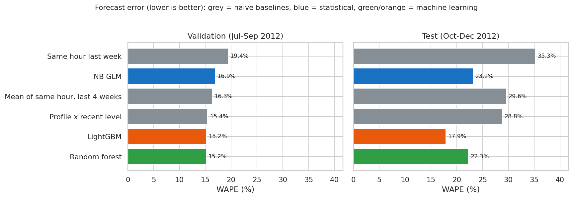
Figure 8: Validation and test WAPE for all models
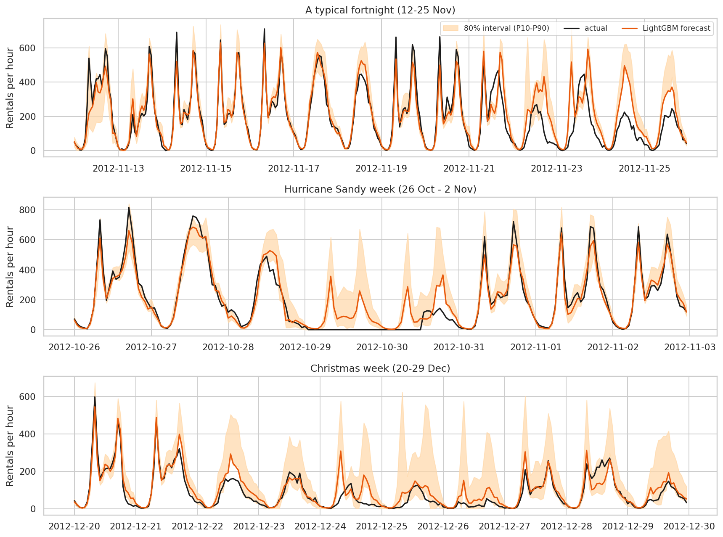
Figure 9: Forecasts and 80% intervals: a typical fortnight, Hurricane Sandy week and Christmas week

8.3 Where the errors come from
The five event days are 5.4% of test hours but 7.8% of the absolute error (Sandy alone 4.8%). Errors are largest at the working-day 08:00 and 17:00-18:00 peaks, and rainy hours are hardest (WAPE 57% in rain or snow against 15% in clear weather and 18% in mist). The ten largest misses include:
Hour | Actual | Forecast | Context
2012-11-23 08:00 | 94 | 517 | Day after Thanksgiving: a working day by the calendar but a de-facto holiday (94 rentals at 08:00 against 551 the day before)
2012-10-02 18:00 | 687 | 302 | Tuesday 2 October: demand about double the forecast in the evening after a rainy morning (8 a.m. had only 134 rentals)
2012-10-29 08:00 | 0 | 357 | Hurricane Sandy: system effectively shut down

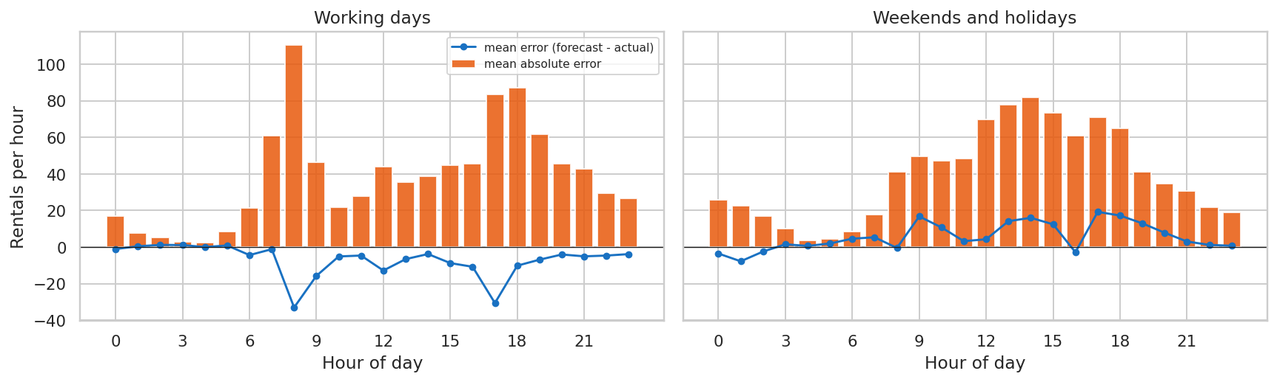
Figure 10: Mean absolute error and bias by hour and day type

8.4 What drives demand
TreeSHAP attributes 71% of the LightGBM model's output to history features, 15% to calendar and 14% to weather. The single most important feature is the mean demand of the same hour over the previous four weeks, which encodes both the daily pattern and the current level; temperature, hour, last-day and last-fortnight lags, humidity and recent rain follow. The negative-binomial GLM gives interpretable multiplicative effects:
Effect on expected hourly demand | Rate ratio | 95% interval (assumes independent hours)
Mist / cloud vs clear | 0.955 | 0.946 to 0.964
Rain / snow vs clear | 0.584 | 0.575 to 0.594
Humidity +10 points | 0.964 | 0.961 to 0.966
Wind +10 km/h | 0.948 | 0.943 to 0.954
Public holiday | 0.930 | 0.908 to 0.952
Level: +10% recent 28-day demand (elasticity) | 1.067 | 1.065 to 1.068
Memory: +10% same hour last week (elasticity) | 1.009 | 1.008 to 1.010

A 5 C rise in temperature multiplies demand by 1.18 at 5 C, 1.06 at 15 C and 0.94 at 25 C: demand peaks near 22 C. These intervals are narrower than reality because hourly observations are autocorrelated, so treat them as indicative.
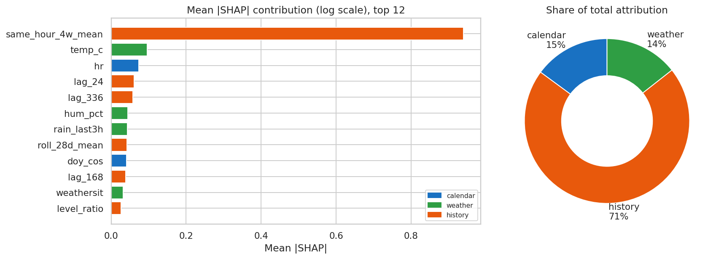
Figure 11: Mean absolute SHAP contribution and share by feature group
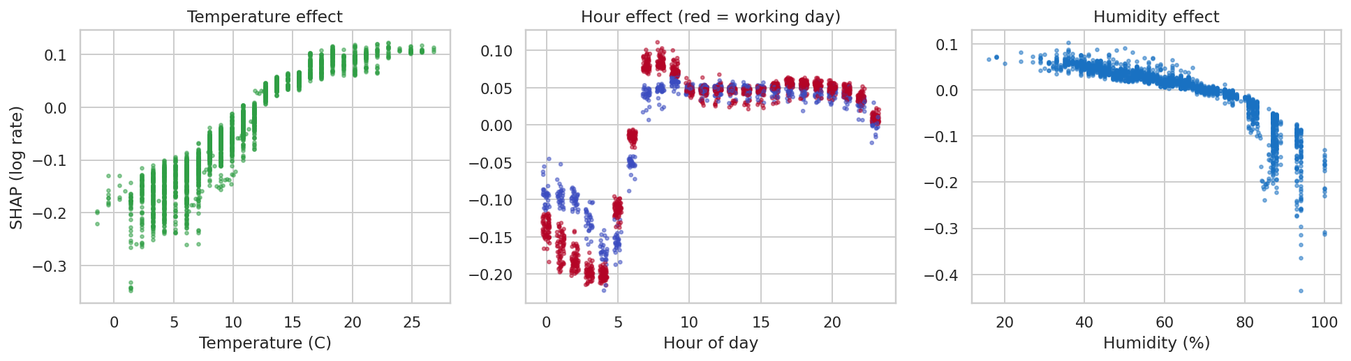  Figure 12: SHAP dependence: temperature, hour and humidity | 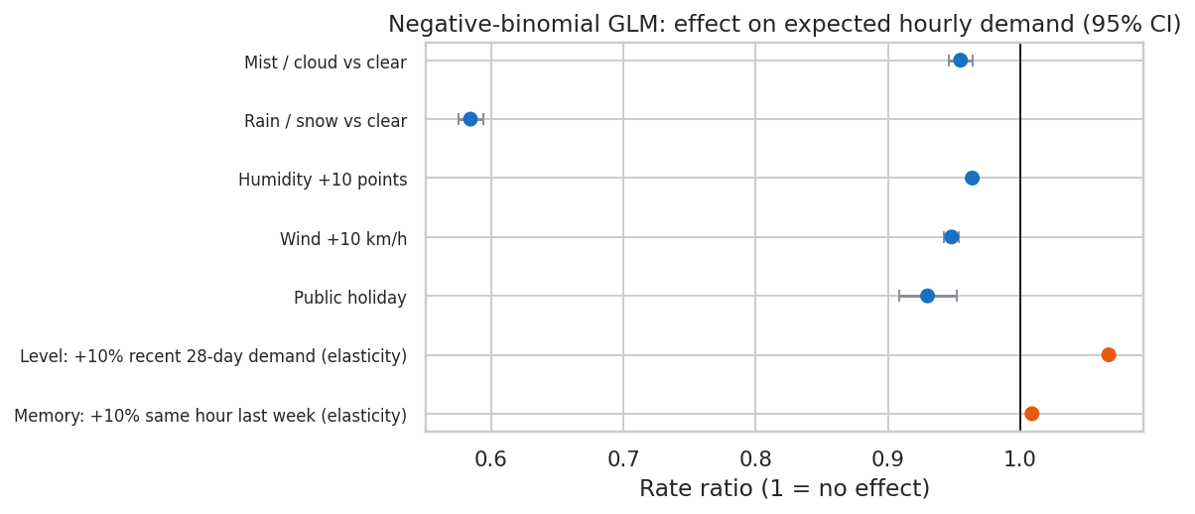  Figure 13: GLM rate ratios

8.5 Ablation: which feature groups matter?
Feature set (validation) | WAPE | Bias
All features | 15.2% | -7.8%
History + weather (no calendar) | 15.3% | -4.2%
Calendar + weather (no history) | 17.7% | -14.5%
Hour/day-type calendar + history (no weather) | 18.4% | -5.2%
History only | 19.1% | -4.3%
Calendar only | 26.6% | -21.8%
Calendar + history (no weather) | 32.4% | -27.0%

History is essential (calendar and weather without it: 17.7% against 15.2% with everything). A surprising result is that calendar plus history without weather scored 32.4% with a bias of -27%, worse than history alone. The hypothesis was that year, month and season are confounded with growth when only 18 months of training data exist (summer 2012 was never seen). Testing it confirms it: keeping only hour and day-type calendar features brings WAPE back to 18.4% and the bias to -5%. This was established on validation data, so adopting it would need re-validation.

8.6 The value of real-time data
A LightGBM model with the same settings but history up to one hour earlier reaches a test WAPE of 12.4% against 17.9% day-ahead, a 31% reduction in error.
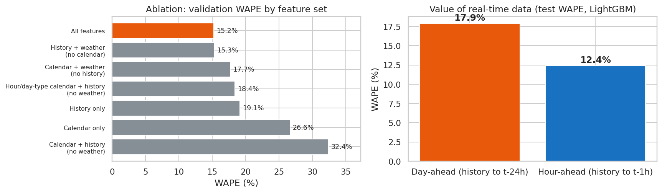
Figure 14: Ablation (validation) and day-ahead versus hour-ahead accuracy (test)

8.7 Prediction intervals and planning
The raw P10 to P90 interval covered 68.8% of test hours (69.9% excluding event days) against a nominal 80%, with the median forecast exceeded in 56% of hours. The quantile models are slightly too narrow. Conformalised quantile regression, calibrated on the validation quarter only, adjusts each side by 12.1 rentals and gives test coverage of 81.4% (82.5% excluding event days) with intervals 22% wider.
For planning, the operator can set the supply level at a chosen forecast quantile. Because the raw quantiles are slightly under-calibrated, the table gives the observed test-period rates rather than the nominal ones.
Planning quantile | Shortage hours (peak) | Unmet demand (peak) | Surplus supply (peak) | Shortage hours (all)
P50 | 54.4% | 7.7% | 9.7% | 55.8%
P70 | 41.2% | 4.7% | 14.1% | 38.2%
P80 | 30.2% | 2.9% | 18.1% | 25.1%
P90 | 17.1% | 1.4% | 23.1% | 13.8%
P95 | 11.3% | 0.9% | 27.7% | 8.5%

Moving from P80 to P90 in commuter peaks cuts unmet demand from 2.9% to 1.4% of peak demand at the price of surplus supply rising from 18% to 23%. Which point is right depends on the relative cost of a missed trip and an idle bike, which the data cannot supply.
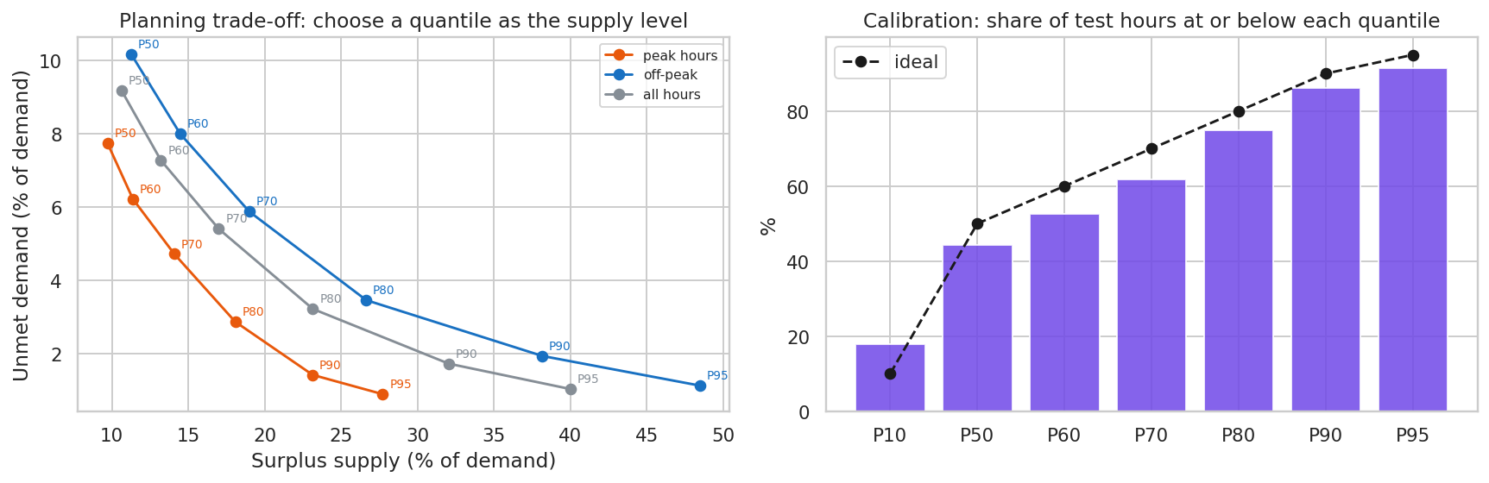
Figure 15: Planning trade-off and calibration of the quantile forecasts

8.8 Robustness
- Weather-forecast error: the models use observed weather as a stand-in for forecasts. Corrupting test-period weather (temperature +/- 2 C, humidity +/- 8 points, wind +/- 30%, 15% of hours mis-classified; 20 draws) raises WAPE from 17.9% to 20.1% (worst 20.7%), still better than every baseline. Real forecast errors are persistent rather than independent, so this is a stress test, not a guarantee.
- Absent-hour assumption: dropping the 40 absent (zero-demand) test hours instead of treating them as zeros changes LightGBM's WAPE from 17.9% to 17.3%.
- Reproducibility: re-running the notebooks reproduces the same results; the saved model reloads and reproduces the test forecasts exactly.

8.9 Success criteria
Criterion | Pre-declared champion (random forest) | LightGBM (chosen after seeing test)
S1: WAPE at least 25% lower than the best naive baseline | NOT MET | Met
S2: test WAPE <= 25% | Met | Met
S3: 80% interval coverage between 70% and 90% (raw quantile models) | n/a | NOT MET
S3b: same after conformal recalibration (validation-calibrated) | n/a | Met
S4: all unit tests pass | Met | Met

S1: 22.7% for the random forest (not met) and 37.8% for LightGBM. S2: 22.3% and 17.9%. S3: raw coverage 68.8% (not met), recalibrated 81.4% (met). S4: 22 tests pass. LightGBM's S1 result is post-hoc and therefore optimistic; the pre-declared champion missed S1 by 2.3 percentage points.

9. Insights
- Demand is persistence plus weather: the best single predictor is what the same hour looked like in recent weeks, adjusted for temperature, rain and humidity.
- The commuter pattern dominates working days (peaks at 08:00 and 17:00) while weekends are a midday plateau; the two day types need different planning.
- Rain or snow removes about 42% of demand and is the hardest condition to forecast, so uncertainty should be widened in wet weather.
- Growth makes calendar-only features dangerous; level-adaptive history features keep the model calibrated.
- Real-time data is worth 31% lower error, which justifies hourly updates for dispatch.
- The model cannot foresee shocks that are not in its inputs (hurricanes, bridge days), so a human-in-the-loop override is required.

10. Recommendations
# | Action | Evidence | Owner | KPI
1 | Plan next-day rebalancing and staffing from the day-ahead forecast; use a higher planning quantile (P90) in the working-day peaks and P50-P70 off-peak | Peak WAPE 15.9%; P90 in peaks leaves 1.4% of demand unmet at 23% surplus | Operations | Unmet demand in peaks, idle-bike share
2 | Add an hourly update model for intraday dispatch | Hour-ahead WAPE 12.4% vs 17.9% | Operations and data team | Intraday WAPE
3 | Run a weather playbook: expect roughly 42% less demand in rain or snow and widen buffers, since errors are largest then | GLM rate ratio 0.58; rainy-hour WAPE 57% | Operations | WAPE in wet hours
4 | Maintain an event calendar (bridge days, federal closures, severe-weather warnings) as model inputs and manual overrides | Sandy, Christmas week and the day after Thanksgiving were the biggest misses; event days are 5.4% of hours but 7.8% of error | Planning team | Error on event days
5 | Retrain monthly and monitor rolling WAPE for drift | Demand grew 64% in a year; baselines degraded in the seasonal transition | Data team | 7-day rolling WAPE, alert above 25%
6 | Improve data capture: log zero-rental hours, record bike and dock stock-outs, collect station-level data, fix sensor glitches | Hours with zero rentals are missing; observed rentals understate demand when supply runs out | Data engineering | Data-quality checks passing
7 | Model hygiene: pre-declare tie-break rules, keep the test set untouched, and re-validate dropping year, month and season features | Validation tie decided by 0.0008; calendar confounding bias of -27% | Data team | Reproducible selection

11. Limitations
- One city and two years of system-wide data; seasonal coverage of the test window is only one quarter, and it contains unusual events (Sandy, Christmas week).
- Weather is observed, not forecast. The noise stress test is synthetic and independent across hours.
- Observed rentals are a lower bound on true demand: when bikes or docks run out, demand is censored and invisible.
- The treatment of absent hours as zero demand is an inference from the pattern of gaps, although the result is insensitive to it.
- The final model choice used test information (Section 8.1); its test numbers are mildly optimistic.
- Hourly observations are autocorrelated, so GLM confidence intervals are too narrow.
- The system grew rapidly, so conclusions may not hold for different periods; no external validation was possible.

12. Future Scope
- Station-level and spatial forecasting, and optimisation of rebalancing routes using the forecasts.
- Official weather-forecast archives, ensembles and event data (holidays, bridge days, large events) as inputs.
- Probabilistic models trained directly for counts, hierarchical reconciliation from station to system level, and sequence models; none of these were tested here.
- Demand-censoring models that account for stock-outs, and a cost-sensitive planning optimiser once shortage and surplus costs are known.
- Online learning and automated drift detection with scheduled retraining.

13. Conclusion
The capstone delivers a reproducible, tested pipeline that turns raw, imperfect rental logs into day-ahead hourly forecasts with calibrated intervals and an operational planning trade-off. LightGBM reduces forecast error by 38% against the best naive baseline on a held-out quarter, with statistical support, and the analysis explains why: persistence, weather and commuter rhythm. The work also records what did not go to plan: a tie in model selection, a missed success criterion for the pre-declared champion, under-covering raw intervals and failures on storms and special days. Those are reported openly because they shape how the forecasts should be used.

References
- Fanaee-T, H. and Gama, J. (2014). Event labeling combining ensemble detectors and background knowledge. Progress in Artificial Intelligence, 2, 113-127. UCI Machine Learning Repository, https://doi.org/10.24432/C5W894
- Diebold, F. X. and Mariano, R. S. (1995). Comparing predictive accuracy. Journal of Business and Economic Statistics, 13(3), 253-263.
- Harvey, D., Leybourne, S. and Newbold, P. (1997). Testing the equality of prediction mean squared errors. International Journal of Forecasting, 13(2), 281-291.
- Romano, Y., Patterson, E. and Candes, E. (2019). Conformalized quantile regression. Advances in Neural Information Processing Systems 32.
- Lundberg, S. M. et al. (2020). From local explanations to global understanding with explainable AI for trees. Nature Machine Intelligence, 2, 56-67.
- Ke, G. et al. (2017). LightGBM: a highly efficient gradient boosting decision tree. Advances in Neural Information Processing Systems 30.

Appendix A: Repository and Reproducibility
Path | Contents
src/download_data.py, data/SOURCE.md | Verified download of the raw data with provenance and checksum
src/bikeshare/ | data.py (cleaning), features.py (leakage-safe features), metrics.py (WAPE, intervals, planning, Diebold-Mariano), modeling.py (GLM, LightGBM, SHAP)
tests/ | 22 unit tests: cleaning, feature leakage, metrics
notebooks/ | 01_Data_Preparation_EDA.ipynb and 02_Modeling_Evaluation.ipynb, both executed
outputs/ | figures, tables, saved models, test predictions, eda_metrics.json and model_metrics.json
docs/ | This report; the presentation can be downloaded from its hosted page and saved here

To reproduce: pip install -r requirements.txt, pip install -e ., python src/download_data.py, pytest -q, then run both notebooks top to bottom. All seeds are fixed (42).

