Data Science Tool Mastery Project
AI ML Research Specialist Internship, Thiruvananthapuram
Task 4 of 6 | Submitted by Balaji Subhash Jadhav | GitHub: itsme2147-eng

1. Executive Summary
This project shows proficiency with the tools an AI/ML specialist uses every day, through three kinds of evidence rather than claims: 31 automated exercise checks (all passing), a tested and installable Python package, and an end-to-end machine-learning project evaluated with nested cross-validation and a pre-declared success criterion.
- Tools covered: NumPy, Pandas, SQL (sqlite3), Matplotlib, Seaborn, SciPy, statsmodels, scikit-learn, LightGBM, Git, pytest, joblib and Jupyter.
- Practical exercises: 31 of 31 checks pass. Examples: a PCA written from scratch with the SVD matches scikit-learn, SQL and Pandas aggregates agree, and a leakage demonstration shows 0.86 accuracy on pure noise when done wrongly against 0.58 when done correctly.
- Portfolio piece 1: the toolkit package with leakage-safe transformers, evaluation utilities, a reproducible training command-line tool and 21 passing tests, built through incremental, descriptive git commits.
- Portfolio piece 2: a malignant-versus-benign classifier on the public UCI Wisconsin data. Test ROC-AUC 0.996 (95% CI 0.986 to 1.000); at a threshold chosen without using the test set, recall 0.976 and specificity 0.958.
- Honest findings are reported, not hidden: the custom correlation filter was not selected by tuning, sigmoid calibration made probabilities worse, and the targets were met on average but not in every one of 20 random splits.

2. Objectives and Approach
Objective | What I did | Where
1. Master industry-standard tools for my specialisation | Chose the stack used in applied ML research (data wrangling, statistics, modelling, evaluation, engineering) and used each tool on a real task | Sections 3 and 4
2. Demonstrate proficiency through practical exercises | 31 exercises, each ending in an assertion against a reference implementation or a known property | Section 4, notebook 1
3. Create portfolio pieces | A tested Python package with a CLI, and a full ML project with model card, in a clean Git repository | Sections 5 and 6, notebook 2

3. Tool Stack and Evidence of Proficiency
Tool (version) | Used for | Evidence
NumPy 2.4.4 | Broadcasting, SVD-based PCA, least squares, fully vectorised bootstrap | Exercises A1 to A3
Pandas 3.0.2 | Method chaining, groupby and transform, crosstab and pivot, validated merges, resampling | Exercises B1, B2
SQL (sqlite3) | Grouped aggregates and a RANK() window function, checked against Pandas | Exercise B3
Matplotlib 3.10.8, Seaborn 0.13.2 | GridSpec panels, faceted plots, regression bands, 12 portfolio figures | Exercises C1 to C3, notebook 2
SciPy 1.17.1 | ANOVA, permutation test, rank correlation, bootstrap | Exercises D1, D3
statsmodels 0.15.0 | OLS with diagnostics, Tukey HSD, seasonal decomposition, Holt-Winters | Exercises B2, D1, D2
scikit-learn 1.8.0 | Pipelines, ColumnTransformer, repeated and nested CV, tuning, calibration, permutation importance, custom transformers | Exercises E1 to E4, notebook 2
LightGBM 4.7.0 | Gradient-boosting model in comparisons and nested CV | Exercise E1, notebook 2
Git | Version control with descriptive, incremental commits | Incremental commit history
pytest | Unit tests for transformers, metrics and training determinism | 21 tests passing
joblib, Jupyter | Model persistence with reload check; executed, reproducible notebooks | Notebook 2, models/

4. Practical Exercises
Each exercise has a task, a solution and an automated check that fails loudly if the claim is wrong. Datasets are real and public: the Palmer penguins measurements and the Box-Jenkins airline passenger series (provenance in data/SOURCE.md).
Section | Tools | Checks | Examples of what was verified
A | NumPy | 7 | Broadcast distance matrix equals a loop and SciPy cdist; SVD PCA equals sklearn; lstsq equals LinearRegression
B | Pandas, SQL, time series | 9 | Within-group z-scores have mean 0 and std 1; seasonal factors average 1; SQL equals Pandas
C | Matplotlib, Seaborn | 3 | Faceted, multi-panel and regression figures generated and saved
D | SciPy, statsmodels | 5 | ANOVA and Tukey results; OLS explains most variance; permutation test
E | scikit-learn, LightGBM | 7 | Models beat the baseline; leakage demonstrated; custom transformer works in a pipeline
Total |  | 31 of 31 passed

A. NumPy
A pairwise distance matrix built with broadcasting was identical to a double loop and to SciPy cdist and ran about 16 times faster (timing is machine-dependent). PCA implemented with np.linalg.svd explained 68.8% of variance in the first component and 88.1% in two, exactly matching scikit-learn. A vectorised bootstrap (one 5000 by 342 index array, no loop) gave a slope of 49.7 g per mm of flipper length with a 95% interval of 46.9 to 52.6.

B. Pandas, SQL and time series
A method-chained cleaning pipeline kept 342 of 344 penguins (two had no measurements). The airline series grew at 12.8% a year with a July seasonal peak 1.23 times the trend and a trough of 0.80. On a 24-month hold-out, Holt-Winters had a MAPE of 6.4% against 15.5% for a seasonal-naive baseline. A SQL query with a window function returned the same aggregates and ranks as Pandas.
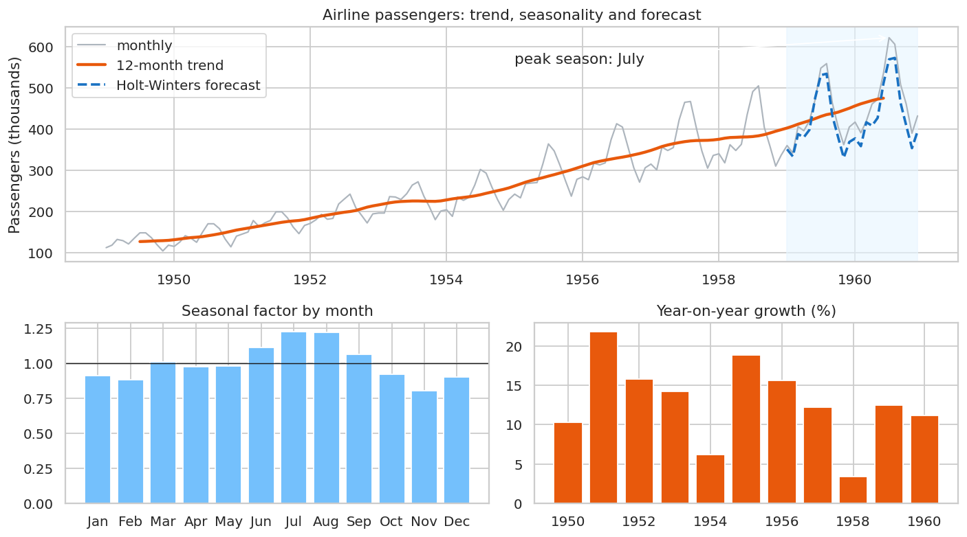
Figure 1: Airline passengers: trend, seasonal factors, growth and Holt-Winters forecast

C. Visualisation
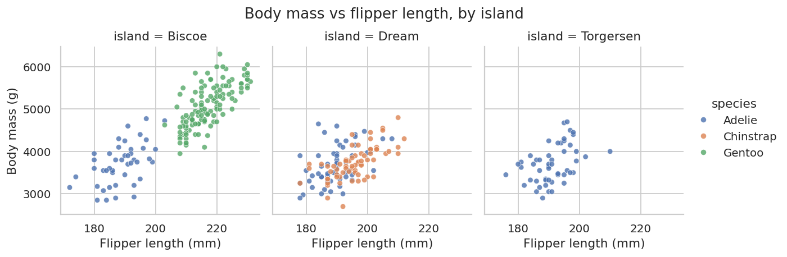  Figure 2: Faceted scatter by island (Seaborn) | 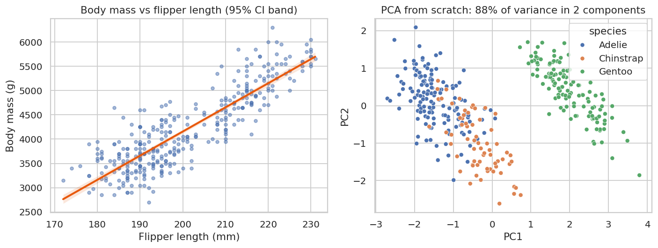  Figure 3: Regression with CI band and from-scratch PCA

D. Statistics
Species explains a large share of body-mass variance (ANOVA F = 343.6, p < 0.001, eta-squared 0.67), and Tukey tests show two of three species pairs differ, because Adelie and Chinstrap are similar. An OLS model of body mass on flipper length, species and sex reached R-squared 0.867 with +20.0 g per mm of flipper and males about 530 g heavier. Residuals looked normal (Shapiro p = 0.82) and the constant-variance test was borderline (Breusch-Pagan p = 0.060), so no strong violation but worth noting. A permutation test gave a 805 g male-female difference in Gentoo penguins (p = 0.0001, the smallest value possible with 9,999 resamples).

E. scikit-learn and LightGBM
Predicting penguin sex under repeated 5-fold cross-validation (3 repeats), every model beat the majority baseline by a wide margin, and the three real models were statistically indistinguishable:
Model | Accuracy | ROC-AUC | AUC std
Dummy (majority) | 0.504 | 0.500 | 0.000
Logistic regression | 0.912 | 0.970 | 0.020
Random forest | 0.911 | 0.969 | 0.022
LightGBM | 0.910 | 0.971 | 0.019

Grid search chose C = 100 with ROC-AUC 0.973, a negligible gain over the default. The leakage exercise used 100 samples of pure noise with 2,000 features: selecting features on all the data before cross-validation gave 0.86 accuracy, while the same selection inside the pipeline gave 0.58, close to the true 0.50 (the remaining gap is sampling noise at n = 100). This is the most common way ML results become inflated.

5. Portfolio Piece 1: A Tested Python Package
The toolkit package (src/toolkit) packages reusable, documented code with a pyproject.toml so it installs with pip install -e .
Module | Contents
transformers.py | CorrelationFilter (drops one of each highly correlated pair) and Winsorizer (clips to training quantiles). Both learn only in fit, so they are safe inside cross-validation.
evaluation.py | bootstrap_ci, threshold_for_recall (choose a threshold from out-of-fold data), expected_calibration_error and summarise_binary.
train.py | Command-line tool: python -m toolkit.train --model logreg --seed 42. Compares five model types, selects the threshold from out-of-fold predictions, evaluates once on a held-out set, saves the model and a metrics file.
data.py | Loaders for the real datasets.

Test file | Tests | What is verified
test_transformers.py | 9 | Drops the right feature, learns only from fit data, works with NumPy, clone and pipelines, validates inputs, clips to training quantiles
test_evaluation.py | 6 | Known confusion-matrix values, threshold hits the recall target, calibration extremes, reproducible and narrowing bootstrap intervals
test_train.py | 6 | Datasets load with expected shapes, artefacts written, training is deterministic, saved model reloads identically
Total | 21 | All passing

Git history
The repository was built incrementally, with one commit per logical step. Key commits (the full history is in the repository):
- Initial project scaffold: requirements, packaging config, data sources
- Add leakage-safe transformers (CorrelationFilter, Winsorizer), evaluation utilities and data loaders
- Add reproducible training CLI with out-of-fold threshold selection
- Add pytest suite (21 tests): transformers, evaluation metrics, training determinism
- Add tool-mastery notebook: 31 verified exercises across NumPy, Pandas, SQL, SciPy, statsmodels, scikit-learn, LightGBM
- Add flagship ML portfolio notebook: nested CV, threshold selection, calibration, interpretation, 20-split robustness
- Add model card, README, and CLI metrics
- Clarify CLI default pipeline vs tuned notebook model

6. Portfolio Piece 2: Detecting Malignant Tumours from Cell Measurements
Data: the UCI Wisconsin Diagnostic Breast Cancer dataset (569 cases, 212 malignant and 357 benign, 30 numeric features), bundled with scikit-learn. This is an educational project on a public research dataset, not a clinical tool.

Framing and success criteria (declared before modelling)
A missed malignant case is far worse than an unnecessary follow-up, so models are judged by ROC-AUC and PR-AUC and at a threshold chosen to reach 98% recall. The criteria were: (1) ROC-AUC of at least 0.98, (2) recall of at least 0.95 and specificity of at least 0.90 at the selected threshold, and (3) the conclusion must hold across repeated random splits.

Exploration
There were no missing values or duplicates. The best single raw feature was worst perimeter (univariate ROC-AUC 0.975), and 15 feature pairs had correlation above 0.95, with radius, perimeter and area nearly interchangeable. A stratified 20% test set (114 cases, 42 malignant) was locked away and used once at the end.
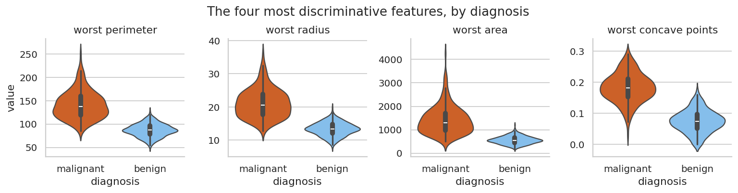  Figure 4: Top four discriminative features by diagnosis | 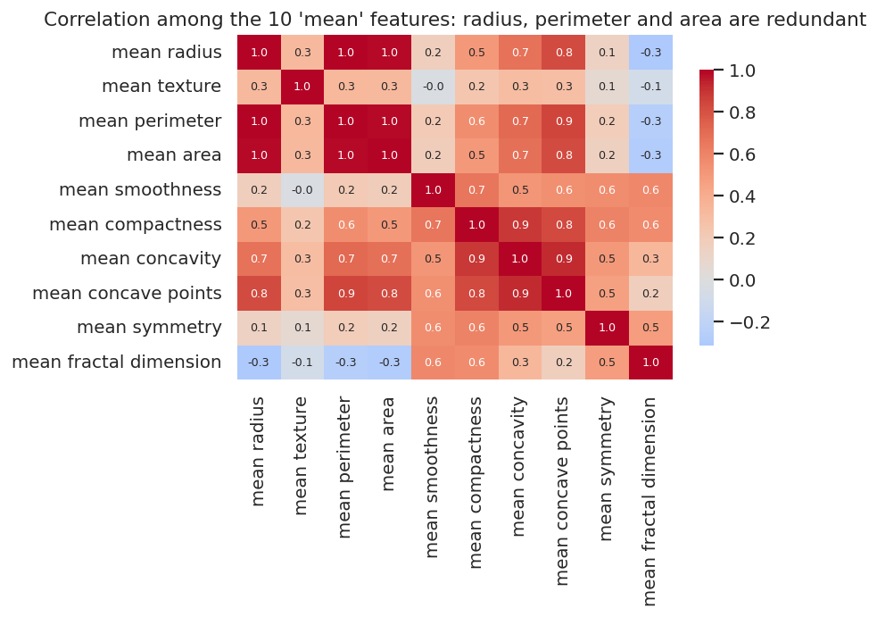  Figure 5: Redundant size features

Model comparison (repeated 5-fold CV, 3 repeats, training set)
Model | ROC-AUC | PR-AUC | Recall @ 0.5 | Precision
Dummy (prior) | 0.500 +/- 0.000 | 0.374 +/- 0.000 | 0.000 +/- 0.000 | 0.000 +/- 0.000
Logistic regression | 0.995 +/- 0.005 | 0.994 +/- 0.005 | 0.943 +/- 0.035 | 0.980 +/- 0.023
SVM (RBF) | 0.994 +/- 0.005 | 0.992 +/- 0.006 | 0.941 +/- 0.043 | 0.964 +/- 0.015
Random forest | 0.990 +/- 0.008 | 0.986 +/- 0.011 | 0.912 +/- 0.055 | 0.969 +/- 0.037
Hist. gradient boosting | 0.992 +/- 0.007 | 0.990 +/- 0.007 | 0.939 +/- 0.039 | 0.969 +/- 0.024
LightGBM | 0.993 +/- 0.005 | 0.991 +/- 0.006 | 0.937 +/- 0.034 | 0.972 +/- 0.024

All models are far above the dummy baseline. Using the Nadeau-Bengio corrected resampled t-test, the best model (Logistic regression) was not significantly better than any other (p = 0.65, 0.29, 0.31, 0.23). When models are statistically tied, the simpler, interpretable one is preferred.
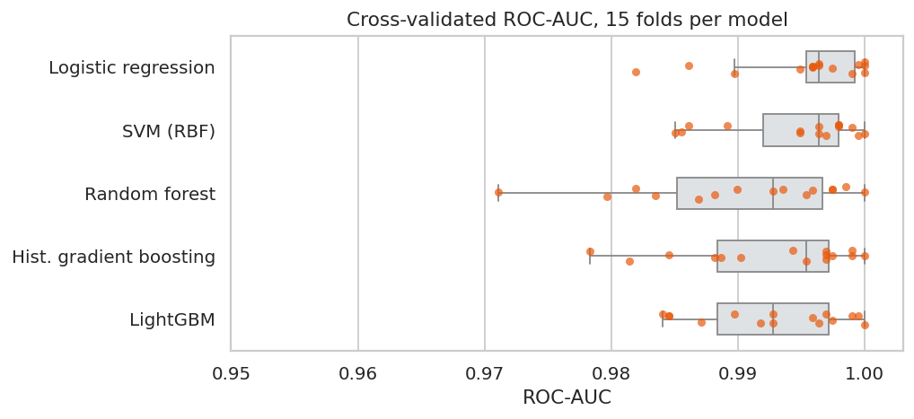
Figure 6: Cross-validated ROC-AUC across 15 folds per model

Nested cross-validation
Tuning on the same folds you report on inflates scores, so tuning used an inner 3-fold loop and scoring an outer 5-fold loop.
Model (tuned) | Nested ROC-AUC | Std
Logistic regression | 0.994 | 0.004
SVM (RBF) | 0.996 | 0.005
LightGBM | 0.995 | 0.003

SVM scored highest, but all three were within one standard deviation. By the pre-declared rule (ties go to the simplest model), logistic regression was chosen with C = 1. Tuning set the correlation-filter threshold to 1, which keeps all 30 features, so my custom CorrelationFilter was not needed for this model because L2 regularisation already handles collinearity.

Threshold choice and the single test evaluation
The decision threshold (0.207) was chosen from out-of-fold training predictions to reach 98% recall (out-of-fold recall 0.982, specificity 0.954). The test set was then evaluated once:
Operating point | TP | FN | FP | TN | Recall | Specif.
Threshold 0.5 | 39 | 3 | 1 | 71 | 0.929 | 0.986
Threshold 0.207 (recall-targeted) | 41 | 1 | 3 | 69 | 0.976 | 0.958

Test ROC-AUC was 0.996 (95% bootstrap CI 0.986 to 1.000), recall 0.976 (CI 0.921 to 1.000) and specificity 0.958 (CI 0.908 to 1.000). The intervals are wide because the test set has only 114 cases.
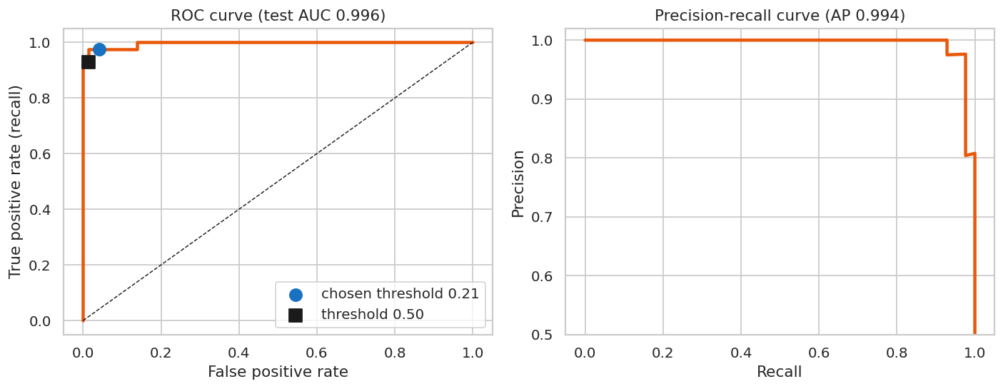  Figure 7: ROC and precision-recall curves with operating points | 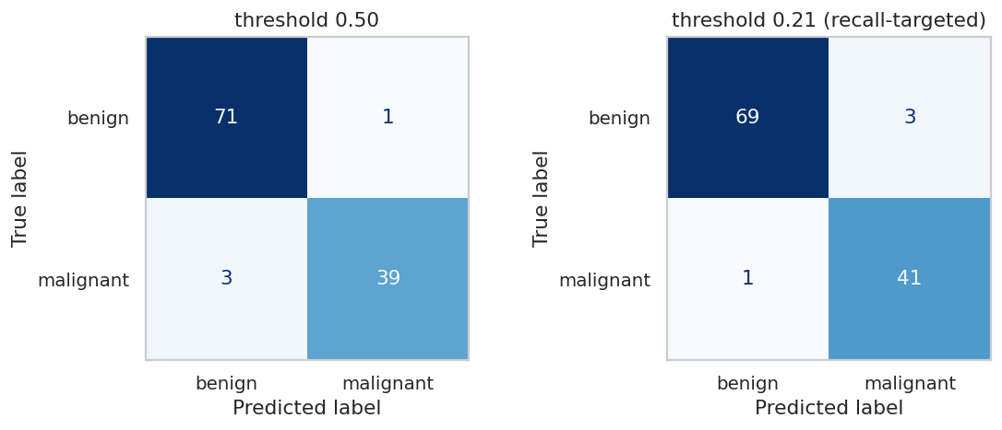  Figure 8: Confusion matrices at two thresholds

Calibration
The raw model was better calibrated than a sigmoid-recalibrated version (Brier 0.021 against 0.031; expected calibration error 0.030 against 0.070). This is expected because logistic regression is already well calibrated by construction, and it shows that extra processing should be tested rather than assumed to help.

Interpretation and error analysis
The largest standardised coefficients were worst texture, radius error and worst symmetry, and permutation importance on the test set ranked worst symmetry, worst texture and worst concavity highest. The rank agreement between coefficients and permutation importance was 0.71 (Spearman). Individual importances are small (about 0.01 AUC) because correlated features cover for each other, so they should be read loosely. There were 4 misclassifications at the chosen threshold: three false positives and one false negative. The false negative was a confident miss (predicted probability 0.06), so lowering the threshold would not fix it.
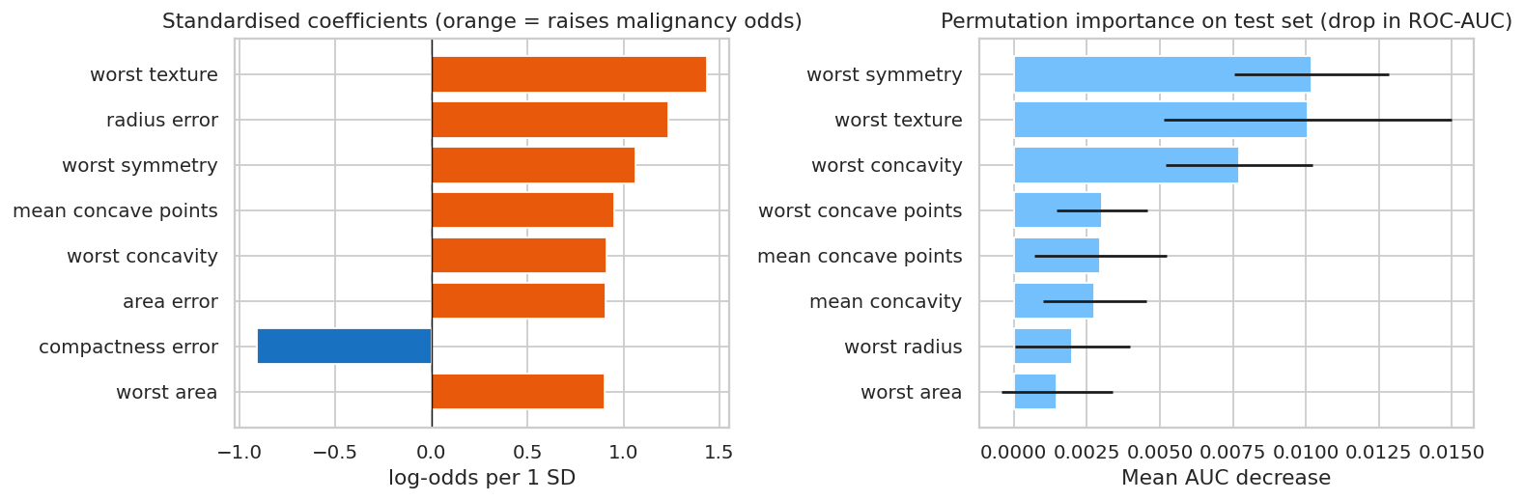
Figure 9: Standardised coefficients and permutation importance

Robustness across 20 random splits
A 114-case test set is small, so the whole procedure (split, fit, out-of-fold threshold, test evaluation) was repeated for 20 seeds.
Metric | Mean | Std | Min | Max
ROC-AUC | 0.995 | 0.005 | 0.980 | 1.000
Recall (malignant) | 0.974 | 0.027 | 0.929 | 1.000
Specificity | 0.928 | 0.042 | 0.847 | 1.000

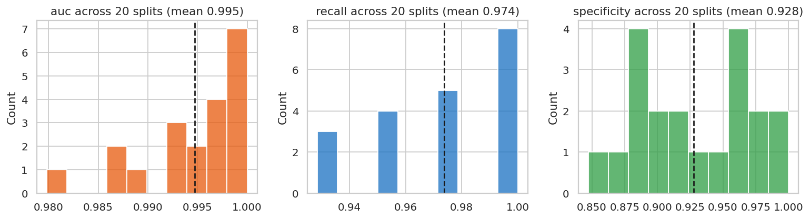
Figure 10: Test performance across 20 random splits

Success criteria: outcome
Criterion | Result | Evidence
1. Test ROC-AUC >= 0.98 (single split) | Met | 0.996
1b. Mean ROC-AUC >= 0.98 over 20 splits | Met | 0.995
2. Recall >= 0.95 and specificity >= 0.90 (single split) | Met | 0.976 and 0.958
3. Mean recall >= 0.95 and specificity >= 0.90 over 20 splits | Met | 0.974 and 0.928

All criteria were met on average, but not in every split: recall reached 0.95 in 17 of 20 splits and specificity reached 0.90 in only 14 of 20. A single small test set can therefore look better or worse than the truth. The final model, decision threshold and a model card (models/MODEL_CARD.md) are saved, and a reload check confirms identical predictions.

7. Lessons Learned
- Evaluation design matters more than model choice: five model families were statistically tied, while leakage inflated a noise result from chance to 0.86 accuracy.
- Report uncertainty: with 114 test cases, confidence intervals and a 20-split check were essential.
- Choose thresholds on out-of-fold training data, never on the test set.
- Negative results are results: the custom filter was not selected, and recalibration did not help.
- Automated checks caught my own wrong guess: my first speed-up check demanded 20 times and the measured ratio was lower, so I replaced it with a conservative, machine-independent bound and report the measured value. A Pandas pivot with margins also failed on categorical columns, so I used crosstab, the idiomatic tool for counts with totals.

8. Scope, Limitations and Next Steps
- Deep-learning frameworks (PyTorch, TensorFlow) are not demonstrated in this project; they are the next skill to add, along with GPU workflows.
- Not yet covered: continuous integration, experiment tracking (for example MLflow), containerisation and model serving.
- The ML project uses one public dataset of 569 cases without external validation, so it is a learning exercise rather than clinical evidence.
- Datasets are small by industry standards; large-scale tools such as Spark were not used.

9. Repository and Reproducibility
Everything is in the GitHub repository (itsme2147-eng): src/toolkit, tests, two executed notebooks, data with provenance, models with a model card, figures and result files. Seeds are fixed (42), the notebooks run top to bottom, re-running notebook 2 reproduced identical results, and requirements.txt lists dependencies. To reproduce: pip install -r requirements.txt, pip install -e ., pytest -q, then run both notebooks.

