Hands-On Data Lab Implementation
AI ML Research Specialist Internship, Thiruvananthapuram
Task 2 of 6 | Submitted by Balaji Subhash Jadhav | GitHub: itsme2147-eng

1. Overview
This report documents a hands-on data lab in which I built a working data analysis environment and completed practical exercises with Python, NumPy, Pandas, Matplotlib, Seaborn and Scikit-learn. The work uses a synthetic retail dataset made of three linked tables (400 customers, 40 products and 5,060 raw orders) that I generated with deliberate quality problems, so that cleaning is a real task rather than a formality. All results come from one Jupyter notebook that runs top to bottom from the raw files.
# | Objective | Where it is covered
1 | Set up the data science environment | SETUP.md, src/check_environment.py, notebook Part 1
2 | Work with data using Pandas and NumPy | Notebook Parts 2A and 2B
3 | Perform data cleaning | Notebook Part 3
4 | Create data visualisations | Notebook Part 4 (8 charts)
5 | Perform basic data analysis | Notebook Part 5
6 | Document practical exercises | Notebook Part 6 and this report

2. Environment Setup
Python 3.12 was installed and an isolated virtual environment was used so that library versions do not clash with other projects. Dependencies are pinned by minimum version in requirements.txt (a conda environment.yml is also provided), and a script verifies the installation.
- Install Python and create a virtual environment: python -m venv .venv, then activate it.
- Install the libraries: pip install -r requirements.txt (NumPy, Pandas, Matplotlib, Seaborn, Scikit-learn, SciPy and Jupyter).
- Verify: python src/check_environment.py imports every library, prints its version and runs a small smoke test.
- Launch Jupyter Notebook and register the kernel if it is not listed (python -m ipykernel install --user).

Component | Version verified | Status
Python | 3.12.3 | OK
NumPy | 2.4.4 | OK
Pandas | 3.0.2 | OK
Matplotlib | 3.10.8 | OK
Seaborn | 0.13.2 | OK
Scikit-learn | 1.8.0 | OK

3. Working with Data Using Pandas and NumPy
The raw tables were loaded and inspected with head, info and describe. I then practised each required skill:
- Selection: column lists, label-based selection with loc and position-based selection with iloc.
- Filtering: boolean masks, combined conditions, isin and query (for example returned orders, or UPI orders with quantity of four or more).
- Sorting: multi-column sorts with mixed ascending and descending order.
- Grouping and aggregation: groupby with named aggregations, pivot tables, and groupby with transform to compute each order's share of its category.
- Merging: orders joined to customers and products with validate='m:1', followed by a check that the row count did not change.
- Transformation: new columns for gross value, revenue, profit, margin, month, weekday, plus pd.cut to create order-size and age-group bands.
- NumPy: array statistics, percentiles, reshaping, axis operations, broadcasting and np.where. A vectorised sum of squares over one million values ran about 148 times faster than a Python loop (timing varies by machine).

4. Data Cleaning
Cleaning followed three stages: detect the problems and count them, fix each with a documented rule, then validate with assertions that fail loudly if a rule is broken. The raw orders table had 5,060 rows and the clean table has 5,000.
Issue detected | Count | Treatment
Duplicate order rows | 60 | Removed with drop_duplicates
Missing quantity | 82 | Imputed with the product median, then the overall median
Invalid quantity (zero or negative) | 6 | Set to missing, then imputed as above
Discount stored as text such as '10%' | 150 | Stripped the % sign and converted to a fraction
Dates not in ISO format (dd/mm/yyyy) | 123 | Parsed both formats into one datetime column
Missing payment method | 40 | Labelled 'Unknown' rather than dropping the order
Payment method case variants (distinct extra labels) | 4 | Mapped to four canonical labels
City case and spacing variants (distinct extra labels) | 12 | strip() and title case, leaving six cities
Missing customer age | 24 | Imputed with the median
Invalid customer age (below 18) | 3 | Set to missing, then imputed
Missing customer segment | 10 | Labelled 'Unknown'
Product price stored as text ('Rs 1,299') | 5 | Removed symbols and converted to numeric

Validation checks confirm that order IDs are unique, no key fields are missing, quantities are positive, discounts lie between 0 and 1, there are exactly five payment labels and six cities, and every order links to an existing customer and product. Medians were used for imputation because they are robust to outliers, and missing categories were labelled explicitly so that no information was silently lost.

5. Data Visualisations
Eight chart types were built with Matplotlib and Seaborn, each with a title and labelled axes. Skewed variables use logarithmic scales so that the pattern is readable. All analysis uses delivered orders only (4,362 orders), because returned and cancelled orders are not realised revenue.
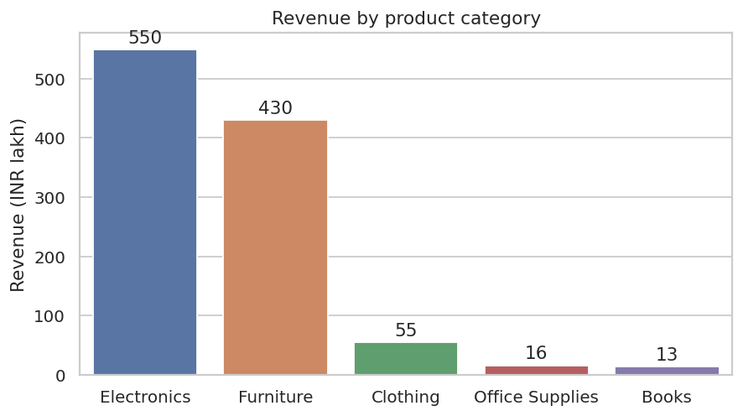  Figure 1 (bar): revenue by category | 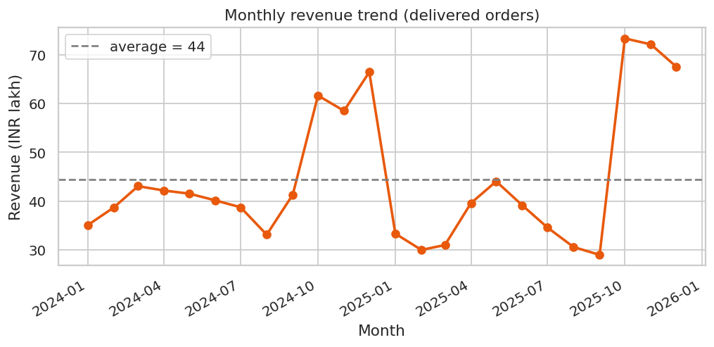  Figure 2 (line): monthly revenue trend
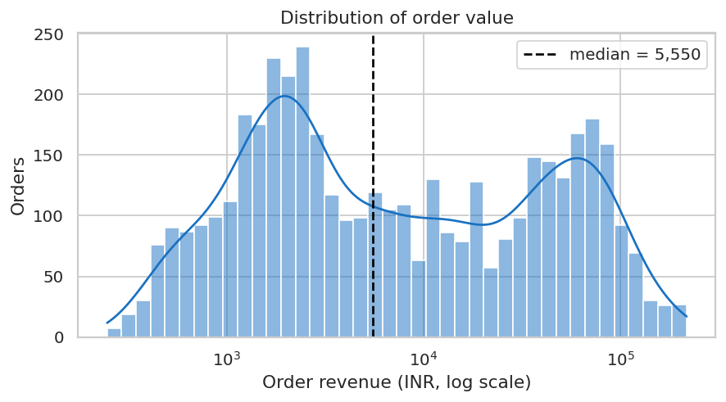  Figure 3 (histogram): order value, log scale | 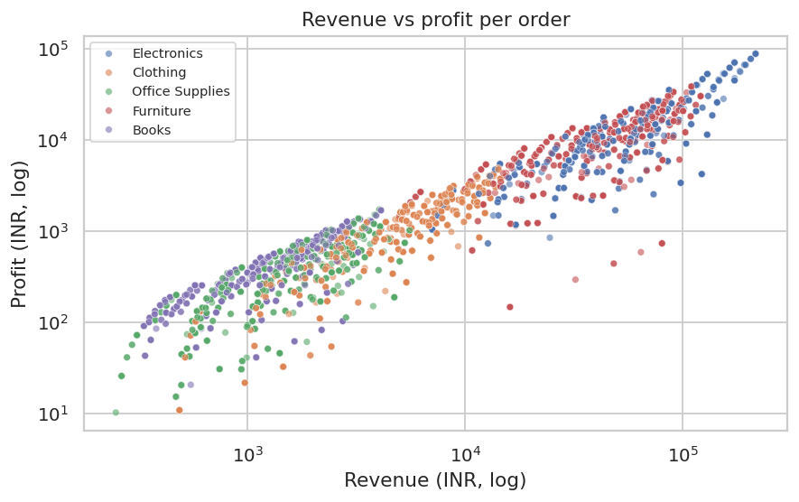  Figure 4 (scatter): revenue vs profit
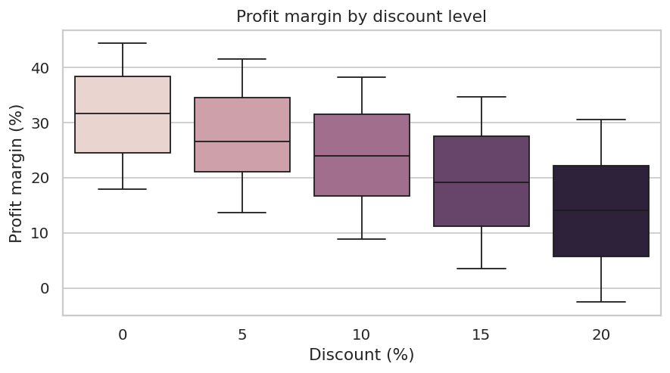  Figure 5 (box): margin by discount level | 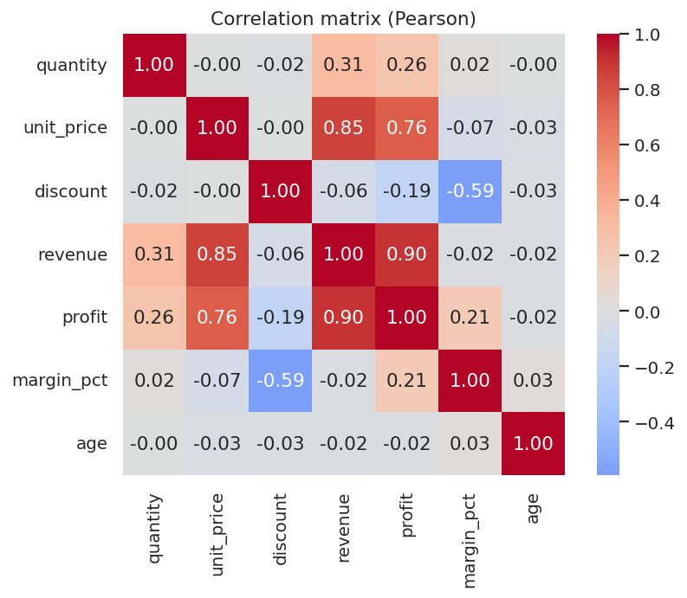  Figure 6 (heatmap): correlation matrix
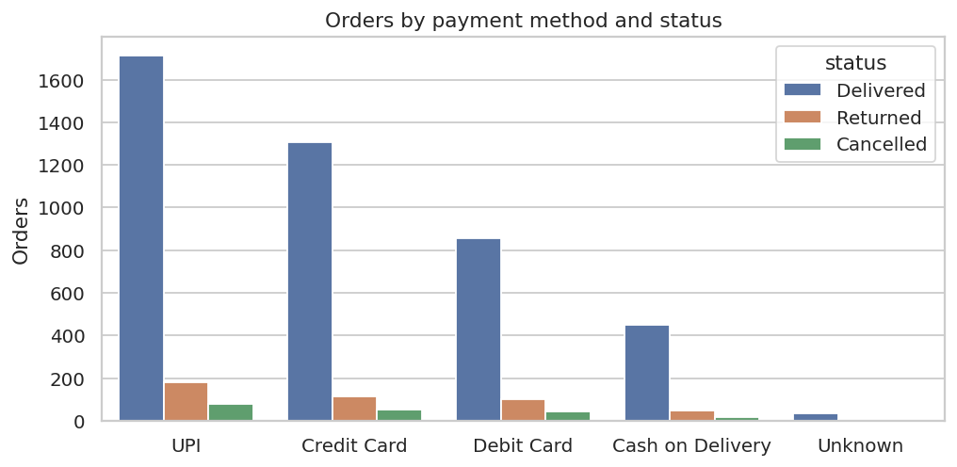  Figure 7 (count): payment method and status | 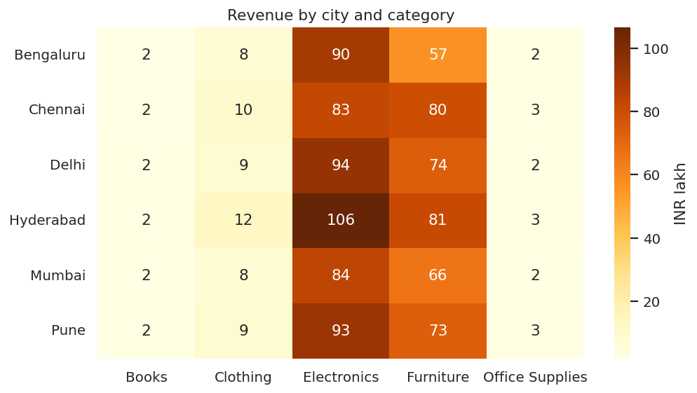  Figure 8 (heatmap): revenue by city and category

6. Basic Data Analysis

Descriptive statistics and distribution
Measure (delivered orders) | Value | Comment
Orders analysed | 4,362
Total revenue | INR 10.65 crore
Total profit | INR 2.68 crore
Overall profit margin | 25.1%
Mean order value | INR 24,409 | Pulled up by large orders
Median order value | INR 5,550 | Typical order
Skewness of order value | 2.11 | Log scale gives 0.16
IQR outliers in order value | 279 | Kept: genuine large purchases

Order value is strongly right-skewed (mean about four times the median), which is why the median and log-scaled charts describe a typical order better. A log transform reduces the skewness from 2.11 to 0.16. Outliers were flagged with the IQR rule but retained, since they are legitimate high-value Electronics and Furniture orders.

Relationships and correlations
- Unit price is the main driver of order value (Spearman correlation 0.92); quantity matters less (Pearson 0.31).
- Discount and profit margin are moderately negatively correlated (-0.59).
- Customer age has essentially no relationship with order value (Spearman -0.01).

Patterns and statistical tests
- Seasonality: average monthly revenue in October to December is 66.6 lakh against 37.0 lakh for January to September, an uplift of 80%.
- Electronics generates 52% of revenue. Category margins range from 23.9% to 32.3%, with Books the highest.
- Welch t-test: discounted orders average a 21.1% margin against 31.5% at full price, a difference that is statistically significant (p below 0.001).
- Chi-square test: payment method and order status show no evidence of association (p = 0.39). Reporting such non-findings is part of honest analysis.
- Operations: 9.0% of orders were returned and 3.8% cancelled. Hyderabad is the top city with 19.4% of revenue, and weekday revenue varies only modestly (highest day is 1.14 times the lowest).
- Scikit-learn smoke test: a scaled linear regression of revenue on quantity, price and discount gave a test R-squared of 0.82. This confirms the library works end to end; it is not a modelling claim because revenue is derived from those inputs.

7. Insights and Recommendations
- Plan stock, staffing and campaigns around the October to December peak, which is the clearest seasonal effect.
- Limit deep discounts. They cut margin by roughly ten percentage points, yet average quantity per order stays near three units at every discount level, so there is no sign that discounts increase basket size. Test targeted discounts instead of blanket ones.
- Report the median order value and use log-scaled charts, because a few very large orders dominate the mean.
- Investigate returns by category, since the return rate is more than twice the cancellation rate.
Limitations: the data is synthetic, so the patterns illustrate technique and are not real business facts; correlation does not prove causation.

8. Reproducibility and Repository
The notebook follows clean and reproducible practice: fixed random seed, printed library versions, documented cleaning rules enforced by assertions, relative paths, and no manual steps between the raw CSV files and the final outputs. The GitHub repository (itsme2147-eng) contains:
- notebooks/Hands_On_Data_Lab.ipynb: the executed notebook with code, outputs, charts and observations.
- src/generate_data.py and src/check_environment.py: data generator and environment verification.
- data/: raw tables, cleaned and merged dataset. outputs/: figures, key metrics and environment check.
- README.md, SETUP.md, requirements.txt and environment.yml: documentation and dependencies.

9. Conclusion
All six objectives were completed. The environment was installed and verified, the data was explored, cleaned and merged with Pandas and NumPy, eight visualisations were produced, and a structured analysis surfaced actionable observations about seasonality, discounting and order-value distribution. Every result can be regenerated by running the notebook.

