Real-World Dataset Analysis Project
NYC Taxi Trips, March 2019
AI ML Research Specialist Internship, Thiruvananthapuram
Task 3 of 6 | Submitted by Balaji Subhash Jadhav | GitHub: itsme2147-eng

1. Executive Summary
This project analyses 6,433 real taxi trips recorded in New York City in March 2019. The data was explored, cleaned with every decision logged, analysed with descriptive statistics, correlations, a regression model and hypothesis tests, and presented through 14 visualisations. The main findings are:
- Demand is concentrated: 82% of pickups are in Manhattan, ten zones hold about 30% of trips, and trips peak at 18:00.
- Traffic is slow all day: median speed is about 9.0 mph between 08:00 and 18:59, against 14.0 mph overnight.
- Fares follow a simple rule: fare is about $2.54 + $2.09 per mile + $0.28 per minute (held-out R-squared 0.94); passenger count has no effect.
- Tipping must be analysed on card trips only, because cash tips are never recorded. The headline gap between yellow and green cabs is largely a location and zero-tip effect, not simply rider behaviour.
- Cleaning removed 63 of 6,433 rows (1.0%); genuine outliers were kept and handled with robust statistics.

2. Dataset Selection and Context

Source and rationale
The dataset is a sample of NYC yellow and green taxi trips for March 2019, based on the Trip Record Data published by the NYC Taxi & Limousine Commission (TLC), the city agency that regulates taxis. This copy is the sample distributed in the seaborn-data repository, and the download script records its URL and SHA-256 checksum in data/SOURCE.md. It was chosen because it is genuine operational data from an authoritative public source, combines numeric, categorical, geographic and time variables, contains real data-quality problems, and supports questions with practical value.

Business and analytical context
A taxi operator earns from fares and card tips, and income depends on when and where demand occurs and how quickly vehicles move through traffic. City planners care about the same patterns for congestion and service coverage.

Objectives and expected outcomes
- When and where is demand highest?
- What determines the fare, and how predictable is it?
- How do tipping behaviour and payment method vary?
- How do yellow and green cabs differ?
- Is there evidence of congestion at particular hours?
Expected outcomes were a cleaned dataset with documented decisions, statistically supported findings, clear visualisations and practical recommendations.

Variables
Variables | Description
pickup, dropoff | Meter start and end timestamps
passengers | Passenger count, entered by the driver
distance, fare, tip, tolls, total | Miles and US dollar amounts; total = fare + tip + tolls + surcharges and taxes
color, payment | Taxi type (yellow or green) and payment method (credit card or cash)
pickup_zone, dropoff_zone | TLC taxi zone names (194 zones)
pickup_borough, dropoff_borough | Borough of each zone

3. Data Exploration
The raw file has 6,433 rows and 14 columns. Exploration covered structure, data types, missing values, duplicates, distributions, relationships and internal consistency.
- Missing values: 186 empty cells, all in payment type (44), pickup zone and borough (26 each) and dropoff zone and borough (45 each). The payment and zone gaps largely do not coincide, so they look like independent recording gaps.
- Duplicates: 0 fully duplicated rows, and none on the pickup, dropoff and zone key either.
- Data types: timestamps were stored as text; payment, colour, zones and boroughs are categorical.
- Distributions: distance, fare, tip and total are strongly right-skewed (fare skewness 3.2 after cleaning).
- Suspicious values: 96 trips with zero passengers, zero-distance trips and non-positive durations.
- Consistency: total always equals fare + tip + tolls plus a small positive surcharge amount. Cash trips never show a tip (0% recorded), so tips are only captured for card payments.
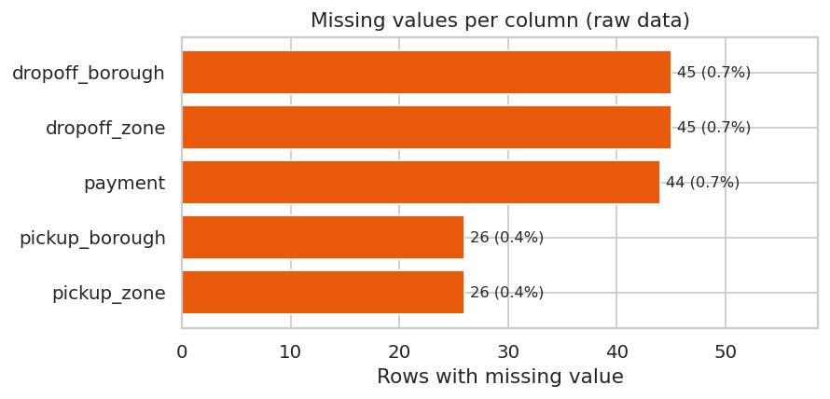
Figure 1: Missing values per column (raw data)
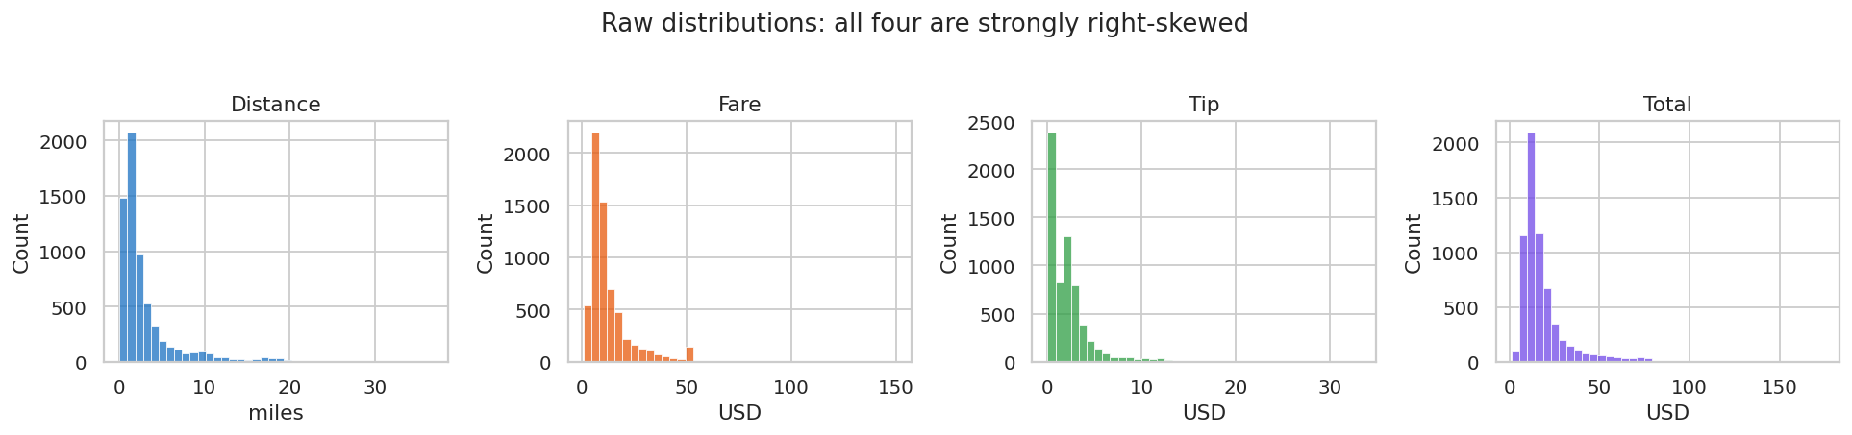
Figure 2: Raw distributions are strongly right-skewed

4. Data Cleaning and Preprocessing
Each step was logged with the number of rows affected and a stated rule, and the final dataset was validated with assertions (unique rows, no missing key fields, positive distances and durations, March-only pickups, non-negative surcharges).
Step | Rows | Decision
Duplicates | 0 | None found; nothing removed
Timestamps to datetime | 6433 | Parsed with pd.to_datetime; categorical columns converted
Missing payment | 44 | Labelled 'Unknown'; trip kept because fare data is valid
Missing pickup zone and borough | 26 | Labelled 'Unknown'; trips kept
Missing dropoff zone and borough | 45 | Labelled 'Unknown'; trips kept
Passengers = 0 | 96 | Treated as unrecorded; median (1) imputed; flag column kept
Zero distance or non-positive duration | 51 | Removed: not valid completed trips
Pickup outside March 2019 | 1 | Removed to keep a clean one-month window
Speed above 80 mph | 11 | Removed: physically implausible

Result: 6,433 rows reduced to 6,370 (63 removed, 1.0%).

Outliers
Outliers were detected with the IQR rule and inspected rather than removed automatically. The largest fares are long airport or out-of-borough journeys where fare, distance and duration agree (for example a $150 fare for 36.7 miles), so they are genuine. They were kept, and the analysis uses medians, trimmed means, log scales and rank-based statistics so that they cannot distort conclusions.
Variable | Upper fence | Outliers | Share | Mean | Median | 5% trimmed
fare | 27.8 | 577 | 9.1% | 13.02 | 9.5 | 11.47
distance | 6.6 | 724 | 11.4% | 3.05 | 1.66 | 2.46
tip | 7 | 265 | 4.2% | 1.97 | 1.7 | 1.66
duration_min | 36.5 | 357 | 5.6% | 14.47 | 10.97 | 13.16
total | 34.5 | 585 | 9.2% | 18.45 | 14.16 | 16.6

Feature engineering
Added columns: trip duration, speed, date, hour, weekday, weekend flag, time-of-day band, surcharges, fare per mile, tip percentage (card trips only, otherwise missing), airport-trip flag and a passenger-imputed flag.
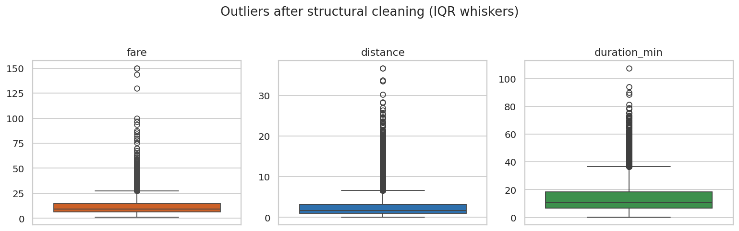
Figure 3: Outliers after structural cleaning

5. Exploratory Data Analysis

Descriptive statistics
A typical trip (median) is 1.7 miles, takes 11 minutes and costs $9.50. The mean fare ($13.02) is well above the median because of a long right tail, so the median describes a typical trip better. Total takings in the sample were $117,548.

Demand: when and where
- Busiest hour 18:00 (416 trips); quietest hour 5:00.
- Weekdays average 213 trips per day against 190 at weekends (Welch t-test p = 0.016). By weekday, the daily average is highest on Wednesday (239) and lowest on Sunday (173). Averages per day are used because March 2019 contains five Fridays, Saturdays and Sundays but only four of each other weekday.
- Geography: 82% of pickups are in Manhattan; 93% of Manhattan pickups also end in Manhattan. Midtown Center is the top zone (229 trips).

Congestion
Median speed is about 9.0 mph from 08:00 to 18:59, 11.1 mph from 20:00 to 23:59 and 14.0 mph overnight (slowest hour 16:00 at 8.7 mph). Slowness therefore lasts the whole working day rather than only at rush hour.

Fare structure
A linear model fitted on a training split gives fare = 2.54 + 2.09 x miles + 0.28 x minutes, with a held-out test R-squared of 0.94 and mean absolute error of $0.74. This matches a metered-fare structure of a starting charge plus distance and time charges. Fare correlates very strongly with duration (Spearman 0.97) and distance (0.94), and not at all with passenger count (0.00). 401 airport trips have a median fare of $36.00 against $9.00 for other trips, and 126 trips cost exactly $52, all yellow cabs and 90% involving a JFK zone, which is consistent with a flat airport rate.

Tipping and payment
Card trips are 71% of trips and cash 28%. Because cash tips are never recorded, tip analysis uses card trips only. The median tip is 25.6% of the fare (mean 23.9%) and 10% of card trips leave no tip. Shorter trips attract a higher tip percentage: 31.8% under one mile against 21.2% over five miles. Time of day makes a statistically significant but practically tiny difference (median 25.0% to 26.3%).

Yellow versus green cabs
Yellow cabs make up 85% of trips. Fares are similar (median $9.50 for both), but yellow cabs are far more Manhattan-centred (92% of pickups against 31%) and do more airport work (7.1% against 1.9% of trips). Green cabs have more cash payments (40.5% against 25.9% of trips).
The raw tip gap is large (median 26.3% yellow against 11.8% green), but 46% of green card trips have a $0 tip against 4.6% for yellow, concentrated in Brooklyn and the Bronx. Within Manhattan pickups only, the medians narrow to 26.7% and 22.3%, a gap that is still statistically detectable but much smaller. The data cannot separate genuine rider behaviour from differences in how tips are recorded.

Statistical tests
Question | Test | p-value | Result and effect size
Tip %, yellow vs green (card) | Mann-Whitney U | < 0.001 | Rank-biserial r = 0.53 (large)
Same, Manhattan pickups only | Mann-Whitney U | < 0.001 | r = 0.38 (medium); 26.7% vs 22.3%
Payment method vs colour | Chi-square | < 0.001 | Cramer's V = 0.12 (small)
Tip % across time bands | Kruskal-Wallis | < 0.001 | Significant, but medians only 25.0-26.3%
Daily trips, weekday vs weekend | Welch t-test | 0.016 | 213 vs 190 trips/day (31 days)
Median fare per mile | Bootstrap, 3,000 resamples | n/a | $5.42, 95% CI [$5.37, $5.48]

With thousands of trips, small differences become statistically significant, so effect sizes and medians are reported alongside p-values. The fare-per-mile figure is high because the starting charge is spread over short trips.

6. Data Visualisations
Eleven further charts communicate the findings: bar, line, histogram (Figure 2), scatter, box, stacked bar, grouped bar and heatmaps. Skewed variables use log scales where needed.
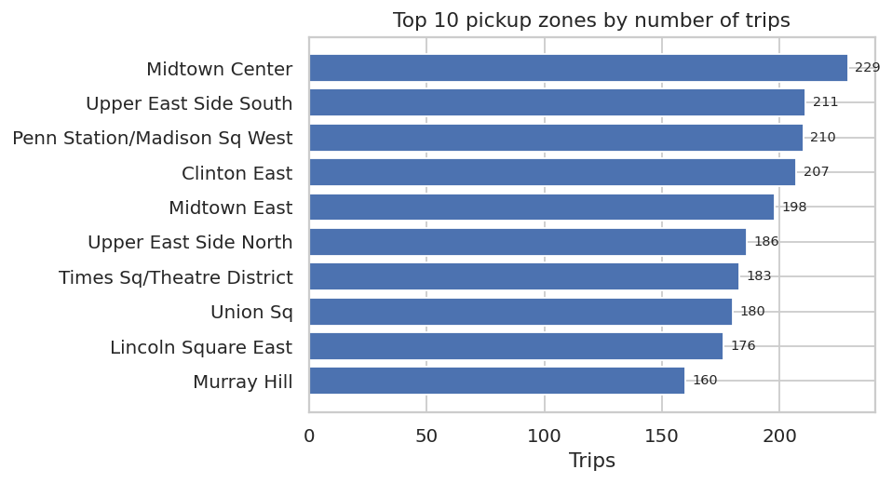  Figure 4 (bar): top 10 pickup zones | 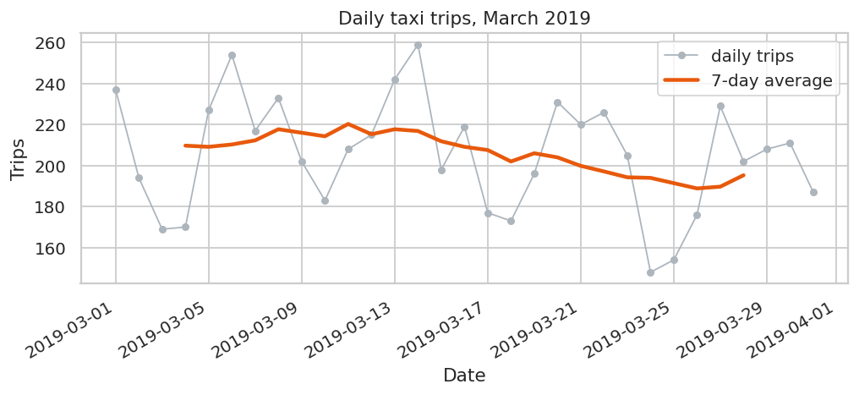  Figure 5 (line): daily trips with 7-day average
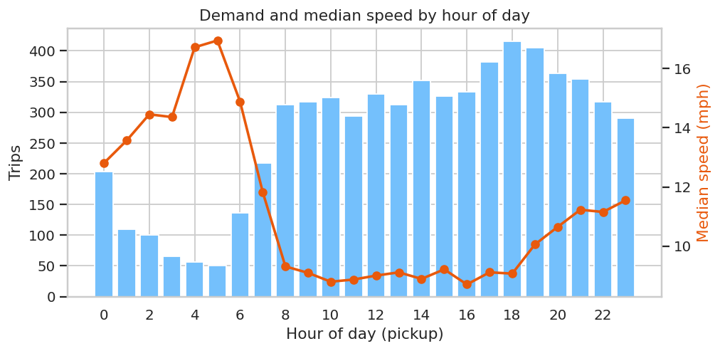  Figure 6 (bar + line): demand and speed by hour | 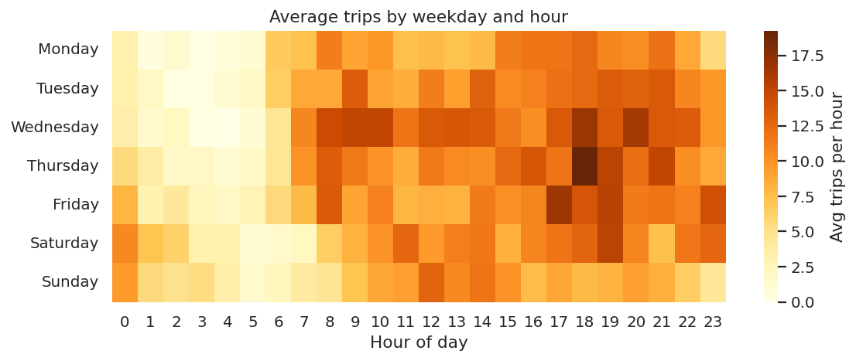  Figure 7 (heatmap): average trips by weekday and hour
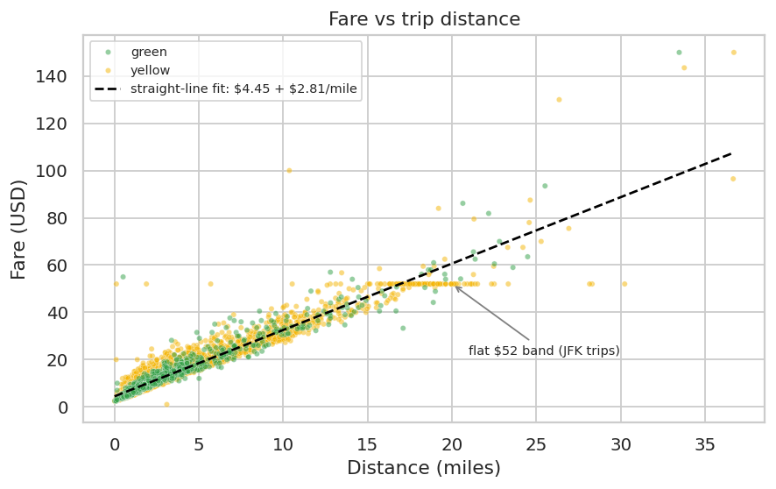  Figure 8 (scatter): fare vs distance; flat band at $52 | 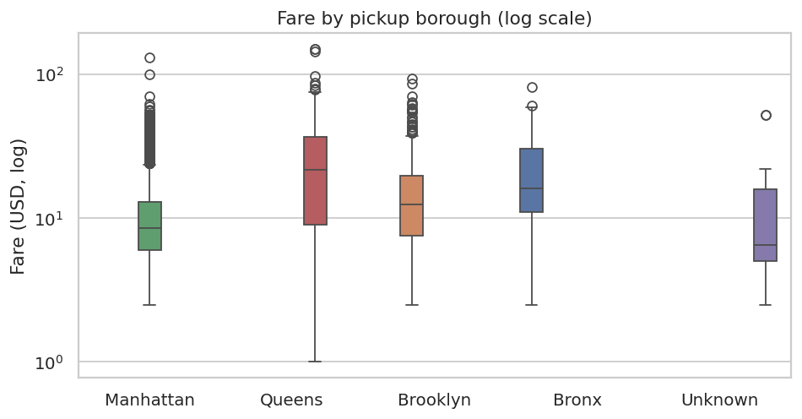  Figure 9 (box): fare by pickup borough, log scale
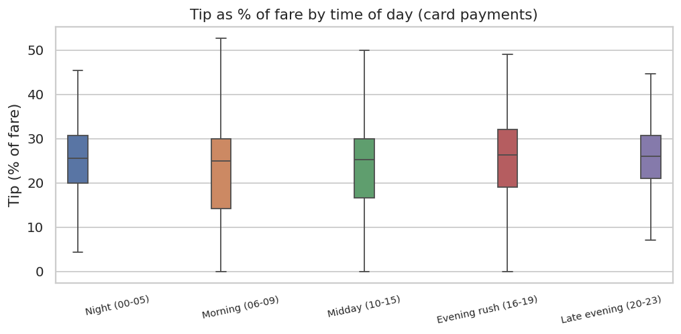  Figure 10 (box): tip % by time of day (card) | 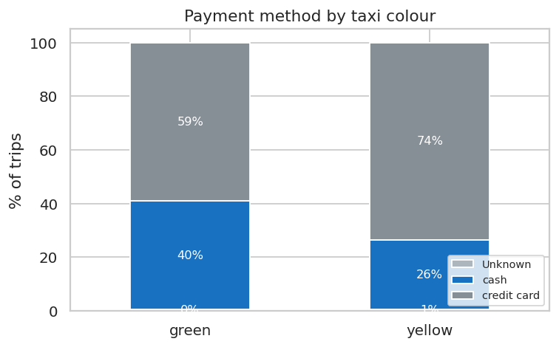  Figure 11 (stacked bar): payment method by colour
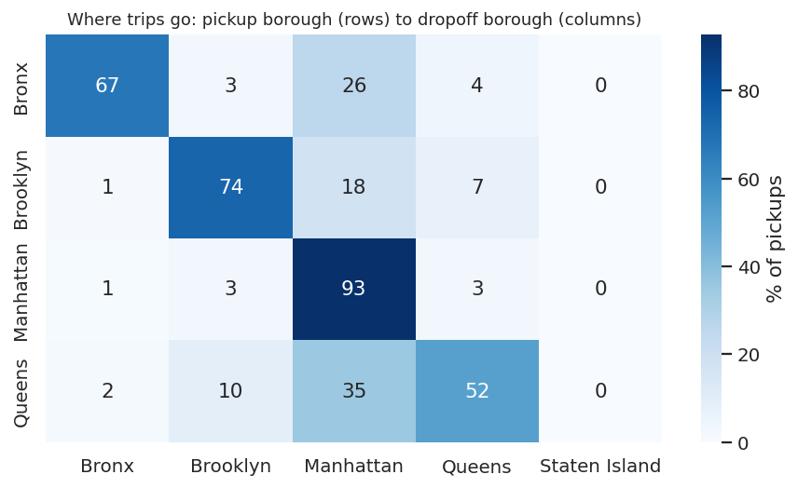  Figure 12 (heatmap): pickup to dropoff borough | 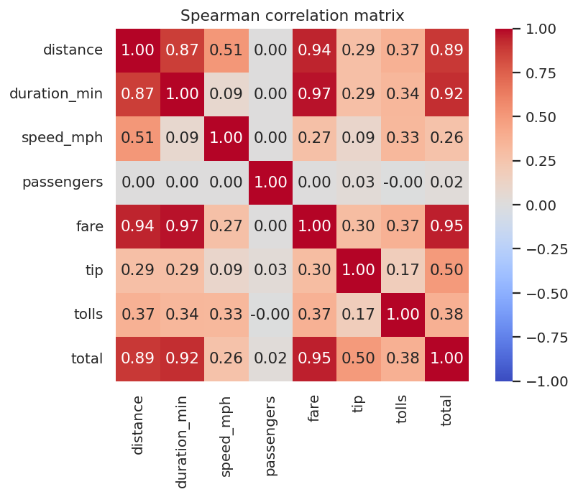  Figure 13 (heatmap): Spearman correlations
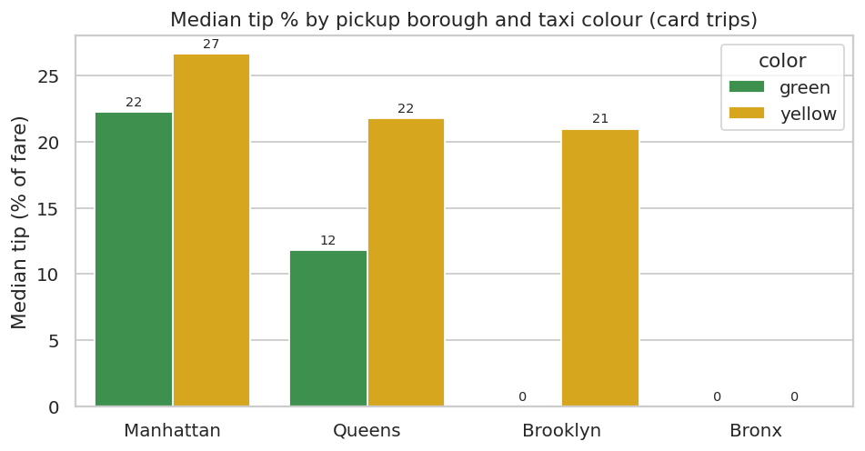
Figure 14 (grouped bar): tip % by borough and colour; Brooklyn and Bronx medians of 0 reflect many zero-tip trips and small yellow samples

7. Insights and Interpretations
- Taxi activity is a Manhattan, daytime and evening phenomenon: concentrated in a few zones and peaking in the early evening.
- Slow traffic lasts all working day. Because the fare includes a time component, trip duration depends on speed more than on distance alone.
- Fares are highly predictable from distance and time. The remaining error comes mainly from flat-rate airport trips and tolls, which a straight-line rule cannot capture.
- Headline averages mislead for skewed money variables. Median values and trimmed means describe typical trips better.
- Tip statistics are only valid for card trips. Even then, a striking yellow versus green gap is substantially explained by location and zero-tip trips, a reminder to test for confounding before reporting a gap.
- Not every variable matters: passenger count has no relationship with fare, and time of day barely changes tip percentages.

8. Conclusions
In this sample, taxi demand is geographically concentrated and time-patterned, traffic is consistently slow during the day, fares follow a simple distance-and-time rule with a few flat-rate exceptions, and tip analysis is trustworthy only when restricted to card payments and compared like with like. The pipeline from raw data to findings is fully documented and reproducible.

9. Potential Recommendations
- Match supply to demand: focus vehicle availability on the top Manhattan zones and the 16:00 to 19:00 peak, and plan shifts around the early-morning trough.
- Plan for slow daytime traffic: use time-of-day aware trip-time estimates, since speed rather than distance drives duration.
- Target airport work: about 6% of trips but a median fare roughly four times higher.
- Improve data capture: record cash tips, validate passenger counts and flag zero-distance trips at source.
- Estimate fares with distance and time, adding tolls and airport flags to improve accuracy.

10. Limitations
- One month (March 2019, before the pandemic) and a sample of about 6,400 trips, so route and zone results are noisy and may not generalise.
- Each weekday occurs only four or five times, so day-of-week conclusions are tentative.
- Cash tips are unrecorded, and the yellow-green difference cannot be separated from recording differences.
- Results show association, not causation; weather, events and incidents were not available.

11. Methodology and Reproducibility
Tools: Python, Pandas, NumPy, SciPy, Scikit-learn, Matplotlib and Seaborn. A fixed random seed (42), relative paths, an unmodified raw file, a logged cleaning process with assertions, and a single notebook that runs top to bottom make the work repeatable. The GitHub repository (itsme2147-eng) contains:
- notebooks/NYC_Taxi_Analysis.ipynb: executed notebook with code, outputs, charts and interpretations.
- src/download_data.py and data/SOURCE.md: data download, source and checksum.
- data/: raw and cleaned datasets. outputs/: 14 figures, cleaning log and key metrics.
- README.md and requirements.txt.

