**SOFTWARE ENGINEERING**

**SOFTWARE DESIGN SPECIFICATION**

**ENGINEERING**

**Big Data Analytics lab**

**Group Members :**

**Shubhendra Gautam (IIT2021142)**

**Subham Panda (IIT2021144)**

**Vishal Kumar (IIT2021196)**

**Chandan Kumar (IIT2021209)**

**Avaneesh Rav Vikram (IIT2021211)**

**Content**

* Introduction
* Overview
* People Page
* Conferences
* Authentication of Users
* Profile Page
* Conferences
* Administration
* Enrolment and Registration
* Navigation and links
* Security
* Conclusion

**Introduction**

* The BDA Lab project is a web-based platform developed to help the Big Data Analytics (BDA) lab handle personnel, conferences, and project enrollments more efficiently. The purpose of this project is to create an efficient and user-friendly system that improves lab members' collaboration, information exchange, and project management.
* The platform is made up of numerous key components that enable various functionality. The People Page acts as a centralized directory, displaying the names of lab members as well as their projects and duties. This feature makes it simple for users to identify persons working on certain projects and understand their contributions to the lab.
* Another essential feature is the Conferences Section, which contains detailed information on both current and forthcoming conferences. Users may view conference schedules, themes, presenters, and pertinent resources. This feature guarantees that lab members are aware of relevant conferences and may actively engage in them.
* The Admin Page is an important component that enables authorized administrators to control and monitor the system. Administrators can view a summary of information, such as persons, conferences, and project enrollments. They can authorize scholars, M.Tech/B.Tech students, and supervise their project involvement. For easy navigation, the Admin Page also includes links to the People Page, Conferences Section, and registration page.
* A Login and Signup mechanism is used to assure data protection and personalized access. To access restricted functionality, users must first authenticate themselves via the login procedure. New users can set up an account by providing their contact details. This feature protects sensitive data and ensures that only authorized users have access to it.
* The portal also features an About section, which offers a summary of the BDA lab initiatives. It contains information on the key members and their efforts, providing users with insights into ongoing research and development initiatives. The Feedback area allows users to submit recommendations and comments, allowing for continual quality development of the project.
* Overall, the BDA Lab project seeks to provide a comprehensive platform for successful collaboration, information sharing, and project management inside the BDA lab. The platform offers effective communication, easy navigation, and better productivity for lab members by combining essential components such as the People Page, Conferences Section, Admin Page, Login/Signup system, and About/Feedback sections.

**Overview of the System**

The BDA Lab project is intended to be a web-based platform that allows people to learn about and engage in BDA research initiatives. The system is made up of the following parts:

**A. People Page**

* The People Page is a key component of the BDA Lab project, serving as a complete database of people working in the lab. Users may find the names of all lab members, as well as their project affiliations and duties, on this page. The goal is to encourage cooperation, improve communication, and increase the visibility of each individual's contributions to the lab.
* A complete profile is accessible for each person mentioned on the People Page. Additional information in these profiles includes educational background, research interests, competence, and past contributions to the BDA Lab. Users may acquire greater insights into the abilities and experiences of lab members by accessing these profiles, enabling future partnerships and information exchange.
* Furthermore, the People Page allows viewers to learn about the initiatives that each individual is working on. Project affiliations are shown alongside names, allowing viewers to see which projects each individual is actively working in. This information aids in the identification of possible collaborators, the exchange of project updates, and the solicitation of assistance from domain experts.
* The People Page highlights the duties of lab members in addition to project affiliations. These occupations might include researchers, project managers, data scientists, software engineers, and others. Users may readily identify persons with specific expertise or duties by showing roles, allowing for effective communication and cooperation inside the lab.

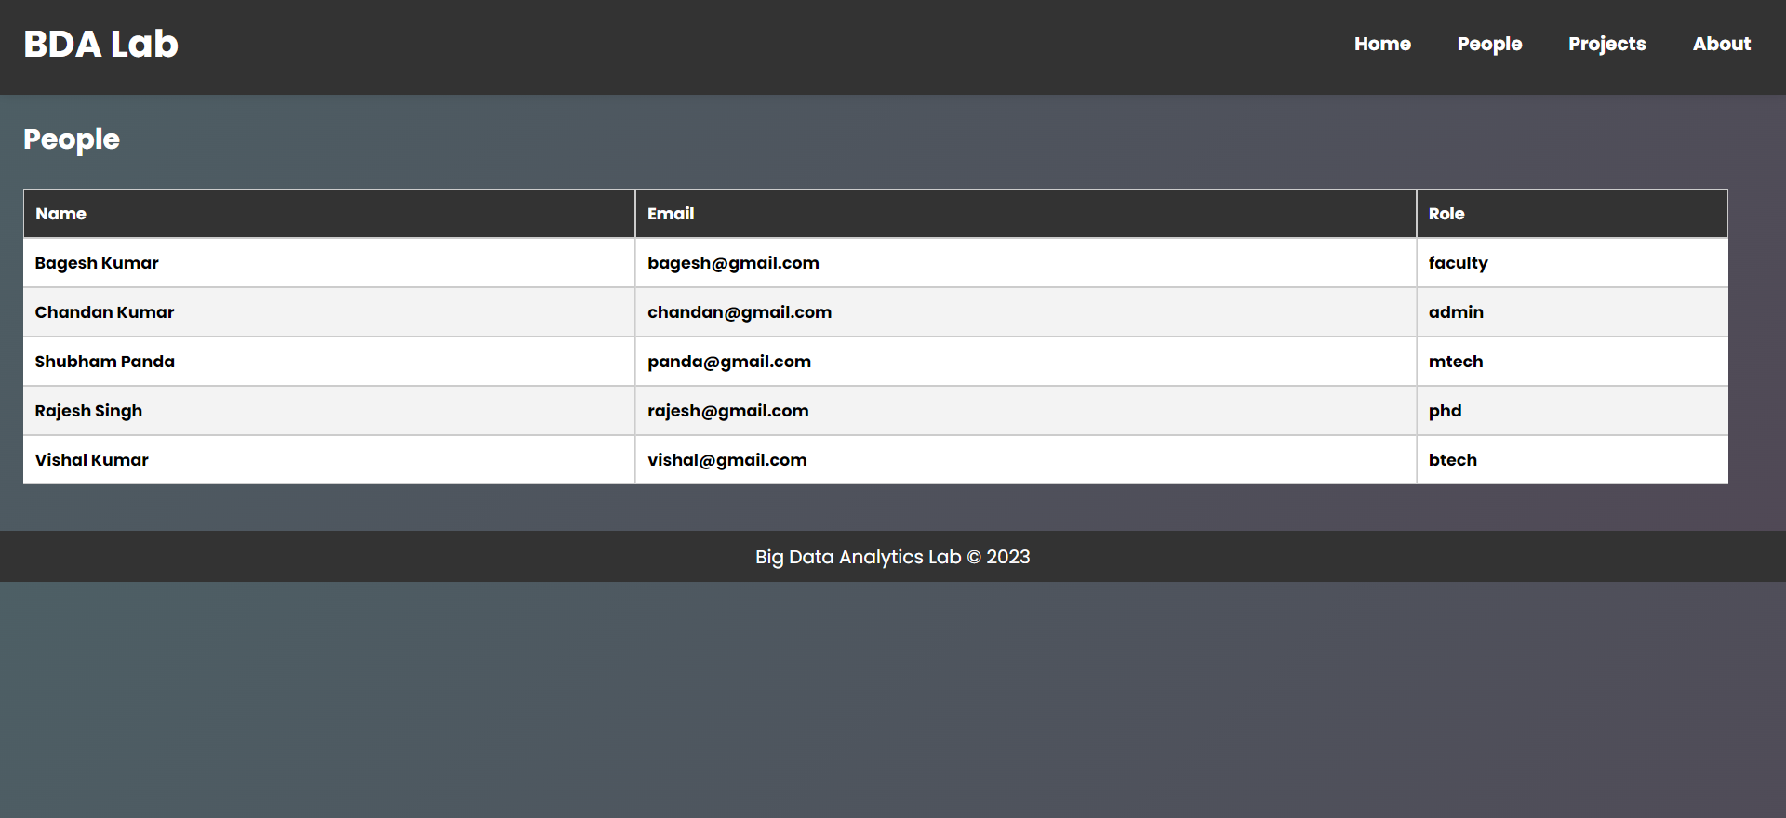

**B. Conferences**

* The BDA Lab project's Conferences section is a great resource for users looking for information about current and forthcoming conferences in the field of Big Data Analytics (BDA). This section includes a detailed summary of conferences, including dates, locations, subjects, submission deadlines, and contact information.
* This area provides users with up-to-date information about conferences, ensuring that they are aware of pertinent industry events. Users may organize their calendars and make required preparations to attend or participate in these conferences by including conference dates and places. Users can select events that correspond with their academic interests or career aspirations by learning about the topics and focal areas of each conference.
* The Conferences section also includes submission deadlines, allowing academics and practitioners to submit their work or proposals on time. Individuals who intend to present their research, offer views, or participate in panel discussions at these conferences must have this information. Users can prepare and submit their work on time if they are aware of the submission dates ahead of time.
* Additionally, contact information for each conference is supplied, allowing users to contact organizers or acquire additional information about the event. This function allows for direct connection with conference organizers, serving as a venue for clarifications, enquiries, and any extra information needed.

**C. Authentication of Users**

* The authentication and user account management components of the BDA Lab project are critical to enabling safe access to the platform's functionalities. Users must establish an account and log in before using the platform's capabilities in order to protect confidentiality and prevent unauthorized access.
* User registration is the first step in the authentication process. New users may set up an account by entering their information, such as their name, email address, and password. The registration procedure verifies the information submitted, assuring its completeness and correctness
* Users can log in to the platform using their credentials once they have registered. The login method validates the user's identification by comparing the submitted username/email and password to the user data saved on the server. To safeguard sensitive information and reduce the danger of data breaches, this method leverages strong encryption techniques.
* Users are provided access to the platform's functionalities depending on their allocated roles and privileges after successfully logging in. Access and permissions for different user roles may vary. Regular users, for example, may have read-only access to explore persons, conferences, and project information, whereas administrators may have extra permissions to manage and alter the data.
* The authentication and user account management systems are critical to the security of the BDA Lab project. The platform guarantees that only authorized persons can access its services by requiring user registration, enforcing secure login protocols, and assigning suitable roles and privileges. This improves data security, integrity, and overall system security.

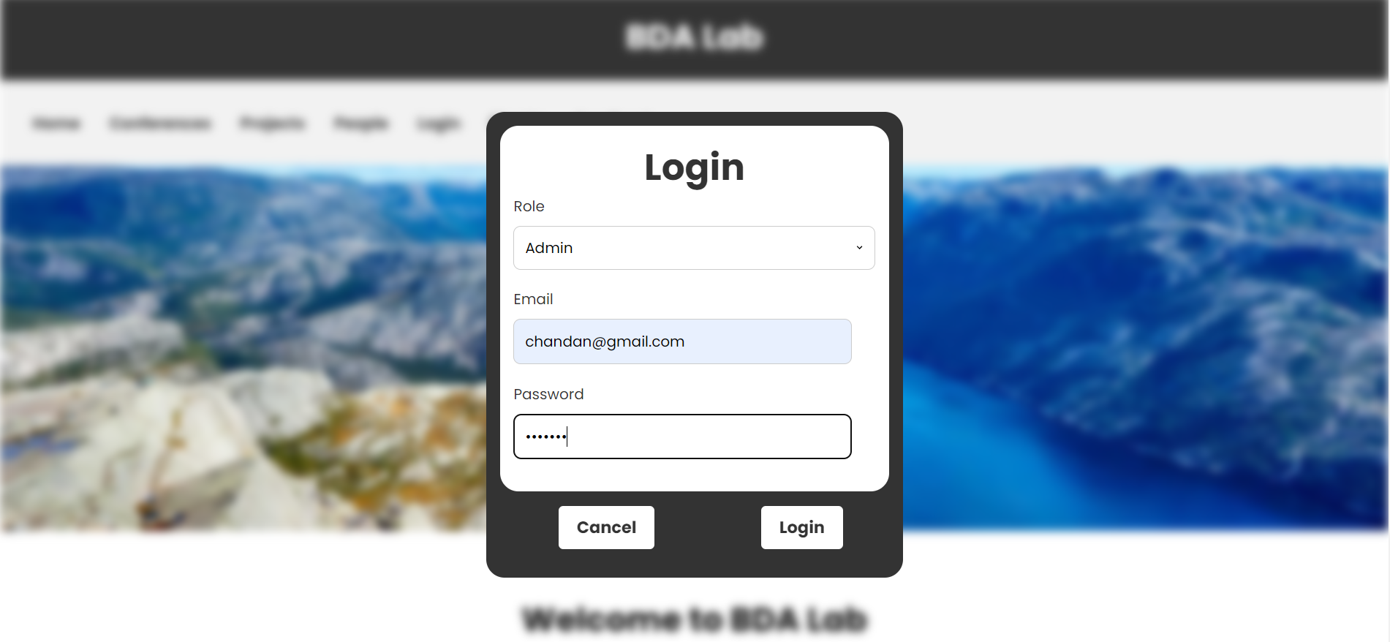

**D. Page of Profile**

* The Profile page is a complete database of people who are actively involved in the BDA Lab project. This page displays a full list of lab members, as well as their project connections and positions within the project. The People page encourages cooperation, simplifies communication, and increases the exposure of each person's contributions to the lab by highlighting the varied spectrum of people participating.
* Users may view a detailed profile for any individual mentioned on the People page by clicking on their name. These profiles include detailed information about the person's engagement in the lab, including project specifics, donations, and contact information.
* The person's profile's projects section shows their individual contributions and engagement in numerous initiatives inside the BDA Lab. This allows viewers to learn about the person's skills, hobbies, and the precise areas of study in which they are involved. The project information also makes it easier for lab members who have similar research interests or are working on relevant topics to collaborate.
* In addition to project facts, the individual's profile may include information about any donations they have made to the BDA Lab project. This demonstrates the individual's commitment to and support for the lab's operations, as well as their commitment to advancing research and development in the field of Big Data Analytics.
* The People page provides a helpful resource for users to discover the knowledge and contributions of lab members by enhancing the content and information available in each person's profile. It serves as a hub for networking, information sharing, and future partnerships within the BDA Lab initiative. The full profiles provide a deeper knowledge of each person's function and engagement, opening up prospects for meaningful interactions and collaborations in the quest of Big Data Analytics research and development.

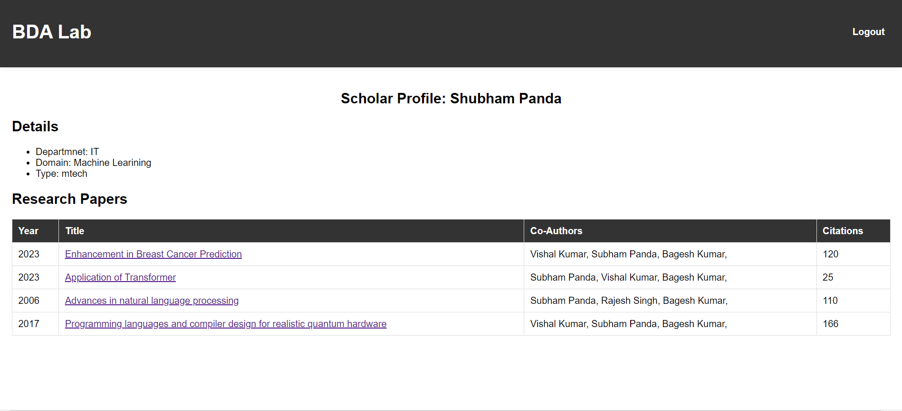

**E. Section of Conferences**

* useful for researchers and practitioners who want to deliver papers, communicate findings, or engage in panel discussions at these conferences. Users may properly organize their study and guarantee timely submission of papers by remaining updated about submission dates.The Conferences area of the BDA Lab project acts as a single gateway for users to obtain information about current and forthcoming Big Data Analytics (BDA) conferences. This section contains a comprehensive list of conferences, including vital information such as dates, locations, subjects, submission deadlines, and contact information.
* The Conferences section provides a significant resource for people wishing to keep informed and connected in the BDA community by providing a thorough compilation of conferences. Users may quickly traverse the list of conferences and investigate the characteristics of each event to identify conferences that match their academic interests, career aspirations, or geographical preferences.
* Furthermore, the section gives information on the conference's topics and key areas. This function helps users to determine whether a certain conference is relevant to their research or industrial knowledge. Users may maximize the effect of their involvement by knowing the conference topics and tailoring their contributions or presentations to suit within the scope of the event.
* The Conferences section also highlights submission dates, giving users the information they need to plan and submit their work or proposals on time.
* The Conferences section's comprehensiveness guarantees that customers have access to a diverse choice of conferences in the BDA industry. The area encourages involvement, networking, and knowledge exchange within the BDA community by offering up-to-date information about current and forthcoming conferences. Users may use this material to remain current on the newest trends, breakthroughs, and research possibilities, boosting their professional development and contributing to the field's progress.

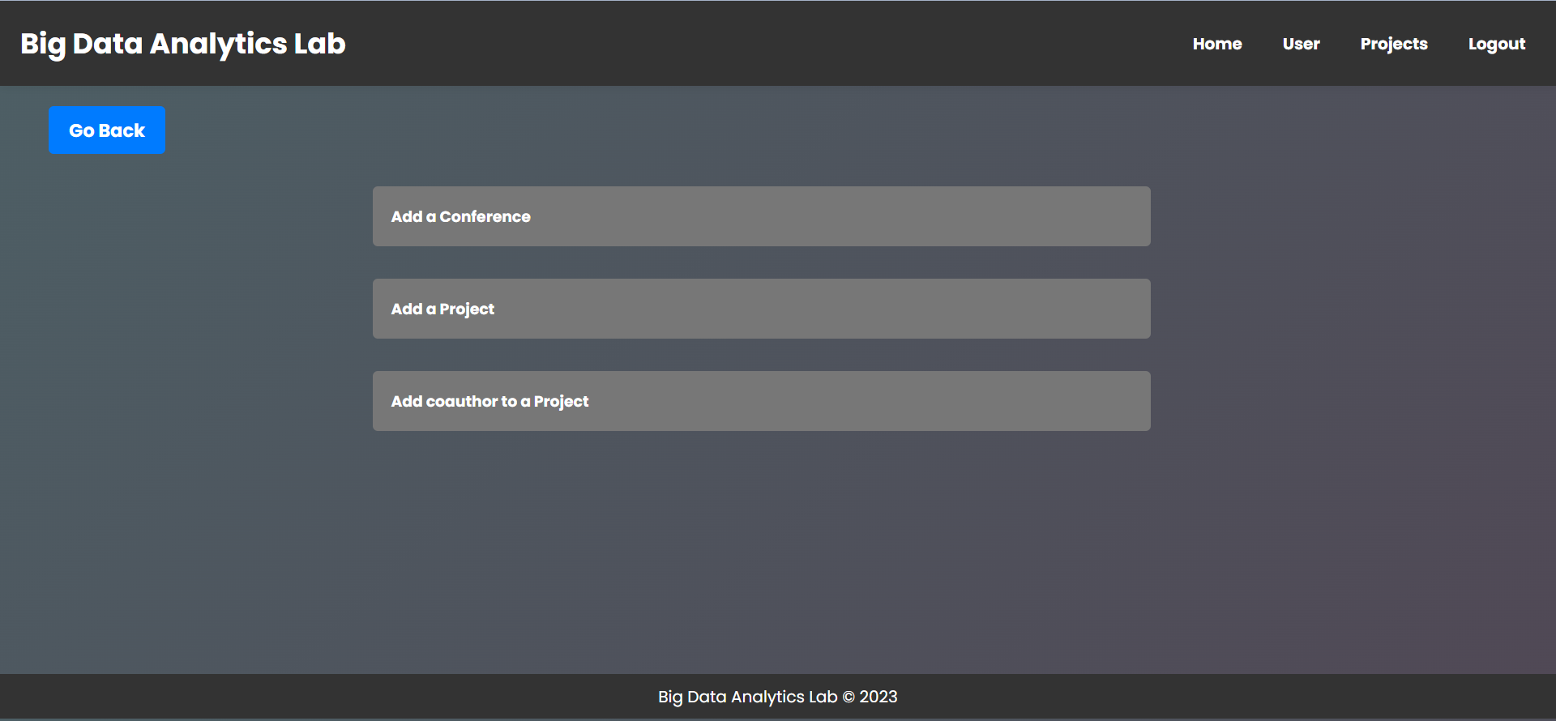

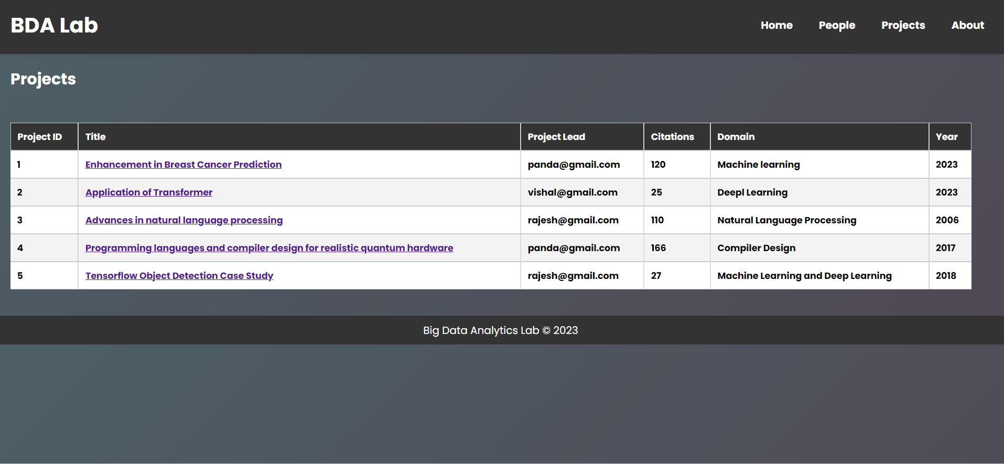

**F. Page of Administration**

* The Admin page is a valuable resource for administrators, providing a centralized interface for managing and overseeing many elements of the BDA Lab project. This page offers administrators with a complete overview of system information as well as specialized privileges to guarantee successful platform administration and control.
* The ability to analyze project enrollments is one of the most important features of the Admin page. Administrators may get an overview of all active initiatives as well as who is involved in each one. Administrators may use this tool to track project progress, team compositions, and ensure that project resources are deployed properly. Administrators can enhance cooperation and make educated decisions about project management and resource allocation by having a comprehensive picture of project enrollments.
* Administrators can also authorize scholar and M.Tech/B.Tech student registrations via the Admin page. Administrators can approve or deny registration requests based on eligibility requirements and project availability. This feature guarantees that qualified persons, such as researchers or students, may contribute their skills and expertise to important research and development activities as part of the BDA Lab initiative.
* The Admin page also includes an overview of persons and conferences. Administrators get access to a consolidated view of the People page, which displays the names, project affiliations, and responsibilities of people working in the BDA Lab project. This summary information assists administrators in keeping an accurate record of lab participants and their contributions, allowing for successful communication and collaboration within the lab
* Administrators may also view a summary of the Conferences section, which includes information about current and forthcoming BDA conferences. This summary gives administrators an overview of conference specifics such as dates, locations, themes, submission deadlines, and contact information. Having this information easily available enables managers to remain up to date on major events and make educated decisions about the lab's participation in conferences.
* Furthermore, the Admin page functions as a navigation hub, giving administrators rapid access to other critical portions of the system. Administrators may quickly access the People page, Conferences section, and Registration page by using dedicated links. This improved navigation improves administrative efficiency and guarantees that system resources are managed consistently.
* The Admin page enables administrators to successfully supervise and preserve the integrity of the BDA Lab project by offering complete functionality and centralized administrative capabilities. The capacity to analyze project enrollments, authorize registrations, get summary information on persons and conferences, and browse to essential areas ensures that the platform's functions run smoothly and efficiently. Finally, the Admin page helps administrators to make educated choices, foster cooperation, and drive the BDA Lab project's success.

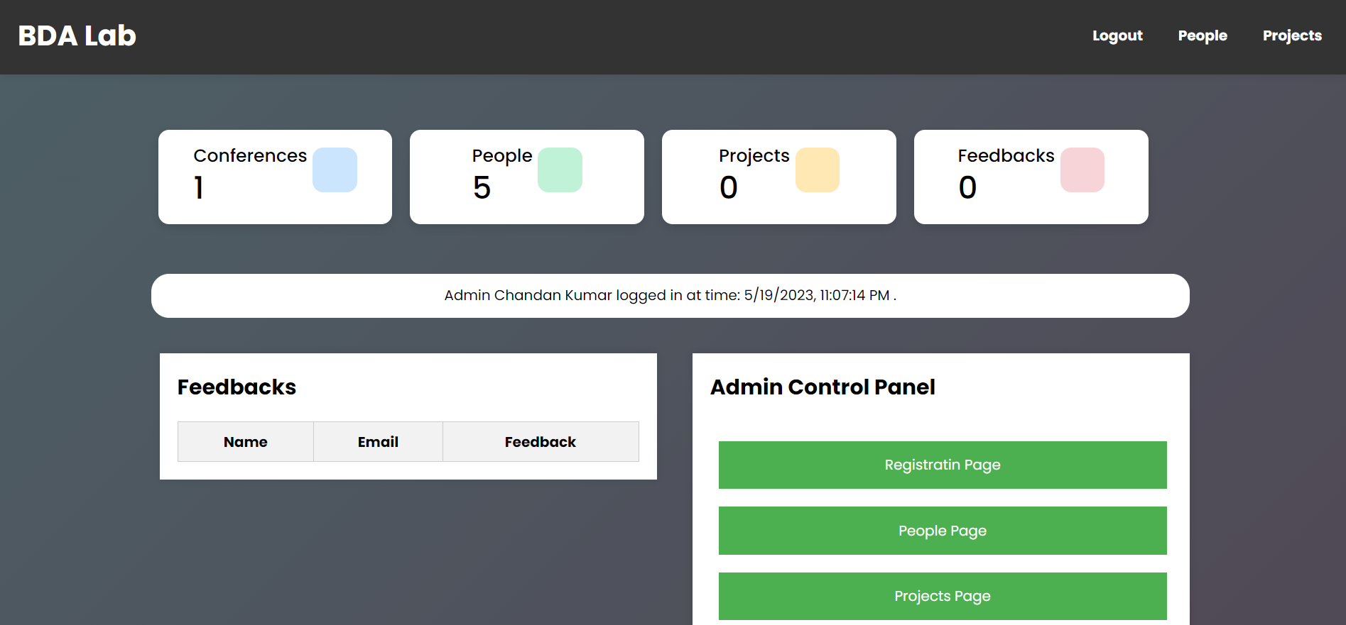

**G. Enrollment and Registration of Users**

* The BDA Lab project's enrollment and registration functionality is critical in generating engagement and supporting the involvement of scholars and M.Tech/B.Tech students in research projects supervised by researchers. Individuals with a love for Big Data Analytics (BDA) can use this feature to offer their skills and expertise to relevant initiatives, advancing their careers in research and development.
* Scholars and students who want to take part in the BDA Lab projects can use the system's enrollment function. They may use the system to browse available projects, read project descriptions, and find ones that correspond to their research interests or academic ambitions. They can begin the enrollment process after they have decided on a project of interest.
* Scholars' and students' enrollment requests are subsequently given to the administration for review and approval. Using the Admin page, the administrator may examine the enrollment requests and assess them based on particular criteria such as project availability, applicant qualifications, and alignment with the project's objectives. The administrator ensures that the correct people are allocated to the right projects by meticulously evaluating each enrollment request, maximizing the likelihood of effective cooperation and significant contributions.
* Scholars and students are urged to register on the BDA Lab project website in addition to the enrolment procedure. They may establish an account and give essential information, such as their educational background, research interests, and contact information, using the registration tool. Scholars and students who register on the site exhibit their interest in the BDA field and their desire to participate in research activities.
* The registration procedure also allows researchers and students to get critical BDA Lab project updates, notifications, and announcements. This guarantees that they are kept up to date on future conferences, new project possibilities, and important changes in the BDA community.
* Overall, the BDA Lab project's enrollment and registration feature acts as a portal for academics and students to become actively involved in research projects and obtain significant experience in the field of Big Data Analytics. The system enables academics and students to create careers in research and development by offering a forum for them to express their interest, present their qualifications, and connect with the project's aims. It encourages cooperation, networking, and skill development, setting the groundwork for future success in the BDA area.

**H. Navigation and hyperlinks**

* Within the BDA Lab project, navigation and hyperlinks play a critical role in improving user experience and providing easy access to various parts and activities. Users may quickly move across the platform and effectively obtain the information or complete the tasks they seek by using well-designed navigation components and properly positioned hyperlinks.
* The BDA Lab project makes use of a user-friendly and intuitive navigation system, allowing users to easily explore different aspects of the website. The main menu, which is prominently displayed at the top of each page, is one of the essential navigation components. This menu usually includes connections to important pages like the People page, Conferences page, and Registration page.
* Furthermore, the BDA Lab initiative makes use of contextual navigation, which entails inserting pertinent hyperlinks inside each page's content. When reading information on a single project or individual, for example, hyperlinks can be used to travel to related sites, such as the project details page or the person's entire profile. This contextual linking allows visitors to obtain more relevant information without having to return to the main menu or do separate searches.
* The BDA Lab project guarantees that users can easily move across the platform and get the relevant information or conduct essential activities by including a combination of main menu links, contextual hyperlinks, and navigation. Within the BDA Lab project, this simple and user-centric approach to navigation improves the entire user experience, decreases cognitive load, and maximizes user engagement and pleasure.

Here is an image of the Home page that will help us to know about the link and navigation.

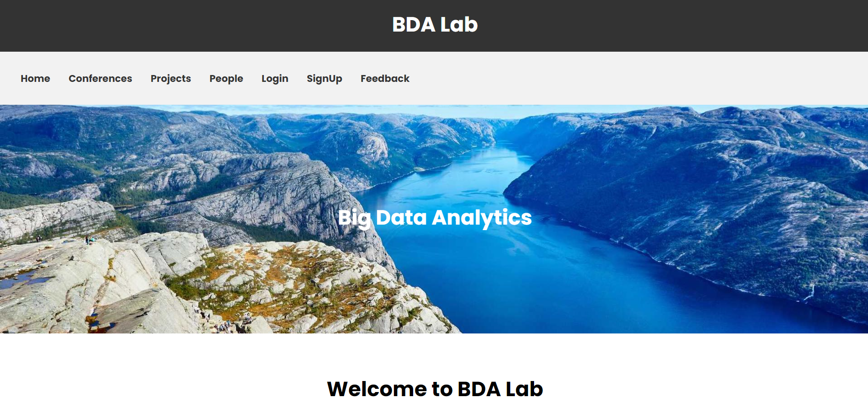

**I. Considerations for Security**

* Security is an important part of the BDA Lab project, as it ensures the security of user data, confidentiality, and the prevention of unauthorised access. Several considerations and methods have been adopted to preserve the system and user information in order to produce a secure environment.
* Authentication is essential for guaranteeing that only authorized users have access to the BDA Lab project. Users must create an account and enter credentials, such as a username and password, to utilize the login and registration method. This authentication procedure validates users' identities and grants them access to the system's features and functions. The project guarantees that only authenticated persons may interact with sensitive information and conduct authorized operations by requiring authentication.
* The BDA Lab project employs a variety of security mechanisms to safeguard the confidentiality and integrity of user data. Data encryption is one of the most important strategies. When sensitive data, such as user credentials or personal information, is communicated across a network, encryption techniques are used to prevent unauthorized interception or manipulation. Encryption guarantees that data stays unreadable and useless to unauthorized persons even if intercepted during transit.
* Furthermore, the BDA Lab project follows best practices in the industry for safe coding and application development. This involves using secure coding practices to address typical vulnerabilities such as input validation.
* Overall, the BDA Lab initiative is dedicated to providing its users with a safe environment. The project guarantees that user data is safeguarded and security risks are minimized by establishing authentication systems, applying encryption, adhering to secure coding practices, respecting user privacy, and actively monitoring system operations. These security measures provide users confidence and create a trustworthy and safe environment for their participation in the BDA Lab initiative.

**J. Conclusion**

* Finally, the BDA Lab project acts as a comprehensive and user-friendly platform for Big Data Analytics cooperation and knowledge exchange. Users may access crucial information, engage in projects, and keep updated about forthcoming conferences through its numerous components and capabilities, which include the People page, Conferences section, and Admin page.
* The People page serves as a primary center for highlighting individuals associated in the BDA Lab initiative. Users can go through the profiles of academics, scholars, and students to learn about their projects, positions, and contact information. This develops a sense of community among project participants and allows for successful networking.
* The Conferences section is a helpful resource for those who want to remain up to speed on current and upcoming Big Data Analytics conferences. Details such as conference dates, venues, subjects, submission deadlines, and contact information are available to users. This feature raises awareness and encourages attendance at relevant conferences, promoting information sharing and professional development.
* The Admin page is essential for administering the BDA Lab project. Administrators have complete information on individuals and conferences, allowing them to supervise project enrollments, authorize registrations, and keep a system overview. This centralized administration enables the project's seamless functioning and effective coordination.
* The BDA Lab project includes a login and signup method to protect the platform's security and integrity. This authentication mechanism protects user data and prevents unauthorized access. The initiative guarantees that only authenticated persons may use the platform's features and participate in its collaborative environment by asking users to create an account.
* Finally, the BDA Lab project provides a powerful and user-centric platform for Big Data Analytics collaboration, project management, and information exchange. The initiative encourages researchers, academics, and students to actively participate, interact, and contribute to the growth of Big Data Analytics research and development through its numerous features, secure authentication, and emphasis on user experience.