**SOFTWARE ENGINEERING**

**SOFTWRE REQUIREMENT ENGINEERING**

**Big Data Analytics Lab**

**Group Members:**

Shubhendra Gautam (IIT2021142)

Subham Panda (IIT2021144)

Vishal Kumar (IIT2021196)

Chandan Kumar (IIT2021209)

Avaneesh Rav Vikram (IIT2021211)

1.Introduction:

Big Data Analytics Lab provides a platform to student and researchers to work and test their big data analytics project in a collaborative and efficient manner. Data generated from various sources to extract valuable insights and make data-driven decisions

1.1Purpose:

The purpose of the software id to provide the resources available in the college to the students and researchers which will boost their productivity and help newbies gain some experience.

1.1.1 From student`s point of view:

The students will be able to see the work on real time projects and collaborate in them under the guidance of a mentor.

There will be access to large datasets which are not readily available on the internet.

The students can log in and work on some project already going on or start their own and get collaborative support of other students.

1.1.2 From researcher`s point of view:

The researchers can continue their work from anywhere and share the results easily.

The professor under which the researchers are working can guide or inspect their work any time and suggest some changes.

Researchers can seek collaboration from their peers or juniors on a fork while working on the main branch.

2. Scope:

2.1 In scope:

Platform for handling bid data analytics projects.

Collaborative handling of project.

All ongoing projects can be placed under a single website

2.2 Out of Scope:

Only the users with valid IIITA institute id can login into the system.

3. References:

IEEE SRS format

4. Overview:

The rest of this SRS is organized as follows: Section 2 gives an overall description of the software. It gives what

level of proficiency is expected of the user, some general constraints while making the software and some

assumptions and dependencies that are assumed. Section 3 gives specific requirements which the software is

expected to deliver. Functional requirements are given by various use cases. Some performance requirements and design constraints are also given.

4.1 Overall Description:

4.1.1 Product Perspective:

This project is aimed to increase the efficiency of the research department of IIITA and overcome the pertaining problems by responsive solution. Both students as well as the management will be benefitted from the website as the product improves the overall quality of research in the institute.

The project will overcome a lot of hurdles like lack of proper computing devices, unavailability of datasets and provide single platform for everyone’s use and collaboration.

4.1.2 Product Functions:

|  |  |  |
| --- | --- | --- |
| Use Cases | Description of use | |
| Admin | | |
| Authorized login | Login with administrator privileges |
| Associate student to a project | View students request on project and associate them to projects accordingly |
| Pause a project work and resources | Halt work of an ongoing project to remove any discrepancy or change the team |
| View all details of a project | View all the projects including their working members, the completion status of the work and the mentor associated. |
| Announce a new project | Student can connect with Phd scholar and research scholar |
| Verify a project | Provide the details of the project to an authorized companies for the project verification |
| Professor | |
| Authorized login | Login into the system with professor level privileges |
| View all project list | View all ongoing projects and the researchers working on it. |
| Act as a mentor in any project | Apply for an empty mentor position in a project |
| Approve a project | Approve a new project or give completion review on any ongoing project. |
| Grade a project | The professor can grade the project accordingly and give their remarks |
| Give comments on improvement | Can comment on an ongoing project and suggest any changes |
| Researcher | |
| Login and view ongoing project | Login with admin level privileges |
| View all the projects | View all ongoing project with all the description of the project |
| Request the professor for a project | Apply for working on a particular project and ask the approval from a particular professor |
| Ask students to join in the project | Announce the empty position for students to apply and collaborate on |
| Work from anywhere using his login | Work on project from anywhere using the authorized login and save work on the portal |
| Student: | |
| Authorized Login | Login with student level privileges |
| View only the description of the project | View all projects description but not all the project files and the members working on |
| Apply for a project to work on | Apply for a project under a mentor |
| Select a mentor from available list | Select a mentor and apply for the project under him |
| Collaborate on a project | Collaborate under the guidance of mentor. |

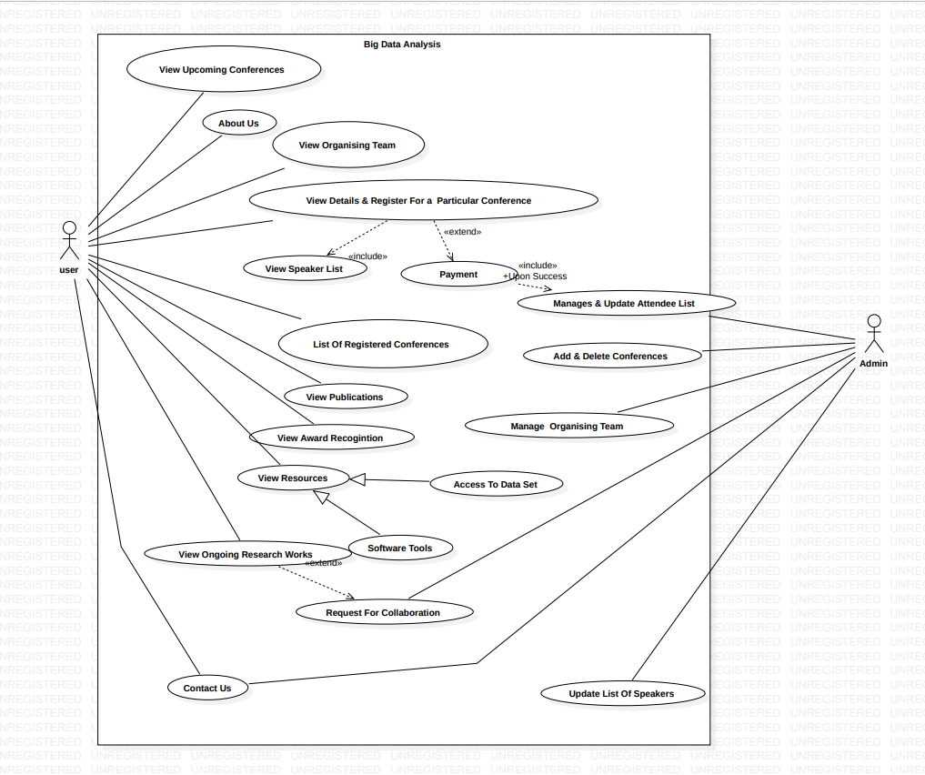

4.2 User Characteristics

The user should be familiar to software’s like Google Collab and Jupyter notebook.

4.2.1 Principal actors:

The four principal actors are Admin, Professor, Researcher and student (BTech and MTech).

5. General Constraints:

Working with BDA LAB requires internet connection.

Every user should have laptop or pc to work as it will not be possible on mobile devices.

6. Assumption and dependencies:

Good Internet connection is the main dependency

The user has taken a prior tutorial on working with the software.

7. Nonfunctional requirements

Login: - Can login after the verification through the admin.

The datasets will be verified by a third-party antivirus software

Security: The program should have strong security mechanisms to safeguard the data and system's confidentiality, integrity, and availability.

Reliability: The software must be dependable and accessible to researchers, data scientists, and analysts.

Usability: The program should have a user-friendly interface that enables for simple navigation and interaction by all user roles, including PHD researchers, MTech students, and administrators. It should be simple to use, well-organized, and give clear explanations or tooltips as needed.

8. Hardware Requirements:

Should run on laptop or computer.

Requires minimum 8GB ram.

9. Software requirement:

Operating system: Windows/Linux/Mac

Browser: Chrome/Safari/Firefox

10. Design Constraint:

**Security**: The projects and the details of the research works should be secured with necessary encryption and the any harmful file uploads should be banned.

**Fault tolerance**: Data should not become corrupted in case of system crash or power failure.

**Scalability**: The lab should be designed to handle increased data volume and velocity. It should have a scalable architecture that can manage huge dataset storage, processing, and analysis without degrading performance.

**Connectivity and Integration**: The lab must be capable of connecting to and integrating with a variety of data sources and systems. It should make it easier to collect data from many sources, such as databases, sensors, social media platforms, and streaming data sources. Integration with third-party tools, platforms, or APIs may also be necessary.

**Future Growth and Flexibility**: The lab should be constructed to accommodate future growth and technology advances. It should allow for the inclusion of new big data analytics technology, tools, and approaches as they develop.