MANIPAL ACADEMY OF HIGHER EDUCATION
(Institution of Eminence Deemed to be University)

MANIPAL INSTITUTE OF TECHNOLOGY
School of Computer Engineering



CES 2112 Digital Systems Lab
(Open Ended Experiment Report)
on
DIGITAL AUDIO BIT CRUSHER

Submitted by
Team member name | Section | Registration / Roll No.
Member 1: __________________ | ________ | Reg.: __________________  Roll: __________________
Member 2: __________________ | ________ | Reg.: __________________  Roll: __________________
Member 3: __________________ | ________ | Reg.: __________________  Roll: __________________
Member 4: __________________ | ________ | Reg.: __________________  Roll: __________________
Member 5: __________________ | ________ | Reg.: __________________  Roll: __________________

Under the guidance of:
Dr Anoop B N, Assistant Professor (Senior Scale)
School of Computer Engineering, MIT Manipal

Date: ____________________

TABLE OF CONTENTS
1. Problem Statement 3
2. Objectives 4
3. System Design and Block Diagram 5
4. Verilog HDL Implementation 7
5. Simulation, Verification and Results 10
6. Individual Contribution 13
7. Conclusion and Future Scope 14
References 15

1. PROBLEM STATEMENT
A digital audio bit crusher deliberately reduces amplitude resolution and the rate at which new samples are accepted to produce coarse, stepped waveforms. This project implements that effect as a modular 16-bit signed Verilog datapath. It connects counters, a ROM, bitwise logic, registers, shifts and comparators to a result that can be inspected in simulation and heard through a PCM audio file [1].
For a Digital Systems Lab demonstration, the main challenge is to make each operation visible and independently testable. A processed audio file alone does not explain which bits were removed, when a sample was captured, or whether gain caused signed overflow. The design therefore exposes raw, quantized and held samples together with the final output and a capture flag.
The proposed system generates a repeating sine wave from a 256-word ROM, clears a selectable number of least significant bits, holds each captured sample for a selectable number of clock cycles, and applies power-of-two gain with saturation. Each effect can be isolated through its control inputs, then combined in the same datapath.
The scope is functional RTL simulation with an internally generated source. All audio values are signed 16-bit two’s-complement numbers. Controls are assumed stable around clock edges. The project does not include an ADC, DAC, audio codec, physical FPGA deployment or measured hardware timing and area.

System requirements
TABLE I. FUNCTIONAL REQUIREMENTS
ID | Requirement | Verification method
R1 | Generate 256 ROM samples repeatedly; reset address and source output to zero. | Check source sequence and wraparound in the full demo.
R2 | Remove k = 0–15 low bits without changing the 16-bit interface. | Exhaustive signed-input check at all 16 settings.
R3 | Capture every N clocks; N = 0 behaves as N = 1. Hold output between captures. | Reset, enable alignment, N = 0, 1, 4, 255 and live-change tests.
R4 | Apply gain 1, 2, 4 or 8; clamp output to −32768 through 32767. | Exhaustive signed-input check at all four gains.
R5 | Produce five distinct demonstrations with deterministic sample timing. | Compare all 163,840 samples with an arithmetic model.

2. OBJECTIVES

2.1 Primary objective
Design and verify a modular digital audio bit crusher that independently controls bit removal, sample holding and saturating gain using fundamental digital logic.

2.2 Specific objectives
- Implement a synchronous 256 × 16-bit sine ROM source with an 8-bit wrapping address counter and active-low asynchronous reset.
- Implement programmable bit masking for all 16 values of bit_depth_sel, with k denoting bits removed and 16 − k denoting retained bit positions.
- Implement a sample register controlled by an 8-bit counter, including N = 0/1 handling, correctly aligned sample_en and changes to hold_count during operation.
- Implement gains of 1, 2, 4 and 8 using a 19-bit signed intermediate and limit the result to the 16-bit signed range without wraparound.
- Verify every signed input at every quantizer and gain setting, and compare the five integrated demonstrations against an independent arithmetic model [2].
- Generate legible simulation figures and a five-second mono WAV demonstration, while preserving held samples in the exported stream.

2.3 Scope and deliverables
The RTL deliverables are audio_source.v, bit_depth_reducer.v, sample_rate_reducer.v, gain_clipper.v and bitcrusher_top.v. Supporting files include sine_rom.mem, gen_sine_table.py, bitcrusher_tb.v, blocks_tb.v, check_demo.py, run_sim.sh, run_tests.sh and convert_to_wav.py.
Verification deliverables are the VCD waveform, the signed-decimal sample log, the five-second WAV file and the results reported in Section 5. The report documents the datapath, complete core RTL, verification method and responsibility allocation for five members.
The browser presentation in viz/index.html provides interactive audio and waveform controls using a separate JavaScript model. It does not execute the Verilog or read the RTL output. Circuit verification uses the VCD and tests; bitcrusher_demo.wav plays the actual RTL output.

3. SYSTEM DESIGN AND BLOCK DIAGRAM

3.1 Proposed architecture
The top module connects four blocks in a fixed order: source, quantizer, sample holder and gain/clipper. Fig. 1 shows the signal flow. The source and holder are clocked; quantization and gain are combinational. Debug outputs expose each intermediate audio bus [1].
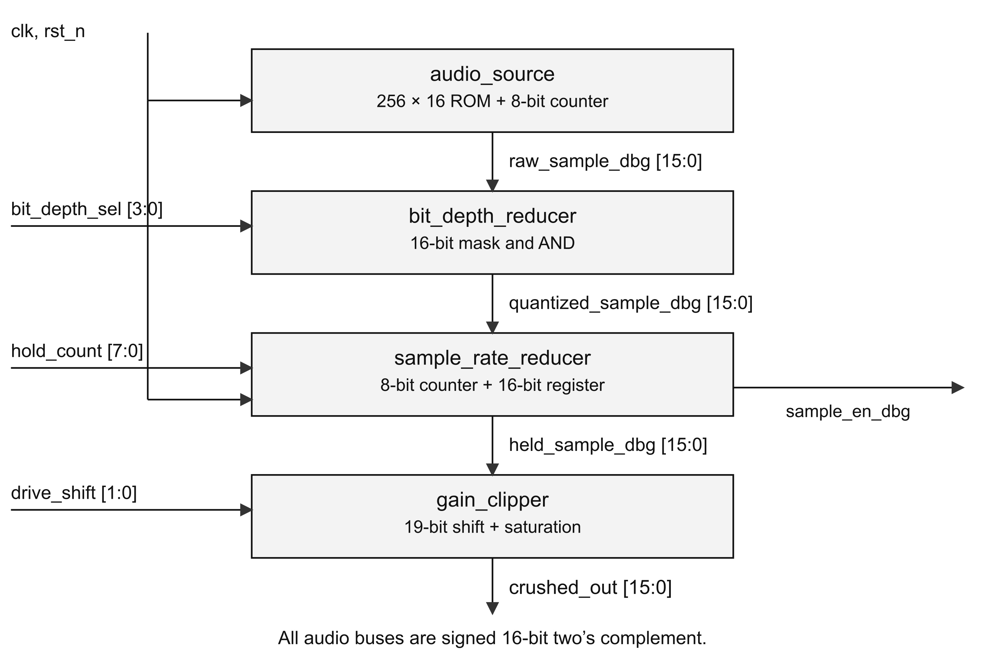
Fig. 1. Bitcrusher datapath, controls and observable signals.

3.2 Module description
TABLE II. RTL MODULE INTERFACES
Module | Inputs | Outputs | Function
audio_source | clk, rst_n | addr_out, sample_out | ROM read and modulo-256 address count.
bit_depth_  reducer | sample_in, bit_depth_sel | sample_out | Clear k low bits with a shifted mask.
sample_rate_  reducer | clk, rst_n, sample_in, hold_count | sample_out, sample_en | Capture every N clocks; otherwise hold.
gain_clipper | sample_in, drive_shift | sample_out | Sign extension, shift and saturation.
bitcrusher_top | clk, rst_n and three controls | crushed_out, three audio debug buses, sample_en_dbg | Structural interconnection.

3.3 Design decisions
Bit-depth reduction uses a 16-bit mask formed by shifting 16’hFFFF left by k. Clearing low bits rounds a signed value downward to a multiple of 2^k. For example, at k = 12, +5000 becomes +4096 and −5000 becomes −8192. This is truncation by masking, not rounding to the nearest level. At k = 15, the only possible outputs are 0 and −32768.
The sample holder uses a counter and a clock-enabled register, as shown in Fig. 2. For stable N ≥ 2, it captures when counter ≥ N − 1 and then clears the counter. The greater-than-or-equal comparison also permits a prompt capture if N is reduced below the elapsed count. N = 0 and N = 1 both capture on every active edge.
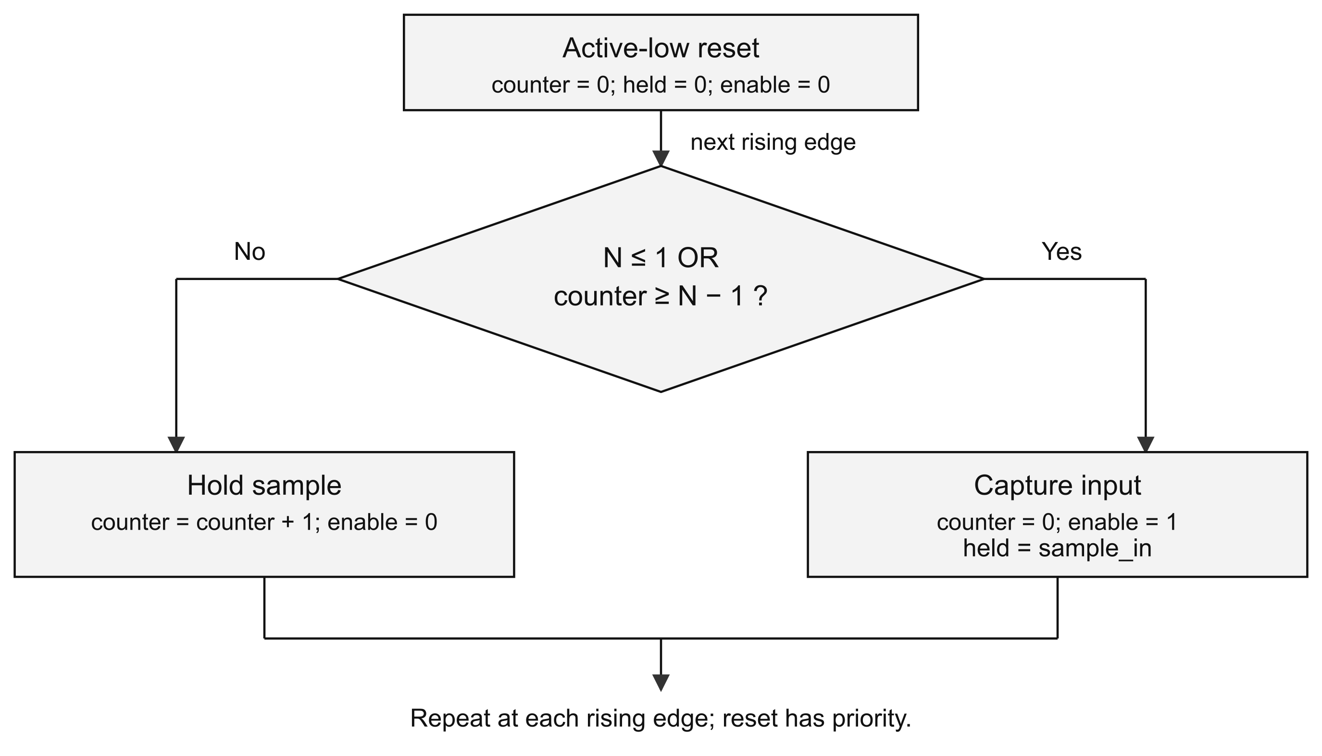
Fig. 2. Capture and hold decision flow in sample_rate_reducer.
Both sequential blocks use nonblocking assignments. On a capture edge, the holder reads the quantized value that existed before the source updates on that same edge. With N = 1, the held/output path therefore lags the raw source register by one clock. sample_en reports a capture on the most recent edge; it is continuously high for N = 1.
Gain is applied after sample holding. Sign extension to 19 bits occurs before the left shift, so the largest gain of eight is represented without overflow in the intermediate value. Signed comparisons clamp this result to −32768 or +32767. The capture rate is fclk / max(1, N); the base clock itself is unchanged.

4. VERILOG HDL IMPLEMENTATION

4.1 Design module
The following listings reproduce the five RTL modules used in the verified simulation [1]. Comments and blank lines are omitted for space; the sample-holder condition is wrapped across lines. The ROM is initialized from sine_rom.mem in the project working directory.

Audio source
`timescale 1ns/1ps
module audio_source (
input wire clk,
input wire rst_n,
output reg [7:0] addr_out,
output reg signed [15:0] sample_out
);
reg [15:0] rom [0:255];
initial $readmemh("sine_rom.mem", rom);
always @(posedge clk or negedge rst_n) begin
if (!rst_n) begin
addr_out <= 0;
sample_out <= 0;
end else begin
sample_out <= rom[addr_out];
addr_out <= addr_out + 1'b1;
end
end
endmodule

Bit-depth reducer
`timescale 1ns/1ps
module bit_depth_reducer (
input wire signed [15:0] sample_in,
input wire [3:0] bit_depth_sel,
output wire signed [15:0] sample_out
);
wire [15:0] mask;
assign mask = 16'hFFFF << bit_depth_sel;
assign sample_out = sample_in & mask;
endmodule
The ROM contains one sine period: round(32767 sin(2πn/256)), for addresses n = 0 through 255. gen_sine_table.py stores negative values as 16-bit two’s-complement hexadecimal words. The address counter naturally wraps after 255. ROM initialization support in a synthesized device depends on the chosen tool and target.

Sample-rate reducer
`timescale 1ns/1ps
module sample_rate_reducer (
input wire clk,
input wire rst_n,
input wire [7:0] hold_count,
input wire signed [15:0] sample_in,
output reg sample_en,
output reg signed [15:0] sample_out
);
reg [7:0] counter;
always @(posedge clk or negedge rst_n) begin
if (!rst_n) begin
counter <= 0;
sample_en <= 0;
sample_out <= 0;
end else if (hold_count <= 1 ||
counter >= hold_count - 1'b1) begin
counter <= 0;
sample_en <= 1;
sample_out <= sample_in;
end else begin
counter <= counter + 1'b1;
sample_en <= 0;
end
end
endmodule

Gain and saturation
`timescale 1ns/1ps
module gain_clipper (
input wire signed [15:0] sample_in,
input wire [1:0] drive_shift,
output reg signed [15:0] sample_out
);
wire signed [18:0] extended_sample;
wire signed [18:0] amplified_sample;
assign extended_sample = {{3{sample_in[15]}}, sample_in};
assign amplified_sample = extended_sample <<< drive_shift;
always @(*) begin
if (amplified_sample > 19'sd32767)
sample_out = 16'sh7FFF;
else if (amplified_sample < -19'sd32768)
sample_out = 16'sh8000;
else
sample_out = amplified_sample[15:0];
end
endmodule

Top-level interconnection
`timescale 1ns/1ps
module bitcrusher_top (
input wire clk,
input wire rst_n,
input wire [3:0] bit_depth_sel,
input wire [7:0] hold_count,
input wire [1:0] drive_shift,
output wire signed [15:0] crushed_out,
output wire signed [15:0] raw_sample_dbg,
output wire signed [15:0] quantized_sample_dbg,
output wire signed [15:0] held_sample_dbg,
output wire sample_en_dbg
);
audio_source u_source (
.clk(clk), .rst_n(rst_n), .addr_out(),
.sample_out(raw_sample_dbg)
);
bit_depth_reducer u_quantizer (
.sample_in(raw_sample_dbg), .bit_depth_sel(bit_depth_sel),
.sample_out(quantized_sample_dbg)
);
sample_rate_reducer u_rate_reducer (
.clk(clk), .rst_n(rst_n), .hold_count(hold_count),
.sample_in(quantized_sample_dbg), .sample_en(sample_en_dbg),
.sample_out(held_sample_dbg)
);
gain_clipper u_gain_clipper (
.sample_in(held_sample_dbg), .drive_shift(drive_shift),
.sample_out(crushed_out)
);
endmodule

4.2 Code explanation
Continuous assignments implement the mask and widened shift. The gain always block assigns every output branch, avoiding an inferred latch. In the holder, omitting sample_out from the non-capture branch intentionally retains a flip-flop value. The top module introduces no additional storage; its debug ports expose the connected stage outputs.

4.3 Testbench
bitcrusher_tb.v toggles clk every 10 ns and resets before each configuration. Each run records 32,768 outputs, one nanosecond after every rising edge, so nonblocking updates and combinational logic settle. The five configurations are (k, N, shift) = (0,1,0), (12,1,0), (0,16,0), (0,1,2) and (12,16,1).
blocks_tb.v uses $fatal on a mismatch and checks the combinational blocks exhaustively. check_demo.py independently computes quantization with integer floor division, capture timing and saturation, then checks every logged output [2]. Held values are logged on every clock, rather than only when sample_en is asserted.

5. SIMULATION, VERIFICATION AND RESULTS

5.1 Experimental setup
The design was compiled with Icarus Verilog and executed using vvp, following the compiler/runtime workflow described in [3]. The verification run used the existing project test scripts.
TABLE III. SIMULATION SETUP
Item | Details
HDL and simulator | Verilog RTL; Icarus Verilog 13.0 (stable); -g2012 -Wall.
Clock and reset | Demo: 20 ns period, 1 ns / 1 ps testbench timescale; active-low asynchronous reset before each case.
Stimulus | 256 × 16-bit sine ROM; five runs of 32,768 output samples.
Checks | Exhaustive quantizer and gain tests; directed holder tests; arithmetic comparison of complete demo.
Synthesis / device | Not performed; no FPGA or ASIC target selected.
Generated outputs | bitcrusher.vcd, crushed_samples.txt and bitcrusher_demo.wav.

5.2 Test cases and expected outcomes
TABLE IV. VERIFICATION RESULTS
Test ID | Input / condition | Expected output | Observed result
T1 | All 65,536 signed inputs; k = 0–15. | Floor input to a multiple of 2^k. | PASS: 1,048,576 cases.
T2 | All signed inputs; gain = 1, 2, 4, 8. | Multiply, then clamp to signed 16-bit range. | PASS: 262,144 cases.
T3 | Reset and N = 0, 1, 4, 255; three periods each. | Zero on reset; correct enable and held value. | PASS: all directed checks.
T4 | Reduce hold_count from 16 to 2 during operation. | Capture 1234 on the next due edge. | PASS: 1234 and enable = 1.
T5 | Five demo configurations, 32,768 samples each. | Exact arithmetic-model match, including latency and wraparound. | PASS: 163,840 samples; zero mismatches.
Reproduction sequence: run ./run_tests.sh from the project folder, then python3 convert_to_wav.py. The test script compiles and checks the blocks, regenerates the demonstration, and runs the independent comparison. The final run completed with no compiler warnings and no functional test failures.

5.3 Simulation waveform
Fig. 3 plots samples 256 through 512 from each measured output segment. Each window covers one complete steady-state source period after startup. The common signed-amplitude scale allows direct comparison of quantization, holding and clipping.
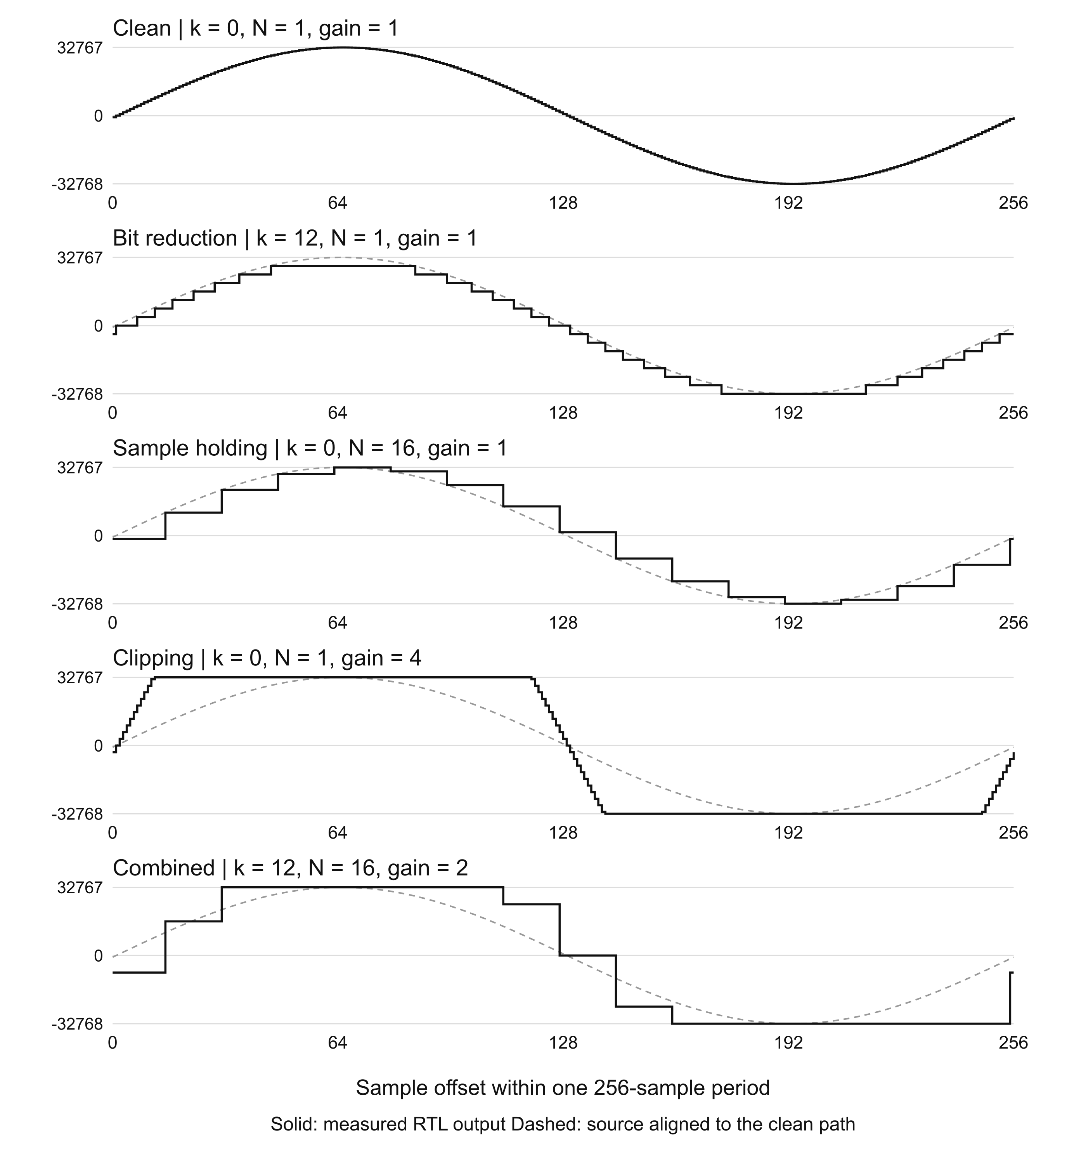
Fig. 3. Actual RTL output for the five configurations; sample log data.
Removing 12 bits produces 4096-count amplitude steps. Holding for 16 cycles produces flat intervals even though the source continues to advance. Gain of four creates flat positive and negative peaks at the saturation limits. The combined case exhibits both coarse amplitude levels and extended holding.

Fig. 4 shows the actual VCD signals during the first 800 ns after reset release in the combined case. New values are captured at 310 ns and 630 ns, corresponding to the 16th and 32nd active rising edges. The clock period is 20 ns, so captures are separated by 320 ns.
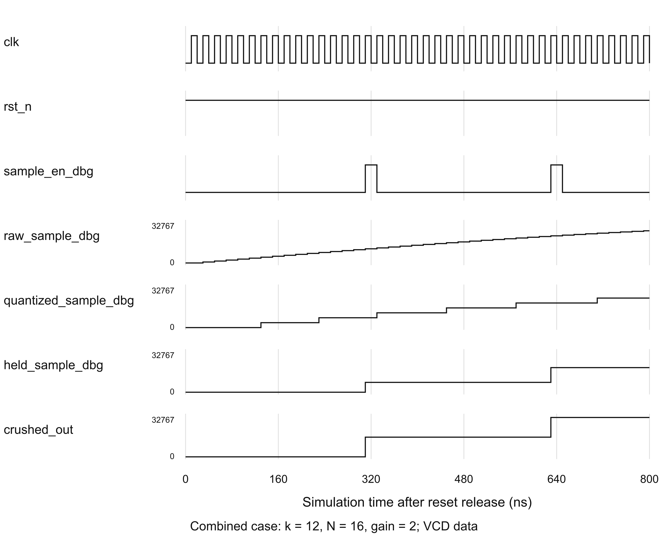
Fig. 4. VCD capture timing for k = 12, N = 16 and gain = 2.

5.4 Results and discussion
TABLE V. MEASURED OUTPUT RANGES
Configuration | Minimum | Maximum | Distinct values
Clean | −32767 | 32767 | 129
Bit reduction | −32768 | 28672 | 16
Sample holding | −32728 | 32728 | 17
Clipping | −32768 | 32767 | 23
Combined | −32768 | 32767 | 7
Table V counts all 32,768 values per case, including startup. Every sample matched the model. The bit-reduced negative minimum reflects downward masking; it does not indicate gain overflow. Distinct-value counts describe this sine stimulus, not every possible input.
The WAV uses mono 16-bit PCM at 32,768 samples/s through Python’s wave module [4]. The 163,840 samples give five one-second segments and a 128 Hz source tone (32,768/256). This playback rate is separate from the 50 MHz simulation clock. No hardware maximum clock frequency, area or power has been measured.

6. INDIVIDUAL CONTRIBUTION
The five-member allocation in Table VI assigns one owner to each major module and pairs implementation with verification and report responsibilities. Member numbers correspond to the order on the cover page.
TABLE VI. FIVE-MEMBER TASK ALLOCATION
Team member | Section / registration no. | Assigned responsibilities | Evidence / deliverables
Member 1  Name:  ____________ | Section: _____  Reg.: _______  Roll: _______ | Own the ROM source and table generation; check reset, address wraparound and sine values; explain the source architecture. | audio_source.v; gen_sine_table.py; sine_rom.mem; source description.
Member 2  Name:  ____________ | Section: _____  Reg.: _______  Roll: _______ | Own bit masking and the block diagram; check all k settings and signed rounding; maintain quantizer tests and explain amplitude steps. | bit_depth_reducer.v; quantizer tests; Fig. 1 block diagram; quantization examples.
Member 3  Name:  ____________ | Section: _____  Reg.: _______  Roll: _______ | Own capture/hold logic; verify reset, N = 0/1, capture flag and live N changes; explain timing and counter flow. | sample_rate_reducer.v; holder tests; capture-flow and timing analysis.
Member 4  Name:  ____________ | Section: _____  Reg.: _______  Roll: _______ | Own widened gain and saturation; check all input/gain combinations and limits; explain clipped and combined results. | gain_clipper.v; gain tests in blocks_tb.v; saturation analysis.
Member 5  Name:  ____________ | Section: _____  Reg.: _______  Roll: _______ | Own top-level integration and demo stimulus; run regression, compare samples, export WAV and assemble the report. | bitcrusher_top.v; bitcrusher_tb.v; check_demo.py; run scripts; convert_to_wav.py.

Contribution statement
Each module owner is responsible for its interface, explanation, tests and corrections. Member 5 coordinates integration after the owners agree on widths, signedness, control meanings and reset behaviour. All five members share final waveform review, cross-checking of report content and preparation for the demonstration. This allocation distinguishes individual ownership from joint review.

7. CONCLUSION AND FUTURE SCOPE

7.1 Conclusion
The digital audio bit crusher implements programmable bit-depth reduction, sample holding and saturating gain in a modular Verilog datapath. A ROM and counter supply repeatable stimulus, while exposed intermediate signals make each transformation observable. The implementation demonstrates sequential storage, combinational bit logic and signed arithmetic within a single project.
Verification satisfied the stated functional requirements. All 1,048,576 quantizer cases and 262,144 gain/clipping cases passed, as did the directed holder checks. The independent model matched all 163,840 integrated output samples, including startup timing and source wraparound. The measured waveforms show the intended staircase, held-sample and clipped behaviour.
The five-second WAV provides an audible demonstration of the same logged RTL output. The project therefore connects the digital logic implementation to both numerical evidence and an audio result. These conclusions apply to functional simulation; physical implementation performance has not been established.

7.2 Limitations and future scope
The present top-level design generates its own sine wave and has no external digital-audio interface. A practical extension would add a sample-valid input or an I²S interface and use an audio-rate clock enable. This would permit testing with recorded signals while keeping sample timing explicit.
Before FPGA deployment, the ROM initialization method must be checked against the selected synthesis tool. Pin assignments, clock constraints, reset release handling and synchronization of external controls would also be required. Synthesis and timing analysis could then provide actual resource counts and a defensible maximum operating frequency.
Further verification can cover every hold_count value, arbitrary control changes, reset asserted between clock edges, and longer mixed input sequences. Randomized scoreboarding would complement the existing exhaustive combinational checks and directed sequential tests.
Additional processing options include a selectable rounding mode, an optional filter before rate reduction, and configurable sample width. A filter would support a cleaner reduced-rate mode; leaving it disabled would preserve the intentional aliasing character of the bitcrusher effect.

REFERENCES
[1] Digital Audio Bit Crusher project, “RTL implementation and sine source,” local project files: rtl/audio_source.v, rtl/bit_depth_reducer.v, rtl/sample_rate_reducer.v, rtl/gain_clipper.v, rtl/bitcrusher_top.v, gen_sine_table.py and sine_rom.mem. Inspected Oct. 15, 2026.
[2] Digital Audio Bit Crusher project, “Simulation and verification suite,” local project files: tb/bitcrusher_tb.v, tests/blocks_tb.v, tests/check_demo.py, run_sim.sh and run_tests.sh. Executed Oct. 15, 2026.
[3] Icarus Verilog contributors, “Simulation Using Icarus Verilog,” Icarus Verilog documentation. Accessed: Oct. 15, 2026. [Online]. Available: https://steveicarus.github.io/iverilog/usage/simulation.html
[4] Python Software Foundation, “wave — Read and write WAV files,” Python documentation. Accessed: Oct. 15, 2026. [Online]. Available: https://docs.python.org/3/library/wave.html

