MANIPAL INSTITUTE OF TECHNOLOGY
CES 2103 Data Analytics | IA3 Mini Project

Estimated and Recorded Smartphone Screen Time Among BTech Students
Team 3
Team member | Registration number
Prithviraj Gokule | 251090052818
Manish G S | 251090052782
Madhav Sunil | 251090051962

1 Introduction and Objective
How accurately do B.Tech students estimate their daily smartphone use? We study this question by comparing an estimate with the average of seven daily phone records. Both measurements refer to the same person, primary phone and seven completed days. This keeps the comparison meaningful.
Our objective is to measure the direction and size of estimation errors, then test whether the average difference is zero. Exploratory data analysis (EDA) describes the patterns. Confirmatory data analysis (CDA) tests the specific hypothesis using a paired t-test.

2 Dataset Source and Description
The current source is data/simulated/screen_time_simulated.csv, created in Python with NumPy and the fixed random seed 20261017. It contains 120 simulated records, of which 112 pass validation. These are generated observations; no Google Forms responses were used for this analysis.
Each row represents one simulated student with an estimate and seven daily totals. The generator includes different usage levels, day-to-day variation, a small weekend increase and estimates rounded to 15 minutes. It assumes mean underestimation of 20 minutes, so the resulting bias partly reflects the model design. Eight invalid records were added to exercise the cleaning rules.
The planned survey uses the same fields: respondents estimate first, then enter daily totals for the same dates. Names, college identifiers and phone operating systems are not required. The current analysis demonstrates the method; conclusions about actual students require genuine responses.

3 Data Preprocessing
We preserve the source CSV and create a separate cleaned table. One row is one observation: seven daily readings are averaged within that row rather than counted as seven independent students.

3.1 Variables and units
Table 1 Main variables used in the analysis
Variable | Meaning | Unit or type
Participant ID | Label assigned after import | Nominal
Estimated daily time | Estimate before checking records | Minutes per day
Seven daily totals | Usage for each completed day | Minutes per day
Recorded daily average | Mean of all seven daily totals | Minutes per day
Signed error | Recorded average minus estimate | Minutes per day
Absolute error | Magnitude of the signed error | Minutes per day

Durations arrive as H:MM text and are converted to minutes. For example, 4:30 = 270 minutes, not 4.30 hours. The reference end date identifies the last day of the seven-day window. Five Yes/No fields record consent, B.Tech eligibility, first response, estimate-before-check confirmation and recording-scope confirmation.

3.2 Validation and exclusions
A row is included only when all five confirmations are Yes, the date is valid, and the estimate plus every daily reading is present and between 0:00 and 24:00. Eight rows fail: one has a missing daily total, one an impossible duration, one an invalid date, and five each fail a different confirmation. Thus 120 − 8 = 112 complete pairs remain.
We do not replace missing durations with zero or an average. An incomplete week is excluded. Identical response patterns are flagged for review rather than automatically deleted, because matching values do not prove that the same person responded twice. The audit records each inclusion decision and its reason.

3.3 Calculated measures
Recorded daily average = sum of the seven daily totals / 7
Signed error = recorded daily average − estimated daily time
Positive error means underestimation; negative error means overestimation. Absolute error is the size of this difference without its sign. For example, an estimate of 240 minutes and a recorded average of 300 minutes gives a signed error of +60 minutes and an absolute error of 60 minutes.

4 Exploratory Data Analysis
EDA describes the 112 included pairs before the hypothesis test. The mean gives the average, the median is the middle value, and the sample standard deviation (SD) describes variation between records. All durations below are in minutes per day.
Table 2 Descriptive statistics for the included records
Measure | Mean | Median | SD
Estimated time | 269.20 | 255.00 | 133.42
Recorded average | 291.68 | 283.93 | 112.84
Signed error | 22.48 | 28.00 | 72.17
Absolute error | 59.42 | 45.57 | 46.44

4.1 Comparing estimates with recorded averages
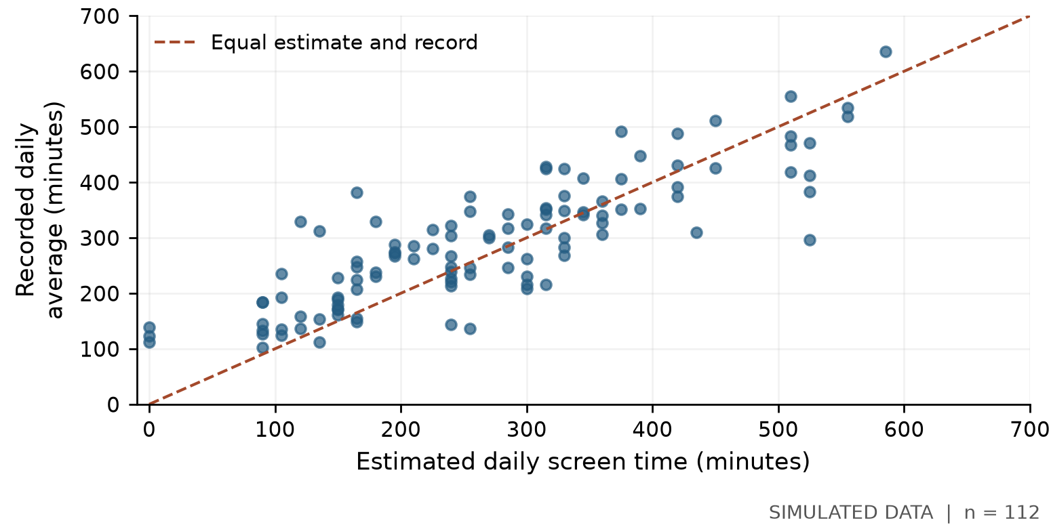
Figure 1 Each point represents one simulated record. The dashed line marks equal values.
Points above the dashed line show underestimation: the recorded average exceeds the estimate. Points below it show overestimation. Points close to the line have smaller errors. Although higher estimates generally accompany higher recorded use, the spread around the line shows that this association does not guarantee accurate estimates.
The mean estimate is 269.20 minutes, while the recorded mean is 291.68 minutes. Their difference is 22.48 minutes per day. The recorded median is 283.93 minutes, slightly below its mean, consistent with some higher-usage records pulling the mean upward.
These summaries answer different questions. The two usage means describe overall levels, while the signed and absolute errors describe how closely each estimate matches its own recorded average.

4 Exploratory Data Analysis Continued

4.2 Direction and size of the errors
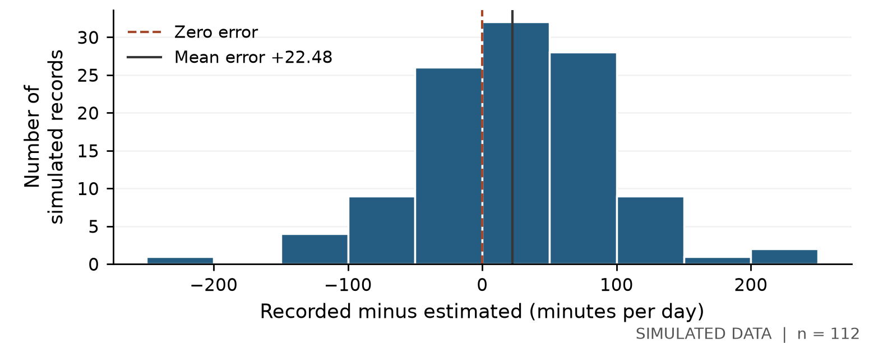
Figure 2 Errors occur on both sides of zero; the mean is positive.
Mean signed error is 22.48 minutes; mean absolute error is 59.42 minutes. Overestimates and underestimates partly cancel when we calculate the mean signed error. For example, errors of +60 and −60 average to zero, although both estimates are wrong by 60 minutes.
Using a descriptive 30-minute tolerance, 53 records (47.3%) underestimate by more than 30 minutes, 22 (19.6%) overestimate by more than 30 minutes, and 37 (33.0%) fall within 30 minutes. This tolerance is a project convention, not a health threshold or a validated accuracy standard.

4.3 Checking the differences before the test
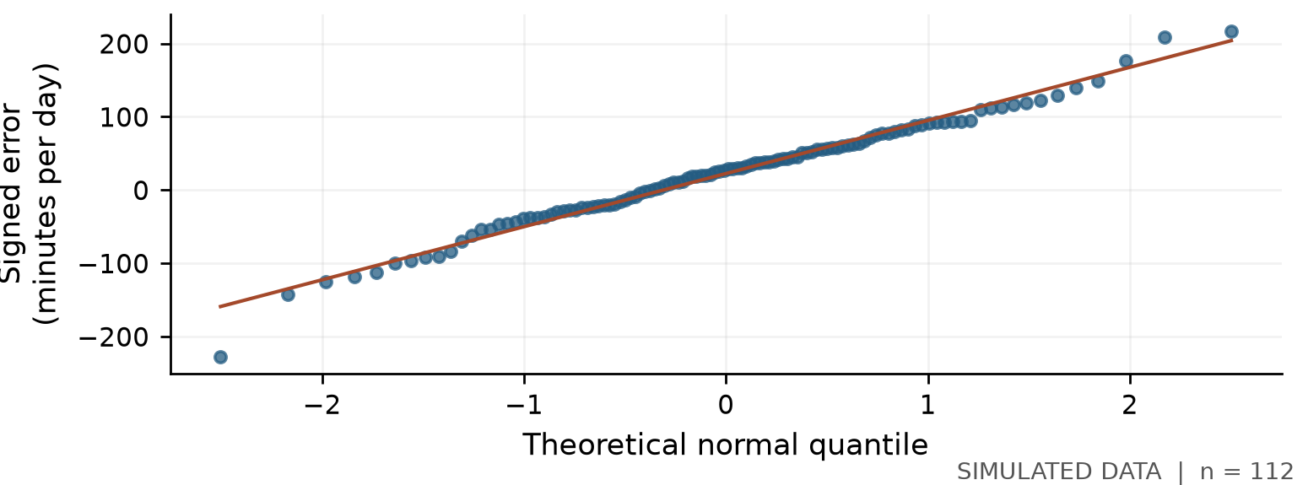
Figure 3 A normal Q–Q plot compares the observed differences with normal reference quantiles.
The Q–Q plot is roughly linear in the centre, with departures in the tails. Three differences fall outside the 1.5 × IQR fences, where IQR is the spread of the middle half of the data. We retain these valid values and report the departures. The paired t-test concerns the distribution of differences; these checks do not prove normality or independence.

5 Confirmatory Data Analysis

5.1 Hypothesis and test selection
We use a two-sided paired t-test at α = 0.05. Each estimate is matched to the same record’s seven-day average, so the analysis tests the within-record differences [1]. The two-sided choice allows either underestimation or overestimation.
H₀: the population mean of recorded minus estimated time is zero. H₁: this mean difference is not zero. In this report, the population is the hypothetical one represented by the simulation.
The test assumes independent participant differences and a sufficiently well-behaved distribution of differences. The previous page shows tail departures to consider when interpreting the result. A large sample cannot correct biased sampling or inaccurate entries.

5.2 Calculation and result
The standard error (SE) describes uncertainty in the estimated mean. It differs from the SD, which describes variation across individual records. The test divides the mean difference by its SE.
SE = 72.1744 / √112 = 6.8198 minutes
t = 22.4847 / 6.8198 = 3.2970 df = 112 − 1 = 111
Table 3 Paired t-test results for the simulated dataset
Result | Value
Complete pairs | 112
Mean difference | 22.48 minutes per day
Test statistic and degrees of freedom | t = 3.297; df = 111
Two-sided p-value | 0.00131
95% confidence interval | 8.97 to 36.00 minutes per day
Standardised paired effect size | Cohen’s dz = 0.312

5.3 Interpretation
Because p = 0.00131 < 0.05, we reject zero mean difference for this simulated analysis. If H₀ and the test assumptions held, a t-statistic at least this far from zero would be unlikely. The p-value is not the probability that H₀ is true.
The 95% confidence interval is 8.97 to 36.00 minutes per day and excludes zero. It describes uncertainty in the population mean difference, not a range containing 95% of individual errors. Under repeated sampling with the model assumptions, 95% of intervals constructed this way would cover that mean.
Cohen’s dz divides the mean difference by the SD of the differences: 22.48 / 72.17 = 0.312. The average bias is about 0.31 SD. The error in minutes remains the more direct measure of practical size.

6 Python Implementation and Reproducibility
The workflow is load, validate, calculate errors, explore, test and export. The notebook explains each step; reusable Python functions perform the calculations.

6.1 Libraries and core calculations
pandas organises the table; NumPy supports calculations. Matplotlib and Seaborn create plots, and SciPy provides the statistical test. CDA is the hypothesis-testing stage, rather than a separate Python library.
Here, numeric_days contains the seven duration columns. axis=1 calculates across each row; skipna=False prevents an incomplete week from being silently averaged.
frame["recorded_daily_minutes"] = frame[numeric_days].mean(
axis=1, skipna=False
)
frame["signed_error_minutes"] = (
frame["recorded_daily_minutes"]
- frame["estimated_daily_minutes"]
)
SciPy compares the matched columns [2]. Their order makes underestimation positive. nan_policy="raise" stops the test if missing values remain.
test = stats.ttest_rel(
clean["recorded_daily_minutes"],
clean["estimated_daily_minutes"],
alternative="two-sided", nan_policy="raise"
)
The code checks that the formula-based t and p-value match SciPy, and exports the confidence interval, effect size and outlier flags. Automated checks cover time conversion, exclusions, source handling and statistical calculations.

6.2 Code files and saved outputs
File or folder | Role
run.py | Command-line entry point
src/screentime/pipeline.py | Validation, EDA, paired test and exports
src/screentime/simulate.py | Reproducible simulation generator
notebooks/01_screen_time_analysis.ipynb | Explained analysis with outputs
config/ and outputs/ | Input settings and saved analysis results

Run python run.py --config config/simulated.json. Outputs include cleaned data, an audit, descriptive statistics, figures and statistics.json. A manifest records the source checksum, settings and software versions.
For a real survey, add data/raw/screen_time_real.csv, map form headings in config/real.json and rerun with that configuration. Refresh the notebook and report from the new outputs. Missing real data never trigger a fallback to simulation.

7 Findings and Conclusions

7.1 What the analysis shows
The generated records show average underestimation of 22.48 minutes per day, but an average absolute error of 59.42 minutes. This distinction is the main finding: a modest net bias can hide much larger errors in individual estimates.
EDA shows errors in both directions and wide variation between records. CDA finds evidence of a nonzero mean difference within the simulated model. These results answer complementary questions: the paired test addresses average bias, while the plots and absolute errors describe the spread and size of the mismatches.

7.2 Limitations and next step
The main limitation is the source. The data are simulated, and the generator already assumes some underestimation. The significant result therefore partly reflects those assumptions; it is not independent evidence about B.Tech students. The current project establishes a working analysis that can be applied to collected responses.
A future survey shared through friends would be a convenience sample, so it would not represent all B.Tech students. Respondents might mistype device totals or change an estimate after checking. An anonymous form also cannot fully verify unique participation. Keeping the same phone, dates and instructions helps consistency but does not remove these limitations.
The next step is to pilot the form, collect genuine responses and rerun the same analysis. The new results may support a different conclusion. Simulated and real records should remain separate, and every reported number and chart must be updated after a change of source.

7.3 Conclusion
We implemented the full process from data validation to statistical interpretation. The analysis explains why mean bias alone is not enough to judge estimation accuracy: the direction, absolute size and spread of the errors all matter. With genuine survey data, this workflow can assess how closely respondents’ estimates match their phone records.

Project Repository
https://github.com/itsmePrithviraj/ia3-data-analytics

References
[1] NIST/SEMATECH. e-Handbook of Statistical Methods, Two-Sample t-Test for Equal Means, discussion of paired observations. Accessed 26 October 2026.
https://www.itl.nist.gov/div898/handbook/eda/section3/eda353.htm
[2] SciPy documentation. scipy.stats.ttest_rel, related-sample t-test API. Accessed 26 October 2026.
https://docs.scipy.org/doc/scipy/reference/generated/scipy.stats.ttest_rel.html

