
SOLVING INVENTORY INEFFICIENCIES USING SQL
Summer Projects’25 Consulting & Analytics Club, IIT Guwahati

Abstract
This documentation is a walk-through of advanced SQL queries & suggested measures for Inventory optimization of a retail store named Urban Retail Co.
SQL enables the generation of actionable insights such as uncovering overstocking, stockout risks and producing key performance indicators to inform data-driven inventory decisions. This enhances overall inventory health. By designing robust relational schemas and employing advanced SQL queries, organizations can track inventory in real time.

Raghav Awadh Sahu
raghav.sahu@iitg.ac.in
OVERVIEW
Inventory optimization is the strategic process of ensuring that a business maintains the ideal amount of inventory to meet customer demand while minimizing costs and maximizing efficiency. Effective inventory optimization has become essential for businesses seeking to stay competitive and profitable in a dynamic marketplace.
About Urban Retail Co.
Urban Retail Co. is a rapidly expanding mid-sized retail chain with a presence in both physical stores and online platforms. They operate across several cities and offer more than 5,000 diverse stock keeping units (SKUs), ranging from daily groceries and home essentials to electronics and personal care items. Our logistics network depends on regional warehouses that feel inventory to individual retail outlets. With growing complexity in operations, we have now started struggling to maintain optimal inventory levels. While data from our sales transactions, product catalogues, and warehouse logs is available, it is underutilized, leading to significant inefficiencies in inventory management.
Challenges before Urban Retail Co.
- Frequent stock outs of fast-moving products.
- Over stocking of slow-moving products.
- No real time tracking of inventory.
- Poor visibility across product categories, stores & regions.
Preliminary actions:
- Exporting entire data to SQL database.
- Extracting whole data using SQL queries
- Understanding the key attributes of data.
As preliminary data analysis I also used some python’s matplotlib to get visible insights from the data. This preliminary assessment has helped to get an overview of the data and to identify any anomaly present in it.
Valuable insights that the plots gave:
- Data quality (nulls, types, duplicates)
- Sales trends over time
- Inventory levels and stock movement
- Top performing products and categories
- Key numerical relationships via correlation heatmap
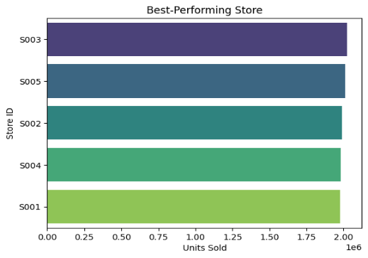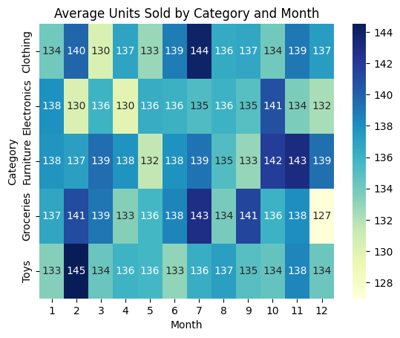
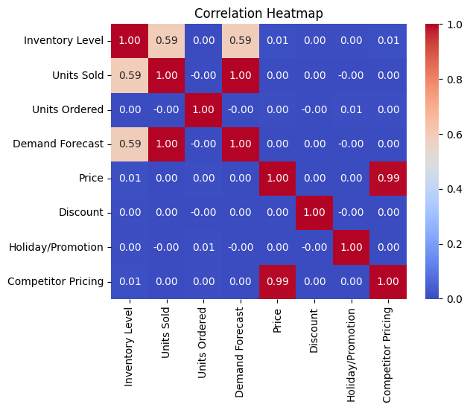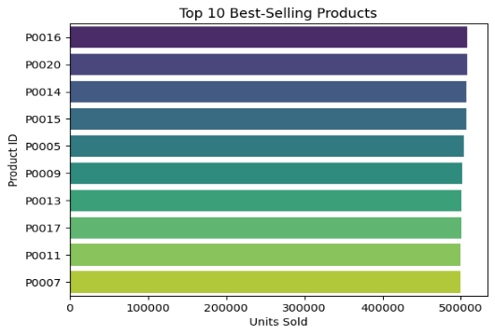

SQL QUERIES
SQL Query to extract whole data first from the table
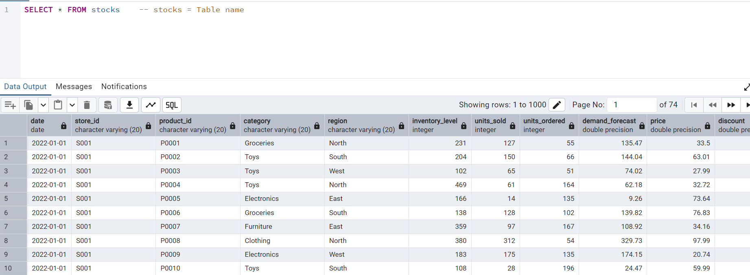
SQL script to extract inventory/stocks from a particular store of a product category
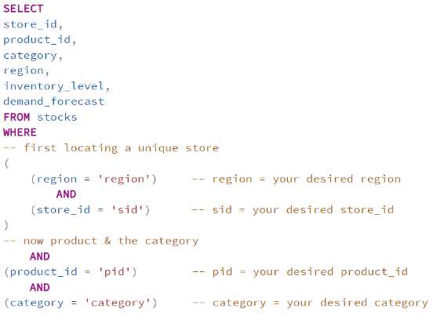
Performing this task and running the query again and again each time to check the inventory level feels tedious, right? Therefore, to uniquely identify a product we create a new column field named SKU (Stock Keeping Unit), which will help to pinpoint a product in any store of any region.

Normalization of inventory data
Normalization is a process to adjust values measured on different scales to a common scale, often to improve efficiency. Normalization means transforming data so that it fits within a specific range (such as 0 to 1). This makes it easier to compare datasets, run analyses, or feed the data into algorithms that require standardized input. The main goal of normalization, regardless of context, is to create consistency, comparability, and efficiency in handling data.
Normalization techniques:
- Min-Max Normalization
Min-max normalization is a technique used to rescale data values so that they fall within a specified range, typically between 0 and 1. This method is commonly used in data preprocessing for machine learning and statistics to ensure that features contribute equally to analysis or modelling.
The formula for min-max normalization is:
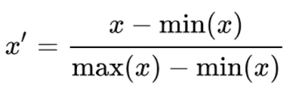
- x = original value
- min(x) = minimum value in the dataset
- max(x) = maximum value in the dataset
- x′ = normalized value
This formula transforms the minimum value to 0, the maximum value to 1, and all other values to a proportional decimal between 0 and 1
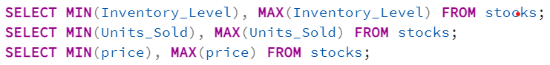
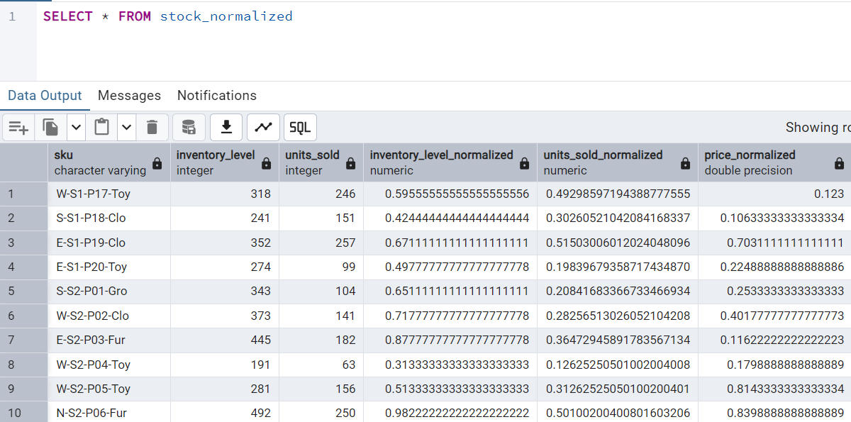
SOLUTIONS
Suggestions for Urban Retail Co. to better understand and keep track of their historic data on sales.
- SKU’s (Stock Keeping Units)
First & foremost, setting up a system of unique code that maps product uniquely, for this we suggest assigning SKU. SKU is used to define a unique code for every product, it benefits in several ways like speeding up the process of locating items and processing orders, enables inventory tracking in an efficient manner,
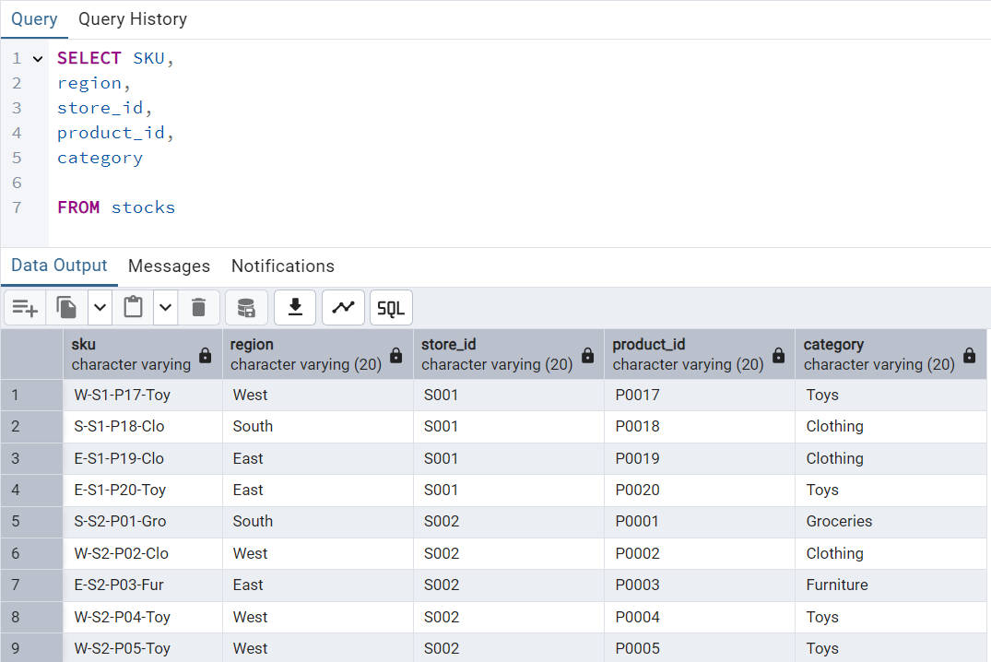

This SKU-based tracking system will help Urban Retail Co. in following ways:
- Track stock levels of each product variation.
- Pin-point which product is moving-fast while which is overstocked.
- Quickly identify when to reorder or discontinue items.

- Safety Stock
Safety stock is the inventory that a company should keep on hand to protect against the risk of running out of stock due to unexpected fluctuations. Safety stock plays a crucial role in modern inventory management, supply chain efficiency, and overall business profitability. Safety Stock also ensures that no product goes into excessive stocking, thereby preventing from both stockout and overstocking.
The general formula for calculating safety stock is Safety Stock = Z * σ * √L
Where,
- Z = z-score,
- σ = Standard deviation of demand forecast
- L = Lead Time (Lead time is the number of days after which the order is delivered since placed. taking it to be 1)

Z score: Also called Service level factor, used for safety stocks calculation. Safety stocks mean the minimum number of stocks that we desire to keep in our warehouse to avoid stock out.
If one says z score is 1.28 for 90% service level, this implies the person wants to have his inventory in stock available for 90% of the time & remaining 10% there’s a stock out risk.

The best fit service level for a firm is usually considered to be near 95%. This balances the need to avoid stockouts and maintains customer satisfaction.
Therefore, Z score considered in this case is 1.65

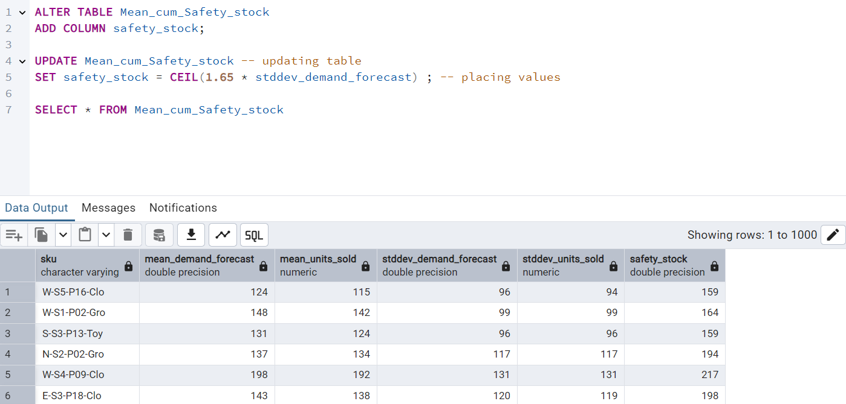

This approach ensures that even if there are unforeseen disruptions or demand exceeds forecasts, the store can continue to fulfil customer orders without interruption, thereby maintaining customer satisfaction and avoiding lost sales.

- Stock Turn-Over Ratio

The stock turnover ratio is a financial metric that measures how many times a company's inventory is sold and replaced over a specific period. A higher normalized stock turnover ratio indicates efficient inventory management, suggesting that inventory is being sold and replenished quickly, which will reduce holding costs and minimize the risk of obsolescence.
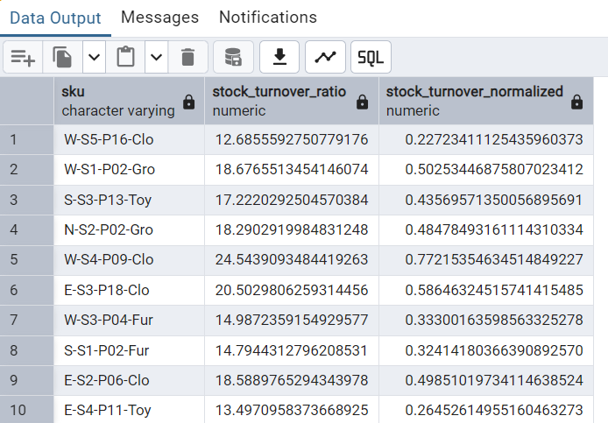
- Resisting Over-stockage
Excessive inventory leads to operational & financial that can undermine profitability and competitiveness.
- Increased Holding Costs: Overstocking requires more storage space, leading to higher warehousing fees, utilities, insurance, and labour costs.
- Reduced Cash Flow: Money invested in excess inventory is not available for other business needs like expansion, or paying down debt.
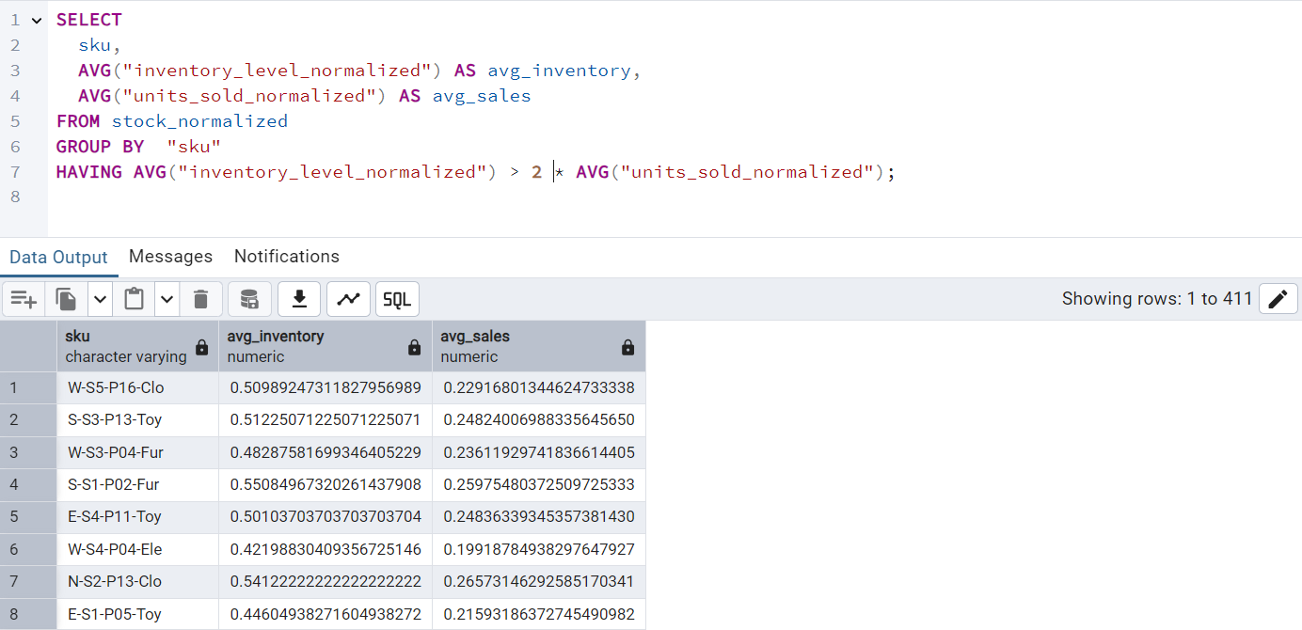

- Reorder point
Reorder Point (ROP) is the inventory level at which a new order should be placed to avoid stockouts. The general formula is:

ROP = (avg_units_sold * lead time) + (z-score * stddev_usage)
Z-score * stddev is also known as Safety stock

Lead Time (Lead time is the number of days after which the order is delivered since placed taking it to be 1)
