IN-SPACe CAN-7USAT
INDIA STUDENT COMPETITION 2026
3rd Edition


PRELIMINARY DESIGN REVIEW (PDR) DOCUMENT

TEAM- VRITRA



INSTITUTE - LOVELY PROFESSIONAL UNIVERSITY

TEAM ID- 2026-INSPACe-CAN-7USAT-025

INDEX
- Mission Overview----------------------------------------------------------------------------------------------------
- Team Description----------------------------------------------------------------------------------------------------
  - Faculty Advisor and Mentor-----------------------------------------------------------------------------------
  - Team Members--------------------------------------------------------------------------------------------------
  - Project Milestone Chart----------------------------------------------------------------------------------------
- List of Acronyms----------------------------------------------------------------------------------------------------
- System Overview----------------------------------------------------------------------------------------------------
  - Brief Summary of the mission--------------------------------------------------------------------------------
    - Mission flow-------------------------------------------------------------------------------------------
  - Changes made from PDR stage------------------------------------------------------------------------------
  - Overview of system level Requirements---------------------------------------------------------------------
  - CANSAT physical layout-------------------------------------------------------------------------------------
  - Entire CAN-7USAT Activities — Design Stage Through Launch, Recovery & Data Retrieval--
    - Design and Fabrication (Mechanical, CDH, Sensor, Comms, EPS, Descent & Recovery, Ground Station) -----------------------------------------------------------------------------------
  - Material Procurement Details----------------------------------------------------------------------------
    - Procurement Strategy----------------------------------------------------------------------------
    - Budget Compliance-----------------------------------------------------------------------------
    - Mass Budget------------------------------------------------------------------------------------
    - Procurement Risk Mitigation-----------------------------------------------------------------
  - System and subsystem level Analysis and Test results---------------------------------------------
    - Mechanical Subsystem (Structural Analysis) -Base Plate, Middle Plate, CANSAT Assembly
    - Command and data Handling (CDH)- Analysis and test----------------------------------------
    - Sensor subsystem- Analysis and test--------------------------------------------------------------
    - Communication subsystem – Link Analysis and test---------------------------------------
    - Electrical power subsystem- Analysis and test--------------------------------------------------
    - Descent and recovery Readiness-----------------------------------------------------------------
  - Flight Readiness Parameters--------------------------------------------------------------------------------
    - Structural & Mechanical Readiness-------------------------------------------------------------
    - Electrical Power Readiness--------------------------------------------------------------------
    - Communication and Telemetry Readiness-----------------------------------------------------
    - Flight Software & State Readiness----------------------------------------------------------------
    - Descent & Recovery Readiness------------------------------------------------------------------
  - Pre-Flight Analysis----------------------------------------------------------------------------------------
    - Descent Trajectory & Wind Drift Analysis---------------------------------------------------
    - Communication Link Prediction------------------------------------------------------------
    - Sensor Calibration Strategy-------------------------------------------------------------
- Sensor Systems Summary, Characterization and Test Results-----------------------------------------------
  - Pressure & Temperature Sensor (BMP585) -----------------------------------------------------------------
  - 6-Axis IMU---------------------------------------------------------------------------------------------------
  - 9-Axis IMU----------------------------------------------------------------------------------------------
  - GNSS Module-----------------------------------------------------------------------------------------------
  - Power Monitor----------------------------------------------------------------------------------------------
  - Particulate Matter sensor------------------------------------------------------------------------------------
  - Lighting Sensor-----------------------------------------------------------------------------------------------
  - UV light sensor-------------------------------------------------------------------------------------------------
  - Ozone gas sensor-------------------------------------------------------------------------------------------------
  - CO2 Sensor---------------------------------------------------------------------------------------------------
  - Real time clock RTC-------------------------------------------------------------------------------------
  - SPI Flash---------------------------------------------------------------------------------------------------
  - Consolidated Test Verification Matrix-------------------------------------------------------------------
- Actuator Summary-----------------------------------------------------------------------------------------------------
  - Control Mechanism of Actuator-------------------------------------------------------------------------------
  - Descent Control Mechanism Incorporated in CANSAT----------------------------------------------------
    - Sensing and Error Computation-----------------------------------------------------------------------
    - Off-Course Decision Gate----------------------------------------------------------------------------
    - Differential Brake Actuation--------------------------------------------------------------------------
    - Stabilization and Termination Check-----------------------------------------------------------------
- Block Diagram of Altitude control loop and actuator control loop--------------------------------------------
  - Attitude control loop-----------------------------------------------------------------------------------------
  - Actuator control loop-------------------------------------------------------------------------------------
- Detailed Description of Realized Subsystem---------------------------------------------------------------
  - Payload Subsystem-------------------------------------------------------------------------------------
    - Imaging Payload------------------------------------------------------------------------------------
    - Innovation payload------------------------------------------------------------------------------------
  - Housekeeping subsystem--------------------------------------------------------------------------------------
    - Mechanical subsystem---------------------------------------------------------------------------------
    - Actuators----------------------------------------------------------------------------------------------
    - Communication and data handling subsystem-----------------------------------------------------
    - Electrical power subsystem------------------------------------------------------------------------
    - Sensor subsystem----------------------------------------------------------------------------------
    - Parachute Deployment and recovery ----------------------------------------------------------
- CNASAT Algorithm, Final test results and deviations-------------------------------------------------------
- TTLC link margin realized-------------------------------------------------------------------------------------
  - Radio Interference Mitigation Plan---------------------------------------------------------------------
- Ground station final test results and deviations-----------------------------------------------------------------
- Mission operation and analysis----------------------------------------------------------------------------------
  - Launch day sequence-----------------------------------------------------------------------------------
- Pre- Flight Requirement check analysis-----------------------------------------------------------------------
- Logistics and transportation------------------------------------------------------------------------------------
  - CANSAT transportation and handling----------------------------------------------------------------
    - Pre-transport preparation---------------------------------------------------------------------
    - Transport method----------------------------------------------------------------------------------
- CANSAT ready to launch and final comment------------------------------------------------------------------
- Conclusion----------------------------------------------------------------------------------------------------------

TABLE INDEX
Table 1. Mentor details-----------------------------------------------------------------------------------
Table 2. Team Members details---------------------------------------------------------------------------
Table 3. Project milestone chart-------------------------------------------------------------------------------
Table 4. List of acronyms--------------------------------------------------------------------------------
Table 5. Mission requirement--------------------------------------------------------------------------------
Table 6. System level requirements--------------------------------------------------------------------------------
Table 7. Primary parachute parameters---------------------------------------------------------------------------
Table 8. Secondary parachute summary---------------------------------------------------------------------
Table 9. Secondary parachute parameters-----------------------------------------------------------------------
Table 10. Budget sheet--------------------------------------------------------------------------------
Table 11. Mass budget--------------------------------------------------------------------------------
Table 12. Power budget--------------------------------------------------------------------------------
Table 13. Structural & Mechanical Readiness-------------------------------------------------------------------
Table 14. Electric Power Readiness-------------------------------------------------------------------------------
Table 15. Communication and telemetry Readiness-----------------------------------------------------------
Table 16. Flight Software & State Readiness--------------------------------------------------------------------
Table 17. Descent & Recovery Readiness -----------------------------------------------------------------------
Table 18. Pressure & Temperature Sensor (BMP585) --------------------------------------------------------
Table 19. 6-Axis IMU (LSM6DSO32) ----------------------------------------------------------------------
Table 20. 9-Axis IMU (ICM-20948) ---------------------------------------------------------------------------
Table 21. GNSS Module (L89HA) --------------------------------------------------------------------------------
Table 22. Power Monitor (INA226) ------------------------------------------------------------------------------
Table 23. Particulate Matter Sensor (BMV080) ----------------------------------------------------------------
Table 24. Lightning Sensor (SEN0290-AS3935) ---------------------------------------------------------------
Table 25. UV Light Sensor (GYML8511) ----------------------------------------------------------------------
Table 26. Ozone Gas Sensor (MQ131) --------------------------------------------------------------------------
Table 27. CO2 Sensor (SCD41) ------------------------------------------------------------------------------
Table 28. Real-Time Clock (DS3231M) -------------------------------------------------------------------------
Table 29. SPI flash (7 Semi) ------------------------------------------------------------------------------
Table 30. Consolidated Test Verification Matrix----------------------------------------------------------------
Table 31. Imaging Payload (XIAO ESP32S3 Camera Module) ----------------------------------------------
Table 32. Innovation Payload (Biochemical Characterization of Atmospheric Bacterial Isolates) ------
Table 33. AGFRC A20BHM (x2) Parafoil Brake-Line Steering----------------------------------------------
Table 34. MG90S #1 Parachute Bay Lid Servo------------------------------------------------------------
Table 35. 2205 2300KV BLDC Motor – Stabilization Flywheel------------------------------------------
Table 36. Communication and Data Handling Subsystem (CDH) -----------------------------------------
Table 37. Onboard Data Storage ----------------------------------------------------------------------------
Table 38. Telemetry Radio (LR1121 LoRa) --------------------------------------------------------------
Table 39. T – Antenna 865 MHz-------------------------------------------------------------------------------
Table 40. Molicel INR-21700-P50B Battery Pack--------------------------------------------------------------
Table 41. Battery Protection (3S 40A Li-ion BMS) -----------------------------------------------------------
Table 42. 5V Power Regulation (AP64500 Buck Converter – 7Semi) -------------------------------------
Table 43. 3.3V Power Regulation (AP62301 Buck Converter – 7Semi) -----------------------------------
Table 44. Power-On Control (External Switch & LED Indicator) ---------------------------------------
Table 45. Power Budget-------------------------------------------------------------------------------
Table 46. Sensor Bus Allocation--------------------------------------------------------------------------------
Table 47. Telemetry Field Mapping--------------------------------------------------------------------------------
Table 48. Mission Operations & Analysis-------------------------------------------------------------------------
Table 49. Pre-Flight Requirement-Check Analysis--------------------------------------------------------------

FIGURE INDEX
Fig 1. CANSAT Figure Layout--------------------------------------------------------------------------------
Fig 2. Parachute Bay Design--------------------------------------------------------------------------------
Fig 3. CANSAT Schematic Design--------------------------------------------------------------------------------
Fig 4. Rod Design--------------------------------------------------------------------------------
Fig 5. Parachute Bay Schematic Design---------------------------------------------------------------------------
Fig 6. Gyro Wheel Schematic Design-----------------------------------------------------------------------------
Fig 7. Primary Telemetry Schematic-------------------------------------------------------------------------------
Fig 8. Backup Telemetry Schematic-------------------------------------------------------------------------------
Fig 9. Power System--------------------------------------------------------------------------------
Fig 10. Descent Schematic--------------------------------------------------------------------------------
Fig 11. Primary Parachute--------------------------------------------------------------------------------
Fig 12. Ground Station--------------------------------------------------------------------------------
Fig 13. Meshing of Base Plate--------------------------------------------------------------------------------
Fig 14. Stress Analysis of Base Plate------------------------------------------------------------------------------
Fig 15. Total Deformation Analysis of Base Plate---------------------------------------------------------------
Fig 16. FOS Analysis of Base Plate--------------------------------------------------------------------------------
Fig 17. Meshing of Middle Plate--------------------------------------------------------------------------------
Fig 18. Stress Analysis of Middle Plate----------------------------------------------------------------------------
Fig 19. Total Deformation Analysis of Middle Plate-----------------------------------------------------------
Fig 20. FOS Analysis of Middle Plate----------------------------------------------------------------------------
Fig 21. Meshing of CANSAT Assembly------------------------------------------------------------------------
Fig 22. Stress Analysis of CANSAT Assembly-----------------------------------------------------------------
Fig 23. Total Deformation Analysis of CANSAT Assembly------------------------------------------------
Fig 24. Buckling Analysis of CANSAT Assembly--------------------------------------------------------------
Fig 25. Command and Data Handling Subsystem---------------------------------------------------------------
Fig 26. Sensor Board-------------------------------------------------------------------------------
Fig 27. FSM Test--------------------------------------------------------------------------------
Fig 28. Data Output--------------------------------------------------------------------------------
Fig 29. Packet Transmission Result--------------------------------------------------------------------------------
Fig 30. MicroSD Card Storage Data-------------------------------------------------------------------------------
Fig 31. Communication Range Test--------------------------------------------------------------------------------
Fig 32. Telemetry Distance Test (Spot 1) ------------------------------------------------------------------------
Fig 32. Teleetry Distance Test (Spot 2) -----------------------------------------------------------------
Fig 33. Telemetry Packet Received--------------------------------------------------------------------------------
Fig 34. Ram-Air Parachute Drop Test----------------------------------------------------------------------------
Fig 35. Secondary Mechanism--------------------------------------------------------------------------------
Fig 36. Secondary Mechanism Control---------------------------------------------------------------------------
Fig 37. MATLAB Parachute Testing-----------------------------------------------------------------------------
Fig 38. Ground Level BMP Testing--------------------------------------------------------------------------------
Fig 39. BMP Testing from a Specific Height---------------------------------------------------------------------
Fig 40. IMU Testing--------------------------------------------------------------------------------
Fig 41. RTC Check--------------------------------------------------------------------------------
Fig 42. SPI Flash Test--------------------------------------------------------------------------------
Fig 43. Actuator for Petri-dish--------------------------------------------------------------------------------
Fig 44. Servo Flip--------------------------------------------------------------------------------
Fig 45. Parachute Bay Actuator Design--------------------------------------------------------------------------
Fig 46. Descent Control Mechanism Actuator Loop-------------------------------------------------------------
Fig 47. Altitude Control Loop-------------------------------------------------------------------------------
Fig 48. Actuator Control Loops--------------------------------------------------------------------------------
Fig 49. Radio Master T-Antenna--------------------------------------------------------------------------------
Fig 50. Power Subsystem--------------------------------------------------------------------------------
Fig 51. Parachute Dead Weight--------------------------------------------------------------------------------
Fig 52. CANSAT Algorithm--------------------------------------------------------------------------------
Fig 53. Communication Subsystem--------------------------------------------------------------------------------
Fig 54. Ground Station Test--------------------------------------------------------------------------------

- CAN-7USAT MISSION OVERVIEW
We are team VRITRA with a team ID as 2026-INSPACe-CAN-7USAT-025 of Lovely Professional University. We are developing a CAN-7USAT for the IN-SPACe CAN-7USAT India Student Competition 2026 which includes designing, fabrication and flight of CANSAT. The CAN sized satellite will be carried to an altitude of 1000 m or $±$100 m above the ground level (AGL) through a launch vehicle. It will be ejected from the rocket at the apogee and should have a two-stage recovery system while transmitting real time telemetry to a ground station.
Primary Mission Objective: This is the primary descent control system which is a hemispherical parachute connected to the outer body with no ejection mechanism and is deployed by the atmospheric drag. It will be activated directly after the ejection of CANSAT from the rocket having the descent rate of 20m/s with deviation of $±$5m/s.
Secondary Mission Objective: This is the secondary descent control system with a secondary deployment of a RAM-air parachute at an altitude of 600 m AGL. This reduces the descent rate to 1-3 m/s at touchdown. It is also an optional objective which covers precision, controlled flight and targeted landing and is demonstrated by GPS guided RAM air parafoil which enables active recovery at the target landing point near launch pad.
This document presents the Comprehensive Design Review (CDR) of a CAN sized satellite designed by team VRITRA.

- TEAM DESCRIPTION

  - Faculty Advisor and Mentor
NO. | NAME | ROLE | DESIGNATION
1 | Mr. Mandeep Singh | Faculty Advisor | Assistant Professor and Assistant Dean
2 | Mr. Ruhul Amin Choudhury | Mentor | Innovation Officer
3 | Dr. Elaya Perumal | Mentor | Assistant Professor
Table 1: Mentor details
  - Team Members
NO. | NAME | ACADEMIC YEAR | BRANCH | ROLE
1 | Numaan Aslma Khan | 4th year | B. Tech – Aerospace Engineering | Structural & Mechanical Systems Design
2 | Atharv Taralkar | 3rd year | B. Tech –Electronics and Communication Engineering | Electrical power subsystem (EPS) design
3 | Sujal Kalbhor | 3rd year | B. Tech –Electronics and Communication Engineering | System and hardware integration
4 | Vaishnavi Mahadik | 3rd year | B. Tech –Electronics and Communication Engineering | Communication and data handling subsystem (CDH)
5 | Rishav Raj | 2nd year | B. Tech – Robotics & Automation | Fight software design
6 | Aakanksha Rathore | 2nd year | B. Tech – Robotics & AI (CSE) | Ground control subsystem (GCS)
7 | Jasmeen Judge | 3rd year | B. Tech – Aerospace Engineering | Descent control design
8 | Ninad Nilesh Mestry | 3rd year | B. Tech – Aerospace Engineering | Can-Sat integration and test
Table 2: Team Members details
Since the PDR stage, a new member is added in our team which is highlighted in the table. This was to fill the gap which was created due to the absence of previous member.
  - Project Milestone Chart
PHASE / ACTIVITY | START DATE | END DATE | RESPONSIBLE
PDR document preparation & submission | May 16, 2026 | June 15, 2026 | All members
Component Purchasing | Jun 15, 2026 | Jul 5, 2026 | Sujal Kalbhor, Atharv Taralkar
PCB design & fabrication | Ju1, 2026 | Jul 30, 2026 | Vaishnavi Mahadik, Atharv Taralkar
Mechanical fabrication (body, bays) | Jul 15, 2026 | Aug 15, 2026 | Ninad Mestry, Numaan Aslma Khan
Flight software development (Teensy FSM) | Jul 18, 2026 | Jul 28, 2026 | Rishav Raj, Aakanksha Rathore
Parafoil & servo integration | Jul 25, 2026 | Aug 1, 2026 | Rishav Raj, Numaan Aslma Khan
Ground station software development | Jul 20, 2026 | Jul 25, 2026 | Aakanksha Rathore, Jasmeen Judge
Subsystem-level testing | Jul 20, 2026 | Aug 5, 2026 | Atharv Taralkar, Ninad Mestry
CDR document preparation | Jul 28, 2026 | Aug 8, 2026 | Vaishnavi Mahadik, Jasmeen Judge
Full integration & functional test | Jul 25, 2026 | Aug 30, 2026 | Atharv Taralkar, Sujal Kalbhor
Flight Readiness Review (FRR) | Sep 1, 2026 | Oct 15, 2026 | Jasmeen Judge, Sujal Kalbhor
Launch & competition | Oct 25, 2026 | Nov 30, 2026 | All members
Table 3: Project milestone chart

- LIST OF ACRONYMOUS
ACRONYM | EXPANSION
BMS | Battery Management System
CDH | Command & Data Handling
CFRP | Carbon Fibre Reinforced Polymer
CSV | Comma-Separated Values
DOF | Degrees of Freedom
EPS | Electrical Power Subsystem
FSM | Finite State Machine
GCS | Ground Control Station
GNSS | Global Navigation Satellite System
GPIO | General Purpose Input/Output
GPS | Global Positioning System
GS | Ground Station
I2C | Inter-Integrated Circuit (serial bus)
IMU | Inertial Measurement Unit
ISM | Industrial Scientific Medical (radio band)
LoRa | Long Range (radio modulation)
LOS | Line of Sight
MCU | Microcontroller Unit
NavIC | Navigation with Indian Constellation
PCB | Printed Circuit Board
PDR | Preliminary Design Review
PID | Proportional-Integral-Derivative (controller)
PM | Particulate Matter
PWM | Pulse-Width Modulation
RF | Radio Frequency
RTC | Real-Time Clock
SPI | Serial Peripheral Interface
UART | Universal Asynchronous Receiver/Transmitter
VCC | Voltage Common Collector (power supply)
CEP | Circular Error Probable
Table 4: List of acronymous

- SYSTEM OVERVIEW

  - Brief summary of the mission
CAN-7USAT is the entry for team VRITRA in IN-SPACe CAN-7USAT India student Competition 2026 which focuses on building a CAN sized satellite with two stage guided descent and full real time telemetry.
PARAMETER | TARGET
Deployment altitude | 1000 m (±100 m) AGL
Ejection shock survival | ≥ 30G
Primary descent rate | 20 m/s (±5 m/s)
Secondary activation altitude | 600 m (±10 m) AGL
Secondary descent rate | 1–3 m/s
Telemetry rate | ≥1 Hz over LoRa
Stabilization | Mechanical gyroscopic wheel
Table 5: Mission requirement
    - Mission flow
1. Ejection and Stabilization: In this stage the CANSAT separates from the rocket at apogee by surviving the ejection shock and stabilizes itself using a mechanical gyroscopic wheel.
2. Primary Descent: After ejection from the rocket, the hemispherical shaped parachute is opened due to the atmospheric drag without any ejection mechanism making the descent rate to 20 m/s $±$5 m/s.
3. Guided secondary descent: At 600 meters above the ground level, a GPS guided RAM air parafoil is deployed with the help of a servo-based ejection mechanism from the parachute bay. This design of parachute is made in such way that it cuts down the descent rate from 20 m/s to 1-3 m/s and is actively steering towards the launch site through the dual axis break line servo control.
4. Continuous telemetry: All 15 mandatory parameters are transferred with the help od LR1121 a LoRa at the rate of 1 Hz. It also has a backup microSD card for storing of data in case of packet or link loss.
Throughout the flight, the CAN-7USAT continuously acquires data from its onboard sensor stack and transmits all 15 mandatory telemetry parameters over a LoRa link at a minimum rate of 1 Hz, while simultaneously logging the complete dataset to an onboard microSD card as a backup in case of telemetry loss. The avionics architecture is built around a Teensy 4.1 primary flight computer running an 8-state finite state machine, supported by a secondary backup avionics board with an independent processing board to ensure telemetry continuity in the event of a primary processor failure.
Beyond the core mission, Team VRITRA also focusses on additional objectives of the mission which can help us in scoring additional points. The bonus capabilities for extra jury weightage are:
- Onboard video capture (descent + ejection)
- NavIC-enabled multi-GNSS positioning
- Environmental sensor suite — PM2.5/PM10, lightning, UV, ozone, CO₂
- Innovation payload: biochemical characterization of atmospheric bacterial isolates collected
- Custom Python ground station for live telemetry, command uplink, and mission logging

  - Any changes made from PDR stage
- Onboard CANSAT telemetry antenna has been changed from Rubber duck omnidirectional antenna (AEACAC049018-S868) to Radio master T antenna of 865 MHz. This change was done due to dual band requirement of frequency during telemetry. Team VRITRA has its primary frequency as 867.0 MHz and the backup frequency as 86.75 MHz, which is important for telemetry transmission without any interference. T antenna from Radio Master is a dual antenna which makes it easy for us to switch the frequency whenever required.
- Material of CANSAT has been changes which were Carbon fiber rods and glass fiber body. The body material which is selected is Acrylonitrile Butadiene Styrene (ABS) filament which is a tough, impact-resistant thermoplastic polymer. The plates are of aluminium and the rods are of glass fiber. This are changes made in material procurement which was done after the design testing on Ansys. According to the results the selected material gave better results as compared to the pervious in perspective of stress, etc.
- The gyro wheel motor was changed from N20 to 2205 2300KV brushless DC motor. This was done after testing our RAM air parachute. To avoid spinning of CANSAT after parachute deployment we needed higher RPM motor than the N20.
The required test results are given below to justify about the changes made in CDR stage.
  - Overview of System Level Requirement
The CANSAT design is made by considering specific conditions and rules as given in the rulebook which covers mass, dimensions, structural survivability, descent performance, telemetry, and power performance.
Parameter | Required Value | Design Target | Margin
Total mass | ≤ 1000 g $±$50 g | ~920 g $±65$g | 80 g
Diameter | ≤ 150 mm | 130 mm OD (fits rocket fairing) | 20mm
Height | ≤ 400 mm | 232 mm | 168
Launch acceleration survival | 15G | Rated > 30G (Al standoffs + CFRP body) | 2×
Shock survival | 30G | LSM6DSO32 rated ±32g range; PCBs on M3 standoffs | —
Primary descent rate | 20 m/s $±$5 m/s | 18–22 m/s | Within band
Secondary activation altitude | 600 m $±$10 m | BMP585, 5-sample average, ±3 m accuracy | ±7 m
Secondary descent rate | 1–3 m/s | 1.5–2.5 m/s under parafoil | Within band
Telemetry rate | ≥ 1 Hz | 1 Hz (Teensy 4.1) | —
Battery endurance on pad | ≥ 2 hours | ~6 hours at avg. 750 mA draw | 3×
Audio beacon SPL | ≥ 92 dB | SFM20 beacon: ≥ 95 dB | 3 dB
Table 6: System level requirements
This table has the design target with the required values in which each has a proper margin set so that it can tolerate manufacturing and flight variabilities. The key design considerations are:
- Modular stacked design — Base Plate, 3 Mid Plates, and a Parachute Bay connected by 4 continuous fiberglass rods, giving a rigid, serviceable structure (130 × 281 mm overall).
- Payload bay — 110 mm internal working diameter housing 3 stacked PCB layers for avionics, power, and mechanisms, within the 140 mm mechanical envelope constraint.
- Parachute bay/shell — hexagonal-lattice perforated cylinder (70 mm) for reduced mass and clean deployment-bag ejection.
- Materials — ABS for the shell/parachute bay (lightweight, printable), fiberglass rods for the primary load path (high strength-to-weight), and Aluminium 6061 plates for rigidity and mounting stability at joint interfaces.
- Load path — the fiberglass rods carry the full stack's structural loads through to the base plate, sized to handle the recovery system's peak opening shock (up to 11.1 G).

  - CANSAT physical layout

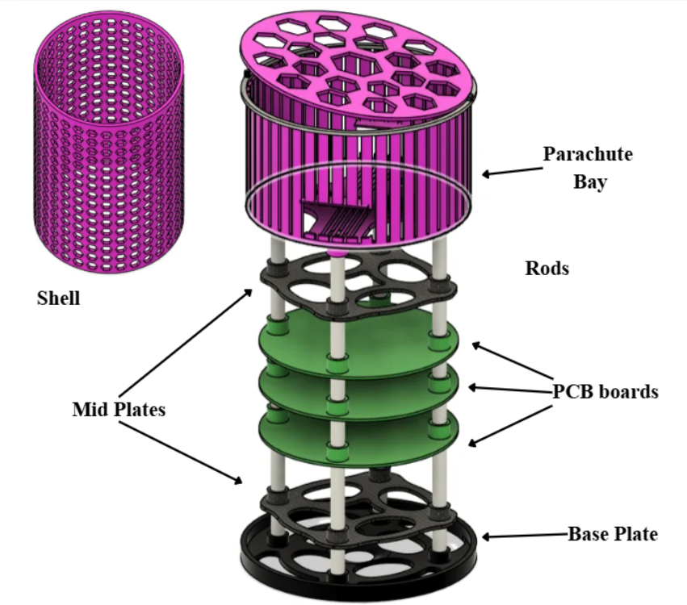

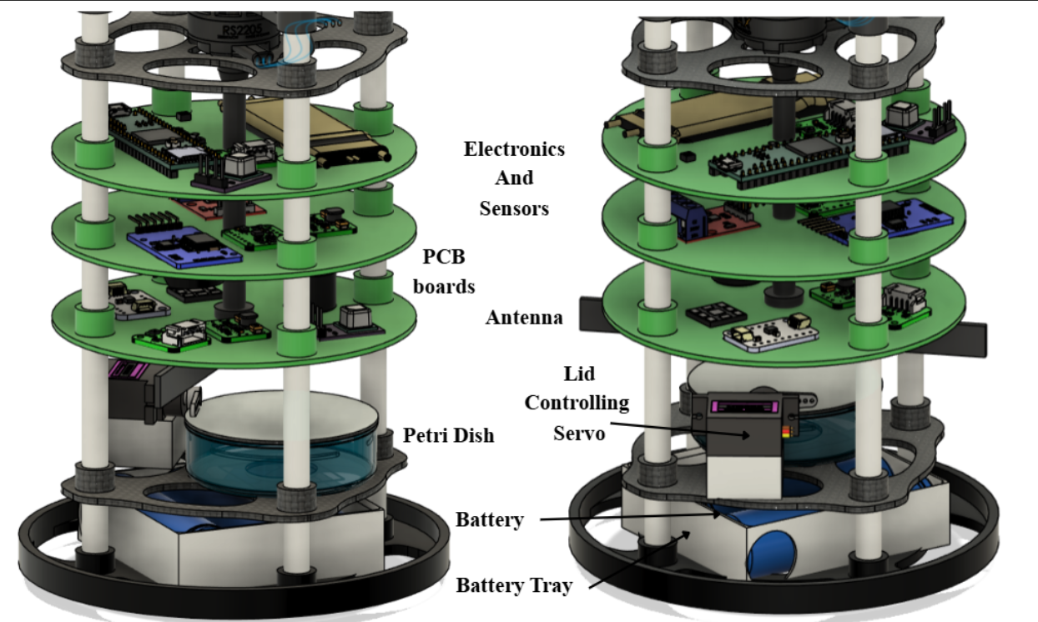

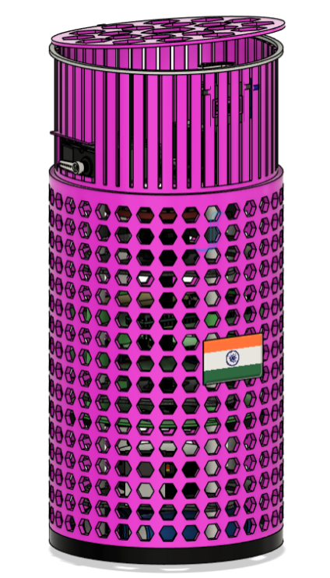
Fig 1: CANSAT Figure Layout
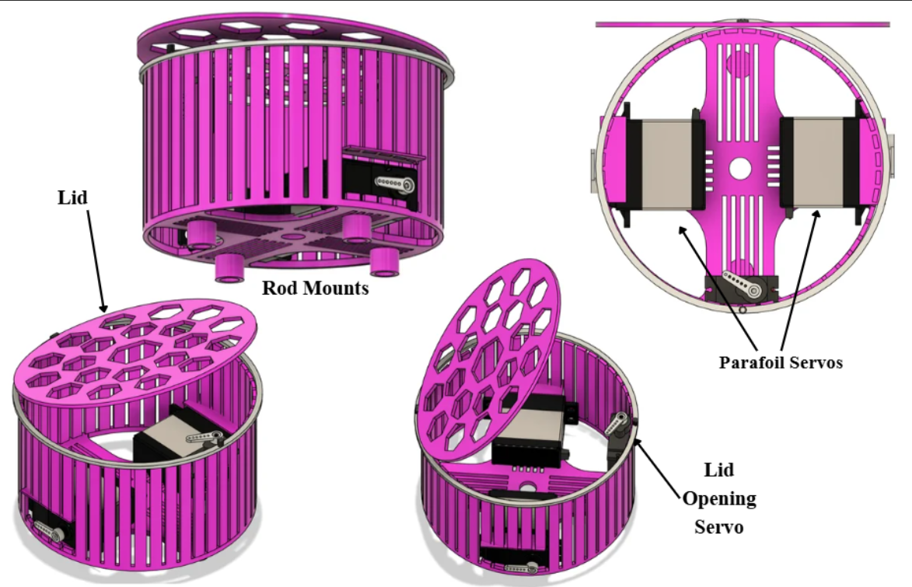
Fig 2: Parachute Pay design
This is the CANSAT physical layout in which all the parts are labelled properly. It consists of a cylindrical body having multiple subsystems inside it. Starting with the parachute bay which is designed for the Secondary descent GPS guided RAM air parafoil and the control mechanism to control the flow of parachute.
Next, we have designed a plate for the placement of gyro wheel and its motor to adjust properly. Followed by the gyro wheel we have electronics plates with all our telemetry components and backup board. The other mid plate after electronics is for battery holding purpose with a self-designed battery pack and can be easily replaced. Shell is designed to cover the CANSAT from external environment and to secure electronics as it has been instructed in the guidelines.
Below are some of the drawings of each part of our CANSAT with their dimensions:
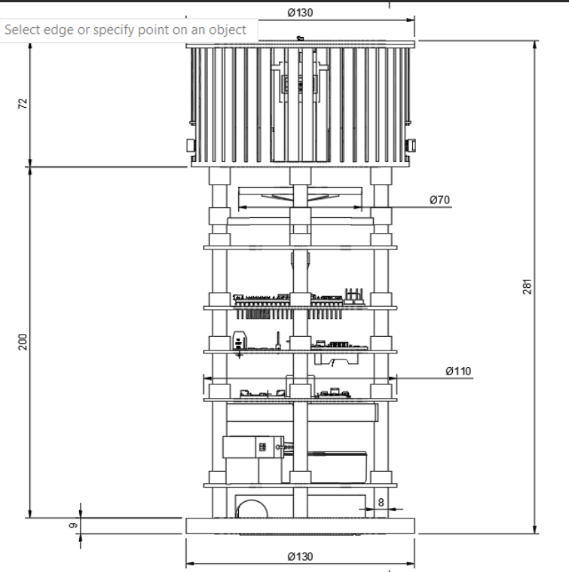
Fig 3: CANSAT Schematic design
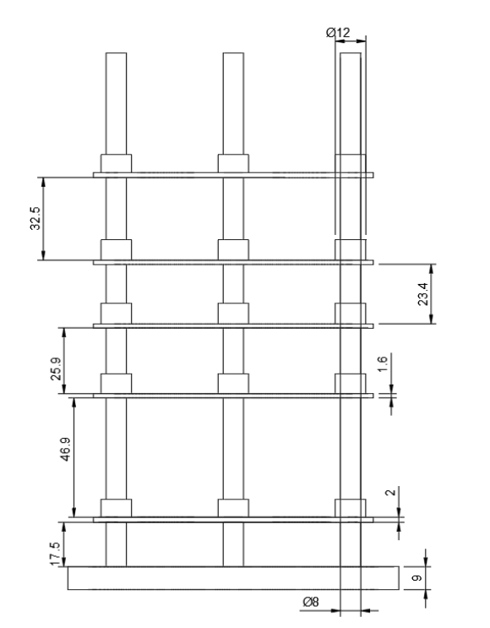
Fig 4: Rod Design
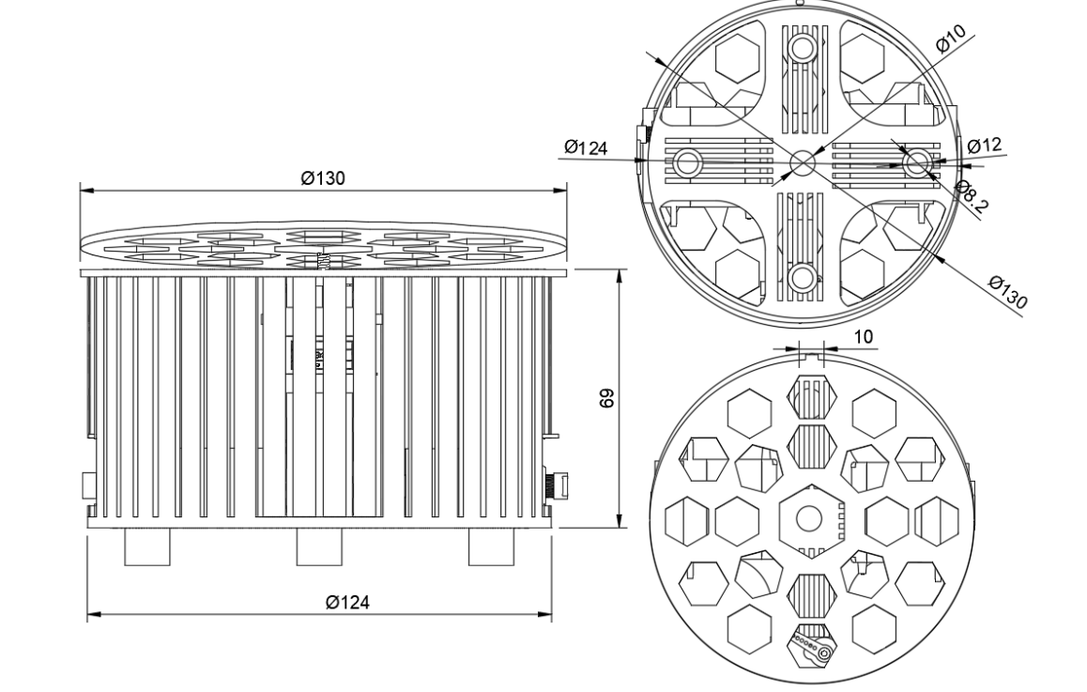
Fig 5: Parachute Bay Schematic Design

  - Entire CAN-7USAT Activities- Design Stage Through Launch, Recovery and Data Retrieval
The CANSAT mission consist of five different phases which goes from ground design and fabrication to post fight data recovery. Each phase carries its own verification checkpoints to ensure the system is flight-ready before proceeding to the next.
    - Design and Fabrication
Different subsystems such as the sensor subsystem, power subsystem, communication and data handling subsystem (CDH), etc have been designed as per the project milestone chart given above.
- Mechanical subsystem
Reaction-Wheel Geometry and Moment of Inertia:
  - A Thin Ring (PRIMARY DESIGN)
The primary design assumes the reaction wheel is constructed as a thin ring (rim-weighted geometry).
Formula: I = mr²
Where: m = wheel mass = 0.070 kg
r = wheel radius = 0.035 m
Calculation:
r² = (0.035) ² = 0.001225 m²
I_wheel, ring = m × r²
I_wheel, ring = 0.070 × 0.001225
I_wheel, ring = 0.00008575 kg·m²
Final Result: I_wheel, ring = 8.575000e-5 kg·m² = 85.75 × 10⁻⁶ kg·m²
This is the primary moment of inertia used throughout the calculation report.
  - Theoretical Motor No-Load RPM
Formula: RPM = KV × V
Condition 1: 3S Nominal Voltage (11.1 V)
Nominal cell voltage: 3.7 V per cell
3 cells in series: V = 3 × 3.7 = 11.1 V
Calculate theoretical no-load RPM:
RPM = KV × V
RPM = 1590 × 11.1
RPM = 17,649 RPM
Theoretical RPM at 11.1 V = 17649 RPM
Condition 2: 3S Fully Charged Voltage (12.6 V)
Full charge cell voltage: 4.2 V per cell
3 cells in series: V = 3 × 4.2 = 12.6 V
Calculate theoretical no-load RPM:
RPM = KV × V
RPM = 1590 × 12.6
RPM = 20,034 RPM
Theoretical RPM at 12.6 V = 20034 RPM
1.3 RPM Margin Above Target Operating Speed
Target wheel speed: N_required = 10000 RPM
Condition 1: Margin at 11.1 V (3S Nominal)
Theoretical RPM = 17,649 RPM
Required RPM = 10,000 RPM
RPM margin = 17,649 − 10,000 = 7,649 RPM
Percentage margin = (7,649 / 10,000) × 100 = 76.49%

At 11.1 V: RPM margin = 7649 RPM (76.49% above target)
Target represents 56.66% of theoretical no-load speed.
Condition 2: Margin at 12.6 V (3S Fully Charged)
Theoretical RPM = 20,034 RPM
Required RPM = 10,000 RPM
RPM margin = 20,034 − 10,000 = 10,034 RPM
Percentage margin = (10,034 / 10,000) × 100 = 100.34%

At 12.6 V: RPM margin = 10034 RPM (100.34% above target)
Target represents 49.92% of theoretical no-load speed.
1.4 Angular Velocity Conversion
Formula: ω = 2πN / 60
Condition 1: 5000 RPM
Step 1: N_rev/s = 5000 / 60 = 83.3333 rev/s
Step 2: ω = 2 × 3.14159265 × 83.3333 = 523.5988 rad/s
Condition 2: 7500 RPM
Step 1: N_rev/s = 7500 / 60 = 125.0000 rev/s
Step 2: ω = 2 × 3.14159265 × 125.0000 = 785.3982 rad/s
Condition 3: 10000 RPM
Step 1: N_rev/s = 10000 / 60 = 166.6667 rev/s
Step 2: ω = 2 × 3.14159265 × 166.6667 = 1047.1976 rad/s
Condition 4: 12000 RPM
Step 1: N_rev/s = 12000 / 60 = 200.0000 rev/s
Step 2: ω = 2 × 3.14159265 × 200.0000 = 1256.6371 rad/s
1.5 Moment of Inertia Summary
Primary design uses thin-ring geometry:
I_wheel, ring = 8.575000e-5 kg·m²
I_wheel, ring = 85.75 × 10⁻⁶ kg·m²
1.6 Angular Momentum
Formula: L = Iω
Angular Momentum at 5000 RPM
ω = 523.5988 rad/s
L = 8.575000e-5 × 523.5988 = 4.4899e-2 kg·m²/s
Angular Momentum at 7500 RPM
ω = 785.3982 rad/s
L = 8.575000e-5 × 785.3982 = 6.7348e-2 kg·m²/s
Angular Momentum at 10000 RPM
ω = 1047.1976 rad/s
L = 8.575000e-5 × 1047.1976 = 8.9797e-2 kg·m²/s
Angular Momentum at 12000 RPM
ω = 1256.6371 rad/s
L = 8.575000e-5 × 1256.6371 = 1.0776e-1 kg·m²/s
1.7 Rotational Kinetic Energy
Formula: E = (1/2)Iω²
Rotational Energy at 5000 RPM
ω = 523.5988 rad/s
ω² = 274155.677808 rad²/s²
E = 0.5 × 8.575000e-5 × 274155.677808 = 11.754425 J
Rotational Energy at 7500 RPM
ω = 785.3982 rad/s
ω² = 616850.275068 rad²/s²
E = 0.5 × 8.575000e-5 × 616850.275068 = 26.447456 J
Rotational Energy at 10000 RPM
ω = 1047.1976 rad/s
ω² = 1096622.711232 rad²/s²
E = 0.5 × 8.575000e-5 × 1096622.711232 = 47.017699 J
Rotational Energy at 12000 RPM
ω = 1256.6371 rad/s
ω² = 1579136.704174 rad²/s²
E = 0.5 × 8.575000e-5 × 1579136.704174 = 67.705486 J
At 10,000 RPM, the wheel stores 47.0177 J of rotational energy.
1.8 Centripetal Acceleration
Formula: a = ω²r
Centripetal Acceleration at 5000 RPM
a = 523.5988² × 0.035 = 274155.677808 × 0.035 = 9595.4487 m/s²
a_g = 9595.4487 / 9.81 = 978.1293 g
Centripetal Acceleration at 7500 RPM
a = 785.3982² × 0.035 = 616850.275068 × 0.035 = 21589.7596 m/s²
a_g = 21589.7596 / 9.81 = 2200.7910 g
Centripetal Acceleration at 10000 RPM
a = 1047.1976² × 0.035 = 1096622.711232 × 0.035 = 38381.7949 m/s²
a_g = 38381.7949 / 9.81 = 3912.5173 g
Centripetal Acceleration at 12000 RPM
a = 1256.6371² × 0.035 = 1579136.704174 × 0.035 = 55269.7846 m/s²
a_g = 55269.7846 / 9.81 = 5634.0249 g
1.9 Battery Theoretical Energy Storage
Battery Specification:
Type: 3S Li-ion
Nominal voltage: 11.1 V
Capacity: 5000 mAh = 5 Ah
Calculate theoretical stored energy:
Formula: E_battery = V × Ah
E_battery = 11.1 × 5 = 55.5 Wh
Convert to joules:
1 Wh = 3600 J
E_battery = 55.5 × 3600 = 199,800 J
Final result:
Battery theoretical stored energy = 55.5 Wh = 199,800 J
This represents total electrical energy available from a fully charged pack. Actual deliverable energy depends on discharge rate, temperature, cycle life, and battery C-rating.
1.10 Reaction-Wheel / CANSAT Moment of Inertia Ratio
Calculate: I_wheel / I_cansat = 8.575000e-5 / 7.969063e-3 = 1.076036e-2
Inertia ratio = 1.076036e-2 = 1.0760%
The reaction wheel's moment of inertia is approximately 1.076% of the CANSAT moment of inertia. This small ratio indicates that significant wheel torque is needed to produce CANSAT Altitude changes, typical for CubeSat-class satellites with limited actuators.
Gyro wheel design:
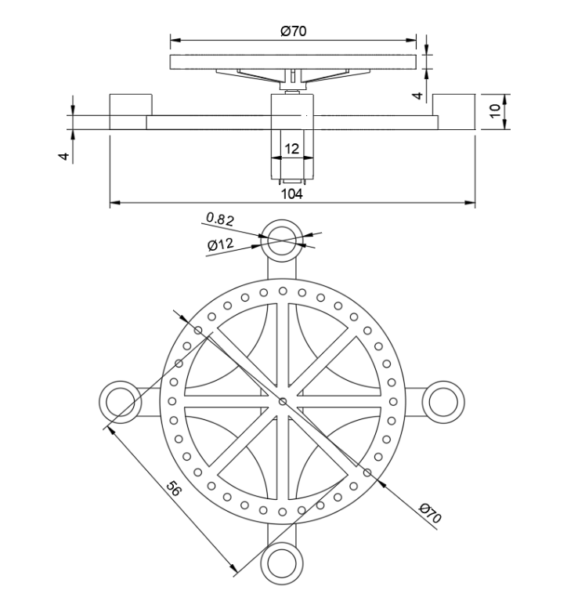

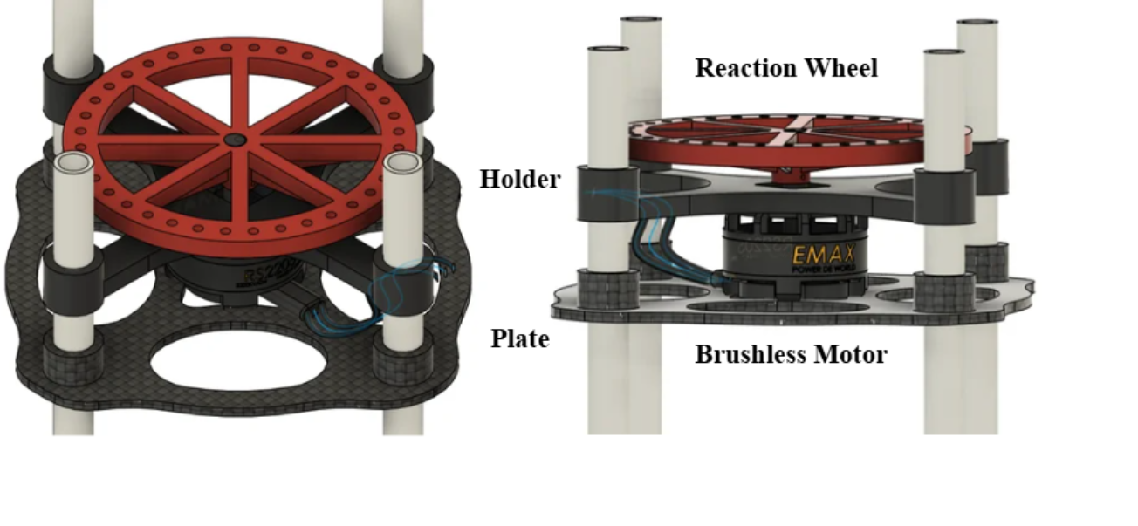
Fig 6: Gyro Wheel Schematic design

- Command and Data Handing (CDH) Subsystem
- Teensy 4.1 was selected as the primary flight computer after comparing multiple microprocessors. The optional microprocessors which were compared a
- re Raspberry pi 0, ESP 32 P4, STM 32, Teensy 4.0, etc. Teensy 4.1 was choose because of its specification which were good as compared to other such as processor speed, memory, pin count, footprint.
- 8-state flight software FSM architected and coded in C++ (Arduino/Teensyduino framework), running a 10 Hz sensor/control loop with 1 Hz telemetry sub-rate.
- XIAO ESP32S3 camera module is added as an independent recording subsystem (isolated from flight-critical control, so a camera failure cannot affect mission success).
- DS3231M RTC and onboard EEPROM is included for mission-time and flight-state persistence across any processor reset.
- SanDisk Ultra MicroSDHC selected for onboard data logging after comparing read/write speed and cost against SanDisk Extreme Pro and Kingston alternatives.

- Sensor Subsystem
- All sensors are selected through comparative trade studies based on the accuracy, power draw, interface compatibility, etc for each measurement type:

- BMP585 - barometric pressure/altitude ($±$0.5 Pa accuracy).
- LSM6DSO32 -6-DOF IMU for Secondary parachute control ($±$32g, $±$4000 dps range).
- ICM-20948 -9-DOF IMU/magnetometer for acceleration and spin-rate sensing.
- L89HA GNSS - multi-constellation GPS with NavIC support, dual-band L1+L5 for <1.8 m CEP accuracy.
- INA226 - real-time bus voltage/current/power monitoring.
- Bonus payload sensors -BMV080 (PM), SEN0290 (lightning), ML8511 (UV), MQ131 (ozone), SCD41 (CO₂).
- Telemetry packet format (15 mandatory and other bonus fields) defined and mapped to source sensors, with resolution/units specified per Interface Control Document.
- Sensor interfacing finalized across I2C, SPI, and UART buses, with bus-conflict mitigation planned (e.g., BMP585 moved to SPI or watchdog-recovery routine if I2C contention arises with the RTC).
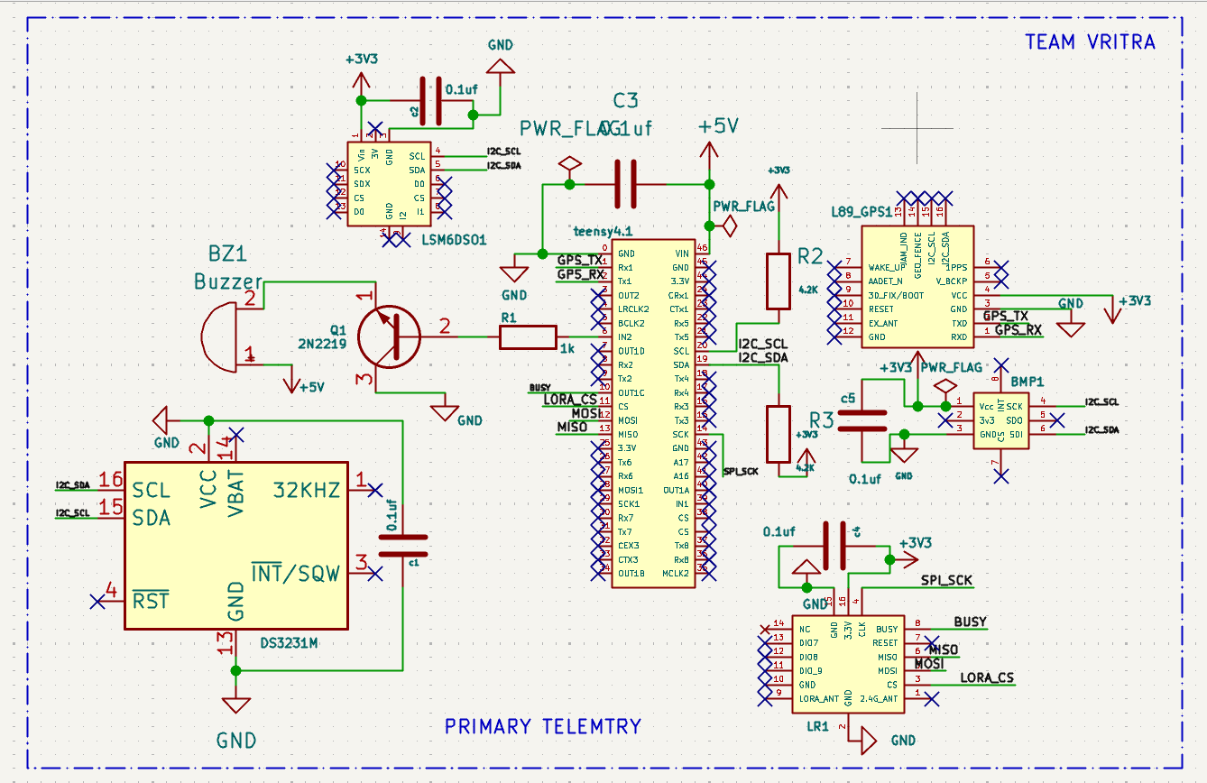
Fig 7: Primary telemetry Schematic
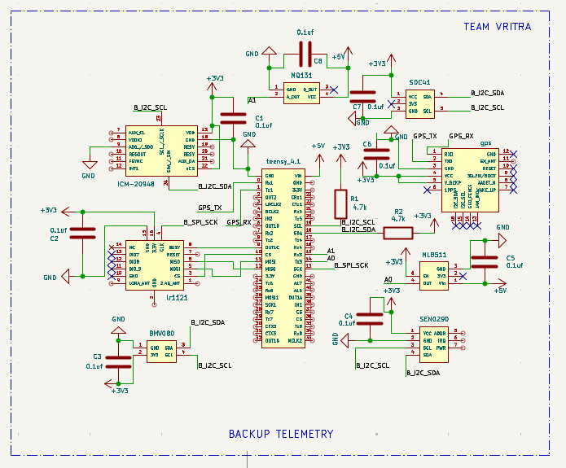
Fig 8: Backup Telemetry Schematic
This is the schematic design for all the important telemetry required from the CANSAT. All sensors are attached with a coupling capacitor to avoid current spikes in the circuit. Teensy 4.1 is the main processor of the CANSAT through which all other sensors are connected.
This is the Schematic design of CANSAT’s backup system and also about the additional environmental sensors used for bonus jury weightage. Backup system has a different processor which is Teensy 4.1. This will help us in getting the data even when the main processor shuts down.
- Communication & Data Handling Subsystem
- LR1121 multi-band transceiver is selected over SX1262/SX1280 for its dual Sub-GHz + 2.4 GHz flexibility and lower power draw.
- Configured as LoRa at 867 MHz (India ISM band) with team-specific NETID/PANID (0x98) to prevent cross-team packet collision.
- Bandit 915/868 MHz T antenna is selected for onboard transmission based on gain, frequency match, and connector compatibility.
- Radio interference mitigation plan defined: orthogonal spreading factor (SF10) selection, directional ground antenna gain, and packet-counter-based loss detection.
- Secondary/backup LR1121 link designed on the backup avionics board for failover telemetry continuity.

- Electrical Power Subsystem (EPS)
- 3S Li-ion battery pack (Molicel INR-21700-P50B, 5000 mAh) is selected and sized against the full mission power budget.
- 3S 40A BMS is used for overcharge/over-discharge/overcurrent/short-circuit protection and cell balancing.
- Dual buck converter architecture is designed by using 7Semi AP64500 (5V/5A rail) and AP62301 (3.3V/2A rail), sized against actuator and sensor current draw respectively.
- INA226 power monitor and status LED incorporated for real-time health telemetry and visual power-on confirmation.
- Power budget is calculated as per mission phase such as standby, pre-launch, ascent, descent, peak, etc to operate for 2-hour pad-endurance requirement and the design achieves roughly 6 hours of margin.
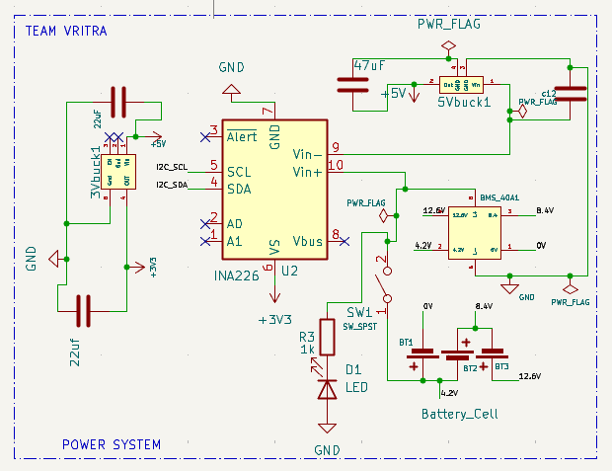
Fig 9: Power System
This schematic is about the power subsystem which is required for complete operation of CANSAT. It consists of 3 molicel 21700 lithium-ion batteries connected in series. This power schematic also consists of BMS and INA226. It has 5V and 3.3 V buck converters for power rails as required. A mandatory switch and a LED is connected through the power supply for the purpose of indication.
- Descent & Recovery Subsystem
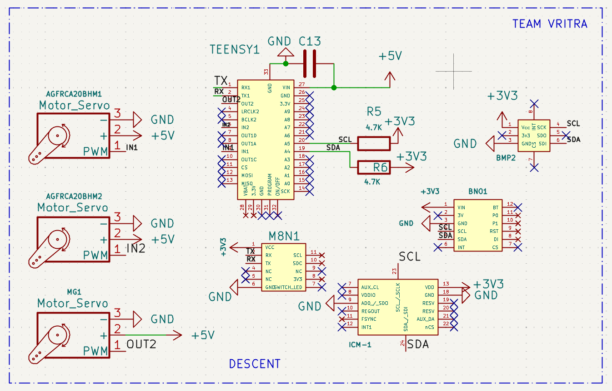
Fig 10: Descent Schematic
This schematic is about the descent subsystem. Team VRITRA’s secondary descent subsystem is about GPS guided RAM air parafoil which includes a different processor independent from any other which is used for telemetry. Teensy 4.0 has been selected for Descent control, so that any error in telemetry side will not affect the descent mechanism of parachute.
Primary Parachute Design:
A flat circular vented canopy is selected for primary parachute on the basis of:
- Fastest and most reliable deployment (critical for primary)
- No preferred orientation required
- Established drag coefficient data
Drag coefficient referenced to constructed (nominal) area = 0.75
At equilibrium descent, aerodynamic drag equals gravitational force:
$$\frac{1}{2}ρ1V_{s,P1}^{2}S_{P1}C_{D,P1}=mg$$
Solving for plan area $S_{P1}$:
$$S_{P1}=\frac{2mg}{ρ1V_{s,P1}^{2}C_{D,P1}}$$
Substituting values ($V_{s,P1}$= 15 m/s):
$$S_{P1}=\frac{2×1.000×9.810}{1.112×{15}^{2}×0.75}=\frac{19.620}{187.65}=0.1045 m^{2}$$
Canopy diameter from plan area:
$$D_{P1}=\sqrt{\frac{4S_{P1},design}{3.14}}=0.383 m$$
Central vent diameter:
d_{v} = 0.12 × D_{P} ₁ = 0.12 × 380 = 45.6 mm
Shroud Line length:
L_{s} = 1.5 × D_{P} ₁ = 1.5 × 380 = 570 mm
Parameters | Symbols | Values
Canopy type | - | Flat circular, vented
Plan area | $$S_{P1}$$ | 0.1134 $m^{2}$
Canopy diameter | $$D_{P1}$$ | 380 mm
Central vent diameter | $$d_{v}$$ | 45 mm
Drag coefficient | $$C_{d,P1}$$ | 0.75
Equilibrium sink rate | $$V_{s,P1}$$ | 14.4 m/s at 1000 m AGL
Number of shroud lines | $$n_{s}$$ | 8
Shroud line length | $$L_{s}$$ | 570 mm
Line spacing on canopy edge | $$Δs$$ | 149 mm
Line rated strength | - | 133 N (30 lb)
Table 7: Primary parachute parameters

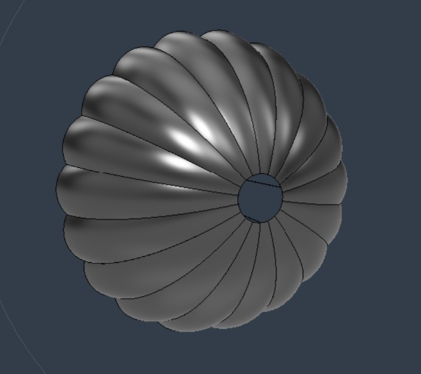
Fig 11 : Primary Parachute
Secondary Parachute design:
A ram-air parafoil is selected for P2 because:
1. It can be steered — two brake lines controlled by servos.
2. Its low equilibrium sink rate satisfies R-02.
3. Forward glide capability allows landing point adjustment.
A rectangular planform with low aspect ratio (AR = 2.30) is chosen for:
- Maximum collapse resistance (critical for autonomous control)
- Stable deployment without feedback
- Forgiving response to asymmetric brake inputs
Basic concept behind the RAM-air parachute idea is:
- Autonomous multi-stage descent controller for mission execution.
- Sensor-fusion-based altitude estimation using barometer and IMU data.
- GPS-guided navigation with wind compensation for target-oriented descent.
- Controlled flare and braking mechanism for safe and accurate landing.
- Real-time telemetry, onboard logging, and fault-recovery capabilities for mission reliability.
Minimum Canopy Area Derivation:
$$S_{P2}=\frac{2mg}{ρ2V_{s}^{2}C_{L}\left(1+GR^{2}\right)}$$
$$=\frac{19.620}{1.155×6.250×0.90×7.250}$$
$$=0.415m^{2}$$
Performance verification:
$$V_{total}=\sqrt{\frac{2mg}{ρ_{2}S_{p2}C_{L}}}$$
$$=\sqrt{\frac{2×1.000×9.810}{1.155×0.40×0.90}}$$
$$=\sqrt{\frac{19.620}{0.4158}}=\sqrt{47.19}=6.87 m/s$$

Forward speed:
V_{f} = GR × V_{s} = 2.50 × 2.55 = 6.37 m/s
Canopy Loading:
$$\frac{W}{S_{P2}}=\frac{mg}{S_{P2}}=\frac{1.000×9.810}{0.40}$$
$$=24.5\frac{N}{m^{2}}=2.50 kg/m^{2}$$
Profile Feature | Ratio (% chord) | Formula | Dimension
Max thickness | 14% | 0.14 × 420 | 58.8 mm ≈ 59 mm
Position of max thickness | 32% from LE | 0.32 × 420 | 134 mm from LE
Max camber (upper surface) | 9% | 0.09 × 420 | 37.8 mm ≈ 38 mm
Position of max camber | 35% from LE | 0.35 × 420 | 147 mm from LE
Leading edge radius | 2.5% | 0.025 × 420 | 10.5 mm ≈ 11 mm
Trailing edge thickness | 1.5% | 0.015 × 420 | 6.3 mm ≈ 7 mm
Table 8: Secondary parachute summary

Parameter | Symbol | Value
Canopy type | - | Ram-air parafoil, rectangular, 7 cells
Plan area | $$S_{P2}$$ | 0.400 m2
Span | b | 960 mm
Mean chord | C | 420 mm
Aspect ratio | AR | 2.30
Number of cells | $$n_{cell}$$ | 7
Number of ribs | $$n_{rib}$$ | 8
Cell width | $$w_{cell}$$ | 137 mm
Max profile thickness | $$t_{max}$$ | 134mm
Max camber | $$f_{max}$$ | 147 mm
Entry mouth height per cell | $$h_{inlet}$$ | 30mm
Lift coefficient | $$C_{L}$$ | 0.90
Glide ratio | GR | 2.50
Equilibrium sink rate | $$V_{s}$$ | 2.55 m/s at 600 m AGL
Forward speed | $$V_{f}$$ | 6.37 m/s
Total trim airspeed | $$V_{total}$$ | 6.87 m/s
Canopy loading | W/S | 24.5 N/m2
Main line length | $$L_{line}$$ | 870 mm
Brake line length | $$L_{brake}$$ | 1050 mm
Riser length | $$L_{riser}$$ | 90mm
Total suspension length | $$L_{total}$$ | 960 mm
Total lines | - | 16 (14 main + 2 brake)
Brake drag force | - | 0.661 N per side
Table 9: Secondary parachute parameters

Parachute material:
Selected material | Selection reason
  Ripstop Nylon 40D | • Lightweight and compact for CanSat parachutes  • High tear resistance due to ripstop weave  • Good strength-to-weight ratio  • Water-resistant and weather-resistant  • Easy to fold and deploy

Parachute threads:
Selected thread | Selection reason
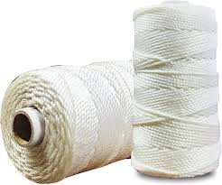  Nylon Thread | • High tensile strength for parachute suspension lines  • Lightweight and flexible  • Good resistance to wear and abrasion  • Easy to stitch and handle during assembly  • Cost-effective and readily available

- Ground Station
- Ground hardware architecture is defined as laptop, LR1121 receiver via ESP32-WROOM bridge, Radio master omnidirectional T antenna 865 MHz.
- Ground software developed in Python (PyQt5 + Matplotlib) for real-time telemetry display, live plotting of all 15 fields and additional telemetry data, CSV logging, command uplink (TX ON/OFF, calibrate), and GPS track visualization.
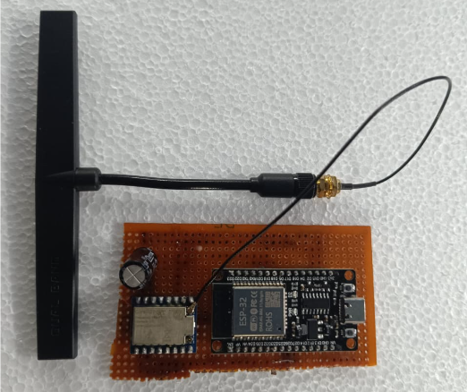
Fig 12: Ground Station
  - Material Procurement details
All components of team VRITRA are sources from combination of different domestic electronics suppliers and international distributers. The main preference is given to the Indian manufactured parts where precision is better as compared to other international components because according to the guidelines of competition, Make-in-India components are given additional points.
4.6.1 The procurement strategy
- Primary domestic suppliers: Robu.in, Amazon India and local Indian electronics vendors for sensors, connectors, and mechanical hardware.
- International/specialty suppliers: Digikey for components not readily available domestically (e.g., specific IMU breakout variants, precision servos).
- Direct manufacturer sourcing: A significant share of the sensor and power-regulation stack such as BMP585, ICM-20948, BMV080, AP64500, AP62301, and others, is sourced directly from 7Semi Technologies, an Indian company based in Navi Mumbai specializing in embedded sensors and wireless communication modules — these components are highlighted in the BOM as Make-in-India contributions.
- Structural materials: Glass fiber rods, plates, and sheet stock procured separately for the shell, base plate, and internal structural elements.
- Procurement timeline: Component purchasing is scheduled as a dedicated milestone immediately after PDR submission, ahead of PCB fabrication and mechanical fabrication, to avoid schedule slip on integration and testing.
4.6.2 Budget Compliance
COMPONENT | PURPOSE | QTY. | SOURCE | TOTAL COST (₹)
BMP585 | Pressure & Altitude Sensor | 3 | 7 Semi | 1,675.20
LSM6DSO32 | 6-DOF IMU + Gyroscope | 1 | Digikey | 1705.00
ICM-20948 | 9-DOF IMU + Magnetometer | 2 | 7 Semi | 1,536.00
SCD41 | CO₂, Temperature & Humidity Sensor | 1 | 7 Semi | 6,224.00
SEN0290 (AS3935) | Lightning Detection Sensor | 1 | Digikey | 2,199.00
ML8511 | UV Sensor | 1 | Robu.in | 2,099.00
MQ131 | Ozone (O₃) Sensor | 1 | Robu.in | 1,449.00
BMV080 | PM2.5 Air Quality Sensor | 1 | 7 Semi | 1,092.00
TPL5010 | Watchdog Timer | 1 | Digikey | 4067.00
W25Q64 SPI Flash | Data Backup Memory | 1 | 7 Semi | 111.20
INA226 | Voltage & Current Monitor | 2 | Robu.in | 219
SN74LV4052A | Analog Multiplexer | 1 | Digikey | 290.00
DS3231N RTC | Real-Time Clock | 1 | Think Robotics | 299.00
Teensy 4.1 | Primary & Backup Flight Controller | 2 | Robu.in | 7998.00
ESP32-S3 | Ground Station Processor | 1 | Robu.in | 2,709.00
XIAO ESP32-S3 | Camera Module | 2 | Robocraze | 2,011.00
LR1121 LoRa | Telemetry Transceiver | 2 | Think Robotics | 2450
T antenna 865 MHz | Onboard and ground station omnidirectional antenna | 2 | Radio master | 3700
L89 GPS | NavIC/GPS/GLONASS GNSS | 2 | 7 Semi | 1,598.40
NavIC GPS Antenna | Active GNSS Patch Antenna | 2 | Edge hex | 1,500.00
AGFRC A20BHM | Parafoil Line Control | 2 |  | 9000
MG90S Servo | Secondary Deployment Mechanism | 2 | Robu.in | 444.00
EMAX2205 2300kv | Gyroscope Wheel Motor | 1 | Robu.in | 750
Bi directional ESC 40A | Motor Driver | 1 | 7 Semi | 1167
3S 40A Li-ion BMS | Battery Protection Circuit | 1 | Amazon India | 817.00
DFR1015 | Multi-Output Buck Converter | 2 | Digikey | 1,000.00
AP64500 5V 5A Buck | Servo Power Supply | 3 | 7 Semi | 1,675.20
AP62301 3.3V 2A Buck | Sensor Power Supply | 3 | 7 Semi | 235.20
Teensy 4.0 | Secondary descent MCU | 1 | Robu.in | 2,549.00
NEO M9N | GPS module | 1 |  | 2,000.00
XT30 Connector | Battery Connection | 5 | 7 Semi | 245.00
Capacitors | 470 µF & 0.1 µF | Set | Amazon India | 100.00
Resistors | Various Values | Set | Amazon India | 125.00
Glass Fibre Rod | Structural Component | 4 |  | 1700.00
SD Cards | Camera & MCU Storage | 2 | Amazon India | 2503.00
2104-SM400204-1-ND | Buzzer | 1 | 7 Semi | 930.00
MAX98357A | Audio Amplifier | 1 |  | 730.00
Parachute Material | Recovery System | - |  | 12000
PCB Custom Fabrication | Main & Secondary PCB | 2 |  | 5000
LEDs | Status Indicators | 2 | Amazon India | 10.00
Power Switch | Main Power Control | 1 | 7 Semi | 252.00
Molicel 21700 power cells | Battery pack | 6 | Robu.in | 3500
Aluminium | Structure | - | Locally Sourced | 2000
ABS | Outer Body | - |  | 1200
Contingency Reserve | - | - |  | 6,000
 |  |  | Total | 99212
Table 10: Budget sheet
Make-in-India components from 7 Semi are highlighted in the budget sheet. Source of the components are mentioned with it. 7 Semi which is an Indian Manufacturing company, has helped team VRITRA by providing 20 per cent of discount during our CANSAT preparation.
4.6.3 Mass budget
COMPONENT/PART | PURPOSE | WEIGHT (g)
BMP585 | Pressure and altitude sensing | 3 (Quantity-2)
LSM6DSO32 (Adafruit) | 6-DOF IMU and gyroscope | 2
ICM-20948 7Semi | 9-DOF IMU and magnetometer | 8 (Quantity-2)
SCD41 | CO₂, temperature, and humidity sensing | 8
SEN0290 DFRobot AS3935 | Lightning detection | 8
ML8511 | UV radiation sensing | 2
MQ131 | Ozone (O₃) gas sensing | 8
BMV080 7Semi | Fanless laser PM sensor | 1
TPL5010 | Watchdog timer | 2
W25Q64 SPI Flash | In-flight data backup | 1.5
INA226 | Voltage and current monitoring | 5
SN74LV4052A | Multiplexer switch | 2
DS3231N RTC | Real-time clock | 3
Teensy 4.1 | Primary and backup flight controller MCU | 12 (Quantity-2)
XIAO ESP32-S3 Sense | Camera module | 5.6
Teensy 4.0 | Secondary ejection control MCU | 10
LR1121 LoRa Transceiver | Telemetry communication | 2
Bandwidth T antenna 865 MHz | CanSat antenna | 22
L89 GPS | NavIC, GPS, and GLONASS GNSS module | 6.7
NavIC GPS Antenna | Active GNSS patch antenna | 28
AGFRC A20BHM | Paraglider line control | 18 (Quantity-2)
MG90S Servo | Secondary deployment/ Bio gel lid | 12.5 (Quantity-2)
2205 2300KV BLDC Motor | Gyroscope wheel motor | 30
40A ESC | Motor Motor control | 30
AP64500 5V 5A Buck | Servo power regulator | 0.6
AP62301 3.3V 2A Buck | Sensor power regulator | 0.4
AMS1117-1.8 LDO | 1.8V voltage regulation | 0.5
XT30 Connector | Battery connection | 3
Capacitors (470µF + 0.1µF) | Power filtering and stabilization | —
Resistors (0.1Ω, 4.7kΩ, 330Ω, 10kΩ) | Signal conditioning and protection | —
Diodes | Protection and switching | —
Molicell 21700 5000mAh | Lithium-ion battery | 72 (Quantity-3)
M9N GPS module | Secondary mechanism GPS | 12
Rods | Structural weight | 35.1
Base plate | Structural weight | 77.11
Descent parachute bay | Structural weight | 62.4
Bay lid | Structural weight | 15.5
Outer shell | Structural weight
Petri plate | Innovation idea | 10
Primary Descent | Parachute | 33
Secondary Descent | RAM-air Parachute | 105
 | Total | 897+shell
Table 11: Mass budget

4.6.4 Procurement Risk Mitigation
Critical long-lead items such as Teensy 4.1, LR1121, GNSS modules and other important telemetry sensors are prioritized for early ordering to prevent delays to PCB design and integration testing. Dual-sourcing or set orders considered for common passive components such as capacitors, resistors, connectors, etc to avoid single-supplier bottlenecks. A contingency budget of ₹6,000 is reserved specifically to overcome price fluctuations or replacement needs identified during subsystem testing.
  - System and sub-system level Analysis and Test Results
This section presents the analytical basis for CAN-7USAT's design margins across each subsystem, paired with the test plan defined to verify those margins on hardware. As of CDR stage the analytical work is complete and hardware test execution is scheduled as per the project milestone chart. Subsystem level testing is done according to the requirement for CDR stage and the rest results which needs upgradation will be shown in FRR.

    - Mechanical Subsystem (Structural Analysis)
      - Base Plate
Software Used: Ansys
Material Selection: Aluminium Alloy
Boundary Conditions: Fixed support applied at rod mounting bosses
Acceleration application: 30G in longitudinal axis
Mesh Setup
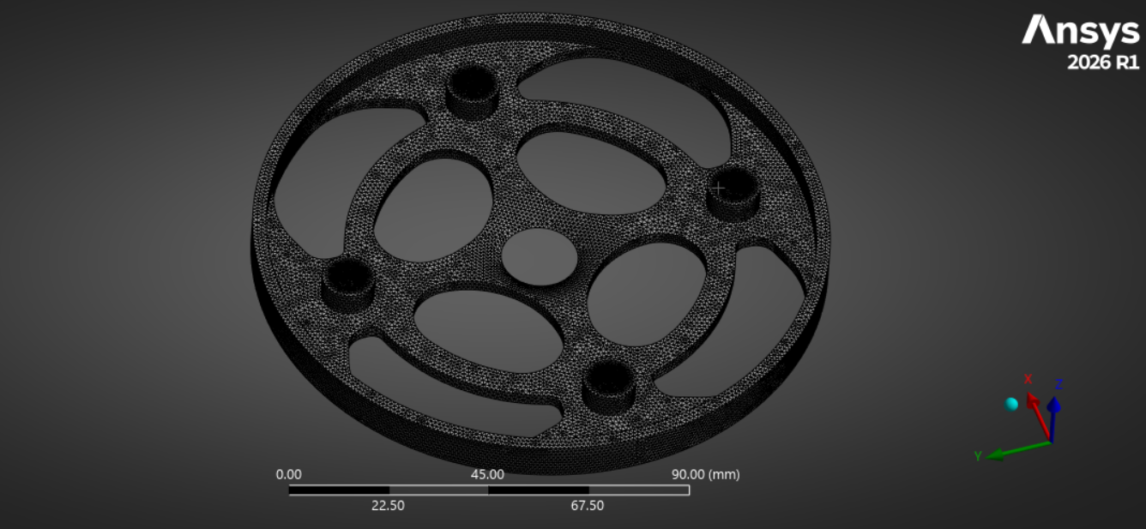
Fig 13: Meshing of Base Plate
Type: Tetrahedral meshing.
Refinement: Finer mesh applied to critical areas, including the holes and thrust pad.
Parameters Simulated: Von Mises Stress, Total Deformation

Results:
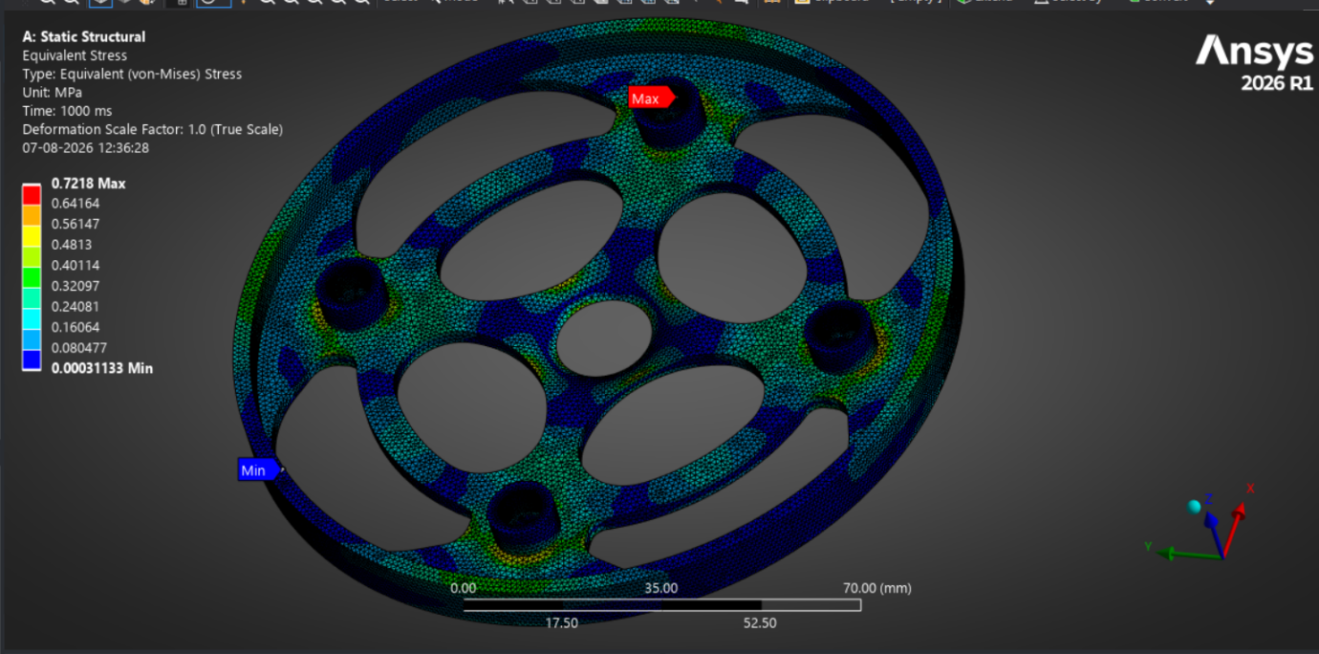
Fig 14: Stress Analysis of Base Plate
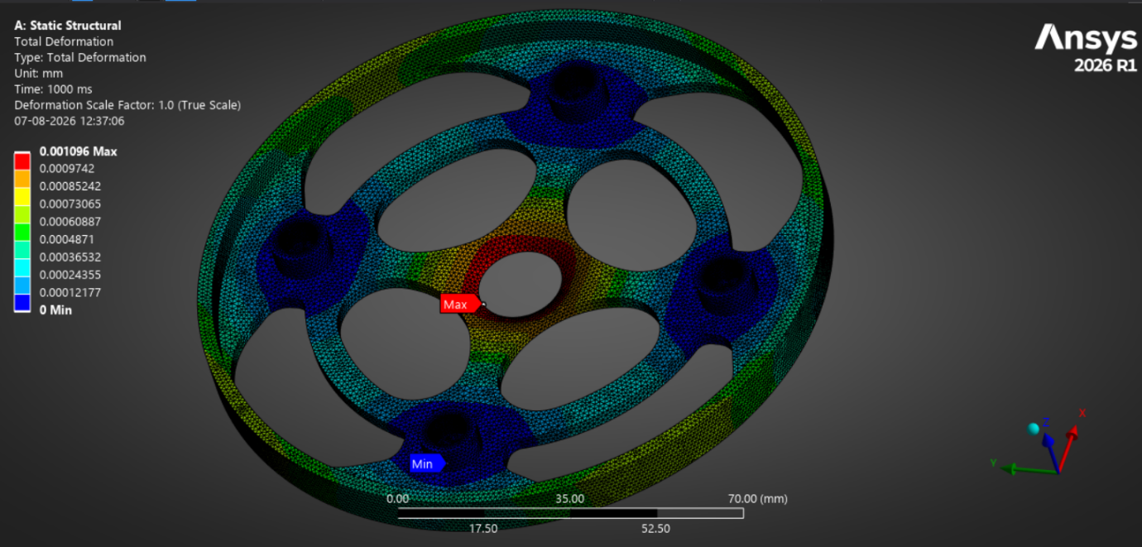
Fig 15: Total Deformation Analysis of Base Plate

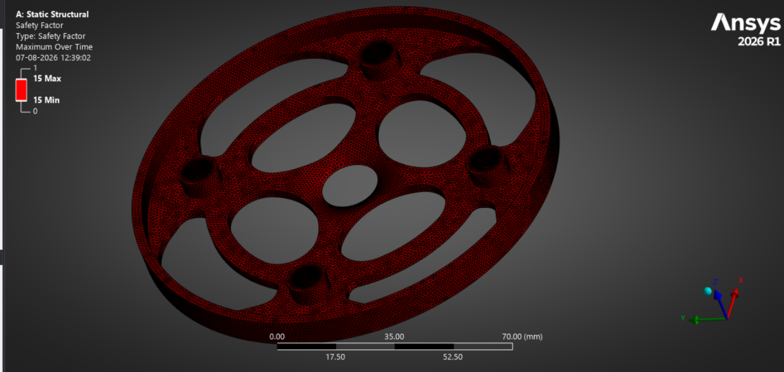
Fig 16 : FOS Analysis of Base Plate
Conclusion
After simulating, the results prove that the structure of the base plate is sound at the applied loads. The stress falls under the acceptable range of selected material’s strength and the deformation value is close to zero. Thus, the component can be considered safe for all the required operations.
Further mass was reduced by removing non critical material while preserving the load path. Topology optimization was used to identify these regions. The optimized design achieves a lower structural mass while satisfying all structural requirements.

      - Middle Plate
Software Used: Ansys
Material Selection: Aluminium Alloy
Boundary Conditions: Fixed support applied to the inner faces of rod mounting bosses
Acceleration application: 30G in longitudinal axis
Mesh Setup
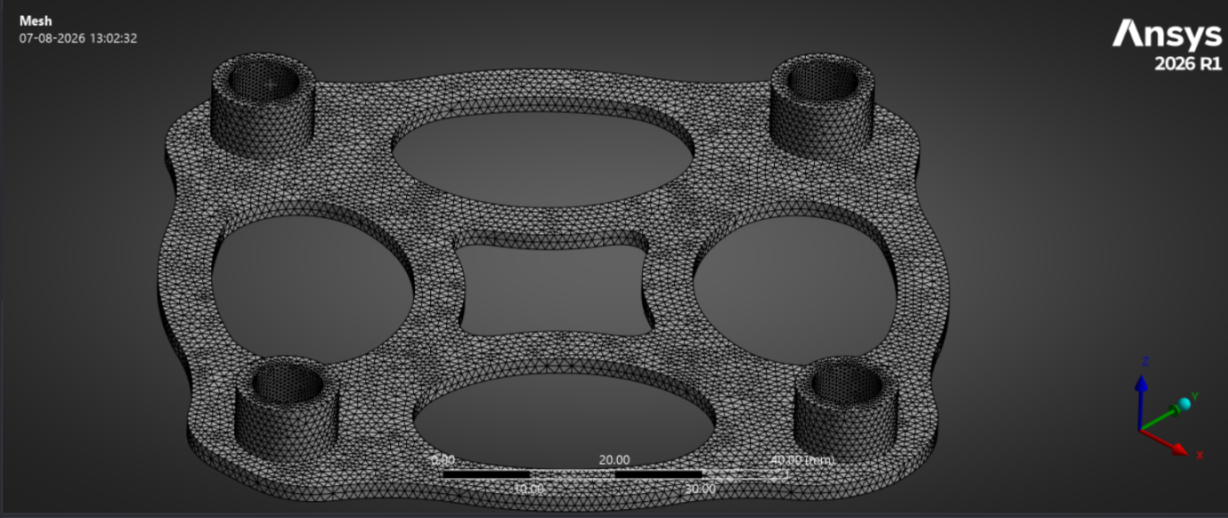
Fig 17: Meshing of Base Plate

Type: Tetrahedral meshing.
Refinement: Finer mesh applied to critical areas, including the holes and thrust pad.
Parameters Simulated: Von Mises Stress, Total Deformation
Results
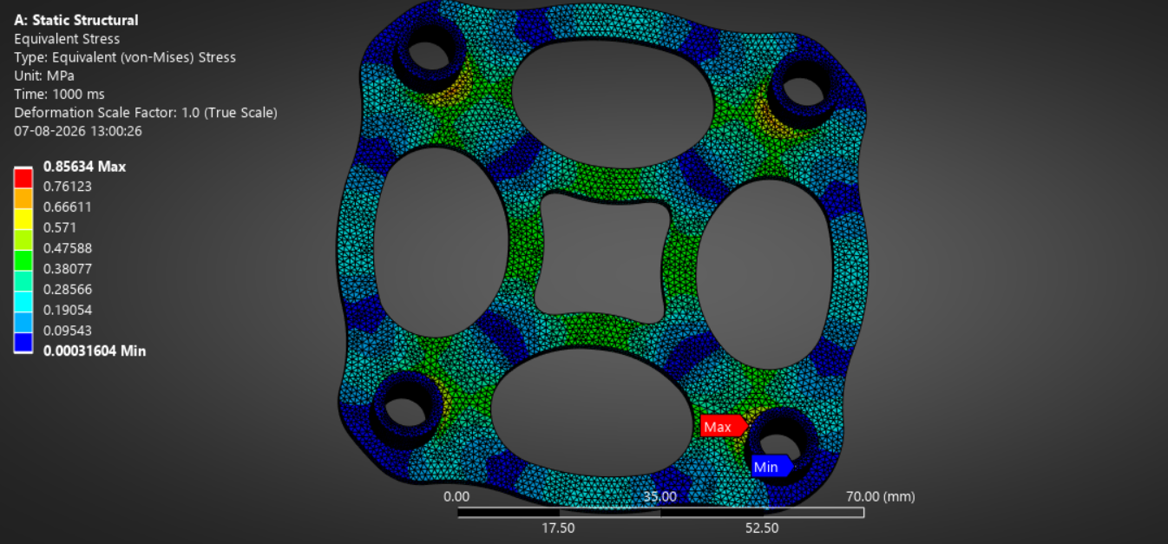
Fig18: Stress Analysis of Middle Plate
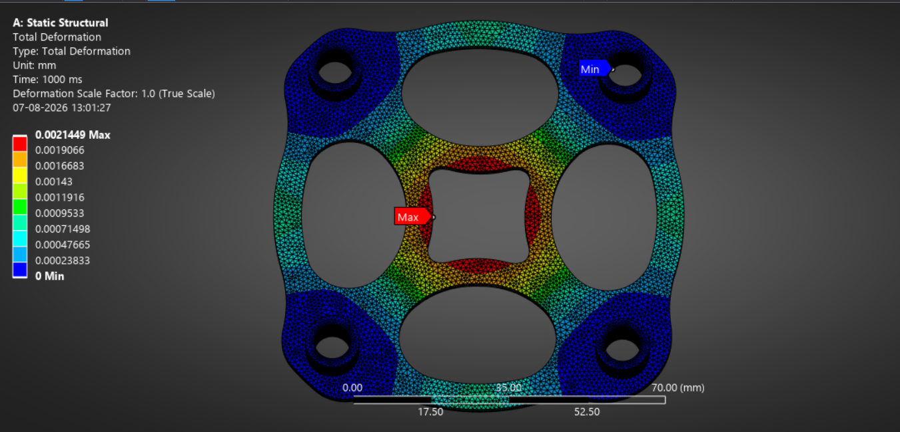
Fig 19: Total Deformation Analysis of Middle Plate

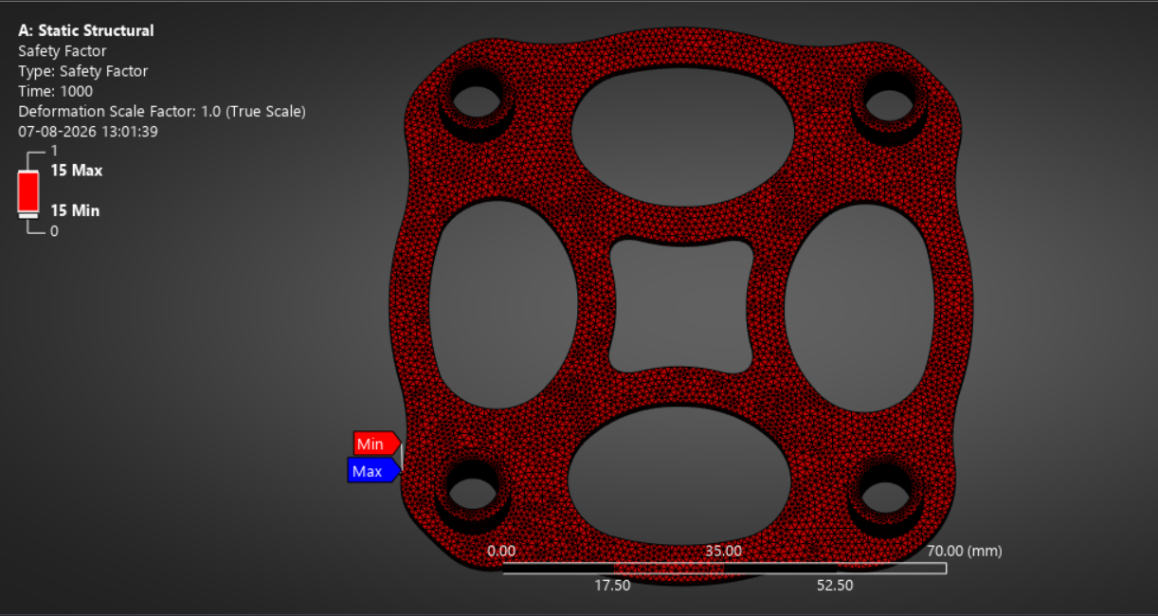
Fig 20: FOS Analysis of Middle Plate
Conclusion
The results prove that the plate has enough structural stability to withstand applied loads. The level of stress induced is far below the maximum acceptable strength of the material and the deformation in the structure is miniscule.
Topology optimization was done to remove materials from areas not critical for load paths. San enhanced strength to weight ratio is maintained without compromising on structural performance.

      - CANSAT Assembly
Software Used: Ansys
Material Selection: Aluminium Alloy for base and middle plates
- Fiberglass for rods
- FR 4 for PCB plates
Boundary Conditions: Fixed support applied at rod mounting bosses at the base plate.
Acceleration application: 30G in longitudinal axis
Component mass representation: The masses of integrated electronic components and other onboard hardware were added as distributed masses in respective places to accurately simulate the real loading conditions.
Mesh Setup
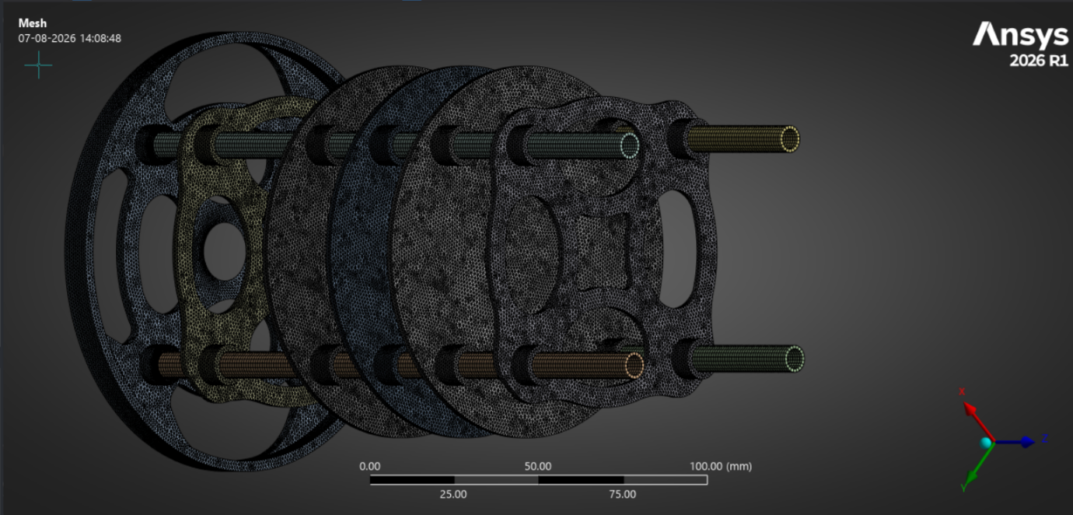
Fig 21: Meshing of CANSAT Assembly

Type: Tetrahedral meshing.
Refinement: Finer mesh applied to critical areas, including the holes and thrust pad.
Parameters Simulated: Von Mises Stress, Total Deformation, Buckling analysis
Results
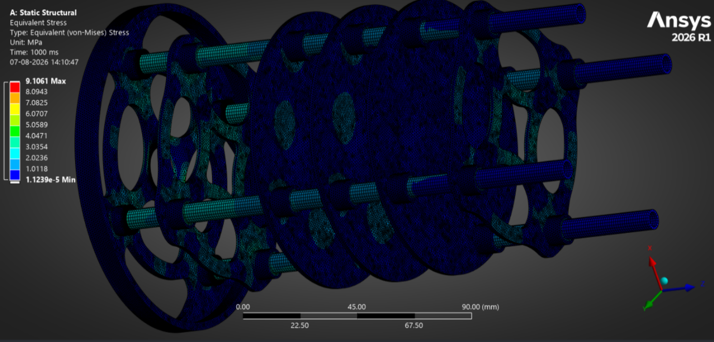
Fig 22: Stress Analysis of CANSAT Assembly
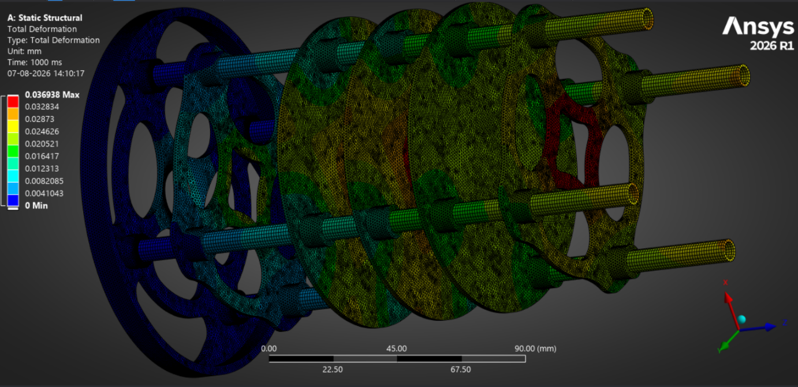
Fig 23: Total Deformation Analysis of CANSAT Assembly
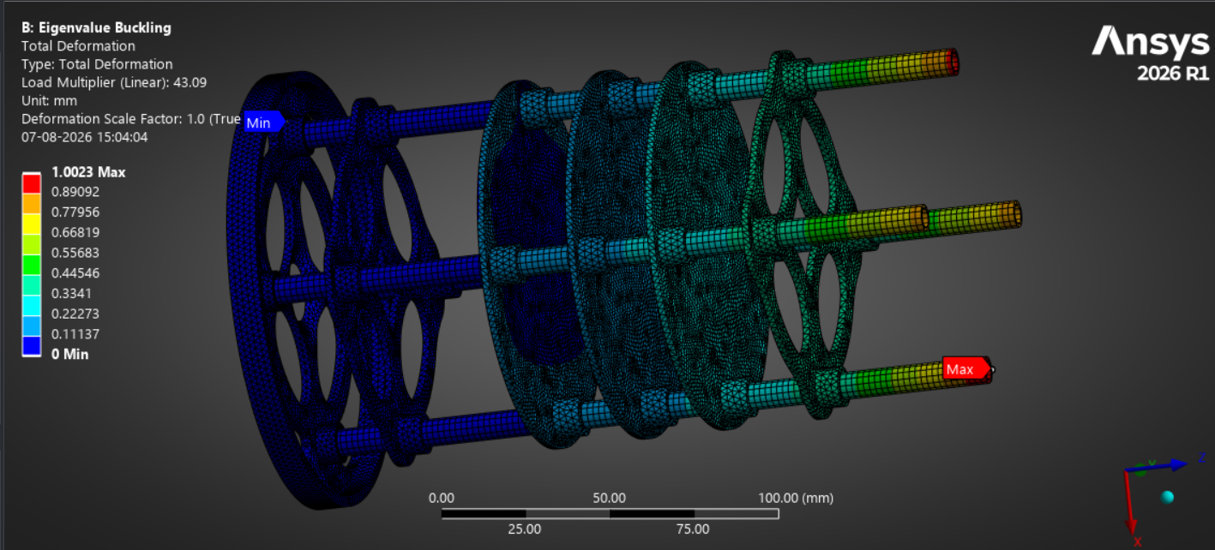
Fig 24: Buckling analysis of CANSAT Assembly
Conclusion
A full-scale structural analysis was performed under simulated launch environment conditions to determine the structural behaviour of the assembly. It is found there is good stress distribution and negligible deformation.
Buckling analysis was also done to ensure the assembly is structurally sound, since the critical buckling load is far more than anticipated loads the structure would face. This shows that there is sufficient margin to avoid instability during launch.
Final verdict
Overall, the results of structural analysis have shown that the CANSAT structure complies with all necessary requirements of strength, rigidity and stability under given loads. The optimised structure is validated for fabrication, integration and mission deployment.

    - Command & Data Handling (CDH) (Analysis & Test)
Downlink data path (CANSAT to ground station)
Sensors
Sample
BMP585, IMU
GPS, INA226
Sensor
Fusion
Baro & GPS alt
IMU filtering
Packet
Assembly
15 fields
1 Hz rate
LoRa TX
LR1121
865 MHz
GS Receive
T-antenna
Display &
Log
15 live plots
CSV to disk

Uplink command path (ground station to CANSAT)
GS Operator
Manual
command
LoRa TX
T-antenna
LoRa RX
LR1121
on CANSAT
Command
Parser
Validate
& decode
FSM State
Transition
Execute
command

Data Handling subsystem
LoRa LR1121
865 MHz, 1 Hz, SPI
Uplink
Ground Station
PyQt5, T-antenna, 15 plots
RF 867 MHz
FLIGHT COMPUTER
Teensy 4.1, ARM Cortex-M7, 600 MHz
8-State FSM (10 Hz main loop)
Sensor Fusion & Data Processing
PID Heading Controller
Uplink Command Parser
Watchdog Timer (1s timeout)
Navigation Sensors
BMP585
Baro / Alt
LSM6DSO32
6-axis IMU
ICM-20948
9-axis AHRS
L89 GNSS
GPS/NavIC
INA226
Power monitor
I2C / SPI
UART
Science Sensors
SCD41, BMV080, MQ131, ML8511, SEN0290

I2C
Actuators
A20BHM x2
Parafoil
MG90S #1
Bay lid
MG90S #2
Bio gel
2205 2300kv BLDC
Flywheel
Buzzer
Beacon
PWM
GPIO
SD Card
CSV @ 1 Hz SPI
Backup MCU
Teensy 4.1, UART
Power Supply
3S Li-ion, 12V, 54Wh

Fig 25: Command and Data handling subsystem

    - Sensor Subsystem (Analysis & Test)
To test about the sensor subsystem, we have assembled all the important components which are required for transmitting the necessary telemetry data. All of it is assembled on a zero board to test the compatibility of the sensors and also to test proper power supply. The diameter of the board is 11 cm which will in future be placed on a Printed circuit board as a plate in our CANSAT.
The image given below is the board consisting of all the sensors on a single plate. The backup system designed will be have all its sensors on other such board. From this we have tried to test the working of sensors which is shown below in the following sections.
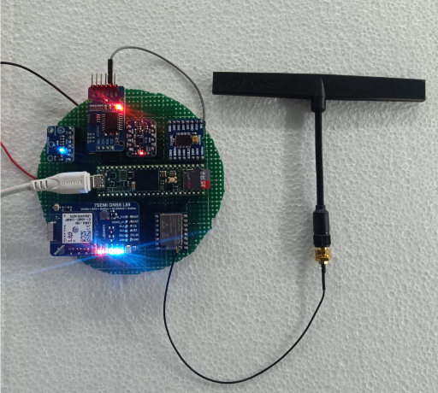
Fig 26: Sensor Board
The flight-state machine (FSM) was tested on Teensy 4.1 hardware using a synthetic telemetry injection test in which a pre-scripted flight profile such as height and vertical rate pairs was given to the state machine in place of live sensor data to work all state transitions perfectly. The given profile simulated a full mission status and provided with the results as given in the image below. The FSM correctly detected:
- Launch on provided height
- Triggered primary parachute deployment at apogee (1000.0 m peak)
- Fired the secondary parafoil at 599.3 m AGL
- Correctly registered landing
This confirms the altitude/state-decision logic (Gates 1–3 of the altitude control loop which is given below) works correctly across the full mission timeline independent of physical sensor noise, isolating the FSM logic itself as a verified component ahead of closed-loop hardware-in-the-loop testing.
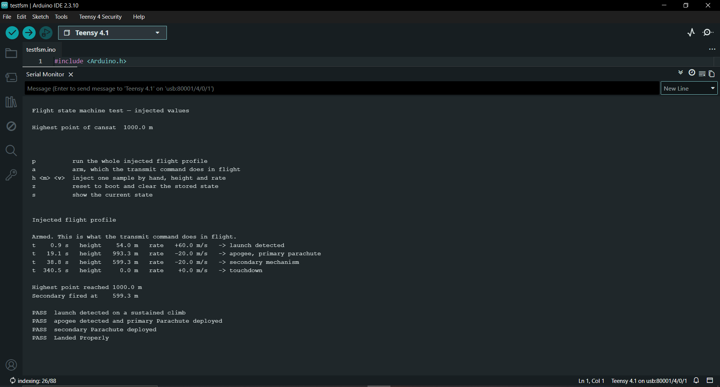
Fig 27: FSM test
The telemetry packet format was tested end-to-end by transmitting a live sample packet from the Teensy 4.1 through the ground-station serial link and confirming correct field-by-field decoding. The captured packet correctly explains into all 17 defined fields:
- Team ID
- Mission time (167 s)
- Packet count (8)
- Barometric altitude (−0.9 m, ground-level offset within calibration)
- Pressure (97398 Pa)
- Temperature (29.8°C)
- Bus voltage (10.09 V)
- GNSS time
- Latitude/longitude (31.2510490°, 75.7052917°)
- GPS altitude (229.9 m)
- Satellite count (4 locked)
- 3-axis acceleration
- Mechanical gyro spin rate (0.4°/s)
- Flight software state
This confirms the packet structure, field ordering, resolution/scaling, and CSV-style analysing all match the defined telemetry, and that GNSS locks 4 satellites and sensor data are being correctly calculated and transmitted over the downlink prior to flight.
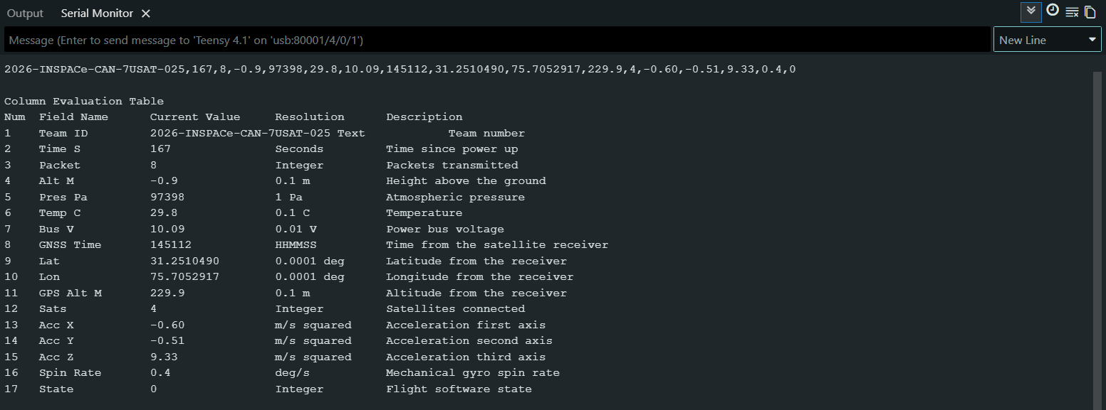
Fig 28: Data Output
Our packet length is 99 bytes. So, in this we limit data input by taking the mandatory 15 fields and the remaining fields which is optional data is actually divided in different packets so each time we get different optional sensor data and in that we use base encoding so that all data is actually compressed and reduced in size. And then it is transmitted using our LoRa module LR1121 of size 99 bytes which actually take around 971 milliseconds of a time to transmit. After that we pause for few milliseconds to listen for the command which are sent from our ground stations. In our ground station that specific command is transmitted three times. Suppose that we are transmitting our current packet then the ground station will try to send that command 3 time as soon as it receives the packet and we actually encode the specific packet field according to the standard encoding that encodes and properly compresses the information. Then that is transmitted in the base station and it decodes that packet and bring it to its original form. We can also check by that packet received is proper or not and if we have missed anything or corrupt. That millisecond gap can be also be utilized for sending and receiving acknowledgement signal.
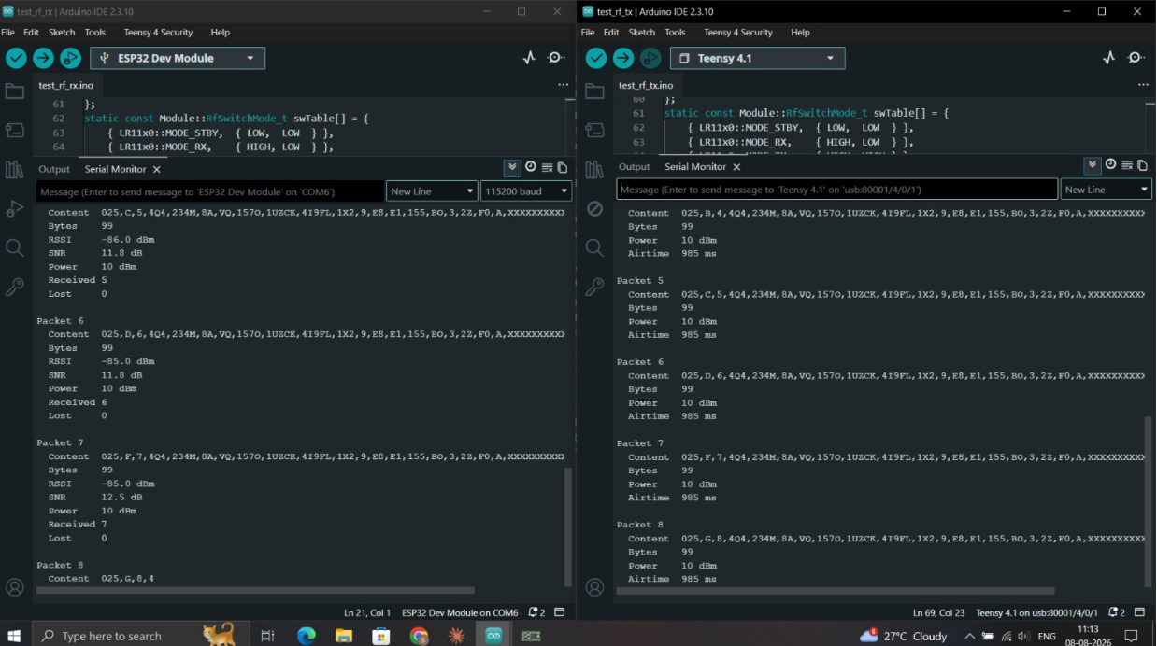
Fig 29: Packet Transmission result
After collecting all the data required, it is transmitted and even stored in MicroSD card for backup purpose so that the telemetry loss could not affect the sensor data readings for even a second. All the stored data in MicroSD is arranged in an Excel sheet in systematic order so that we can directly handover the Card to jury post flight period. The given image shows the data arrangement in a single Excel sheet:
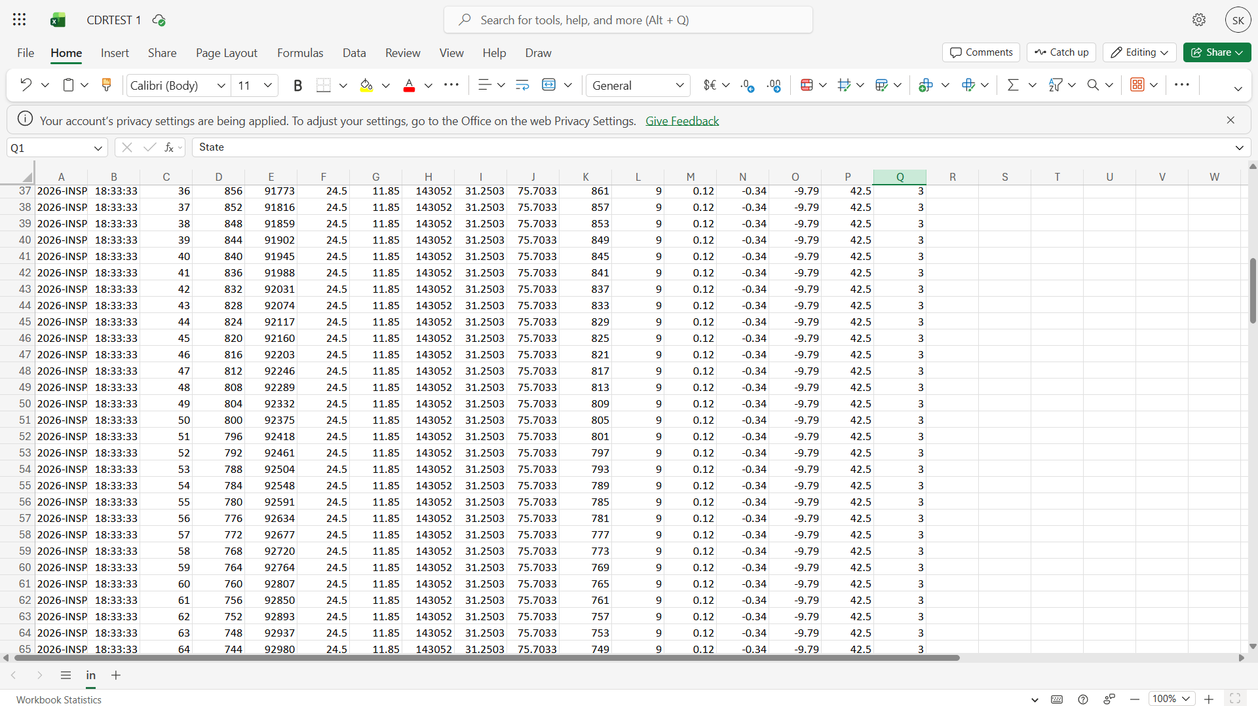
Fig 30: MicroSD Card storage Data
    - Communication Subsystem (Link Analysis & Test)
For testing communication subsystem, we are using 865 MHz Rubber duck omnidirectional antenna and a LoRa module having as LR1121. First, we made the circuit connections required for communication testing. A basic ground station platform was used to see the reading and telemetry data transfer. After finalising the circuit connections, we moved forward from breadboard and designed a PCB board for proper testing.
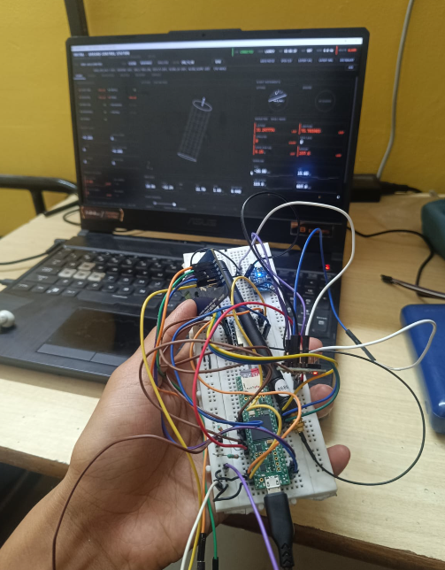
Fig 31: Communication Range Test
After testing the new selected antenna which is Dual band T-antenna from Radio master the results we got are:
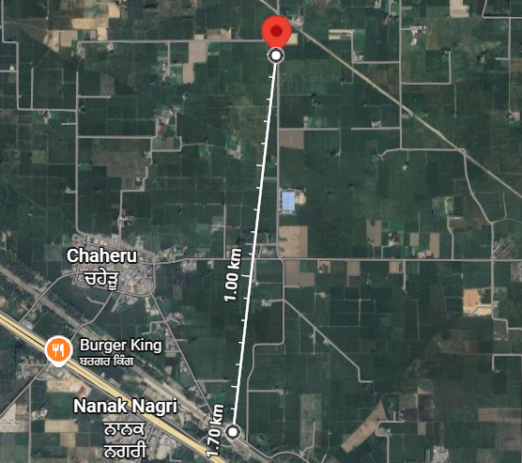

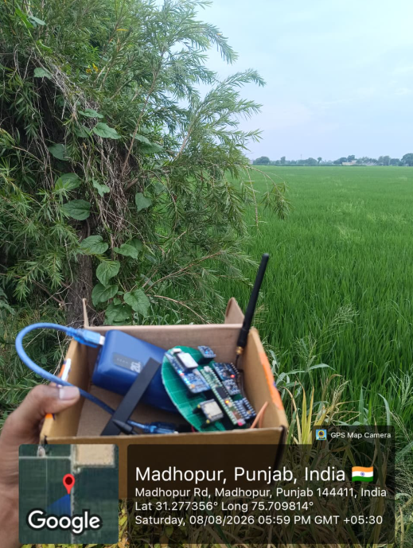
Fig 32: Telemetry Distance Test (Spot 1)

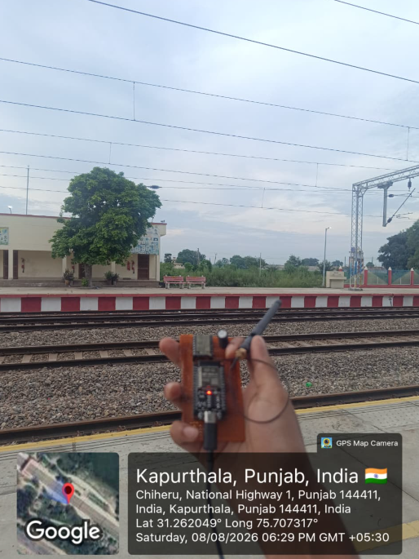
Fig 32: Telemetry Distance Test (Spot 2)

We tested our communication subsystem with both the antennas which are rubber duck 865 MHz antenna and Radio master dual band T antenna 867 MHz. According to the result we understood that it has high signal connectivity as we tested it with the distant of 1.6 KM. The received data packets were proper as shown in image given below. It was also tested on our Ground station software and the results are attached below in the upcoming sections.
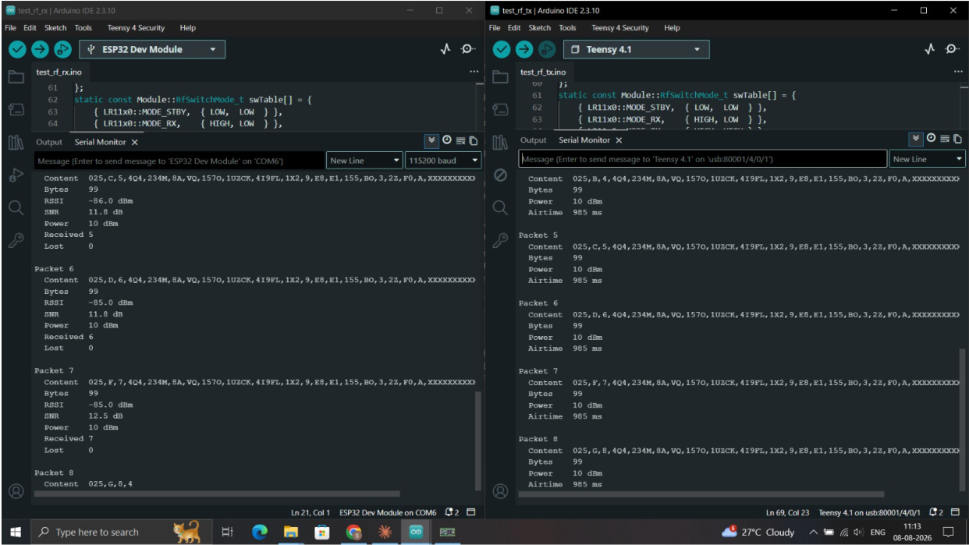
Fig 33: Telemetry Packet Received

    - Electrical Power Subsystem (Analysis & Test)
Component | Voltage | Current | Maximum Power | Duty Cycle (%) | Average Power | Source
Teensy 4.1 | 5 | 0.18 | 1.8 | 100 | 1.8 | Existing
ESP32-S3 | 5 | 0.18 | 1.8 | 70 | 1.26 | Existing
LR1121 LoRa (TX) | 3.3 | 0.055 | 0.1815 | 20 | 0.0363 | Existing
L89 GNSS | 3.318 | 0.032 | 0.106176 | 100 | 0.106176 | Existing
ICM-20948 IMU | 3.322 | 0.0045 | 0.029898 | 100 | 0.029898 | Existing
SCD41 CO2 | 5 | 0.018 | 0.09 | 100 | 0.09 | Existing
AS3935 Lightning | 3.3 | 0.0001 | 0.00033 | 100 | 0.00033 | Datasheet
AS7343 Spectral | 3.3 | 0.0x98 | 0.00825 | 100 | 0.00825 | Datasheet
HDC3020 Temp/Humidity | 3.3 | 0.0008 | 0.00264 | 100 | 0.00264 | Datasheet
ML8511 UV | 3.3 | 0.0003 | 0.00099 | 100 | 0.00099 | Existing
MQ131 Ozone | 5 | 0.15 | 0.75 | 50 | 0.375 | Existing
BMV080 PM | 3.3 | 0.018 | 0.0594 | 100 | 0.0594 | Existing
TPL5010 Timer | 2.5 | 0.000000035 | 8.75E-08 | 100 | 8.75E-08 | Datasheet
W25Q64 Flash | 3.3 | 0.025 | 0.0825 | 20 | 0.0165 | Datasheet
INA226 | 3.3 | 0.0012 | 0.00396 | 100 | 0.00396 | Existing
SN74LV4052A MUX | 3.3 | 0.00008 | 0.000264 | 100 | 0.000264 | Datasheet
DS3231 RTC | 3.3 | 0.00011 | 0.000363 | 100 | 0.000363 | Datasheet
Hobbywing XRotor 40A ESC | 10.8 | 0.1 | 1.08 | 30 | 0.324 | Datasheet
2205 2300KV BLDC Motor | 10.8 | 4 | 43.2 | 30 | 12.96 | Datasheet
AGFRC A20BHM Servo #1 | 7.4 | 1.5 | 11.1 | 20 | 2.22 | Datasheet
AGFRC A20BHM Servo #2 | 7.4 | 1.5 | 11.1 | 20 | 2.22 | Datasheet
Teensy 4.0 (DCS) | 5 | 0.08 | 0.4 | 100 | 0.4 | Existing
BMP585 | 3.3 | 0.001 | 0.0099 | 100 | 0.0099
7.4V BEC | 7.4 | 0.02 | 0.296 | 100 | 0.296 | Existing
7Semi AP62301 Buck 3.3V 2A | 5 | 0.02 | 0.2 | 100 | 0.2 | Existing
7Semi AP64500 Buck 5V 5A | 10.8 | 0.03 | 0.648 | 100 | 0.648 | Estimate
 |  |  |  | Total Maximum Power | 72.9501709
 |  |  |  | Total Average Power | 23.06797109
Battery Capacity (mAh) | 5000
Battery Voltage (V) | 10.8
Battery Energy (Wh) | 54
Estimated Endurance (Hours) | 2.341
Table 12: Power budget
    - Descent & Recovery Subsystem (Analysis & Test)
During our parachute testing, we first started with understanding the idea behind RAM air parachute which controls the direction with the help of servos. So, we calculated about the dimensions of the parachute given above.
This parachute testing was done from a heighted building of around 120 feet. According to the test results, the RAM air parachute has a proper shape and nodes attachment. It carried 840 g of dead weight and the parachute. It had proper opening without any entanglement with in the codes.
Improvement done after testing: Length of the cord is reduced according to the calculations.
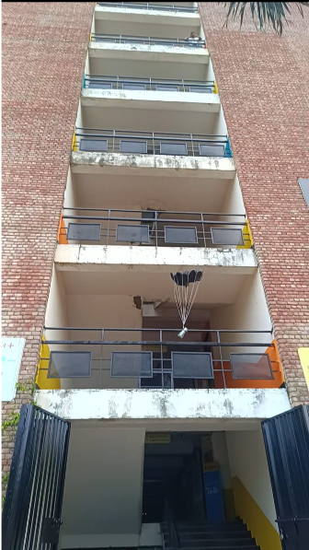
Fig 34: Ram-Air Parachute Drop Test
Electronics part for controlled RAM air parachute was tested through a simulated panel. The panel shows about the rotation of servos with respect to the direction of flow of air in virtual environment. The image given below shows about the test:
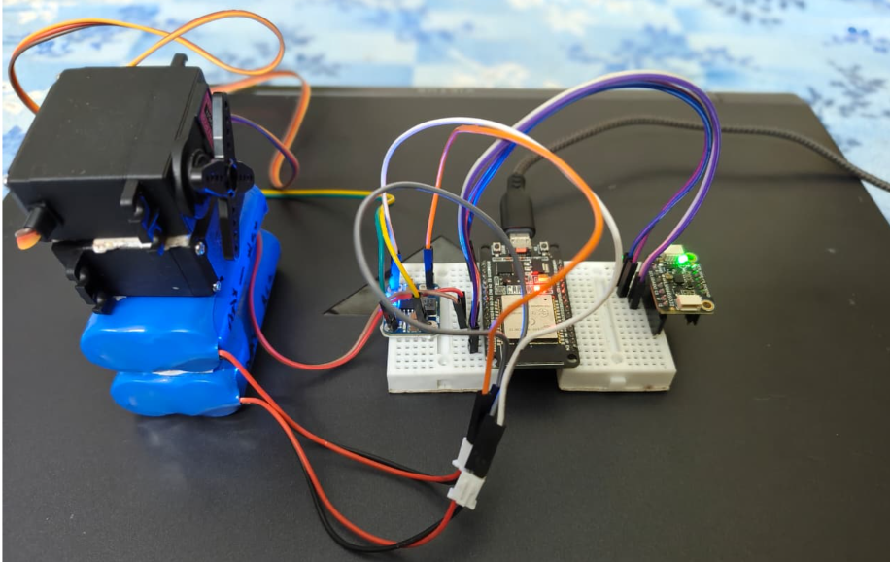
Fig 35: Secondary Mechanism
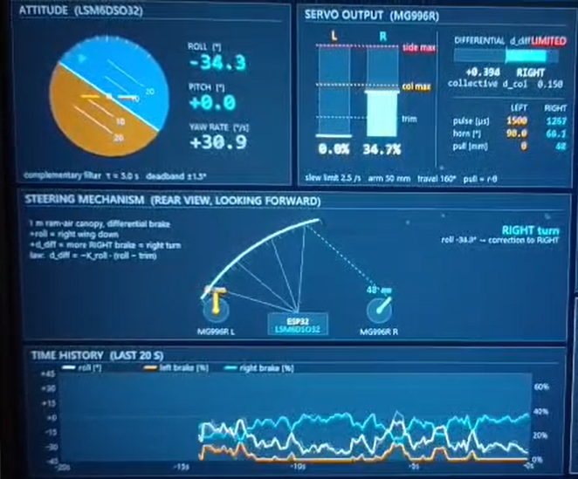
Fig 36: Secondary Mechanism Control
  - Flight Readiness Parameters
Flight readiness for CANSAT is assessed against a defined set of quantitative parameters spanning structural integrity, power, communication, descent performance, and software state. Each parameter carries a pass/fail threshold that must be verified during pre-launch checkout before the CANSAT is cleared for integration into the rocket payload bay. The important Go readiness parameters required are:
- All mandatory telemetry fields streaming and logging correctly at GS and onboard SD card.
- Bus voltage, structural fit, and mass should be within specified limits.
- GNSS fix acquired and target waypoint recorded.
- Primary and secondary descent systems are packed and mechanically verified.
- FSM is confirmed in TEST_MODE with successful calibration response.
    - Structural & Mechanical Readiness
PARAMETER | READINESS THRESHOLD | VERIFICATION METHOD
Total mass | ≤ 1000 g (±50 g) | Pre-integration weigh-in
Envelope fit | ≤ 150 mm diameter × 400 mm height | Fit-check in mock rocket fairing
Structural integrity | No visible damage, cracks, or loose standoffs | Visual inspection post-vibration test
Gyro-wheel spin-up | 5000 ±500 RPM within 30 s | Hall-sensor RPM verification
Shell/lid closure | Secure latch, no exposed electronics | Physical inspection
Table 13: Structural & Mechanical Readiness
    - Electrical Power Readiness
PARAMETER | READINESS THRESHOLD | VERIFICATION METHOD
Bus voltage at power-on | ≥ 8.0 V | INA226 reading on GS dashboard
Battery endurance margin | ≥ 2 hours remaining at current charge | Pre-flight SOC estimate
Power indicator LED | Illuminates on power-on | Visual check
Voltage rail stability | 5.0 V and 3.3 V rails within $±$5% | Multimeter/INA226 cross-check
Table 14: Electric Power Readiness

    - Communication and telemetry Readiness
PARAMETER | READINESS THRESHOLD | VERIFICATION METHOD
LR1121 link status | Packets received at GS, RSSI > −120 dBm | GS dashboard link indicator
Telemetry rate | ≥ 1 Hz sustained | GS packet-rate counter
All 15 mandatory TM fields | Present, correctly formatted | GS live field display
CMD_TX_ON / CMD_CALIBRATE | Uplink command acknowledged | GS command panel confirmation
GNSS fix | ≥ 6 satellites locked | GS GNSS status panel
SD card logging | CSV row count incrementing at 1 Hz | GS/onboard log cross-check
Table 15: Communication and telemetry Readiness

    - Flight Software & State Readiness
PARAMETER | READINESS THRESHOLD | VERIFICATION METHOD
FSM state | TEST_MODE confirmed before CMD_TX_ON | GS state field
Sensor self-test | All sensors initialized without fault | Boot-sequence telemetry
Calibration | Baro altitude, gyro, accel zeroed at pad level | Post-CMD_CALIBRATE readback
Backup avionics | Standby, heartbeat signal nominal | Failover monitor status
Target waypoint | Launch pad GPS coordinates set | GS waypoint confirmation
Table 16: Flight Software & State Readiness
    - Descent & Recovery Readiness
PARAMETER | READINESS THRESHOLD | VERIFICATION METHOD
Primary parachute packing | Z-fold secured | Visual/physical inspection
Parafoil packing | Deployment bag pinned, no line tangle | Visual/physical inspection
Brake-line servo range | Full deflection without stall | Bench actuation check
Audio beacon | ≥ 92 dB SPL on trigger | Pre-flight beacon test
Table 17: Descent & Recovery Readiness
  - Pre-Flight Analysis
Pre-Fight Analysis talks about the expected performance envelope of CANSAT prior to launch by using analytical models and simulation to predict system behaviour under different conditions.
    - Descent Trajectory & Wind Drift Analysis
A MATLAB-based simulation was run against expected launch-site wind conditions to understand about the parafoil's guided descent trajectory. The simulation output shows a top-down ground track and altitude-vs-time profile which is used to:
- Predict the parafoil's glide path and expected landing dispersion radius under the PID waypoint-steering logic.
- Verify that the glide ratio (2.50) and forward speed (6.37 m/s) provide sufficient cross-range authority to pay for given wind drift between 600 m activation and descent.
- Get an expected recovery search radius around the target waypoint for the ground recovery test.
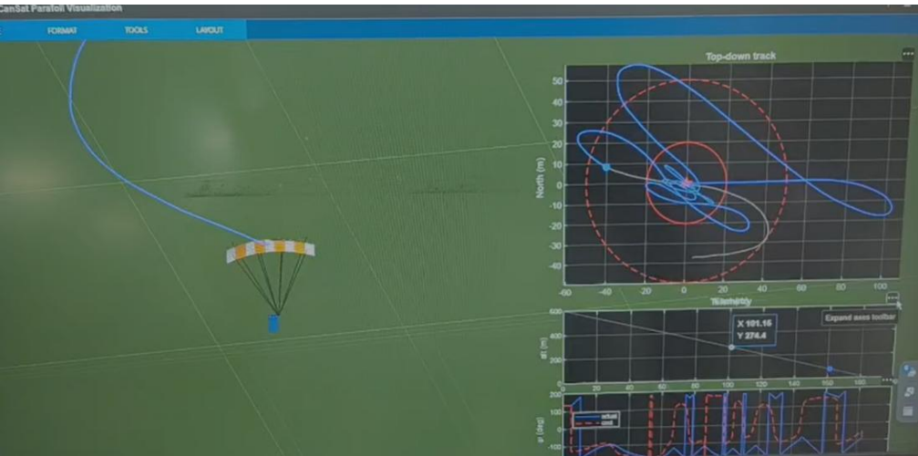
Fig 37: MATLAB parachute testing

    - Communication Link Prediction
- Calculated link margin of 71.6 dB at 1 km (867 MHz, SF10) and is well above the 10 dB minimum needed for reliable LoRa telemetry.
- No packet loss expected under nominal line-of-sight conditions between CanSat and ground station.
- Sufficient headroom to tolerate antenna misalignment, multipath, and orientation changes near touchdown.
- NETID/PANID isolation (0x98) and SF10 orthogonality expected to prevent cross-interference with other teams' radios at the shared launch site.

    - Sensor Calibration Strategy
- Ground calibration (CMD_CALIBRATE) zeroes barometric altitude, gyroscope offset, and accelerometer bias at pad level, immediately before flight.
- Eliminates day-to-day atmospheric pressure drift from affecting the 600 m secondary-deployment trigger.
- Removes IMU bias accumulated during transport and handling, ensuring gyro-wheel stabilization and apogee detection operate against a true zero reference.
- Calibration is deliberately timed as late as possible in the pre-launch sequence to minimize the window in which drift could re-accumulate before flight.

- SENSOR SYSTEMS SUMMARY, CHARACTERIZATION AND TEST RESULTS
CANSAT carries 11 sensors in total in which each sensors have its own flight-critical measurements such as altitude, orientation, GPS, power and some bonus sensors such as air quality, lightning, UV, ozone and CO₂, which can help team VRITRA with better scoring points. Each sensor was selected through a comparative study against its alternatives and each one carries a defined characterization method and test plan which is in detail below.
5.1 Pressure & Temperature Sensor (BMP585)
The BMP585 is a barometric pressure and temperature sensor from 7 Semi, which acts as the primary altitude measurement sensor for CANSAT. It was selected over the BMP390 and BMP581 for its better pressure accuracy and ultra-low power consumption which are important for proper performance, drift-free altitude detection throughout the descent. Onboard CANSAT will be having two units of BMP585 in which one will be for primary telemetry and other for the backup subsystem if required.
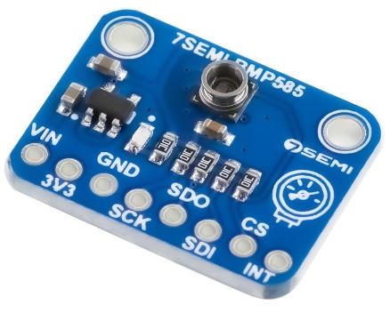
PARAMETER | VALUE
Model | BMP585
Sensor Type | Barometric Pressure & Temperature
Interface | I²C, SPI
Pressure Range | 300–1250 hPa
Accuracy | ±0.5 Pa
Supply Voltage | 1.71–3.6 V
Power Consumption | 2.5 µA
Quantity | 2
Table 18: Pressure & Temperature Sensor (BMP585)

The BMP585 barometer was tested in a two-phase validation such as a ground-level reference position and then followed by a controlled height to verify AGL tracking. The results which can after testing are visible in the image given below.
This confirms the barometric altitude pipeline is correctly zeroed at the launch pad and responds accurately to small real-world height changes, validating it ahead of integration with the combination of BMP585, GPS module and Kalman filter altitude estimate used in the flight-state machine.
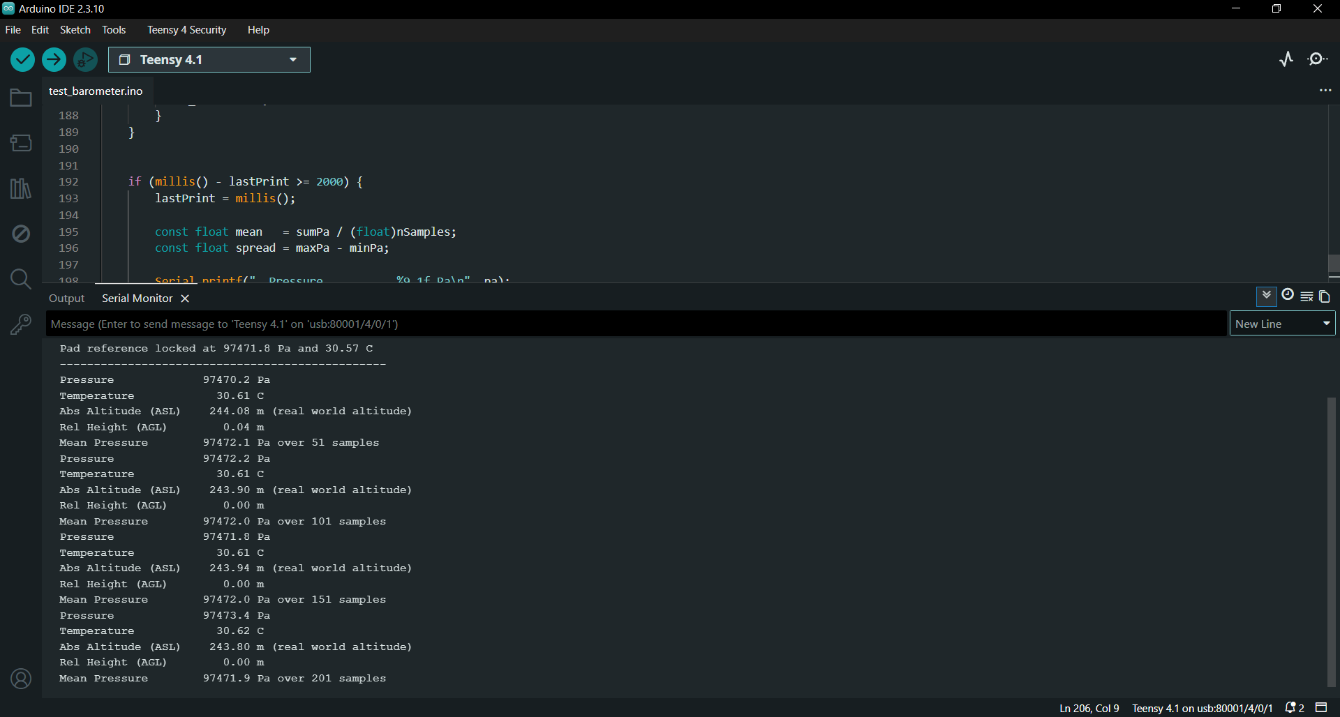
Fig 38: Ground level BMP testing
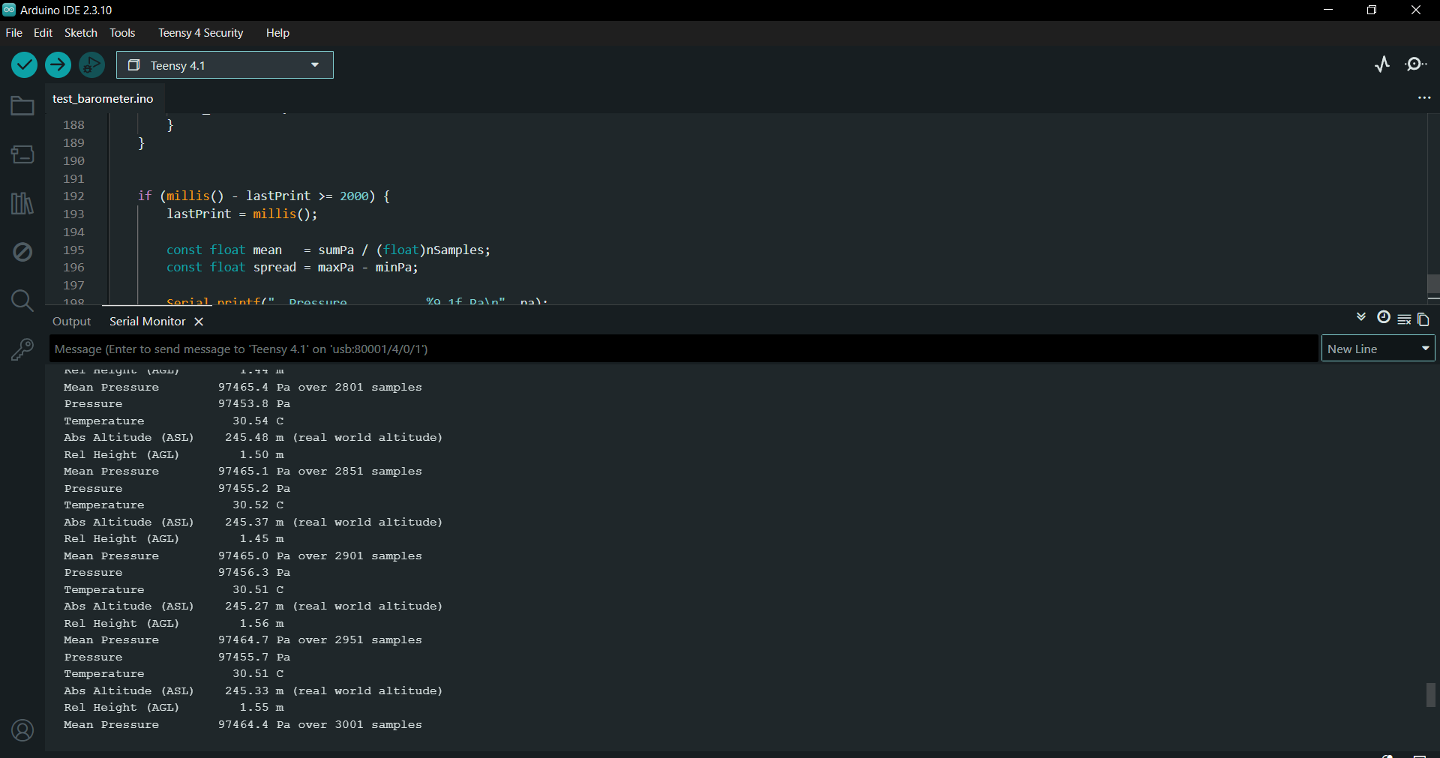
Fig 39: BMP testing from a specific height
5.2 6-Axis IMU (LSM6DSO32)
The LSM6DSO32 is the sensor manufactured by Adafruit which is used for inertial measurement which provides 3-axis acceleration and 3-axis angular rate data. It is used for controlling secondary descent mechanism of GPS guided RAM air parafoil. It was chosen over the MPU6050 and BMI270 for its wide measurement range, ensuring the sensor stays within range and does not break during the 30G ejection shock event.
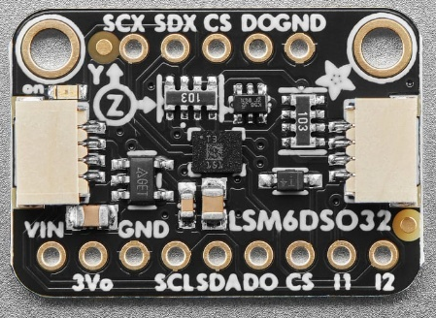
PARAMETER | VALUE
Model | LSM6DSO32
Sensor Type | 6-DOF IMU (Accelerometer + Gyroscope)
Interface | I²C, SPI
Accelerometer Range | ±4/8/16/32 g
Gyroscope Range | ±125/250/500/1000/2000/4000 dps
Supply Voltage | 1.71–3.6 V
Quantity | 1
Table 19: 6-Axis IMU (LSM6DSO32)
5.3 9-Axis IMU (ICM-20948)
The ICM-20948 from 7 Semi, provides orientation and motion sensing on the avionics board which is about combining accelerometer, gyroscope, and magnetometer in a single module. It was selected over the MPU9250 and BNO055 for its lower cost at 9-DOF capability. Onboard CANSAT will be having two units of BMP585 in which one will be for primary telemetry and other for the backup subsystem if required.
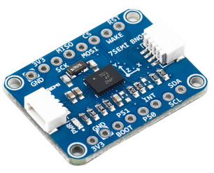
PARAMETER | VALUE
Model | ICM-20948 (7Semi)
Sensor Type | 9-DOF IMU (Accel + Gyro + Magnetometer)
Interface | I²C, SPI
Accelerometer Range | ±2/4/8/16 g
Gyroscope Range | ±250/500/1000/2000 dps
Magnetometer | Yes (3-axis)
Quantity | 2
Table 20: 9-Axis IMU (ICM-20948)

The IMU which is the combination of accelerometer and orientation, was tested across four static orientations such as home position (0°), and 90° tilts left, right, and front, with 5 continuous samples logged per orientation to characterize both mean reading and sample-to-sample noise.
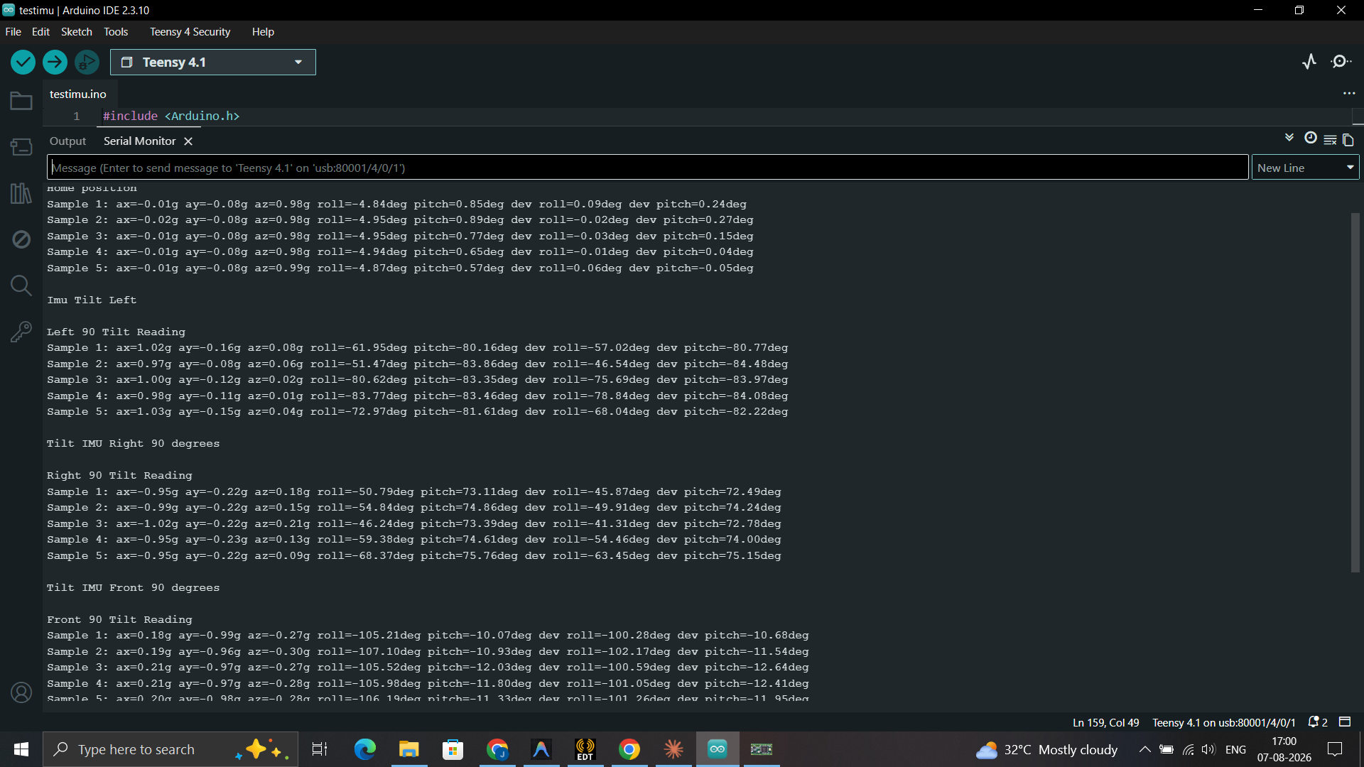
Fig 40: IMU Testing

5.4 GNSS Module (L89HA)
The L89HA GNSS from 7 Semi is a module which provides real-time position, altitude, speed, and timing data throughout the mission. It was selected over the NEO-M8N and L86-M33 for its NavIC (IRNSS) feature and also is an earning bonus jury weightage. It is along with dual-band L1+L5 operation for faster achievement and greater positioning accuracy.
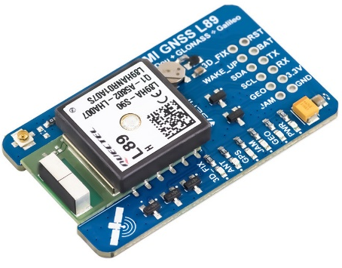
PARAMETER | VALUE
Model | L89HA (7Semi)
GNSS Support | GPS, NavIC, GLONASS, BeiDou, Galileo, QZSS
Frequency Bands | L1 + L5
Interface | I²C, UART
Position Accuracy | < 1.8 m CEP
Supply Voltage | 3.3 V
Quantity | 1
Table 21: GNSS Module (L89HA)

5.5 Power Monitor (INA226)
The INA226 is selected because of its features such as it continuously monitors bus voltage, current, and power draw across the CANSAT power system. This helps in tracking real-time battery health and power telemetry throughout flight. It was selected over the INA219 and ACS712 for its wider bus voltage range and continuous voltage/current/power measurement over a digital I²C interface. It also reduces noise exposure compared to analog current-sensing sensor.
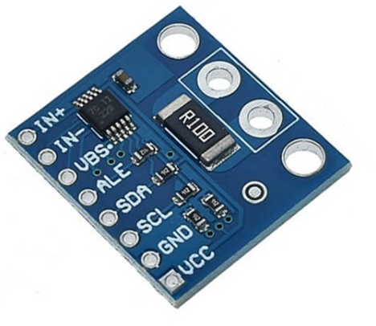
PARAMETER | VALUE
Model | INA226
Sensor Type | Power Monitor
Interface | I²C
Bus Voltage Range | 0–36 V
Current Measurement | Yes (Shunt-based)
Power Calculation | Yes
Quantity | 2
Table 22: Power Monitor (INA226)
5.6 Particulate Matter Sensor (BMV080)
The BMV080 sensor is an ultra-compact air quality sensor used for measuring PM1.0, PM2.5, and PM10 concentrations using laser scattering technology. This sensor is used as an extra additional telemetry as part of the bonus environmental payload. It was chosen over the PMSA003I and SPS30 for being the world's smallest particulate matter sensor with the lowest power consumption which makes it well suited to CANSAT's tight mass and power budget.
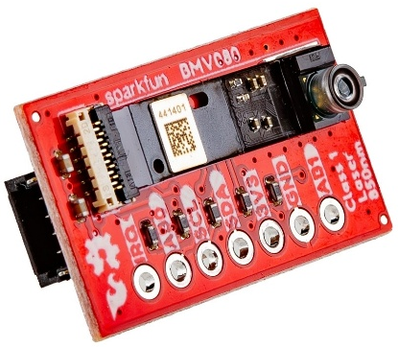
PARAMETER | VALUE
Model | BMV080 (7Semi)
Sensor Type | PM Sensor
Interface | I²C
Particle Size Detection | PM1, PM2.5, PM10
Power Consumption | 55 mW
Supply Voltage | 1.8–3.3 V
Quantity | 1
Table 23: Particulate Matter Sensor (BMV080)
5.7 Lightning Sensor (SEN0290-AS3935)
The SEN0290 is a Gravity Lightning Sensor which detects lightning activity up to 40 km away and gives data about the distance, intensity, and strike frequency. This sensor is used as an extra additional telemetry as part of the bonus environmental payload. It uses intelligent noise filtering to minimize false detections from onboard electrical interference which makes it perfect for use CANSAT's active RF and motor-driven subsystems.
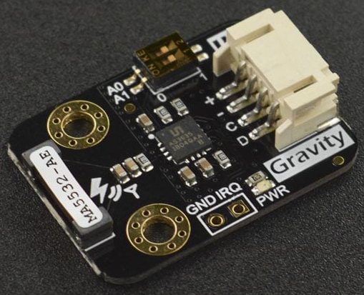
PARAMETER | VALUE
Model | SEN0290 (AS3935)
Sensor Type | Lightning Detector
Interface | I²C, SPI
Detection Range | Up to 40 km
Operating Voltage | 2.4–5.5 V
Features | Lightning distance & storm warning
Quantity | 1
Table 24: Lightning Sensor (SEN0290-AS3935)

5.8 UV Light Sensor (GYML8511)
The GYML8511 sensor is an analog-output ultraviolet light sensor covering the Ultraviolet B and most of the UVA spectrum. This sensor is used as an extra additional telemetry as part of the bonus environmental payload. It has a output of a voltage linearly proportional to UV intensity which provides a simple and easy way to capture UV index data during descent without added interface complexity.
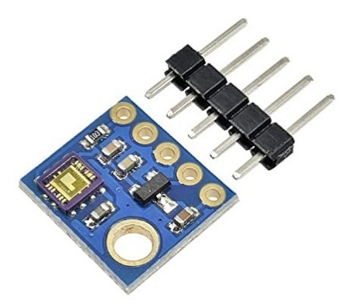
PARAMETER | VALUE
Model | GYML8511
Sensor Type | UV Sensor
Interface | Analog
Spectral Range | 280–390 nm
Supply Voltage | 3.0–5.0 V
Output Type | Analog Voltage
Quantity | 1
Table 25: UV Light Sensor (GYML8511)

5.9 Ozone Gas Sensor (MQ131)
The MQ131 sensor is a metal-oxide gas sensor whose conductivity decreases in the presence of ozone and allows ozone concentration to be indirect from the resulting signal change. It was selected for its wide detection range and fitness for atmospheric ozone sampling during descent. This sensor is used as an extra additional telemetry as part of the bonus environmental payload.
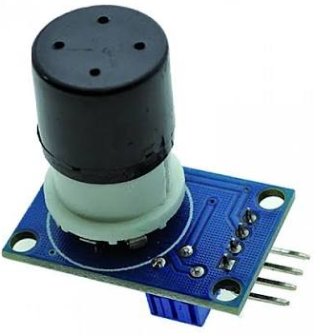
PARAMETER | VALUE
Model | MQ131
Sensor Type | Ozone Sensor
Interface | Analog, Digital
Detection Range | 10–1000 ppm
Supply Voltage | 5 V
Power Consumption | 750 mW
Quantity | 1
Table 2: Ozone Gas Sensor (MQ131)
5.10 CO₂ Sensor (SCD41)
The SCD41 sensor is a small environmental sensor that is used to measure carbon dioxide concentration with temperature and humidity. This sensor is used as an extra additional telemetry as part of the bonus environmental payload. It was chosen over the SCD30 and ENS160+SHT40 for providing true CO₂ readings with strong accuracy at low power draw, communicating over the same I²C bus as the rest of the sensor stack.
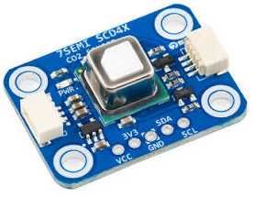
Parameter | Value
Model | SCD41
Sensor Type | CO₂, Temperature, Humidity
Interface | I²C
CO₂ Range | 400–5000 ppm
Accuracy | $±$(40 ppm + 5%)
Supply Voltage | 2.4–5.5 V
Quantity | 1
Table 2: CO₂ Sensor (SCD41)
5.11 Real-Time Clock (DS3231M)
The DS3231M RTC maintains mission time independently of the flight computer which makes sure that the mission clock continues uninterrupted even if the Teensy 4.1 experiences a processor reset mid-flight. This directly supports the competition's requirement for steady one-second-resolution mission timing and correct flight-state recovery after any onboard reset event.
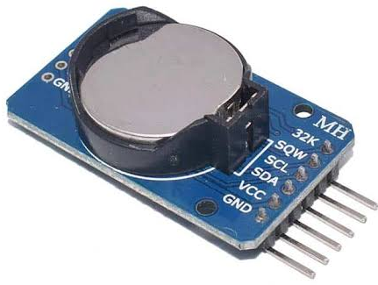
PARAMETER | VALUE
Model | DS3231M
Sensor Type | Real-Time Clock
Interface | I²C
Function | Mission timekeeping across resets
Quantity | 1
Table 28: Real- Time Clock (DS3231M)
The onboard RTC module was tested for correct timekeeping and battery-backed time holding power cycles. The results of RTC are given below in the image. This confirms the RTC is correctly wired, battery-backed, and suitable as the CANSAT determined time source for telemetry timestamping independent of GNSS lock.
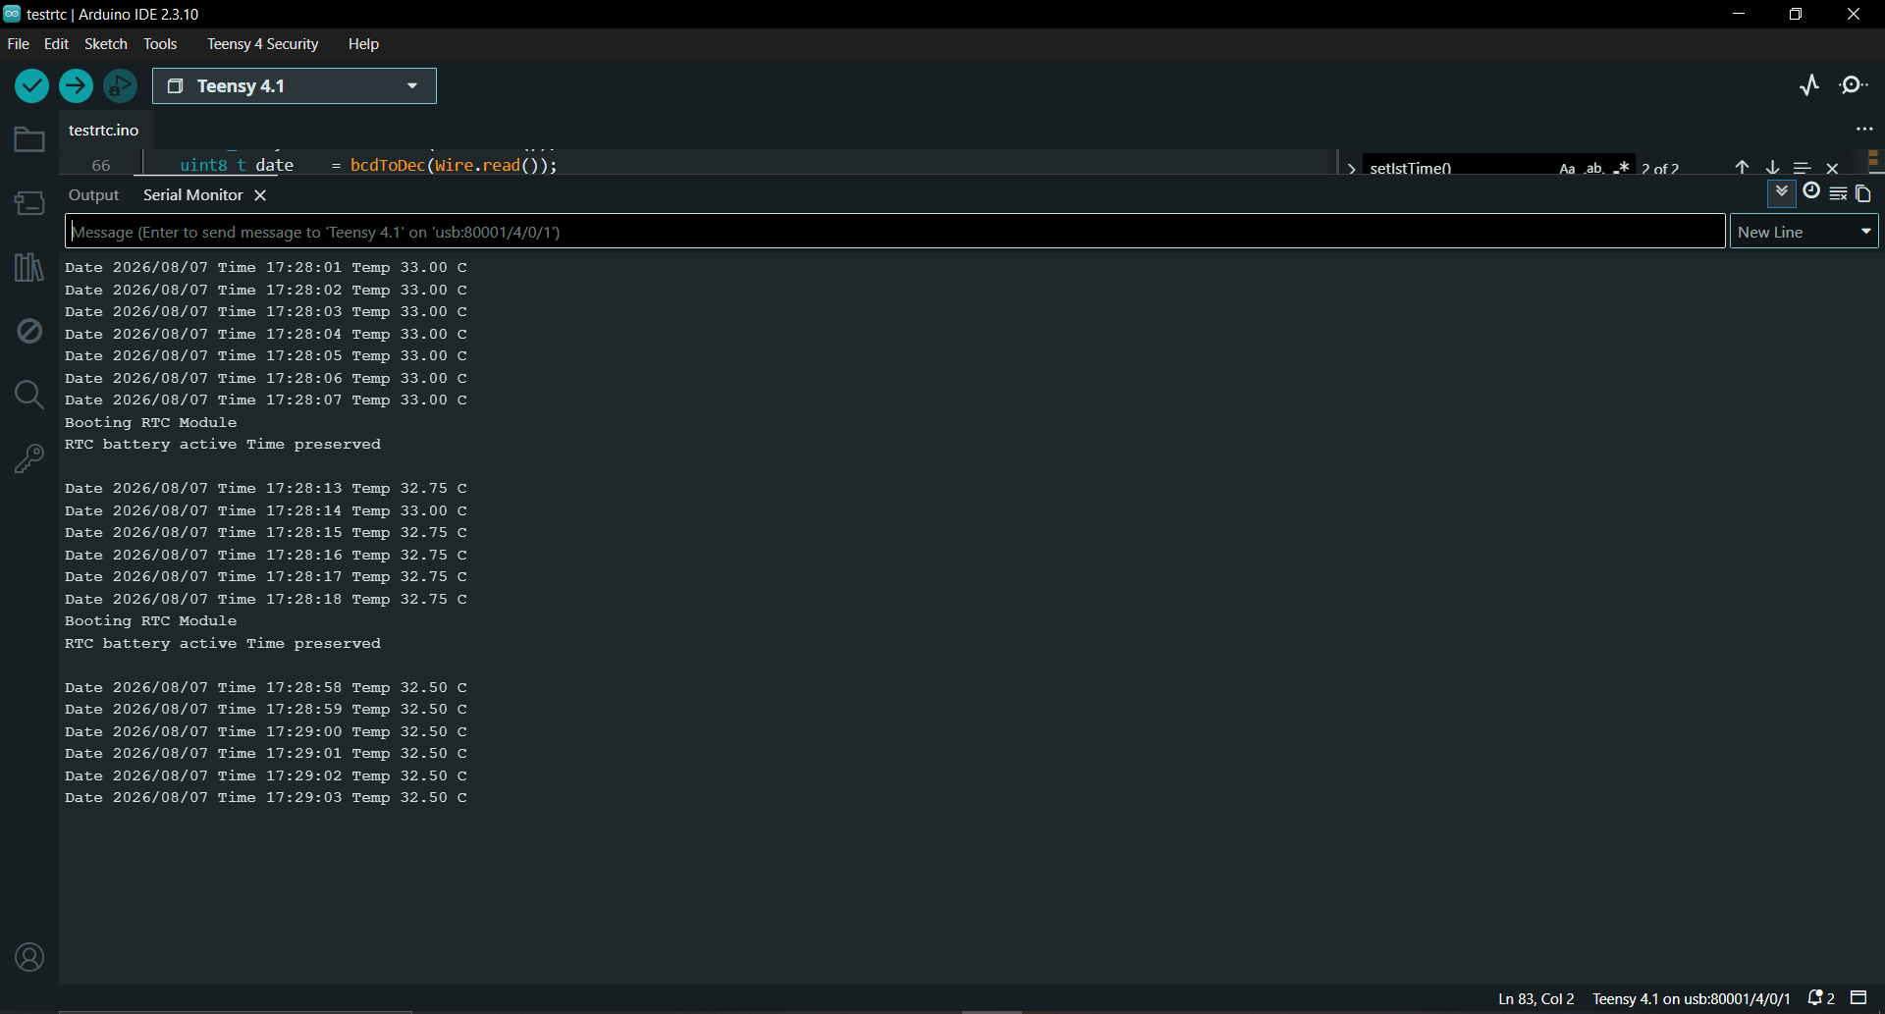
Fig 41: RTC check

5.12 SPI flash (7 Semi)
Parameter | Specification
Manufacturer | 7Semi
Flash IC | Winbond W25Q-series (16 Mbit / 64 Mbit / 128 Mbit variants)
Interface | Standard SPI; Dual/Quad SPI on 64/128 Mbit variants
Max Clock Speed | Up to 104 MHz (16/64 Mbit) / 133 MHz (128 Mbit)
Operating Voltage | 3.3 V (some variants down to 3.0 V)
Erase Granularity | 4 KB sector / 32 KB / 64 KB block / full-chip erase
Mounting | Solder-free breakout, standard pin headers
Typical Use in CanSat | Onboard non-volatile black-box data logging, backup to LoRa downlink
Compatibility | Arduino, Teensy, STM32, ESP32, Raspberry Pi
Table 29: SPI flash (7 Semi)

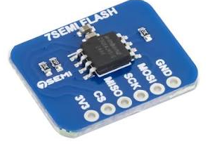
The 7Semi SPI flash breakout was tested as a crash-survivable black-box data logger by continuously streaming barometric telemetry such as pressure, temperature, ASL/AGL altitude, running mean, and noise spread while a simulated crash/power-loss event was triggered mid-log ("Sensor Read finished (Simulated Crash)"). The results are shown in the image given below. This confirms the SPI flash successfully preserves and recovers logged flight data across an unplanned reset/power-interruption event, validating it as a viable non-volatile backup store for flight telemetry independent of the live LoRa downlink.
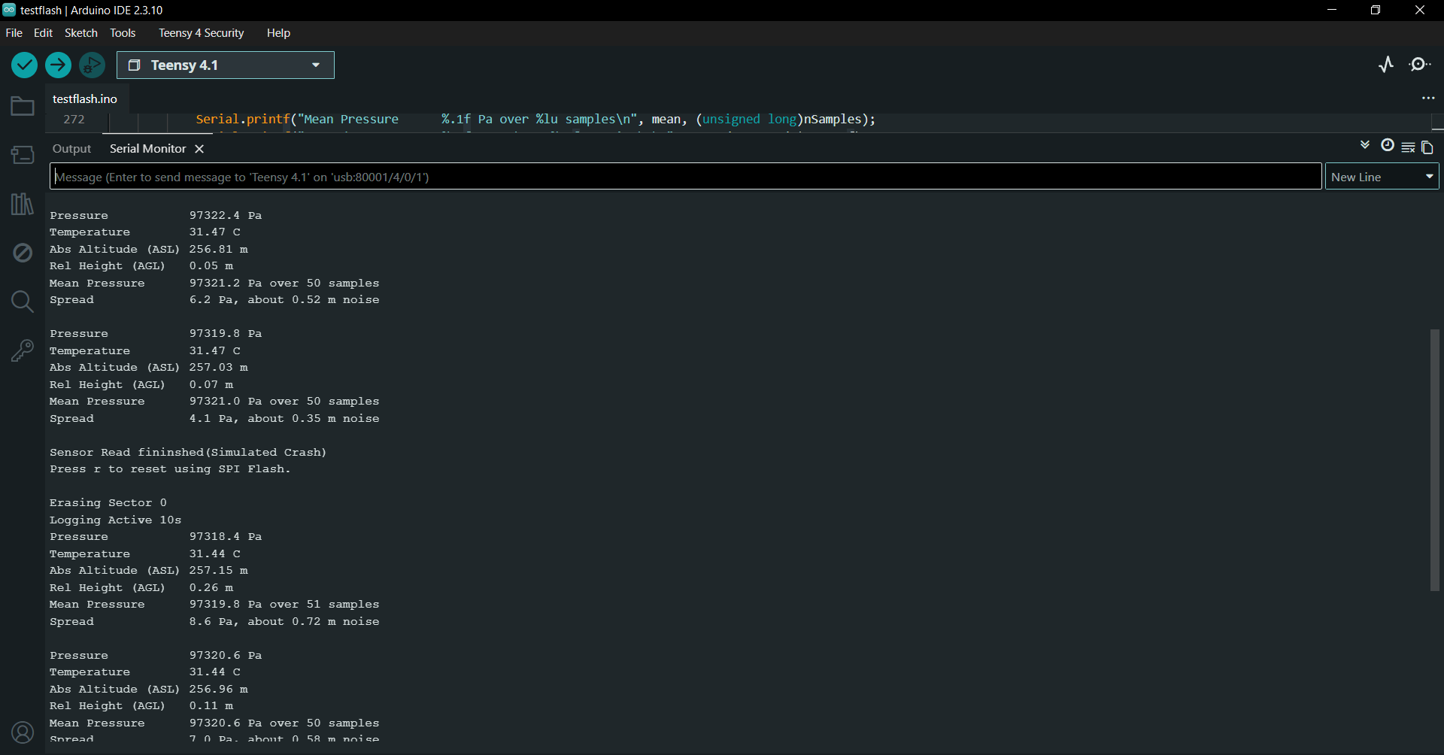
Fig 42: SPI Flash Test

5.13 Consolidated Test Verification Matrix
TEST | PASS CRITERION | STATUS
Barometer accuracy | Within ±5 m of known elevation | Planned
Barometer 600 m simulation | Deploy servo fires within 100 ms | Planned
IMU shock test | No sensor lock-up, FSM continues | Planned
GPS fix test | ≥6 sats, 0.0001° position stability | Planned
Vibration test | No PCB loosening, no sensor error post-test | Planned
Power monitor validation | Accurate V/I/P readback under load | Planned
Bonus sensor functional checks | Correct telemetry field population | Planned
Table 30: Consolidated Test Verification Matrix

- ACTUATOR SUMMARY

  - Control mechanism of actuator
Actuator are used in three different places in our CANSAT. The very first application for which it is used is the Innovation part of Team VRITRA for extra jury points weightage. It is about the Biochemical Characterization of Atmospheric Bacterial Isolates. The petri dish will be closed during the fight till the ejection of CANSAT. This will be done with a servo attached to the lead. The mechanism and placement are shown in the image given below.

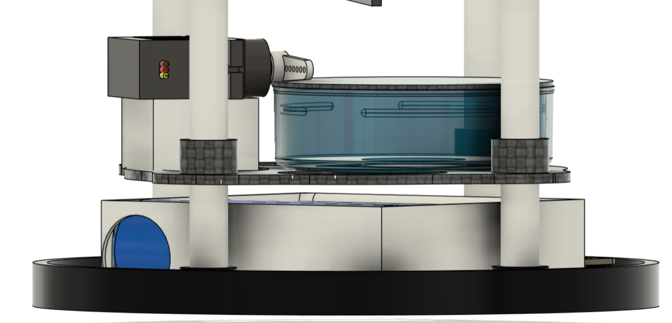
Fig 43: Actuator for Petri-dish

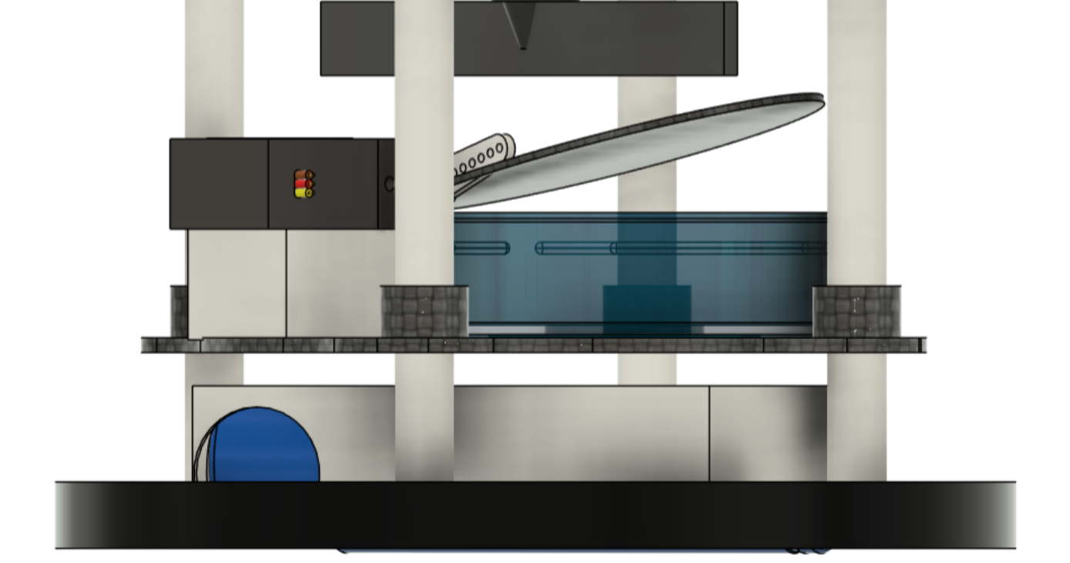
Fig 44: Servo Flip
The second actuator is used for parachute bay. The drug chute will be kept above the CANSAT during the flight readiness and the secondary RAM air parachute will be folded properly according to the steps given in further sections and kept in parachute bay. At an altitude of 600 m, the servo would flip the lead to allow RAM air to open. It also has a spring at opposite side of servo to avoid the back flip of led. The images for the same are given below.
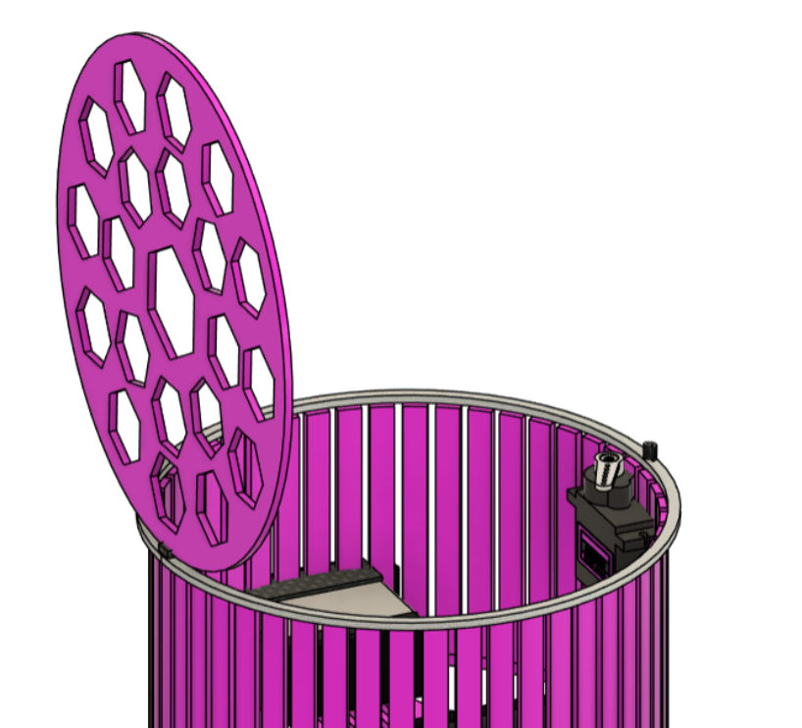

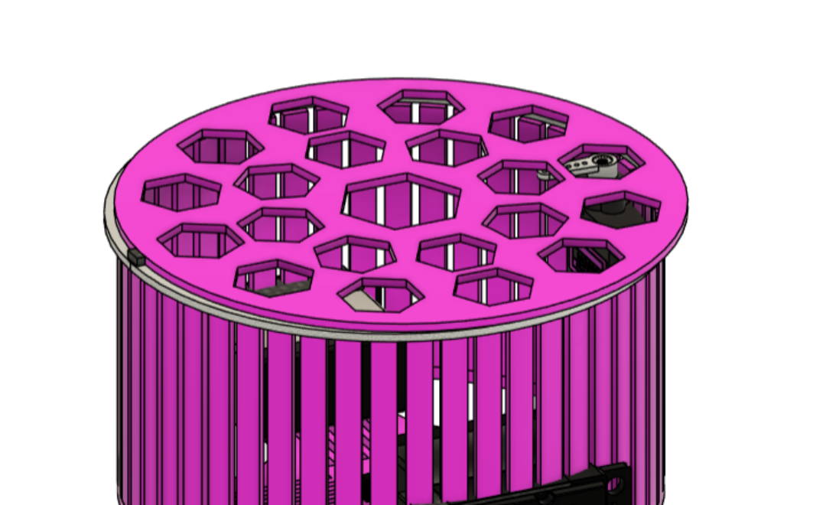
Fig 45: Parachute Bay Actuator design

The third actuators used in our CANSAT is for controlling secondary descent GPS guided RAM-air parachute. Two servos are attached parallelly in opposite direction. The servo test results have been performed in are shown below with a ground station software.
  - Descent control mechanism incorporated in CAN-7USAT
START
Read Sensors
IMU orientation + GPS position
Compute Heading Error
Current heading vs. target waypoint
Off course?
(error > deadband)
Keep Straight
Hold servos neutral
Run PID Controller
Calculate servo deflection angle
Turn which
direction?
Pull Left Line
Left servo actuates
Pull Right Line
Right servo actuates
Stabilize with Gyro Wheel
Maintain roll balance
Still
flying?
LANDED
Yes
No
Left
Right
No
Yes
Repeat
every 100 ms

Fig 46: Descent Control Mechanism Actuator Loop

  - Sensing and error computation
The loop begins at START and, every cycle, executes:
- Read Sensors data of IMU orientation and GPS and gets current heading (IMU) and position (GPS).
- Compute Heading Error compares current heading/track against the target bearing to the landing point, producing the error signal that drives the control decision.
  - Off-course decision gate
- If No: It is kept Straight and no correction is applied and the loop proceeds directly to the stabilization stage.
- If Yes: It falls through to the correction path and Run PID Controller by Calculating servo, which calculates the required servo command from the heading error.
  - Differential brake actuation
Tells about turning to which branches on the sign of the PID output:
- If Left: Then pull the left line (left brake servo pulls down, right stays at/near trim) which is a asymmetric drag induces a left turn.
- If Right: Then pull the right line (mirror case).
  - Stabilization and termination check
- The stabilize with Gyro Wheel happen after any steering command or after "Keep Straight" command. Spinning the mechanical gyro to constant RPM before secondary parachute deployment so no reaction torque acts during guided flight, and countering any residual yaw. If it is still flying:
- If Yes: Then the loop returns back to Read Sensors, repeating the whole cycle at 100 ms (10 Hz), and matching the cadence of altitude-determination loop.
- If No: It is dismissed and landed.

- BLOCK DIAGRAM OF ALTITUDE CONTROL LOOP AND ACTUATOR CONTROL LOOP
  - Altitude Control Loop

Start
Initialize BMP585 &
L89 GNSS Sensors
Read Barometric
Pressure (BMP585)
Calculate Barometric
Altitude (Hypsometric)
Read GPS Altitude
from L89 GNSS
Sensor Fusion:
Baro + GPS Altitude
Apply Kalman Filter
& Noise Reduction
Transmit Altitude
Telemetry (LoRa 1 Hz)
← Loop (100 ms cycle)
Is altitude
increasing?
Set State: ASCENT
Monitor Peak Altitude
Yes
Set State: DESCENT
Primary Parachute Active
No
Altitude
≤ 600m AGL?
Set State: AEROBREAK_RELEASE
Deploy RAM-Air Parafoil
Yes
No
Activate PID Steering
(GPS-Guided Descent)
Altitude ≤
ground level?
Set State: IMPACT
Activate Audio Beacon
Yes
No
End

Fig 47: Altitude Control Loop

The altitude descent control loop known as ADCL have multiple steps within it. The steps are:
- Sensor acquisition and altitude estimation:
The loop starts at Start and initializes the two altitude sensors which are the BMP585 barometer and the L89 GNSS module. Each 100 ms cycle then performs the process as:
- Read Barometric Pressure (BMP585) and calculate barometric altitude, converting raw pressure to altitude through the standard barometric formula.
- Read GPS Altitude from L89 GNSS independently of the barometric path.
- Sensor data fusion of BMP585 and GPS Altitude. This further combines the two independent altitude values, giving idleness against single sensor failure (e.g., GPS dropout or barometer drift) and improving accuracy over either source alone.
- Apply Kalman Filter & Noise [rejection] is used to smoothen the fused altitude estimate by rejecting sensor noise and reducing estimation lag which matters for the timing-critical events downstream (600 m release, ground impact).
- Transmit Altitude Telemetry (LoRa, 1 Hz) downlinks the filtered altitude at 1 Hz regardless of flight state, so ground station tracking is continuous even though the decision logic runs faster (100 ms).
- Loop (100 ms cycle) closes the sensor-acquisition loop back to the pressure read by giving a 10 Hz internal rate against a 1 Hz telemetry rate.
- Flight-state decision chain
The filtered altitude provides three sequential decision diamonds in which each gating a distinct mission phase:
Gate 1: Is altitude increasing?
- If Yes: It is still ascending under boost/coast. State is set to ASCENT: Monitor Peak which then automatically goes to DESCENT: Primary Parachute once apogee is detected in which the ascent state itself watches for the peak and hands off to the descent state this is deployment trigger event from our recovery subsystem.
- If No: The altitude is not increasing (past apogee, under descent), so control falls through to Gate 2.
Gate 2: Altitude ≤ 600 m AGL?
- If Yes: State is set to AEROBRAKE_RELEASE, which triggers Activate PID Steering (GPS-Guided) that is the software-side trigger for releasing primary parachute and enabling the guided parafoil descent under closed-loop GPS/PID control.
- If No: It is still above 600 m, loop back through the "No" path to re-check on the next altitude update.
Gate 3: Altitude ≤ ground level?
- If Yes: The landing is detected. State is set to IMPACT: Activate Audio (locator beacon), and the state machine terminates at End.
- If No: It is not yet at ground level and the control returns to the sensor-acquisition loop for the next 100 ms cycle.
  - Actuators Control Loop
START
Read All Sensors
IMU + GPS + Baro (10 Hz)
Evaluate FSM State
Which mission phase?
EJECTION (State 4)
Gyro Wheel Motor ON
GA12-N20 via TB6612FNG
Spin-up flywheel
Altitude stabilization begins
DESCENT (State 5)
Bay Lid Servo OPEN
MG90S #1 to 90 deg
Primary chute deploys
Drag descent 20 m/s
Gyro wheel maintains
Roll stability continues
AEROBREAK (State 6)
Deploy Servo fires
MG90S #2 releases parafoil
PID Steering Activates
Heading error computed
Left Brake Servo
AGFRC A20BHM #1
Right Brake Servo
AGFRC A20BHM #2
GPS-guided descent
1-3 m/s to landing zone
IMPACT (State 7)
Center All Servos
Steering to neutral
Gyro Wheel Motor OFF
GA12-N20 stops
Bio Gel Lid Servo
MG90S opens for sample
Audio Beacon ON
Recovery mode active
Loop back to Read Sensors (100 ms cycle)

Fig 48: Actuator Control loops
The actuator control loop tells how CAN-7USAT's flight computer changes the current FSM state into physical actuator commands. Running on the same 100 ms (10 Hz) cycle as the main sensor loop, the FSM evaluates its current state after every sensor read and branches into one of four actuator response paths which are Ejection, Descent, Aerobrake, and Impact.

- DETAILED DESCRIPTION OF REALIZED SUBSYSTEM
  - Payload Subsystem
Team VRITRA has included two payload elements other than the required telemetry data in our CAN-7USAT. One of the payloads is an imaging payload for capturing video of ground from the height of 1 KM and for descent/ejection documentation. The second additional payload is an innovation payload for atmospheric biosciences sampling. Both of this are selected to earn bonus jury weightage while remaining fully different from flight-critical control so that a payload fault cannot affect the primary mission.
    - Imaging Payload (XIAO ESP32S3 Camera Module)
The imaging payload captures video footage of two types such as one for the ejection till the CANSAT recovery stage and the other is for video capturing. This captured video will be saved in MicroSD card and will be later used for AI-based Urban planning system. It operates on an entirely independent processing path as XIAO Camera has its own processor as ESP32S3 which was selected over MIPI CSI-2 for real-time image acquisition.
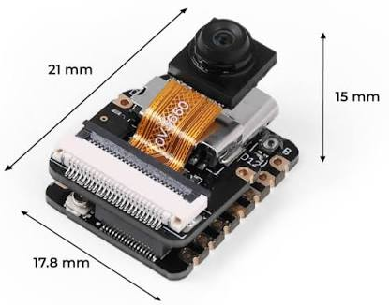
PARAMETER | DETAIL
Module | XIAO ESP32S3 Sense
Function | Onboard video capture
Interface | MIPI CSI-2 (to ESP32-P4 companion computer)
Offload | Wi-Fi 6, post-flight
Mission criticality | Non-critical (isolated from flight control/telemetry)
Mass | 5.6 g
Resolution | 1600x1200 pixels
Table 31: Imaging Payload (XIAO ESP32S3 Camera Module)

Design rationale: By keeping the camera subsystem fully different from the FSM, telemetry chain, and descent control loop, a camera or main processor failure which is teensy 4.1, has zero impact on flight safety, telemetry data transfer, or descent operation.

    - Innovation Payload (Biochemical Characterization of Atmospheric Bacterial Isolates)
Team VRITRA has a unique innovation payload which is the biochemical characterization of atmospheric bacterial isolates that will be present during the CANSAT descent through the atmosphere. Petri dishes with culture media are exposed during flight and are tested after the recovery. This is to identify and characterize bacterial isolates collected at specific altitude.
PARAMETER | DETAIL
Payload type | Passive biological sampling (Petri plate with media)
Mounting location | Dedicated Petri dish bay within the electronics stack
Analysis method | Gram staining, biochemical test panel, carbohydrate fermentation
Isolates characterized | 5 (ATB-01 through ATB-05)
Mission criticality | Non-critical (innovation/bonus scoring element)
Mass | 10 g
Table 32: Innovation Payload (Biochemical Characterization of Atmospheric Bacterial Isolates)

Design rationale: The Petri dish is placed below the electronics bay housing (as shown in physical structure) but structurally kept different from sensitive electronics to avoid contamination risk during handling. After recovery, isolates undergo standard microbiological characterization such as morphology, Gram reaction, catalase/oxidase, carbohydrate fermentation as per the methodology and baseline results.
  - Housekeeping Subsystem
The housekeeping subsystem have the six supporting systems that keep CAN-7USAT structurally sound, powered, communicating, sensing, actuating, and recovering. Full design and specifications for each are presented in their respective sections given below.
    - Mechanical Subsystem
- Manufacturing approach — Shell and parachute bay are additively manufactured (3D printed) for complex lattice geometry, while plates and rods are machined/cut for dimensional precision at load-bearing interfaces.
- Assembly & maintainability — the rod-and-plate stack allows tool-less or minimal-tool disassembly, enabling individual PCB layers to be pulled for testing, rework, or replacement without disturbing the rest of the stack.
- Mass efficiency — the lattice/perforated shell pattern removes non-structural material to minimize weight while the load-bearing members (rods, plates) retain full cross-section, keeping the structure light without under-designing the critical path.
- Thermal/venting consideration — the perforated shell and lattice pattern also aid passive airflow around internal electronics and allow clean strip-away of the parachute deployment bag without snag points.
- Alignment & repeatability — the four-rod symmetric layout constrains all plates to a fixed radial position, ensuring consistent PCB stack alignment across builds and simplifying connector/wiring routing between layers.
- Interface with recovery system — the parachute bay geometry and internal lid/spring mechanism is mechanically hosted at the top of this stack, so the structure directly interfaces with the release device (R1) and P2 deployment bag housing.

    - Actuators
CAN-7USAT has five actuator functions across four actuator types: dual brake-line servos for parafoil steering, two independent MG90S servos for bay lid and bio-gel lid release, a brushless DC motor driving the stabilization flywheel, and a buzzer for post-landing recovery.
  - AGFRC A20BHM (×2) Parafoil Brake-Line Steering
The AGFRC A20BHM is a high-voltage-compatible brushless micro servo which will be used in pairs for differential brake-line deflection during GPS-guided parafoil steering. Its brushless motor design (the first of its kind in a 12 mm-thick RC servo form factor) gives it significantly higher torque and speed than a traditional coreless servo of the same size, which is necessary to overcome brake-line tension under load during active steering corrections.
PARAMETER | VALUE
Model | AGFRC A20BHM
Motor type | Brushless
Torque | 11.4 kg-cm at 8.4 V
Speed | 0.068 sec/60° at 8.4 V
Operating voltage | 4.8–8.4 V (HV compatible)
Gear material | Steel gear, CNC aluminium case
Weight | 21 g
Quantity | 2 (left brake, right brake)
Table 33: AGFRC A20BHM (x2) Parafoil Brake-Line Steering

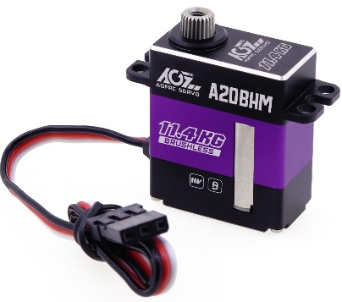

  - MG90S #1 Parachute Bay Lid Servo
The first MG90S micro servo actuates the parachute bay lid latch. Its compact size and adequate torque for a lightweight latch mechanism make it well suited to this single-shot, low-load release function.
PARAMETER | VALUE
Model | MG90S
Motor type | Coreless DC, metal gear
Torque | 1.8 kg-cm @ 4.8 V / 2.2 kg-cm @ 6 V
Speed | 0.1 sec/60° @ 4.8 V
Operating voltage | 4.8–6 V
Weight | 13.4 g
Quantity | 1
Table 34: MG90S #1 Parachute Bay Lid Servo

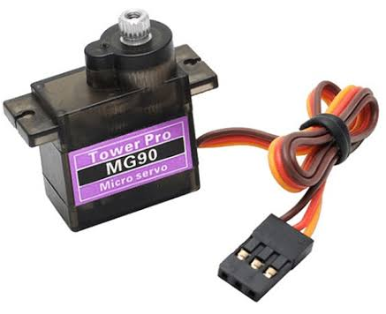
  - MG90S #2 Bio-Gel Lid Servo
The second MG90S servo actuates the bio-gel plate lid, exposing the Petri dish sampling surface for the biochemical characterization payload. This actuation is purposely sequenced into the IMPACT state, ensuring the sampling plate is only exposed to the atmosphere for its intended descent-through-landing collection window rather than throughout the entire flight.
  - 2205 2300KV BLDC Motor — Stabilization Flywheel
The 2205 2300KV brushless DC motor works for CAN-7USAT's reaction flywheel, spinning up during the EJECTION state to provide gyroscopic Altitude stabilization ahead of parachute deployment shock. Its brushless design offers substantially higher achievable RPM and torque density than a brushed DC motor of similar size, giving the flywheel a faster spin-up time and greater stored angular momentum for stabilization authority.
PARAMETER | VALUE
Model | 2205, 2300KV
Motor type | Brushless (outrunner)
KV rating | 2300 KV (RPM per volt)
Compatible cells | 3–4S LiPo
Stator dimensions | 22 mm diameter × 5 mm length
Max continuous current | 32 A
Max continuous power | ~500 W
Weight | ~28–30 g
Quantity | 1
Table 35: 2205 2300KV BLDC Motor- Stabilization Flywheel

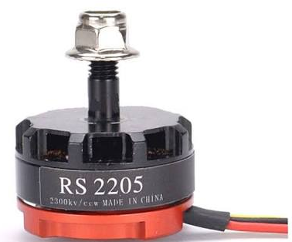
  - Buzzer Recovery Beacon
The onboard buzzer serves as CAN-7USAT's audio recovery beacon, activating continuously upon reaching the IMPACT state to guide the ground recovery team to the landed CANSAT. It is a general-purpose magnetic speaker rather than a piezo element, giving it a broad audible frequency range suited to reliable detection in open-field recovery conditions.

    - Communication and Data Handling Subsystem (CDH)
The CDH subsystem is the main subsystem of CAN-7USAT which is used to collects data from every onboard sensor and manages telemetry transmission and onboard logging. It is built with the help of a primary flight computer, an independent camera and recording path, and storage layer.
- Primary Flight Computer (Teensy 4.1)
PARAMETER | DETAILS
Role | Central processing unit
Core | ARM Cortex-M7, 600 MHz
Interfaces | 55 Digital I/O, 35 PWM, 8 UART, 3 SPI, 3 I²C
Memory | 8 MB Flash, 1 MB RAM, 4284 KB EEPROM
Operating voltage | 3.3–5 V
Boot time | 0.005 s
Loop rate | 100 ms (10 Hz) main loop, 1 Hz telemetry sub-rate
Deployment | One unit primary, one unit backup (secondary avionics board)
Table 36: Communication and Data Handling Subsystem (CDH)
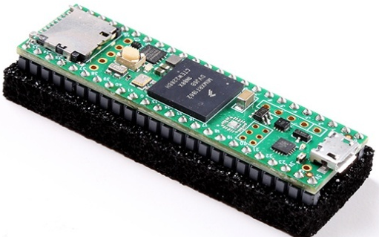

Teensy 4.1 was chosen because of the fastest boot time and clock speed. It is the largest available memory for telemetry, sufficient I/O count for the full sensor/actuator connections. The footprint is small enough not to strain the mass budget.
- Onboard Data Storage
PARAMETER | DETAILS
Role | Continuous onboard backup
Hardware | SanDisk Ultra MicroSDHC, 16 GB
Interface | SPI1
Logging rate | 1 Hz, CSV format
Purpose | Recovers full mission dataset even if telemetry link is lost mid-flight
Table 37: Onboard Data Storage

- Telemetry Radio (LR1121 LoRa)
Parameter | Details
Role | Bidirectional telemetry downlink and telecommand uplink
Device type | Multi-band LoRa transceiver (Sub-GHz + 2.4 GHz)
Configured mode | LoRa, 865 MHz (India ISM sub-band)
Network ID | NETID/PANID set to team number — 0x98
Transmit power | +10 dBm pad / +14 dBm flight
Receiver sensitivity | ~ −130 dBm (SF9, 125 kHz)
Fallback mode | Reconfigurable to 2.4 GHz LoRa if sub-GHz band congested
Deployment | One primary unit, one backup unit (independent failover link)
Table 38: Telemetry Radio (LR1121 LoRa)
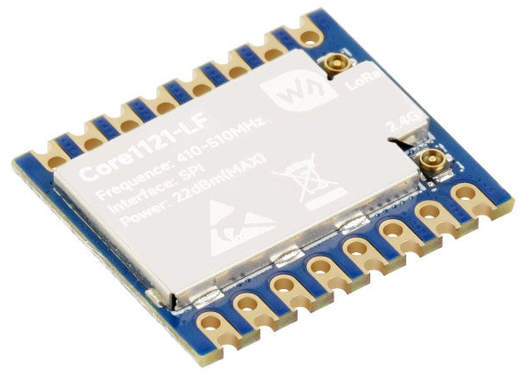
- T- Antenna 865 MHz
The RadioMaster Bandit T Antenna is a omnidirectional whip antenna selected as an alternative to the team's primary onboard antenna, covering the 860–930 MHz band that fully includes CAN-7USAT's 867 MHz LoRa telemetry frequency. It uses the same heavy-duty RG402 coaxial line and 360° swivel RP-SMA connector as the rest of the Bandit antenna series, in a lighter, smaller housing suited to onboard mounting.
PARAMETER | VALUE
Model | RadioMaster Bandit 915/868MHz T Antenna
Bandwidth | 860–930 MHz
Polarisation | Linear
Radiation direction | Omnidirectional
Gain | 2.7 dBi
VSWR | ≤ 1.5:1
Connector | RP-SMA
Input impedance | 50 Ω
Cable | RG402 coax, 80 mm
Dimensions | 107 × 98 mm
Weight | 14.00 g
Table 39: T – Antenna 865 MHz

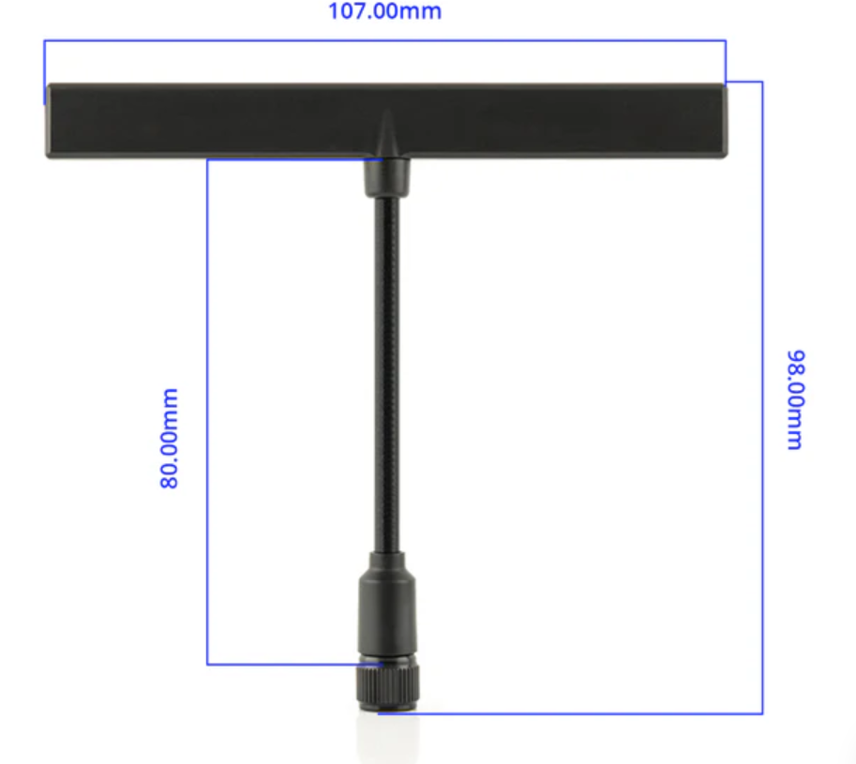
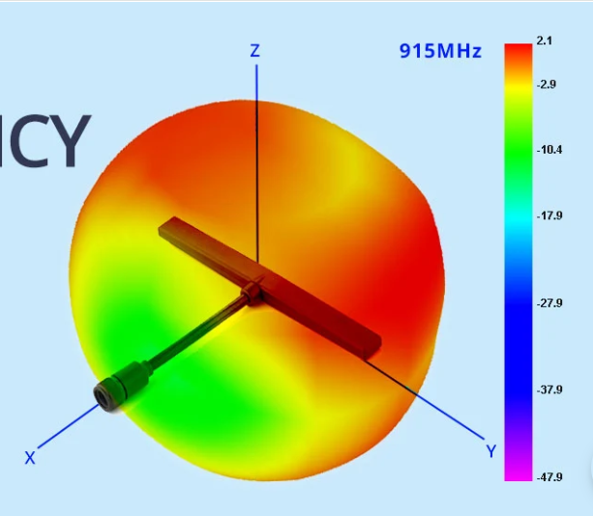
Fig 49: Radio Master T-Anteena

    - Electrical Power Subsystem
The EPS helps us with stable, protected power to every onboard subsystem by converting raw battery voltage into regulated rails while providing real-time health monitoring and multi-layer protection against overcharge, over-discharge, and short-circuit conditions.
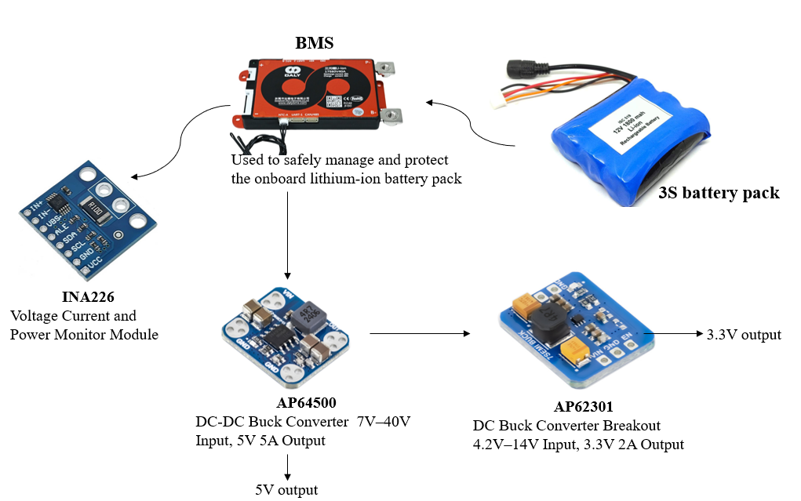
Fig 50: Power Subsytem

- Molicel INR-21700-P50B Battery Pack
PARAMETER | DETAILS
Role | Primary energy source for the entire CAN-7USAT power system
Configuration | 3 × Molicel INR-21700-P50B cells (3S)
Nominal voltage | 10.8 V
Fully charged voltage | 12.6 V
Capacity | 5000 mAh
Total energy | 54 Wh (3 × 18 Wh)
Usable energy (80% DoD) | ~43.2 Wh
Deployment | Single pack, feeding VBAT rail
Table 40: Molicel INR-21700-P50B Battery Pack

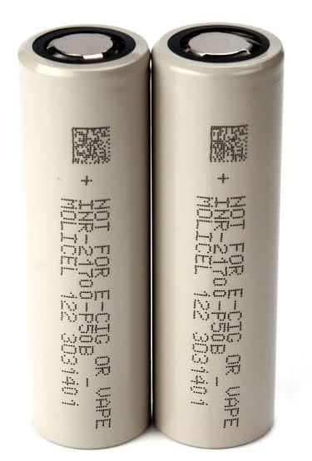
- Battery Protection (3S 40A Li-ion BMS)
PARAMETER | DETAILS
Role | Safeguards the battery pack during charge and discharge operation
Protection functions | Overcharge, over-discharge, overcurrent, short-circuit
Current rating | 40 A
Additional feature | Built-in cell balancing for extended battery life
Interface | In line with battery pack, upstream of power distribution
Table 41: Battery Protection (3S 40A Li-ion BMS)

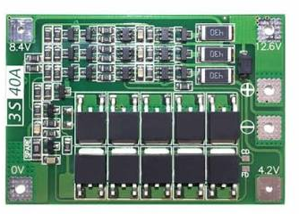
- 5V Power Regulation (AP64500 Buck Converter-7Semi)
PARAMETER | DETAILS
Role | Converts battery voltage to a stable 5V rail
Input range | 7–40 V
Output | 5.0 V, up to 5 A
Efficiency | Up to 95%
Consumers powered | Teensy 4.1, servos, XIAO ESP32S3 camera module, gyro motor driver
Interface | Direct 5V power rail (5V_MAIN)
Table 42: 5V Power Regulation (AP64500 Buck Converter – 7Semi)
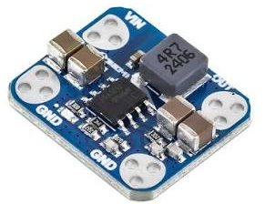
- 3.3V Power Regulation (AP62301 Buck Converter-7Semi)
PARAMETER | DETAILS
Role | Converts battery voltage to a stable 3.3V rail
Output | 3.3 V, up to 2 A
Consumers powered | LR1121, BMP585, ICM-20948, INA226, DS3231M RTC, L89 GPS
Interface | Direct 3.3V power rail (3V3_MAIN)
Advantage over linear regulation | Higher efficiency than AMS1117-type LDOs
Table 43: 3.3V Power Regulation (AP62301 buck Converter -7Semi)
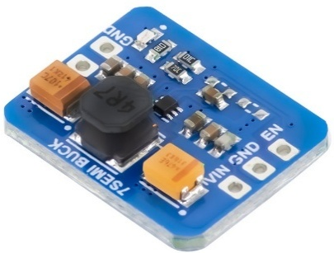
- Power-On Control (External Switch & LED Indicator)
PARAMETER | DETAILS
Role | Manual power control and visual power-state confirmation
Switch type | External SPST switch (SW1)
Indicator | LED (illuminates when supply is active, off when no current flows)
Requirement satisfied | External power switch with visual on/off indication
Table 44: Power-On Control (External Switch & LED Indicator)
- Power Budget
Component | Voltage | Current | Maximum Power | Duty Cycle (%) | Average Power | Source
Teensy 4.1 | 5 | 0.18 | 1.8 | 100 | 1.8 | Existing
ESP32-S3 | 5 | 0.18 | 1.8 | 70 | 1.26 | Existing
LR1121 LoRa (TX) | 3.3 | 0.055 | 0.1815 | 20 | 0.0363 | Existing
L89 GNSS | 3.318 | 0.032 | 0.106176 | 100 | 0.106176 | Existing
ICM-20948 IMU | 3.322 | 0.0045 | 0.029898 | 100 | 0.029898 | Existing
SCD41 CO2 | 5 | 0.018 | 0.09 | 100 | 0.09 | Existing
AS3935 Lightning | 3.3 | 0.0001 | 0.00033 | 100 | 0.00033 | Datasheet
AS7343 Spectral | 3.3 | 0.0x98 | 0.00825 | 100 | 0.00825 | Datasheet
HDC3020 Temp/Humidity | 3.3 | 0.0008 | 0.00264 | 100 | 0.00264 | Datasheet
ML8511 UV | 3.3 | 0.0003 | 0.00099 | 100 | 0.00099 | Existing
MQ131 Ozone | 5 | 0.15 | 0.75 | 50 | 0.375 | Existing
BMV080 PM | 3.3 | 0.018 | 0.0594 | 100 | 0.0594 | Existing
TPL5010 Timer | 2.5 | 0.000000035 | 8.75E-08 | 100 | 8.75E-08 | Datasheet
W25Q64 Flash | 3.3 | 0.025 | 0.0825 | 20 | 0.0165 | Datasheet
INA226 | 3.3 | 0.0012 | 0.00396 | 100 | 0.00396 | Existing
SN74LV4052A MUX | 3.3 | 0.00008 | 0.000264 | 100 | 0.000264 | Datasheet
DS3231 RTC | 3.3 | 0.00011 | 0.000363 | 100 | 0.000363 | Datasheet
Hobbywing XRotor 40A ESC | 10.8 | 0.1 | 1.08 | 30 | 0.324 | Datasheet
2205 2300KV BLDC Motor | 10.8 | 4 | 43.2 | 30 | 12.96 | Datasheet
AGFRC A20BHM Servo #1 | 7.4 | 1.5 | 11.1 | 20 | 2.22 | Datasheet
AGFRC A20BHM Servo #2 | 7.4 | 1.5 | 11.1 | 20 | 2.22 | Datasheet
Teensy 4.0 (DCS) | 5 | 0.08 | 0.4 | 100 | 0.4 | Existing
BMP585 | 3.3 | 0.001 | 0.0099 | 100 | 0.0099
7.4V BEC | 7.4 | 0.02 | 0.296 | 100 | 0.296 | Existing
7Semi AP62301 Buck 3.3V 2A | 5 | 0.02 | 0.2 | 100 | 0.2 | Existing
7Semi AP64500 Buck 5V 5A | 10.8 | 0.03 | 0.648 | 100 | 0.648 | Estimate
 |  |  |  | Total Maximum Power | 72.9501709
 |  |  |  | Total Average Power | 23.06797109
Battery Capacity (mAh) | 5000
Battery Voltage (V) | 10.8
Battery Energy (Wh) | 54
Estimated Endurance (Hours) | 2.341
Table 45: Power Budget

    - Sensor Subsystem
The sensor subsystem provides CAN-7USAT with all mandatory flight-critical measurements such as altitude, orientation, position, and power state. Additionally, Team VRITRA have added five-sensor bonus environmental payload for atmospheric characterization during descent.
- Sensor Bus Allocation
BUS | SENSORS ON BUS
I2C0 | BMP585, DS3231M RTC, SCD41, SEN0290, BMV080
Backup I2C0 | ICM-20948
UART1 | L89HA GNSS
Analog | GYML8511, MQ131
SPI (shared with LR1121/SD) | LSM6DSO32
Table 46: Sensor Bus Allocation
- Telemetry Field Mapping
SR NO. | TM PARAMETER | SENSOR | FUNCTION | RESOLUTION/ FORMAT
1. | <TEAM ID> | - | Team Name | 2026-IN-SPACeCAN-7USAT-0x98
2. | <TIME STAMPING> | DS3231M RTC | Time since the initial power | Seconds
3. | <PACKET COUNT> | EEPROM counter | Count of transmitted packets
4. | <ALTITUDE> | BMP585 | Altitude in units of meters and must be relative to ground | 0.1 meters
5. | <PRESSURE> | BMP585 | Measurement of atmospheric pressure | 1 pascal
6. | <TEMP> | BMP585 | Temperature in Celsius | 0.1 oC
7. | <VOLTAGE> | INA226 | Voltage of the CAN-7USAT power bus | 0.01 Volts
8. | <GNSS TIME> | L89_GPS | Time generated by the GNSS receiver | Seconds
9. | <GNSS LATITUDE> | L89_GPS | Latitude generated by the GNSS receiver | 0.0001 degrees
10. | <GNSS LONGITUDE> | L89_GPS | Longitude generated by the GNSS receiver | 0.0001 degrees
11. | <GNSS ALTITUDE> | L89_GPS | Altitude generated by the GNSS receiver | 0.1 meters
12. | <GNSS SATS> | L89_GPS | GNSS satellites connected | integer number
13. | <ACCELEROMETER DATA> | LSM6DSO32 | Data received from the gyroscopic sensor | m/s2
14. | <GYRO SPIN RATE> |  | Spin rate of Mechanical Gyro wrt. CAN-7USAT | deg/s
15. | <FLIGHT SOFTWARE STATE> | Teensy FSM | Operating state of the software | (boot, idle, launch detect, deploy, etc.)
16. | < AIR QUALITY SENSING> | BMV080 | Measures fine particulate matter concentration | PM1.0, PM2.5, and PM 10
17. | <GRAVITY LIGHTNING SENSOR> | SEN0290 | Measures lightning distance, intensity, and frequency | 21-bit resolution
18. | <UV LIGHT SENSOR MODULE> | GYML8511 | Detects ultraviolet light in the 280 nm – 390 nm wavelength | peak sensitivity at 365 nm
19. | <OZONE GAS SENSOR> | MQ131 | Detects Ozone particles | 10 – 1000 ppm
20. | <CARBON DIOXIDE CONCENTRATION> | SCD41 | Measure carbon dioxide (CO₂), temperature, and humidity | 400 – 5000 ppm
Table 47: Telemetry Field Mapping

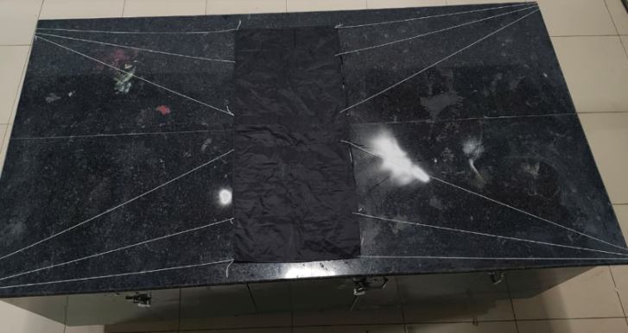
    - Parachute deployment and recovery
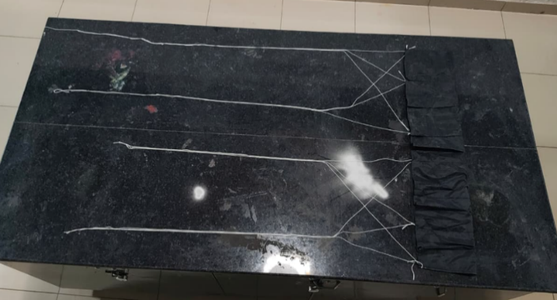

Stage 1 Stage 2
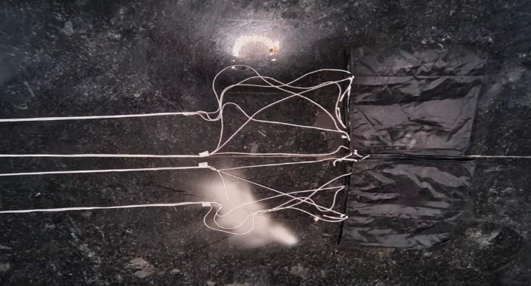
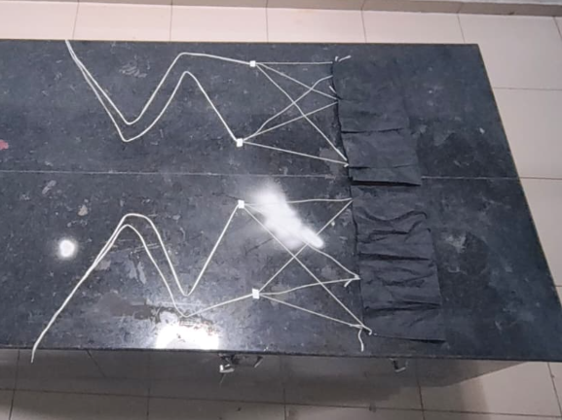

Stage 3 Stage 4
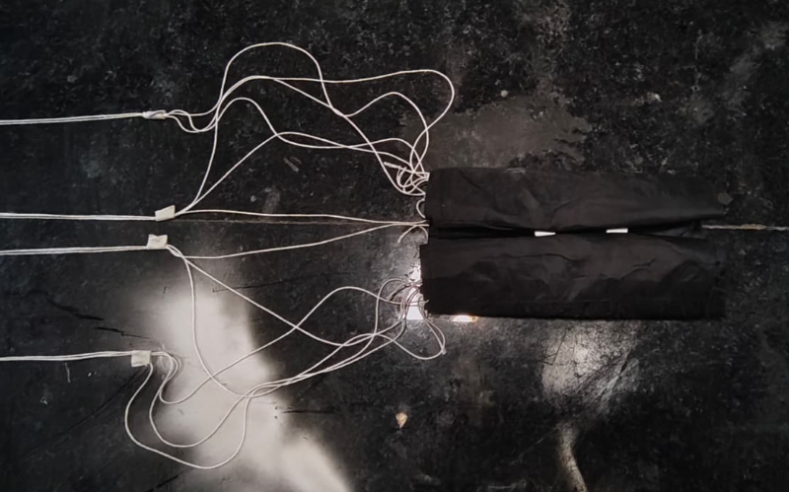
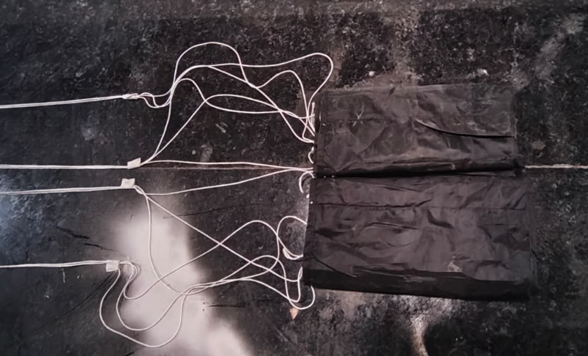

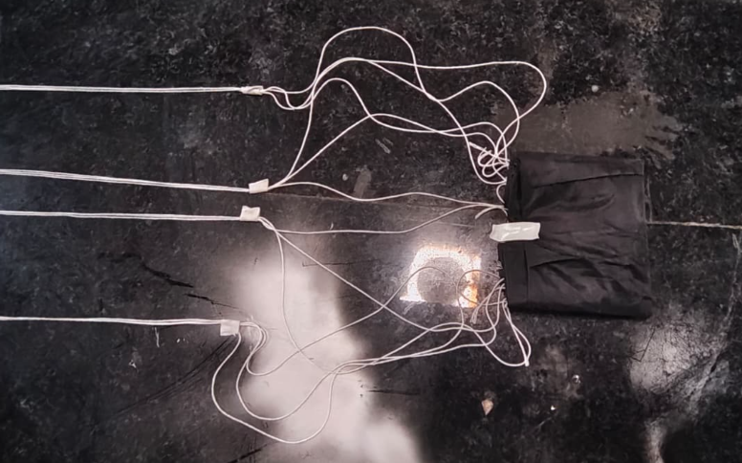
Stage 5 Stage 6
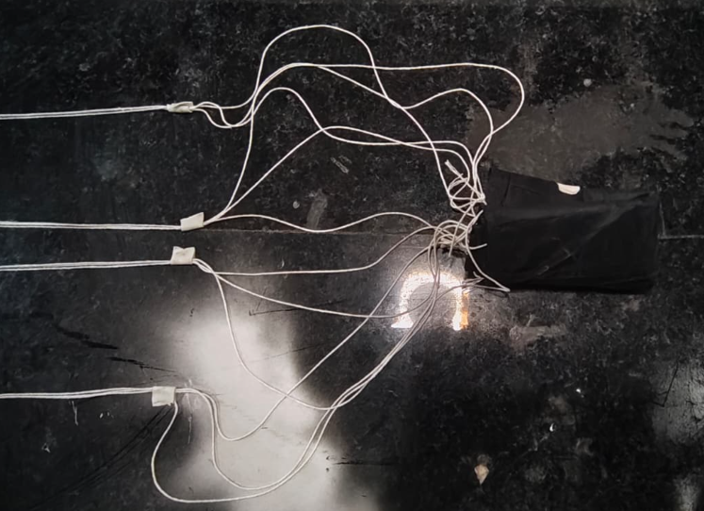

Stage 7 Stage 8
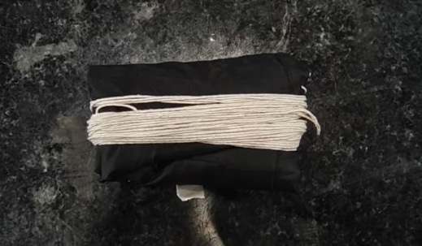
Stage 9
Above is the step-by-step process of folding a RAM air parachute. This folding method is done for proper adjustment of parachute in parachute bay and to avoid entanglement of cords during deployment.
This parachute testing was done from a heighted building of around 120 feet. According to the test results, the RAM air parachute has a proper shape and nodes attachment. It carried 840 g of dead weight and the parachute. It had proper opening without any entanglement with in the codes.
Improvement done after testing: Length of the cord is reduced according to the calculations.
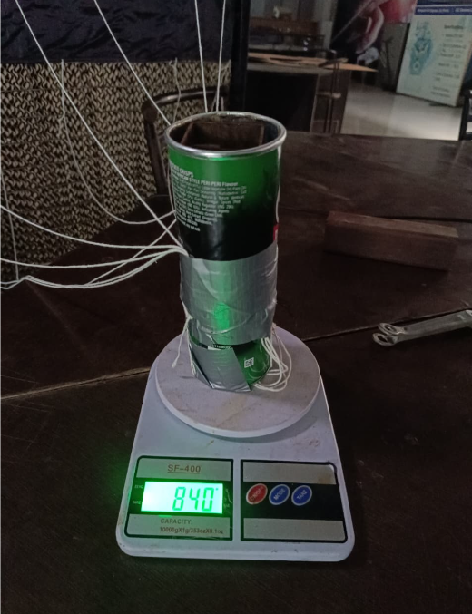
Fig 51: Parachute dead weight



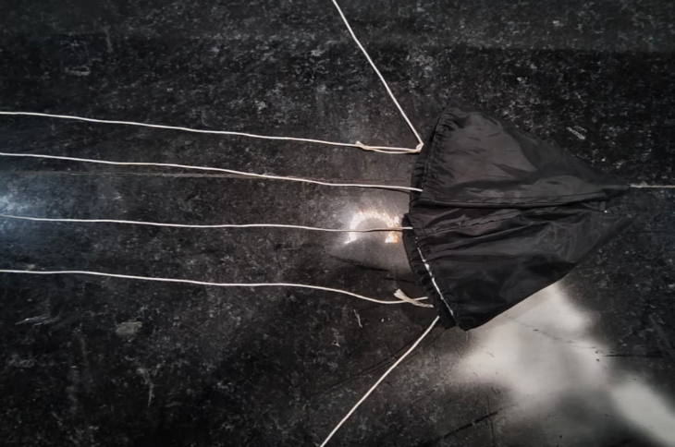
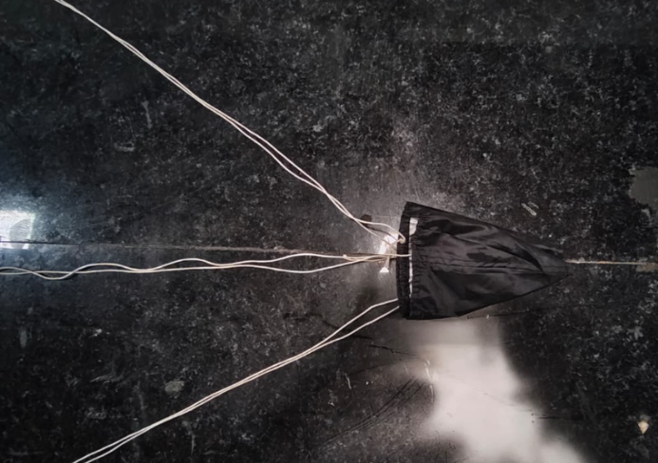
Stage 1 Stage 2

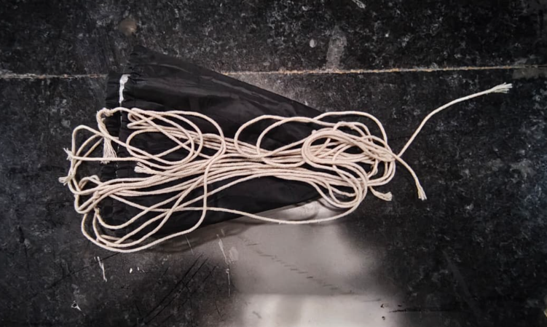
Stage 3 Stage 4


Stage 5 Stage 6

Above given is the step-by-step guid of folding out primary parachute.

- CAN-7USAT ALGORITHM, FINAL TEST RESULTS, ALONG WITH ANY DEVIATIONS
POWER ON
3S Li-ion
HW INIT
Sensors, LoRa, SD
SELF TEST
All subsystems
All
Pass?
No
Yes
TEST MODE
Calibrate sensors
CMD
TX_ON?
No
Yes
LAUNCH PAD
Armed, waiting
Launch
detect?
No
Yes
ASCENT
Log &transmit
Apogee
detect?
No
Yes
ROCKET DEPLOY
Separation
DEPLOY CHUTE
Primary drag
DESCENT
~20 m/s
Alt <
600m?
No
Yes
PARAFOIL
RAM-air deploy
PID STEER
GPS to target
Landing?
No
Yes
IMPACT
Buzzer and GPS
Yes
Yes
Yes

Fig 52: CANSAT Algorithm

- TTLC LINK MARGIN REALIZED
Given Parameters according to the datasheet and instruction manual:
TX Power = 22 dBm
Onboard Antenna Gain = 2.7 dBi
Ground Antenna Gain = 2.7 dBi
Frequency (f) = 867 MHz
Distance (d) = 1 km
Spreading Factor = SF10
Bandwidth = 125 kHz
Receiver Sensitivity at SF10
Sensitivity at SF7, BW 125 kHz = −127 dBm
Sensitivity at SF12, BW 125 kHz = −141 dBm
Sensitivity per SF step = $\frac{-141-\left(-127\right)}{(12-7)}$
Sensitivity per SF step = −14 / 5 = −2.8 dB per step
S_RX (SF10) = S_RX (SF7) + (SF10 − SF7) × (−2.8)
S_RX (SF10) = −127 + (10 − 7) × (−2.8)
S_RX (SF10) = −127 − 8.4
S_RX = −135.4 dBm
Free Space Path Loss (FSPL)
FSPL = 20 $log₁₀($d) + 20 $log₁₀($f) + 32.44
FSPL = 20 $log₁₀($1) + 20 $log₁₀($867) + 32.44
FSPL = 0 + 58.76 + 32.44
FSPL = 91.2 dB
Received Power
P_RX = P_TX + G_TX + G_RX − FSPL
P_RX = 22 + 2.7 + 2.7 − 91.2
P_RX = −63.8 dBm
Link Margin
Link Margin = P_RX − S_RX
Link Margin = −63.8 − (−135.4)
Link Margin = 71.6 dB
Results: The calculated received signal strength of around −63.8 dBm is higher than the LR1121 receiver sensitivity of −135.4 dBm at SF10, 125 kHz bandwidth. This results in an estimated link margin of 71.6 dB is confirming that the telemetry system holds large signal headroom for proper communication between CAN-7USAT and the ground station over the full 1 km design range.
10.1 Radio Interference Mitigation Plan:
- NETID/PANID unique to team number (provided as team number-25) prevents packet collision with other teams' LR1121 units. (PANID- 0x98)
- Pre-launch RF checks will be performed using the ground station receiver to verify signal quality and identify nearby interference sources before launch.
- Critical telemetry packets will include packet counters and status information to help detect packet loss during communication.
- Ground station T-antenna provides better gain, reducing off-axis interference
- LR1121 LoRa SF10 spreading factor is orthogonal to SF7/SF8.

- GROUND STATION FINAL TEST RESULTS, ALONG WITH ANY DEVIATIONS
The VRITRA Ground Control Station was tested end-to-end against a simulated flight by performing all six operational tabs while decoding live telemetry at 3.8 Hz over the 867 MHz downlink. The Flight tab confirms correct 3D CANSAT visualization, real-time Altitude /heading display, GPS fix, and full flight-sequence state tracking. Across all tabs the GCS correctly reflected realistic degraded-link without crashing or losing packet sync, confirming the ground software is stable and ready to support live flight operations.
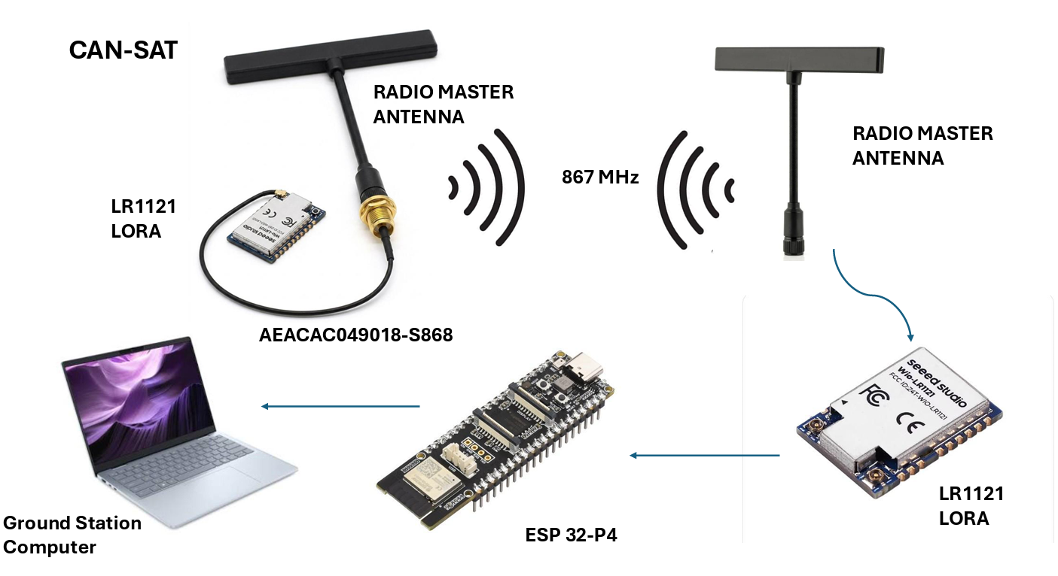
Fig 53: Communication Subsystem

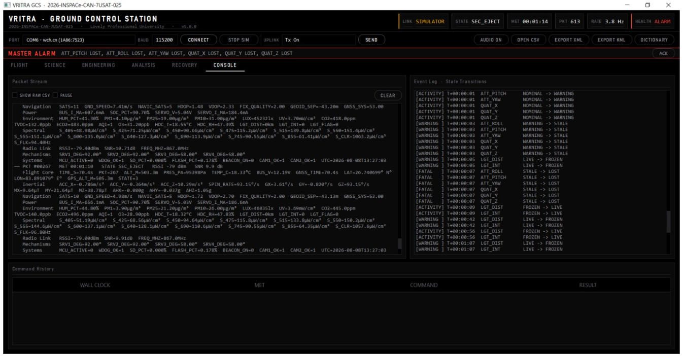

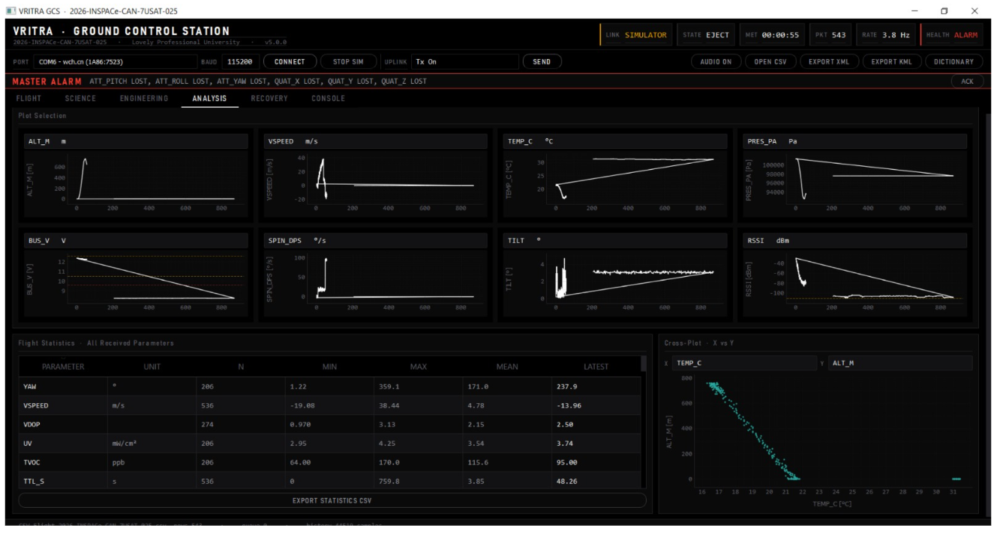

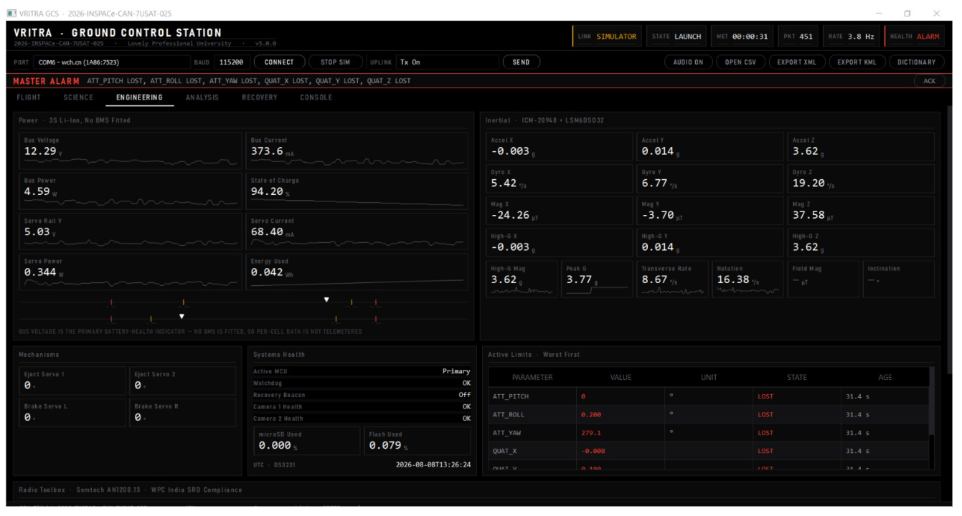

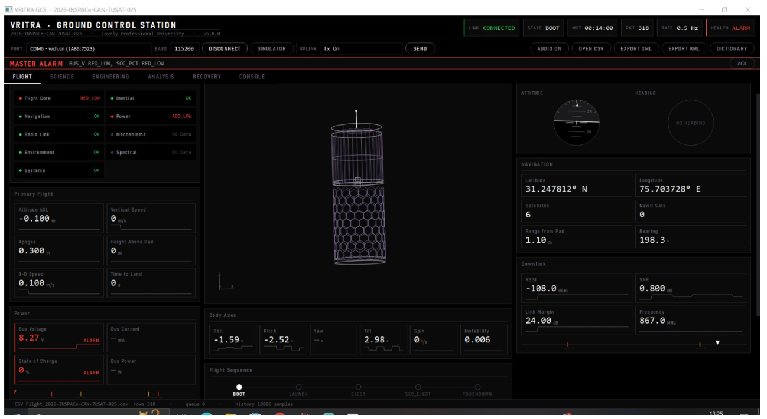
Fig 54: Ground Station Test

- MISSION OPERATIONS & ANALYSIS
This section defines how Team VRITRA is going to operates CAN-7USAT across the mission timeline from ground preparation through flight execution to recovery.
Phase | Duration (approx.) | Primary Operator Role
Ground station setup | 30–45 min | GCS lead + antenna crew
Pre-flight checkout & calibration | 20–30 min | Avionics lead
Pad wait | Up to 2 hours | Full team, telemetry monitoring
Powered ascent | ~15–30 s | Passive monitoring
Primary descent | ~50–70 s (est.) | Telemetry monitoring
Secondary guided descent | ~120–200 s (est.) | Telemetry monitoring + recovery team staging
Recovery | Beacon-guided | Recovery team
Table 48: Mission Operations & Analysis

12.1 Launch Day Sequence
- Arrive at launch site ≥ 3 hours before launch slot
- Set up ground station: laptop, LR1121 receiver, and antenna
- Power on GS laptop — open Python GS software, verify LR1121 receiver detected on COM port
- Install CANSAT batteries — verify voltage reading on INA226 (≥ 8.0 V), close battery hatch
- Power on CANSAT via external switch — green LED illuminates, GS software shows BOOT packets
- Send CMD_CALIBRATE from GS — CANSAT zeros baro altitude, gyro offsets, accel offsets at pad level
- Verify TEST_MODE telemetry: all sensors reading correctly, GPS fix acquired (≥ 6 sats)
- Record launch pad GPS coordinates as target waypoint for parafoil PID (CMD_SET_WAYPOINT)
- Fold primary chute in Z-fold, secure against outer body with Velcro tab per packing procedure
- Pack parafoil in deployment bag, insert pin, place in Parachute Bay
- Hand CANSAT to launch crew for placement in rocket payload bay
- Send CMD_TX_ON from GS — CANSAT transitions to LAUNCH_PAD, confirms telemetry streaming
- Verify GS CSV is logging: Flight_[TEAM_ID].csv row count incrementing at 1 Hz
- Launch — monitor all TM fields in real-time on GS dashboard
- At AEROBREAK_RELEASE (state 6): observe GPS track converging toward launch pad waypoint
- At IMPACT (state 7): note final GPS position, move to recovery with audio beacon guidance
- Retrieve CANSAT — download full CSV and video from ESP32-P4.

- PRE-FLIGHT REQUIREMENT-CHECK ANALYSIS
Before CAN-7USAT is cleared for integration into the launch vehicle, every mandatory competition requirement is checked against the as-built system through a defined verification method such as analysis, test, inspection, or demonstration.
Sr. | Category | Requirement | Status
1 | Structural | No sharp edges on container body | Checked
2 | Structural | Fluorescent body color + Indian flag | Checked
3 | Structural | No use of rocket airframe as CanSat structure | Checked
4 | Structural | Team details in English, Hindi, and regional language | Checked
5 | Structural | Electronics enclosed/shielded (sensors excepted) | Checked
6 | Structural | Circuit boards hard-mounted (standoffs/screws) | Checked
7 | Power | External switch with LED and sound indicator | Tested
8 | Power | Battery type compliance (Li-ion) | Checked
9 | Power | Battery accessible/removable in <1 minute | Planned
10 | Power | No spring-contact battery connections | Checked
11 | Descent & Recovery | Primary descent parachute | Tested
12 | Descent & Recovery | Primary chute deploys immediately post-ejection | Checked
13 | Descent & Recovery | Primary chute attached to body, no separate ejection mechanism | Planned
14 | Descent & Recovery | No pyrotechnic/explosive/hazardous chemical deployment | Checked
15 | Descent & Recovery | Gyroscopic wheel stabilization during descent | Planned
16 | Communication | Radio XBEE or LoRa | Tested
17 | Communication | NETID/PANID set to team number | Tested
18 | Communication | No broadcast mode used | Checked
19 | Communication | No interference with other teams' radios | Checked
20 | Communication | RF-commanded telemetry start/stop capability | Checked
21 | Communication | Radio interference mitigation plan presented | Checked
22 | Ground Station | Own ground station developed by team | Tested
23 | Ground Station | Real-time telemetry display, SI units | Tested
24 | Ground Station | GS commands CanSat to start telemetry | Tested
25 | Ground Station | Elevated ground antenna | Tested
26 | Ground Station | CanSat does not transmit until commanded | Tested
27 | Ground Station | Ground calibration command (gyro/baro/accel zero) | Checked
28 | Ground Station | CSV generation, mission time resolution | Tested
29 | Ground Station | Mission clock/state persists across processor reset | Tested
30 | Ground Station | Portable ground station (<5 min setup) | Checked
31 | Flight Software | FSM state maintained and telemetered | Checked
32 | Flight Software | Correct state determination after processor reset | Tested
33 | Flight Software | All states described in review presentation | Checked
34 | Telemetry | Full mission telemetry saved as CSV on GS | Tested
35 | Telemetry | Onboard data storage utilized | Tested
Table 49: Pre-Flight Requirement-Check Analysis

- LOGISTICS AND TRANSPORTATION
  - CAN-7USAT transportation and handling
CAN-7USAT is designed to be transported and handled with minimum risk to its structural, electronic, and descent-system integrity between Lovely Professional University and the competition launch site in khushinagar, UP. The following handling protocol is followed by Team VRITRA:
    - Pre-Transport Preparation
- Battery will be disconnected/powered off via the external switch prior to transport, as per the competition's power-safety requirement.
- Primary parachute and RAM-air parafoil will be packed into their respective bays and will be opened only at the launch site immediately before integration to avoid canopy compression damage or line tangling over an extended packed duration.
- The CANSAT will be placed in a custom-fitted protective transport case with foam cutouts matching its dimensions, cushioning the structure against shock and vibration during vehicle transport.
- All exposed sensor apertures (GPS antenna, air-quality sensor inlets, UV sensor window) will be covered with protective caps/tape during transit and removed only during final pre-launch checkout.
- Spare batteries, tools, and the Petri dish culture media for the biochemical payload will be transported separately in a dedicated accessory case to avoid contamination or accidental damage to the primary structure.
    - Transport Method
CAN-7USAT and the ground station equipment are transported by road from LPU to the launch site by team members and mentors, using the protective case described above secured against movement in the vehicle.

- CAN-7USAT READY TO LAUNCH AND FINAL COMMENTS
CAN-7USAT balances competition mandatory consistency such as redundant avionics, dual-confirmed deployment triggers, conservative structural margins and meaningful innovation in its atmospheric biosciences payload and NavIC-enabled navigation. With outstanding verification items completed, Team VRITRA is confident in CAN-7USAT's readiness to proceed toward full integrated testing and flight.

- CONCLUSION
Team VRITRA's CAN-7USAT presents a Critical Design Review that carries forward and matures every design commitment made at PDR into a fabricated, analytically verified, and largely bench-tested flight vehicle. The two-stage descent architecture of a drag-deployed primary parachute followed by a GPS-guided RAM-air parafoil with dual-axis brake-line steering meets all mandatory descent-rate and activation-altitude requirements with demonstrated margin, while the Teensy 4.1 avionics architecture, dual LR1121 telemetry links, and dual-confirmed altitude triggers reflect a design cantered rather than single points of failure.
The communication link comes as 71.6 dB margin at the full 1 km design range even under the competition-specified 867 MHz/SF10 configuration. Beyond mandatory compliance, CAN-7USAT differentiates itself through its innovation payload of biochemical characterization of atmospheric bacterial isolates collected during descent and also a five-sensor bonus environmental suite and NavIC-enabled dual-band GNSS, reflecting the team's intent to contribute genuine atmospheric science value beyond the competition's baseline mission profile.
A small set of verification items such as full-scale vibration testing, field RF range confirmation, and power budget revalidation remain open ahead of the Flight Readiness Review. Team VRITRA views these not as design uncertainties but as the final confirmatory steps of a design that has already been carried through structural analysis, FEA simulation, link budget calculation, and subsystem-level bench testing.
With eight team members contributing across aerospace, electronics, and robotics disciplines under faculty and mentor guidance from Lovely Professional University, Team VRITRA submits this Critical Design Review confident that CAN-7USAT is on track to meet every mission requirement of the IN-SPACe CAN-7USAT India Student Competition 2026, and looks forward to demonstrating its performance at launch.

