ASSIGNMENT-3

ANSWERS FOR PRACTICE QUESTIONS ROLL NO:64
CYCLE 1

1.Display your current directory.
command: pwd
output:
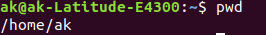

2.Change to the /etc directory.
command: cd /etc
output:
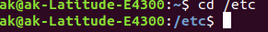

3.Now,change to your home directory using single commamd.
command: cd ~
output:
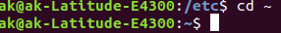

4.Change to the parent directory of the current directory.
command: cd ..
output:
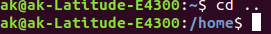

5.Go to the root directory.
command: cd /
output:
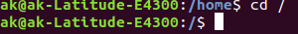

6.Give a long listing of the root directory.
command: ls -l /
output:
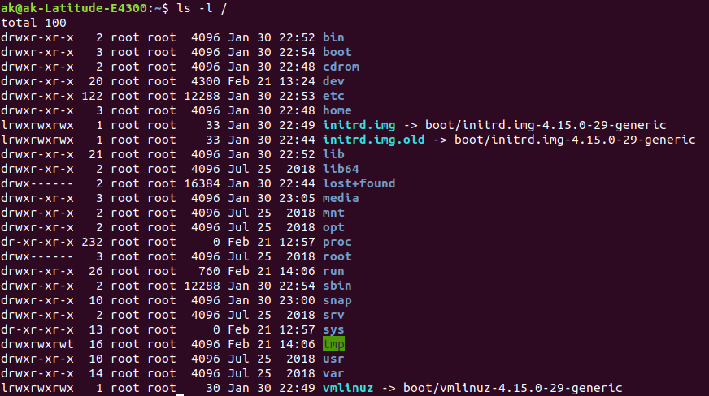

7.Give a listing of a last 10 files in the root directory.
command: ls / | tail
output:
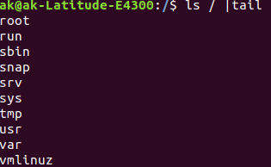

8.Stay where you are, and list the contents of /etc.
command: ls /etc
output:
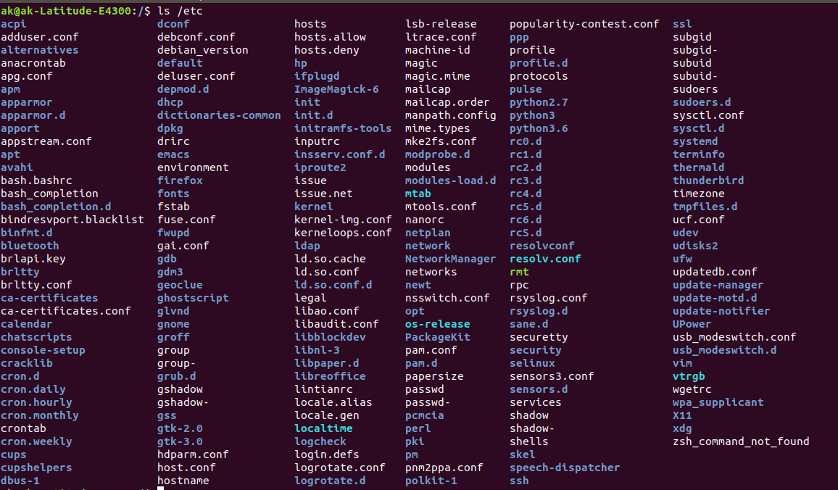

9.Create a directory testdir in your home directory.
Command: mkdir ~/testdir
output:
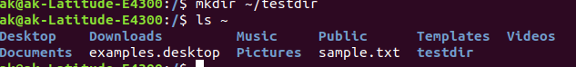

10.Change to the /etc directory, stay there and create a directory newdir in your home
directory(using a single command).
Command: cd etc | mkdir ~/newdir
output:
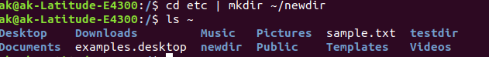
11.Create in one command the directories ~/dir1/dir2/dir3 (dir3 is a subdirectory from dir2,
and dir2 is a subdirectory from dir1).
Command: mkdir -p ~/dir1/dir2/dir3
output:
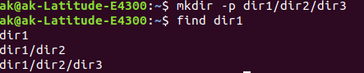

12.Display the calendar for April 2019.
command: cal april 2019
output:
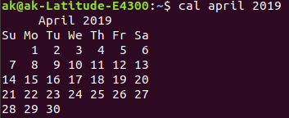

13.Display that ‘There are ....... files in my current directory’ . The ..... should be filled with the
count of the files.
Command: echo "There are ` ls | wc -w ` in my current directory"
output:

14.List all the files (including hidden files) in your home directory.
Command: ls -a ~
output:
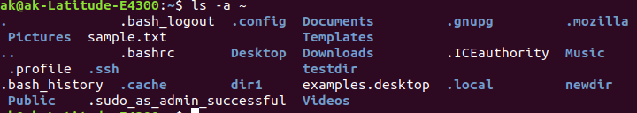

15.Redirect the output of the above command to a new file FileList.txt.
Command: ls -a ~ >>FileList.txt
output:
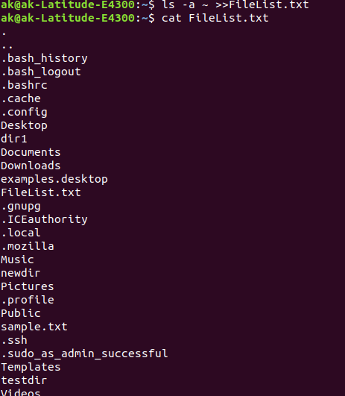

16.Redirect the number of lines of FileList.txt to CountFile.txt.
Command: wc -l Filelist.txt >> countfile.txt
output:
17.List all the files in your home directory starting with ‘s’ .
command: ls | grep s*
output:
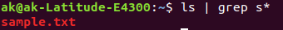

18.List all the file-names starting with “a”, “b” or “s” .
command: ls [abs]*
output:
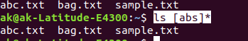

19.Create two files ‘Countries.txt’, containing country names and their corresponding capital cities
and ‘Story.txt’ contains some arbitrary lines of text.
Command: nano countries.txt
nano story.txt
output:
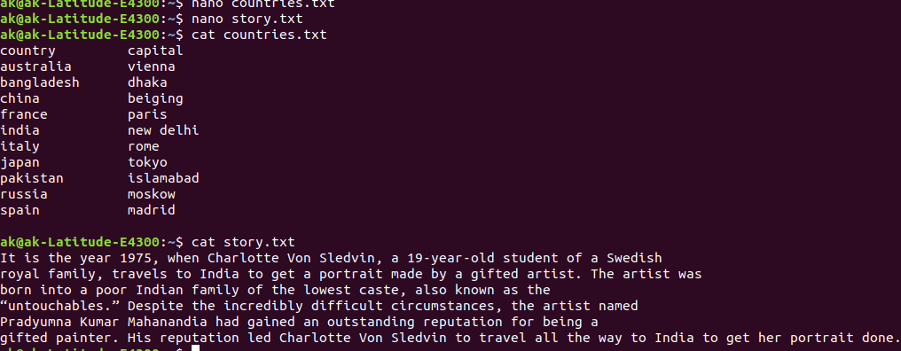

20.Convert all lowercase characters from ‘Story.txt’ to uppercase and store it in a file
‘Capstory.txt’.
Command: tr [:lower:] [:upper:] < story.txt >> capstory.txt
output:
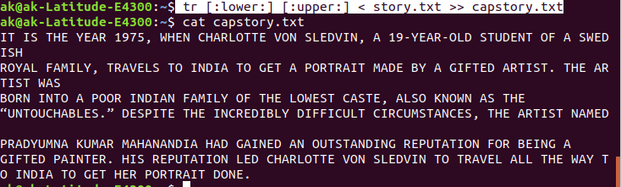
21.Toggle the cases in ‘Story.txt’ and store it in a file ‘Togglestory.txt’.
Command: tr 'A-Za-z' 'a-zA-z' < story.txt >> togglestory.txt
output:
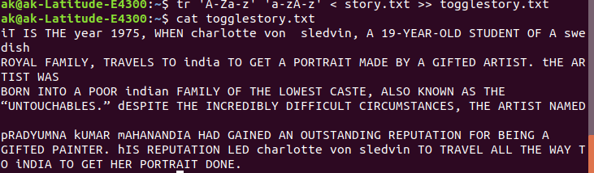

22.Sort the contents of ‘Countries.txt’with Capital as the primary sort key and write the sorted
output to ‘SortCountry.txt’ .
Command: sort -k2 countries.txt >> sortCountries.txt
output:
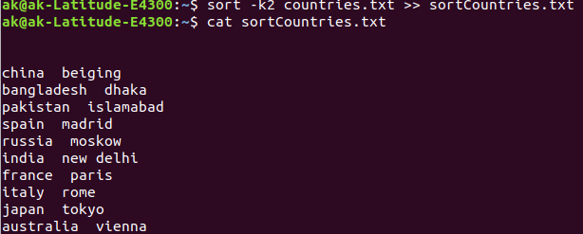

23.Display only the capital cities from ‘Countries.txt’.
Command: awk ‘{print $2}’ countries.txt
output:
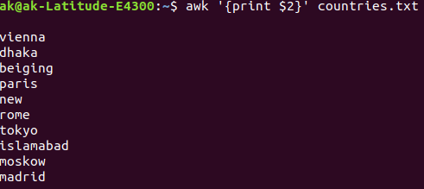

24.Locate all ‘.txt’ and ‘.doc’ files in the current directory .
Command: ls *.txt *.doc
output:
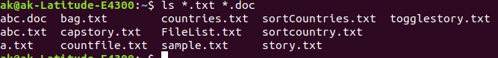
25.Count the number of occurence of ‘the’ in ‘Story.txt’.
Command: grep -o the countries.txt
output:

RESULT:
commands for different tasks in the assignment are identified and the output of each command is obtained.

