MNC Growthand Workforce Analytics Using Python
Project Documentation
Python | Pandas | NumPy | Matplotlib | Seaborn | Google Colab / Jupyter Notebook

1. Project Overview
This project focuses on analyzing the Inc 5000 Companies dataset using Python to extract meaningful insights about company growth and workforce performance. The analysis includes data loading, data cleaning, data transformation, feature engineering, exploratory data analysis (EDA), statistical analysis, and visualization.
The project aims to understand company revenue growth, industry performance, workforce expansion, geographical distribution, revenue efficiency, and company age patterns. The analysis transforms raw company information into useful findings that can support business understanding and decision-making.

2. Data Source
Details | Project Information
Dataset Name | Inc 5000 Companies dataset
Original Source | Maven Analytics Data Playground
Source URL | https://mavenanalytics.io/data-playground
Domain | Finance
File Type | CSV
Number of Records | 502 rows
Number of Original Attributes | 14 fields
Dataset Coverage | Companies on the 2019 Inc 5000 list
Timeline | Founding years from 1909 to 2015
Geographical Coverage | 43 states, 293 cities and 54 metropolitan-area labels
The dataset contains company profile information, including company name, location, industry, revenue, revenue growth, founding year, and workforce details.

3. Problem Statement
Organizations need to understand how companies perform across revenue, growth, workforce, industries, and geographical locations. However, raw company data may contain missing values, inconsistent formats, and information that requires transformation before meaningful analysis can be performed.
This project aims to clean and analyze the Inc 5000 Companies dataset to identify important business patterns, compare company and industry performance, understand workforce growth, and examine the relationships between revenue, growth, and company characteristics.

4. Objectives
- Analyze Company Growth — Identify companies with the highest revenue growth percentage.
- Compare Industry Performance — Determine which industries generate the highest total revenue and have thelargest workforce.
- Evaluate Workforce Growth — Identify companies with the highest employee growth compared to their previousworkforce.
- Analyze Geographical Distribution — Identify the states and cities with the highest number of companies andcompare business performance by location.
- Study Revenue and Growth Trends — Analyze the relationship between company revenue and revenue growthpercentage.
- Analyze Revenue per Employee — Identify companies with the highest revenue per employee to evaluate workforceproductivity.
- Study Company Age and Business Trends — Analyze the distribution of companies across founding years, comparethe growth of newer and older companies, and identify industries with the highest and lowest representation.

5. Attribute (Column / Feature) Details
Attribute Name | Description
Rank | Company rank in the Inc 5000 list.
Profile | Company profile reference or URL.
Company_name | Name of the company.
url | Company website or web address field.
state | State where the company is located.
city | City where the company is located.
Industry | Industry or business sector of the company.
Metro | Metropolitan-area label associated with the company.
Founded | Year in which the company was founded.
Revenue_in_millions | Company revenue converted to a numeric value in millions.
Revenue_Growth_Percentage | Company revenue growth percentage.
Years_On_List | Number of years the company appeared on the list.
Previous_Workers | Previous reported number of workers.
Current_Workers | Current reported number of workers.
Employee_Change | Difference between current and previous workers.
Employee_Growth_Percentage | Percentage change in workforce compared with previous workers.
Company_Size | Company category based on current workforce: Small, Medium or Large.
Company_Age | Company age calculated using 2015 as the reference year.
Revenue_Per_Employee | Revenue divided by current workforce, expressed as revenue per employee.
The original dataset contains 14 attributes. Additional calculated features were created during preprocessing and feature engineering to support the analysis.

6. Tools & Technologies
Technology | Usage
Python | Programming language used for data analysis.
Pandas | Loading, cleaning, transforming, grouping and analyzing tabular data.
NumPy | Numerical calculations and handling numeric values.
Matplotlib | Creating charts and visual representations.
Seaborn | Creating statistical charts such as count plots, box plots, scatter plots and heatmaps.
Jupyter Notebook / Google Colab | Writing and executing Python code and documenting the analysis.

7. Data Pre-Processing and Feature Engineering
The dataset was prepared for analysis using data preprocessing and feature engineering techniques.

Data Cleaning Steps
- Checked the data types and structure of the dataset.
- Identified missing values in the columns.
- Replaced the text value “Unknown” in the Metro column with a missing value and filled those entries using the citycolumn.
- Checked duplicate records.
- Renamed columns for clearer and more consistent naming.
- Removed extra spaces from text columns.
- Converted the revenue column from text values such as “36.9 Million” into numeric values.
- Rounded revenue growth percentage values to two decimal places.
- Checked zero values in the previous and current workforce columns.

Feature Engineering
New features were created from existing columns to support additional analysis.
- Employee_Change: Current_Workers minus Previous_Workers.
- Employee_Growth_Percentage: Employee_Change divided by Previous_Workers, multiplied by 100 and rounded totwo decimal places.
- Company_Size: Small for fewer than 50 workers, Medium for 50 to 249 workers, and Large for 250 or more workers.
- Company_Age: Calculated as 2015 minus Founded, using 2015 as the reference year because the dataset periodends in 2015.
- Revenue_Per_Employee: Revenue in millions converted to the actual revenue amount and divided byCurrent_Workers.
A zero current-worker value was replaced with a missing value for the revenue-per-employee calculation to avoid division by zero. The resulting missing value was retained rather than being incorrectly changed to zero.

8. Analysis and Visualizations
The dataset was analyzed using Exploratory Data Analysis techniques, statistical measures, and visualizations to understand company growth, revenue, workforce patterns, industry performance, and geographical distribution.
- Initial dataset inspection and data quality checks.
- Descriptive statistical analysis of numerical variables.
- Univariate analysis to study individual variables.
- Bivariate analysis to examine relationships between two variables.
- Multivariate analysis to compare multiple business and workforce variables.
- Objective-wise analysis to answer the seven project objectives.

9. Exploratory Data Analysis (EDA)
Initial inspection and final EDA were performed to understand the structure, completeness, and statistical characteristics of the dataset.

Initial Inspection Included
- Verified the number of rows and columns.
- Reviewed column names and data types.
- Displayed sample records using head().
- Reviewed numerical summaries using describe().
- Checked missing values and duplicate records.

Final EDA Included
- Reviewed the cleaned and transformed dataset.
- Checked numerical columns and calculated features.
- Reviewed company-size distribution.
- Checked the missing revenue-per-employee value caused by a zero current-worker value.
- Prepared the dataset for statistical analysis and visualization.
The EDA helped confirm the dataset's structure and identify data characteristics that needed attention before business analysis.

10. Statistical Analysis
Statistical measures were used to summarize the dataset and understand the distribution and variability of company revenue, workforce, and revenue growth.

Measures Included
- Mean
- Median
- Mode
- Minimum value
- Maximum value
- Variance
- Standard deviation
- Skewness
- Kurtosis
- Correlation

Important Statistical Findings
- Revenue: Mean approximately 24.37 million and median approximately 8.05 million. The mean being higher than themedian indicates a right-skewed revenue distribution.
- Workforce: Median workforce approximately 38 employees and average workforce approximately 104 employees,indicating that a smaller number of companies with large workforces raise the average.
- Revenue growth: Mean approximately 2,717.96% and median approximately 1,701.41%.
- Revenue growth variance: Approximately 10.5 million; standard deviation approximately 3,230%.
- Revenue growth skewness: Approximately 5.40, indicating a strongly right-skewed distribution.
- Excess kurtosis: Approximately 41.13, indicating a heavy-tailed distribution.
- Potential outliers: 52 values were identified using the 1.5 × IQR rule. These values should be investigated rather thanautomatically removed.
Key Insight: Revenue and revenue growth are unevenly distributed across companies. A small number of companies with unusually high values influence the overall averages and variation.
Business Insight: Businesses should consider median values alongside averages and investigate extreme observations before drawing conclusions about typical company performance.

11. Data Visualization
Visualization techniques were used to represent the data graphically and make patterns, comparisons, and relationships easier to understand.
1. Univariate Analysis
Univariate analysis was performed to examine one variable at a time.

Analysis Performed
- Histogram — Distribution of Revenue Growth: Shows the spread of revenue growth percentages.
- Histogram — Revenue Distribution: Shows the distribution of company revenue. Mean revenue was approximately
24.37 million and median revenue was 8.05 million.
- Count Plot — Distribution of Company Size: Small companies: 298; Medium companies: 163; Large companies: 41.
- Box Plot — Distribution of Workforce Size: Median workforce was approximately 38 and average workforceapproximately 104.
Interpretation: Most companies fall within the Small category and have relatively small workforces. A smaller number of companies have substantially higher revenue or workforce values, which influence the averages.
2. Bivariate Analysis
Bivariate analysis was performed to study the relationship between two variables.

Analysis Performed
- Scatter Plot — Revenue vs Revenue Growth: Correlation approximately 0.07.
- Bar Plot — Total Revenue by Industry: Health generated approximately 2,895.5 million, followed by Logistics &Transportation at approximately 1,183.8 million.
- Scatter Plot — Current Workforce vs Employee Growth: Correlation approximately 0.03.
Interpretation: Revenue and revenue growth have a very weak positive relationship. Current workforce size and employee growth also have a very weak positive relationship. Company size alone does not explain growth performance.
3. Multivariate Analysis
Multivariate analysis was used to examine relationships among multiple variables.

Analysis Performed
- Correlation Heatmap — Company Performance: Examined revenue, revenue growth, current workforce, andemployee growth percentage.
- Grouped Analysis — Industry Revenue and Workforce: Compared total revenue and current workforce acrossindustries.
- Revenue per Employee — Workforce Productivity: Compared revenue generated relative to current workforce acrosscompanies.
Interpretation: Different industries contribute to revenue and workforce at different levels. Revenue per employee offers an additional way to compare revenue efficiency, although it does not directly measure profit or individual employee performance.

4. Company Age and Business Trends
- Histogram — Distribution of Company Founding Years.
- Bar Chart — Average Revenue Growth by Company Age Group.
- Bar Chart — Number of Companies by Industry.
- Box Plot — Distribution of Revenue Growth by Company Age Group.
Interpretation: The analysis compares company representation and revenue growth across founding periods and age groups. Outliers in growth should be investigated before making comparisons.

5. Geographical Analysis
- Top 10 States by Number of Companies: California leads with approximately 90 companies; Florida has around 46,Texas 43, and New York 38.
- Top 10 Cities by Number of Companies: New York leads with approximately 26 companies, followed by Atlanta witharound 16, Chicago with 14, and Austin with 13.
- Top 10 States by Total Company Revenue: California leads with approximately 1,775 million, followed by Texas ataround 1,435 million, Florida at 1,135 million, and Pennsylvania at 1,065 million.
Interpretation: Company presence and revenue are concentrated in selected states and cities. California leads both the state-wise company count and total revenue among the states analyzed.

12. Summary of Findings
- Revenue growth differs significantly across companies, with a few companies showing exceptionally high growthpercentages.
- The Health industry generates the highest total revenue among the industries analyzed.
- Most companies belong to the Small company category: 298 out of 502 companies.
- California has the highest number of companies among the states analyzed and the highest total revenue among thetop 10 states.
- New York has the highest city-wise company count in the analysis.
- Higher company revenue does not necessarily mean higher revenue growth.
- Larger workforce size does not necessarily indicate faster employee growth.
- Revenue per employee provides a way to compare revenue relative to workforce size.

13. Types of Analysis

1. Descriptive Analysis
Descriptive analysis summarizes historical data and explains what is present in the dataset.
- Calculated mean, median, mode, variance, and standard deviation.
- Analyzed revenue, workforce, company size, industry, and location distributions.
- Created histograms, count plots, box plots, bar charts, scatter plots, and heatmaps.
Outcome: Provided an overall understanding of company growth, revenue, workforce, and business distribution. 2. Diagnostic Analysis
Diagnostic analysis examines relationships and patterns to help understand why certain results may occur.
- Examined the relationship between revenue and revenue growth.
- Compared current workforce size with employee growth percentage.
- Compared revenue growth across company age groups.
- Compared revenue and workforce contributions across industries and locations.
Outcome: The analysis showed that revenue size and workforce size do not necessarily determine higher growth.

3. Predictive Analysis
Predictive analysis uses historical data and statistical or machine learning models to estimate possible future outcomes.
- Future possibility: Predict company revenue using multi-year historical data.
- Future possibility: Estimate workforce growth.
- Future possibility: Apply regression and machine learning models for business forecasting.
Outcome: Predictive models were not developed in the current project; this is a possible future extension.

4. Prescriptive Analysis
Prescriptive analysis suggests actions based on analytical findings.
- Future possibility: Identify industries and locations that may offer business opportunities.
- Future possibility: Suggest workforce planning strategies based on employee growth patterns.
- Future possibility: Use revenue efficiency measures to identify areas for further productivity analysis.
Outcome: A formal optimization or prescriptive model was not developed in the current project. The findings can nevertheless inform business recommendations.

14. Future Enhancements and Suggestions
- Use Updated Datasets: Include more recent company data and compare performance across multiple years.
- Expand the Dataset: Include more companies, industries, locations, profit, expenses, investment, and market-shareinformation.
- Perform Advanced Statistical Analysis: Apply regression and other statistical techniques to study factors associatedwith company growth.
- Apply Machine Learning Techniques: Explore revenue and workforce forecasting and clustering companies withsimilar performance patterns.
- Improve Geographical Analysis: Compare states, cities, and countries and use maps to visualize companyconcentration.
- Develop an Interactive Dashboard: Create a Power BI or Tableau dashboard with filters, charts, and key performanceindicators.
- Conduct Industry-wise Comparisons: Compare revenue, workforce, and growth across industries and company-sizecategories.
- Improve Workforce Productivity Analysis: Add employee costs, department details, and productivity measures whereavailable.
- Handle Outliers and Missing Values More Effectively: Investigate extreme values and improve data-quality checks.
- Perform Time-series Analysis: Use multi-year company data to study long-term revenue and workforce trends.

15. Conclusion
The MNC Growth and Workforce Analytics project used Python to clean, transform, analyze, and visualize the Inc 5000 Companies dataset. The project examined company revenue growth, industry performance, workforce expansion, geographical distribution, revenue per employee, and company age patterns.
The analysis identified important business patterns, including the leading revenue-generating industry, geographical concentration of companies, and weak linear relationships between revenue and revenue growth and between workforce size and employee growth. Data preprocessing, statistical analysis, and visualization helped turn raw company records into meaningful findings.
The results provide a foundation for understanding company performance and supporting data-informed business discussions. Predictive and prescriptive modeling, updated data, and interactive dashboards are possible future enhancements.

11. Data Visualization – Chart Gallery
The following charts are taken from the executed project notebook and provide visual support for the statistical, business, industry, workforce, company-age, and geographical analyses.

Statistical Analysis
Distribution of Revenue Growth Percentage
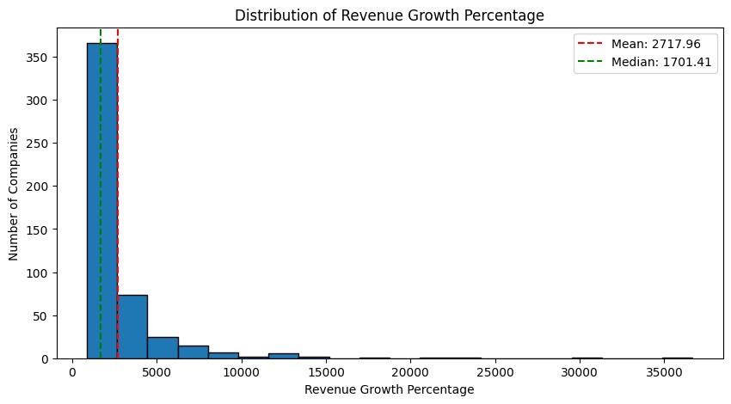
Standard Deviation of Revenue Growth
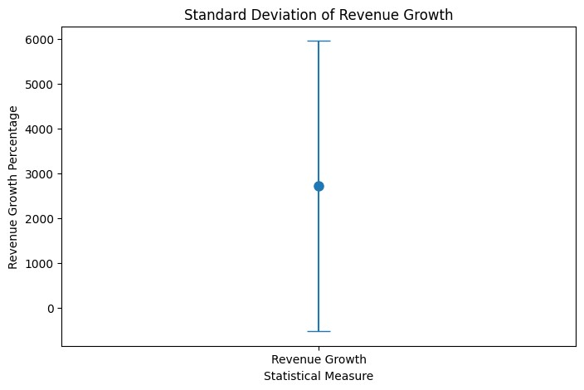
Box Plot of Revenue Growth Percentage
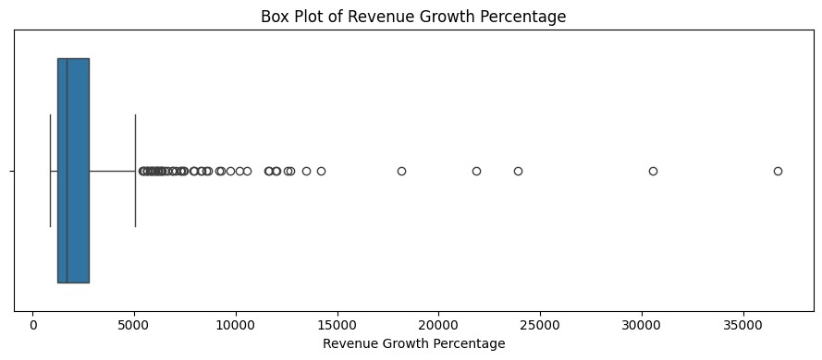

Revenue and Workforce Analysis
Distribution of Company Revenue
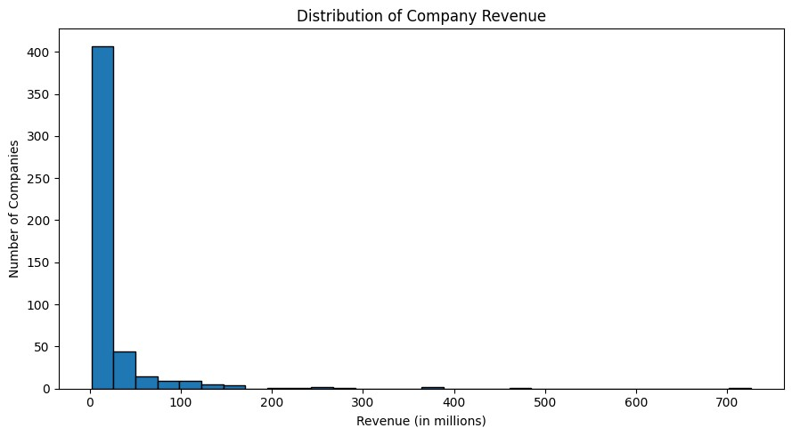
Distribution of Companies by Size
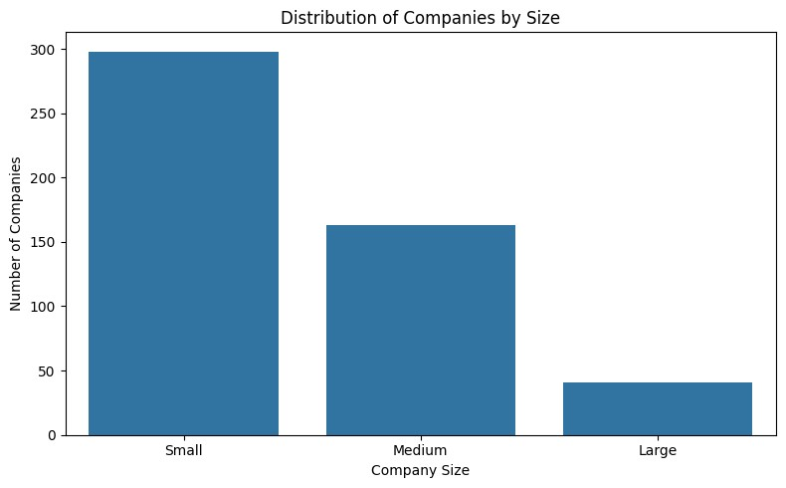
Distribution of Current Workforce
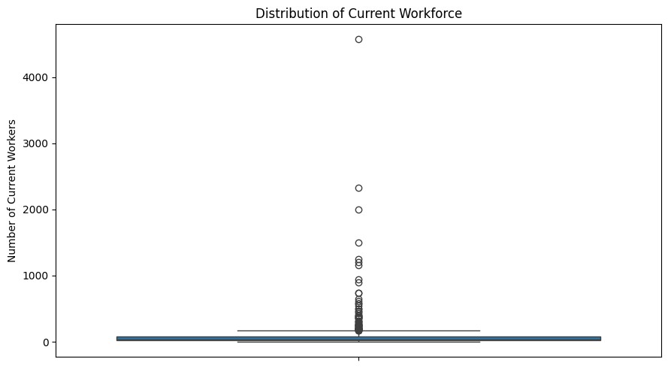
Revenue vs Revenue Growth
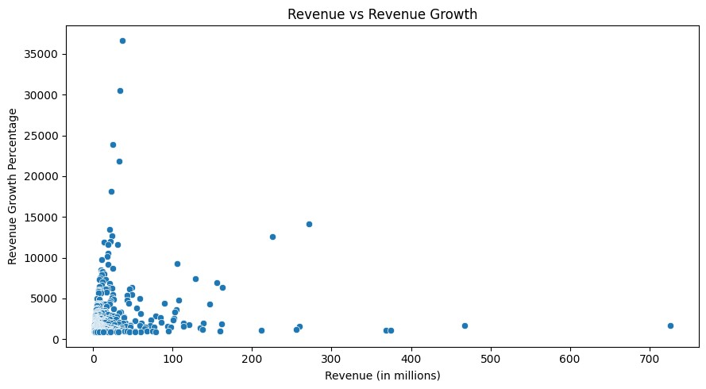

Industry Performance
Top 10 Industries by Total Revenue
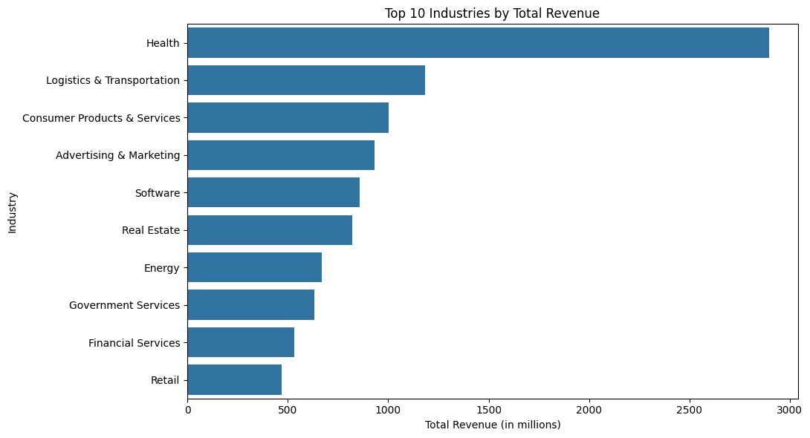

Workforce Growth
Current Workforce vs Employee Growth
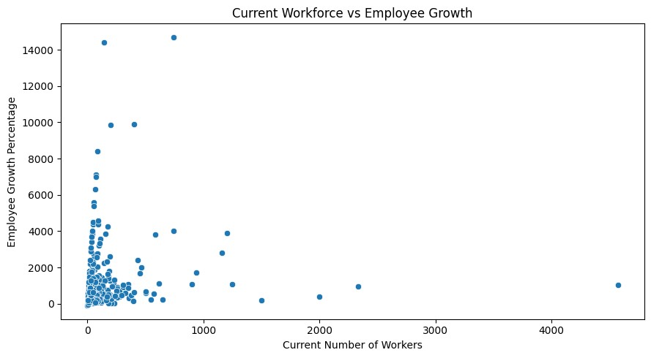

Multivariate Analysis
Correlation Heatmap of Company Performance
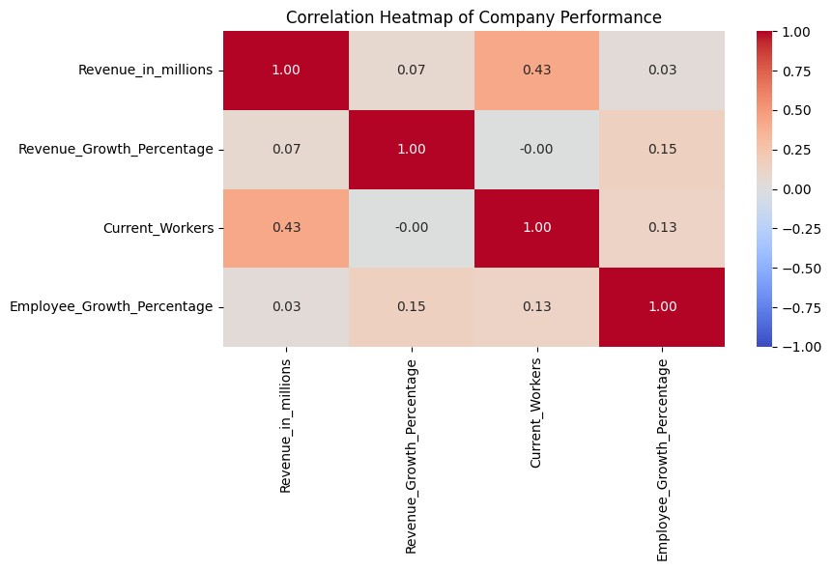

Industry Performance
Analysis chart 11
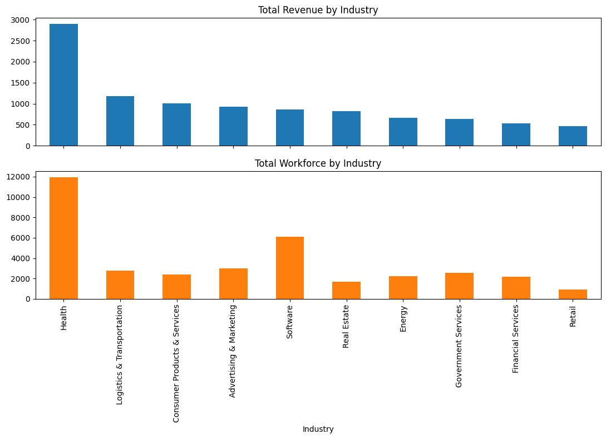

Revenue per Employee
Top 10 Companies by Revenue per Employee
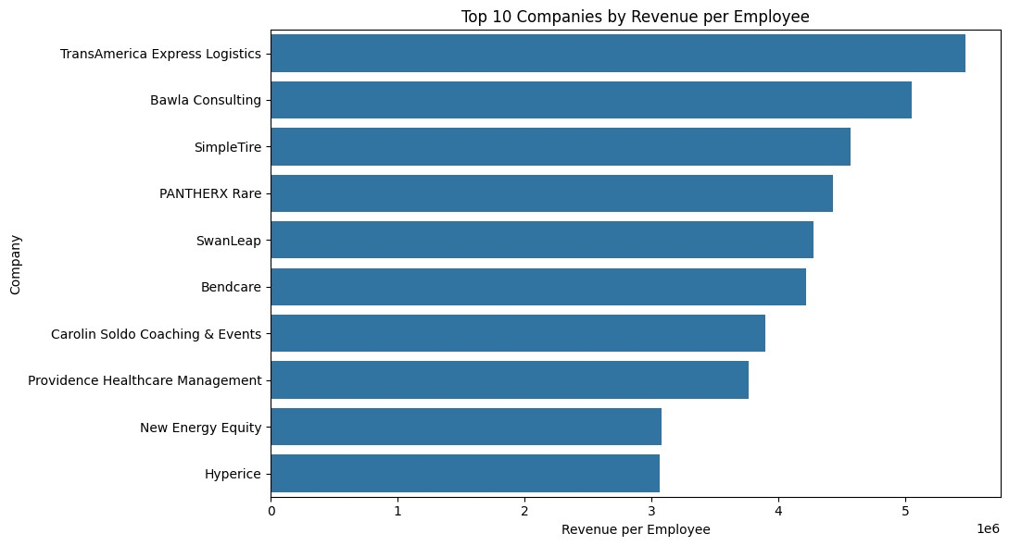

Company Age and Business Trends
Distribution of Companies by Founding Year
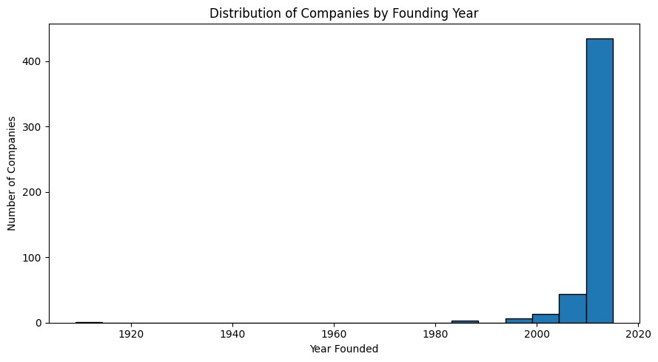
Average Revenue Growth by Company Age Group
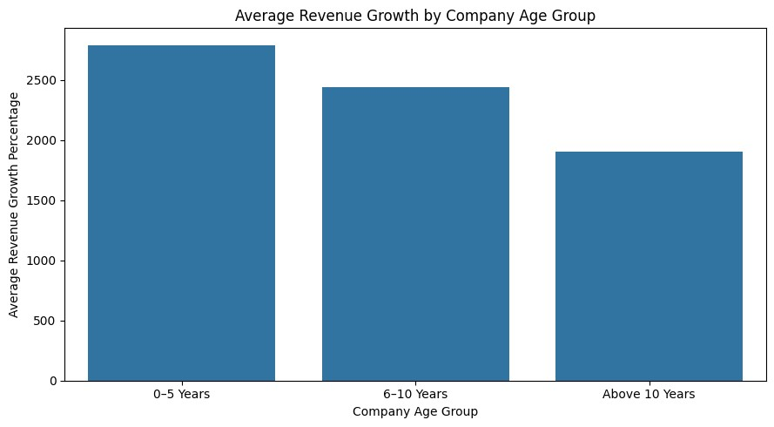

Industry Performance
Number of Companies by Industry
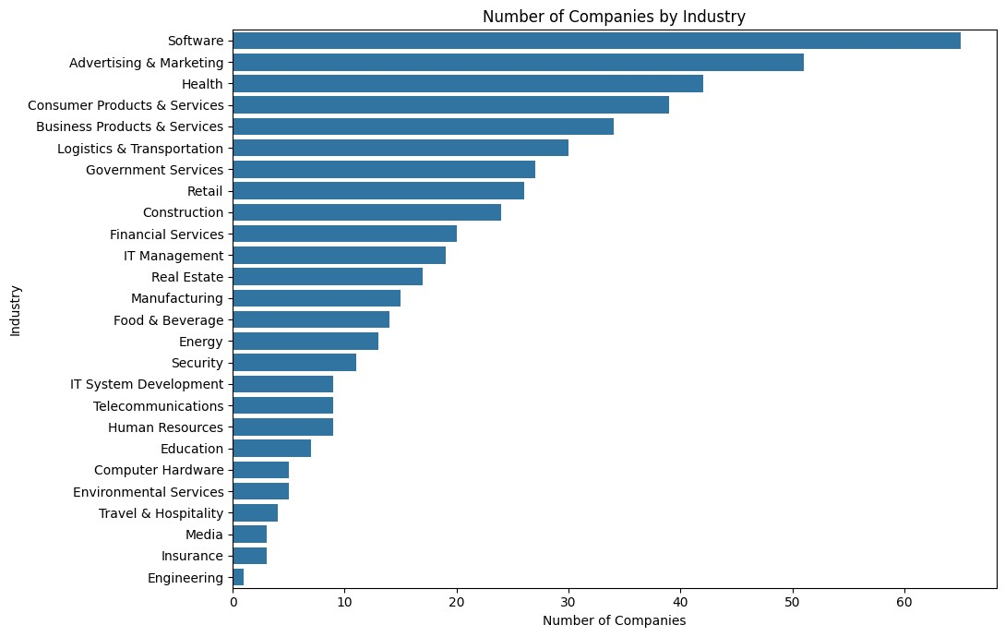

Company Age and Business Trends
Distribution of Revenue Growth by Company Age Group
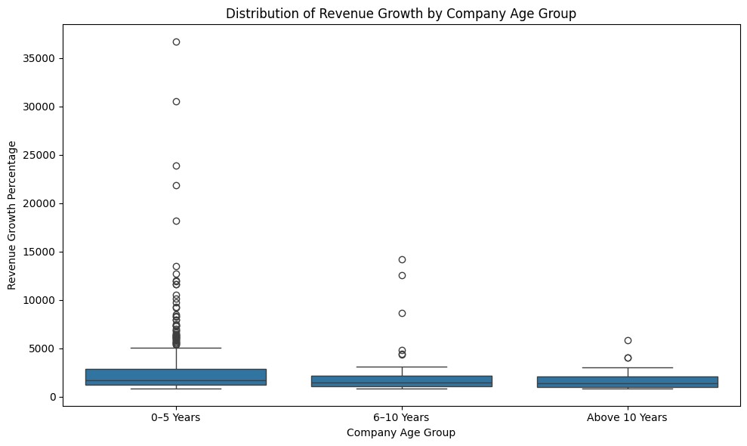

Geographical Distribution
Top 10 States by Number of Companies
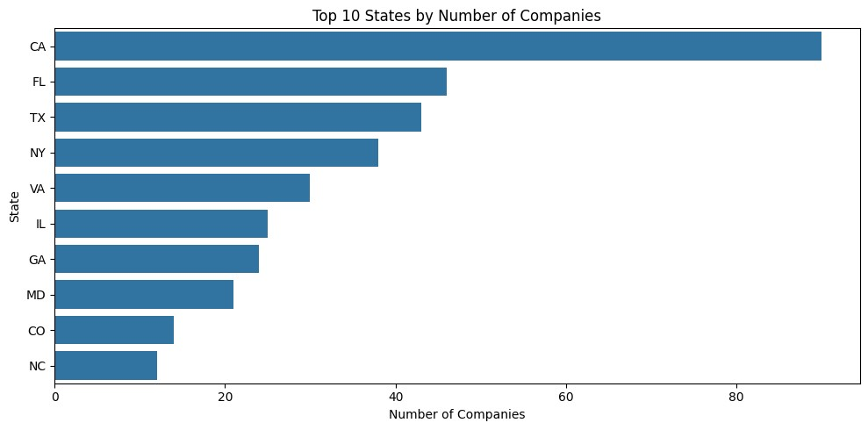
Top 10 Cities by Number of Companies
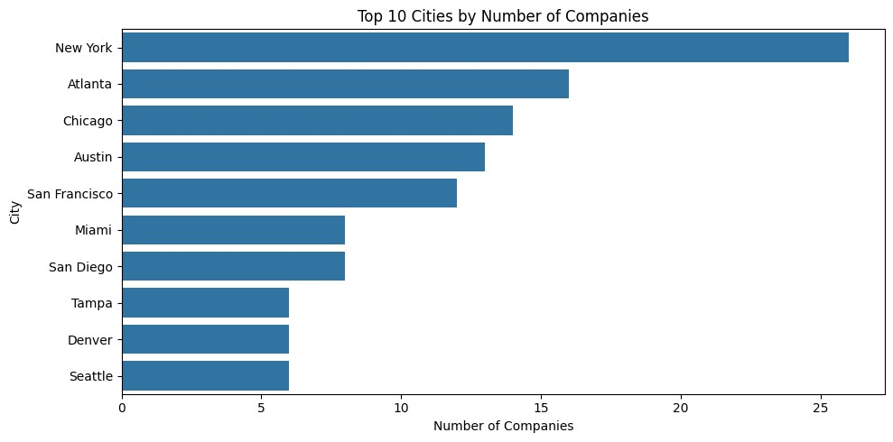
Top 10 States by Total Company Revenue


