Analyzing E-Learning Platform Purchases using MySQL
1.Database Setup & Data Entry
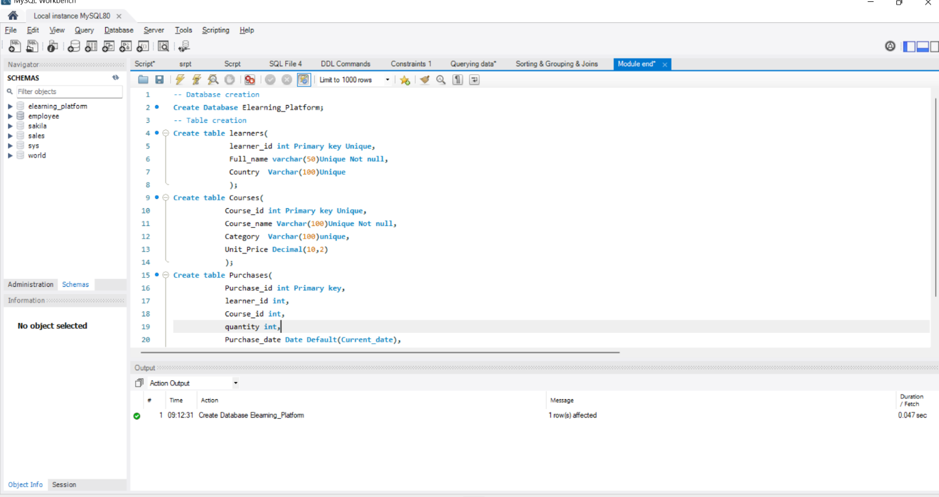
Database Creation

2.Insertion of data:
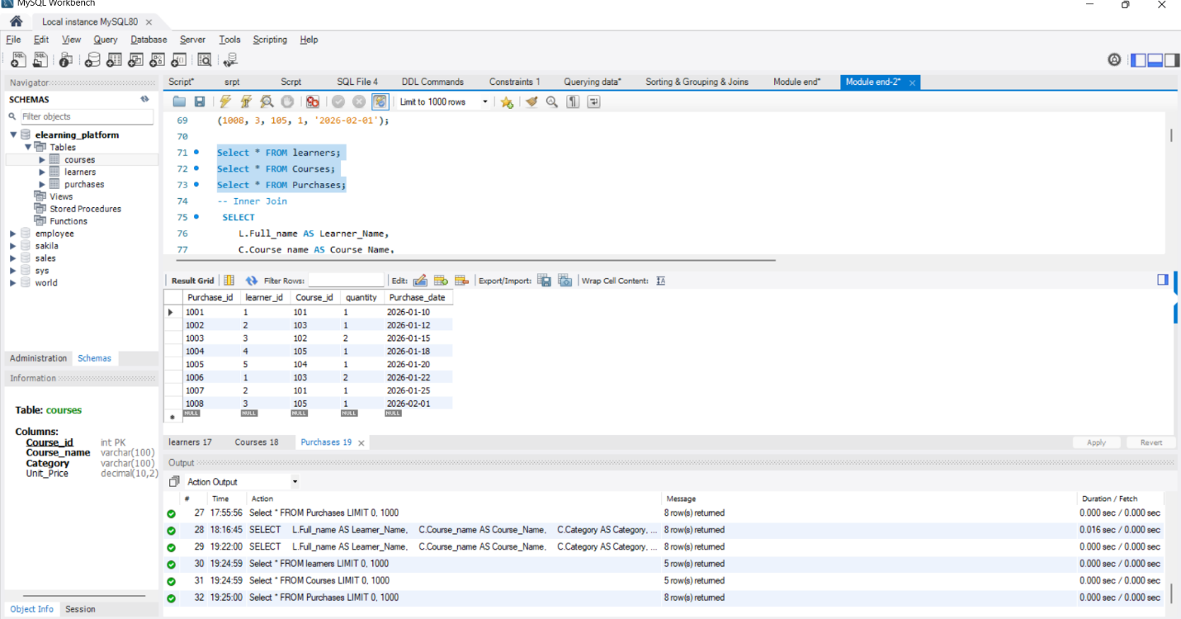
Insert DATA INTO Purchases table

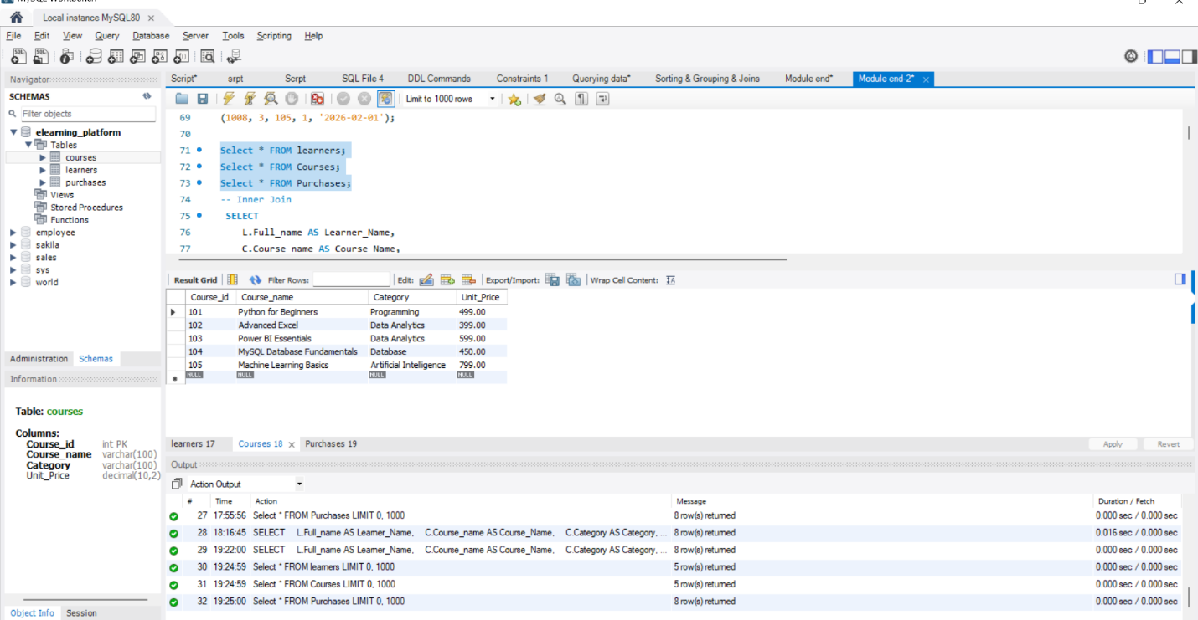
Insert DATA INTO Courses table

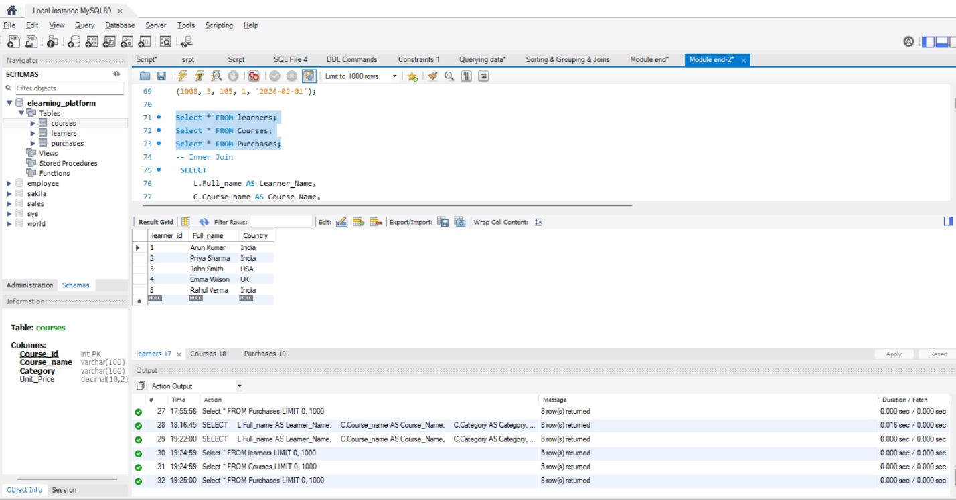
Insert DATA INTO Learners table

3.Data Exploration Using Joins
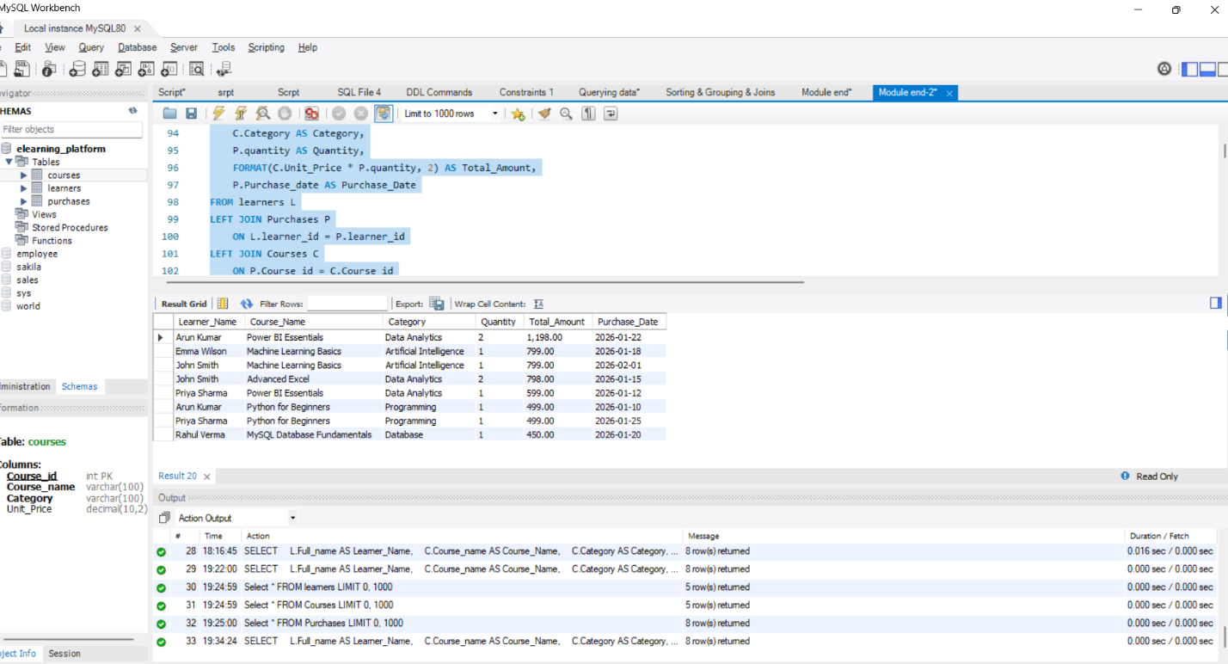
Left Join:

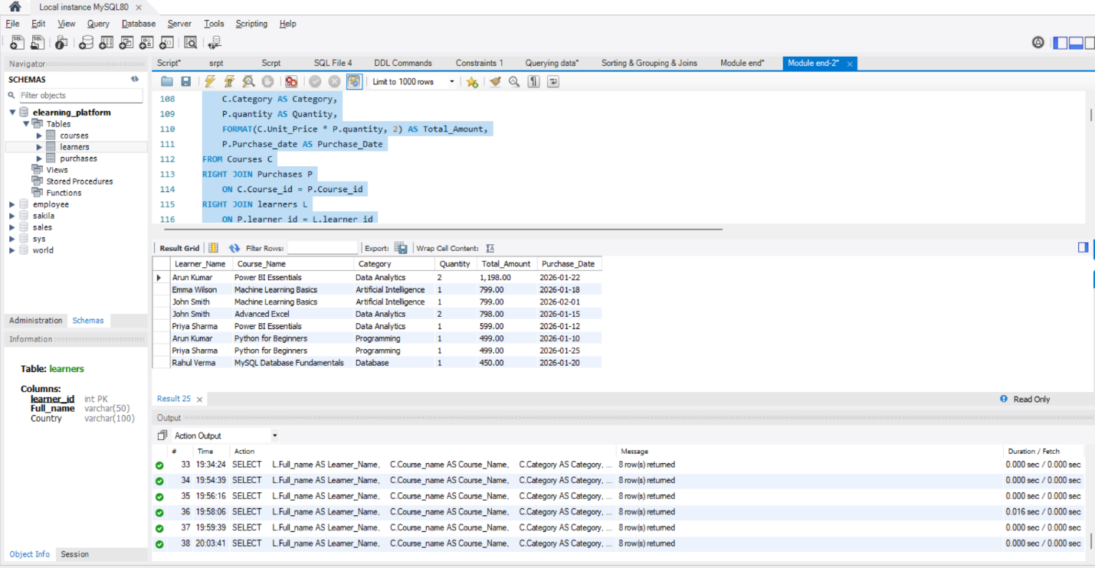
Right Join:

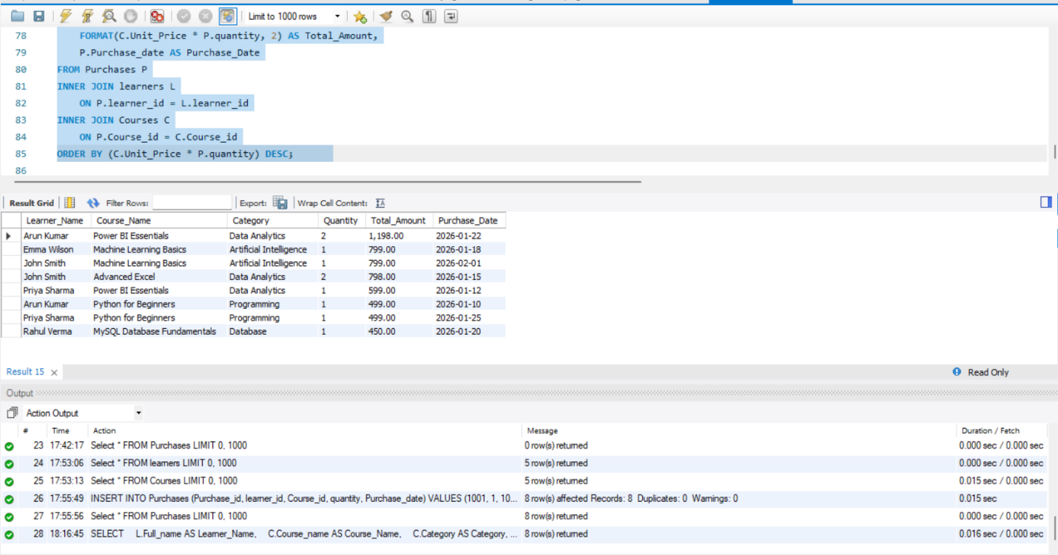
Inner Join:

4. Core Analytical Queries (Q1–Q5)
Q1. Display each learner’s total spending with their country
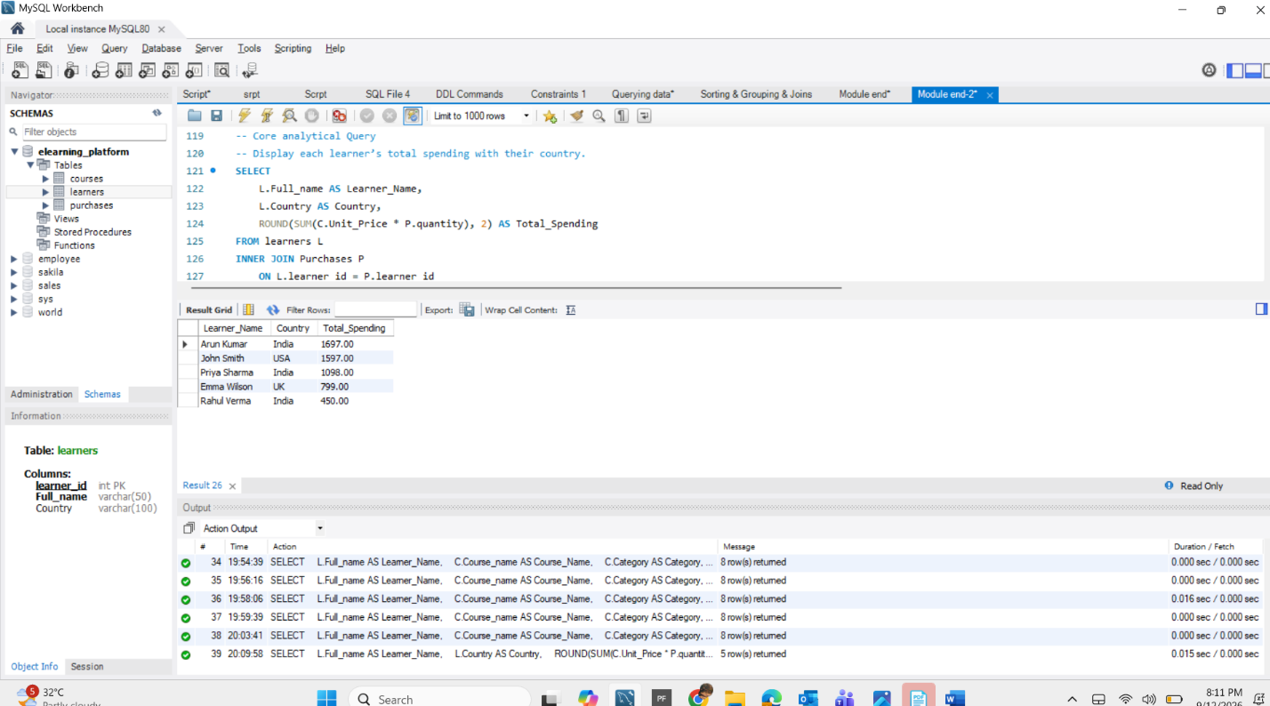
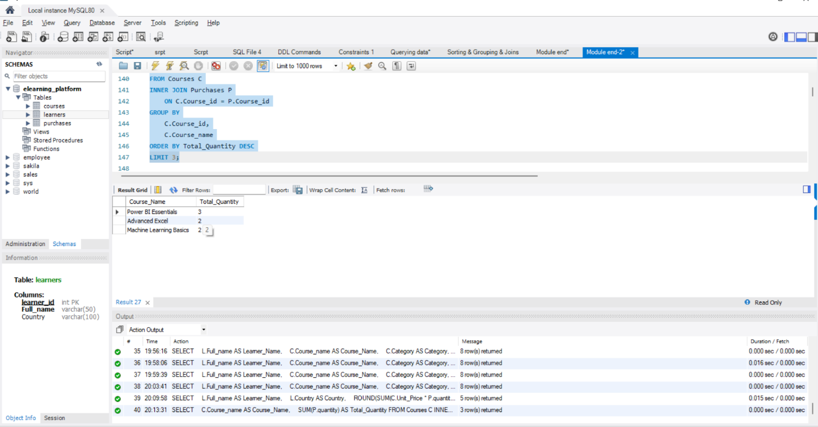
Q2. Find the top 3 most purchased courses by quantity

Q3. Show each category’s:
- Total revenue
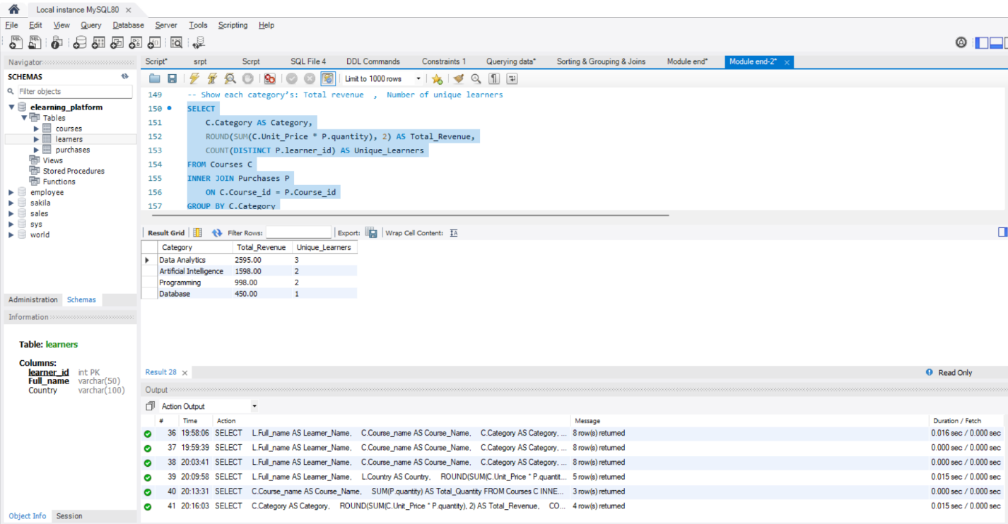
- Number of unique learners

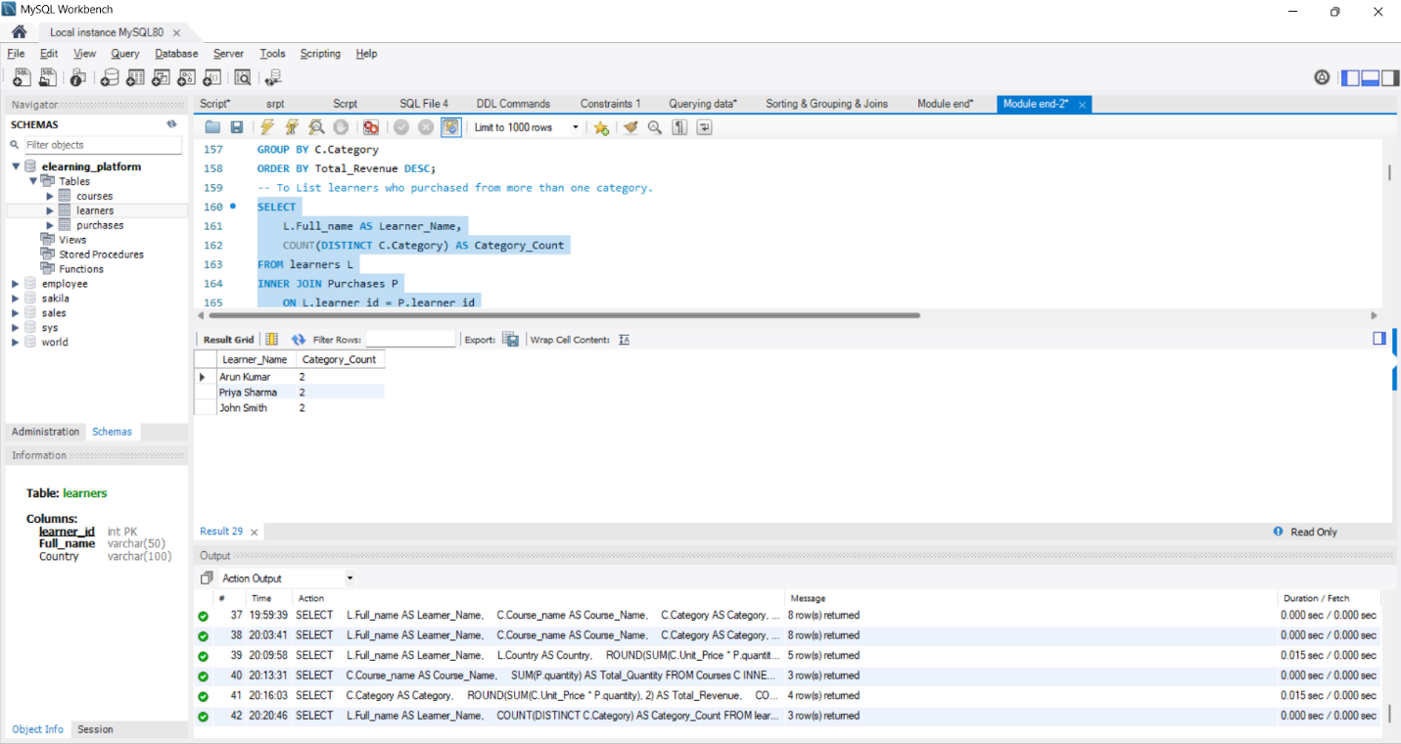
Q4. List learners who purchased from more than one category.

Q5. Identify courses never purchased. 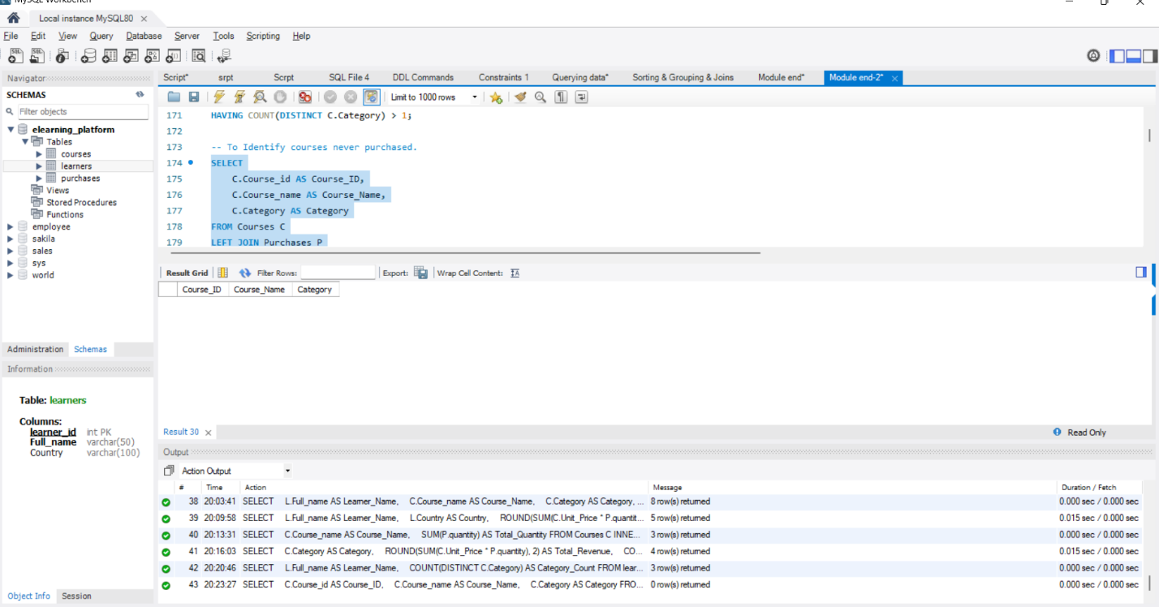

5. Subqueries & Correlated Subqueries
Q6. Find learners whose total spending is above the average learner spending
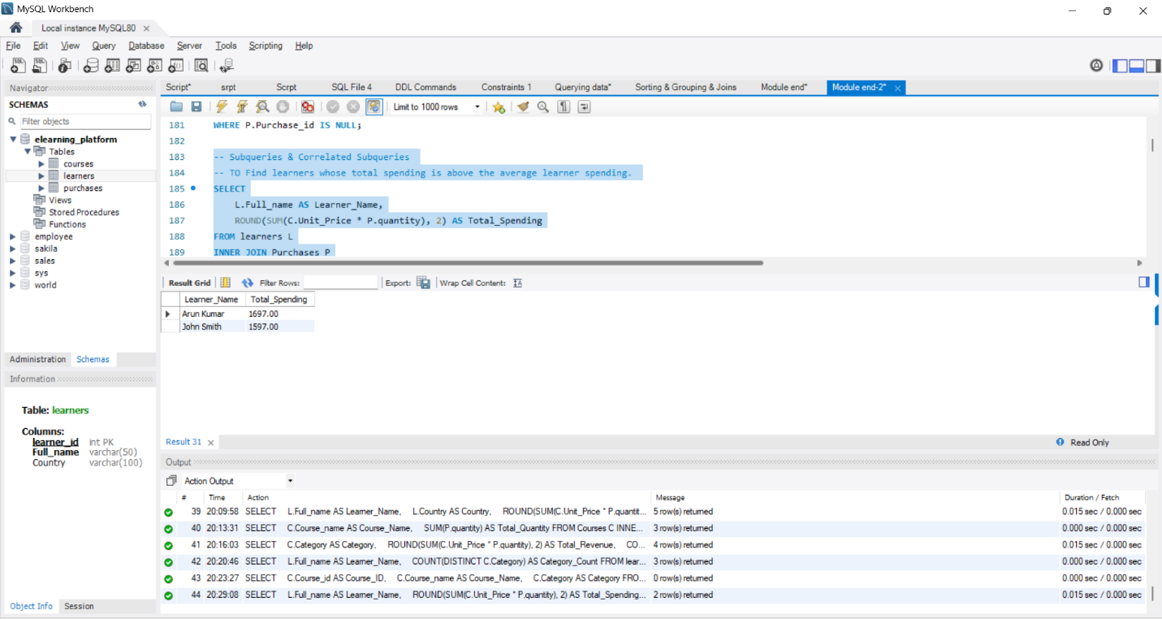
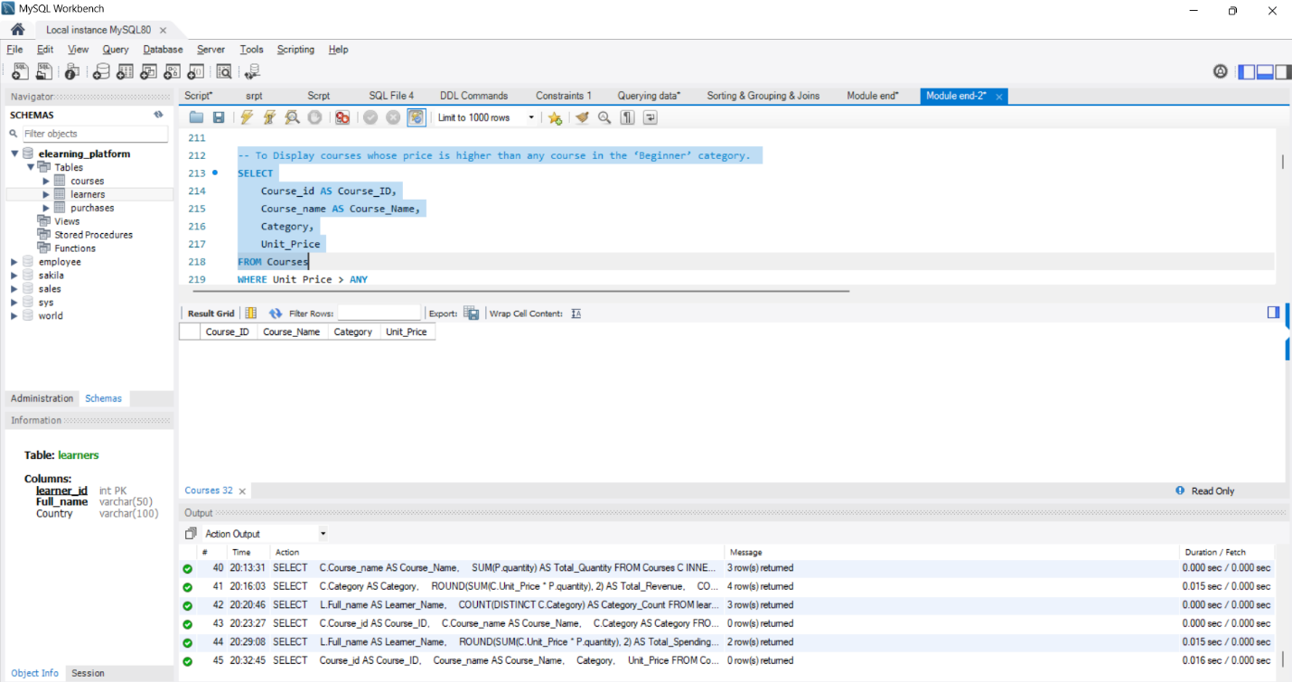
Q7. Display courses whose price is higher than any course in the ‘Beginner’ category.

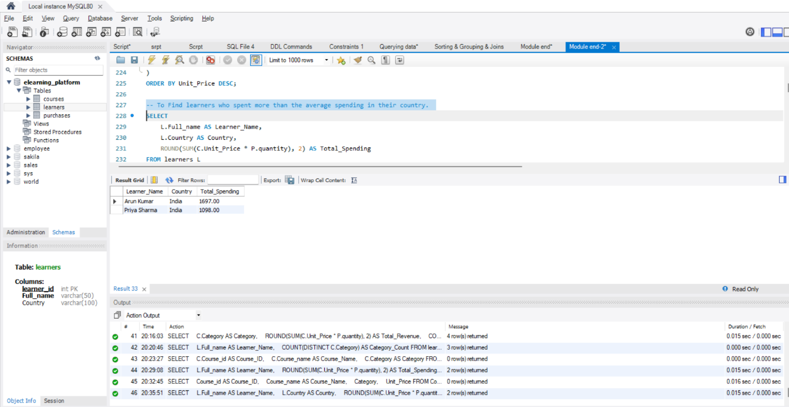
Q8 . Find learners who spent more than the average spending in their country.

6. CTE, CASE, View, and NULL Handling
Q9. Use a CTE to calculate total spending per learner, then:
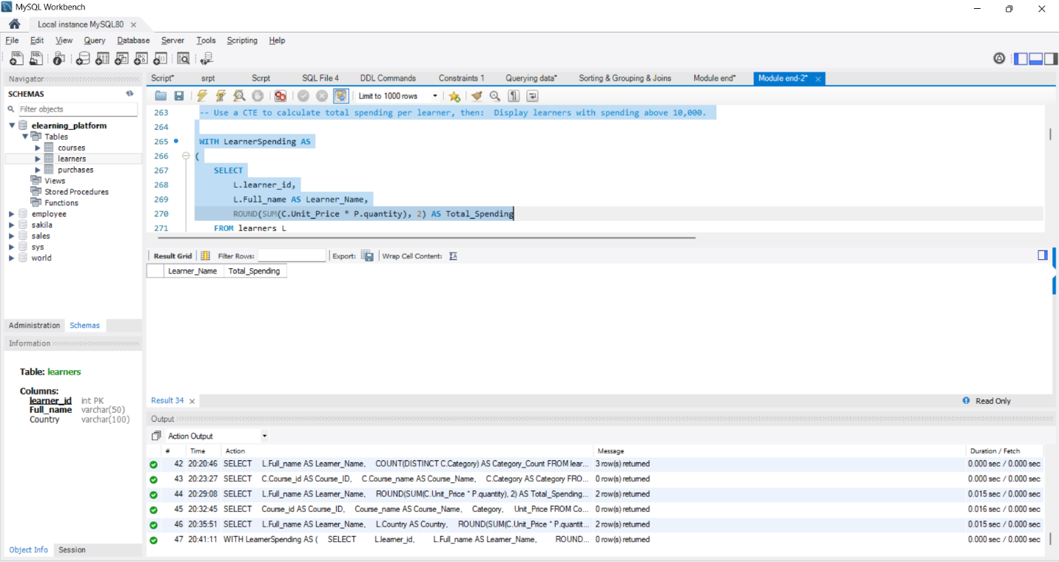
Display learners with spending above 10,000.

Q10. CASE Expression
Classify learners based on spending:
- Above 15,000 → “High Value”,
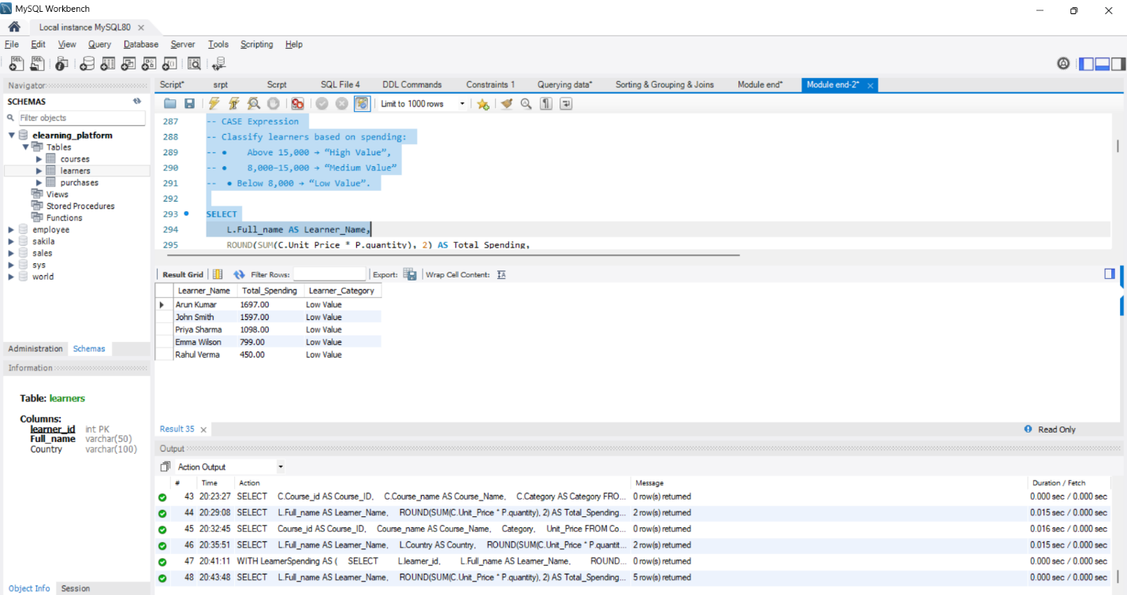
- 8,000–15,000 → “Medium Value”, ● Below 8,000 → “Low Value”.

Q11 . NULL Handling
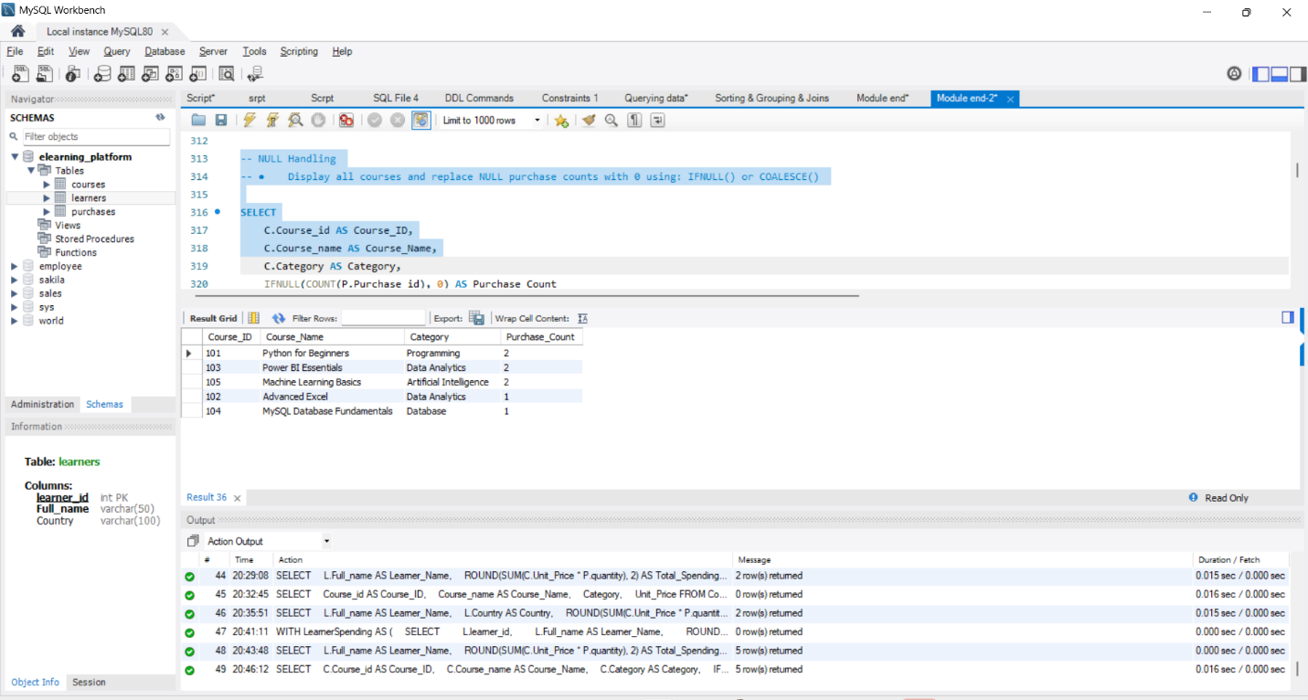
- Display all courses and replace NULL purchase counts with 0 using: IFNULL() or COALESCE()

Q12 . View
- Create a view: category_performance_view ● Showing:
- Category
- Total revenue
- Number of purchases
- Average revenue per purchase
