A minor Project-I Proposal on

**Tour Package Management System**

Submitted in the partial fulfillment of the

Degree of Bachelor of Engineering in Software Engineering at

Pokhara University.

**By**

**Ankit Adhikari**

**Dipesh Adhikari**

**Biswas Banstola**

**Subash Dahal**

Department of Research and Development

**GANDAKI COLLEGE OF ENGINEERING AND SCIENCE**

Lamachaur -Kaski, Nepal

(2023, June 17)

# Approval Certificate

This project entitled “**Tour Package management System**”, prepared and submitted by Subash Dahal, Ankit Adhikari, Biswas Banstola and Dipesh Adhikari under the supervision of the “Er. Rajendra Bahadur Thapa ” in the partial fulfillment of the requirement for the Degree of Bachelor of Engineering in Software Engineering has been examined and is recommended for the approval and Acceptance.

Date of Evaluation**:**

Er. Rajendra Bahadur Thapa

(Project Supervisor )

**Research Management Committee**

**Gandaki college of Engineering And Science**

# Abstract

The goal of this project is to create a "Tour & Travel Website," an online platform that facilitates easy bookings and planning of travel. Offering a variety of travel packages and adventure experiences, the website focuses on promoting travel and adventure activities in Nepal. Important characteristics include popular travel, thorough descriptions of adventure activities, and an easy-to-use interface with social media integration. By giving the necessary details, a separate booking part makes it simple for users to schedule trips, and an extensive contact section guarantees quick access to policies and inquiries. Secure data management and access are ensured by having separate login sites for administrators and users. The platform strives to improve the experience of arranging travel for both domestic and foreign travelers by utilizing responsive design and contemporary online technology.

# TABLE OF CONTENT

Approval Certificate ii

Date of Evaluation ii

Abstract iii

Chapter 1 Introduction 1

1.1. Background 1

1.2. Problem Statements 1

1.3. Objectives 2

1.4. Implications 2

Chapter 2 Literature Reviews 3

Chapter 3 Tools and Methodology 6

3.1. Required Tools and Programming Languages: 6

3.2. APPROACH USED 7

3.3. Methodology: 8

3.3.1. Use case Diagram 8

3.3.2. Entity Relationship Diagram (ERD) 11

3.3.3. System Sequence Diagram (SSD): 12

Chapter 4 Expected Outcomes 14

Chapter 5 Timeline 15

Bibliography 16

# LISTS OF TABLES

Table 1: Required Tools 12

Table 2: Required Programming Language 12

Table 3: Timeline Table 21

# LISTS OF FIGURES

Figure 1: Waterfall Model 14

Figure 2: Use Case Diagram 15

Figure 3: Entity Relationship Diagram 18

Figure 4: System Sequence Diagram for User 19

Figure 5: System Sequence Diagram for Admin 20

Figure 6: Days Required For Every Stages 22

# 

# Chapter 1 Introduction

## Background

Nepal is well-known for its breathtaking scenery and vibrant culture, drawing many of travelers and adventurers. However, because there are so many possibilities, organizing and booking travel to Nepal can be challenging. The goal of the "Tour & Travel Website" project is to streamline this procedure by providing a single point of contact for all travel-related needs. The website makes it simpler for customers to organize their travels by offering comprehensive information on a variety of adventure activities and vacation packages. This platform will improve travel planning by utilizing contemporary online technology, making it more convenient and pleasurable for all the users.

## Problem Statements

Many times, current websites are not user-friendly, lacking in-depth descriptions of adventures and packages that can be customized. They also fail on secure handling of personal data and fail to provide adequate customer support. Our project aims to remedy these issues with a secure, mobile-friendly platform that enhances user experience through detailed adventure descriptions, customizable packages, seamless booking processes

## Objectives

The main objectives are:

1. Enhance User Experience: Develop a platform that simplifies travel planning, booking, and management of tours and travel packages.
2. Detailed information on travel destinations, adventure activities, and customizable tour packages.
3. Choose the desired Packages

## Implications

With the help of this software users can choose the desired packages after logging in. We can get enough description about the available packages. We can talk to the admin without the need of logging in because all the visitors might not have created any account. Also, the admin is responsible for accepting and rejecting the packages chosen by the users.

# Chapter 2 Literature Reviews

There are a lot of the website that provide the similar services like our Software. Our goal is to provide much better, user friendly, smooth, secure website that provides the tour package services. Some of the projects that are similar to our project are: -

## TOUR PACKAGE PRICE SYSTEM IN TRAVEL BUREAU COMPANIES:

This system gives the user the freedom to choose and arrange their own tour package as they wish and the system will set the price of the product according to the applicable policy. The pricing policy includes the country of origin, the number of persons and the service time associated with the high/peak season period. The system can also present the price of the package in various currencies. [1]

## Web-Based Tourism Package Information:

System in CV Cendana Tour old procedures are takes time to obtain information about holiday packages. Therefore, a tour package application with a website service on CV Cendana Tour is expected to be able to handle problems about bidding and order process. Making it easier to manage data and settings centrally. To overcome existing problems, a new system is required in booking tour packages, namely online. In addition to facilitating transactions, the new system also aims to expand promotion so that company profits are expected to increase. The existence of this new system will make it easier for tour package administrators to manage package data, manage websites, and print orders. In addition, it is also expected to provide convenience for customers to get information about tour packages. [2]

## Online Tour Package Reservation System:

This Tour Package Reservation is a web-based system. There are 3 types of users in this system. They are administrator, Customer and guest. The system allows the user to easily manage the shopping process where an online cart will allow the customer to buy from our outlet from their home. The shopping process such as browsing for product and manual payment method using cash which customer nowadays use is time consuming. The development of this system is done by using PHP language and MySQL as the database management. Web applications are popular due to the ubiquity of the browser as a client, sometimes called thin client. The ability to update and maintain web applications without distributing and installing software on potentially thousands of client computers is a key reason for their popularity. System will present a mostly complete view of application focusing especially on the design process. The solution was developed as an online web application. Client will use a web browser to access the application. Finally the system fully tested with most common browsers and an evaluation is also done using a survey and the outcomes discussed

[3]

## Searching, categorizing and tour planning :

Tourism is one of the fastest growing and profitable industries. This paper proposes a system for people who want to make a trip to places they are unaware off and wish to explore them. A web application is developed which categorizes different tours on their type. According to these categories a user can select a tour and every detail regarding that tour will be displayed. Hence this allows the user to easily know about that place instead of searching the whole internet for the trip he is going to make. Also a tour manager/guide can manually book the trip for user which contains accommodation, food and travel expenses depending on the user's requirements. This web application has been implemented for all the tours that can be made in Karnataka.

[4]

## Development of Website-Based Thousand Island Tour Package Booking Application Using Waterfall Method :

Process of booking Pulau Seribu tour packages at Explore Seribu Pulau Tour and Travel is still done manually, causing visitor data, bookings, payments, and visitor reviews to not be recorded properly. This website-based thousand island tour package online booking application is designed. The features developed make it easier for visitors to find information on tour packages, book, pay, and review tour trips that have been carried out .

[5]

# Chapter 3 Tools and Methodology

## Required Tools and Programming Languages:

The following tools will be used for development of our project:

#### Table : Required Tools

|  |  |
| --- | --- |
| **Tools Name** | **Purpose** |
| Vs code | To edit codes |
| Xampp | Used as localhost |
| Microsoft Office Package | For document creation |
| Dia | To make ER-diagrams, use case diagrams, Sequence diagrams. |

#### Table : Required Programming Language

|  |  |
| --- | --- |
| **Programming languages** | **Description** |
| HTML | Webpage programming |
| CSS | Webpage styling |
| JavaScript | Front-end and Client side Programming |
| PHP | Backend and server side programming |
| MySQL | Database handling. |

## APPROACH USED

Since we are developing small project with unchanged requirements, waterfall model is best to use. So, we chose waterfall model to develop our project. Our whole project is based on waterfall model from design to testing. The iterative waterfall model provides feedback paths from every phase to its preceding phases, which is advantage over classical waterfall model. The whole process is repeated until final product is obtained.

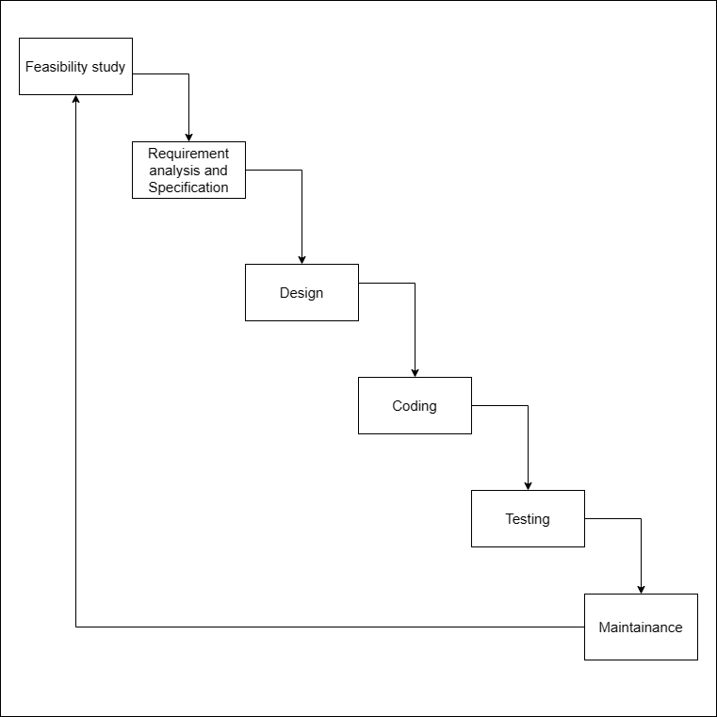

#### Figure : Waterfall Model

## Methodology:

## Use case Diagram

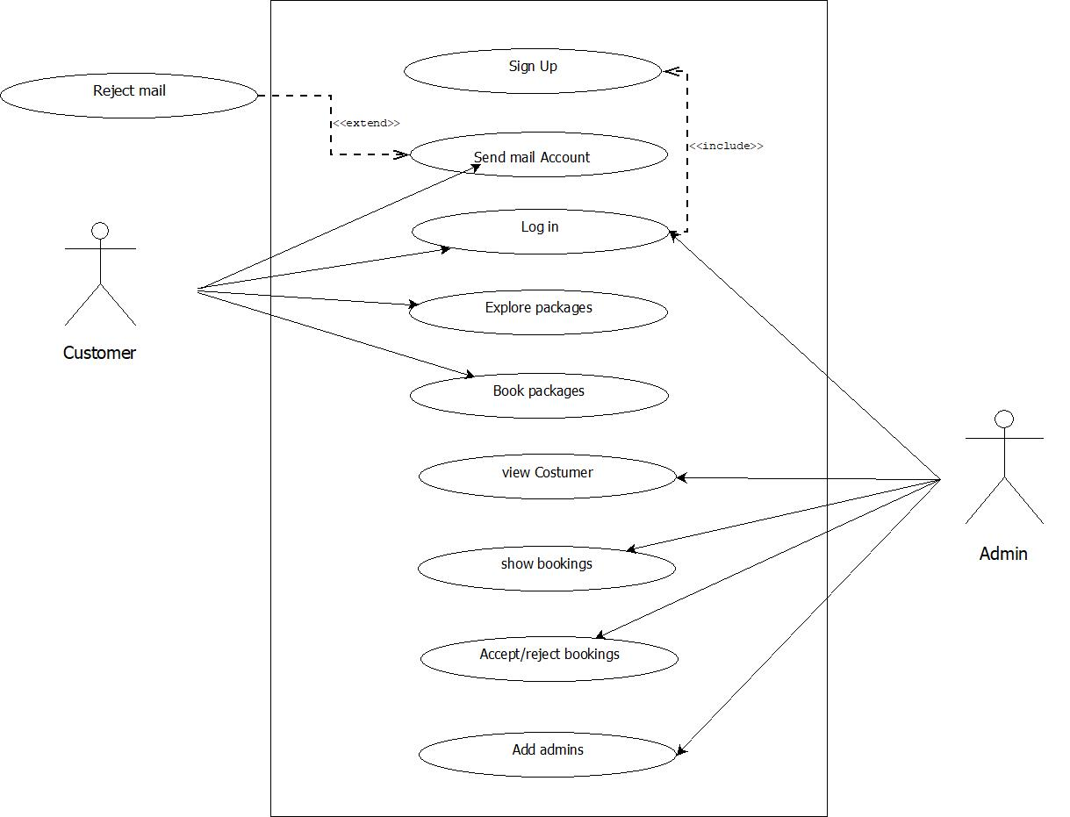

#### Figure : Use Case Diagram

##### 

##### 

##### UC1: Sign Up

**Primary Actor:** User

**Stakeholders:**

* + **User:** wants to register
  + **Admin:** wants to update the database

**Precondition:** User should fill out the registration form

**Post condition:** The user can log in if he or she has already registered

**Basic Flow:**

1. User fills out the form
2. User clicks on the register button
3. Admin updates the user information in the database

##### Use case UC2: Book a Tour

**Primary Actor:** User

**Stakeholders:**

* **User:** wants to book a tour
* **Admin:** wants to update the booking database

**Precondition:** User should be logged in

**Post condition:** The tour is booked, and the user receives a confirmation

**Basic Flow:**

1. User selects a tour package
2. User fills in the necessary details
3. User clicks on the book button
4. Admin updates the booking information in the database
5. Admin sends a booking confirmation to the user

##### Use case UC3: Explore Tours

**Primary Actor:** User

**Stakeholders:**

* **User:** wants to explore available tours
* **Admin:** wants to provide tour information

**Precondition:** User should login into the site.

**Post condition:** The user views the list of available tours

**Basic Flow:**

1. User navigates to the explore tours section
2. User browses through the list of available tours
3. Admin displays detailed information for each tour.

##### UC4: Accept /reject bookings

**Primary Actor:** Admin

**Stakeholders:**

* **User:** User wants the booking either to be accepted , Rejected and then Finished
* **Admin:** wants to update the booking status

**Precondition :** Admin should be logged in .

**Post condition:** The booking is Accepted , Rejected or finished .

**Basic Flow:**

1. Admin navigates through the Accept/Reject section
2. Admin selects Accepts or Reject bookings.
3. Confirmation of the status is seen in the screen.

## Entity Relationship Diagram (ERD)

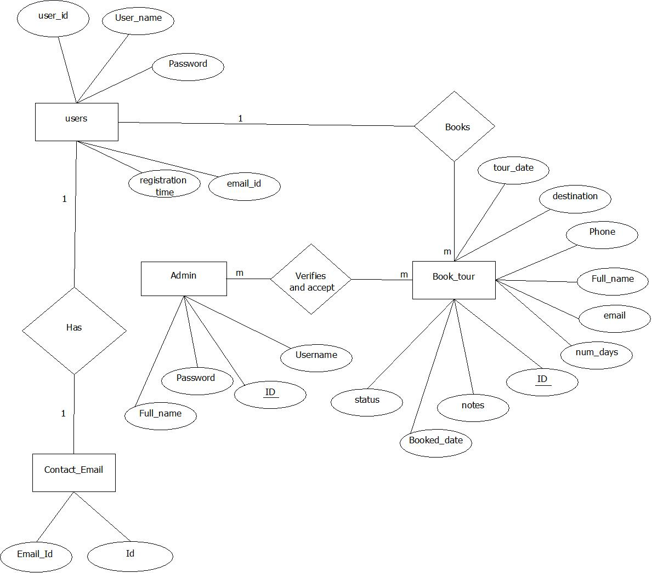

#### Figure : Entity Relationship Diagram

## System Sequence Diagram (SSD):

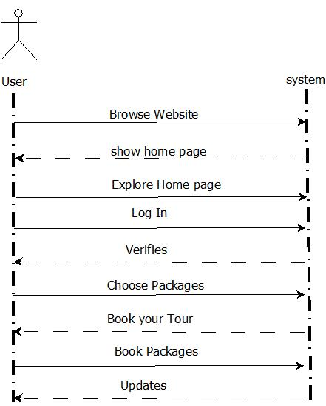

#### Figure : System Sequence Diagram for User

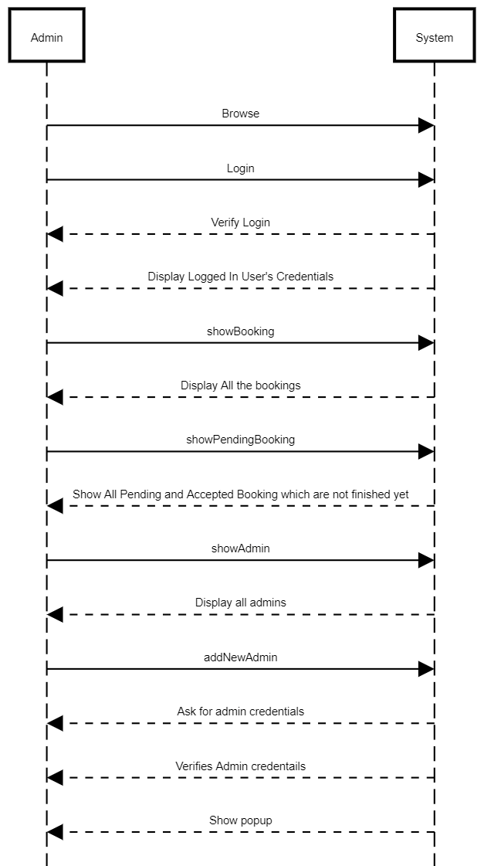

#### Figure : System Sequence Diagram for Admin

# Chapter 4 Expected Outcomes

Users can do seamless booking process that allows users to easily select and book travel packages and activities, reducing the time and effort required. They can also interact with the admins via email by sending the email address from the homepage. The website is expected to attract more users and increase bookings, thereby boosting revenue as well.

# Chapter 5 Timeline

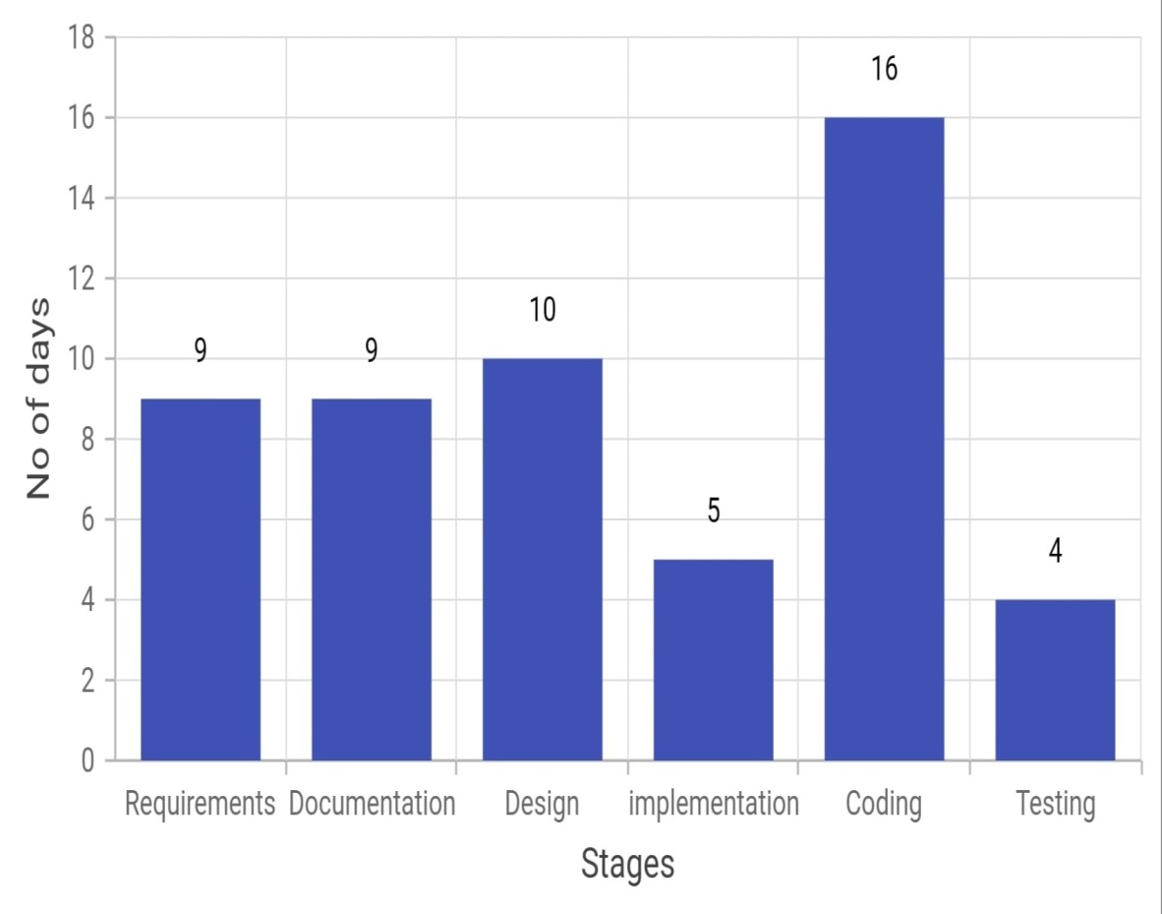

#### Figure : Days Required For Every Stages

|  |  |  |  |  |  |  |
| --- | --- | --- | --- | --- | --- | --- |
|  | Requirement analysis | Documentation | Design | implementation | Coding | Testing |
| No.of days | 9 | 9 | 10 | 5 | 16 | 4 |
| Start date(2024) | Jun 10 | Jun 10 | June 19 | June 29 | July 4 | July 20 |

#### Table : Timeline Table

# Bibliography

|  |  |
| --- | --- |
| [1] | J. &. K. Susanti, Developing tour package price system in travel bureau companies, 2019. |
| [2] | G. A. W. e. al, "Web-Based Tourism Package Information," 2018. |
| [3] | R. Rajapaksha, "Online Tour Package Reservation System," 2021. |
| [4] | R. H. Goudar, "Searching, categorizing and tour planning: A novel approach towards e-tourism," 2018. |
| [5] | N. H. N Nurhaliza, "Development of Website-Based Thousand Island Tour Package Booking Application Using Waterfall Method," 2022. |
| [6] | G. A. e. a. Wijaya, "Web-Based Tourism Package Information," 2018. |