**TEACHING REPORT**

Submitted in partial fulfillment of the requirements for the degree in Bachelor of Information and Communication Technology in Education (B.Ed. ICT) 9th Semester –ICT Ed. 495 of Tribhuwan University, Nepal

**Submitted by:**

**Atish Gurung (74288010)**



**Department of Science and Technology**

**AADIKAVI BHANUBHAKTA CAMPUS**

Vyas-01, Damauli, Nepal

**August, 2024**

**APPROVAL PAGE**

This is to certify that the ''Teaching report'' was duty approved in the department of BICTE, and was carried out by high school level student of Shree Chandi Devi Rastriya Secondary School. Submitted by Mr.Atish Gurung in partial fulfillment for the degree of Bachelors of Information Communication Technology in Education, this ensure that it is satisfactory in the scope and quality of the required degree.

…………………………..

Mr.Anil Kumar Shrestha

Aadikavi Bhanubhakta Campus

(Micro teaching report Supervisor)

……………………………………

Er.Sulove Kumar Shrestha

BICTE Coordinator

**Executive Summary**

Practice teaching is an important component towards becoming a teacher. It provides experiences to student teachers in the actual teaching and learning environment. During teaching practice, a student-teacher is given the opportunity to try the art of teaching before actually getting into the real world of the teaching profession. Student-teachers also know the value of teaching practice and they perceive it as the important aspect of their preparation for the teaching profession since it provides for the real interface between student hood and membership of the profession. This report is the overall activity of my teaching practice period. It explains about how I planned my lesson, how I conducted teaching classes, teaching learning methods that I applied, materials that I used and about my peer observation experience. I took a lesson of secondary level students for 6 weeks.

During the period I prepared individual educational plan with consultation school management, 30 lessons with integration ICT pedagogy in consultation with supervisor and instructional materials for delivery of lessons including digital interactive materials. I observed 1 lessons of peer’s teaching with feedback. And also constructed test, administration and analysis of test results. These all activities helped me to develop the qualities which is needed to be a good teacher. In the time of teaching practice, I understood and learned about good classroom management, appearance in class room, good initiation of lesson, development of lesson, language, instructional materials and proper use of student’s participation, teachers’ activity and closing of the lesson.

**TABLE OF CONTENETS**

1. Introduction of Teaching Practice ………………………………………………...……….1

1.1 Background of Teaching Practice………………………………………………...1

1.2 Objective of Teaching Practice…………………………………….......................1

2. Operation of Teaching Practice …………………………………………………………...2

2.1 Activities of Teaching ……………………………………………………………2

2.2 Evaluation of Student ……………………………………………………………3

2.3 Analysis of Result …………………………………………………......................5

3. Peer Observation …………………………………………………………….....................7

3.1 Introduction of Peer Observation ………………………………………………..7

3.2 Analysis of Peer Observation …………………………………………………....7

4. Conclusion ……………………………………………………………………………….11

5. References ………………………………………………………………………………..12

**LIST OF TABLES**

Table 1. Result of Test Examination………………………………………………….…….5

Table 2. Item Analysis of Question ………………………………………………………...6

**LIST OF FIGURES**

Figure 1. Question paper of test examination……………………………………………….4

Figure 2. Peer Observation Form ………………………………………………………….8

**1. Introduction of Teaching Practice**

* 1. **Background of Teaching Practice**

Teaching can be defined as engagement with learners to enable their understanding and application of knowledge, concepts and processes. It includes design, content selection, delivery, assessment and reflection. Teaching practice is a period that a student-teacher spends teaching at a school as part of his or her training. The course Bachelor of Information Communication and Technology in Education (B.Ed. ICT) curriculum has a session for teaching practice for student. Teaching Practice forms an integral part of the B.Ed. ICT program and it is designed to prepare students for maximum practical and professional training in the field of education and technology using digital interactive materials. It is in essence a period of immersion where by student teachers are given the opportunities to apply and integrate theoretical knowledge acquired in the university to realities of a classroom situation. It also aimed at preparing student teachers for their future profession. It helps the student teacher to evaluate himself, acquire deep knowledge on teacher-student contact. Without teaching practice, a trainee cannot be considered or termed a qualified teacher. Especially in class experience, teaching practice give opportunity to student teacher to develop skill of class management, lesson delivering strategies, ICT tools management, identify and use appropriate teaching aid. It is also an opportunity to use different types of evaluations. This is the report of my teaching practice journey of six weeks to Shree Chandi Devi Rastriya Secondary School, vyas-10 . During the period I took a lesson of class nine students, evaluated students and analyzed an outcome as well as a 1 peer-observation of my colleague.

**1.2 Objective of Teaching Practice**

Teachers are not only responsible for teaching the students but for shaping their behavior and developing discipline in them as well. Following are the objectives of teaching practice:

* To acquire classroom management skills.
* To develop skills of delivering content, handle questions and answers.
* To apply theoretical knowledge acquired in university to realities of a classroom.
* To become a professional teacher.
* To develop lesson delivering strategies and skill of evaluation.

**2. Operation of Teaching Practice**

**2.1 Activities of Teaching**

During my teaching practice, I’ve taken 30 periods of computer science of class nine. Time allocated for each period was 40 minutes. For all those 30 periods I’ve made 30 lesson plans for effective detailed instruction. A lesson plan is the instructor's road map of what students need to learn and how it will be done effectively during the class time. Therefore, I’ve always tried to make it more effective and appropriate. Computer Programming is the chapter I lesson throughout my teaching practice which needs 27 and 34 Tentative No. of Classes for theoretical and practical. For grade nine, Computer Programming includes learning about Programming language, Algorithm and Flowchart, Programming in QBASIC, Data types, operators, operands and expression, programming statement, sequence structure, library function and arrays as well as number system. The main objective of this chapter is to introduce Computer programming and develop skill of Programming.

Computer science is a practical subject. Student needs to be taught theoretically and practically both. For that, we need to apply different teaching learning strategies. To fulfill this objective I’ve applied demonstration, question answer, discussion, practical exercise, project work and problem-solving method. This method helped me to get students attention all the time. The teaching learning tools and technology I used are, computer and internet.

Throughout my teaching practice I improved my teaching by continuous suggestion of campus supervisor and computer science teacher. I also got a chance to get suggestion from my colleague who came for peer observing. Their comments and suggestion helped me to enhance my teaching skill.

**2.2 Evaluation of Student**

Evaluation is a process to measure students capacity, their progress and how they are performing, understanding, participating and learning. A successful evaluation generates outcomes that are valid, reliable and indicate directions and action for development. School administrators and teachers alike are conducting evaluations of their own to improve school performance and foster creative spaces for learning. For the evaluation of students, I used question-answer, observation, participation methods. Throughout my teaching practice, I observed each and every student. How are they performing, understanding, participating and learning. It is crucial to teach student based on their current level. To understand their level, it is necessary for continuous evaluation. Since, computer science is the practical course in which student need to practice more often than learning a theory. I used to observe students practice and their progression on computer lab.

As I mentioned the chapter that I’ve taught was Computer Programming. The student was given a task as a project work mostly for QBASIC at lab. Then I used to evaluate each student’s performance. This helps me to understand their level of knowledge and I used to apply required activity for the improvement of students’ knowledge and skill. I used to ask some side questions which is already covered in a class. That also helped me to evaluate students. I also used to revise some of the topics frequently which gave students an opportunity to reflect on what they've learned.

We conducted our 30 lessons, we took an examination for students. The question had 25 full marks and pass mark of 12. Test paper had 6 types questions true/false, fill in the blanks, short question answer and Programming and number system question

**Figure 1**

Question paper of test examination

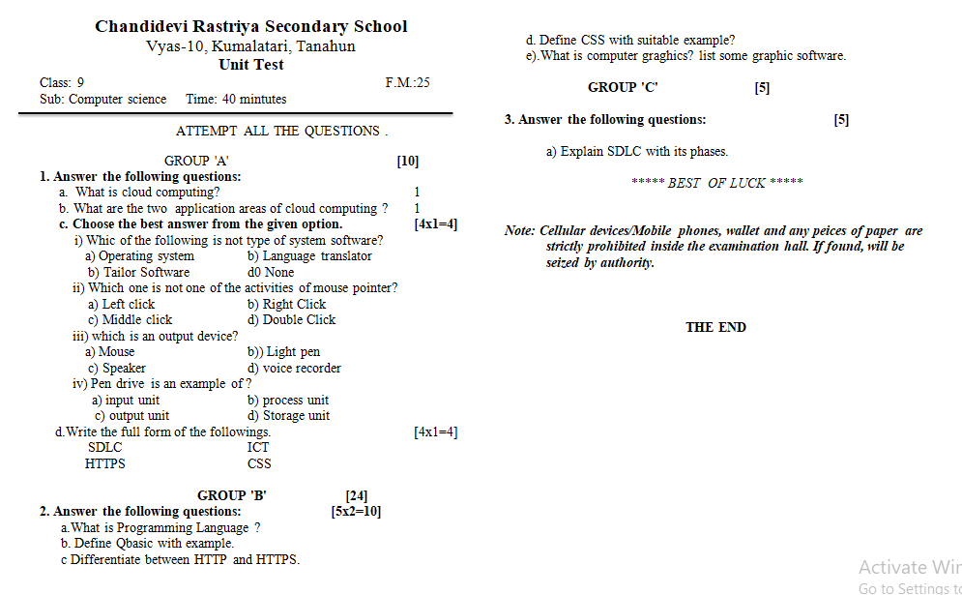

* 1. **Analysis of Result**

Results Analysis help us to understand how our students are learning, and how they have performed in each area of the syllabus. Following is the result of test examination:

**Table 1**

Result of test examination

|  |  |  |  |
| --- | --- | --- | --- |
| **Roll.** | **Student Name** | **Obtained Marks** | **Remarks** |
| 1 | Amisha Thapa | 18 | Pass |
| 2 | Anjan Bhote | 16 | Pass |
| 3 | Ankita Bhote | 19 | Pass |
| 4 | Anup Pariyar | 16 | Pass |
| 5 | Bhuvan Sapkota | 20 | Pass |
| 6 | Bhuddhi Maya Ale | 22 | Pass |
| 7 | Gaurav Bhusal | 18 | Pass |
| 8 | Milan Bhote | 17 | Pass |
| 9 | Nabin Darai | 13 | Pass |
| 10 | Prabin Darai | 10 | Fail |
| 11 | Rojina Chhettri | 14 | Pass |
| 12 | Safal Sunar | 19 | Pass |
| 13 | Sagar Lama | 12 | Pass |
| 14 | Samir Ojha | 14 | Pass |
| 15 | Samundra Darai | 12 | Pass |
| 16 | Sandip Thapa | 10 | Fail |
| 17 | Sankhar Ale | 11 | Fail |
| 18 | Saurav Bhusal | 19 | Pass |
| 19 | Saurav Bote | 18 | Pass |
| 20 | Saurav Bote | 16 | Pass |
| 21 | Shishir Bote | 16 | Pass |
| 22 | Sidika Bhote | 15 | Pass |
| 23 | Sanjok Thapa | 11 | Fail |
| 24 | Sudip Bote | 13 | Pass |
| 25 | Suman Rana | 19 | Pass |
| 26 | Susan Rana | 18 | Pass |

**Total Students: 26**

**Total Pass Students: 22**

**Total Failed Students: 4**

**Pass Percentage: 84.62%**

Out of 26 students 22 students were passed and only 4 students were failed. Pass percentage was 84.62% and failed percentage was 15.38%. The result was quite satisfying even though every teacher expects all their students to pass an examination. Which was same for me.

To find average marks obtained by students and amount of variation or dispersion, lets calculate Mean and Standard Deviation from above result data.

**Calculation of MEAN**

Here,

18,16,19,16,20,22,18,17,13,10,14,19,12,14,12,10,11,19,18,16,16,15,11,13,19,18

$\sum{X}$ = 406  
N = 26

Now, MEAN ($\overline{X}$) = $\frac{\sum{X}}{N}$ = $\frac{406}{26}$ = 15.62

**Table 2**Item Analysis of Question

|  |  |  |  |  |
| --- | --- | --- | --- | --- |
| **S. N.** | **Question** | **Total Correct Response** | **Difficulty Index** | **Decision** |
| 1 | Q 1. a | 22 | 0.84 | Very Easy |
| 2 | Q 1. b | 19 | 0.73 | Very Easy |
| 3 | Q 1. c | 20 | 0.76 | Very Easy |
| 4 | Q 1. d | 26 | 1.00 | Very Easy |
| 5 | Q 1. e | 23 | 0.88 | Easy |
| 6 | Q 2. a | 25 | 0.96 | Very Easy |
| 7 | Q 2. b | 13 | 0.50 | Hard |
| 8 | Q 2. c | 16 | 0.61 | Average |
| 9 | Q 2. d | 18 | 0.69 | Very hard |
| 10 | Q 2. e | 17 | 0.65 | Easy |
| 11 | Q 3. a | 16 | 0.61 | Average |

**3. Peer Observation**

**3.1 Introduction of Peer Observation**

Peer observation is about teachers observing each others' practice and learning from one another. It aims to support the sharing of best practice and build awareness about the impact of your own teaching. I observed 1 of my friend’s class who was practicing teaching at the same school as I was. This helps to enhance students' learning through reflective practice, demonstrate leadership by observing and supporting other teachers, celebrate excellent teachers through the establishment of an esteemed college of peer observers, gather evidence of teaching quality to support career progression. The peer observation not only helped my friend for improvement of his teaching but also helped me to amend my weaknesses.

**3.2 Analysis of Peer Observation**

As I observed one of my colleagues teaching practice class. His appearance in the class room was clean, self-confident and punctual. His language was fluent clear and voice loudness was as required. All the students were listening attentively however some of the students were side talking sometimes. To prevent this, he used to ask a question sometimes. The students used to answer the question. If they couldn’t answer, he used to revise a lesson. The teacher didn’t discourage students and clarifies student’s options. At the end of the class, he used to summarize his lesson.

His performance was excellent but still had few lacking points. I feel glad that I got a change to observe their class and suggest him for his teaching improvement. My suggestion for the teacher was to try avoiding lecturing methods which leads to haphazard and they may lose students attention. Another suggestion for him was not to speak fast. Similarly, my suggestion was to conduct more extra activities like play quiz, games, play audio/visual etc. During this peer observation I got to learn peer’s instructional techniques, classroom management, selection of teaching learning materials and appropriate teaching activities. His overall performance was remarkable.

**Figure 2.1**Peer Observatiom Form - 1

**4. Conclusion**

In conclusion, teaching practice is engaging with learners to enable their understanding and application of knowledge, concepts and processes. It includes design, content selection, delivery, assessment and reflection. Teaching practice is a period that a student-teacher spends teaching at a school as part of his or her training. The qualities of a good teacher should have positive attitudes and always give confidence to their students. It is clear that student practical experience is vital to the preparation of qualified teachers. The effectiveness of the Teaching Practice program is highly linked to its quality components. Therefore, it is imperative that the concerned bodies must ensure the quality of the teaching practice so that the students can find it educative and supportive. Practicum experiences are very much important and must be acted up on to make the experience fulfilling and satisfying.

**5. Reference**

Angeli, C., & Valanides, N. 2005. Preservice teachers as ICT designers: An instructional design model based on an expanded view of pedagogical content knowledge. Journal of Computer Assisted Learning, 21 (4), 292–302.

https://sharetheinfo.com/category/grade-9/

Chandi Devi Rastriya Secondary School, *https://www.collegenp.com/college/chandi-devi-rastriya-secondary-school/*

Teaching computer science in secondary education, *https://www.academia.edu/22002761/Teaching_computer_science_in_secondary_education* [online]

Harris, J. B., & Hofer, M. J. 2011. Technological pedagogical content knowledge in action: A descriptive study of secondary teachers' curriculum-based, technology-related instructional planning. Journal of Research on Technology in Education, 43 (3), 211–229.