**A major Project Proposal on**

**Online AMS**

Submitted in partial fulfillment of the requirements

For the degree of Bachelor of Information and

Communication Technology in Education

at Tribhuvan University

By

ANJU GURUNG

SANDEEPA GURUNG



**Department of Science and Technology**

**AADIKAVI BHANUBHAKTA CAMPUS**

Vyas-01, Damauli , Nepal

**(June, 2022)**

1. **Introduction**

Online Assignment System is application which is developed for enhancing assignment collection and evaluation process. The main purpose of this project is to reduce the works or save time for educators grading and guides students to turn their best work with originality reports. It creates an easy and comfortable sharing platform for students and educators. It can be logged in form anywhere with internet access because of being an online application.

During semester examination, assignment is another means of evaluation of student’s study and performed by many universities all around the world. But, giving and collecting assignments manually is obviously tedious and time consuming. The manual system wastes time of submitter as well as receiver. So, a web based system to manipulate assignment is needed to solve the existing problem in evaluation system.

1. **Problem Statement**

There are many online assignment management systems available in the market. But user faced difficulty to use features in those systems. They have to take some lessons or read instructions properly before using it. The user feels more comfortable to use manually so they are returning to traditional method. The objective of online assignment management system is to reduce the work and save time. The students don’t have to come to class to give assignment and can upload from anywhere with internet access. The system is not user friendly. They do not have proper responding features after submitting assignment. If we do not solve the problem, they may go back to manual system.

1. **Objective**

The objective of this project is to develop an online assignment management system for universities students as well as for lecturers. A web based online assignment submission system that facilitated submission of assignments by students has been presented. The proposed system will consist of modules in that students could download assignments, participate in automated assessments created by lecturers and upload their assignments on due dates. Notifications will be sent to students when a new assignment is available and get an alert before the last submission date.

1. **Primary Objectives:**

The objective of this project is to develop an online assignment management system for university students as well as for lecturers to submit and collect reports.

**b) Secondary objectives:**

* To develop an online platform for assessing student's assignment
* Protect student privacy
* Time saving
* Instantly excess relevant data
* Review assignment with interactive reports

1. **Scope and Limitation**
   1. **Scope**

The main intention of this project is to solve the issues encountered in the manual assignment which consumes more time and waste of papers The system will provide benefits to students and lecturers and will allow students to submit their assignments any time and from anywhere, hence the proposed system is to develop an automated online platform where the student assignment can be managed effectively and efficiently. There is no need of the presences of lecturer as the student is submitting the assignment online.

* It is an online web-based application.
* The project makes easy and comfortable interaction between Teachers and Students.
* The appropriate suggestion and feedbacks can be delivered fast and effectively to students.
  1. **Limitation**

The limitation of Online AMS is given below:

* A low internet connection
* There will be a burden for student to finish in limited time.

1. **Methodology**

**5.1Requirement Identification**

* + 1. **Study of existing system**

There are many online assignment management systems which are being used all around the world. But there are problems in these systems like there is not able to give feedback with grade in the assignment. They have met up in person to get feedback or receive grade in classroom. So they are not actively using these systems or for limited time only. They cannot keep or show records of assignments which are submitted by students and not submitted in time.

* + 1. **Requirement Collection**

There are two types of requirement collection i.e. functional requirement and non-functional requirement.

1. **Functional Requirement**

* **Admin modules:**
* Register Teachers
* Register Courses
* Register Student
* Managing Users Account
* Registration details
* Post and get feedback
* View student information and status
* **Student modules:**
* Login Details
* Download Posted Assignment
* Submit assignment before deadline.
* Get feedback and grade
* View Submitted Assignment
* **Teacher modules:**
* Login Details
* Post Assignment
* View Submitted Assignment
* Post Assignment Result
* Provide Feedback

1. **Non- functional Requirement**

* **Security:** The system will be able to prevent illegal or incorrect operations from teachers and students by using certain tools.
* **Understandability:** The system will be easy for students to use and deal with, user friendly by developing good interface.
* **Accessibility:** The system will be available via the internet and can be accessed any time and any place with internet.
* **Performance:** The system will be fast.
* **Reliability:** The defined facility provided by application should be consistent.
  1. **Feasibility Study**
     1. **Economic Feasibility**

It involves a cost / benefits analysis of the project, helping organizations determine the cost and benefits associated with a project before financial resources are allocated. It also serves as an independent project assessment and enhances project credibility – helping decision - makers determine the positive economic benefits to the organization that the proposed project will provide.

* **Cost estimation:**

Software cost comprises a small percentage of overall computer based system cost. There are a number of factors, which are considered, that can affect the ultimate cost of the software such as – human, technical, hardware and software availability, etc.

|  |  |  |
| --- | --- | --- |
| **S.N** | **Particulars** | **Amount** |
| **1.** | **Paper print** | **Rs.3000/-** |
| **2.** | **Per person** | **Rs.5000*2 = Rs.10000/-** |
| **3.** | **Internet cost** | **Rs.4000/-** |
| **4.** | **Miscellaneous expenses** | **Rs.5000/-** |
|  | **Total cost** | **Rs.22000/-** |

* **Payback period:**

A payback period calculator is a utility tools, shows the time taken to recover the cost of the project or an investment. We can determine the number of years. It takes to recover the cost of the investment. The payback period calculator consists of a formula box, where you enter the initial investment and the periodic cash flow. The payback period will show you the payback period of the investment. Formula:

Payback period = initial investment / net annual cash inflow

= 22000 /30000 = 7 months

* **Return on investment:**

Return on investment or ROI shows the return from investments. It helps to choose the best investment across different investment options. In simple terms, the return on investment is a financial ratio that helps to determine the benefit of investment against the costs. We will calculate the return on investment using the formula:

ROI = Net Profit / Cost of the investment * 100

= 15000 / 22000 * 100 = 68%

* **AMC (Annual maintenance cost):**

AMC stands for annual maintenance contract. It is also known as annual maintenance charges. It is offered by all manufacture after sales. The manufacturer company provides the maintenance service to their buyer for their variable products. In this project the web hosting cost from Rs.4500 to Rs.10000 per year. This price may go up if new feature is added from providers.

* + 1. **Technical Feasibility**

Our system is built for any type of operating system. It can adopt the technological upgrades as it is developed under the considerations of software engineering principles. Moreover, it uses object-oriented approach of programming which can enhance the upgrading with new classes and modules as per requirement.

* + 1. **Operational Feasibility**

This system has a simple UI. Anyone with the basic knowledge of application can easily go to the home page of the application to perform the task and perform actions easily by clicking bottoms. The developed application will be reliable, maintainable, usable, user friendly, sustainable and affordable. The system is tested under several circumstances with varying inputs in unit approach of testing to integrated approach of testing.

* 1. **Tools used**
     1. **Analysis and Design Tools**

The project will be complete using the incremental modeling and behavior driven development.

* Draw.io
* UML Diagram
* PowerPoint and Microsoft word (documentation and presentation)

**5.3.2 Front end tools**

**ReactJS**

React.js, more commonly known as React, is a free, open-source JavaScript library. It works best to build user interfaces by combining sections of code (components) into full websites. Originally built by Facebook, Meta and the open-source community now maintain it.  **VS Code**

**VS Code** is a free open source text editor by Microsoft. VS Code is available for Windows, Linux, and macOS. Although the editor is relatively lightweight, it includes some powerful features that have made VS Code one of the most popular development environment tools in recent times.

* + 1. **Backend Tools**

**Language: Python**

We use python for backend part as Python is extremely versatile and well designed. It is a platform-independent language, meaning that software created using Python can be used on a wide variety of operating systems with no need of an interpreter. It allows programmers to use different programming styles to create simple or complex programs, get quicker results and write code almost as of speaking in a human language.

**Django Framework**

Django is a high-level Python web framework that encourages rapid development and clean, pragmatic design. It was designed to help developers take applications from concept to completion as quickly as possible. It takes security seriously and helps developers avoid many common security mistakes.

**Database: MySQL**

We use MySQL as for our database. It is easy to use. We have to get only the basic knowledge of SQL. We can build and interact with it by using only a few simple SQL statements. Also, it consists of a solid data security layer that protects sensitive data from intruders. It is free to use so that we can download it from MySQL official website without any cost.

**Draw.io**

It is an application for making diagrams for projects like Use Case Diagrams, ER Diagrams and Flow Charts etc.

**IDE: Pycharm**

Pycharm is an integrated development environment used in computer programming, especially for the python language. PyCharm is a dedicated Python Integrated Development Environment (IDE) providing a wide range of essential tools for Python developers, tightly integrated to create a convenient environment for productive Python, web, and data science development.

1. **High level design of Proposed System (ER Diagram, use cases or other appropriate diagrams )** 
   1. **Data Modeling (ER diagram)**

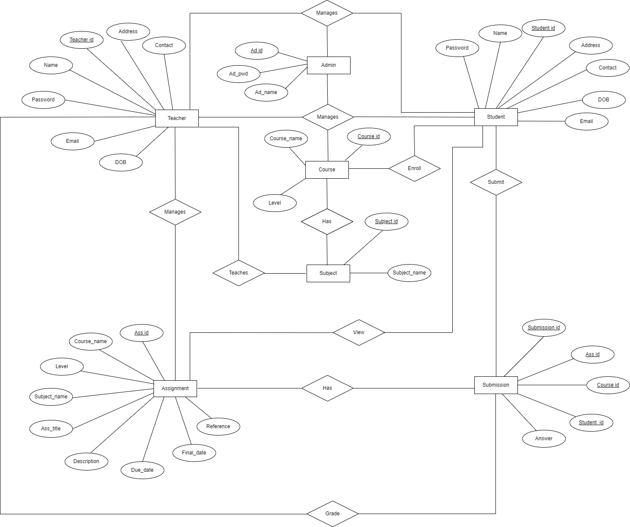

Fig.1: - Entity Relationship Diagram

**6.2 Use Case Diagram**

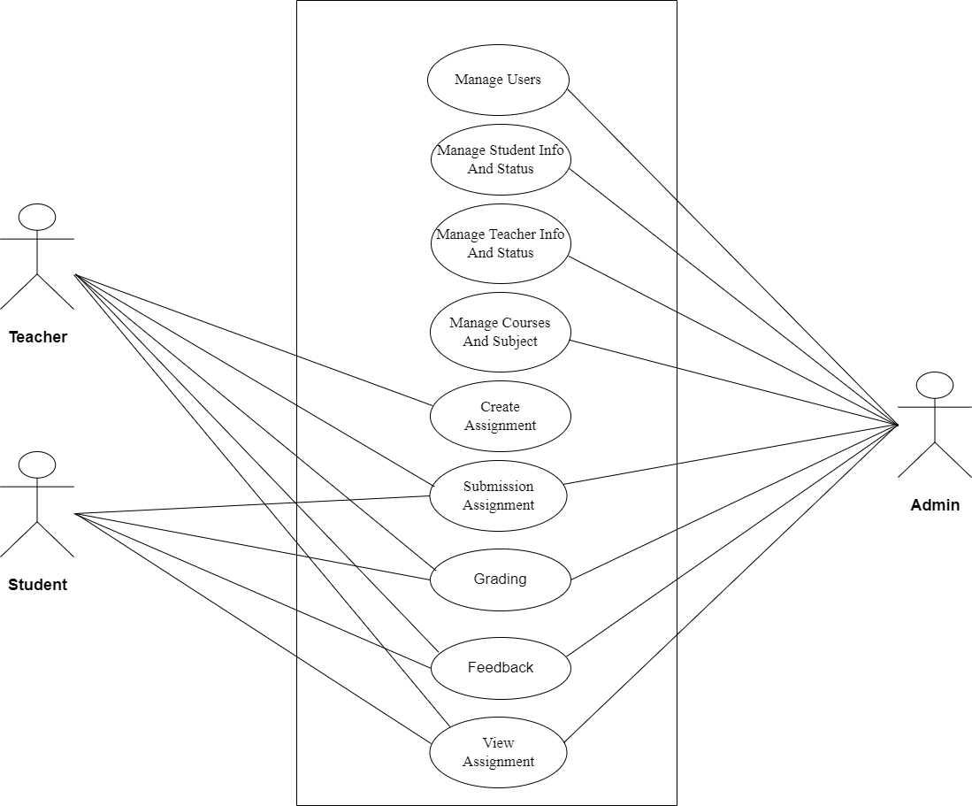

Fig.2: Use case Diagram

**6.3 UML Class Diagram**

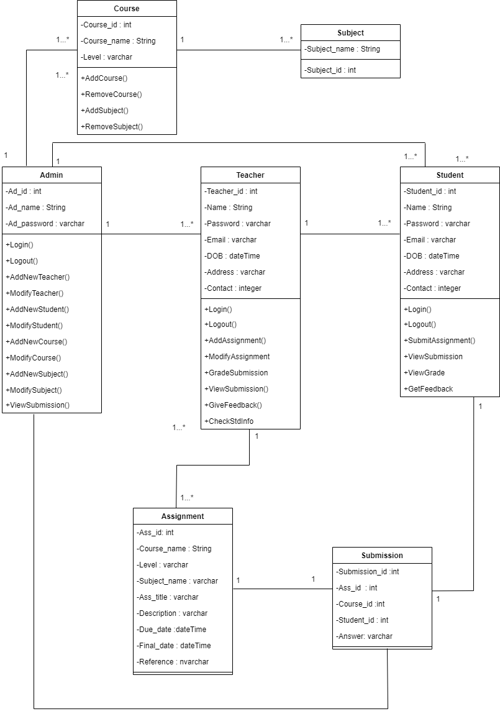

Fig.3: UML Class Diagram

1. **Gantt chart to show the project time planning**

Time planning is a determination of whether a proposed project can be implemented within a stipulated time frame. If a project takes too much time it is likely to be rejected.

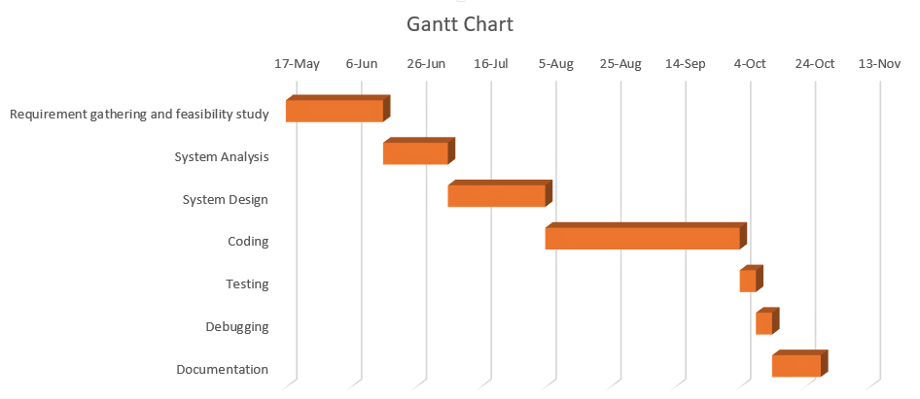

Fig.4: Gantt Chart

1. **Expected Outcome**

When this project is completed, it will able to collect assignment from students without submitting any physical file. It will help to reduce and minimize human error to manage student’s assignment. It will develop an automated online platform where the students’ assignment can be managed effectively and efficiently. This system can deliver feedback fast and effective to student. The main purpose of developing this system is to eliminate drawbacks of manual assignment collection.