WORK, POWER AND ENERGY











SAMPLE PROBLEM

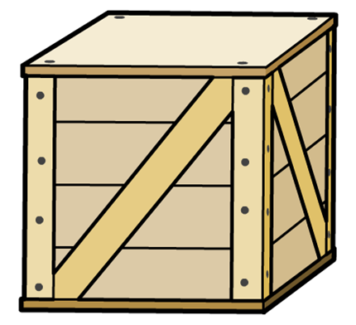

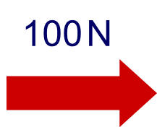



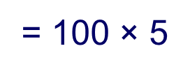















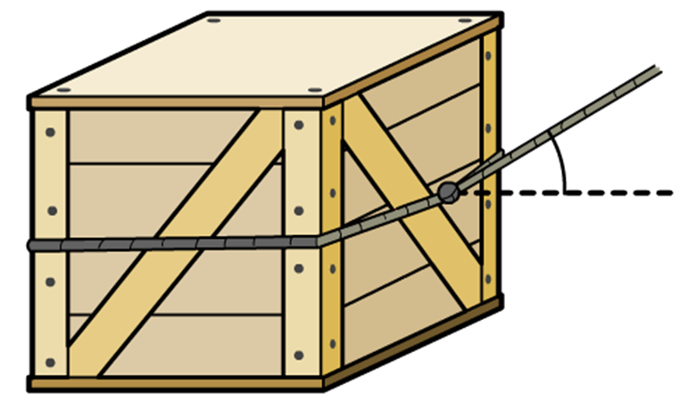











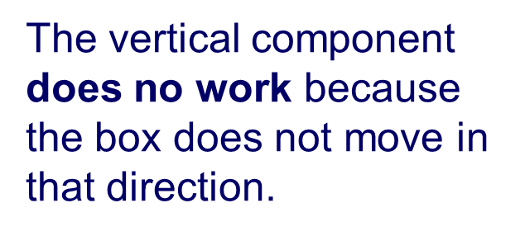

















SAMPLE PROBLEM

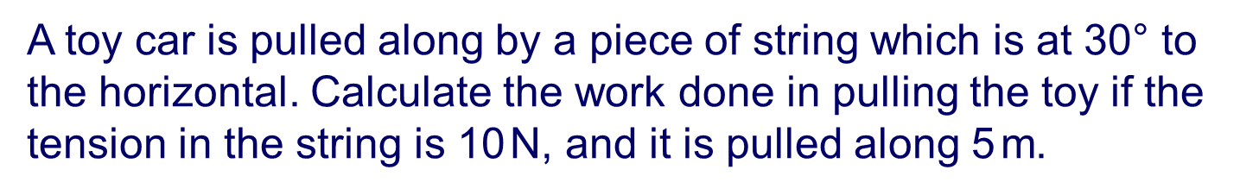

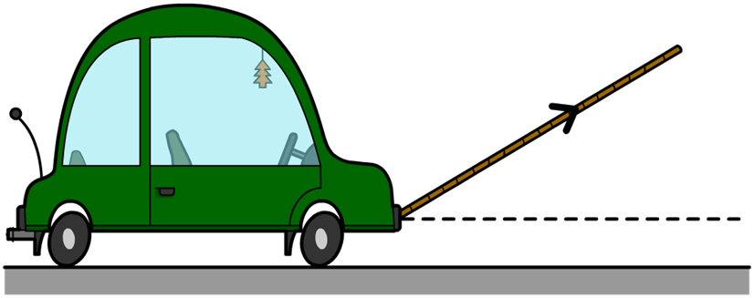







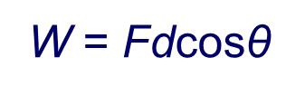

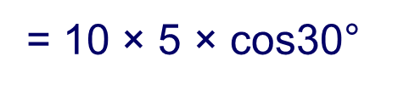

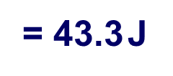

DRILL: SOLVE THE FOLLOWING PROBLEMS:Determine the force that is applied on an object in order to perform a work of 500 J and distance of 6.0 m.What is the displacement that is obtained by applying a force of 5.5 KN and the work applied is 4600 ergs.1 erg= 1x10-7JA load is pulled by a string which is 35 degrees with respect to the horizontal. If the force applied is 3.45 KN, determine the work if the displacement is 115 ft.Determine displacement by pulling a 34.55 KN object using a string that is 55 degrees with respect to vertical. The work done is 1.75 KJ





















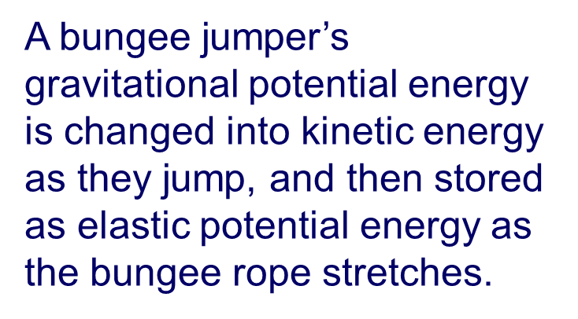















SAMPLE PROBLEM:

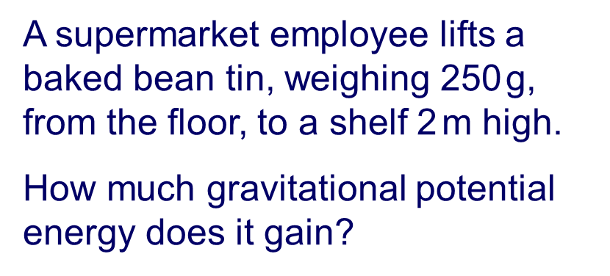





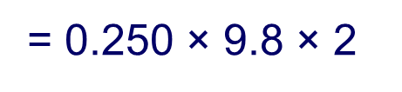

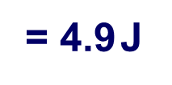





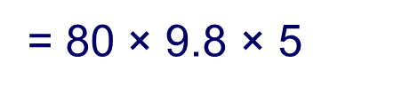

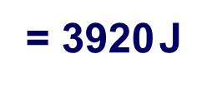

PRACTICE:

1.Determine the weight of an object if it gains a GPE of 4.5 KJ and it is 45 m from the ground.2.Determine the height of an object if the GPE is 55.90 KJ and the mass is 980 grams.3. What is the GPE obtained by an 1090 dyne object if its 500 ft from the ground.1 dyne= 1x10-5 N4. A mass of 5kg is taken from the ground for 5m uphill on the wedge. The wedge makes an angle of 300 with the ground. Find the potential energy of the block.









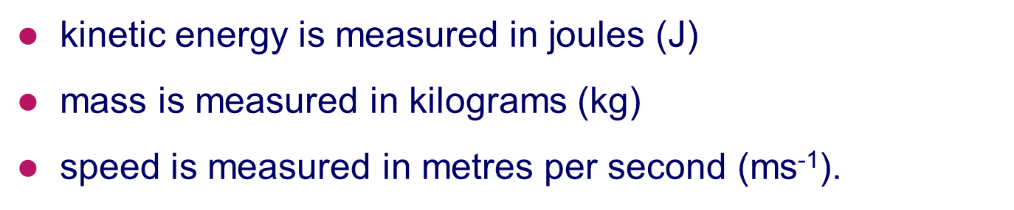





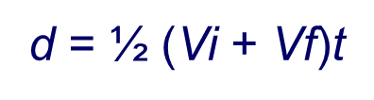

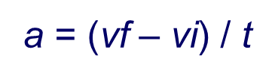

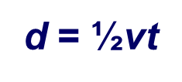



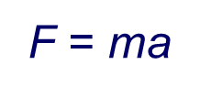



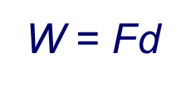

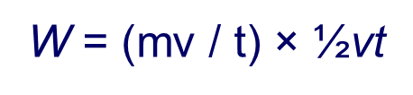







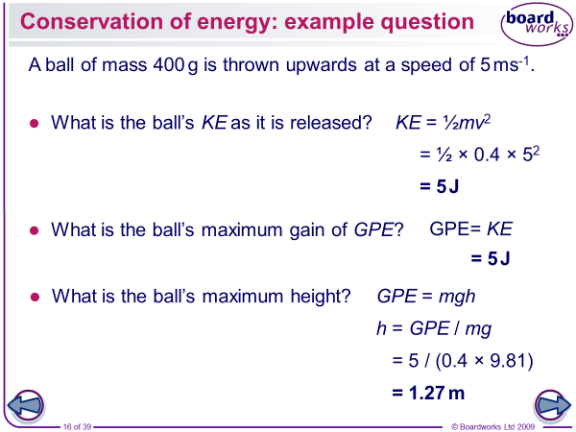

PRACTICEA car with a mass of 700 kg is moving with a speed of 20m/s. Calculate the kinetic energy of the car.2. A tennis ball is traveling at 50m/s and has a kinetic energy of 75J. Calculate the mass of the tennis ball.3. What is the kinetic energy of a 34.5 kg body moving at an initial velocity of 2 m/s and final velocity of 5 m/s?

4. Determine the weight of a moving body whose kinetic energy is 500J and moves from 50 m/s to 65 m/s.5. A moving body whose kinetic energy is 4500 J travels at a velocity of 50cm/s initially. If it weighs 4500 N, determine the final velocity.

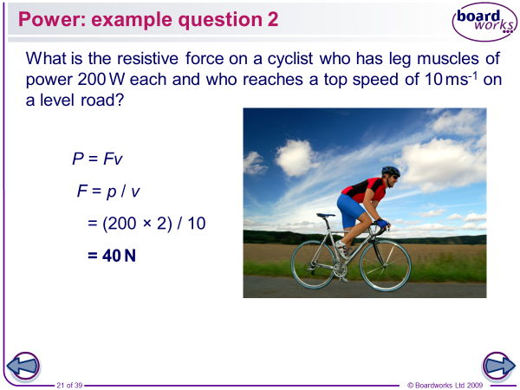

Please solve the following problems:Determine the power obtained from 55 Joules of work in 2 minutesWhat is the power obtained by Eric who is pushing a load using a force of 500 N and a distance of 5.55 m in 1.45 seconds?3. What is the power obtained by pushing a load of 5.5 KN using a string which is 70 degrees with respect to the horizontal? The displacement is 400 cm and the elapsed time is 2 seconds?4. Migo, weighing 700 N climbs at a height of 15 meters. He obtained a power rating of 25 Watts. Determine the time when he reaches the destination.

5. Jasper climbs a flight of stairs in 0.63 minutes at a constant speed. If his mass is 65 kg and the stairs are 12m high, what is the power output?6. A gardener pushes a lawn mower 20m in 30 s by exerting a force of 150N at an angle of 35 degrees horizontally. Find the power in kW that he expended?