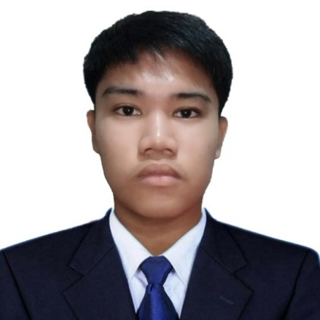**CLARK C. LAYOS**

2x2

Sitio Kaluwasan brgy. Inayawan, Cebu City

0981 240 0774

[clarklayos123@gmail.com](mailto:wilmarclyde.glipa@gmail.com)

**CAREER OBJECTIVE**

Seeking a challenging opportunity where I will be able to utilize my skills,

educational background, and ability to work well with people, which will

allow me to grow personally and professionally.

**SKILLS AND QUALIFICATIONS**

* Knowledge in Programming language: HTML,CSS and JAVASCRIPT
* Hardworking
* Willing to be trained

**EDUCATION**

* **Asian College of Technology (2022 - Present)**
* **Inayawan National Highschool(2018 – 2022)**
* **Inayawan Elementary School(2012 – 2018)**