**Chapter 2**

**REVIEW OF RELATED LITERATURE AND SYSTEMS**

**Related Literature**

[1]

Analytics will largely dictate how the teaching-learning process is conducted in the future. Applying analytical tools can make it easier to make insights-driven decisions on some important educational requirements, like configuring teaching styles to fit the learning patterns of students and creating a tailored learning environment. Analytics has a major impact on the caliber of instruction, the competency of teachers, and the long-term advantages for students. The main goal of this research project is to use text analytics and machine learning to estimate faculty members' efficacy as teachers based on input from students. This study established a taxonomy of evaluation factors for data analysis and acknowledged the necessity for analytics-enabled faculty effectiveness measurement. Post-graduate students from Indian higher education institutes (N=427) made up the respondent population. The proper data science methods were applied to the analysis of the information gathered from a structured questionnaire. According to the findings, students had favorable opinions of the professors who supported learner-engagement activities, a practical orientation, and real-world scenarios. The work makes two contributions. Firstly, it expanded the use of text analytics and machine learning to a relatively unexplored area of faculty assessment research. Second, from the standpoint of post-graduate teaching and learning, this work identified and examined pertinent context-relevant factors.

[2]

The purpose of this literature review is to synthesize what has been learned about the factors that influence student-faculty relationships and how those factors affect student outcomes. The researchers address the value, obstacles, and enablers of student-faculty academic connections in nursing education while contributing to the body of knowledge. Following an EBSCO host search that produced 56 reports, abstracts were examined and 29 were disqualified according to the inclusion/exclusion criteria. The rejected reports either demonstrated little to no correlation with factors influencing nursing students' academic outcomes or relationships with faculty, or they satisfied some criteria but not all of them. A review and extraction of emerging themes were conducted using an inductive approach of analysis. The four main factors that determine student-faculty relationships are incivility, diversity, support, and compassion. These factors seemed to have an effect on the academic achievements of students and were related to one another.

[3]

Natural language processing as a whole is studied in the discipline of sentiment analysis (SA) or opinion mining (OM). In order to provide knowledge and pertinent information about a given issue, SA aims to comprehend people's thoughts, sentiments, assessments, attitudes, and emotions through text. In the business world, this is especially important since it helps to comprehend how things are evaluated. Whether the attitude underlying the text is neutral, negative, or good, we can usually go back to our interpretation of it. The rise in social networks, opinions, criticism, forum discussions, and blogs, among other things, is correlated with the increasing significance of SA. Opinions are important in virtually all activities and are one of the influential variables in human and social behaviors, beliefs, and perceptions of our own decisions. As a result of the exponential expansion of data, there is a growing demand to apply SA in practically all social and commercial sectors. This is a very relevant topic these days because opinion is one of the primary influencing aspects in people's choice, which has broadened the scope of study for enterprises. This study showed that while methods, approaches, and frameworks to support SA implementations have made significant progress, there is still a need to discover advantages for business applications.

[4]

The educational system's goal is to strengthen such ideals and enhance individuals' aptitudes and abilities so that they can support any nation's efforts toward sustainable development. It is the main component of the development of human resources. It has long been believed that education essential to a better future. tool for national development. Among the various degrees of education levels include elementary, middle school, high school, and Higher education, whether at a university or otherwise, is important. Important part in the enhancement of individuals' capacity to   
fulfill the sociological, technological, and economic needs of the nation. Over the past 20 years, Bangladesh's higher education has expanded really quickly. Frequent review of faculty members' performance is   
really important, just as the caliber of instruction and the standing of an educational establishment is primarily dependent on its faculty. Those who are part of that group. It also presents the foundation. to strengthen and expand the abilities that are necessary for good performance. The issue pertaining to the educators. The task of evaluating performance is by no means simple. choose the one immediately since it affects the teachers' caliber. on multifaceted elements. Teachers' work output an assessment problem can be thought of as a multiphase challenge requiring decision making with both numerical and qualitatively incompatible standards.

[5]

When it comes to understanding what students need, what has and has not been helpful or beneficial, and when and how to intervene in the learning process when student feedback calls for it, instructors and course designers have always found that student feedback is a particularly informative source. The curriculum and course content, staff quality, assessment, learning support, teaching strategies, teaching and learning resources, course management, and the learning environment can all be improved with the help of qualitative feedback. Typically, lecturers analyze feedback by hand, which involves recognizing themes, classifying them, marking them as codes, reporting the data both with and without the use of learning theory-based organizing categories, and emphasizing issues. Natural language processing (NLP) applications, which allow machines to understand spoken or written human language, are helping to develop models for analyzing student feedback, predicting student satisfaction, performance, etc., and identifying important feedback that requires immediate action. The students' qualitative text feedback is analyzed using concepts of opinion mining, sentiment analysis, and language models. As an example, Google Forms provides a template for a brief exit ticket at the conclusion of the lesson.

**Related Systems**

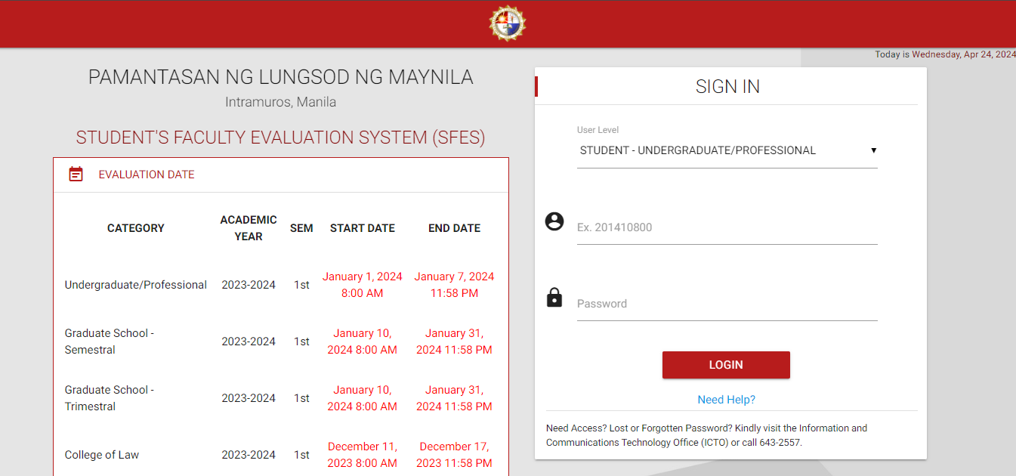Pamantasan ng Lungsod ng Maynila Student Faculty Evaluation System (SFES)

Figure 2.1

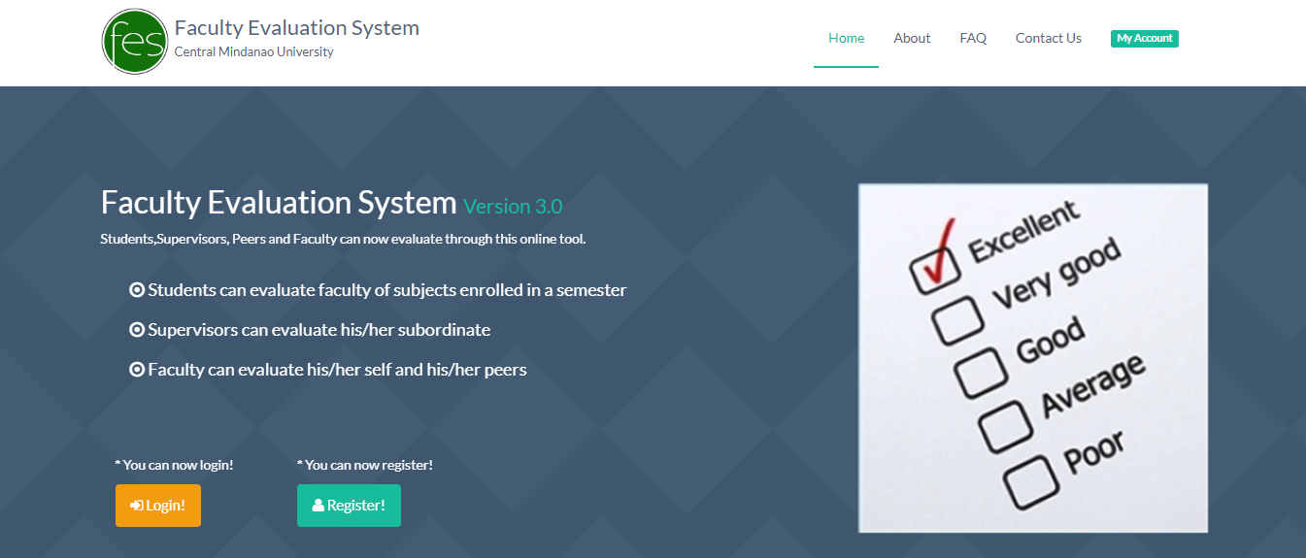Central Mindanao University Faculty Evaluation System

Figure 2.2

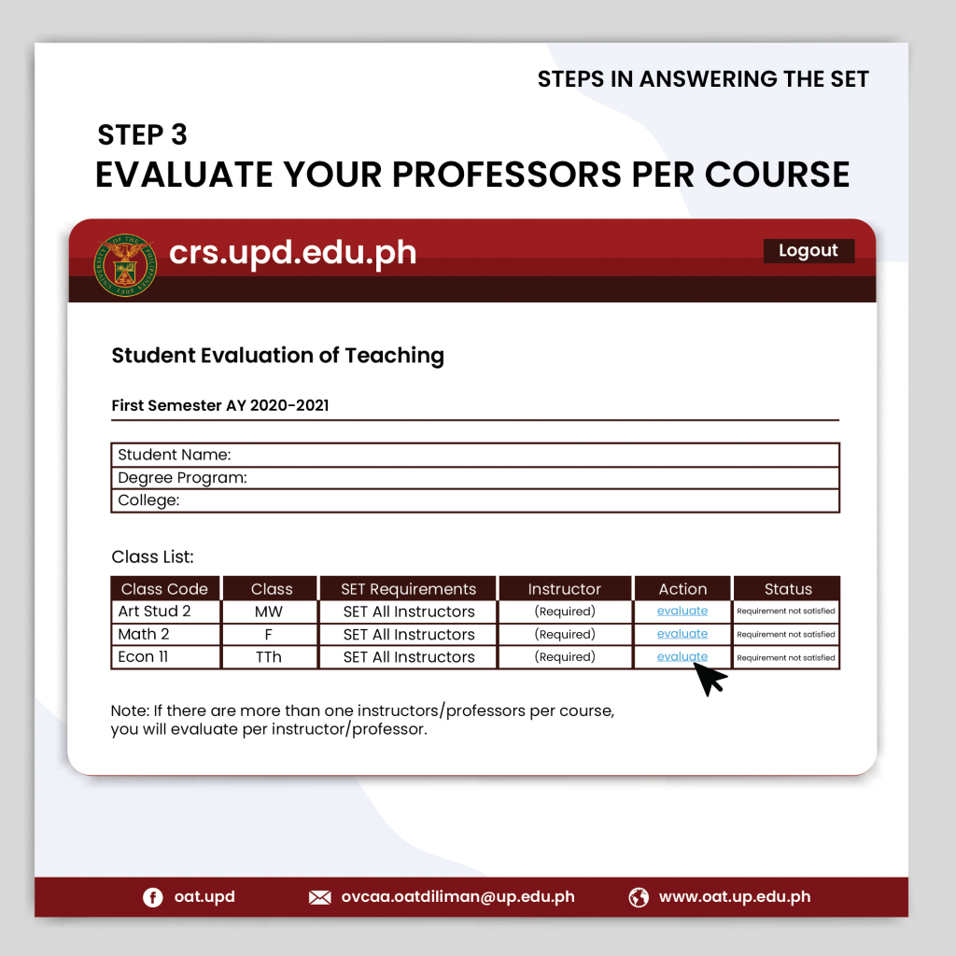University of the Philippines Student Evaluation of Teaching

Figure 2.3

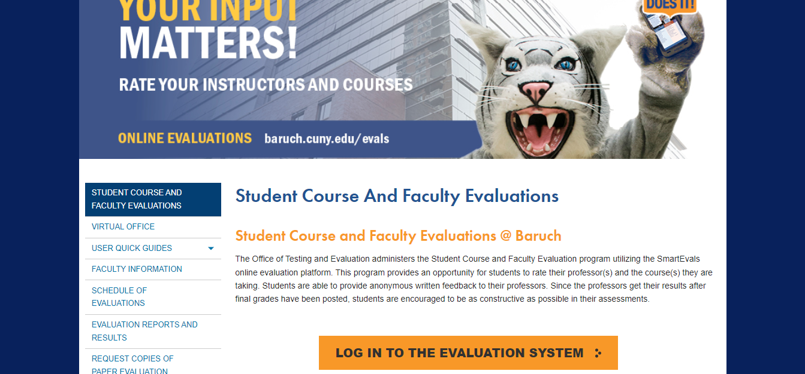The City University of New York Student Course and Faculty Evaluation

Figure 2.4

**Conceptual Framework**

**INPUT PROCESS OUTPUT**







Evaluation and Performance Test:

**ISO 25010:2011**

**Definition of Terms**

***System*****-** a complex configuration composed of hardware, software, and additional equipment designed to work in synchrony to facilitate data processing.

***Sentiment Analysis******-***is a natural language processing (NLP) technique used to determine whether data is positive, negative or neutral.

***Platform -*** Computer or hardware device and/or associated operating system, or a virtual environment, on which software can be installed or run.

***Taxonomy -*** is a method for organizing data.

# References

|  |  |
| --- | --- |
| [1] | S. V. B. R. R. Dhanya Pramod, "Faculty Effectiveness Prediction using Machine Learning and Text Analytics," *2022 IEEE Technology and Engineering Management Conference (TEMSCON EUROPE),* pp. 1034-1039, 2022. |
| [2] | S. D. O. Y. Kenchera C. Ingraham, "Student-faculty relationships and its impact on academic outcomes," *Nurse Education Today,* vol. 71, pp. 17-21, 2018. |
| [3] | M. N. M. J. N. M. Pedro Neves Mata, "Sentiment analysis - A literature review," *Academy of Entrepreneurship Journal,* vol. 27, no. 25, 2021. |
| [4] | Mustafizur Rahman, "A framework of faculty performance evaluation: A case study in Bangladesh," *International Journal of Research in Advanced Engineering and Technology,* vol. IV, no. 3, pp. 18-24, 2018. |
| [5] | M. S. K. Ayse Saliha Sunar, "Natural Language Processing of Student's Feedback to Instructors: A Systematic Review," pp. 1-14, 2023. |

**Chapter III**

**Design and Methodology**

**Software Development Methodology**

The researchers chose the Agile Methodology for the software development process. This methodology is used as incremental approaches promoting flexibility and feature-centricity. It breaks down the project into small, and this will work well because our project has a clear understanding of its features.

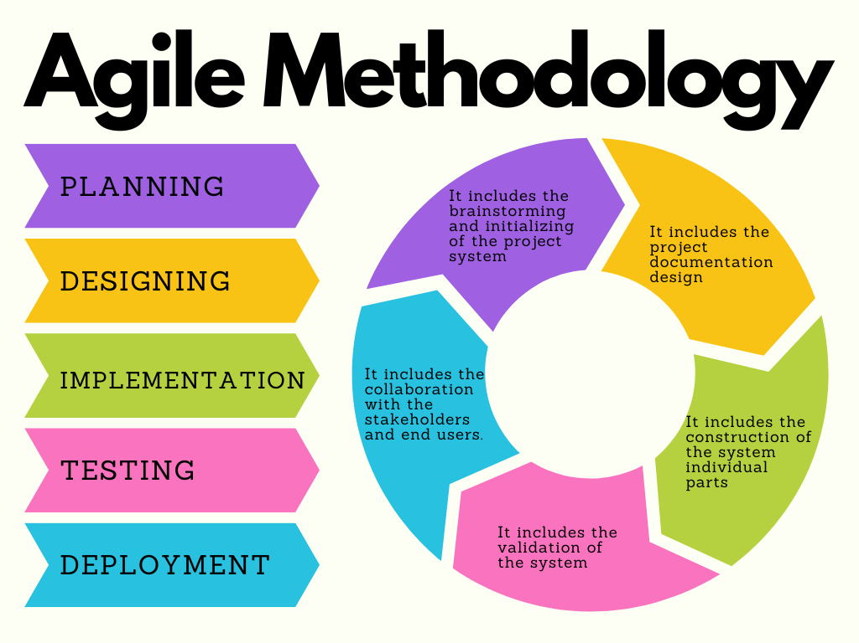

Figure 2.5

**Phases of Agile Methodology**

**Planning -** The team defines the project’s overall goals during the planning phase of the agile model and decides what must be accomplished throughout each sprint. This entails determining the project’s scope, identifying the main stakeholders, and developing a high-level roadmap for the system design. The team also establishes the development methodology, including the agile procedures and practices to be followed.

**Designing -** The team develops intricate designs for the system interfaces and components at this stage. The team creates any necessary prototypes as well as the architecture and design patterns that will be employed. This phase’s objectives are to lay a strong framework for the system and make that the design is scalable and consistent.

**Implementation -** The team constructs and incorporates the system’s parts into the overall design during the implementation phase. The team completes each sprint with the delivery of usable software. The team also adjusts the backlog of needs and makes sure the system is being developed according to the design.

**Testing -** During the testing phase, the team validates the system by putting each component through its paces and ensuring it complies with the specifications. The crew also finds and resolves any flaws or problems while testing. This phase aims to ensure the system is high-quality and prepared for deployment.

**Deployment -** The system is given to the end users during this last phase. The team deploys the system in collaboration with the stakeholders and offers any required support and training. This phase’s objective is to guarantee that the system is correctly implemented and that end users can efficiently utilize it.

**Requirements Analysis**

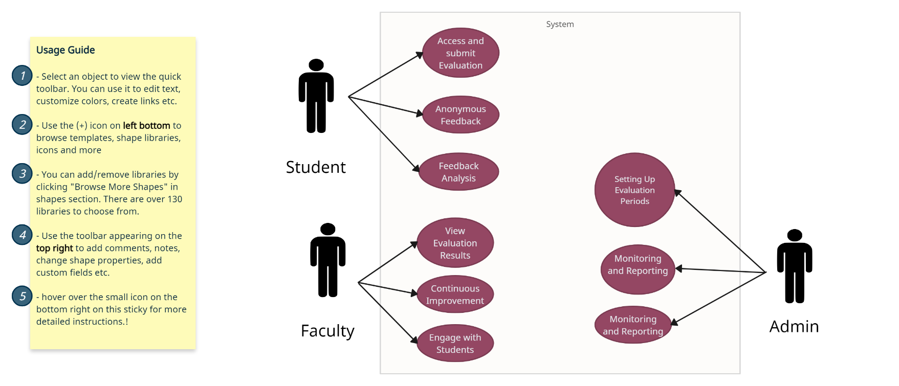

Figure 3.1

Requirement analysis for comprehensive student-faculty performance evaluation system involves a comprehensive process of gathering, documenting, analyzing, and validating the needs and expectations of stakeholders.

Student – Students can access and submit evaluation. They can also feedback anonymously.

Faculty – Faculty, including professors can view evaluation results.

Admin – Admins can set the evaluation period, configure evaluation forms, manage participants, and manage reports.

**Requirements Documentation**

The purpose of this document is to outline the requirements for the development of student-faculty evaluation system for the Lyceum of Alabang. The comprehensive student-faculty performance evaluation with sentiment analysis is intended to streamline the planning, organization, and execution of various events within the institution.

**SYSTEM OVERVIEW:**

The system will provide a platform for students to evaluate their respective subject professor performance. The evaluation will include both quantitative and qualitative feedback with sentiment analysis to gain deeper insights.

**USER ROLES:**

Students: Evaluate subject professors.

Faculty: View evaluations submitted by students.

Admin: Manage user accounts and permissions.

Generate reports on evaluations.

Monitor system performance and security.

**FUNCTIONAL REQUIREMENTS:**

Evaluation Forms: Pre-defined evaluation forms for student, tailored for different courses.

Likert scale and open-ended response questions.

Sentiment Analysis: API to analyze open-ended responses.

Identify positive, negative, and neutral sentiment in student feedback.

Anonymity: Professors should only see aggregated data and no individual student names.

Report: Generate reports for instructors summarizing student feedback, including sentiment analysis.

Security: Secure user authentication and authorization.

Data encryption for sensitive information.

**USABILITY:**

The user interface should be intuitive and easy to navigate for both students and faculty.

**PERFORMANCE:**

The system should respond promptly to user actions and generate reports efficiently.

**Project Design**

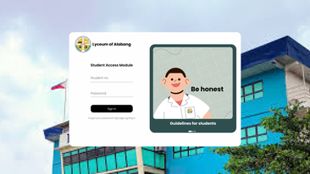

**Log In**

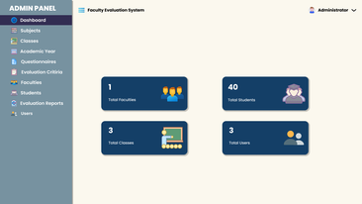

**Admin Dashboard**

**Evaluation Procedures**

**Instrument**

The instrument used for evaluating the system is web. A web-based student-faculty performance evaluation system is imbed to the respondents. The web-based system is combined of pre-defined forms, open ended responses, and a sentiment analysis.

**Respondents of the Study**

The respondents of this study will be all college student from Lyceum of Alabang.

**Statistical Treatment of Data**

Descriptive Statistics: Calculate the basic statistics like mean, median, and standard deviation for each Likert scale question.

Sentiment Analysis: Utilize the sentiment analysis engine’s output to categorize student responses as positive, negative, or neutral for each faculty member.

Sentiment Scores with Quantitative Data: Overlay sentiment analysis scores (percentage of positive, negative, and neutral responses) with quantitative data (Likert scale scores).

**Testing Procedures**

Unit Testing: The individual functionalities of the system; question submission, answer recording, data validation, and report generation.

Integration Testing: The communication between different components of the system, especially with API’s.

User Testing: The usability and clarity of the interface for each user roles.

Sentiment Analysis Testing: The accuracy of the sentiment analysis engine which classifies student feedback.

Security Testing: System’s vulnerability to cyberattacks and data breaches.

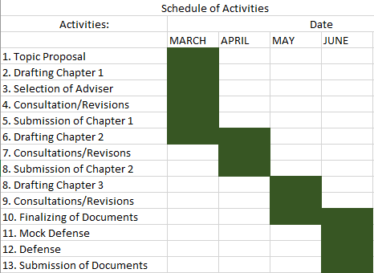**Implementation Plan**

Figure 3.2