**TRIBHUVAN UNIVERSITY**

**INSTITUTE OF ENGINEERING**

ADVANCED COLLEGE OF ENGINEERING AND MANAGEMENT

DEPARTMENT OF ELECTRONICS AND COMPUTER ENGINEERING

             KALANKI, KATHMANDU



**A Minor Project Final Defense Report On**

**“CAR PARKING SYSTEM USING ML CONTROLLED**

**ESP32 CAM”**

[**EX 654**]

**Submitted By:**

ROJDEEP KHAREL 33224

SAGAR PANTHA 33225

SUMAN BHANDARI 33231

**Supervisor:**

Er. DHIRAJ PYAKUREL

Er. AMIT KUMAR RAUNIYAR

A Minor Project Final report submitted to the Department of Electronics and Computer Engineering in the partial fulfillment of the requirements for degree of Bachelor in Electronics Communication and Information Engineering.

Kathmandu, Nepal

March 06, 2024

ADVANCED COLLEGE OF ENGINEERING AND

MANAGEMENT

DEPARTMENT OF COMPUTER AND ELECTRONICS ENGINEERING

APPROVAL LETTER

The undersigned certify that they have read and recommended to the Institute of

Engineering for acceptance, a project report entitled

“CAR PARKING SYSTEM USING ML CONTROLLED ESP32 CAM”

Submitted by:

ROJDEEP KHAREL 33224

SAGAR PANTHA 33225

SUMAN BHANDARI 33231

In partial fulfillment for the degree of Bachelor in Electronics Communication and Information Engineering.

|  |  |
| --- | --- |
| …………………… | …………………………… |
| Project Supervisor | Project Supervisor |

..................................

External Examiner

..................................

Er. Laxmi Prasad Bhatt

Academic Project coordinator

Department of Computer and Electronics Engineering

March 6, 2024

# ACKNOWLEDGEMENT

We take this opportunity to express our deepest and sincere gratitude to our Project Supervisor **Er. Dhiraj Pyakurel, Er. Amit Kumar Rauniyar** for his/ her insightful advice, motivating suggestions, invaluable guidance, help and support in successful completion of this project and also for his/her constant encouragement and advice throughout our Bachelor's programme.

We express our deep gratitude to **Er. Ajaya Shrestha**, Head of Department of Electronics and Computer Engineering, **Er. Bikash Acharya, Er. Dhiraj Pyakurel** Deputy Head, Department of Electronics and Computer Engineering, **Er. Laxmi Prasad Bhatt,** Academic Project Coordinator, Department of Electronics and Computer Engineering for their regular support, co-operation, and coordination.

We would like to convey our thanks to the teaching and non-teaching staff of the Department of Electronics & Communication and Computer Engineering, ACEM for their invaluable help and support till the date. We are also grateful to all our classmates for their help, encouragement and invaluable suggestions.

Finally, yet more importantly, I would like to express our deep appreciation to my grandparents, parents, siblings for their perpetual support and encouragement throughout the Bachelor’s degree period.

ROJDEEP KHAREL 33224

SAGAR PANTHA 33225

SUMAN BHANDARI 33231

# ABSTRACT

This study introduces an innovative car parking system designed to enhance security. As the number of parking space increased, the manpower required for management for barriers also increased significantly which has been a major problem in the parking system. The system exhibits ESP32 CAM with WIFI, servo motor, jumper wire, matrix board with robust control mechanism. MIT App inventor techniques are used to develop an application that is used to view slots that are vacant or not. Also, the time and cost can be viewed through the app as well.

***Keywords:*** *Barrier, MIT App inventor, Servo motor*

# Table of Contents

**Title** **Page**

ACKNOWLEDGEMENT iii

ABSTRACT iv

Table of Contents v

List of Figures vii

List of Abbreviations/Acronyms viii

List of Units and Conversions ix

CHAPTER 1 1

INTRODUCTION 1

1.1 Background 1

1.2 Motivation 2

1.3 Statement of the Problem 3

1.4 Project objective 3

1.5 Significance of the study 3

CHAPTER 2 4

LITERATURE REVIEW 4

2.1 Advanced CAR Parking System using Arduino (2017) 4

2.2 IoT based Smart Parking System (2018) 5

2.3 A Real-Time Cloud-Based Intelligent Car Parking System for Smart Cities (2019) 5

CHAPTER 3 7

REQUIREMENT ANALYSIS 7

3.1 Hardware Requirements 7

3.1.1 ESP32 CAM 7

3.1.2 Servo Motor 7

3.1.3 Jumper Wire 8

3.1.4 Matrix Board 9

3.1.5 Lithium-Ion Batteries 9

3.1.6 IR SENSOR 10

3.2 Software Requirement 10

3.2.1 Arduino IDE 10

3.2.2 Visual Studio Code (IDE) 10

3.2.3 MIT App inventor 11

3.3 Functional Requirements 12

3.3.1 Camera-Based Vehicle Detection: 12

3.3.2 Automated Gate Control: 12

3.3.3 Reservations and Dynamic Space Allocation: 12

3.4 Non-Functional Requirements 12

3.4.1 Performance 12

3.4.2 Reliability 12

3.4.3 Scalability 13

3.4.4 Usability 13

3.5 Feasibility Study 13

3.5.1 Economic Feasibility 13

3.5.2 Operational Feasibility 13

3.5.3 Technical Feasibility 13

CHAPTER 4 14

SYSTEM DESIGN AND ARCHITECTURE 14

4.1 Block Diagram 14

CHAPTER 5 15

METHODOLOGY 15

5.1 Flowchart 15

5.2 Working Principle 16

5.2.1 Car Entering Module 17

5.2.2 Car Exiting Module 17

5.2.3 Working of Servo Motor 17

CHAPTER 6 18

RESULT AND ANALYSIS 18

6.1 RESULT 18

6.2 ANALYSIS 19

CHAPTER 7 21

CONCLUSION, LIMITATIONS AND FUTURE ENHANCEMENT 21

7.1 CONCLUSION 21

7.2 LIMITATIONS 21

7.3 FUTURE ENHANCEMENTS 21

REFERENCES 22

# List of Figures

Figure 3.1.1: ESP32 CAM 7

Figure 3.1.2: Servo Motor 8

Figure 3.1.3: Jumper Wire 8

Figure 3.1.4: Matrix Board 9

Figure 3.1.5: Lithium-Ion Battery 9

Figure 3.1.6: IR Sensor 10

Figure 3.2.3.1: MIT App Inventor Designer Screen 11

Figure 3.2.3.2: MIT App Inventor Blocks Editor Screen 11

Figure 4.1: Block diagram of the system 14

Figure 5.1: Flowchart of the system 15

Figure 5.2.1: Barrier rotates for parking not occupied after cam detects car 16

Figure 5.2.3: PWM pulse for servo rotation 17

Figure 6.2.1: vacant slots 19

Figure 6.2.2: Car detection through the ESP32CAM 19

Figure 6.2.3: slot 2 occupied by car 20

Figure 6.2.4: time and cost display of the system 20

# List of Abbreviations/Acronyms

BMP Bitmap

CCK Complementary Code Keying

DES Data Encryption Standard

DIP Dual In-line Package

ESP32 CAM Espressif32 Camera

IEEE Institute of Electrical and Electronics Engineers

IDE Integrated Development Environment

IoT Internet of Things

JPEG Joint Photographic Experts Group

LCD Liquid Crystal Display

LED Light Emitting Diode

MAC Media Access Control

Mbps Megabits Per Seconds

MIT Massachusetts Institute of Technology

PCB Printed Circuit Board

PSRAM Pseudo Static Random-Access Memory

PWM Pulse Width Modulation

RAM Random Access Memory

Wi-Fi Wireless Fidelity

WPA Wi-Fi Protected Access

WPS Wi-Fi Protected Setup

## 

# List of Units and Conversions

A Ampere

°C Degree Celsius

mA Milli Ampere

mm Millimeter

mV Milli Volt

V Volt

# CHAPTER 1

# INTRODUCTION

The project entitled “Car Parking System using ESP32 Cam” is to manage the parking facilities to a user. The recent growth in population has been the consequences of heavy traffic jams, pollution, and less availability of roads and spots to drive the motor car. One of the important concerns, which is to be taken into account, is the problem of parking those vehicles. Though, if there is space for parking the vehicle but so much time is squandered in finding that exact parking slot resulting in more fuel intake and also not being environmentally friendly. It will be a great deal if in some way we find out that the parking itself can provide the precise vacant position of a parking slot then it'll be helpful not limited to the drivers also for the environment. Initially when the user is about to enter the location the LCD displays the number of empty and filled spots and when the user is with their vehicle near to the parking detector sensor, he/she would be thrown with a notification on their mobile app of the parking slot number, where they should park their vehicle.

## 1.1 Background

The evolution of security infrastructure has witnessed a transformative shift from traditional manual systems to advanced automated solutions, prominently exemplified by the development of automatic vehicle barriers. Over the years, the imperative to safeguard critical assets, public spaces, and transportation hubs has driven the continuous innovation and refinement of these automated barrier systems.

Historically, manual barriers and access control mechanisms were the norm, requiring human intervention for effective security management. However, the limitations of such systems in responding to rapid threats, coupled with the need for enhanced efficiency, prompted the exploration of automated alternatives. This transition forms the foundation of our exploration into the background of automatic vehicle barriers.

Technologically, automatic vehicle barriers have evolved to leverage sophisticated sensor technologies, actuators, and intelligent control systems. The integration of sensors enables real-time detection of approaching vehicles, while advanced control mechanisms streamline the barrier operation process. This intersection of hardware and software has not only increased the reliability of these barriers but has also paved the way for the incorporation of cutting-edge technologies like computer vision and machine learning.

The applications of automatic vehicle barriers extend across diverse industries, ranging from transportation and critical infrastructure to residential and commercial spaces. Through an examination of case studies and research findings, we gain insights into how these barriers adapt to and address the unique security challenges posed by different environments.

In conclusion, the background of automatic vehicle barriers unfolds as a dynamic narrative of technological evolution, driven by the imperative to enhance security, efficiency, and adaptability. This exploration sets the stage for a deeper understanding of the intricacies involved in the deployment of these barriers, offering a comprehensive foundation for further research and innovation in the realm of automated security systems.

## 1.2 Motivation

Since the first meeting of our team members, we have asked each other what we want to do in this project. As a conclusion of that meeting, we came to know that all of us are excited to do something related to the automated system. Our country uses a manual system for management of barriers, watching the present scenario and being an aspirant of Electronics and Communication engineering, we had a feeling of helping barrier management by using this technology in their organization. It is observable that the IOT is an important field that the whole world seeks to make the best use of it in order to decrease the use of human manpower that decreases the overall cost and increases the efficiency of barrier management. For this reason, the automatic vehicle barrier system is presented as a solution for barrier management. The objective now is to develop an app interface for barrier management.

## 1.3 Statement of the Problem

The use of human manpower can be reduced by an automated system that manages the barrier system. The fact that the efficiency of an automated system is more than a manual human managed system is known to all. The manual management of barriers can be time consuming and less efficient. Here we are going to see how to reduce the barrier management problem of automating car parking using offerings that are transforming cities by improving infrastructure, creating more efficient and cost-effective municipal services, enhancing public transportation, and reducing traffic congestion.

## 1.4 Project objective

The main objective of our project is listed below:

* To develop a car parking system that includes ESP32 Cam controlled entry and exit section with additional overview of time and cost in MIT app inventor.

## 1.5 Significance of the study

This project can be used by anyone desiring to build a parking area. Hotels, shopping malls, Cinema Halls, Government, and private offices where many people come in their personal vehicle this project can help guide the parking management team on the aspects of barrier management.

# 

# CHAPTER 2

# LITERATURE REVIEW

This section consists of the last decade's methodologies of car parking systems explaining different sensors and algorithms working. Last decade methodologies include paper from 2017 to 2020 with reference to the discussion paper. This may help the researcher to understand the previous working of researchers in this topic and also provide a baseline to our project.

## 2.1 Advanced CAR Parking System using Arduino (2017)

In this paper, the proposed architecture design is based on Arduino control. The proposed system allows to park a car only to authorized persons using a card containing information about the vehicle number and other details. If the user is authorized, he can park his car only if the parking slot is free, if parking is busy, he is unable to park his car even if he is authorized. If a user parked his car in parking mobile notification is generated. The parking system is not allowed to park a car by unauthorized users. This parking system is a multi-floored parking system and displays the free parking slot on each floor.

The proposed system uses IR sensors on the parking slot to sense any obstacle and vehicles. Sensor’s information is displayed on the Entry and Exit gate. If the user's RFID is matched with the punched card, it allows the user for entry and exit. Database is maintained to check the user’s entry and exit. There are two gates used in the parking:

Entry

Exit

On the exit gate, the user again punches his RFID card on the RFID Reader, IR senses the vehicle and decrements the value by 1 if he is an authorized user and opens the gate by sending a signal to the electric motor. All information of increment and decrement is displayed on LED screens in the parking lot.

## 2.2 IoT based Smart Parking System (2018)

In this paper, the proposed system consists of a great combination of IoT technology and web page or mobile device to display the parking slots. The proposed system uses RFID for automatic billing and security purposes as well. Features of system involves:

IR Sensor

LM35 Sensor (Temperature)

LDR Sensor (Light)

Arduino Mega+ Ethernet Shield

Cloud

HTML Page/ Mobile

Commands

These features are the combination of both software and hardware. Further, this system is divided into two parts:

* Monitor the empty slots
* Monitor the light and temperature for the concerned person.

Both cases include cloud due to its availability in the protocol of MQTT that accomplish the core element tasks of a real time system for servers, client, and topics . Monitoring of temperature and light requires LM35 and LDR sensors and their data after processing will be sent to the authorized person and indicate darkness and temperature change. Monitoring of empty slots is accomplished by IR/Ultrasonic sensors. IR sensors are being used for indoor parking and ultrasonic sensors are used for outdoor parking. Web Page indicates about the free slots to users, filled slots are highlighted through red spots on the screen.

## 2.3 A Real-Time Cloud-Based Intelligent Car Parking System for Smart Cities (2019)

In this paper, the proposed system is based on real-time cloud based IoT technologies that operate without image processing. To enhance the security in the system different MAC addresses are used for routers and wireless sensors placed on different parking places along Data Encryption Standard (DES). Proposed system architecture includes:

Wireless Sensors

Wireless Router

Integrated Cloud Platform

Digital Parking Signs

Web Apps and Analytics

Mobile Apps

The status of the proposed real-time status is detected by WSNs and sent to the wireless router. Wireless routers are cost effective for large-scale parking. In this parking system users can login into the system and select the slot for parking. The slot status changes to the “pending” after user’s selection, if the user does not pay the fees of parking within two minutes, it will again change the status of “available”. The status of parking is updated through WSN nodes, and the parking slots selection can be accomplished by a different set of notification steps done by the user.

# CHAPTER 3

# REQUIREMENT ANALYSIS

## 3.1 Hardware Requirements

### 3.1.1 ESP32 CAM

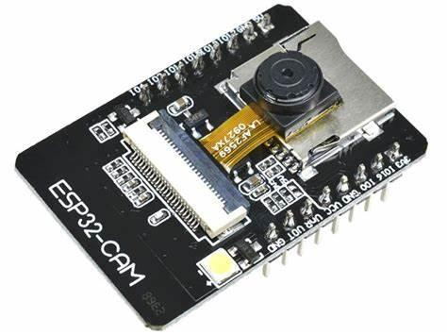ESP32 CAM is a versatile development board that combines the ESP32 microcontroller with a camera module making it capable of capturing images and videos. The ESP32 developed by Espressif system is a powerful and widely used microcontroller with built-in Wi-Fi and Bluetooth capabilities. It features an OV2640 camera module, capable of capturing images with a resolution of up to 2 megapixels. With integrated Wi-Fi and Bluetooth, the ESP32-CAM can connect to networks and communicate with other devices, making it suitable for IoT applications. The board includes a variety of GPIO pins, allowing for the connection of additional sensors, actuators, or other peripherals. An onboard microSD card slot provides storage for captured images and video. Programming the ESP32-CAM can be done using the Arduino IDE, making it accessible to a wide range of developers.

Figure 3.1.1: ESP32 CAM

Source:[OIP.3Iqs9kcWkdm3nf3CQk1-cAHaFj (474×355) (bing.com)](https://th.bing.com/th/id/OIP.3Iqs9kcWkdm3nf3CQk1-cAHaFj?rs=1&pid=ImgDetMain)

### 3.1.2 Servo Motor

A servomotor is a rotary actuator or linear actuator that allows for precise control of angular or linear position, velocity, and acceleration. It consists of a suitable motor coupled to a sensor for position feedback. It can rotate with great precision. It is just made up of a simple motor which runs through a servo mechanism. A servo motor usually comes with a gear arrangement that allows us to get a very high torque servo motor in small and lightweight packages.

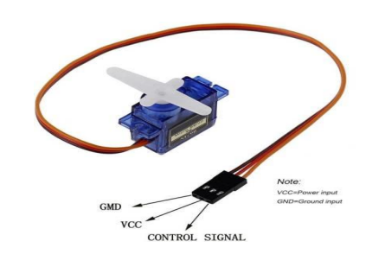

Figure 3.1.2: Servo Motor

Source:[OIP.P5BPCfBiFG2oBdUCvU4-aAHaHa (474×474) (bing.com)](https://th.bing.com/th/id/OIP.P5BPCfBiFG2oBdUCvU4-aAHaHa?rs=1&pid=ImgDetMain)

### 3.1.3 Jumper Wire

A jumper wire is an electrical wire, or group of them in a cable, with a connector or pin at each end, which is normally used to interconnect the components of a breadboard or other prototype or test circuit, internally or with other equipment or components, without soldering. Individual jump wires are fitted by inserting their "end connectors" into the slots provided in a breadboard, the header connector of a circuit board, or a piece of test equipment.

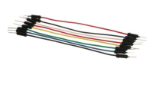

Figure 3.1.3: Jumper Wire

Source:[OIP.cfAnu3c1lfIupyAsdyRV8QFNC7 (474×266) (bing.com)](https://th.bing.com/th/id/OIP.cfAnu3c1lfIupyAsdyRV8QFNC7?rs=1&pid=ImgDetMain)

### 3.1.4 Matrix Board

Matrix boards are prototype circuit boards used for laying out electrical components securely and can be used for both high frequency and analogue circuit building. When using a matrix board, electrical parts are soldered together and joined with tinned copper wire.

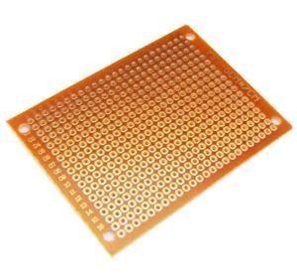

Figure 3.1.4: Matrix Board

Source: [s-l300.jpg (300×278) (ebayimg.com)](https://i.ebayimg.com/images/g/wuYAAOSwEoxanLvu/s-l300.jpg)

### 3.1.5 Lithium-Ion Batteries

Lithium-ion batteries have become the dominant technology for portable electronic devices, and their use in electric vehicles and renewable energy storage systems is also increasing. Researchers continue to work on improving the performance, safety, and cost-effectiveness of lithium-ion battery technology. Additionally, other types of advanced batteries, such as lithium-polymer and solid-state batteries, are being explored as potential alternatives or improvements.

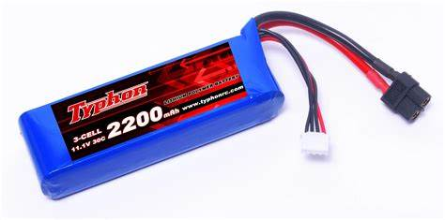

Figure 3.1.5: Lithium-Ion Battery

Source: [OIP.KwjX6PQB92RORf7GE3MQhAHaDr (474×235) (bing.com)](https://th.bing.com/th/id/OIP.KwjX6PQB92RORf7GE3MQhAHaDr?rs=1&pid=ImgDetMain)

### 3.1.6 IR SENSOR

An IR (Infrared) sensor is an electronic device that emits and/or detects infrared radiation to sense some aspect of its surroundings. IR sensors can measure the heat of an object as well as detect motion. They are used in various applications such as in security systems, TV remote controls, night vision equipment, and proximity sensors.

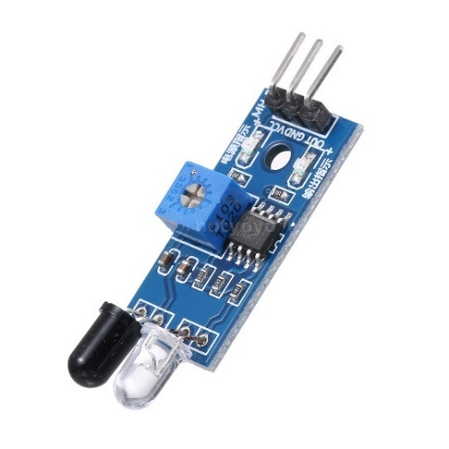

Figure 3.1.6: IR Sensor

Source: [IR SENSOR - Search Images (bing.com)](https://www.bing.com/images/search?view=detailV2&ccid=sPmIrJlr&id=ECCE14BC4BBB462F68046D3297E5A51AB62A8322&thid=OIP.sPmIrJlrSN61l1LaW-UlJgHaHa&mediaurl=https%3a%2f%2fhotyoyo.guphotos.com%2fi%2fw%3fu%3d%2fimages%2fE%2f1%2fE9111%2fE9111-1-327e-uW5N.jpg&cdnurl=https%3a%2f%2fth.bing.com%2fth%2fid%2fR.b0f988ac996b48deb59752da5be52526%3frik%3dIoMqthql5ZcybQ%26pid%3dImgRaw%26r%3d0&exph=1500&expw=1500&q=IR+SENSOR&simid=607992272588337972&FORM=IRPRST&ck=0C5C90DE7968E9191240917A5FFAAF6F&selectedIndex=1&itb=0&ajaxhist=0&ajaxserp=0)

## 3.2 Software Requirement

Following Software Components were required for our Car Parking system.

### 3.2.1 Arduino IDE

Arduino IDE is an open-source cross platform application that is used to write and upload programs to the microcontrollers that are compatible with the Arduino. It supports both the C as well as C++ languages. In our project, we used this software to program ESP32 CAM.

### 3.2.2 Visual Studio Code (IDE)

Visual Studio Code (VS Code) is a free, open-source Integrated Development Environment (IDE) developed by Microsoft. It supports a wide range of programming languages and frameworks out of the box, with further extensions available through its marketplace to enhance its functionality. Features include debugging, syntax highlighting, intelligent code completion, snippets, code refactoring, and embedded Git control.

### 3.2.3 MIT App inventor

MIT App Inventor is an intuitive, visual programming environment that allows everyone to build a fully functional app for smartphones and tablets. Its blocks-based tool facilitates the creation of complex, high-impact apps in significantly less time than traditional programming environments. It uses a graphical interface which helps users to create applications just by knowing execution logic.

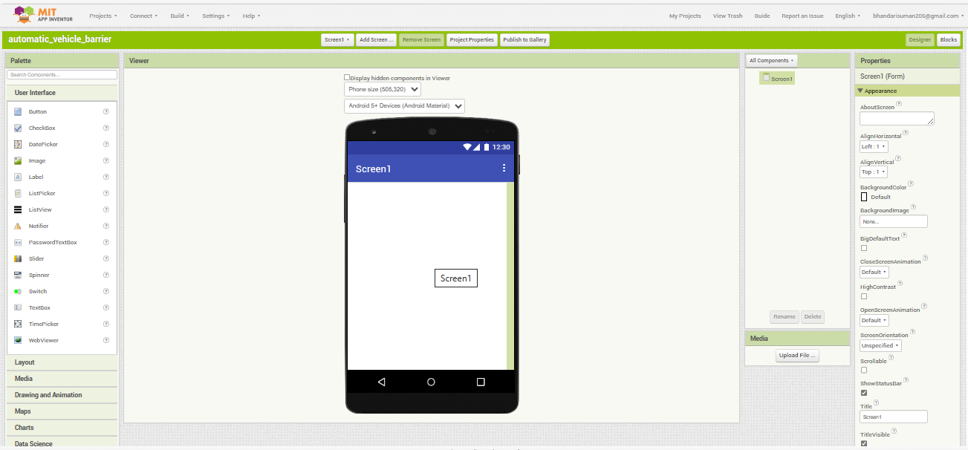

Figure 3.2.3.1: MIT App Inventor Designer Screen

In the Designer Screen we identify and select the required tools. Here the two tools required for automating the barrier are two buttons. One of the buttons is used for closing the barrier whereas the other is used for opening the barrier.

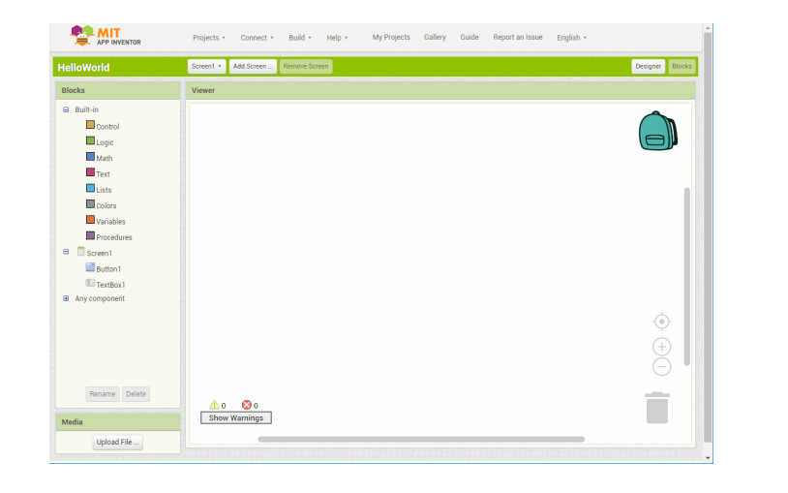

Figure 3.2.3.2: MIT App Inventor Blocks Editor Screen

In the blocks editor screen, we define the algorithm of the system.

Source: [MIT App Inventor](https://ai2.appinventor.mit.edu/#4790688537247744)

## 3.3 Functional Requirements

Following are the functional requirements for an automatic vehicle barrier:

### 3.3.1 Camera-Based Vehicle Detection:

* Utilize the ESP32-CAM's camera module to capture images or video frames of the parking spaces.
* Implement image processing algorithms to detect the presence of vehicles in the captured frames.
* Use motion detection or object recognition techniques to identify changes in the parking space.

### 3.3.2 Automated Gate Control:

* Connect the ESP32-CAM to servo motors or other actuators to control the opening and closing of entry and exit gates.
* Implement logic to automatically open gates upon detecting an authorized vehicle and close them after the vehicle has passed.

### 3.3.3 Reservations and Dynamic Space Allocation:

* Develop a reservation system using the ESP32-CAM to manage pre-booked parking spaces.
* Implement dynamic space allocation logic to optimize parking space usage based on real-time availability.

## 3.4 Non-Functional Requirements

### 3.4.1 Performance

* Response Time: Specify the maximum acceptable response time for vehicle detection, gate control, and user authentication.
* Throughput: Define the system's capacity to handle a certain number of vehicles entering and exiting per unit of time.

### 3.4.2 Reliability

* System Availability: Specify the required percentage of time the system must be available for users (e.g., 99.9% uptime).
* Fault Tolerance: Define the system's ability to operate in the presence of hardware or software failure

### 3.4.3 Scalability

* Number of Parking Spaces: Specify the maximum number of parking spaces the system can handle.
* User Capacity: Define the maximum number of registered users or vehicles the system can manage.

### 3.4.4 Usability

* User Interface Design: Ensure a user-friendly interface for administrators and maintenance personnel.
* Accessibility: Implement features to accommodate users with disabilities, if applicable.

## 3.5 Feasibility Study

### 3.5.1 Economic Feasibility

This study is to assess the financial aspects exemplified by determining the economic feasibility of implementing the system. The system is more hardware than software. So, it will be economically feasible. But to make the model run, we need to program it which is considerable. For the deployment, we can use ESP32 CAM which is a very low-cost microcontroller which is available at an affordable price.

### 3.5.2 Operational Feasibility

It refers to the evaluation which analyzes how well a system operates. The ESP32 CAM was designed to help students to create automated systems in an easy and low-cost manner. So, the system will be easy to use and understand and someone with knowledge of microcontrollers and sensors can easily operate.

### 3.5.3 Technical Feasibility

It is done to make sure whether the resources work in the existing infrastructure or not. It also compares the level of technology available for the users and the level of technology required for the system development. Here, the level of technology consists of programming language, hardware and open-source app development software.

# CHAPTER 4

# SYSTEM DESIGN AND ARCHITECTURE

# 4.1 Block Diagram

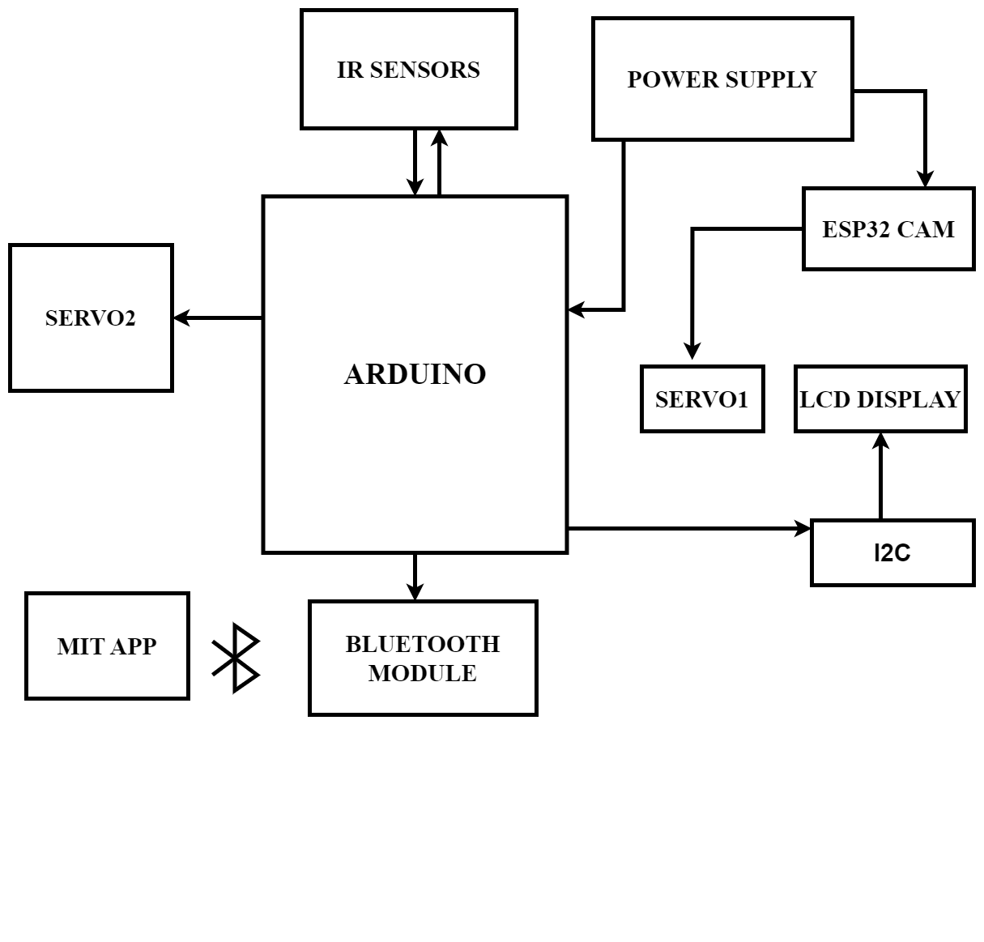

Figure 4.1: Block diagram of the system

# CHAPTER 5

# METHODOLOGY

## 5.1 Flowchart

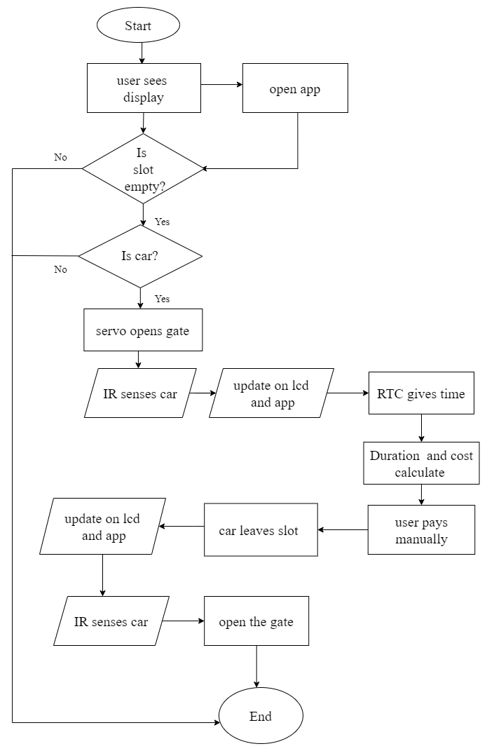

Figure 5.1 Flowchart of the system

## 

## 5.2 Working Principle

In this project of our Car Parking System. we have ESP 32 CAM as the central controller, IR sensors, servo motor, lithium-ion battery, Arduino uno and we have also created a separate app for the public access of the available slots.

Hence any object near is detected by ESP 32 CAM. Now, we use an algorithm whereby the servo motor at entry is rotated to let the vehicle in only when the IR sensors at the parking lot detects there is no vehicle in the parking lot. Also, the servo motor at the exit barrier is rotated by the sensor at exit senses the car.

|  |
| --- |
| **IR sensor** |

**Parking slot**

**Barrier**

**Servo Motor**

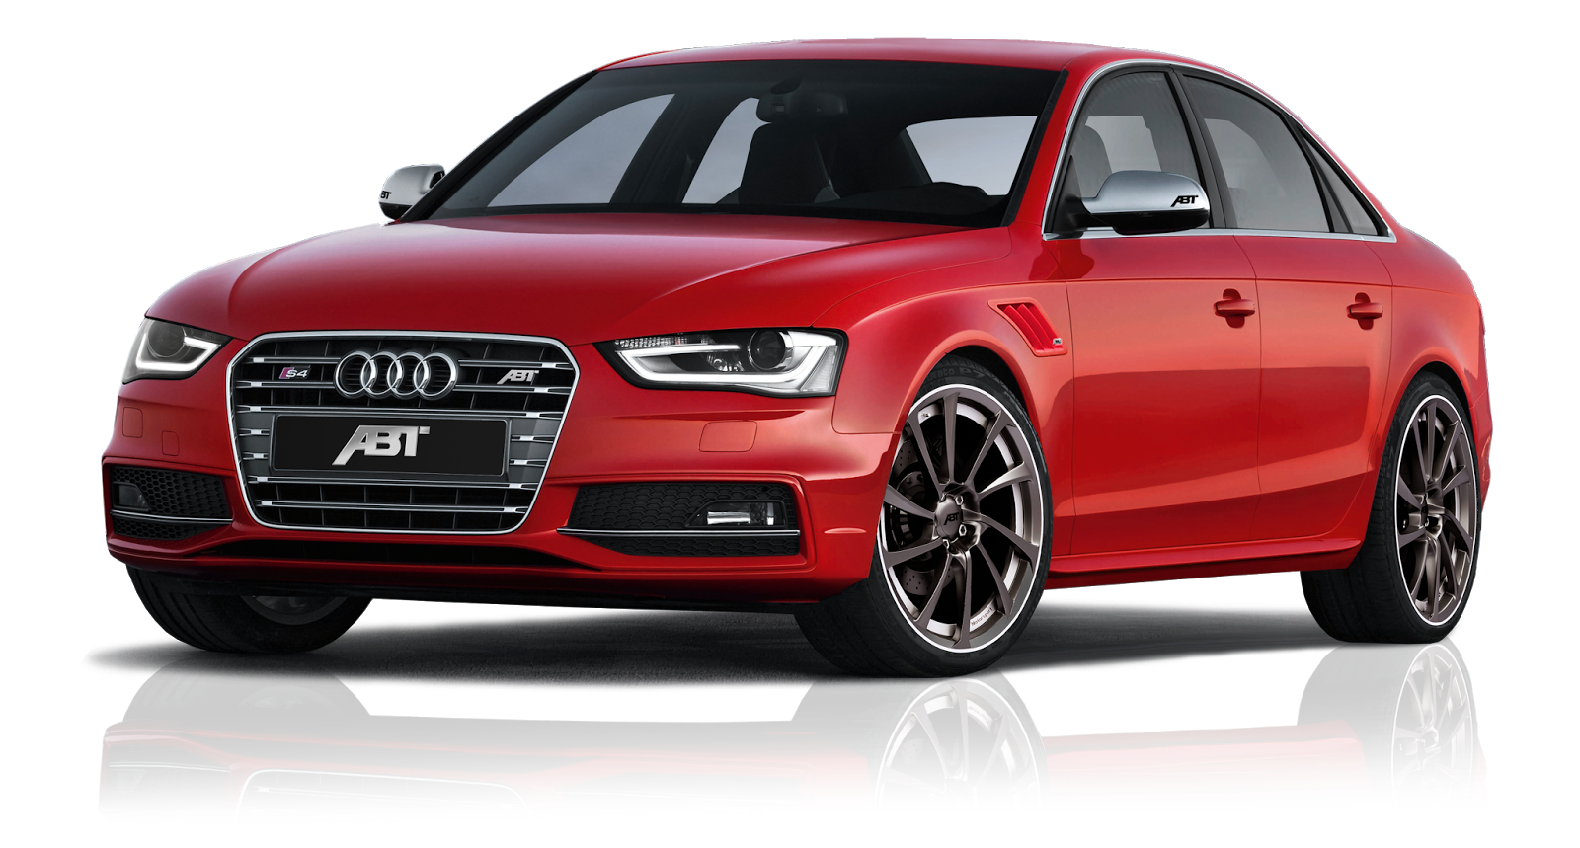

**ESP32CAM**

**Entry**

Figure 5.2.1: Barrier rotates for parking not occupied after cam detects car

### 

### 5.2.1 Car Entering Module

The IR sensors in the parking lot detects whether there is a vehicle or not and based on detection of the vehicle, if the slot is vacant the barrier is automated by the ESP32CAM.

### 5.2.2 Car Exiting Module

The servo motor at the exit barrier is rotated by the Arduino uno after the IR sensor detects the car at the exit section.

### 5.2.3 Working of Servo Motor

Servo motors are controlled via a pulse width modulated (PWM) signal. Servo motors usually have three wires: power, ground and the control signal. Most servos fixedly rotate between 0° and 180° - starting and ending at fixed points relative to the motor.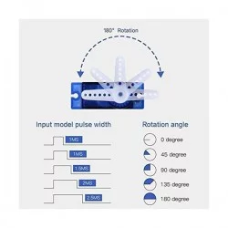

Figure 5.2.3: PWM pulse for servo rotation

Source: [61zV4aGXsOL._AC_UF350,350_QL80_.jpg (350×350) (media-amazon.com)](https://m.media-amazon.com/images/I/61zV4aGXsOL._AC_UF350,350_QL80_.jpg)

They accept pulses within a fixed range commonly between 500 and 2500 us as shown in Figure 5.2.3. To put it all together, say we send a 500us width pulse to a servo accepting pulses between 500us and 2500us. The servo will rotate its arm to the 0° position in response - no matter which position the arm was in before. It will respond with appropriate increments when the pulse width is increased up until 2500us, then it will stop moving. When the servo is receiving signals continuously, it will apply force to attempt to stay in the position that is being signaled. When the servo is unpowered and sends no signals, it won’t actively try to restore position. Manually moving the servo arm is possible when unpowered, but it should not be done as it can damage the servo.

# CHAPTER 6

# RESULT AND ANALYSIS

## 6.1 RESULT

The automatic car parking system successfully demonstrated the functionality of the parking system using ESP32 CAM along with other sensors like Infrared (IR) Sensors, accurately detecting car in the entry section and displaying the parking slots in the LCD display screen and also in the mobile application of the system.

In the system, the car detection was done by ESP32 CAM using the SSD (Single Shot Multibox Detector) and the occupancy of the parking slots is detected by the Infrared (IR) Sensors. Then the information about the parking slots was displayed in the entry section of the system with the help of LCD display and also in the app. So, car drivers can see whether there are free parking slots or not.

Also, with the use of RTC (Real Time Clock), we were able to calculate the time of the individual slots. And finally with calculation of the time, the amount of money for each slot which has to be paid is calculated. And in the exit section there is an IR to open the barrier.

## 6.2 ANALYSIS

Figure 6.2.1 vacant slots

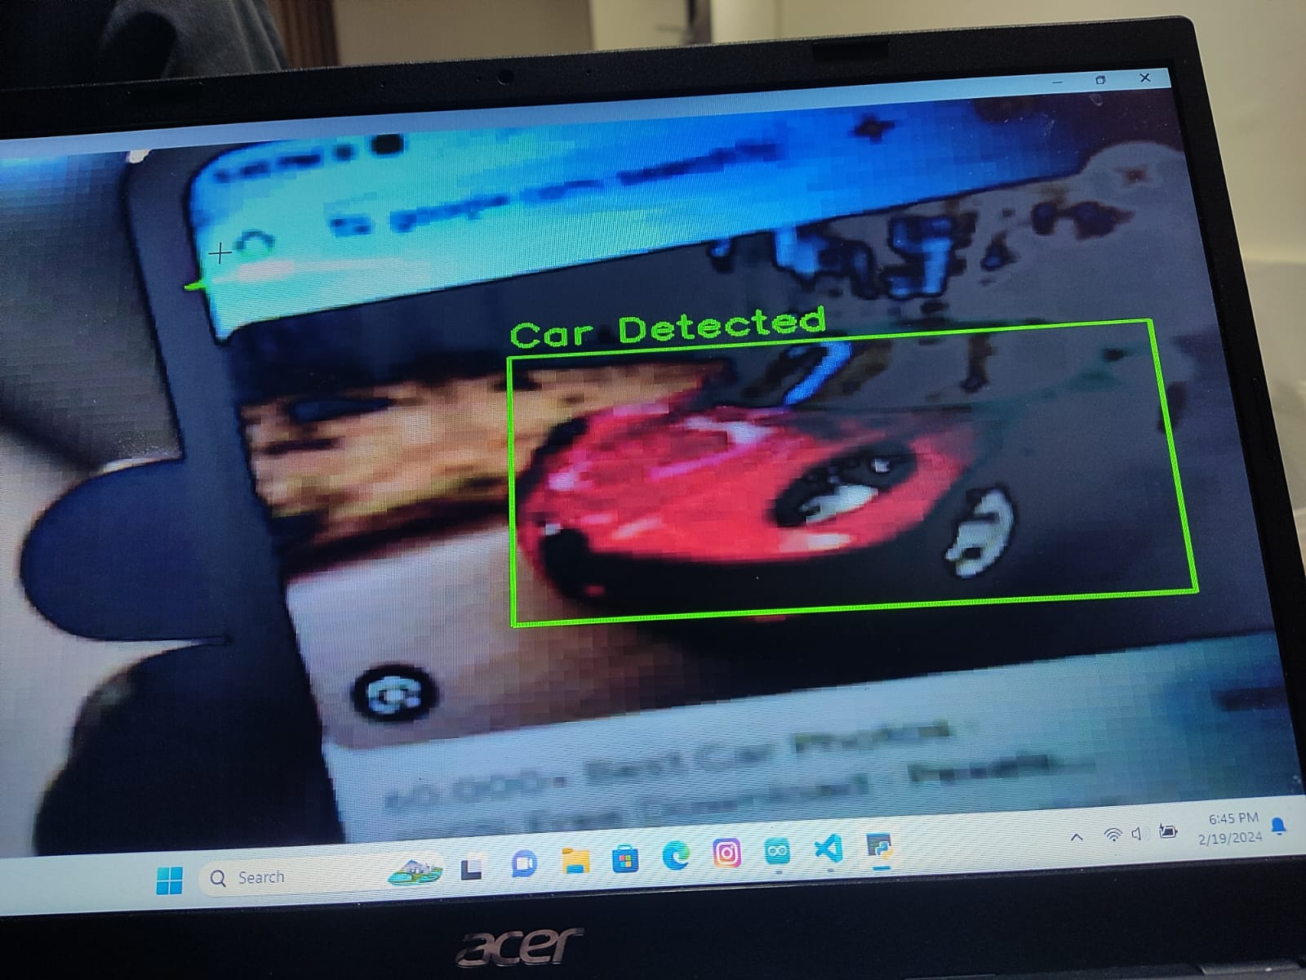

Figure 6.2.2 Car detection through the ESP32CAM

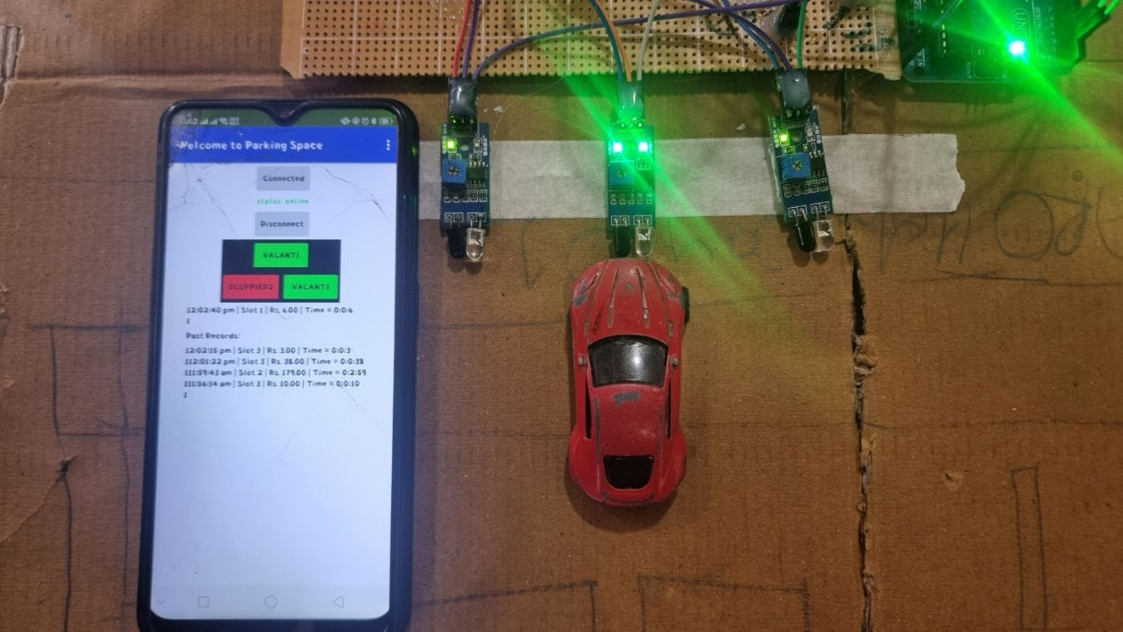

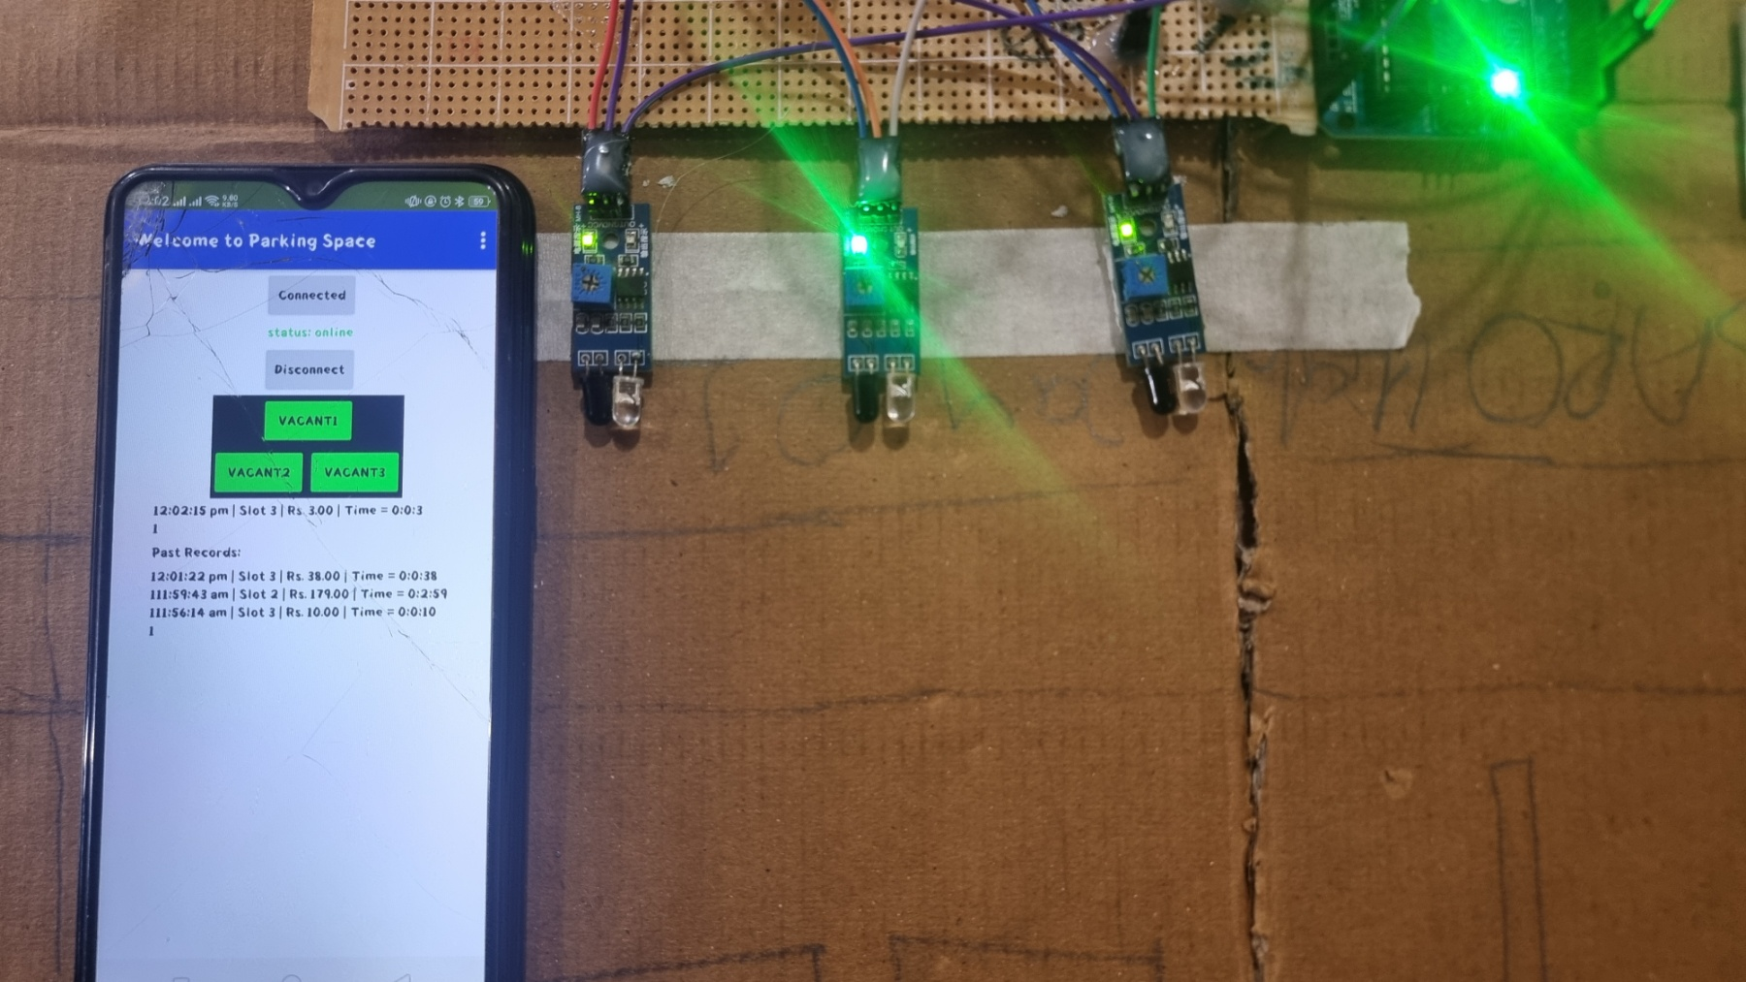Figure 6.2.3 slot 2 occupied by car

Figure 6.2.4 time and cost display of the system

# CHAPTER 7

# CONCLUSION, LIMITATIONS AND FUTURE ENHANCEMENT

## 7.1 CONCLUSION

In summary, the automatic car parking system marks a significant advancement in the field of parking management. The integration of various components, including ESP32 Cam for car detection, infrared sensors (IR) for the parking slots, also the use of servo motors at entry and exit section. Finally, the use of RTC to calculate time and duration along with relative cost. This integration of these components has resulted in an efficient management of the parking system.

Also, we have created a mobile application of our system using which we can get the information related to our parking system. Through meticulous design and testing, our system meets the highest standard of functionality and reliability.

The user experience was a primary consideration throughout the development process with a focus of providing users a reliable and automated parking system. The inclusion of the lcd display at the entry section ensures the information will be provided to the users. This project is a prototype of the parking system which in future will be enhanced and its significance marks the initiation of the automated vehicle system throughout the world.

## 7.2 LIMITATIONS

* Limited processing power of ESP32CAM
* Payment manually
* Cam detects the car only not the number plate
* App connected via Bluetooth only

## 7.3 FUTURE ENHANCEMENTS

* Payment through the app
* Number plate recognition for better parking information
* Self-parking system
* Implementation of vehicle to infrastructure communication.

# REFERENCES

[1] H. Chaudhary, P. Bansal, and B. Valarmathi, "Advanced CAR parking system using Arduino," proc. 4th International Conference on Advanced Computing and Communication Systems (ICACCS), 2017.

[2] P. Chippalkatti, G. Kadam, and V. Ichake, "I-SPARK: IoT based smart parking system," proc. 2018 International Conference on Advances in Communication and Computing Technology (ICACCT), 2018.

[3] F. Mohammadi, G.-A. Nazri, and M. Saif, "A real-time cloud-based intelligent car parking system for smart cities," in proc. IEEE 2nd International Conference on Information Communication and Signal Processing (ICICSP), 2019.

[4] J. Lee, H. Kim, and K. Y. Lee, "Design and implementation of an intelligent parking system using machine learning," in Proceedings of the 2020 IEEE International Conference on Big Data and Smart Computing (BigComp), 2020, pp. 405-408.

[5] M. A. F. Aljoumani, N. Z. Jhanjhi, and M. Humayun, "Smart parking system for Internet of Things using RFID and mobile application," in Proceedings of the 2020 International Conference on Computer and Information Sciences (ICCIS), 2020, pp. 1-6.

[6] S. Kumar and A. Malani, "Blockchain-based secure and efficient smart parking system using IoT," in Proceedings of the 2021 International Conference on Intelligent Technologies (CONIT), 2021, pp. 1-5.

[7] Z. Xiao, W. Li, and D. Zhang, "Deep learning-based image recognition system for car parking management," in Proceedings of the 2019 11th International Conference on Machine Learning and Computing (ICMLC), 2019, pp. 265-269.

[8] A. B. M. S. Ali, M. S. Hossain, and M. F. Mridha, "Automated vehicle identification and parking slot allocation for smart parking system," in Proceedings of the 2019 International Conference on Robotics, Electrical and Signal Processing Techniques (ICREST), 2019, pp. 590-595.