**Computer** **Networks**

**Revision** **of** **Content**

**Task** **1;**

**Rasikh** **Ali**

*Lab* *9*

*Lab* *9* *-* *Task*

Different Between “Sub-Netting & Super-Netting”, with Example (draw structure in cisco)

**Answer:**

**Subnetting** and **supernetting** are two concepts used in network addressing, but they serve different purposes and are applied in different situations. Here’s the difference between them:

### 1. ****Subnetting****

Subnetting is the process of dividing a larger network into smaller, more manageable sub-networks (subnets). It involves borrowing bits from the host part of the IP address to create multiple subnets within the original network. This helps improve network performance, security, and address management.

#### Example:

Let's say you have a **Class C** network:  
192.168.1.0 /24

* You want to create 4 subnets. To do this, you need to borrow **2 bits** (since 2^2 = 4).
* The new subnet mask would be **/26** (255.255.255.192), and the network is divided as follows:

1. **Subnet 1:** 192.168.1.0 - 192.168.1.63
2. **Subnet 2:** 192.168.1.64 - 192.168.1.127
3. **Subnet 3:** 192.168.1.128 - 192.168.1.191
4. **Subnet 4:** 192.168.1.192 - 192.168.1.255

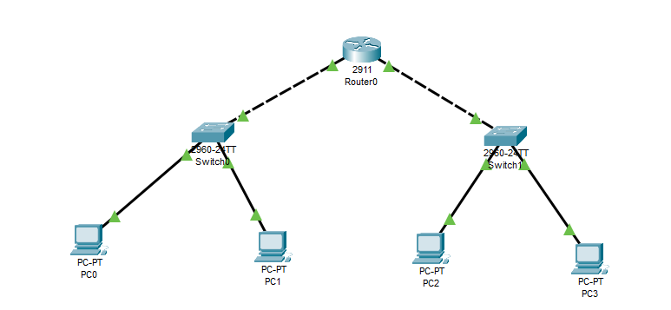**Structure**

### 2. ****Supernetting****

Supernetting is the opposite of subnetting. It involves combining several smaller subnets into a larger network. It is typically used to reduce the size of routing tables by merging multiple networks into a single address space. This is often done by borrowing bits from the network portion and reducing the number of bits for the subnet portion.

#### Example:

Let’s say you have these three **Class C** networks:

1. 192.168.1.0 /24
2. 192.168.2.0 /24
3. 192.168.3.0 /24

You want to combine them into a **single network** using supernetting. To combine these three networks, you borrow **2 bits** from the host part of each network, which results in a **/22** network mask.

* The supernet would be: **192.168.0.0 /22**
* This supernet includes all the addresses from 192.168.0.0 to 192.168.3.255.

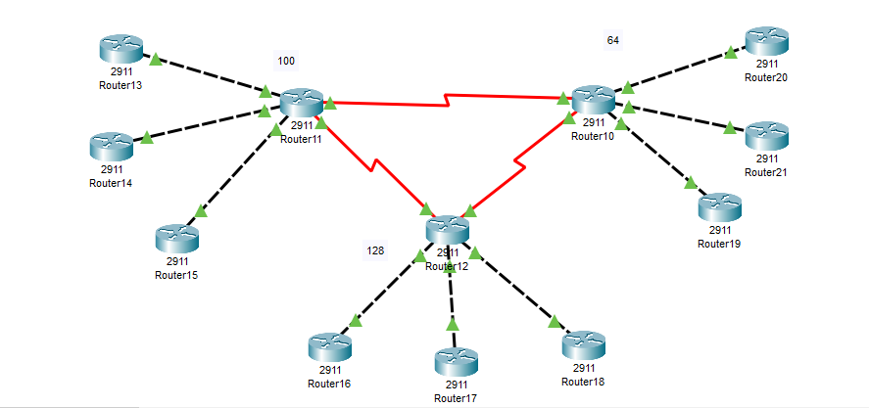**Layout**

### Key Differences:

* **Subnetting**: Divides a larger network into smaller sub-networks.
* **Supernetting**: Combines smaller networks into a larger network to optimize routing.

Both techniques help optimize the use of IP addresses, but they are applied based on the need for smaller sub-networks or combining multiple networks into a larger block.