

**Computer Network Project Report**

**Semester End Report Writing**

**Submitted by:**

Dawood Ayub

SU92-BSSEM-F22-170

**Submitted to:**

MR. RASIKH ALI

Table of Contents:

Contents

Network Topology 3

IP Plan 5

IP Addressing 6

Static Routing 7

Dynamic Routing 7

PINGING 8

VLANs 10

DHCP: 12

DNS 13

WEB Server 14

NAT/PAT 15

ACL: 16

Iot Device 18

Conclusion 21

## Network Topology:

My network consists between 4 Routers.

LAN 1 consist of DHCP, DNS and WEB servers and 2 PC’s . NAT/PAT Applied on PC2. LAN 2 consists of 3 PCs in which ACL Applied.

LAN 3 consists of 2 PCs and a server and access point which wireless connect to Iot Device. LAN 4 consists of 3 PCs and 3 switch in which inter vlan routing performed.

All 4 LANs connect through dynamic and static routing both.

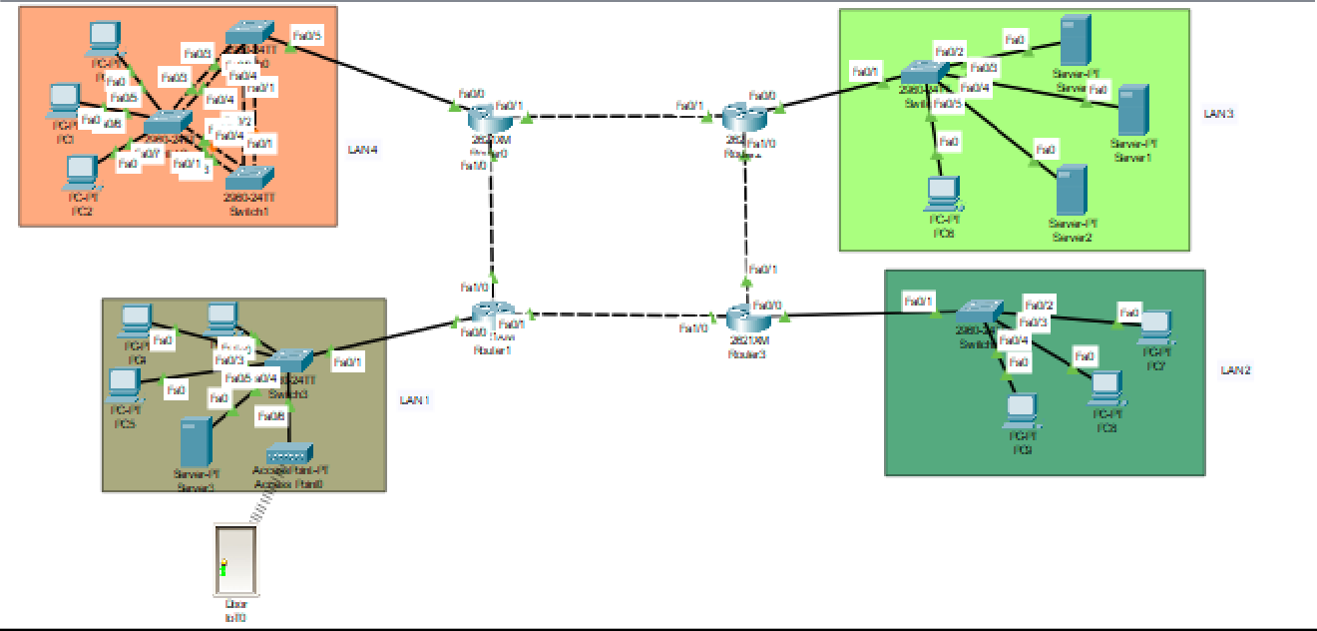

## IP Plan:

So according to our single digit roll no our designated class is C IP starting from 192.0.1.0. After subnetting my IP block consist of 8 IPs. So, here is my IP Plan according to subnetting.

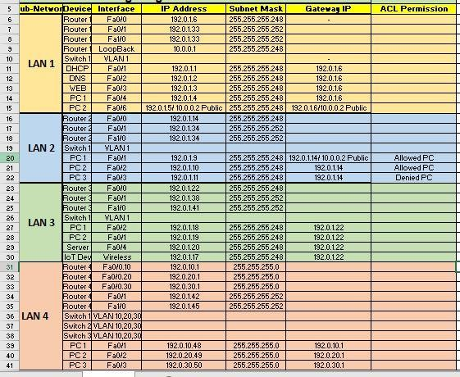

## IP Addressing:

After creating the topology, I assigned IPs to PCs, Routers and Servers.

**Example Configure IP to a PC:**

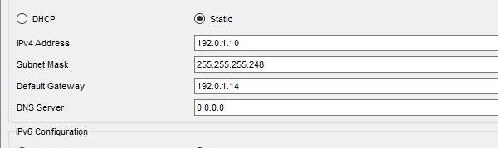

**Example Configure IP to a Server:**

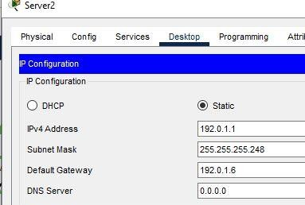

**Example Configure IP Gateway to Router:**

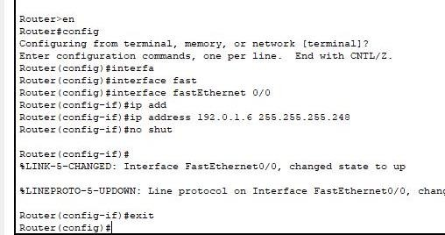

**Example Configure IP to Routers Other ports:**

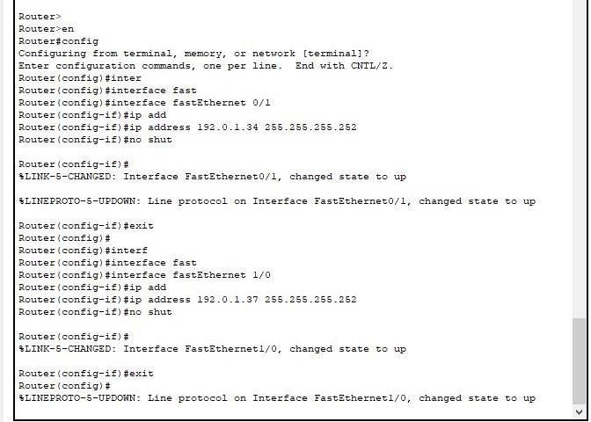

## Static Routing:

Syntax: Destination Network Address + Subnet Mask + Next Hop/Port IP.

**Example:**

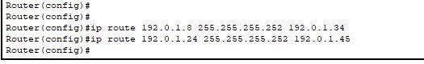

## Dynamic Routing:

Syntax: Source network Address + destination Port network Address.

**Example:**

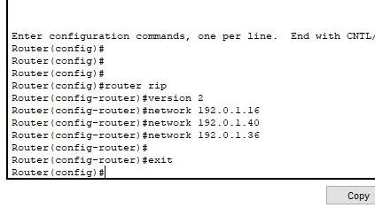

# PINGING:

After configure IPs addresses and applying routing we check communication between network by ping them.

**LAN 1 PC to Lan 3 PC:**

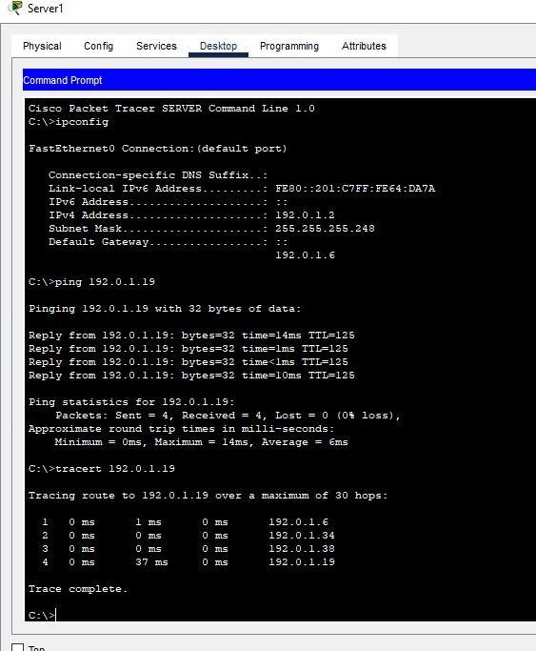

**LAN 2 PC to LAN 1 PC:**

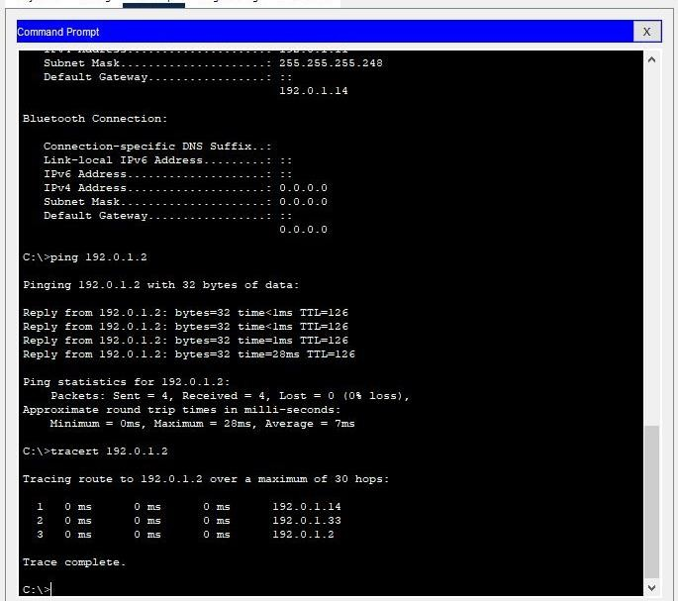

**LAN 2PC to LAN 3 PC:**

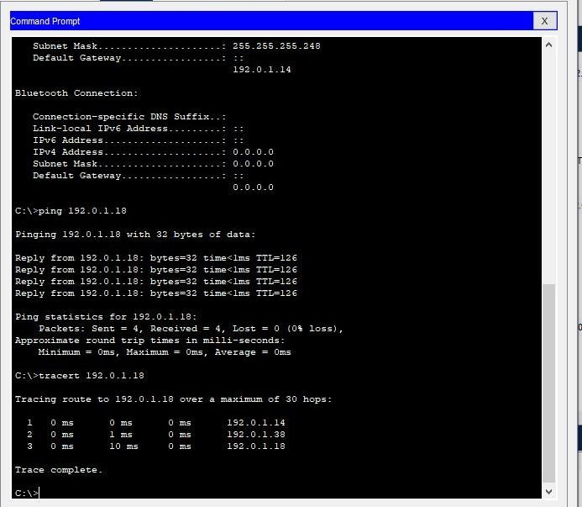

## VLANs:

For inter vlan connection first we gave IPs to our PCs. According to my plan, I gave IPs like

**PC 1 192.0.10.48**

**PC 2 192.0.20.49**

**PC 3 192.0.30.50**

**Topology:**

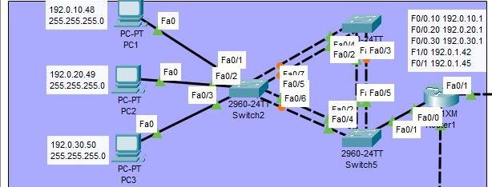

After giving IPs we configure all of our switches.

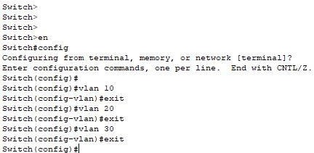

Then we have to give trunk mode to the ports of switches connected through each other and router.

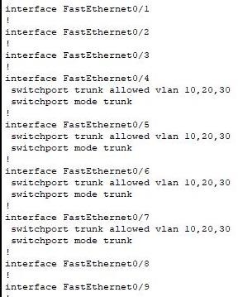

After giving trunk mode to switches ports we have to configure router ports.

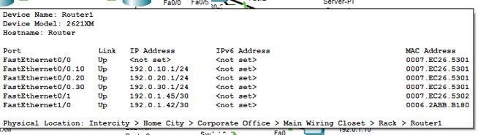

After configuring router we gave access mode to our ports of PCs which are connected to a switch.

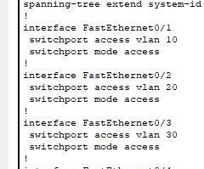

After all these steps we now ping our PCs.

**Pinging PC 1 to PC 3:**

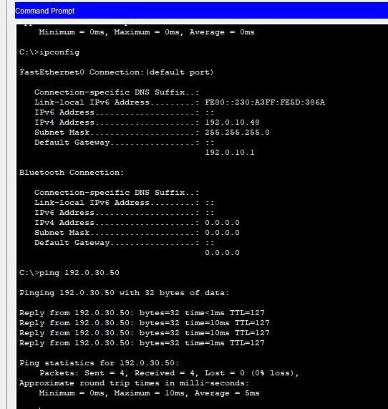

# DHCP:

To apply DHCP IPs we first go to our DHCP server and turned on DHCP service and Turned the other Services off. Then we add our LAN network in our DHCP server by giving them max number of devices, starting IP, DNS Server IP, Subnet Mask etc.

**Result:**

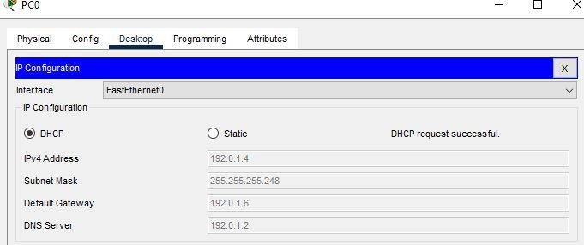

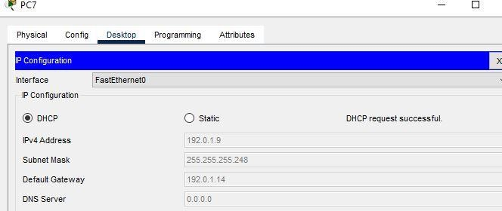

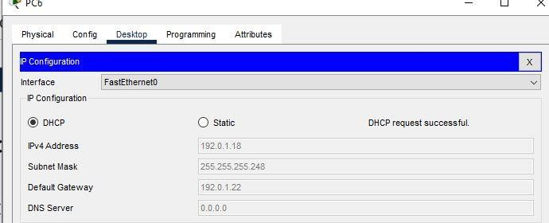

# DNS:

For applying DNS, first go to your DNS server than turned on DNS service and tuned the others off. Give your DNS name of your choice like I Gave **su92-bssem-170@superior.edu.pk**. Give the IP address of your web server and then press the add button.

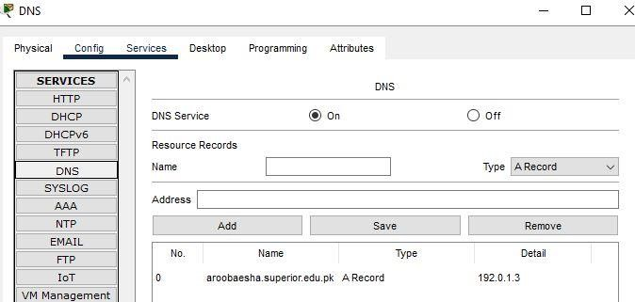

## WEB Server:

First go to your web server and turned on http service and turned the other service off. Then go to index.html file and edit the file as you want.

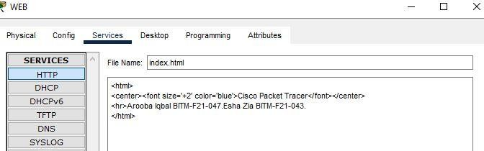

After save the changings go to the web browser of any PC and write your DNS Name in URL

# NAT/PAT:

In NAT/PAT we actually convert our private IP to a public IP.

IN my LAN 1, PC 2 I assigned them a private IP of 10.0.0.2. and I ping this Public IP from LAN 2 PC.

Here is how I applied NAT/PAT.

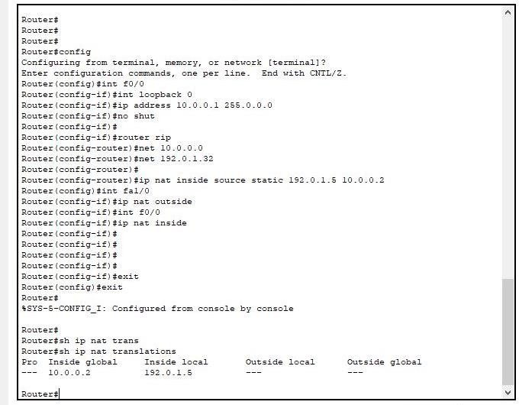

**Result:**

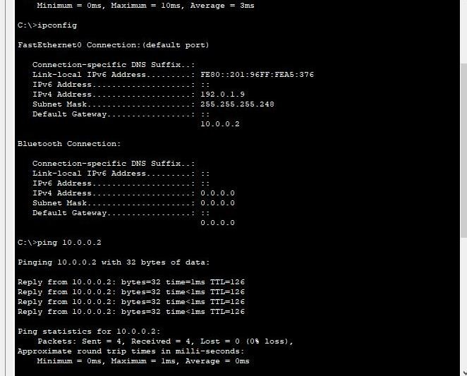

# ACL:

To apply ACL we first have to select our denied PC and Allow PC. In LAN 2, I assigned my 1 PC denied access and other two permit access by doing this configuration called ACL by number.

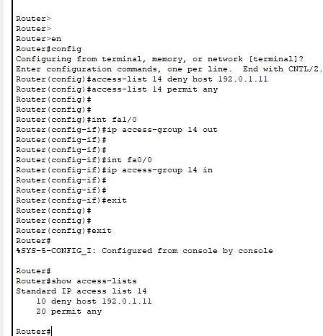

**Allowed PC Ping:**

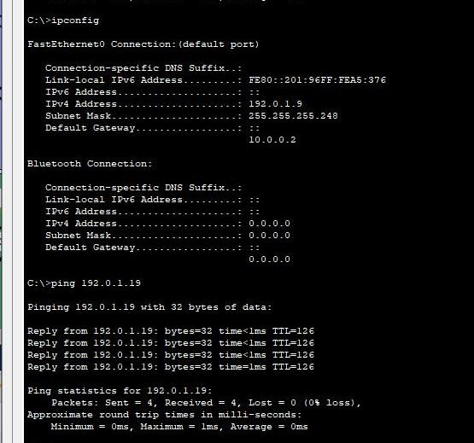

**Denied PC Ping:**

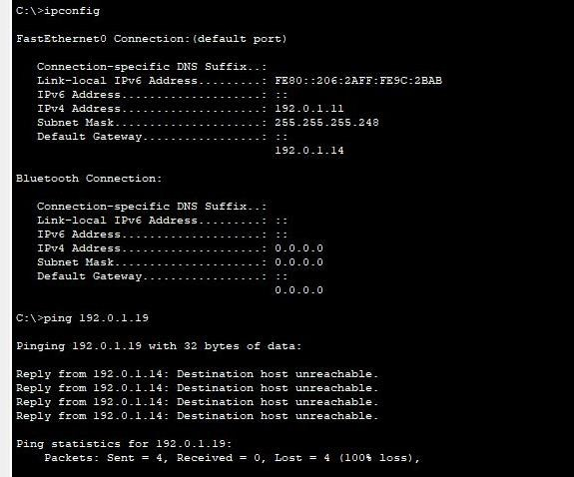

## Iot Device:

To connect a iot device and ensures communication first go to server and gave an SSID according to your choice like I gave SSID of “HOME”.

After giving SSID to server I gave the same SSID to Iot Device and Gave both server and Iot Device IP addresses and gateway.

**Server configuration:**

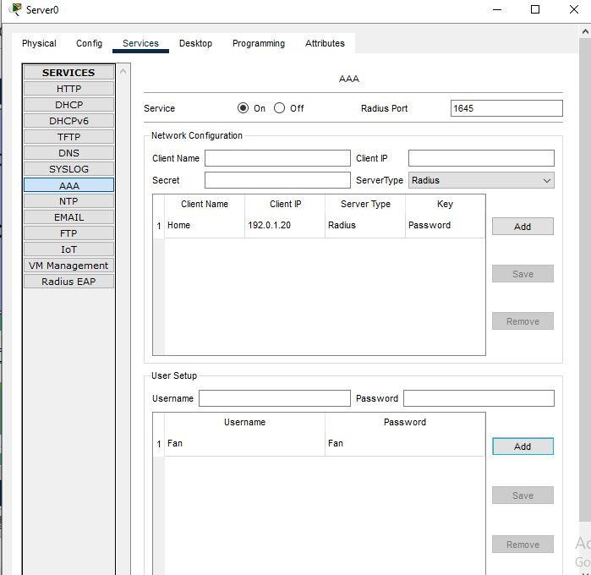

After configure my server I register my server on the browser.

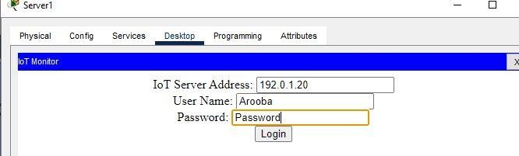

After register my server, I configure my Iot Device and connect my Iot device to the browser.

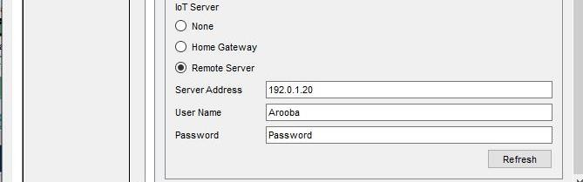

After connect my Iot server just go to any PC in your LAN and on desktop, click on iot monitor tab. Enter your server id, username and password.

After successful login, it showed your Iot device controls.

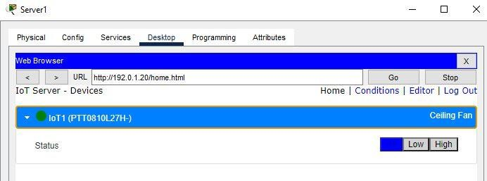

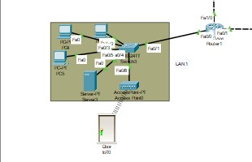**Result:**

## Conclusion:

This Project covered all the important aspects of computer networking. We tried our best to implement all the given tasks and its working according to the requirements. During this completion, me and my member faced lots of problems and tricky errors which we solved by our teacher guidance and from youtube videos. This project implement dynamic, static routing with DHCP,DNS,WEB server, NAT/Pat, ACL and Iot device configuration.