**3.12**

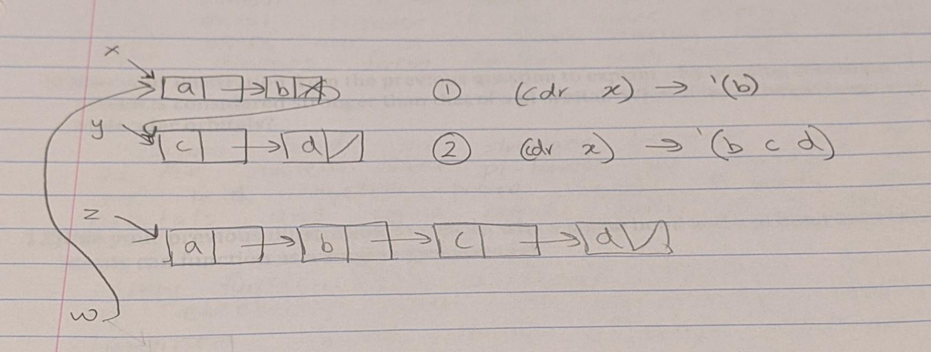

**3.15**

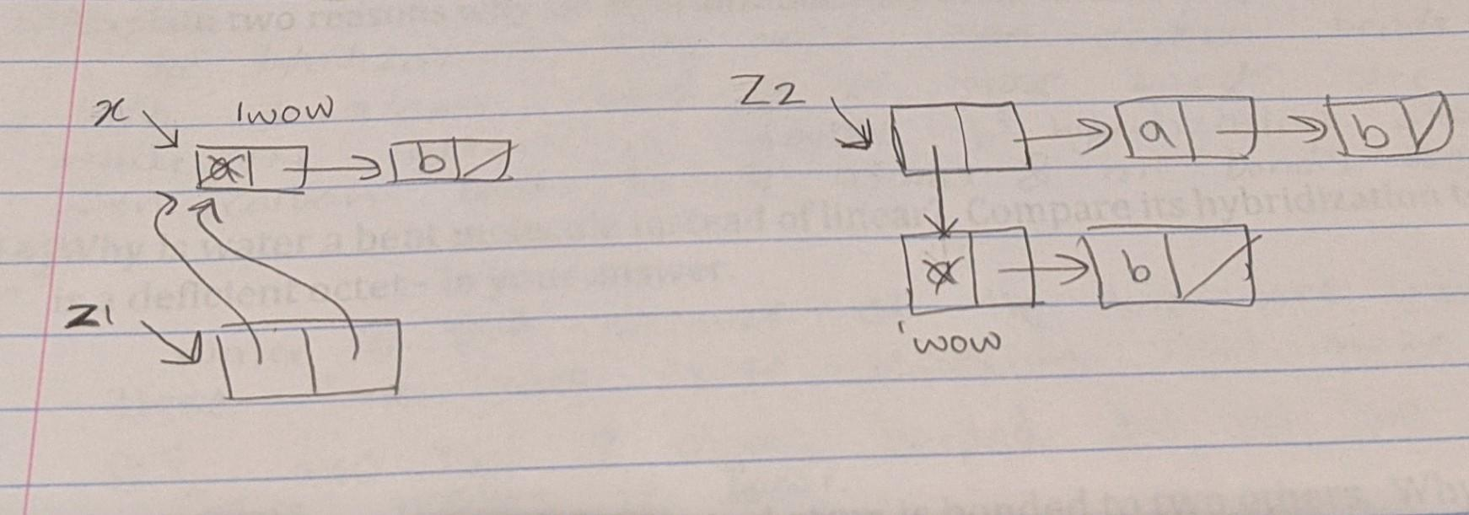

**3.16**

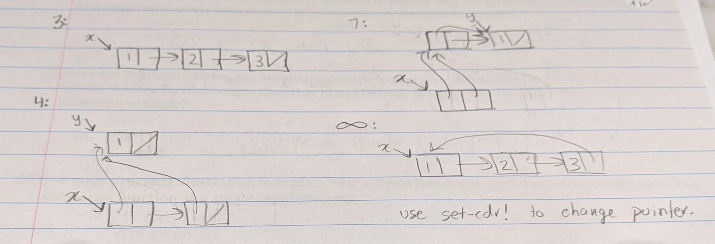

**3.22**

(define (make-queue)

(let ((front-ptr '())

(rear-ptr '()))

(define (front-queue)

(if (null? front-ptr)

'EMPTY

(car front-ptr)))

(define (rear-queue)

(if (null? front-ptr)

'EMPTY

(car rear-ptr)))

(define (insert-queue! item)

(let ((new-pair (cons item '())))

(cond ((null? front-ptr)

(set! front-ptr new-pair)

(set! rear-ptr new-pair))

(else

(set-cdr! rear-ptr new-pair)

(set! rear-ptr new-pair)))))

(define (delete-queue!)

(cond ((null? front-ptr)

'(DELETE! called with an empty queue))

(else

(set! front-ptr (cdr front-ptr)))))

(define (dispatch m)

(cond ((eq? m 'insert) insert-queue!)

((eq? m 'delete) (delete-queue!))

((eq? m 'print) (print-queue))

((eq? m 'front) (front-queue))

((eq? m 'rear) (rear-queue))

(else

'(Error operator))))

dispatch))