**3.17**

(define (cp pair)

(let ((visited '()))

(define (visited? pair vl)

(cond ((null? vl) #f)

((eq? pair (car vl)) #t)

(else (visited? pair (cdr vl)))))

(define (cp2 pair)

(cond ((not (pair? pair)) 0)

((visited? pair visited) 0)

(else (set! visited (cons pair visited))

(+ (cp2 (car pair)) (cp2 (cdr pair)) 1))))

(cp2 pair)))

**3.20**

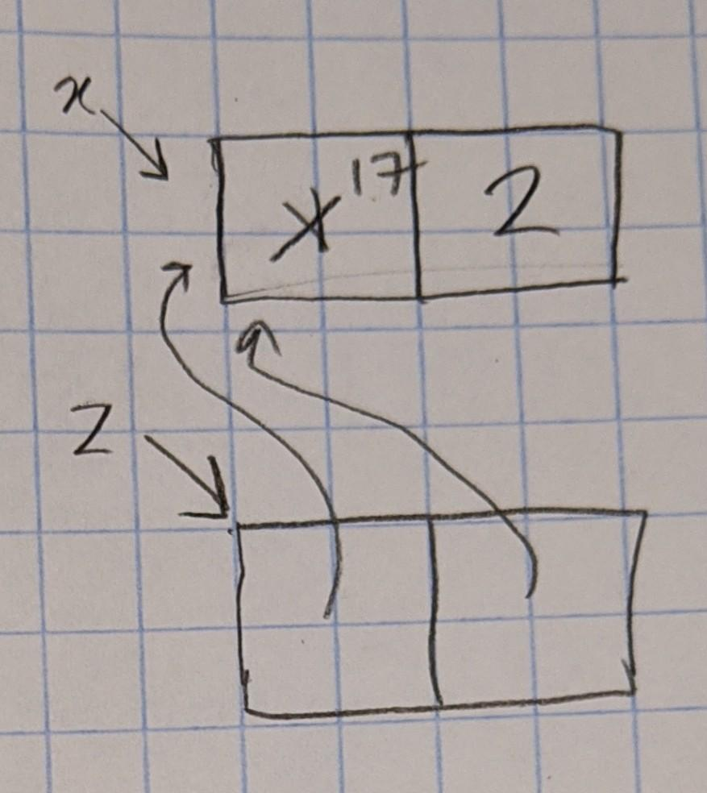

**3.25**

(define (make-table)

(define local-table (list '*table*))

(define (associ key records)

(cond ((null? records) #f)

((equal? key (caar records)) (car records))

(else (associ key (cdr records)))))

(define (lookup keys)

(cond ((null? keys) false)

((null? local-table) false)

((not (list? local-table)) false)

(else

(let ((subtable (assoc (car keys) (cdr local-table))))

(if subtable

(if (= (length keys) 1)

(cdr subtable)

(lookup (cdr keys)))

false)))))

(define (insert! keys value)

(let* ((key (car keys))

(subtable (assoc key (cdr local-table))))

(if subtable

(if (= (length keys) 1)

(set-cdr! subtable value)

(insert! (cdr keys) value))

(let ((new-subtable (cons (cons key '())

(cdr local-table))))

(set-cdr! local-table new-subtable)

(insert! keys value)))))

(define (dispatch m)

(cond ((eq? m 'lookup) lookup)

((eq? m 'insert!) insert!)

(else (error "Unknown operation -- TABLE" m))))

dispatch)

**3.27**

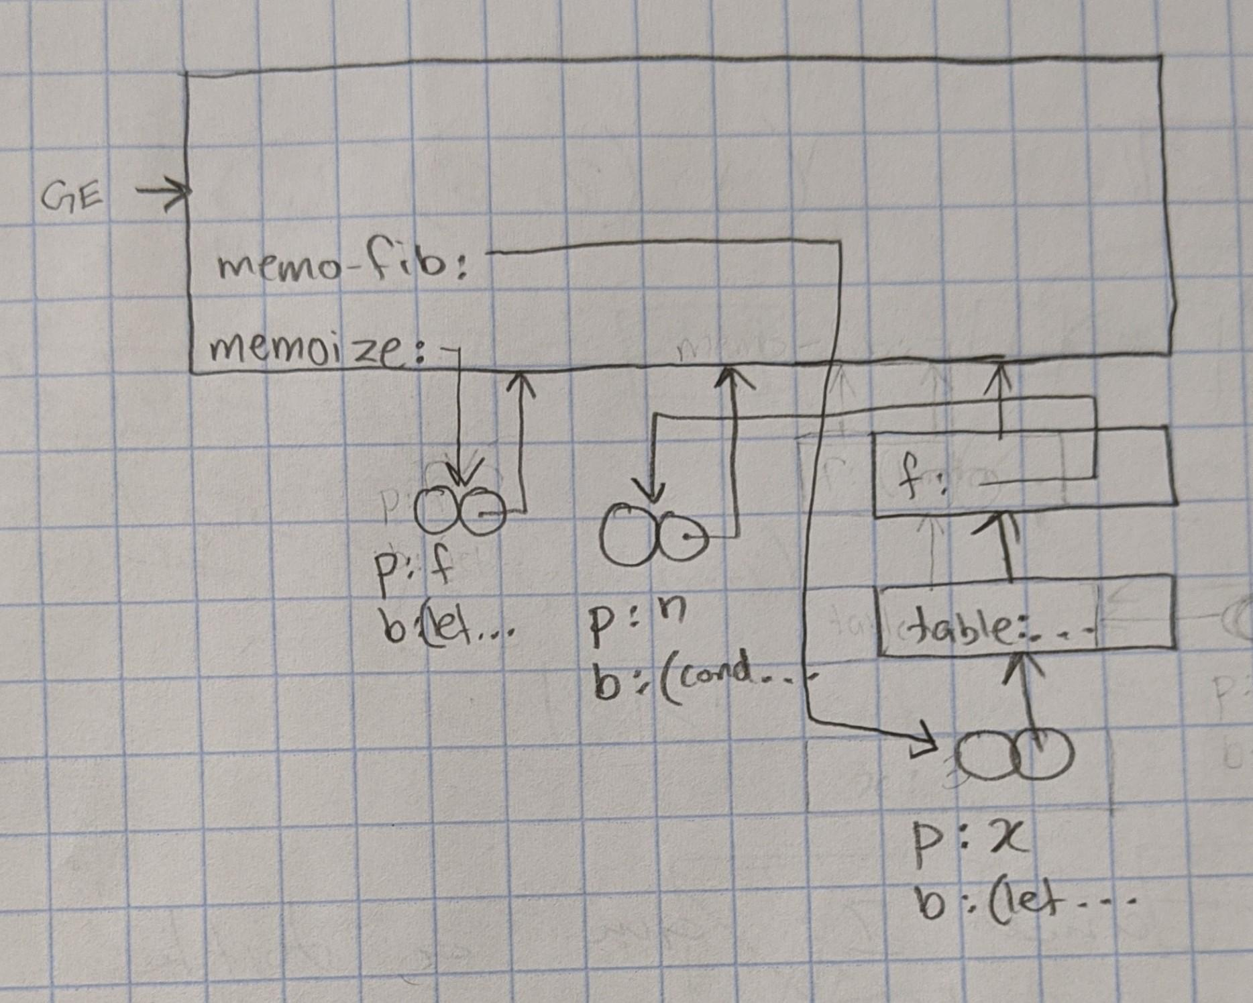

1. **Since memo-fib only calls fib of a certain value only once, the value will already be saved in the table. When the left branch is called, the table contains all the necessary fib calls that the right branch needs so it doesn’t do any more computation.**
2. **The scheme would not have worked because fib calls fib itself. Only the first call of fib will be recorded into the table. Intermediate calls won’t.**