NAME: KALAIARASI NG
REGNO : 23MIS0216
COURSE : AGILE DEVELOPMENT PROCESS AND DEVOPS LAB
FACULTY : KALAIVANI S
DATE : 18-12-2025
ASSIGNMENT 1
CASE STUDIES
Case Study 1: New Project Version Control Setup Scenario: You are assigned to develop a Library Management System. Before coding, your team decides to enable version control.

Tasks: - Create a project folder and open it in VS Code - Initialize a Git repository - Create a Python file and track it using Git - Commit the initial version


“kalai agile” folder created in desktop.

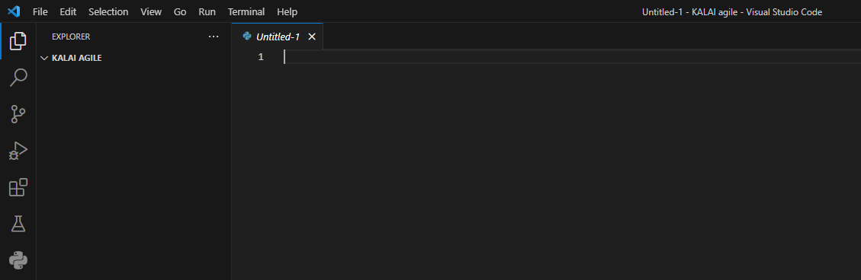
created folder opened in VS .
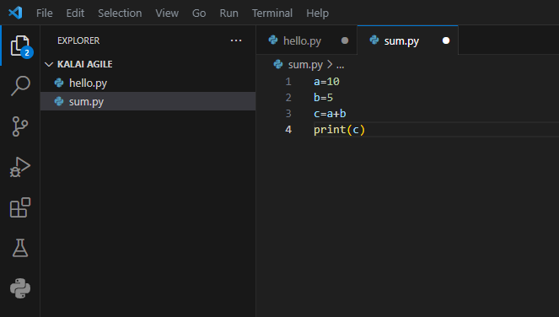
.

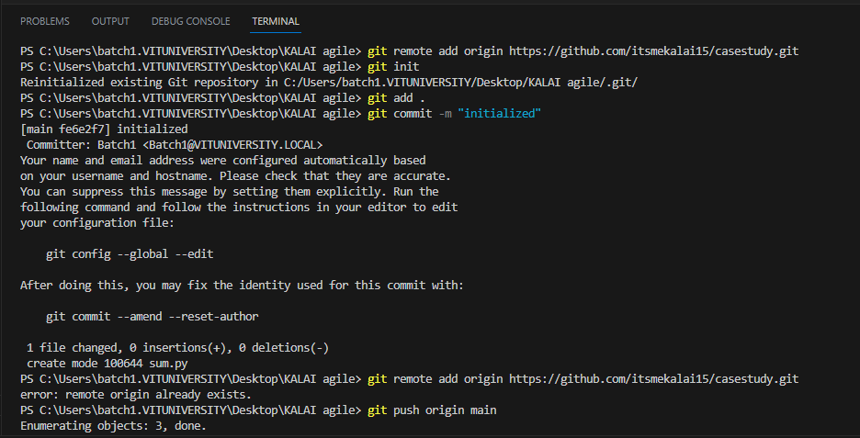
.

Case Study 2: Tracking Daily Code Changes Scenario: You are working on a Student Registration Module. You make small updates daily and need to record them.

Tasks: - Modify an existing file - Check file differences - Stage and commit changes - View commit history

