
CHARLES DARWIN UNIVERSITY
Faculty of Science and Technology
PRT681 | Software Project | Assessment 4
OraEarn
Handover document
Detail | Entry
Student | Dharma Bahadur Budhathoki
Student number | S395172
Role | Developer
Group | Group 4, Sydney
Unit | PRT681 Software Project
Date | 16 October 2026

Repository PRT_681_SYDNEY_GROUP-4
Jira board EARN project

Contents
Contents 1
Table of figures 2
1. What the submission asks for 3
2. URLs 3
3. Set-up instructions 4
3.1 Tools and versions 4
3.2 Libraries and versions 4
3.3 Architecture 5
3.4 Authentication and authorisation 7
3.5 Git download 9
3.6 Database setup 10
3.7 Entity Framework commands 11
3.8 Connection strings 11
3.9 How to run the applications 12
3.10 Dependency injection 14
3.11 Exception handling 14
3.12 Unit testing 14
3.13 Class diagram and data model 15
4. Adding a new feature 16
5. My contribution 19
References 24

Table of figures
Figure 1. EARN board, 16 October 2026. The work is in Done. DB on a card is me, Dharma Bahadur Budhathoki (S395172). 4
Figure 2. How the browser, the API, the database, and Aura sit next to each other. 5
Figure 3. The project folders. Each feature has its own place in the API and in the React app. 6
Figure 4. Login. The eye shows the password. The database stores the hash, not the typed password. 8
Figure 5. Registration. The account stays Pending until an admin approves it. 9
Figure 6. Public repository PRT_681_SYDNEY_GROUP-4. I am Dharma001 in the contributor list. 10
Figure 7. Git history for the work on this branch. One commit, one reason. 10
Figure 8. The database side of the API. Shifts point at a job. The job points at the user. 11
Figure 9. Swagger on port 5203. I try an endpoint here before I wire the React screen. 13
Figure 10. GET /health returns 200 when the API is up. 13
Figure 11. The 48-hour check runs in the API before a student shift is saved. 14
Figure 12. The tests I run before I call a feature finished. 15
Figure 13. The tables. A shift points at a job. The job points at the user. 16
Figure 14. Class diagram for the same model. 16
Figure 15. Jobs. The hourly rate on the job is what a shift gets paid. 18
Figure 16. Add-job dialog. The message under the field is the browser check. 18
Figure 17. The same jobs page on a narrow screen. The layout stacks. It does not hide the form. 19
Figure 18. Shift calendar. Hours and pay are calculated on the server. The visa bar is on this page. 20
Figure 19. Dashboard. Net, earnings, and expenses for the period I pick. 21
Figure 20. Expenses, with category and type. 21
Figure 21. Savings goals. A goal takes a share of leftover pay. 22
Figure 22. My timesheet, Dharma Bahadur Budhathoki, S395172. 22

1. What the submission asks for
Written by Dharma Bahadur Budhathoki (S395172)
Assessment 4 asks us to hand the project over. The marker wants the working app, and a write-up someone else can follow without ringing me. Three parts are required, and each part has to name who wrote it.
- URLs. The git repository, the Jira board, the learning documents, and each person's timesheet.
- Set-up instructions. Tools, libraries, architecture, sign-in, git, the database, Entity Framework, connection strings, first run, dependency injection, exceptions, tests, and the data model.
- Adding a new feature. From the Jira card, through the code, a new service, libraries, styles, validation, a test, and the commit.
Where I have put a screenshot, the caption under it is the comment. The list of those pictures is in the table of figures.

2. URLs
Written by Dharma Bahadur Budhathoki (S395172). The requirements files are Jenish's.
These are the links I actually use. The Jira one opens the EARN board, which is where my developer cards live.
What | Where
Jira board (EARN) | students-team-dh8zehye.atlassian.net — EARN board
Git repository | github.com/itsmekrishnaaaaaa/PRT_681_SYDNEY_GROUP-4
Requirements | oraEarn-WebApp/docs/OraEarn-Requirements.md
Project proposal | oraEarn-WebApp/docs/OraEarn-Project-Proposal.md
Normalisation (1NF to 3NF) | oraEarn-WebApp/docs/OraEarn-Normalization-1NF-to-3NF.md
ERD | oraEarn-WebApp/docs/OraEarn-ERD-3NF.drawio
My timesheet, weeks 4 to 12 | Dharma Bahadur Budhathoki (S395172), weeks 4-12.xlsx
Jenish timesheet | Jenish_Gurung_s395321/IndividualTimesheet_JenishGurung_s395321.xlsx
Krishna timesheet | Krishna_sapkota_S395795/Individual_timesheet_Krishna_S395795.xlsx
Group timesheet | Group4_Timesheet_PRT681.xlsx

Jira: https://students-team-dh8zehye.atlassian.net/jira/core/projects/EARN/board?filter=&groupBy=none
Git: https://github.com/itsmekrishnaaaaaa/PRT_681_SYDNEY_GROUP-4
When I am running it on my own machine, these are the addresses.
Service | Address
React app | http://localhost:5173
API and Swagger | http://localhost:5203/swagger
Health | http://localhost:5203/health
SignalR hub | http://localhost:5203/hubs/shifts
Aura, optional | http://localhost:8000

Once the API has seeded the demo data, I sign in as alice@oraearn.local with User123! when I want the student. Bob uses the same password and is a citizen, so the 48-hour rule does not apply to him. The admin is admin@oraearn.local with Admin123!.
The README at the top of the GitHub repository is the short version of this handover. It carries the same GitHub link, the same Jira link, the three run commands, and the demo sign-ins. My name on that page is Dharma Bahadur Budhathoki, student number S395172.
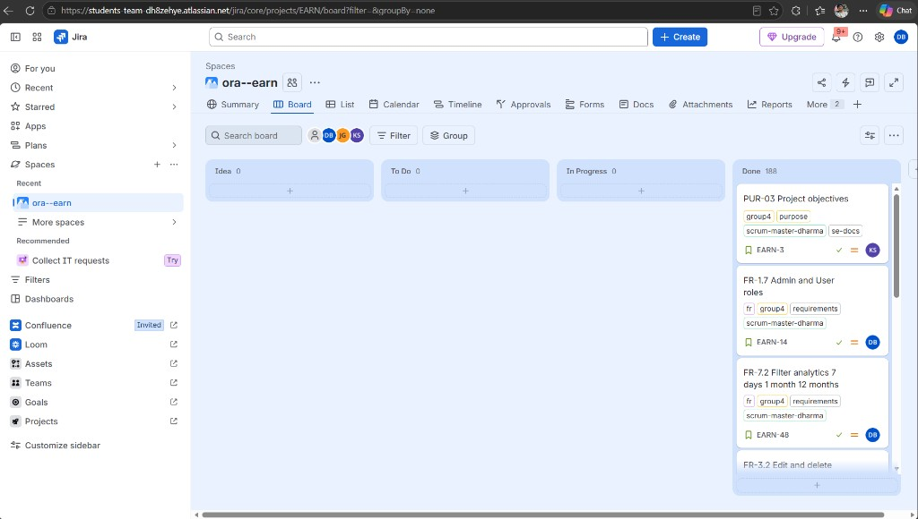
Figure 1. EARN board, 16 October 2026. The work is in Done. DB on a card is me, Dharma Bahadur Budhathoki (S395172).

3. Set-up instructions
I wrote this for a clean Windows laptop and PowerShell. The bits I touch every day are mine. Krishna's database steps and Suraj's data model are here too, so the next person is not stuck waiting on us.

3.1 Tools and versions
Written by Dharma Bahadur Budhathoki (S395172)
Install these first. If dotnet, node, or npm is missing, setup.ps1 stops and tells you.
Tool | Version | Used for
.NET SDK | 10 (net10.0) | API, Identity, Entity Framework
Node.js | 20 or newer | React app
PostgreSQL | 16 or newer, port 5432 | The only database
Python | 3.11 or newer | Aura. The rest of the app runs without it
Git | current | The repository above

dotnet --version
node --version
python --version

3.2 Libraries and versions
Written by Dharma Bahadur Budhathoki (S395172)
I copied these out of the project files so the versions are the ones we actually build with. Add a package with npm or dotnet add. Don't edit the lock file by hand.
API package | Version
Microsoft.AspNetCore.Authentication.JwtBearer | 10.0.11
Microsoft.AspNetCore.Identity.EntityFrameworkCore | 10.0.11
Microsoft.EntityFrameworkCore.Design | 10.0.11
Npgsql.EntityFrameworkCore.PostgreSQL | 10.0.3
Swashbuckle.AspNetCore | 8.1.4

Frontend package | Version
react, react-dom | 19.2
vite | 8.2
typescript | 6.0
react-router-dom | 7.18
axios | 1.19
@microsoft/signalr | 10.0
tailwindcss | 4.3

Tests use xUnit 2.9.3. Aura uses FastAPI 0.115 or newer, Uvicorn 0.32 or newer, and Pydantic 2.10 or newer.

3.3 Architecture
Written by Dharma Bahadur Budhathoki (S395172)
There are three programs. I did not glue them into one. The website only calls the API. The API talks to PostgreSQL, and it calls Aura if that Python process is running. If Aura is off, shifts, money, and the visa bar still work. The chat just says it could not get an answer.
Browser (React, port 5173)
-> ASP.NET Core API (port 5203) JWT, REST, SignalR
-> PostgreSQL
-> Aura, Python FastAPI (port 8000) optional
On the API, each feature has its own folder: Auth, Jobs, Shifts, Expenses, SavingsGoals, Analytics, Notifications, Admin, VisaCompliance, and AiAdvisor. The class, the DTOs, the service, and the controller sit together. Program.cs stays short. I register everything in ServiceCollectionExtensions.
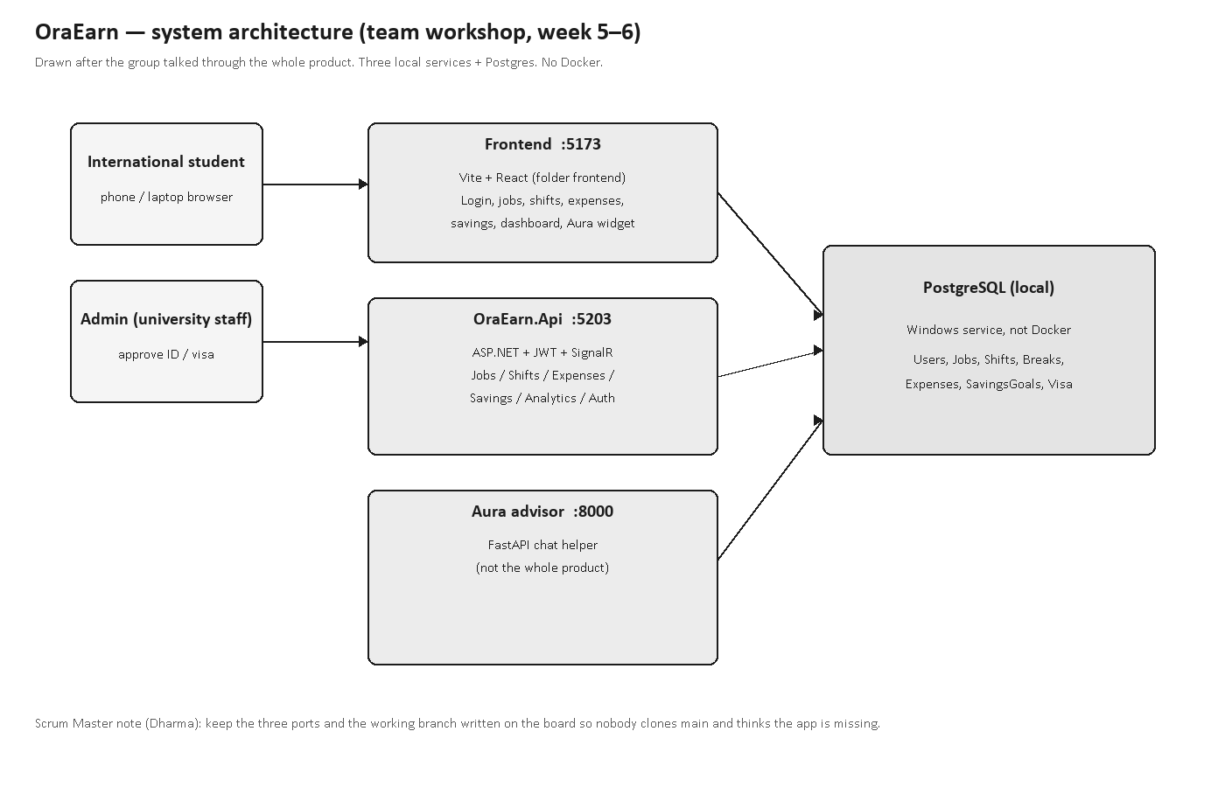
Figure 2. How the browser, the API, the database, and Aura sit next to each other.
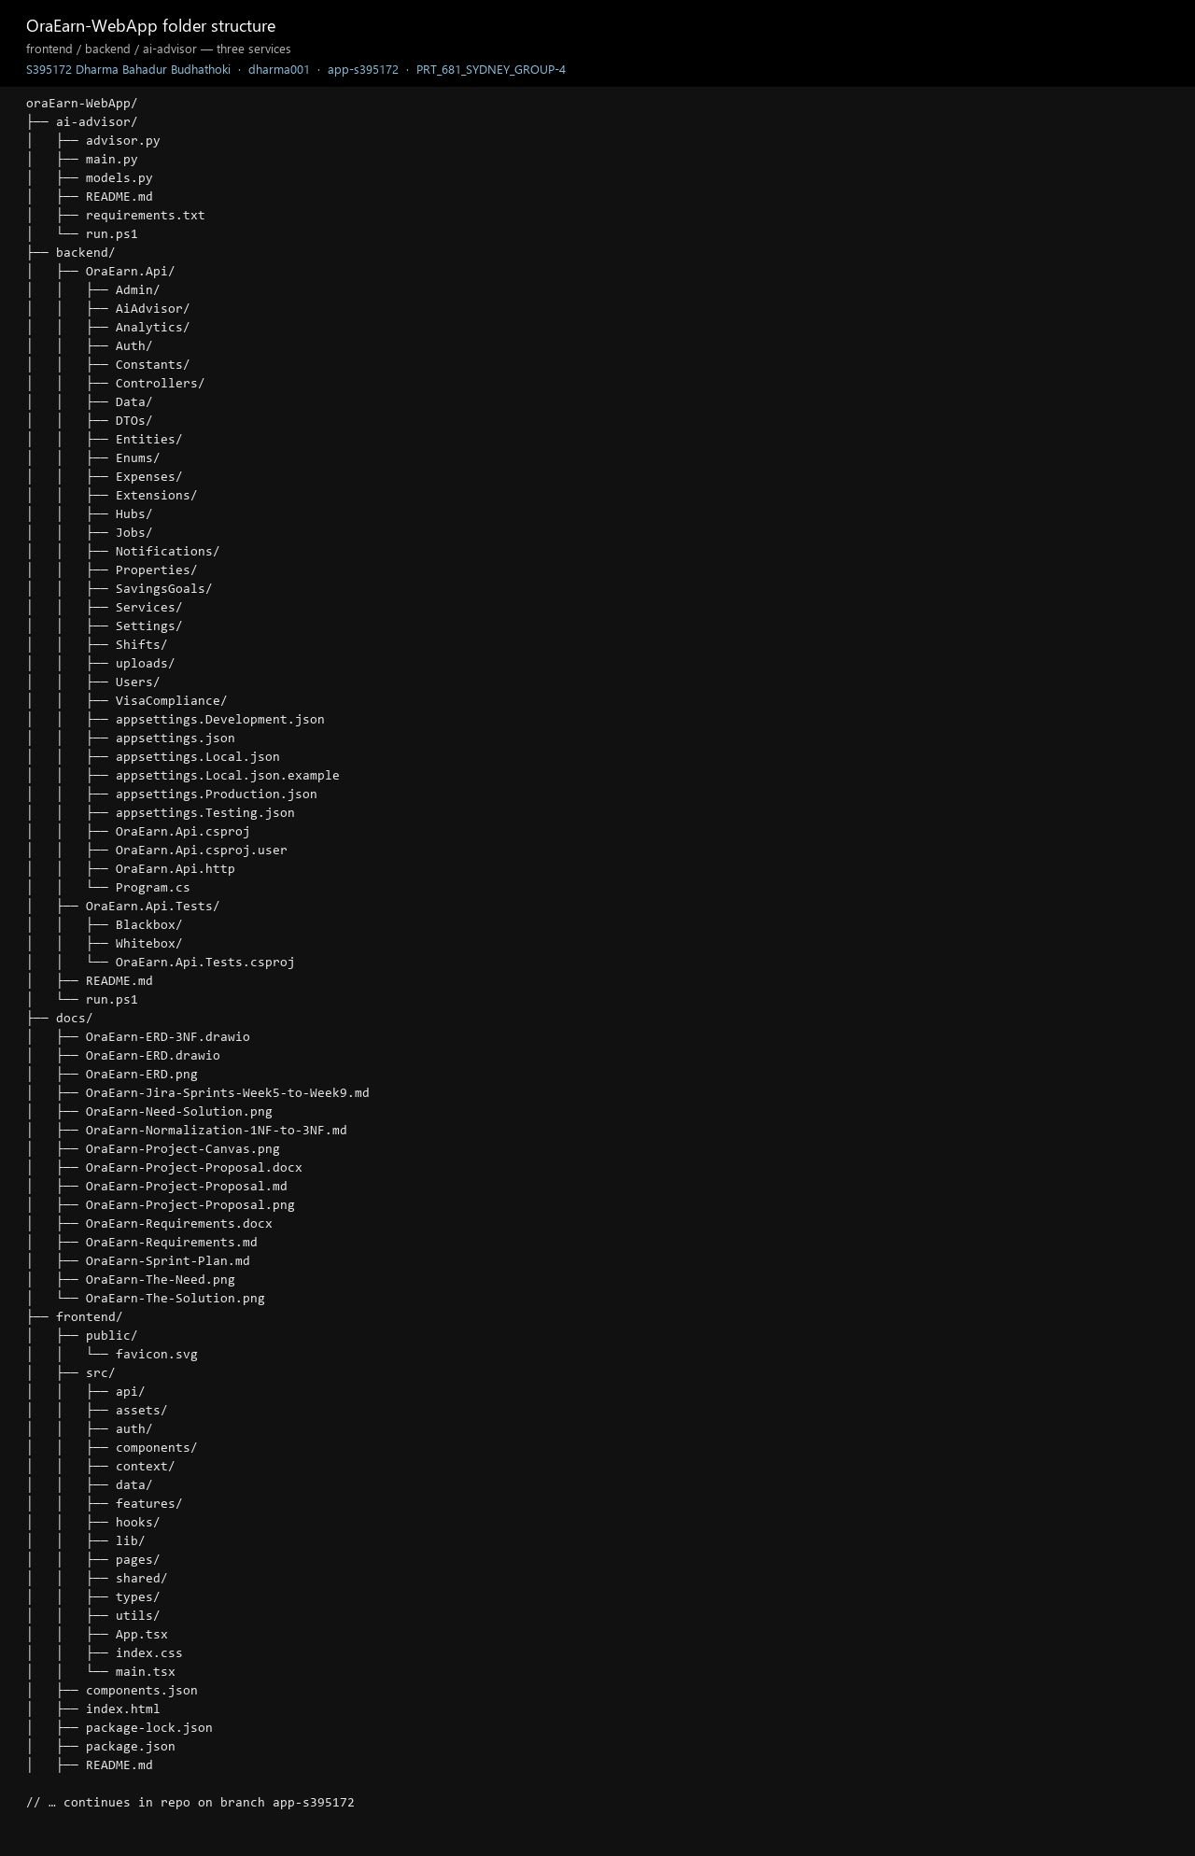
Figure 3. The project folders. Each feature has its own place in the API and in the React app.
On the website, each screen is under src/features. Sign-in is under src/auth. The axios client is src/shared/api/client.ts. The form checks are under src/shared/form-field. I put the routes in App.tsx.

3.4 Authentication and authorisation
Written by Dharma Bahadur Budhathoki (S395172)
Sign-in is who you are. The role is what you are allowed to do. I built both. Hiding a page in React is not the same as locking the API.
- Register is POST /api/auth/register. The form includes the visa file. I save the account as Pending. I don't give out a token until an admin approves it.
- Login is POST /api/auth/login. A good login returns an access token that lasts 15 minutes and a refresh token that lasts 7 days.
- The website stores both in localStorage under the key auth, and sends Authorization: Bearer on each call.
- If a call comes back 401, the client tries the refresh token once. Logout wipes the refresh token on the user row.
- Passwords go through ASP.NET Identity. I ask for 8 characters, an upper letter, a lower letter, and a digit. Five wrong tries lock the account for 15 minutes. The table stores PasswordHash. It never stores the password the person typed.
- The token must say issuer OraEarn and audience OraEarnClient, and the secret has to be at least 32 characters. SignalR reads the same token from the access_token query on /hubs, because the socket can't set the header.
Place | Rule
Almost every controller | [Authorize]. No token is 401.
AdminController | [Authorize(Roles = Admin)]. A student token is 403.
ProtectedRoute | A signed-out person goes to /login. An admin goes to /admin.
AdminRoute | A student goes back to /dashboard.
Services | Queries use the user id inside the token. One student cannot read another student's pay.

If I add a new endpoint, it still needs [Authorize]. Swagger will happily call anything the API leaves open.
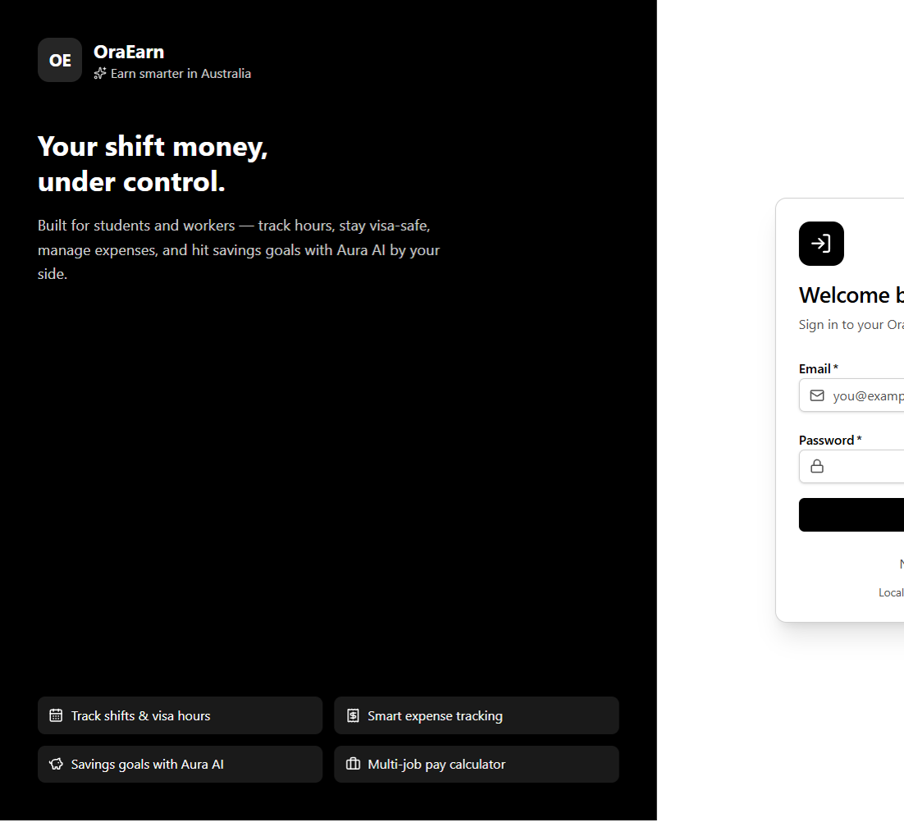
Figure 4. Login. The eye shows the password. The database stores the hash, not the typed password.
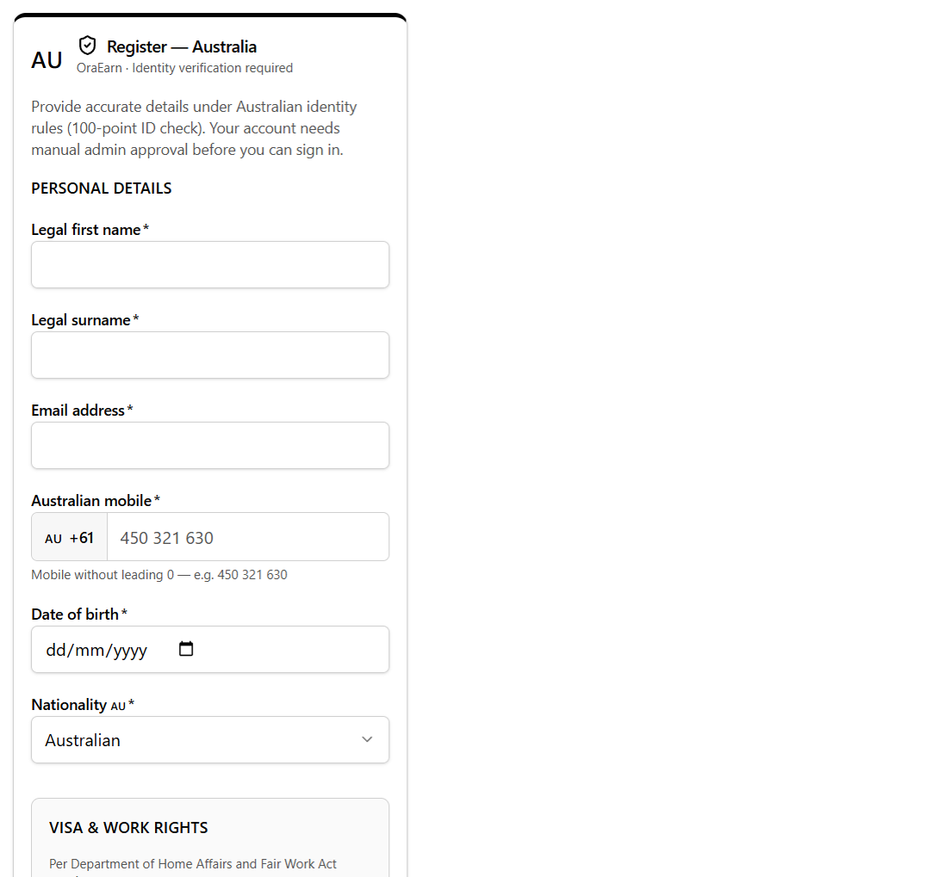
Figure 5. Registration. The account stays Pending until an admin approves it.

3.5 Git download
Written by Dharma Bahadur Budhathoki (S395172)
Clone it once, then make a branch. I don't commit straight to main.
git clone https://github.com/itsmekrishnaaaaaa/PRT_681_SYDNEY_GROUP-4
cd PRT_681_SYDNEY_GROUP-4
git checkout -b OE-<ticket>-short-name
The git root is the folder above oraEarn-WebApp. Open oraEarn-WebApp in the editor. Don't commit appsettings.Local.json, frontend/.env, node_modules, bin, obj, or the Python .venv. On the board I name the card with an EARN key.
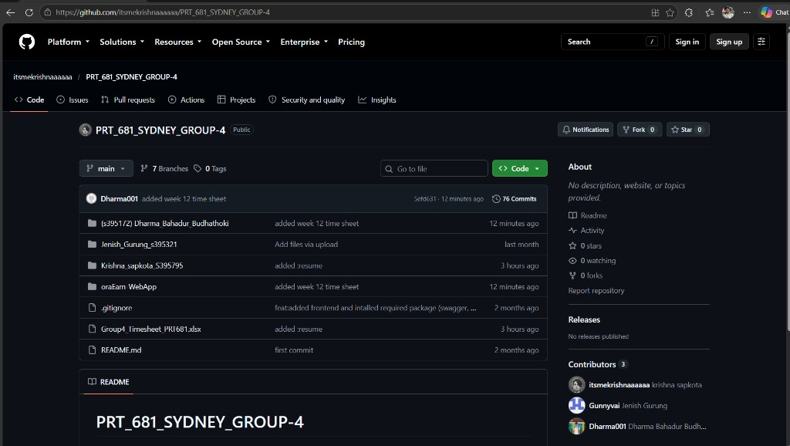
Figure 6. Public repository PRT_681_SYDNEY_GROUP-4. I am Dharma001 in the contributor list.
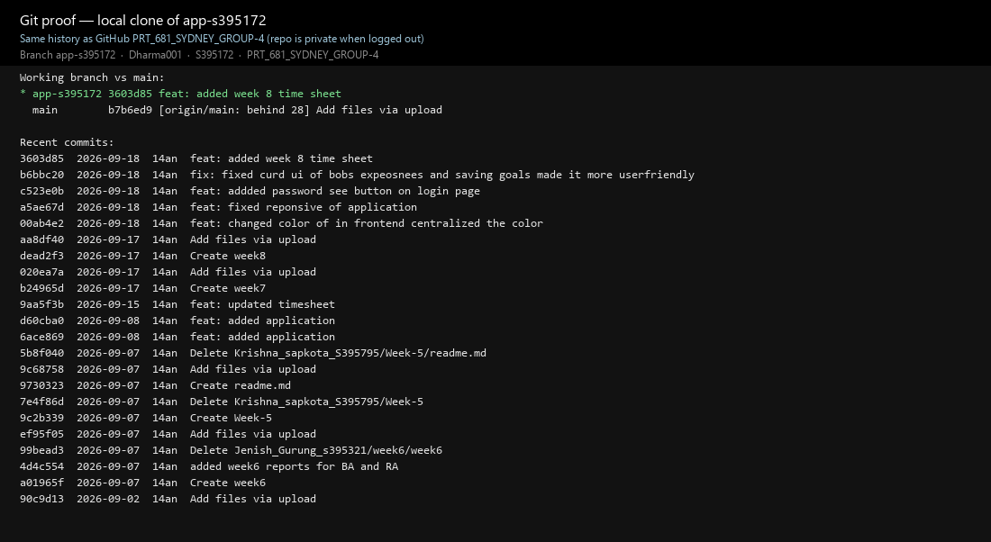
Figure 7. Git history for the work on this branch. One commit, one reason.

3.6 Database setup
Written by Krishna Sapkota (S395795). I checked it against the API on my machine. Dharma Bahadur Budhathoki, S395172.
PostgreSQL has to be running on port 5432. The first time the API starts, it connects to the postgres database, creates oraearn if it is not there yet, runs the migrations, and in Development it seeds the roles, the payment methods, and the demo users.
Get-Service postgresql* | Start-Service
On my machine the user is postgres and the password is 12345. If yours is different, change only backend/OraEarn.Api/appsettings.Local.json. After the first start you should see Jobs, Shifts, ActiveShiftSessions, ExpenseCategories, PaymentMethods, Expenses, SavingsGoals, and UserNotificationReads, plus the Identity tables. Shifts does not have a UserId column. You get the worker through the job.
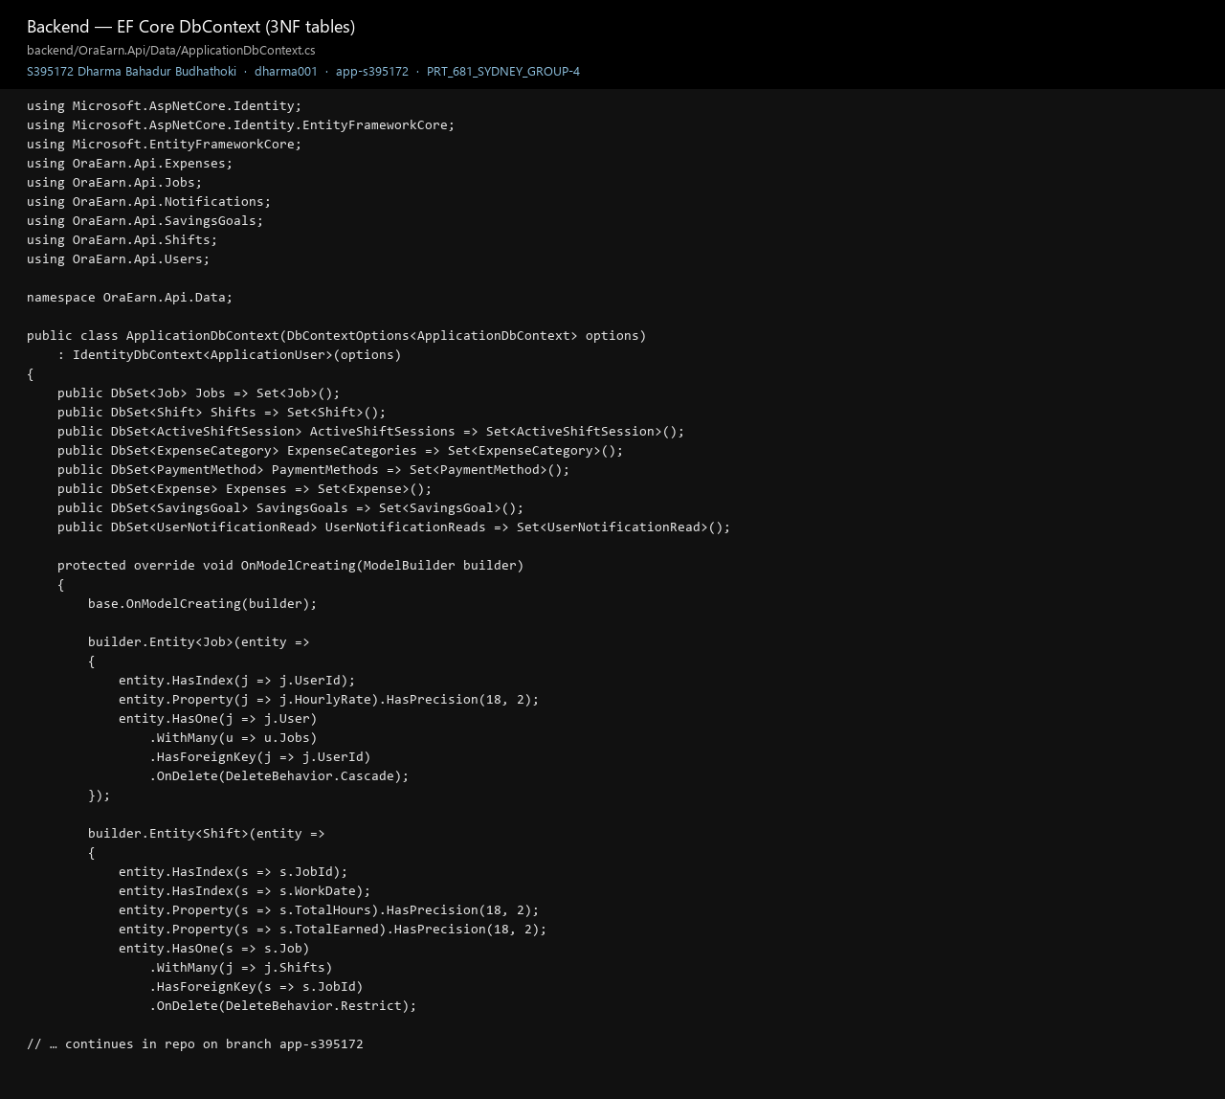
Figure 8. The database side of the API. Shifts point at a job. The job points at the user.

3.7 Entity Framework commands
Written by Krishna Sapkota (S395795). The migration names are the ones in the repo.
You don't need to run a migration just to start the app. Startup already calls MigrateAsync. After you change a model, from backend/OraEarn.Api:
dotnet tool install --global dotnet-ef
dotnet ef migrations add <Name> --project OraEarn.Api.csproj
dotnet ef database update --project OraEarn.Api.csproj
Name the migration for the reason, like AddLeaveRequests. Read the Up method before you commit it. Deleting a user also deletes that person's jobs, categories, goals, and the live clock-in. You can't delete a job while shifts still point at it, or a category while expenses still point at it. The tests use an in-memory database, so dotnet test does not need PostgreSQL.

3.8 Connection strings
Written by Krishna Sapkota (S395795). On my machine I only edit the Local file. Dharma Bahadur Budhathoki, S395172.
File | Committed | What belongs here
appsettings.json | Yes | Empty secret, empty CORS, demo seed off
appsettings.Development.json | Yes | CORS for port 5173, development secret, demo seed on
appsettings.Local.json | No | Your Postgres host, user, and password
Environment variables | On the server | Production connection string, JWT, CORS, seed

{
"ConnectionStrings": {
"DefaultConnection": "Host=localhost;Port=5432;Database=oraearn;Username=postgres;Password=12345"
}
}
If DefaultConnection is missing, the API stops and says so. On a real server, set ConnectionStrings__DefaultConnection, Jwt__Secret (at least 32 characters, and not the development one), Cors__AllowedOrigins__0, Seed__DemoData=false, and the admin email and password. Don't put Aura on the public internet.

3.9 How to run the applications
Written by Dharma Bahadur Budhathoki (S395172)
From the oraEarn-WebApp folder, run this once:
.\scripts\setup.ps1
That copies frontend/.env and appsettings.Local.json if they are missing, installs the npm packages, restores the API, and makes the Aura virtual environment if Python is there. Then I open three terminals:
cd backend
.\run.ps1
cd frontend
.\run.ps1
cd ai-advisor
.\run.ps1
Open http://localhost:5173 and sign in as Alice. Start the API before you open the browser. Aura is the third terminal. You can skip it and the rest of the app still runs. frontend/.env only needs VITE_API_URL=http://localhost:5203/api and VITE_HUB_URL=http://localhost:5203/hubs/shifts.
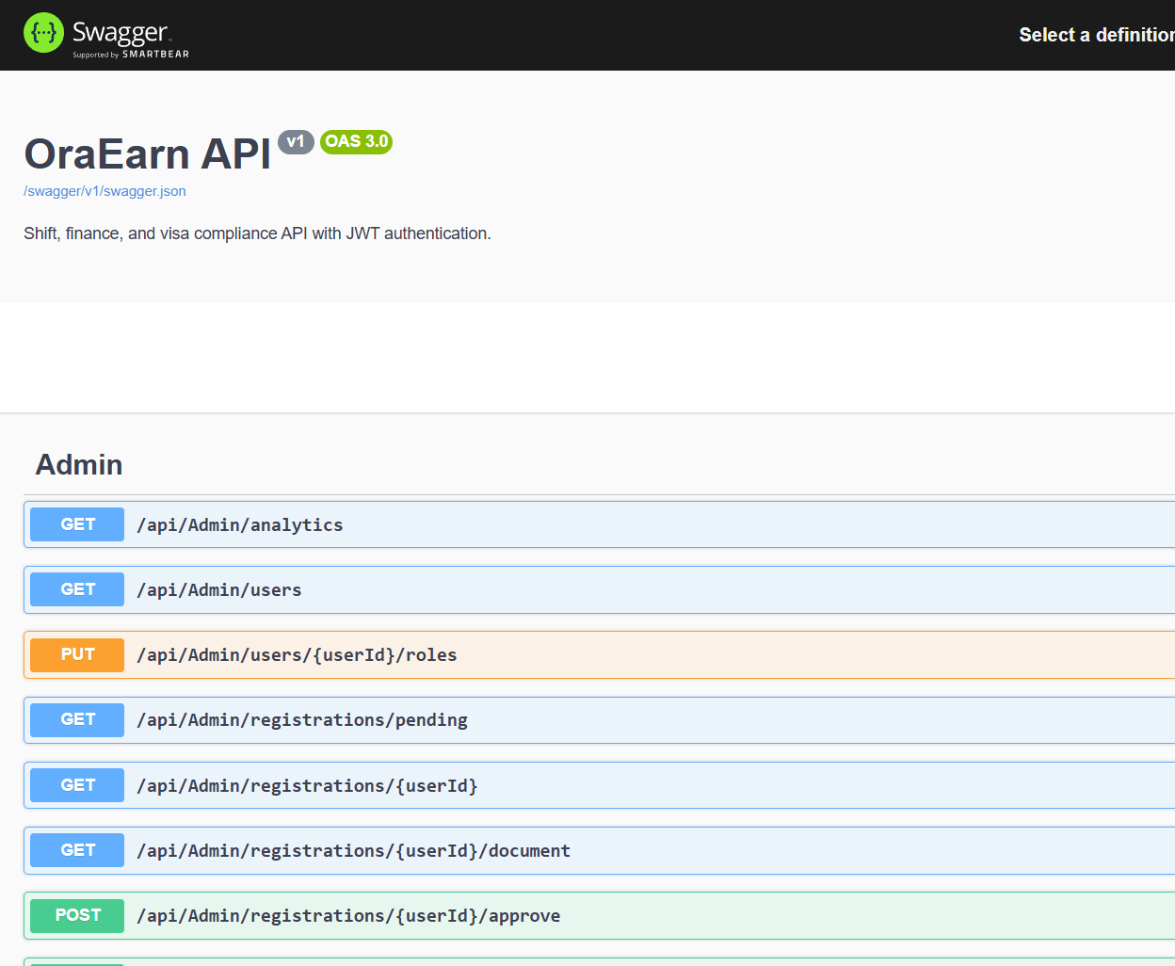
Figure 9. Swagger on port 5203. I try an endpoint here before I wire the React screen.
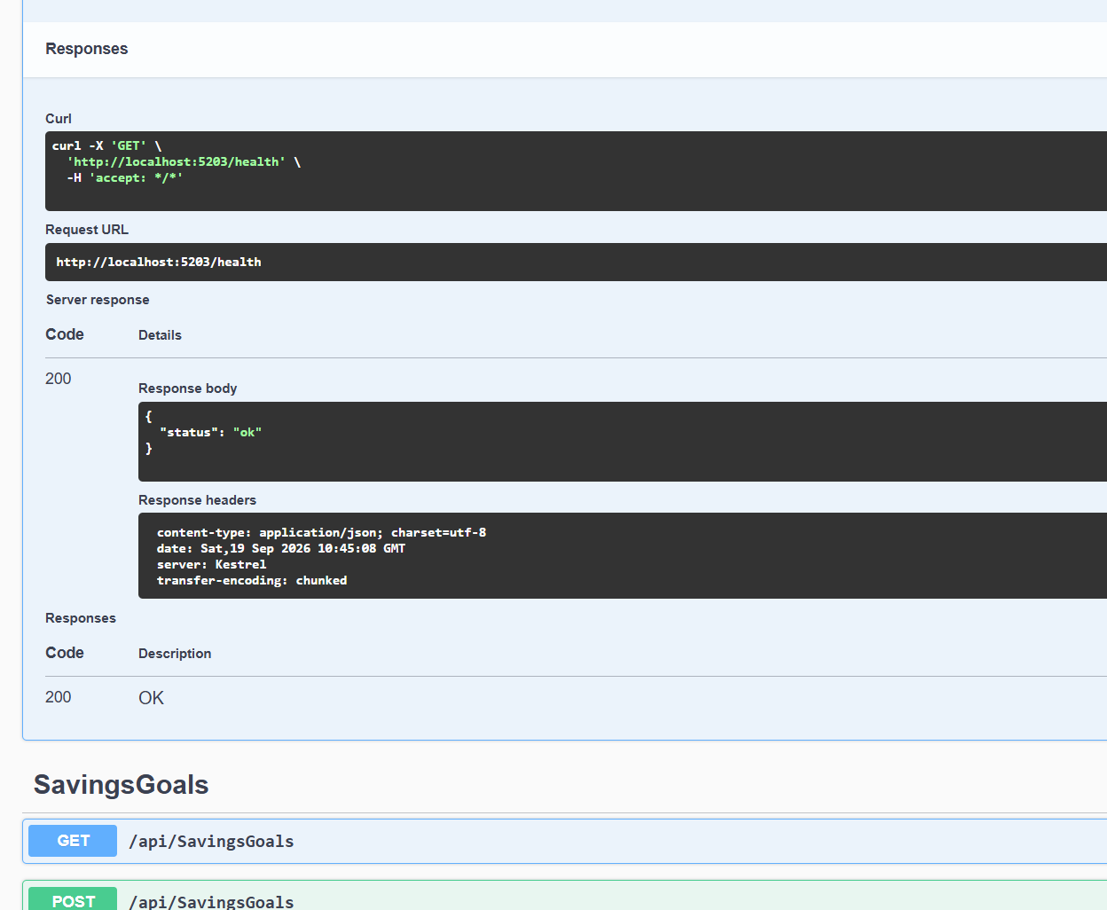
Figure 10. GET /health returns 200 when the API is up.

3.10 Dependency injection
Written by Dharma Bahadur Budhathoki (S395172)
Program.cs calls AddApplicationServices. That is the only place I register a service, and each one lives for a single request. The list is AuthService, TokenService, JobService, ShiftService, ActiveShiftSessionService, ShiftNotificationService, ExpenseCategoryService, ExpenseService, SavingsGoalService, SavingsGoalSyncService, SavingsGoalAnalyticsService, SavingsAdvisorService, AdminService, AnalyticsService, NotificationService, VisaComplianceService, RegistrationApprovalAdvisorService, RegistrationApprovalService, and VisaDocumentStorageService.
ApplicationDbContext is registered with AddDbContext. PythonAdvisorClient uses AddHttpClient, so it gets a proper HttpClient instead of one I create myself. A controller takes the service in its constructor. I don't write new JobService() inside a controller. If I forget the AddScoped line, the API can't find the service and it won't start that request.

3.11 Exception handling
Written by Dharma Bahadur Budhathoki (S395172)
When something the user did is wrong, I catch it in the controller and send a normal HTTP response. I don't let it fall through as a raw 500.
What happened | What the code does | HTTP
Empty title, rate of zero, bad allocation | ArgumentException, body { message } | 400
Student shift would pass 48 hours | InvalidOperationException from the visa check, before the insert | 400
Row missing, or not this user's row | Service returns null | 404
No user id on the token | UnauthorizedAccessException | 401
Aura is down | Client logs a warning and returns null. The API still answers. | 200
Postgres is down at startup | Message points at appsettings.Local.json | Process stops
JWT secret missing or still the dev value outside Development | Thrown while building services | Process stops

On the website the dialog stays open. The job dialog copies the API message into the summary at the top. A failed save does not wipe what the person typed. In production, anything I didn't catch goes through UseExceptionHandler.
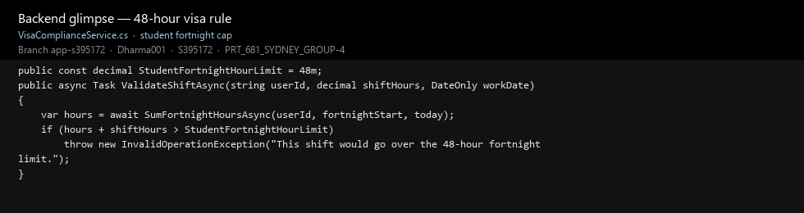
Figure 11. The 48-hour check runs in the API before a student shift is saved.

3.12 Unit testing
Written by Krishna Sapkota (S395795). I run this before I call a feature finished. Dharma Bahadur Budhathoki, S395172.
dotnet test backend\OraEarn.Api.Tests\OraEarn.Api.Tests.csproj
The white-box tests call the classes directly: shift pay, savings allocation, job checks, the registration review, and the analytics dates. The black-box tests start the real API on an in-memory database. A bad login is 401. A good login returns a token. Jobs with no token are 401. The 48-hour block lives in VisaComplianceService and ShiftsController. It runs before the shift is inserted. A bad login is rejected with 401, and a job with no token is rejected the same way.
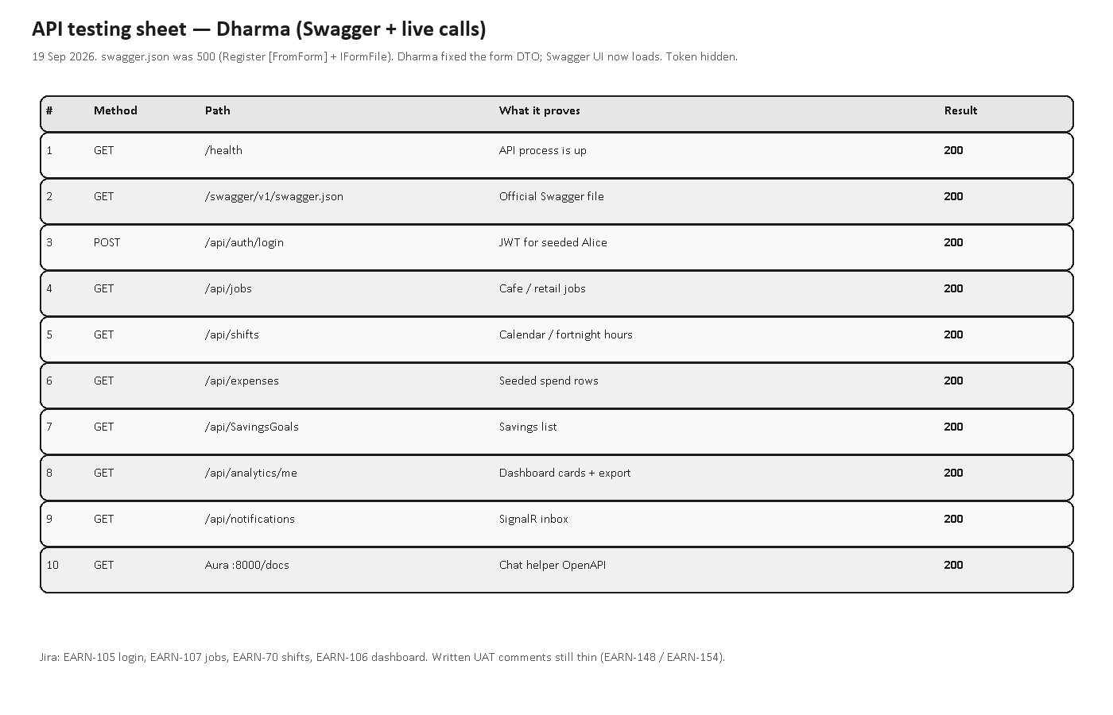
Figure 12. The tests I run before I call a feature finished.

3.13 Class diagram and data model
Written by Suraj Khadka (S394949), with Krishna Sapkota. This is the shape I code against. Dharma Bahadur Budhathoki, S395172.
The tables are in third normal form. A shift does not store the worker or the hourly rate. An expense does not store the worker, and it does not store the words "Card" or "Cash". It points at a payment method. TotalHours and TotalEarned stay on the shift, so if I change the job rate later, old payslips stay as they were.
ApplicationUser 1 -- * Job 1 -- * Shift
| |
| +-- * ActiveShiftSession (one live clock-in per user)
+-- * ExpenseCategory 1 -- * Expense * -- 1 PaymentMethod
+-- * SavingsGoal
+-- * UserNotificationRead
The visa file sits on disk. The user row only stores the path and the original file name. Krishna's write-up of how we got from a spreadsheet to these tables is docs/OraEarn-Normalization-1NF-to-3NF.md.
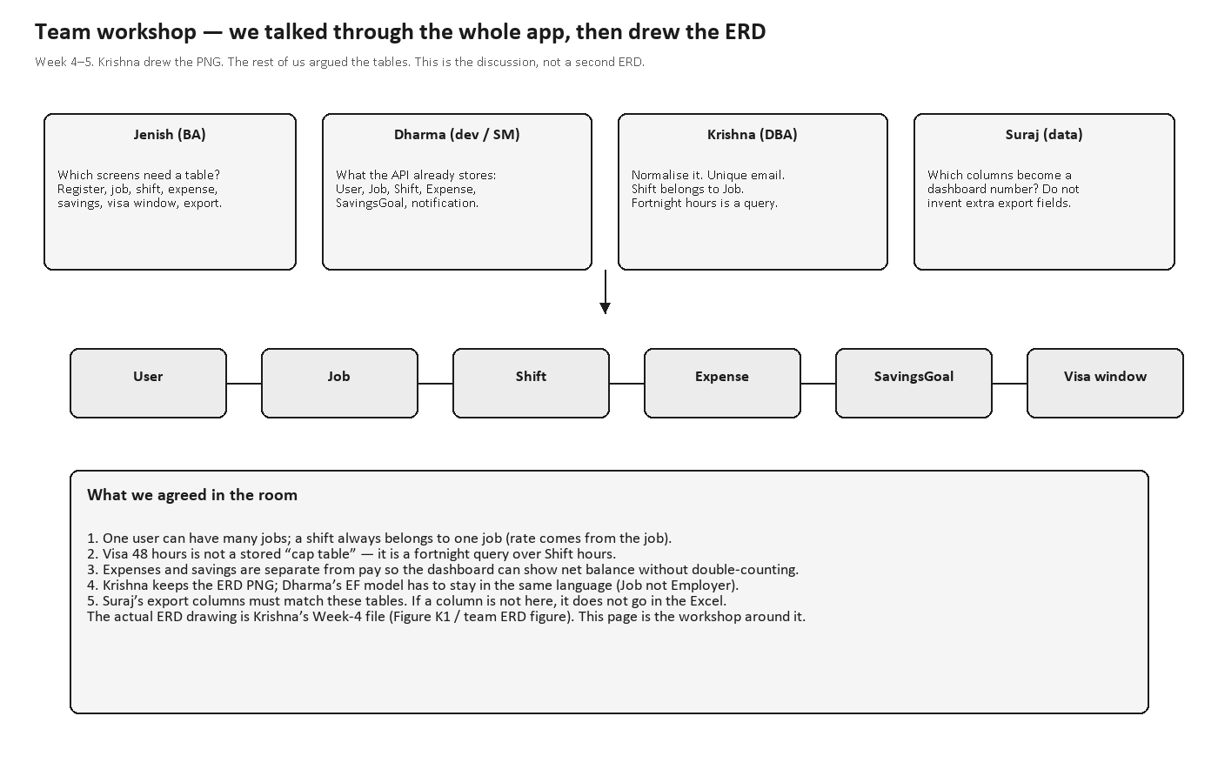
Figure 13. The tables. A shift points at a job. The job points at the user.
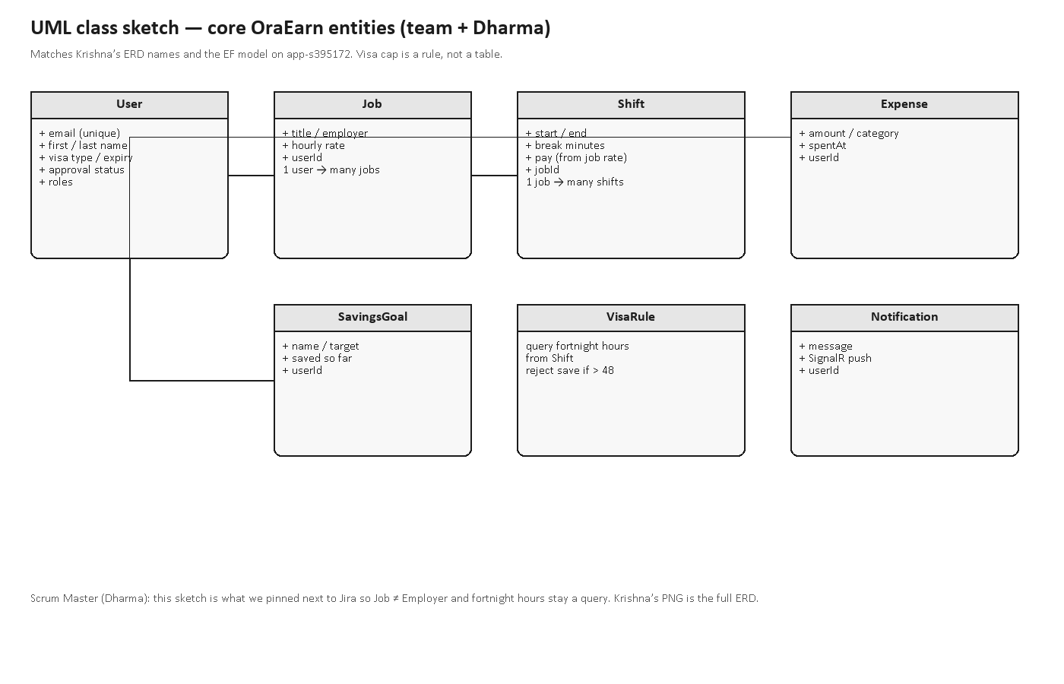
Figure 14. Class diagram for the same model.

4. Adding a new feature
Written by Dharma Bahadur Budhathoki (S395172)
I'll use a leave request as the example. It has a date, a reason, and a status. Follow the same order I use. Don't start in the controller and hope the rest shows up.
I make the Jira card first, on the EARN board, something like EARN-### Leave requests. One sentence says what a signed-in user can do. Then the branch:
git checkout main
git pull
git checkout -b OE-###-leave-requests
Backend folder backend/OraEarn.Api/Leave/:
- LeaveRequest.cs holds Id, UserId, Date, Reason, and the link to ApplicationUser.
- LeaveDtos.cs holds the request and the response.
- LeaveService.cs filters every query by the user id on the token. An empty reason throws ArgumentException.
- LeaveController.cs has [Authorize]. It catches ArgumentException and returns BadRequest with { message }.
Add the DbSet on ApplicationDbContext, index UserId, and delete the rows with the user, the same way a savings goal works. Then register the service. This is the line I miss when I go too fast:
services.AddScoped<LeaveService>();
From backend/OraEarn.Api:
dotnet ef migrations add AddLeaveRequests --project OraEarn.Api.csproj
Read the Up method. Restart the API so the migration runs. Only add a NuGet package if you really need one:
dotnet add package <PackageName>
On the website I add frontend/src/features/leave/ with api.ts, LeavePage.tsx, and a dialog. api.ts uses the shared axios client. I add the route inside ProtectedRoute in App.tsx, and a nav item in Layout.tsx. I copy the loading text and the empty state from the jobs page.
If the screen needs a JavaScript package we don't already have, install it from the frontend folder and commit package.json with package-lock.json:
npm install <package>
I don't add another CSS framework. The app already uses Tailwind. I reuse flex, gap-3, rounded-lg, bg-card, and text-muted-foreground. The colours live in frontend/src/index.css. I only change those variables when the whole app should change, not for one screen.
The checks in the browser use shared/form-field, the same way the job dialog does. If validate comes back false, I don't post.
validate(() => pickErrors([
['reason', validators.required(form.reason, 'Reason is required.')],
['date', validators.dateRequired(form.date)],
]))
The red line under the box is from the browser. The summary at the top is the message from the API, for a rule only the server knows, like the 48-hour limit. I still keep that check in the service.
I add one test that an empty reason throws, and one test that GET /api/leave with no token is 401. Then I run dotnet test, and I commit only the leave files:
git commit -m "Add leave requests so a user can record time away from shifts."
I only comment a line when the next person would otherwise guess, like the visa rule or why a delete is blocked. I don't comment "get the user". The card goes to Done after someone else has looked at the branch and the tests pass.
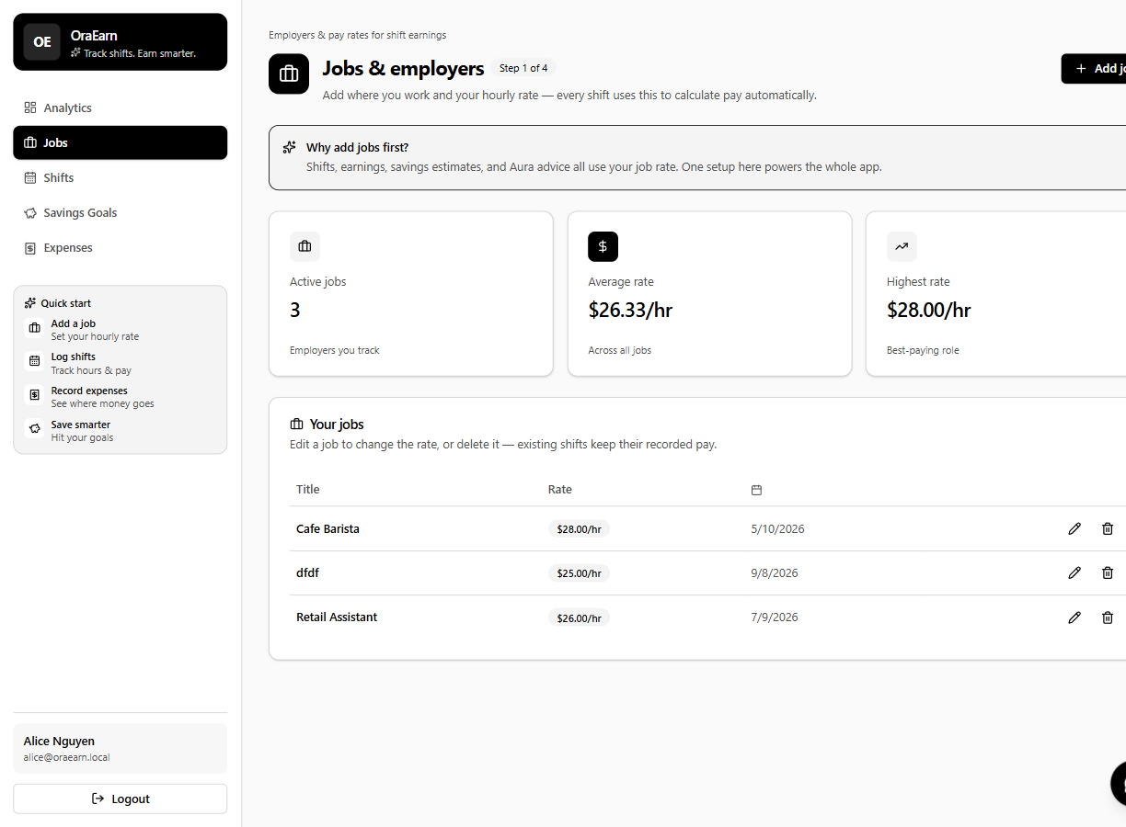
Figure 15. Jobs. The hourly rate on the job is what a shift gets paid.
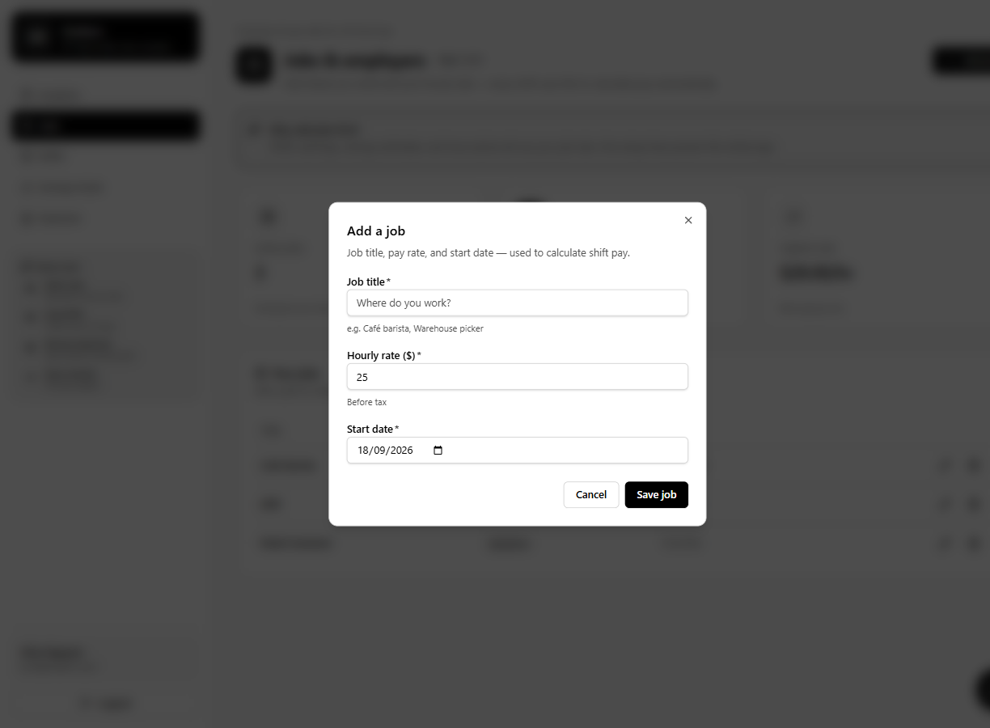
Figure 16. Add-job dialog. The message under the field is the browser check.
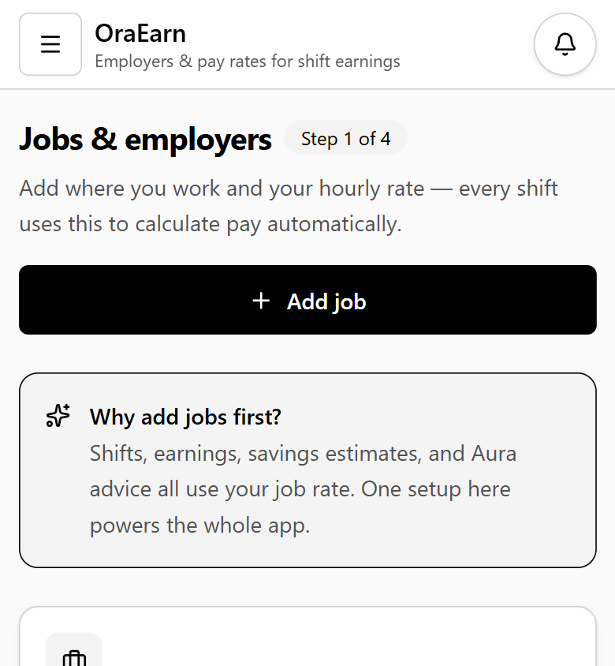
Figure 17. The same jobs page on a narrow screen. The layout stacks. It does not hide the form.

5. My contribution
Written by Dharma Bahadur Budhathoki (S395172)
My name is Dharma Bahadur Budhathoki and my student number is S395172. I am the developer. The screens a student uses, the sign-in, and the way the API is put together are the work I led. Krishna led the tables and the test project. Jenish led the requirements. Suraj led the numbers on the charts.
These are the developer cards I have finished. The key is a link to that card on Jira.
Key | Card | What I delivered
EARN-105 | Login | Email and password sign-in, access and refresh tokens, show-password on the login form.
EARN-106 | User dashboard | Personal totals for net, earnings, and expenses, with the period filter.
EARN-107 | Jobs | Create, list, update, and delete. The hourly rate on the job is what shift pay uses.
EARN-70 | Log a shift | Shift form, calendar, hours and pay calculated on the server.

EARN-105 Login
EARN-106 Dashboard
EARN-107 Jobs
EARN-70 Log a shift
Register, admin approval, and the Excel and PDF export are in the app. The EARN board screenshot in this handover shows the project cards in Done.
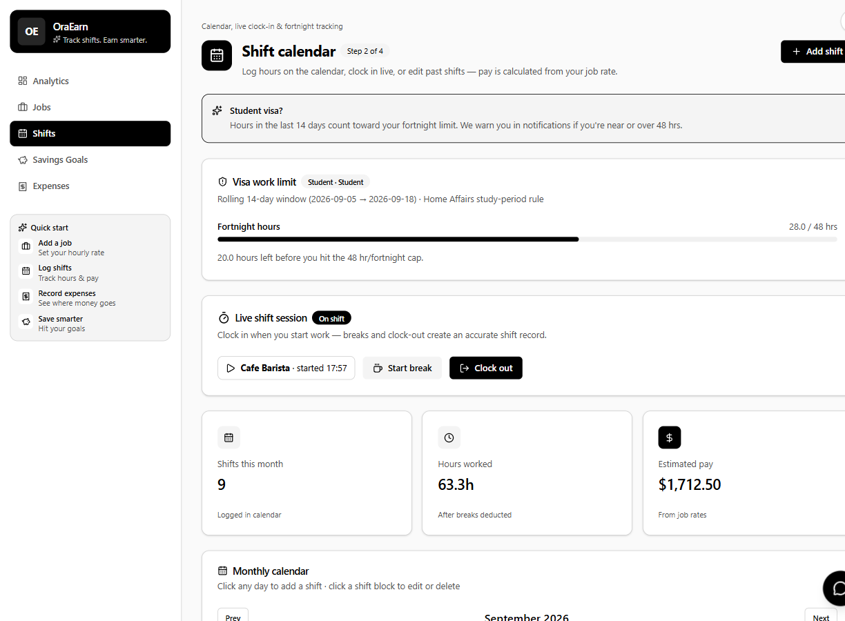
Figure 18. Shift calendar. Hours and pay are calculated on the server. The visa bar is on this page.
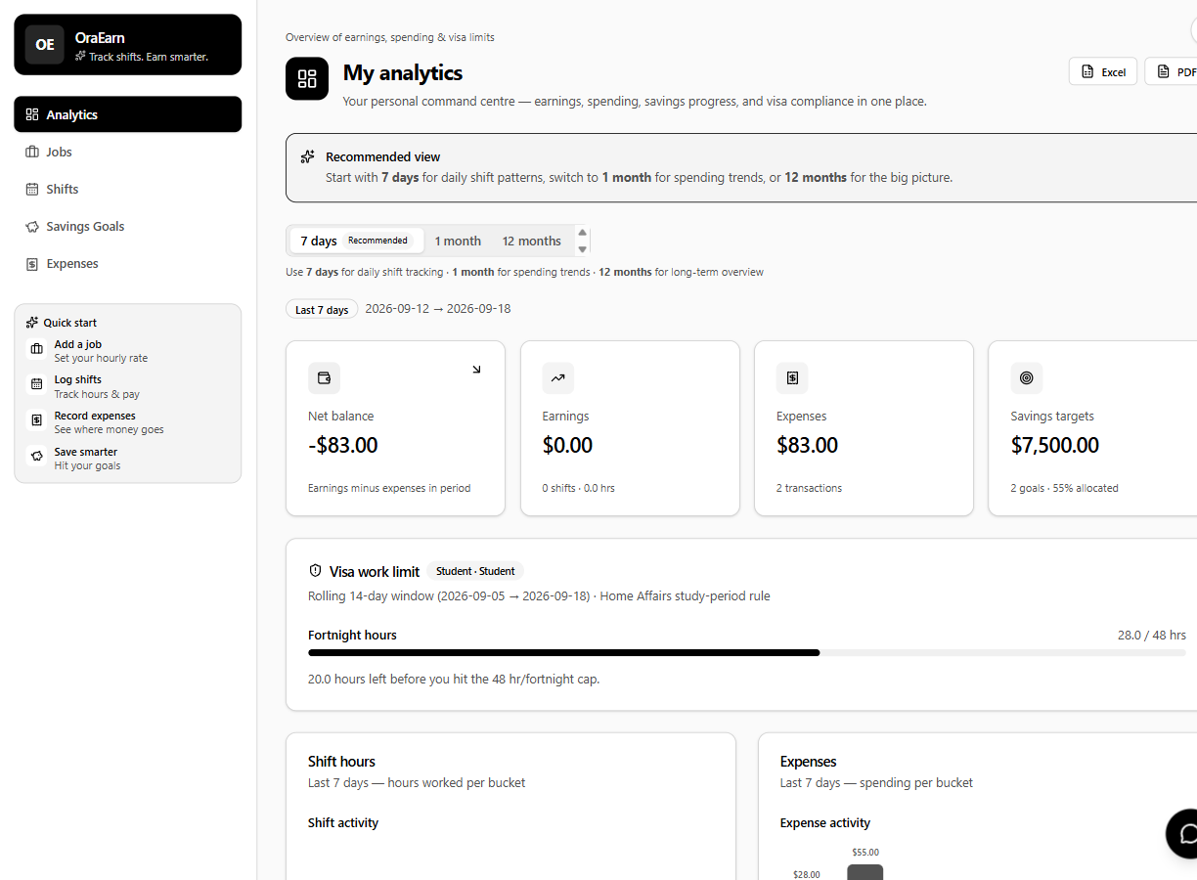
Figure 19. Dashboard. Net, earnings, and expenses for the period I pick.
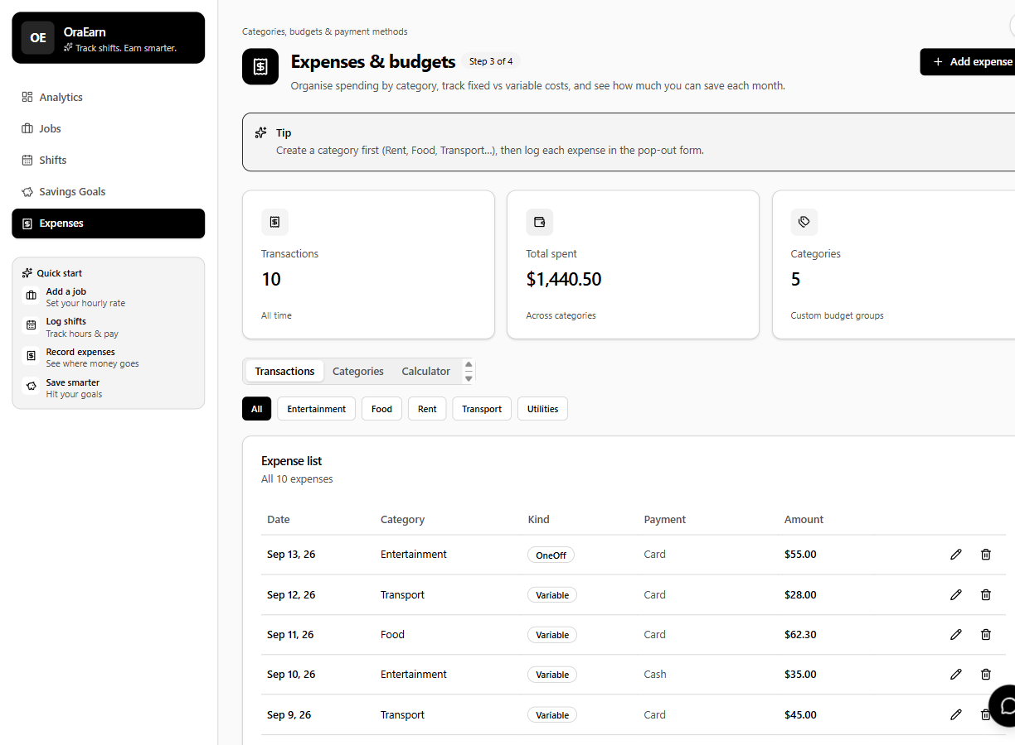
Figure 20. Expenses, with category and type.
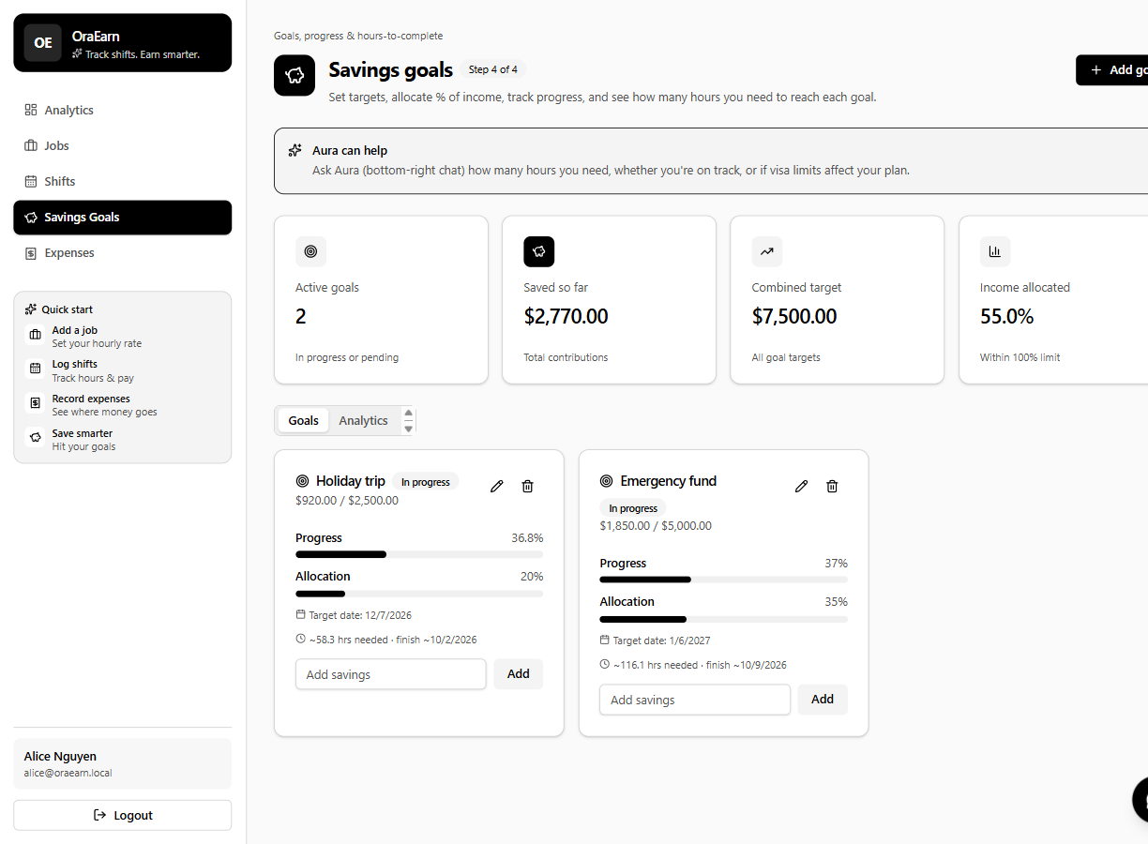
Figure 21. Savings goals. A goal takes a share of leftover pay.
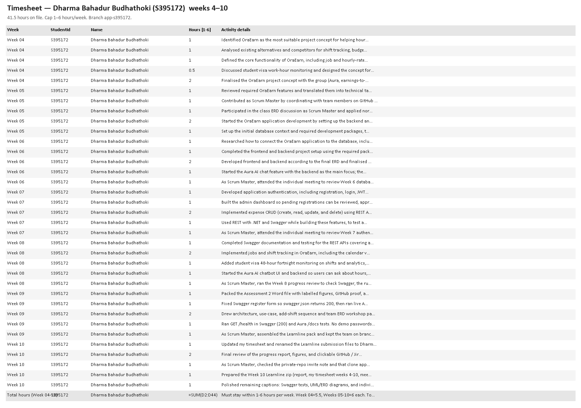
Figure 22. My timesheet, Dharma Bahadur Budhathoki, S395172.
Over the weeks I also:
- Set up the React app and the .NET API, including Swagger, PostgreSQL, and Entity Framework.
- Built registration, the admin approval screens, expenses, jobs, the shift calendar, the 48-hour bar, and the start of Aura.
- Centralised the black-and-white theme, updated the home page, and changed savings so a goal takes a share of leftover pay. That change is the migration AllocateSavingsFromNetMoney.
- Wrote this handover, and my timesheet through week 12. The file is under my name, Dharma Bahadur Budhathoki (S395172), weeks 4 to 12. Week 4 is 5.5 hours. Weeks 5 to 12 are 6 hours each. The total is 53.5.
The board I keep current is the EARN Jira board. The code is in PRT_681_SYDNEY_GROUP-4.

References
Written by Dharma Bahadur Budhathoki (S395172). Each title opens the source.
I have listed the sources a new developer needs. The web addresses are links. Click the title.
[1] Group 4 (2026) PRT_681_SYDNEY_GROUP-4. GitHub repository.
[2] Group 4 (2026) EARN board. Jira, Atlassian.
[3] Budhathoki, D.B. (2026) OraEarn handover, Assessment 4. Charles Darwin University.
[4] Gurung, J. (2026) OraEarn requirements.
[5] Group 4 (2026) OraEarn project proposal.
[6] Sapkota, K. (2026) OraEarn database normalisation, UNF to 3NF.
[7] Budhathoki, D.B. (2026) Individual timesheet, weeks 4 to 12.
[8] Microsoft (2026) ASP.NET Core documentation.
[9] Microsoft (2026) Entity Framework Core.

