**Lauren Carter**

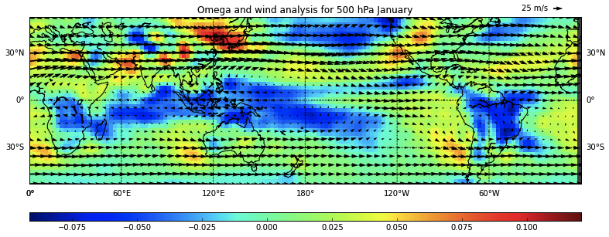

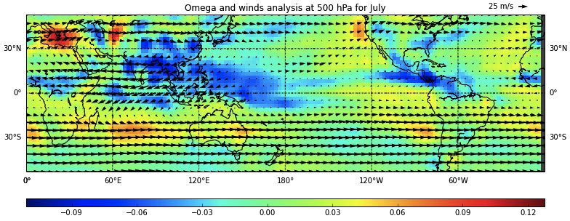

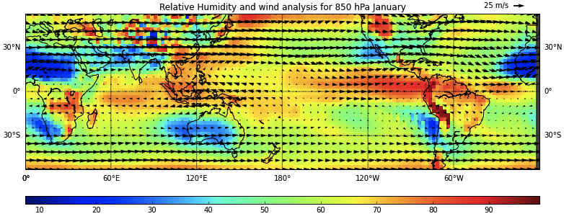

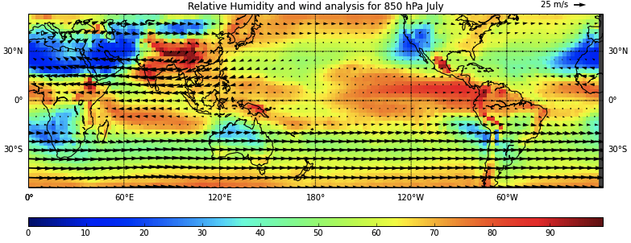

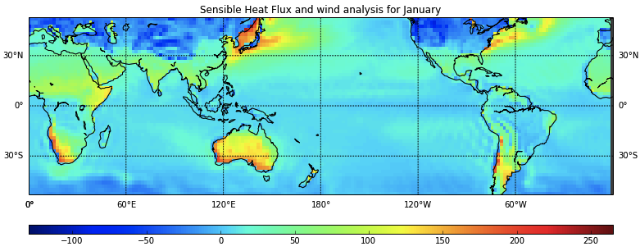

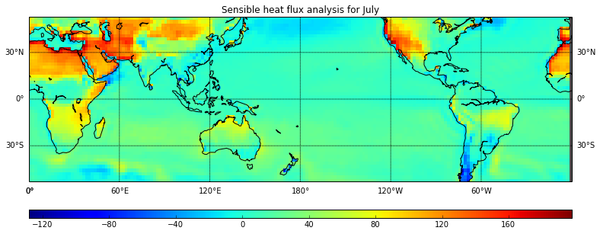

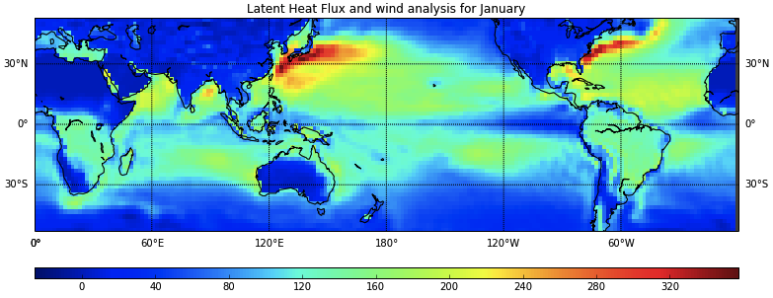

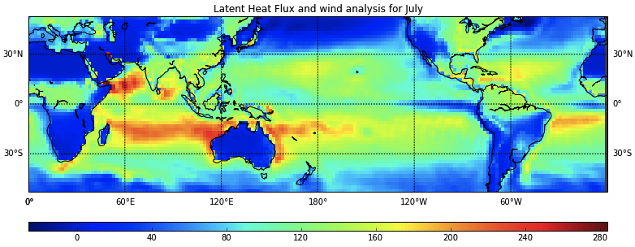

**(5)**

There is no apparent correlation between winds and RH. However, looking at the graphs: As RH increases, omega becomes more negative and as RH decreases, omega becomes more positive. This is because air becomes more dry as it sinks, and more moist as it rises.

**(6)**

Higher RH aloft is indicative of rising air since air becomes more moist as it rises. Rising air cools and condenses, giving off latent heat. Therefore, higher RH leads to greater latent heat flux, as can be seen in the graphs.

With sensible heat, it can be seen that higher RH aloft gives way to lower sensible heat at the surface, and vice versa. This makes sense since evaporation is a cooling process lowering heat at the surface, and evaporation at the surface rises and condenses into the atmosphere, increasing RH aloft.