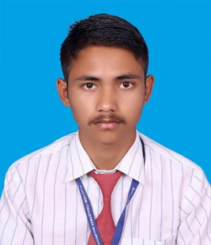**RESUME**

**Laxman Magarati**

**Add:** Panauti Village 45200 ,Nepal

**Mobile No. :** 9813631697

**Email ID:** [Laxmanmagrati@gmail.com](mailto:Laxmanmagrati@gmail.com)

**CARRIER OBJECTIVES:-**

To seek a dynamic and challenging career an organization strives for excellence with my knowledge and team effort while making positive contribution to promote the individual opportunity and professional growth.

**ACADEMIC QUALIFICATION:-**

|  |  |  |  |  |
| --- | --- | --- | --- | --- |
| Sr. No. | **Class/ Degree** | **Board/University** | **Year** | **Division /Percentage** |
| 1. | High School | Siddhartha Vanasthali Institite | 2020 | Distinctiion |
| 2. | Intermediate | Siddhartha Vanasthali Institite | 2022 | 1ST Division |
| 3. | Diploma In Computer Science | KATHMANDU UNIVERSITY | 2025 | 62% |

**Computer SKILL:-**

* **Basic Computer Course (BCC)**
* **Diploma in Computer Hardware & Networking (DCHN)**
* **Programming (MySql ,PHP ,Html and CSS ,Javascript , C ,C++ etc.)**
* **Web Designing**

**WORK EXPERIENCE:-**

* 2 years work experience in Computer Field.

**PERSONAL DETAILS:-**

**Father Name: -** : ShivaRam Magarati

**Date of Birth: -** : 01/10/2003

**Gender: -** : Male

**Marital Status: -** : Unmarried

**Nationality: -** : Nepali

**Religion: -** : Hindu

**Language Knowledge: -** : Nepali & English

**DECLARATION:-**

I’m here to declare that the above information is true best of my knowledge