190905514 MOHAMMAD TOFIK BATCH : C2
SEM : 6th ROLL NO : 62 SECTION : C

-: DS-LAB-WEEK-5 :-

1. mapper.py

import sys
import pandas as pd
df = pd.read_csv("in.csv")
l = df['Country/Region'].tolist()
for x in l:
print("%s\t%s"%(x,1))

reducer.py

from operator import itemgetter
import sys
currentWord = None
currentCount = 0
word = None
for line in sys.stdin:
line = line.strip()
word, count = line.split('\t', 1)
try:
count = int(count)
except ValueError:
continue
if(currentWord == word):
currentCount += count
else:
if(currentWord):
print('%s\t%s'%(currentWord, currentCount))
currentCount = count
currentWord = word
if (currentWord == word):
print('%s\t%s'%(currentWord, currentCount))

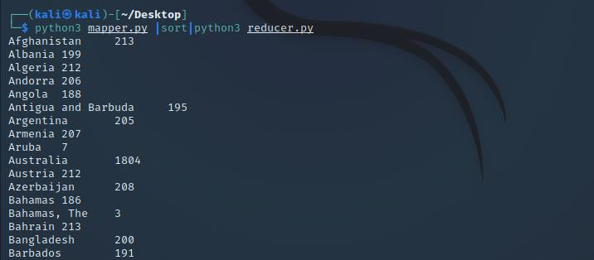

2. freqmap1.py

from __future__ import print_function
import sys
import pandas as pd
df = pd.read_csv('covid_19_data.csv')
country = df['Deaths']
for word in country:
print(word,'\t',1)

freqred.py

from __future__ import print_function
import sys
lastWord = None
sum = 0
for line in sys.stdin:
word, count = line.strip().split('\t', 1)
count = int(count)
if(lastWord == None):
lastWord = word
sum = count
continue
if(word == lastWord):
sum += count
else:
print(lastWord,'\t',sum)
sum = count
lastWord = word
if(lastWord == word):
print(lastWord,'\t',sum)

freqmap2.py

from __future__ import print_function
import sys
for line in sys.stdin:
word, count = line.strip().split('\t', 1)
count = int(count)
print(count,'\t',word)

freqred2.py

from __future__ import print_function
import sys
mostFreq = []
currentMax = -1
for line in sys.stdin:
count, word = line.strip().split('\t', 1)
count = int(count)
if(count > currentMax):
currentMax = count
mostFreq = [word]
elif(count == currentMax):
mostFreq.append(word)
for word in mostFreq:
print(word,'\t',currentMax)
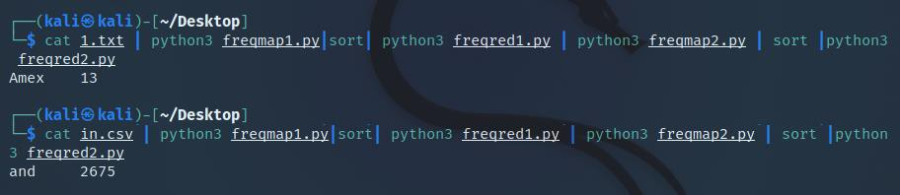

3. mapper.py

import pandas as pd
df = pd.read_csv("c19.csv")
l = df['Country/Region'].tolist() for x in l:
print('%s\t%s'%(x, 1))

reducer.py

from operator import itemgetter import sys
current_word = None current_count = 0
country_count = 0 word = None
for line in sys.stdin:
line = line.strip()
word, count = line.split('\t', 1) try:
count = int(count) except ValueError:
continue current_count+=count
if current_word != word:
country_count+=1 current_word = word
if current_word == word: country_count+=count
print("Total number of Countries affected: %d\nTotal number of cases: %d"%(state_count,current_count))

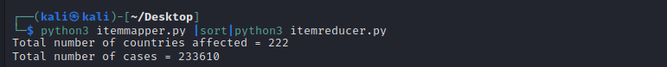

4.mapper.py

import sys
def read_input(file):
for line in file:
yield line.split()

def main(separator='\t'):
data = read_input(sys.stdin) for words in data:
for word in words:
print ('%s%s%d' % (word, separator, 1))

if name == " main ": main()

reducer.py

from itertools import groupby from operator import itemgetter import sys
def read_mapper_output(file, separator='\t'): for line in file:
yield line.rstrip().split(separator, 1)

def main(separator='\t'):
data = read_mapper_output(sys.stdin, separator=separator) for current_word, group in groupby(data, itemgetter(0)):
try:
total_count = sum(int(count) for current_word, count in group) print ("%s%s%d" % (current_word, separator, total_count))
except ValueError: pass

if name == " main ": main()

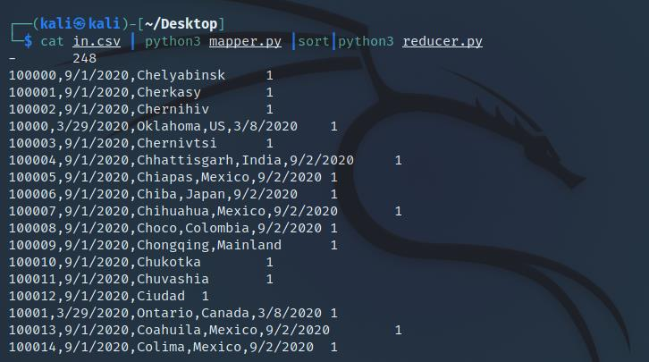

5.mapper.py

import sys
import pandas as pd
df = pd.read_table("example.txt",index_col=False) df.columns=['Date','Time','Location','Item','Cost','Payment'] df.dropna(axis=0,subset=['Location'],inplace=True)
df = df.iloc[:,2:5:2]
d = df.to_records(index=False) for x in d:
print("%s\t%s"%(x[0],x[1]))

reducer.py

import sys res = dict()
for line in sys.stdin:
location, price = line.strip().split('\t', 2) try:
price = float(price) except ValueError:
continue
if res.get(location,price)==price: res[location]=price d = res.get(location)
if price>d: res[location]=price for key,val in res.items():
print(key,": ",str(val))

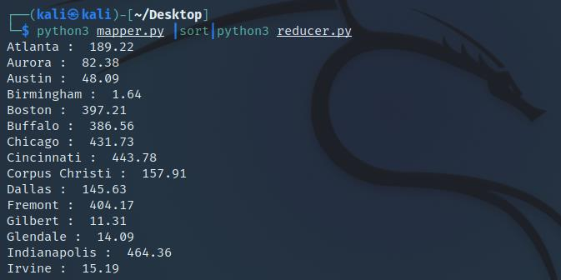

6.mapper.py

import sys def f(x):
return 4.0/(1.0+x*x)

N = int(input("Enter number of intervals for integration: ")) dx = 1.0/N
for i in range(N):
print("%1.10f"%(f(i*dx)*dx))

reducer.py

from operator import itemgetter
import sys
current_year = None
year_tot = [0]
year_male = [0]
year_fem = [0]
month_tot = [0]
month_male = [0]
month_fem = [0]
specyear = 2000
i = 1
while i<40:
year_tot.append(0)
year_male.append(0)
year_fem.append(0)
i += 1
i = 0
while i<12:
month_tot.append(0)
month_male.append(0)
month_fem.append(0)
i += 1
year = None
for line in sys.stdin:
line = line.strip()
sex, month, year = line.split(' ')
sex = int(sex)
month = int(month)
year = int(year)
year_tot[year-1980] += 1
if sex == 0:
year_male[year-1980] += 1
else:
year_fem[year-1980] += 1
if year == specyear:
month_tot[month-1] += 1
if sex == 0:
month_male[month-1] += 1
else:
month_fem[month-1] += 1
i = 0
while i<40:
if year_tot[i] == 0:
i += 1
continue
print('Year %d Total: %d' %(i+1980, year_tot[i]))
print('Males: %d' %(year_male[i]))
print('Females: %d' %(year_fem[i]))
print('\n')
i += 1
print('Year %d'% (specyear))
i = 0
while i<12:
if month_tot[i] == 0:
i += 1
continue
print('Month %d Total: %d' %(i+1, month_tot[i]))
print('Males: %d' %(month_male[i]))
print('Females: %d' %(month_fem[i]))
print('\n')
i += 1

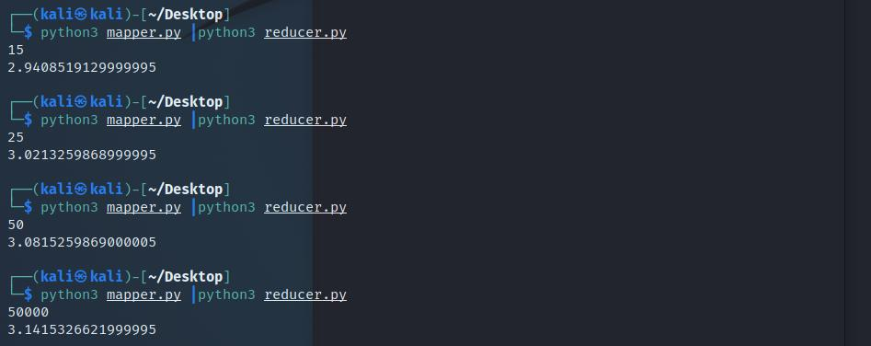

7.mapper.py

import numpy as np import sys
l = list(np.random.randint(low=1,high=1000,size=150)) for i in l:
print("%d"%(i))

reducer.py

from operator import itemgetter
import sys
odd_count = 0
even_count = 0
for line in sys.stdin:
line = line.strip()
num = line.split()
for currnum in num:
try:
odd_count = int(odd_count)
even_count = int(even_count)
currnum = int(currnum)
except ValueError:
continue
if currnum%2 == 0:
even_count += 1
else:
odd_count += 1
print ('%s odd and %s even'%(odd_count, even_count))

