190905514 MOHAMMAD TOFIK BATCH : C2
ROLLNO : 62 SECTION : C SEM : 6th

WEEK1-LAB1

LAB EXCERCISE :

1.Write a web page which contains table with 3 X 3 dimensions (fill some data) and
one image. Style the rows with alternate color. Move the table and image together from
right to left when button is clicked.

<!DOCTYPE html>
<html>
<head>
<meta charset="utf-8">
<meta name="viewport" content="width=device-width, initial-scale=1">
<title>Image and Table</title>
<style>
body{
background-color: aliceblue;
}
.table {
background-color: yellow;
text-align: center;
width: 400px;
}

tr,td {
background-color: black;
color: white;
font-family: sans-serif;
font-weight: bold;
font-size: 12px;
text-transform: uppercase;
}
.image {
width: 200px;
height: 200px;
}

h1 {
text-align: center;
font-family: sans-serif;
font-weight: bold;
font-size: 40px;
text-transform: uppercase;
text-shadow: 0 0 3px brown;
}
button{
width: 150px;
height: 30px;
background-color: black;
color: white;
font-family: sans-serif;
font-weight: bold;
font-size: 12px;
text-transform: uppercase;
cursor: pointer;
margin-top: 10px;
border-radius: 100px;
border: none;
}
button:active{
transition: 0.5 ease;
transform: scale(1.2);
background-color: blue;
color: white;
}
.main{
float: right;
}
</style>
<script type="text/javascript" src="jquery-3.6.0.min.js"></script>
<script type="text/javascript" language="javascript">
$(document).ready(function () {
$("button").click(function () {
$("div").animate({ right: '500px' });
});
});
</script>
</head>
<body>
<button>Click to Move</button><br>
<h1>TABLE</h1><br>
<div style="position: absolute; right: 200px;" class="main">
<table class="table">
<tr>
<th>Name</th>
<th>RollNo</th>
<th>RegNo</th>
</tr>

<tr>
<td>Mohammad Tofik</td>
<td>62</td>
<td>190905514</td>
</tr>
<tr>
<td>Mohammad Tofik</td>
<td>62</td>
<td>190905514</td>
</tr>
<tr>
<td>Mohammad Tofik</td>
<td>62</td>
<td>190905514</td>
</tr>
</table><br>
<img src="Birthday.png" class="image">
</div>

</body>
</html>

Before Clicking :
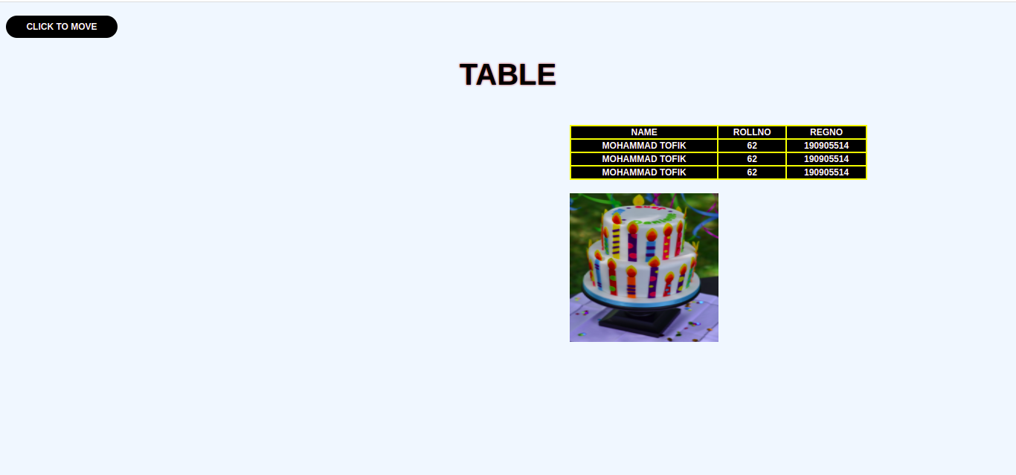
After Clicking :
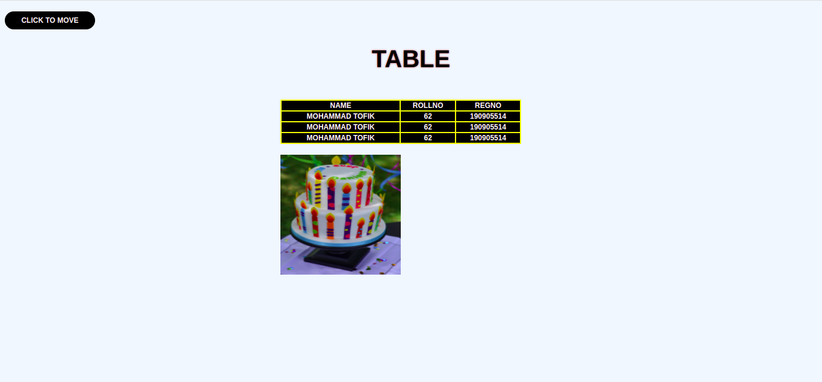

2. Design a calculator to perform basic arithmetic operations. Use textboxes and buttons
to design web page.

<!DOCTYPE html>
<html lang="en">

<head>
<meta charset="UTF-8">
<meta http-equiv="X-UA-Compatible" content="IE=edge">
<meta name="viewport" content="width=device-width, initial-scale=1.0">
<title>A Simple Calculator</title>
<style>
body {
background-color: gray;
}

input[type="text"] {
background-color: white;
color: black;
width: 150px;
height: 30px;
border: none;
position: relative;
top: 30px;
margin-left: 130px;
padding-left: 20px;
font-family: sans-serif;
font-weight: bold;
font-size: 12px;
border-radius: 5px;
outline: none;
}

input[type="button"] {
width: 140px;
height: 30px;
background-color: black;
color: white;
border: none;
margin-top: 10px;
cursor: pointer;
position: relative;
top: 100px;
margin-left: 130px;
font-family: sans-serif;
font-weight: bold;
font-size: 12px;
text-transform: uppercase;
border-radius: 5px;
}

input[type="button"]:active {
transition: 0.5 ease;
transform: scale3d(1.2);
background-color: cadetblue;
border: 1px solid brown;
box-shadow: 0 0 3px black;
}

.calc {
background-color: aliceblue;
width: 700px;
height: 500px;
position: absolute;
top: 100px;
left: 300px;
border: 1px solid black;
border-radius: 10px;
box-shadow: 0 0 10px black;

}

h1 {
text-align: center;
font-family: 'Courier New', Courier, monospace;
font-weight: bold;
text-transform: uppercase;
font-size: 20px;
}
input[type="text1"]{
width: 300px;
height:30px;
position: relative;
top: 30px;
left: 130px;
border: none;
outline: none;
cursor: pointer;
font-family: 'Courier New', Courier, monospace;
font-weight: bold;
font-size: 20px;
text-transform: uppercase;
color: black;
text-align: center;

}
h3{
position: relative;
top: 75px;
left: 40px;
font-family: 'Courier New', Courier, monospace;
font-weight: bold;
text-transform: uppercase;
}
input[type="reset"]{
width: 400px;
height: 40px;
text-align: center;
color: white;
background-color: rgb(24, 145, 135);
font-family: 'Courier New', Courier, monospace;
font-weight: bold;
font-size: 15px;
text-transform: uppercase;
position: relative;
top: 150px;
left: 135px;
border: 1px solid white;
box-shadow: 0 0 3px rgb(0, 0, 0);
outline: none;
cursor: pointer;
border-radius: 5px;
}input[type="reset"]:active {
transition: 0.5;
transform: scale(.9);
background-color: red;
}
</style>
<script src="jquery-3.6.0.min.js"></script>
<script>
$(document).ready(function () {
$("#btnAdd").on('click', function () {
Add();
});
$("#btnSubstract").on('click', function () {
Substract();
})
$("#btnMultiply").on('click', function () {
Multiply();
})
$("#btnDivide").on('click', function () {
Divide();
})
});
function Add() {
var no1 = parseInt($("#txtNo1").val());
var no2 = parseInt($("#txtNo2").val());
var result = no1 + no2;
document.f1.op.value = result;
}
function Substract() {
var no1 = parseInt($("#txtNo1").val());
var no2 = parseInt($("#txtNo2").val());
var result = no1 - no2;
document.f1.op.value = result;
}
function Multiply() {
var no1 = parseInt($("#txtNo1").val());
var no2 = parseInt($("#txtNo2").val());
var result = no1 * no2;
document.f1.op.value = result;
}
function Divide() {
var no1 = parseInt($("#txtNo1").val());
var no2 = parseInt($("#txtNo2").val());
var result = no1 / no2;
document.f1.op.value = result;
}
</script>

</head>

<body>
<form name="f1">
<div class="calc">
<h1>A Simple Calculator</h1>
<input type="text" id="txtNo1" placeholder="Enter first number" autocomplete="off">
<input type="text" id="txtNo2" placeholder="Enter second number" autocomplete="off"><br>
<h3>Result: </h3><input type="text1" name="op" id=""><br>
<input type="button" id="btnAdd" value="Add">
<input type="button" id="btnSubstract" value="Substract"><br>
<input type="button" id="btnMultiply" value="Multiply">
<input type="button" id="btnDivide" value="Divide"><br>
<input type="reset" value="Reset" name="Reset">
</div>
</form>

</body>

</html>

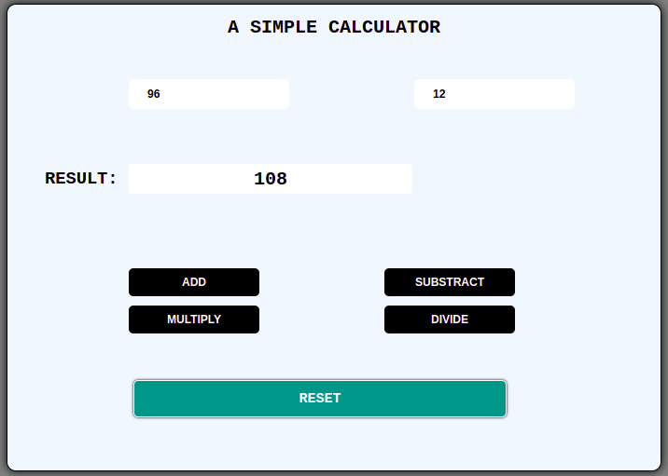
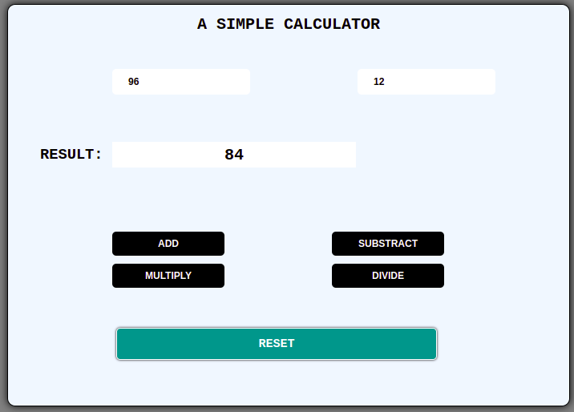

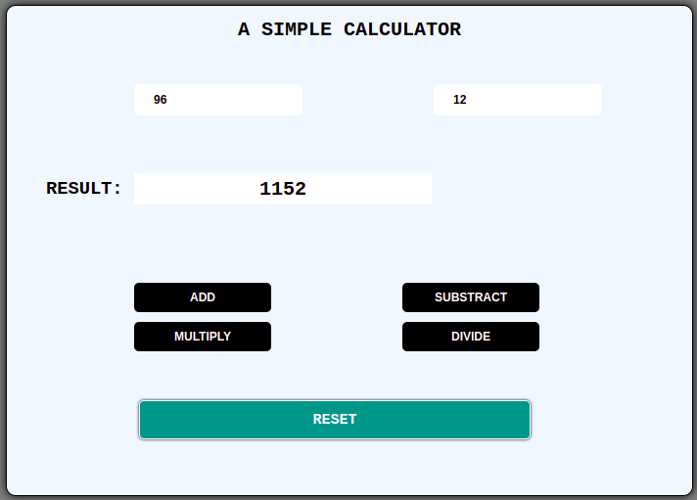
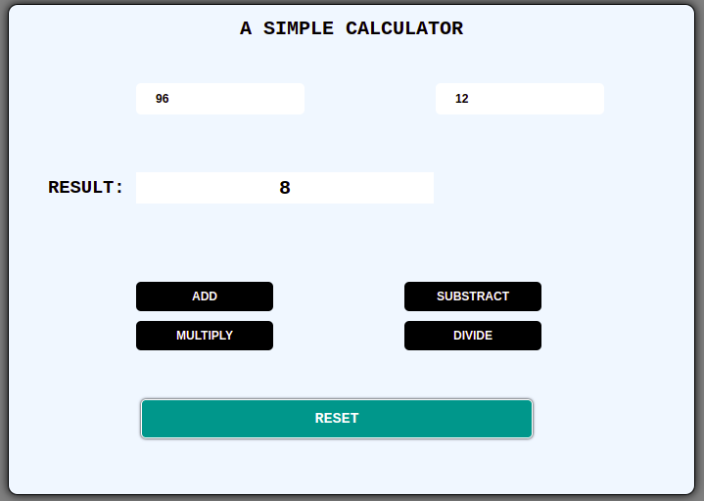

3.Create a web page to design a birthday card shown below.
<!DOCTYPE html>
<html lang="en">

<head>
<meta charset="UTF-8">
<meta http-equiv="X-UA-Compatible" content="IE=edge">
<meta name="viewport" content="width=device-width, initial-scale=1.0">
<title>Birthday Program</title>
<script src="jquery-3.6.0.min.js"></script>
<style>
.main {
width: 600px;
height: 600px;
background-color: red;
padding-left: 100px;
border-radius: 10px;
border: 1px solid black;
box-shadow: 0 0 3px black;
}
h1 {
font-family: sans-serif;
font-weight: bold;
font-size: 40px;
text-transform: uppercase;
text-shadow: 0 0 3px white;
}
select {
width: 150px;
height: 30px;
border-radius: 5px;
cursor: pointer;
padding-left: 5px;
background-color: azure;
font-family: sans-serif;
font-weight: bold;
font-size: 12px;
text-transform: uppercase;
}
input[type="text"] {
background-color: aliceblue;
color: black;
width: 150px;
height: 30px;
border: 1px solid black;
font-family: sans-serif;
font-weight: bold;
font-size: 12px;
border-radius: 5px;
padding-left: 10px;
}
input[type="radio"] {
width: 15px;
height: 15px;
cursor: pointer;
}
input[type="checkbox"] {
width: 30px;
height: 30px;
position: relative;
top: 10px;
color: white;
cursor: pointer;
}
input[type="textarea"] {
height: 60px;
border-radius: 5px;
border: 1px solid black;
box-shadow: 0 0 3px black inset;
padding-left: 20px;
font-family: sans-serif;
font-weight: bold;
font-size: 12px;
}
button {
width: 140px;
height: 30px;
background-color: black;
color: white;
border: none;
margin-top: 10px;
cursor: pointer;
font-family: sans-serif;
font-weight: bold;
font-size: 12px;
text-transform: uppercase;
border-radius: 5px;
}
button:active {
transition: 0.5 ease;
transform: scale3d(1.2);
background-color: cadetblue;
border: 1px solid brown;
box-shadow: 0 0 3px black;
}
#divright {
width: 500px;
height: 600px;
position: absolute;
right: 20px;
border-radius: 10px;
}
</style>
<script>
$(document).ready(function () {
$("button").click(function () {
$("#divright").css("background-color", $("#bgcolor").val());
$("#greet").css("font-family", $("#fonttype").val());
$("#greet").css("font-size", parseInt($("#text1").val()));
if ($("#None").is(":checked")) {
$("#divright").css("border-style", "None");
}
else if ($("#Double").is(":checked") && $("#Solid").is(":checked")) {
$("#divright").css("border-style", "Double Solid",);
}
else if ($("#Double").is(":checked")) {
$("#divright").css("border-style", "Double");
}
else if ($("#Solid").is(":checked")) {
$("#divright").css("border-style", "Solid");
}
$("#greet").text($("#txarea1").val());
if ($("#checkbox1").prop("checked") == true) {
$("img").attr("src", "Birthday.png");
$("img").attr("width", "400px");
$("img").attr("height", "300px");
}
});
});
</script>
</head>
<body>
<div id="divright">
<p id="greet" align="center"></p>
<img width=0px height=0px style="margin-left: 50px">
</div>
<div style="position: absolute; left: 100px" class="main">
<h1>Birthday Card</h1>
<p1>Choose a bg color</p1>
<select id="bgcolor">
<option value="Yellow">Yellow</option>
<option value="Blue">Blue</option>
</select>
<br></br>
<p1>Choose a font</p1>
<select id="fonttype">
<option value="Verdana">Verdana</option>
<option value="Times New Roman">Times New Roman</option>
</select>
<br></br>
<p1>Choose a font size</p1>
<input type="text" id="text1">
<p>Choose a border Style</p>
<input type="radio" id="None" value="None" name="group1">
<label for="None">None</label><br>
<input type="radio" id="Double" value="Double" name="group1">
<label for="Double">Double</label><br>
<input type="radio" id="Solid" value="Solid" name="group1">
<label for="Solid">Solid</label>
<br>
<br>
<p1>Add default Picture</p1>
<input type="checkbox" id="checkbox1" value="cb1">
<br>
<br>
<p1>Enter greeting text below</p1><br><br>
<input type="textarea" id="txarea1"><br><br>
<button>Update</button>
</div>
</body>
</html>

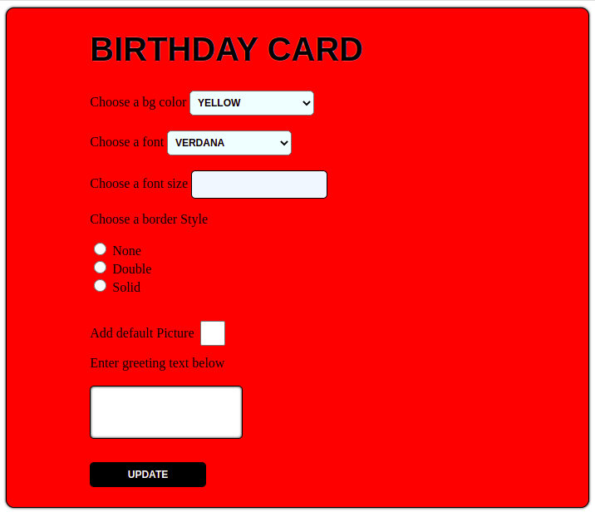

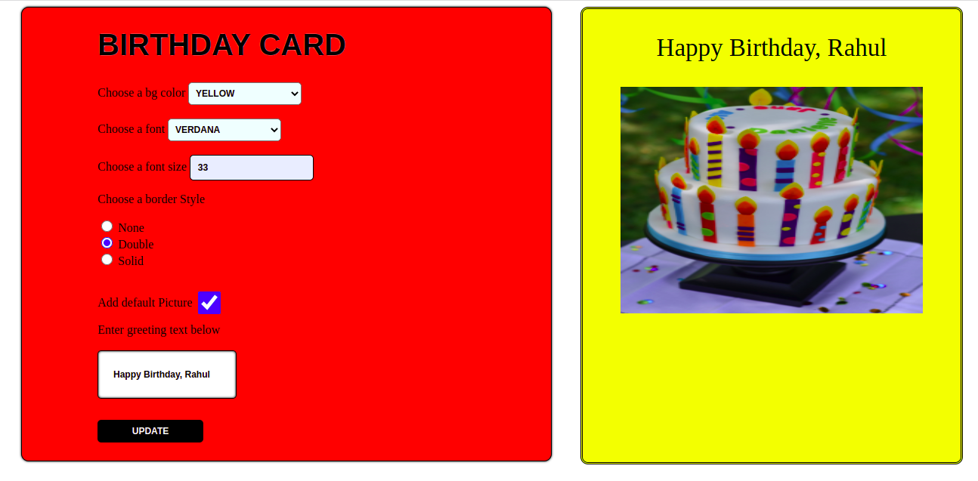

4.Design a webpage. The page contains:
• Dropdown list with HP, Nokia, Samsung, Motorola, Apple as items.
• Checkbox with Mobile and Laptop as items.
• Textbox where you enter quantity.
• There is a button with text as ‘Produce Bill’.
On Clicking Produce Bill button, alert should be displayed with total amount.

<!DOCTYPE html>
<html lang="en">

<head>
<meta charset="UTF-8">
<meta http-equiv="X-UA-Compatible" content="IE=edge">
<meta name="viewport" content="width=device-width, initial-scale=1.0">
<title>Drop Down List</title>
<script src="jquery-3.6.0.min.js"></script>
<style>
body {
background-color: white;
}

.drop-down-main {
width: 600px;
height: 500px;
background-color: whitesmoke;
position: absolute;
top: 40px;
left: 350px;
border: 1px solid rgb(0, 0, 0);
border-radius: 5px;
box-shadow: 0 4px 8px 0 rgba(0, 0, 0, 0.5), 0 6px 20px 0 rgba(0, 0, 0, 0.5);
}

.drop-down-main h1 {
font-family: 'Courier New', Courier, monospace;
font-weight: bold;
font-size: 30px;
text-align: center;
text-transform: uppercase;
text-shadow: 0 0 3px brown;
}

.drop-down-main select {
width: 300px;
height: 30px;
text-align: center;
font-family: 'Courier New', Courier, monospace;
font-weight: bold;
font-size: 15px;
outline-color: rgb(165, 42, 155);
position: relative;
left: 150px;
cursor: pointer;
background-color: rgb(165, 42, 155);
color: white;
border: 1px solid black;
border-radius: 5px;
}

.drop-down-checkbox {
width: 320px;
height: 30px;
position: relative;
top: 30px;
left: 150px;
display: inline-block;
font-family: 'Courier New', Courier, monospace;
font-weight: bold;
font-size: 15px;

}

.drop-down-checkbox input[type="checkbox"] {
width: 20px;
height: 20px;
}

.drop-down-checkbox h3 {
font-size: 20px;
position: relative;
top: -45px;
left: 30px;
}

.drop-down-checkbox-two {
width: 150px;
height: 30px;
position: relative;
top: -25px;
left: 150px;
}

.drop-down-checkbox-two input[type="checkbox"] {
width: 20px;
height: 20px;

}

.drop-down-checkbox-two h4 {
font-size: 20px;
position: relative;
top: -50px;
left: 30px;
}

input[type="text"] {
width: 300px;
height: 30px;
text-align: center;
color: black;
font-family: 'Courier New', Courier, monospace;
font-weight: bold;
font-size: 20px;
text-transform: uppercase;
position: relative;
top: -100px;
left: 150px;
border: none;
outline:none;
}
h5{
font-family: 'Courier New', Courier, monospace;
font-weight: bold;
font-size: 20px;
text-transform: uppercase;
position: relative;
top: -40px;
left: 10px;
}
input[type="button"]{
width: 300px;
height: 40px;
text-align: center;
color: white;
background-color: blue;
font-family: 'Courier New', Courier, monospace;
font-weight: bold;
font-size: 15px;
text-transform: uppercase;
position: relative;
top: -30px;
left: 150px;
border: 1px solid white;
box-shadow: 0 0 3px rgb(0, 0, 0);
outline: none;
cursor: pointer;
border-radius: 5px;
}

input[type="button"]:active {
transition: 0.5;
background-color: green;
color: white;
transform: scale(1);
}
input[type="reset"]{
width: 100px;
height: 40px;
text-align: center;
color: white;
background-color: black;
font-family: 'Courier New', Courier, monospace;
font-weight: bold;
font-size: 15px;
text-transform: uppercase;
position: relative;
top: -30px;
left: 150px;
border: 1px solid white;
box-shadow: 0 0 3px rgb(0, 0, 0);
outline: none;
cursor: pointer;
border-radius: 5px;
}input[type="reset"]:active {
transition: 0.5;
transform: scale(.9);
background-color: red;
}
#result{
width: 300px;
height: 30px;
text-align: center;
color: black;
font-family: 'Courier New', Courier, monospace;
font-weight: bold;
font-size: 20px;
text-transform: uppercase;
position: relative;
top: -50px;
left: 150px;
outline: none;
border: none;
}
h2{
font-family: 'Courier New', Courier, monospace;
font-weight: bold;
font-size: 20px;
text-transform: uppercase;
position: relative;
left: 10px;
top: -5px;
}
</style>
</head>

<body>
<form name = "f1">
<div class="drop-down-main">
<h1>shopping</h1>
<select name="dropdown">
<option value="">SELECT</option>
<option value="HP">HP</option>
<option value="Nokia">Nokia</option>
<option value="Samsung">Samsung</option>
<option value="Motorola">Motorola</option>
<option value="Apple">Apple</option>
</select><br>
<div class="drop-down-checkbox">
<input type="checkbox" name="check1" id="checkbox1" value="Mobile">
<h3>Mobile</h3><br>
</div>
<div class="drop-down-checkbox-two">
<input type="checkbox" name="check1" id="checkbox2" value="Laptop">
<h4>Laptop</h4><br>
</div>
<h2>TOTAL(RS): </h2><input type="text1" name="result" id="result" autocomplete="off" ><br>
<h5>Quantity : </h5><input type="text" name="quantity" id="quantity" autocomplete="off" required>
<input type="button" value="Produce Bill" id="button">
<input type="reset" value="Reset" name="reset">

</div>
</form>
<script>
$(document).ready(function () {
$("#button").click(function () {
var sum = 0;
var sum1 = 0;
if ($("select").val() == "HP") {
if ($("#checkbox1").prop("checked") == true && $("#checkbox2").prop("checked") == true) {
sum = sum + parseInt($("#quantity").val()) * 25000;
sum = sum + parseInt($("#quantity").val()) * 30000;
document.f1.result.value = sum;
}else if ($("#checkbox1").prop("checked") == true) {
sum = sum + parseInt($("#quantity").val()) * 25000;
document.f1.result.value = sum;
} else {
sum = sum + parseInt($("#quantity").val()) * 30000;
document.f1.result.value = sum;
}
}
if ($("select").val() == "Nokia") {
if ($("#checkbox1").prop("checked") == true && $("#checkbox2").prop("checked") == true) {
sum = sum + parseInt($("#quantity").val()) * 40000;
sum = sum + parseInt($("#quantity").val()) * 50000;
document.f1.result.value = sum;
}else if ($("#checkbox1").prop("checked") == true) {
sum = sum + parseInt($("#quantity").val()) * 40000;
document.f1.result.value = sum;
} else {
sum = sum + parseInt($("#quantity").val()) * 50000;
document.f1.result.value = sum;
}
}
if ($("select").val() == "Samsung") {
if ($("#checkbox1").prop("checked") == true && $("#checkbox2").prop("checked") == true) {
sum = sum + parseInt($("#quantity").val()) * 70000;
sum = sum + parseInt($("#quantity").val()) * 80000;
document.f1.result.value = sum;
}else if ($("#checkbox1").prop("checked") == true) {
sum = sum + parseInt($("#quantity").val()) * 70000;
document.f1.result.value = sum;
} else {
sum = sum + parseInt($("#quantity").val()) * 80000;
document.f1.result.value = sum;
}
}
if ($("select").val() == "Motorola") {
if ($("#checkbox1").prop("checked") == true && $("#checkbox2").prop("checked") == true) {
sum = sum + parseInt($("#quantity").val()) * 44000;
sum = sum + parseInt($("#quantity").val()) * 47000;
document.f1.result.value = sum;
}else if ($("#checkbox1").prop("checked") == true) {
sum = sum + parseInt($("#quantity").val()) * 44000;
document.f1.result.value = sum;
} else {
sum = sum + parseInt($("#quantity").val()) * 47000;
document.f1.result.value = sum;
}
}
if ($("select").val() == "Apple") {
if ($("#checkbox1").prop("checked") == true && $("#checkbox2").prop("checked") == true) {
sum = sum + parseInt($("#quantity").val()) * 120000;
sum = sum + parseInt($("#quantity").val()) * 140000;
document.f1.result.value = sum;
}else if ($("#checkbox1").prop("checked") == true) {
sum = sum + parseInt($("#quantity").val()) * 120000;
document.f1.result.value = sum;
} else {
sum = sum + parseInt($("#quantity").val()) * 140000;
document.f1.result.value = sum;
}
}
});

});
</script>
</body>

</html>
