190905514 MOHAMMAD TOFIK BATCH : C2
ROLLNO SECTION : C SEM : 6th

-: DS-LAB-WEEK : 3 :-

import numpy as np
import random
print("Array Creation : \n\n")
A = np.array([2, 5, 10])
print(A.dtype)
B = np.array([2.4, 10.6, 5.2])
print(B.dtype)

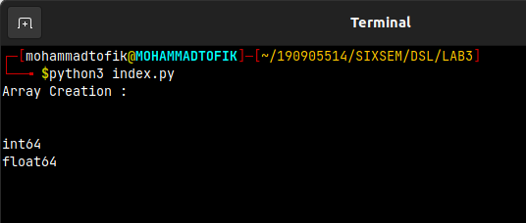
print("\n\n")
print("Creating sequences of sequence will create 2 dimensional array : \n")
X = np.array([(3, 4, 5), (12, 6, 1)])
print(X)
Y = np.zeros((2, 4))
print(Y)
Z = np.ones((3, 3))
print(Z)

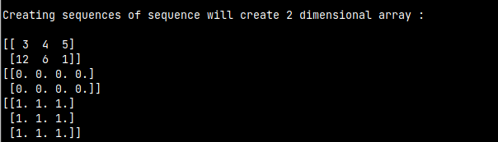

print("To create a sequence of data : \n\n")
S = np.arange(10, 30, 5)
print(S)
P = np.arange(0, 2, 0.3)
print(P)

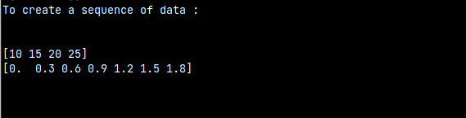
print("\n\n")
print("Uses of Random Number function : \n")
print(random.choice([1, 2, 3, 4, 5]))
print(random.choice('python'))
print(random.randrange(25, 50))
print(random.randrange(25, 50, 2))
print(random.random())
print(random.uniform(5, 10))
print(random.shuffle([1, 2, 3, 4, 5]))
print(random.seed(10))

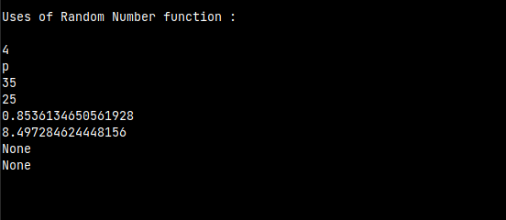
print("\n\n")
print("2-dimensional array (Matrix)")
a = np.arange(15).reshape(3, 5)
print(a)
print(a.shape)
print(a.size)
print(a.T)

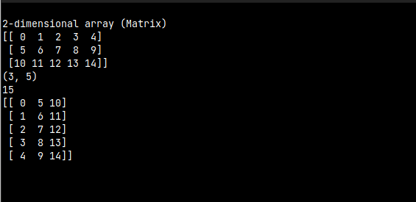
print("\n\n")
print("3-dimensional array : \n")
c = np.arange(24).reshape(2, 3, 4)
print(c)
print(c.shape)
print(c[1, :, :])
print(c[:, :, 2])

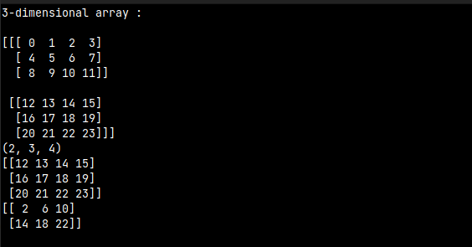
print("\n\n")
print("Array operation : \n")
a = np.array([20, 30, 40, 50])
b = np.arange(4)
print(b)
c = a-b
print(c)
print(b**2)
print(10*np.sin(a))
print(a < 35)

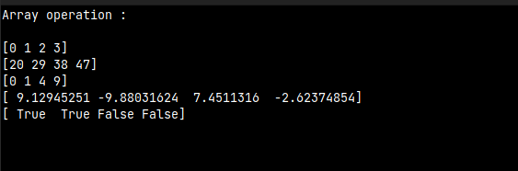

print("\n\n")
print("Matrix operation : \n")
A = np.array([[1, 1], [0, 1]])
B = np.array([[2, 0], [3, 4]])
print(A*B)
print(A.dot(B))
print(np.dot(A, B))
C = np.arange(12).reshape(3, 4)
print(C)
print(C.sum(axis=0))
print(C.sum(axis=1))

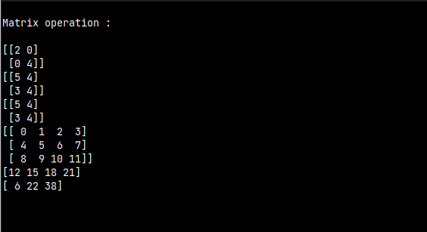
print("\n\n")
print("Indexing, Slicing Litrating array : \n")
x = np.arange(10)**3
print(x)
print(x[2:5])
print(x[0:6:2])
y = np.array([[0, 1, 2, 3], [10, 11, 12, 13], [20, 21, 22, 23],
[30, 31, 32, 33], [40, 41, 42, 43]])
print(y[2, 3])
print(y[:5, 1])
print(y[-1, :])
print(y[:, -1])
for row in y:
print(row)
for element in y.flat:
print(element)
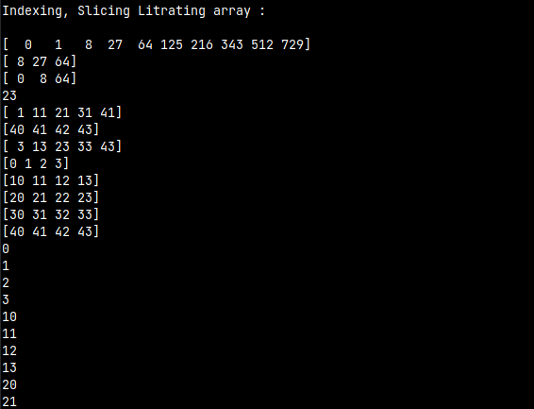
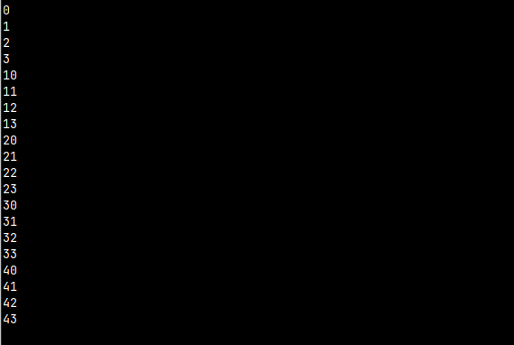
print("\n\n")
print("Creating the shape of the matrix : \n")
x = np.arange(10)**3
print(x)
print(x[2:5])
print(x[0:6:2])
y = np.array([[0, 1, 2, 3], [10, 11, 12, 13], [20, 21, 22, 23],
[30, 31, 32, 33], [40, 41, 42, 43]])
print(y[2, 3])
print(y[:5, 1])
print(y[-1, :])
print(y[:, -1])
for row in y:
print(row)
for element in y.flat:
print(element)
print(y.ravel())
B1 = y.reshape(4, 5)
print(B1)

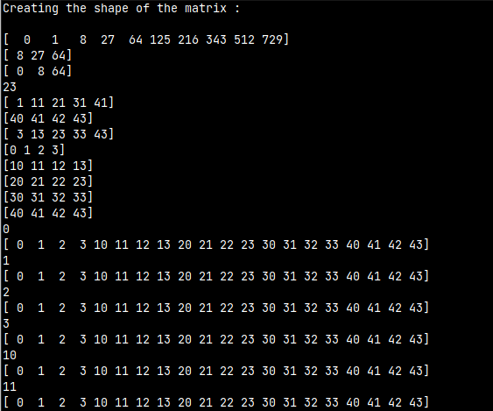

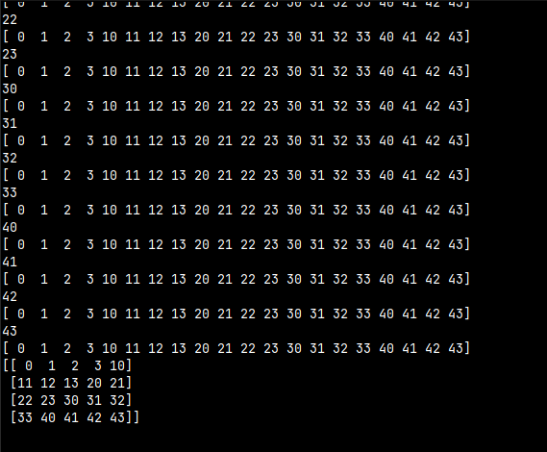
print("\n\n")
print("Stacking together different array : \n")
A1 = np.array([(3, 4, 5), (12, 6, 1)])
A2 = np.array([(1, 2, 6), (-4, 3, 8)])
D1 = np.vstack((A1, A2))
D2 = np.hstack((A1, A2))
print(A1)
print(A2)
print(D1)
print(D2)

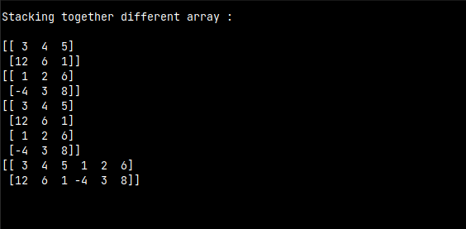
print("\n\n")
print("Stacking one D array into 2-D array : \n")
a = np.array([4., 2.])
b = np.array([3., 8.])
print(np.column_stack((a, b)))
print(np.hstack((a, b)))

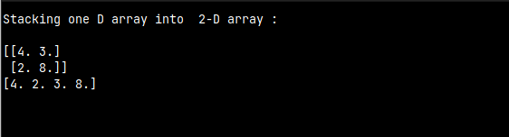
print("\n\n")
print("Indexing with array of the indices : \n")
k = np.arange(12)**2
i = np.array([1, 1, 3, 8, 5])
j = np.array([[3, 4], [9, 7]])
print(k[i])
print(k[j])

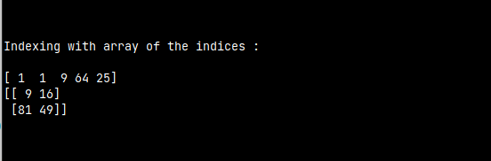

print("\n\n")
print("Use of for loop (Mapping by value : \n")
x = np.array([(3, 2, 9), (1, 6, 7)])
s1 = 0
for row in x:
for col in row:
s1 += col
print(s1)

print("\n\n")
print("Use of for loop (Mapping by Index : \n")
y = np.array([(3, 2, 9), (1, 6, 7)])
s = 0
for p in range(y.shape[0]):
for q in range(y.shape[1]):
s += y[p, q]
print(s)

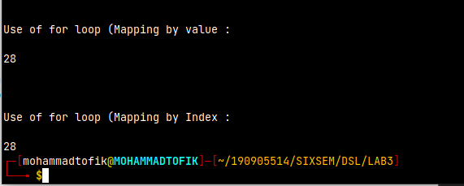

EXCERCISE QUESTION :

1.Write a program to find the factor of a given number(get input from user) using for loop.

n = int(input("Enter number: "))
print('1', end=' ')
for i in range(2,n):
if n%i == 0:
print(i, end=' ')
print(n)

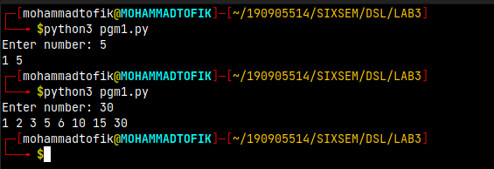

2.Find the sum of column and row usinf axis

import numpy as np
b = np.array([[2,0],[3,4]])
print(b)
print('Column sum: ',b.sum(axis=0))
print('Row sum: ',b.sum(axis=1))

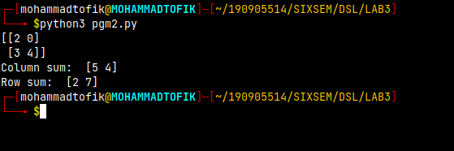

3.Operations on an array(use numpy wherever required):
(a)Create array from list with type float
(b)Create array from tupple
(c)Creating 3 X 4 array with all zeros;
(d)Creating a sequence of integers from 0 to 20 with step of 5
(e)Reshape 3 X 4 array to 2x2x3 array
(f)Find Maximum and minimum elements of an array, Row wise max and min, column wise max, and min and sum of elements.(Use function max(),min(),sum())

import numpy as np
# a)
a = np.array([1, 2, 3, 4, 5, 6])
print(a)
# b)
a = np.array((1, 2, 3, 4, 5, 6, 7, 8, 9, 10))
print(a)
# c)
c = np.zeros((3, 4))
print(c)
# d)
d = np.arange(0, 20, 5)
print(d)
# e)
e = c.reshape(2, 2, 3)
print(e)
# f)
c = a.reshape(5, 2)
print(c)
print('Col min:', end=' ')
for i in range(c.shape[0]):
print(min(c[i, :]), end=' ')
print('\nRow min:', end=' ')
for i in range(c.shape[1]):
print(min(c[:, i]), end=' ')
print('Col max:', end=' ')
for i in range(c.shape[0]):
print(max(c[i, :]), end=' ')
print('\nRow max:', end=' ')
for i in range(c.shape[1]):
print(max(c[:, i]), end=' ')
print('\nColumn sum: ', c.sum(axis=0))
print('Row sum: ', c.sum(axis=1))

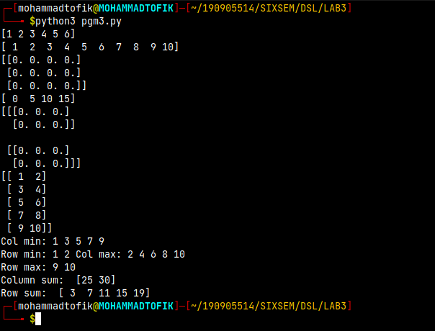

4.Write a program to transpose of the matrix

import numpy as np
a = np.arange(0,10).reshape(2,5)
print(a)
a = a.T
print(a)

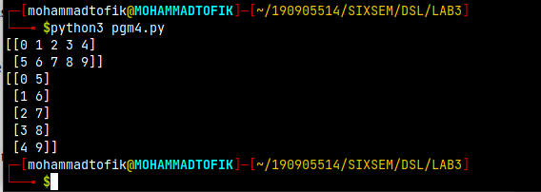

5.Write a program to add two matrix

import numpy as np
a = np.arange(0,10).reshape(2,5)
b = np.arange(10,20).reshape(2,5)
print(a)
print(b)
print(a+b)

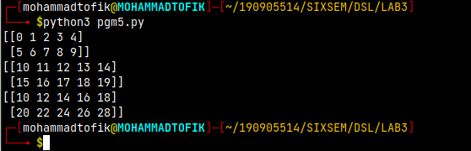
6.Write a program to find elements wise product between two matrices.
import numpy as np
print("Array Creation : ")
a = np.arange(0,10).reshape(2,5)
b = np.arange(10,20).reshape(2,5)
print(a)
print(b)
c = np.zeros((2,5))
for i in range(a.shape[0]):
for j in range(a.shape[1]):c[i,j]=a[i,j]*b[i,j];
print(c)

